Contents

Microservices 4

Microservices vs APIs 4

12 Factor App 6

When to use or not use? 6

When might Microservices be a bad idea? 6

To change Monolith or not 7

Migration 7

Strangler Fig Application 7

Branch By Abstraction 19

Domain Driven Design 24

Introduction 24

Strategic Design 25

Tactical Design Tools 31

Implementing DDD 34

Implementing DDD in Code 37

Domain Driven Design ( Summary ) 40

Monolith and Microservices Ecosystem 41

BASE 45

CAP Theorem 47

SAGAS 49

The Need for Sagas 52

SAGA Co-ordination 59

Order Allocation SAGA 61

State Machine Enumerations 64

Configure State Machine States 64

Refactor Model to Common Package 65

Pattern Implementations 67

CR – Eventuate.io framework 127

SAGA and related Patterns 188

Challenges 189

Fallacies of a Distributed System 190

Spring State Machine 196

Overview 196

Credit Card Payment State Machine Overview 200

Initial Project 202

State Machine Enumerations 204

Payment Domain Object 205

Configuring the State Machine 206

Transition Configuration 209

Event Listener 212

Payment Service 215

Initialize State Machine from the Database 217

Sending Events to the State Machine 219

State Change Interceptor 221

Progressing State from New to Pre-Auth 227

State Machine Actions 237

State Machine Guards 240

Event Sourcing 244

Design Patterns 244

Refactoring to microservices patterns 245

Monolith Decomposition Patterns 246

Ambassador 247

Sidecar 249

Anti-Corruption Layer 251

Saga distributed transactions 255

Backends for Frontends 259

Data Management patterns 260

Pipes and Filters 287

Publisher-Subscriber 292

Bulkhead pattern 297

Scheduler Agent Supervisor 299

Sequential Convoy 305

Gatekeeper 307

Gateway Offloading 311

Gateway Routing 312

Choreography 314

Circuit Breaker 316

Compensating Transaction 322

Claim Check 325

Health Endpoint Monitoring 327

Competing Consumers 336

External Configuration Store 339

Retry pattern 345

Throttling pattern 348

Federated Identity 351

Geodes 354

Data Consistency Primer 356

Managing Data Consistency 356

Strong Consistency 357

Eventual Consistency 358

Spring MVC REST Services 361

Beer Distribution Project 361

Project 397

MapStruct 435

Trade-Offs 444

Principles 445

Videos 445

Distributed Caching 445

Thoughts – Good Articles 445

Temp 445

# Microservices

## Microservices vs APIs

**APIs**

An application programming interface, or API, is the part of an application that communicates with other applications. More technically speaking, an API is a group of protocols and methods that define how two applications share and modify each other’s data.

APIs are necessary in our modern digital infrastructure because they enable standardized and efficient communication between applications which might differ in function and construction.

An API sits between a software’s core components and the public, and external developers can access certain parts of an application’s backend without needing to understand how everything works inside the app. This is what makes an API an interface for programmers.

Since an API is more of a concept, programmers can build an API for their app however they please. However, most rely on frameworks to create them.

REST, which stands for Representational State Transfer, is a framework for developing APIs, and APIs that conform to REST are called REST APIs. REST APIs are the most common type of API for cross-platform integrations and are also used in microservices.

**External vs. Internal APIs**

Now, full disclosure: The APIs I’ve talked about thus far are all instances of a specific type of API called a web API. Web APIs facilitate communication between web servers. My examples are also all open APIs, which means that they are available for anyone to use, including third-party software developers. However, API’s don’t have to be publicly available. Internal APIs are used for communication within an application, and access is usually restricted to the organization’s employees and authorized developers. Knowing this, we can now start to unpack microservices.

**“Three-layered” API-led connectivity architecture**

Large enterprises have complex, interwoven connectivity needs that require multiple API-led connectivity building blocks. In this context, putting in a framework for ordering and structuring these building blocks is crucial. Agility and flexibility can only come from a multi-tier architecture containing three distinct layers:

**System Layer:** Underlying all IT architectures are core systems of record (e.g. one’s ERP, key customer and billing systems, proprietary

databases etc). Often these systems are not easily accessible due to connectivity concerns and APIs provide a means of hiding that complexity from the user. System APIs provide a means of accessing underlying systems of record and exposing that data, often in a canonical format, while providing downstream insulation from any interface changes or rationalization of those systems. These APIs will also change more infrequently and will be governed by Central IT given the importance of the underlying systems.

**Process Layer:** The underlying business processes that interact and shape this data should be strictly encapsulated independent of the source systems from which that data originates, as well as the target channels through which that data is to be delivered. For example, in a purchase order process, there is some logic that is common across products, geographies and retail channels that can and should be distilled into a single service that can then be called by product-geography- or channel-specific parent services. These APIs perform

specific functions and provide access to non-central data and may be built by either Central IT or Line of Business IT.

**Experience Layer:** Data is now consumed across a broad set of channels, each of which want access to the same data but in a variety of different forms. For example, a retail branch POS system, ecommerce site and mobile shopping application may all want to access the same customer information fields, but each will require that information in very different formats. Experience APIs are the means by which data can be reconfigured so that it is most easily consumed by its intended audience, all from a common data source, rather than setting up separate point-to-point integrations for each channel.

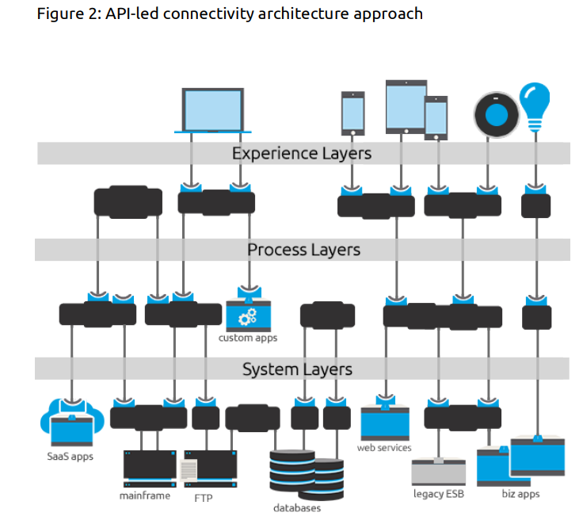

**What is the Difference Between an API and Microservice?**

Trying to compare the difference between APIs and microservices is a bit misleading because APIs are actually an essential part of a microservice architecture. Each microservice in the architecture will have its own API. The API sits in front of the microservice and allows communication between the different components of the microservice architecture.

A microservice architecture likely contains many APIs, though APIs can also be used for other purposes without being a part of a microservice architecture. This is likely where the confusion comes from when comparing the two.

It can also be confusing because APIs and microservices can seem to accomplish similar goals. For example, if you could use an email API in your application like SendGrid to deliver emails. Alternatively, it is also possible to have an email service within a microservice architecture.

Microservices and APIs are similar, but both have distinct characteristics. Understanding the differences and how the two interact together can help you choose which one might be best for your project. Review the chart below for a review of the key points.

|  |  |  |
| --- | --- | --- |
|  | **API** | **Microservices** |
| **Purpose** | Allows communication between two components coupled | A style for building applications that organizes loosely Services |
| **Characteristics** | Lightweight, fast, usually specialized | Decentralized, scalable, modular |
| **Use Cases** | Used to add specific functions to an application. | Also used within a microservice architecture to allow communication between the different component. Used instead of a monolithic architecture to create applications |

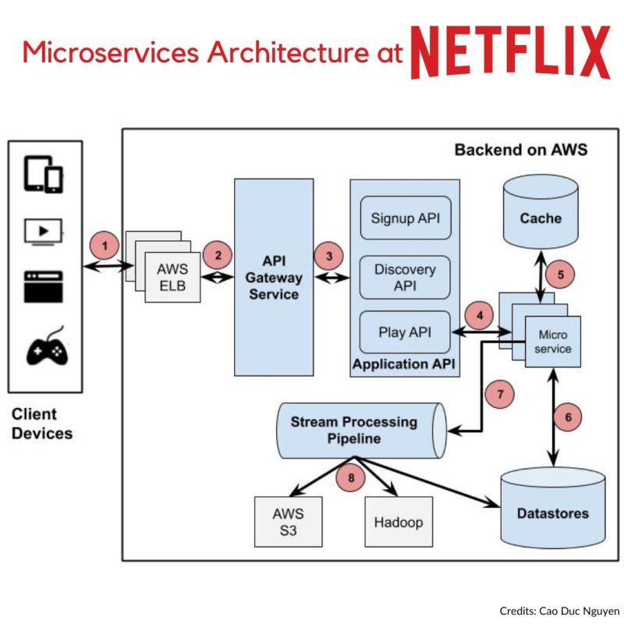

## 12 Factor App

## When to use or not use?

### When might Microservices be a bad idea?

**Unclear Domain**

Getting service boundaries wrong can be expensive. It can lead to a larger number of cross-service changes, overly coupled components, and in general could be worse than just having a single monolithic system.

**Startups**

This might seem a bit controversial, as so many of the organizations famous for their use of microservices are considered startups, but in reality many of these companies including Netflix, Airbnb, and the like moved toward microservice architecture only later in their evolution. Microservices can be a great option for “scale-ups”— startup companies that have established at least the fundamentals of their product/market fit, and are now scaling to increase (or likely simply achieve) profitability.

Startups, as distinct from scale-ups, are often experimenting with various ideas in an attempt to find a fit with customers. This can lead to huge shifts in the original vision for the product as the space is explored, resulting in huge shifts in the product domain.

A real startup is likely a small organization with limited funding, which needs to focus all its attention on finding the right fit for its product. Microservices primarily solve the sorts of problems startups have once they’ve found that fit with their customer base. Put a different way, microservices are a great way of solving the sorts of problems you’ll get once you have initial success as a startup. So focus initially on being a success! If your initial idea is bad, it doesn’t matter whether you built it with microservices or not.

It is much easier to partition an existing, “brownfield” system than to do so up front with a new, greenfield system that a startup would create. You have more to work with. You have code you can examine, and you can speak to people who use and maintain the system. You also know what good looks like — you have a working system to change, making it easier for you to know when you may have made a mistake or been too aggressive in your decision-making process.

You also have a system that is actually running. You understand how it operates and how it behaves in production. Decomposition into microservices can cause some nasty performance issues, for example, but with a brownfield system you have a chance to establish a healthy baseline before making potentially performance impacting changes

**Customer-Installed and Managed Software**

If you create software that is packaged and shipped to customers who then operate it themselves, microservices may well be a bad choice. When you migrate to a microservice architecture, you push a lot of complexity into the operational domain. Previous techniques you used to monitor and troubleshoot your monolithic deployment may well not work with your new distributed system. Now teams who undertake a migration to microservices offset these challenges by adopting new skills, or perhaps adopting new technology—these aren’t things you can typically expect of your end customers.

**Not Having a Good Reason!**

And finally, we have the biggest reason not to adopt microservices, and that is if you don’t have a clear idea of what exactly it is that you’re trying to achieve. As we’ll explore, the outcome you are looking for from your adoption of microservices will define where you start that migration and how you decompose the system. Without a clear vision of your goals, you are fumbling around in the dark. Doing microservices just because everyone else is doing it is a terrible idea.

### To change Monolith or not

In some situations, however, there will be a hard constraint in place, denying you this opportunity. The existing system may be a vendor product for which you don’t have the source code, or it may also be written in a technology that you no longer have the skills for. There may also be softer drivers that might divert you away from changing the existing system. It’s possible that the current monolith is in such a bad state that the cost of change is too high—as a result, you want to cut your losses and start again (although as I detailed earlier, I worry that people reach this conclusion far too easily).

Another possibility is that the monolith itself is being worked on by many other people, and you’re worried about getting in their way. Some patterns, like the Branch by Abstraction pattern we’ll explore shortly, can mitigate these issues, but you may still judge that the impact to others is too great

<NeedContent>

**Refactoring the Monolith**

* I’ve observed that often the biggest barrier to making use of existing code in the monolith in your new microservices is that existing codebases are traditionally not organized around business domain concepts. Technical categorizations are more prominent (think of all the Model, View, Controller package names you’ve seen, for example). When you’re trying to move business domain functionality, this can be difficult: the existing codebase doesn’t match that categorization, so even finding the code you’re trying to move can be problematic!

## Migration

### Strangler Fig Application

Our new system initially be supported by, and wrapping, the existing system. The idea is that the old and the new can coexist, giving the new system time to grow and potentially entirely replace the old system. The key benefit to this pattern, as we’ll see shortly, is that it supports our goal of allowing for incremental migration to a new system. Moreover, it gives us the ability to pause and even stop the migration altogether, while still taking advantage of the new system delivered so far

While the strangler fig pattern has been commonly used to migrate from one monolithic system to another, we will look to migrate from a monolith to a series of microservices. This may involve actually copying the code from the monolith (if possible), or else reimplementing the functionality in question. In addition, if the functionality in question requires the persistence of state, then consideration needs to be given to how that state can be migrated to the new service, and potentially back again.

Implementing a strangler fig pattern relies on three steps, as outlined in Figure 3-1. First, identify parts of the existing system that you wish to migrate. You’ll need to use judgement as to which parts of the system to tackle first, using the sort of trade-off activity we discussed in Chapter 2. You then need to implement this functionality in your new microservice. With your new implementation ready, you need to be able to reroute calls from the monolith over to your shiny new microservice.

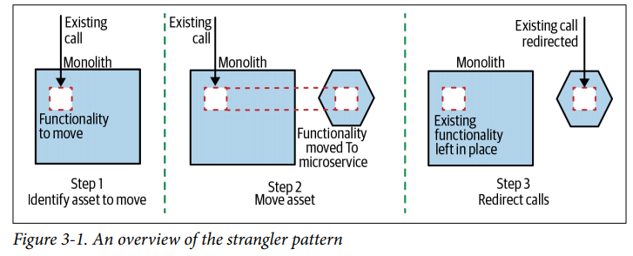

A key point of this strangler application approach is not just that we can incrementally migrate new functionality to the new system, but that we can also roll back this change very easily if required. Remember, we all make mistakes—so we want techniques that allow us to not only make mistakes as cheaply as possible (hence lots of small steps), but also fix our mistakes quickly.

* If the functionality being extracted is also used by other functionality inside the monolith, you need to change how those calls are made as well.

A key point of this strangler application approach is not just that we can incrementally migrate new functionality to the new system, but that we can also roll back this change very easily if required. Remember, we all make mistakes—so we want techniques that allow us to not only make mistakes as cheaply as possible (hence lots of small steps), but also fix our mistakes quickly.

If the functionality being extracted is also used by other functionality inside the monolith, you need to change how those calls are made as well. We’ll cover a few techniques for this later

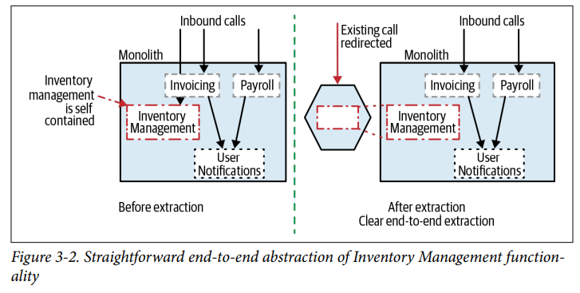

In order to perform a clean end-to-end extraction like this, you might be inclined to extract larger groups of functionality to simplify this process. This can result in a tricky balancing act—by extracting larger slices of functionality, you are taking on more work, but may simplify some of your integration challenges. If you do want to take a smaller bite, you may have to consider more “shallow” extractions, like those we see in Figure 3-3. Here we are extracting Payroll functionality, despite the fact it makes use of other functionality that remains inside the monolith—in this example, the ability to send User Notifications.

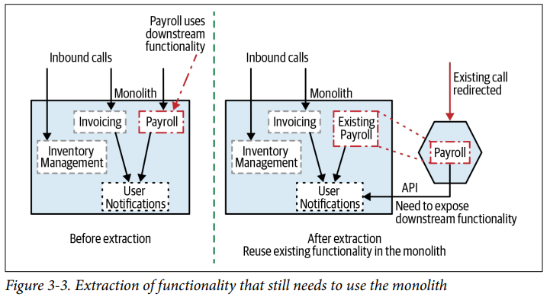

Rather than also reimplementing the User Notifications functionality, we expose this functionality to our new microservice by exposing it from the monolith—something that obviously would require changes to the monolith itself.

For the strangler to work, though, you need to be able to clearly map the inbound call to the functionality you care about to the asset that you want to move. For example, in Figure 3-4, we’d ideally like to move out the ability to send User Notifications to our customers into a new service. However, notifications are fired as a result of multiple inbound calls to the existing monolith. Therefore, we can’t clearly redirect the calls from outside the system itself. Instead, we’d need to look at a technique like the one described in the section “Pattern: Branch by Abstraction”

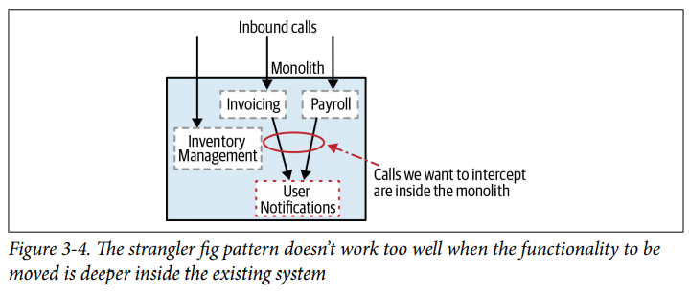

**The strangler fig pattern doesn’t work too well when the functionality to be moved is deeper inside the existing system**

You will also need to consider the nature of the calls being made into the existing system. As we explore shortly, a protocol such as HTTP is very amenable to redirection. HTTP itself has the concepts of transparent redirection built in, and proxies can be used to clearly understand the nature of an inbound request and divert it accordingly. Other types of protocols, such as some RPCs, may be less amenable to redirection. The more work you have to do in the proxy layer to understand and potentially transform the inbound call, the less viable this option becomes. Despite these restrictions, the strangler fig application has proven itself time and again to be a very useful migration technique. Given the light touch, and easy approach to handle incremental change, it’s often my first port of call when exploring how to migrate a system.

**Example: HTTP Reverse Proxy**

|  |  |
| --- | --- |
|  | HTTP has some interesting capabilities, among them that it is very easy to intercept and redirect in a way that can be made transparent to the calling system. This means that an existing monolith with an HTTP interface is amenable to migration through use of a strangler fig pattern.  In Figure 3-5, we see an existing monolithic system that exposes an HTTP interface. This application may be headless, or the HTTP interface may, in fact, be being called by an upstream UI. Either way, the goal is the same: to insert an HTTP reverse proxy  between the upstream calls and the downstream monolith.  Figure 3-5. A simple overview of an HTTP-driven monolith prior to a strangler being implemented   * **Step 1: Insert proxy**   Unless you already have an appropriate HTTP proxy in place that you can reuse, I  suggest getting one in place first, as seen in Figure 3-6.   * In this first step, the proxy will just allow any calls to pass through without change |
|  | This step will allow you to assess the impact of inserting an additional network hop between the upstream calls and the downstream monolith, set up any required monitoring of your new component, and basically, sit with it a while.  From a latency point of view, we will be adding a network hop and a process in the processing path of all calls. With a decent proxy and network, you’d expect a minimal impact on latency (perhaps in the order of a few milliseconds), but if this turns out not to be the case, you have a chance to stop and investigate the issue before you go any further.  If you already have an existing proxy in place in front of your monolith, you can skip this step—although do make sure you understand how this proxy can be reconfigured to redirect calls later on. I suggest at the very least experimenting with the redirection to make sure it will work as intended before assuming that this can be done later on. It would be a nasty surprise to discover that this is impossible just before you plan to send your new service live! |

* **Step 2: Migrate functionality**

With our proxy in place, next you can start extracting your new microservice, as we see in Figure 3-7.

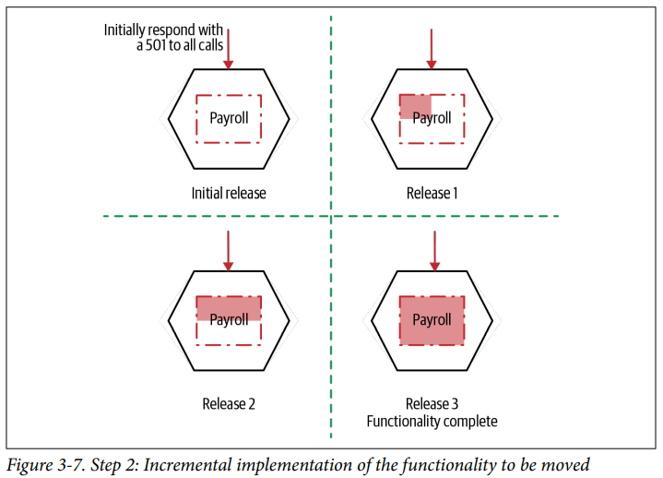

This step itself can be broken into multiple stages. First, get a basic service up and running without any of the functionality being implemented. Your service will need to accept the calls made to the matching functionality, but at this stage you could just return a 501 Not Implemented. Even at this step, I’d get this service deployed into the production environment. This allows you to get comfortable with the production deployment process, and test the service in situ. At this point, your new service isn’t released, as you haven’t redirected the existing upstream calls yet. Effectively, we are separating the step of software deployment from software release, a common release technique that we’ll revisit later on

* **Step 3: Redirect calls**

|  |  |
| --- | --- |
| Step 3: Redirecting the call to Payroll functionality, completing the migration  It’s only once you’ve completed movement of all the functionality that you reconfigure the proxy to redirect the call, as we see in Figure 3-8. If this fails for whatever reason, then you can switch the redirection back—for most proxies, this is a very quick and easy process, giving you a fast rollback.  You may decide to implement the redirection using something like a feature toggle, which can make your desired configuration state much more obvious. The use of a proxy to redirect the calls is also a great location to consider incremental rollout of the new functionality through a canary rollout, or even a full-blown parallel run, another pattern we discuss in this chapter |  |

**Proxy Options**

How you implement the proxy is in part going to depend on the protocol used by the monolith. If the existing monolith uses HTTP, then we’re off to a good start. HTTP is such a widely supported protocol that you have a wealth of options out there for managing the redirection. I would probably opt for a dedicated proxy like NGINX, which has been created with exactly these sorts of use cases in mind, and can support a multitude of redirection mechanisms that are tried and tested and likely to perform fairly well.

Some redirections will be simpler than others. Consider redirection around URI paths, perhaps as would be exhibited making use of REST resources. In Figure 3-9, we move the entire Invoice resource over to our new service, and this is easy to parse from the URI path.

#### Redirection by Resource

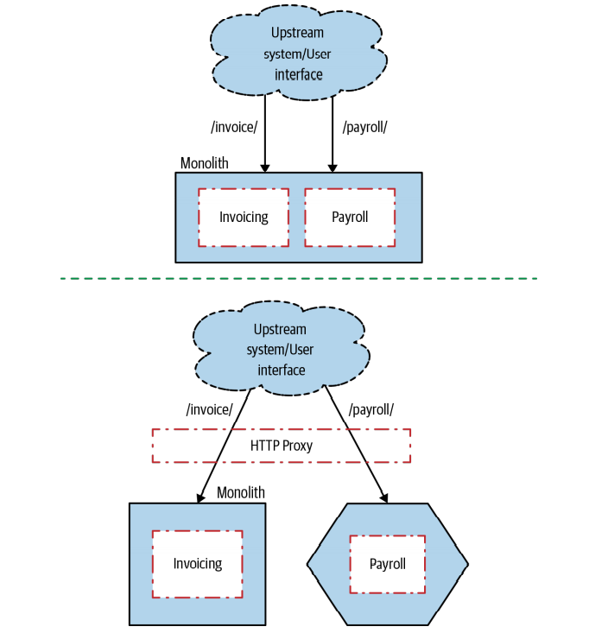

If, however, the existing system buries information about the nature of the functionality being called somewhere in the request body (perhaps in a form parameter), our redirection rule will need to be able to switch on a parameter in the POST—something that is possible, but more complicated. It is certainly worth checking the proxy options available to you to make sure they are able to handle this if you find yourself in this situation.

If the nature of interception and redirection is more complex, or in situations where the monolith is using a less well-supported protocol, you might be tempted to code something yourself, but you should be very cautious about this approach. I’ve written a couple of network proxies by hand before (one in Java, the other in Python), and while it may say more about my coding ability than anything else, in both situations the proxies were incredibly inefficient, adding significant lag into the system. Nowadays if I needed more custom behavior, I’d be more likely to consider adding custom behavior to a dedicated proxy—for example, NGINX allows you to use code written in Lua to add custom behavior.

**Incremental rollout**

As you can see in Figure 3-10, this technique allows for architectural changes to be made via a series of small steps, each of which can be done alongside other work on the system.

You might consider the switchover to a new implementation of the Payroll functionality to still be too big, in which case you can take smaller slices of functionality. You can consider, for example, migrating only part of the Payroll functionality and diverting calls appropriately—having some of the behavior implemented in the monolith, and part in the microservice, as shown in Figure 3-11. This can cause issues if both the functionality in the monolith and in the microservice need to see the same set of data, as this will likely require a shared database and all the problems this can bring.

No big bang, stop-the-line re-platforming required. This makes it much easier to break this work into stages that can be delivered alongside other delivery work. Rather than breaking your backlog into “feature” and “technical” stories, fold all this work together. Get good at making incremental changes to your architecture while still delivering new features

**An overview of implementing an HTTP-based strangler**

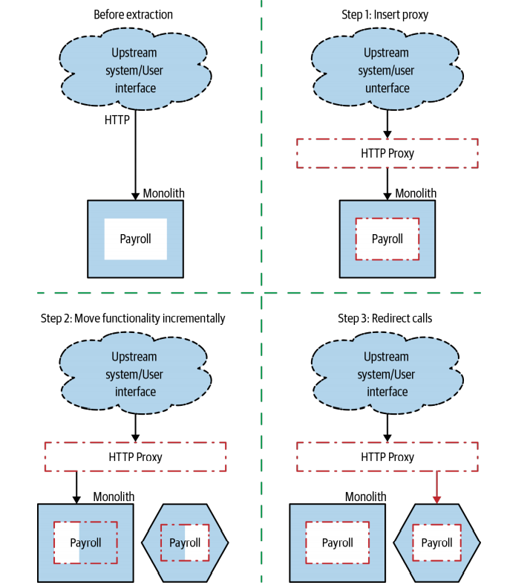

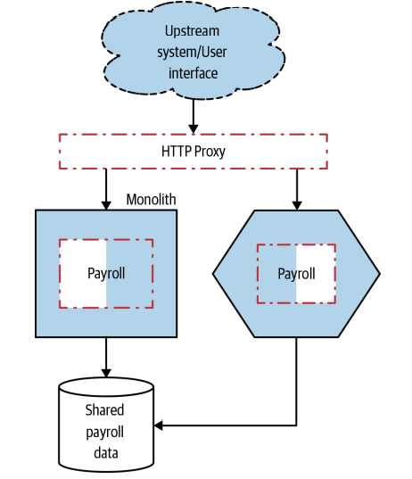

#### Changing Protocols

You could also use your proxy to transform the protocol. For example, you may currently expose a SOAP-based HTTP interface, but your new microservice is going to support a gRPC interface instead. You could then configure the proxy to transform requests and responses accordingly

*Using a proxy to change communication protocol as part of a strangler migration*

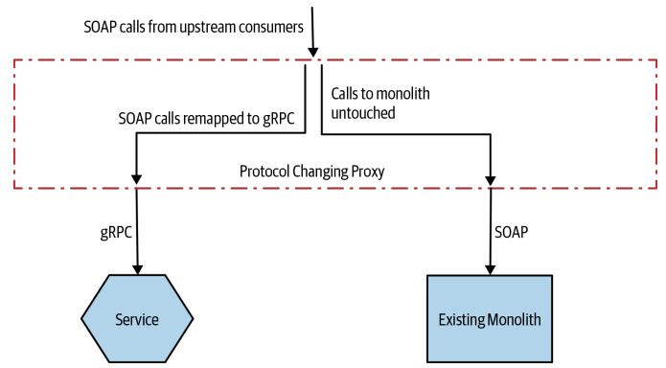

I do have concerns about this approach, primarily due to the complexity and logic that starts to build up in the proxy itself. For a single service, this doesn’t look too bad, but if you start transforming the protocol for multiple services, the work being done in the proxy builds up and up. We’re typically optimizing for independent deployability of our services, but if we have a shared proxy layer that multiple teams need to edit, this can slow down the process of making and deploying changes. We need to be careful that we aren’t just adding a new source of contention. There is the oft-stated mantra of “Keep the pipes dumb, the endpoints smart” when we discuss microservice architecture. We want to reduce how much functionality gets pushed into shared middleware layers, as this can really slow down feature development.

I do have concerns about this approach, primarily due to the complexity and logic that starts to build up in the proxy itself. For a single service, this doesn’t look too bad, but if you start transforming the protocol for multiple services, the work being done in the proxy builds up and up. We’re typically optimizing for independent deployability of our services, but if we have a shared proxy layer that multiple teams need to edit, this can slow down the process of making and deploying changes. We need to be careful that we aren’t just adding a new source of contention. There is the oft-stated mantra of “Keep the pipes dumb, the endpoints smart” when we discuss microservice architecture. We want to reduce how much functionality gets pushed into shared middleware layers, as this can really slow down feature development.

*If you want to change protocol type, consider having a service expose its capabilities over multiple types of protocol*

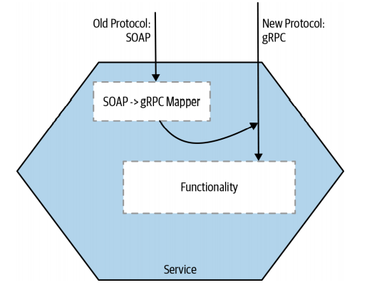

#### And service meshes

At Square, they adopted a hybrid approach to solve this problem.1 They had decided to migrate away from their own homegrown RPC mechanism for service-to-service communication, in favor of adopting gRPC, a well-supported open source RPC framework with a very broad ecosystem. To make this as painless as possible, they wanted to reduce the amount of change needed in each service. To do this, they made use of a service mesh.

With a service mesh, shown in Figure 3-14, each service instance communicates with other service instances via its own, dedicated local proxy. Each proxy instance can be configured specifically for the service instance it is partnered with. You can also provide centralized control and monitoring of these proxies by using a control plane. As there is no central proxy layer, you avoid the pitfalls regarding having a shared “smart” pipe—effectively, each service can own its own piece of the service-to-service pipe if needed. It’s worth noting that because of the way Square’s architecture had evolved, the company ended up having to create its own service mesh specific to its needs, albeit making use of the Envoy open source proxy, rather than being able to use an established solution like Linkerd or Istio.

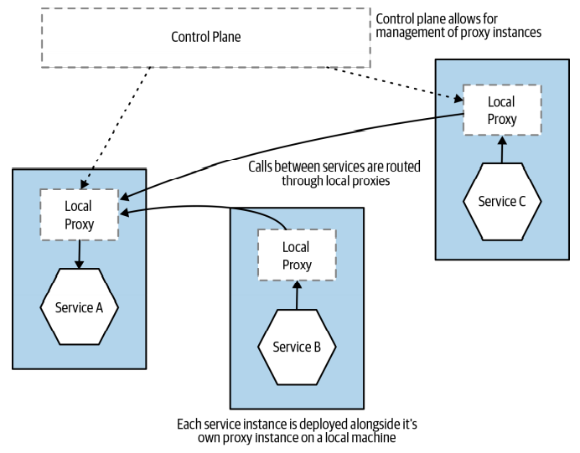

Service meshes are growing in popularity, and conceptually I think the idea is spot on. They can be a great way to handle common service-to-service communication concerns. My worry is that despite a lot of work by some very smart people, it has taken a while for the tooling in this space to stabilize. Istio seems to be the clear leader, but it’s far from the only option in this space, and there are new tools emerging on what seems to be a weekly basis. My general advice has been to give the service mesh space a bit more time to stabilize if you can before making your choice.

Example: FTP

Although I’ve spoken at length regarding the use of the strangler pattern for HTTP based systems, there is nothing to stop you from intercepting and redirecting other forms of communication protocols. Homegate, a Swiss real estate company, used a variation of this pattern to change how customers uploaded new real estate listings.

Homegate’s customers uploaded listings via FTP, with an existing monolithic system handling the uploaded files. The company was keen to move over to microservices, and also wanted to start to support a new upload mechanism that, rather than supporting batch FTP upload, was going to use a REST API that matched a soon-to-beratified standard.

The real estate company didn’t want to have to change things from the customer point of view—it wanted to make any changes seamless. This means that FTP still needed to be the mechanism by which customers interacted with the system, at least for the moment. In the end, the company intercepted FTP uploads (by detecting changes in the FTP server log), and directed newly uploaded files to an adapter that converted the uploaded files into requests to the new REST API, as shown in Figure 3-15.

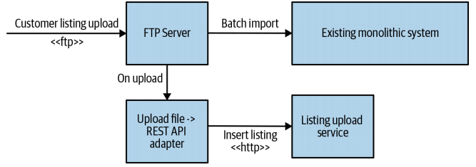

Intercepting an FTP upload and diverting it to a new listings service for Homegate

From a customer point of view, the upload process itself didn’t change. The benefit came from the fact that the new service that handled the upload was able to publish the new data much more quickly, helping customers get their adverts live much faster. Later on, there is a plan to directly expose the new REST API to customers. Interestingly, during this period, both listing upload mechanisms were enabled. This allowed the team to make sure the two upload mechanisms were working appropriately. This is a great example of a pattern we’ll explore later in “Pattern: Parallel Run”.

#### Message Interception

So far we’ve looked at intercepting synchronous calls, but what if your monolith is driven from some other form of protocol, perhaps receiving messages via a message broker? The fundamental pattern is the same—we need a method to intercept the calls, and to redirect them to our new microservice. The main difference is the nature of the protocol itself.

Content-based routing

In Figure 3-16, our monolith receives numerous messages, a subset of which we need to intercept.

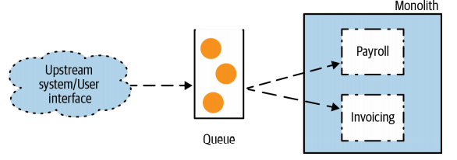

**A monolith receiving calls via a queue**

A simple approach would be to intercept all messages intended for the downstream monolith, and filter the messages on to the appropriate location, as outlined in Figure 3-17. This is basically an implementation of the content-based router pattern, as described in Enterprise Integration Patterns.

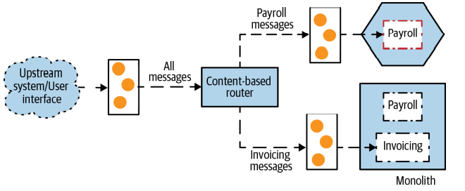

#### Using a content-based router to intercept messaging calls

This technique allows us to leave the monolith untouched, but we’re placing another queue on our request path, which could add additional latency and is another thing we need to manage. The other concern is how many “smarts” are we placing into our messaging layer? In Chapter 4 of Building Microservices, I spoke about the challenges caused by systems making use of too many smarts in the networks between your services, as this can make systems harder to understand and harder to change

Instead I urged you to embrace the mantra of “smart endpoints, dumb pipes,” something that I still push for. It’s arguable here that the content-based router is us implementing a “smart pipe”—adding complexity in terms of how calls are routed between our systems. In some situations, this is a highly useful technique, but it’s up to you find a happy balance.

Selective consumption

An alternative would be to change the monolith and have it ignore messages sent which should be received by our new service, as we see in Figure 3-18. Here, we have both our new service and our monolith share the same queue, and locally they use some sort of pattern-matching process to listen to the messages they care about. This sort of filtering is quite a common requirement in message-based systems and can be implemented using something like a Message Selector in JMS or using equivalent technology on other platforms.

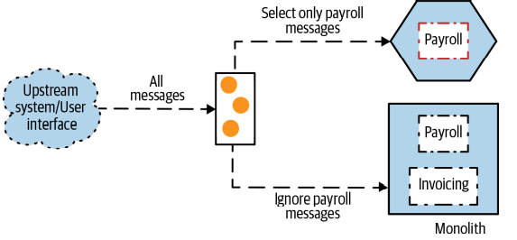

This filtering approach reduces the need to create an additional queue but has a couple of challenges. First, your underlying messaging technology may or may not let you share a single queue subscription like this (although this is a common feature, so I would be surprised if this was the case).

Second, when you want to redirect the calls, it requires two changes to be fairly well coordinated. You need to stop your monolith from reading the calls meant for the new service, and then have the service pick them up. Likewise, reverting the call interception requires two changes to roll back. The more types of consumers you have for the same queue, and the more complex the filtering rules, the more problematic things can become. It can be easy to imagine a situation in which two consumers start receiving the same message due to overlapping rules, or even the opposite—some messages are being ignored altogether. For this reason, I would likely consider using selective consumption with only a small number of consumers and/or with a simple set of filtering rules. A content-based This filtering approach reduces the need to create an additional queue but has a couple of challenges. First, your underlying messaging technology may or may not let you share a single queue subscription like this (although this is a common feature, so I would be surprised if this was the case). Second, when you want to redirect the calls, it requires two changes to be fairly well coordinated. You need to stop your monolith from reading the calls meant for the new service, and then have the service pick them up. Likewise, reverting the call interception requires two changes to roll back.

The more types of consumers you have for the same queue, and the more complex the filtering rules, the more problematic things can become. It can be easy to imagine a situation in which two consumers start receiving the same message due to overlapping rules, or even the opposite—some messages are being ignored altogether. For this reason, I would likely consider using selective consumption with only a small number of consumers and/or with a simple set of filtering rules. A content-based

Other Protocols

As I hope you can understand from this example, there are lots of ways to intercept calls into your existing monolith, even if you use different types of protocols. What if your monolith is driven by a batch file upload? Intercept the batch file, extract the calls that you want to intercept, and remove them from the file before you forward it on. True, some mechanisms make this process more complicated, and it’s much easier if using something like HTTP, but with some creative thinking the strangler fig pattern can be used in a surprising number of situations.

### Branch By Abstraction

For the useful strangler fig pattern, to work, we need to be able to intercept calls at the perimeter of our monolith. However, what happens if the functionality we want to extract is deeper inside our existing system? Coming back to a previous example, consider the desire to extract the Notification functionality, as seen in Figure 3-4.

In order to perform this extraction, we will need to make changes to the existing system. These changes could be significant, and disruptive to other developers working on the codebase at the same time. We have competing tensions here. On the one hand, we want to make our changes in incremental steps. On the other hand, we want to reduce the disruption to other people working on other areas of the codebase. This will naturally drive us toward wanting to complete the work quickly.

Often, when reworking parts of an existing codebase, people will do that work on a separate source code branch. This allows the changes to be made without disrupting the work of other developers. The challenge is that once the change in the branch has been completed, these changes have to be merged back, which can often cause significant challenges. The longer the branch exists, the bigger these problems are. I won’t go into detail now as to the problems associated with long-lived source code branches, other than to say they run contrary to the principles of continuous integration. I could also throw in that data gathered from “The 2017 State of DevOps Report” shows that embracing trunk-based development (where changes are made directly on the main line and branches are avoided) and using short-lived branches contributes to higher performance of IT teams. Let’s just say that I am not a fan of long-lived branches, and I’m not alone.

So, we want to be able to make changes to our codebase in an incremental fashion, but also keep disruption to a minimum for developers working on other parts of our codebase. There is another pattern we can use that allows us to incrementally make changes to our monolith without resorting to source code branching. The branch by abstraction pattern instead relies on making changes to the existing codebase to allow the implementations to safely coexist alongside each other, in the same version of code, without causing too much disruption.

How It Works

Branch by abstraction consists of five steps:

1. Create an abstraction for the functionality to be replaced.

2. Change clients of the existing functionality to use the new abstraction.

3. Create a new implementation of the abstraction with the reworked functionality. In our case, this new implementation will call out to our new microservice.

4. Switch over the abstraction to use our new implementation.

5. Clean up the abstraction and remove the old implementation.

Let’s take a look at these steps with respect to moving our Notification functionality out into a service

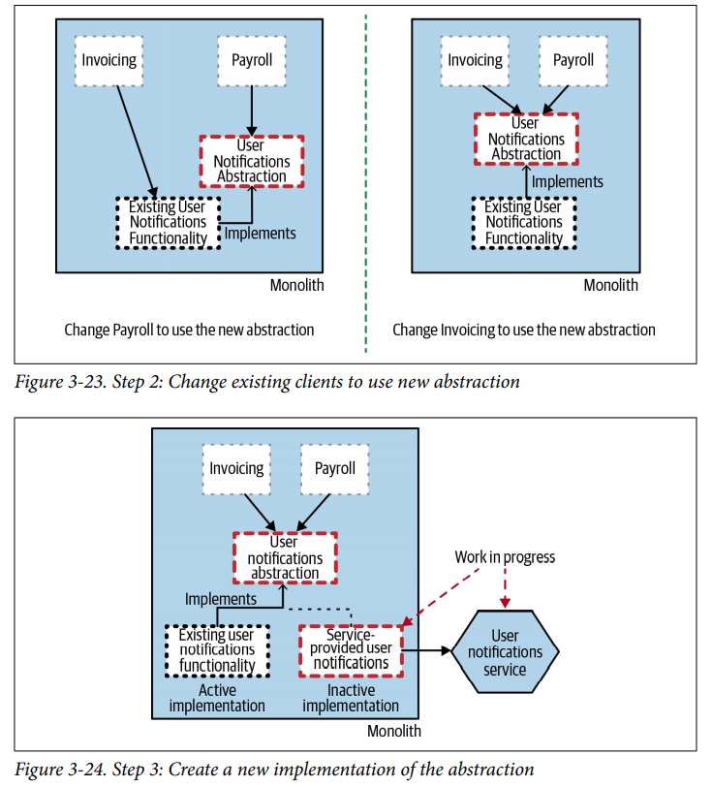

During this process, we can also deploy our work-in-progress User Notification service into production, just as we did with the strangler fig pattern. The fact that it isn’t finished is fine—at this point, as our implementation of the Notifications abstraction isn’t live, the service isn’t actually being called. But we can deploy it, test it in situ, and verify the parts of the functionality we have implemented are working correctly.

This phase could last a significant amount of time. Jez Humble details the use of the branch by abstraction pattern to migrate the database persistence layer used in the continuous delivery application GoCD (at the time called Cruise). The switch from using iBatis to Hibernate lasted several months—during which the application was still being shipped to clients on a twice weekly basis.

|  |  |
| --- | --- |
|  | **Switch implementation**  Once we are happy that our new implementation is working correctly, we switch our abstraction point so that our new implementation is active, and the old functionality is no longer being used, as seen in Figure 3-25  Ideally, as with the strangler fig pattern, we’d want to use a switching mechanism that can be toggled easily. This allows us to quickly switch back to the old functionality if we found a problem with it. A common solution to this would be to use feature toggles. In Figure 3-26, we see toggles being implemented using a configuration file, allowing us to change the implementation being used without having to change code.  If you want to know more about feature toggles and how to implement them, then Pete Hodgson has an excellent write-up. |
|  |  |

*Step 5: Using feature toggles to switch between implementations*

At this stage, we have two implementations of the same abstraction, which we hope should be functionality equivalent. We can use tests to verify equivalency, but we also have the option here to use both implementations in production to provide additional

verification. This idea is explored further in “Pattern: Parallel Run” on page 113.

**Step 5: Clean up**

With our new microservice now providing all notifications for our users, we can turn our attention to cleaning up after ourselves. At this point, our old User Notifications functionality is no longer being used, so an obvious step would be to remove it, as shown in Figure 3-27. We are starting to shrink the monolith!

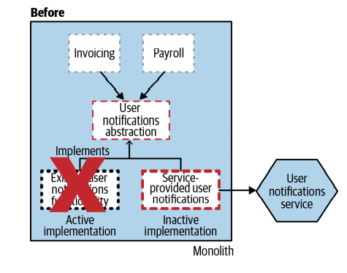 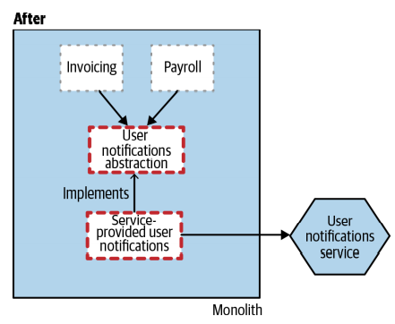

**Step 6: Remove the old implementation**

When removing the old implementation, it would also make sense to remove any feature flag switching we may have implemented. One of the real problems associated with the use of feature flags is leaving old ones lying around—don’t do that! Remove flags you don’t need anymore to keep things simple.

Finally, with the old implementation gone, we have the option of removing the abstraction point itself, as in Figure 3-28. It’s possible, however, that the creation of the abstraction may have improved the codebase to the point where you’d rather keep it in place. If it’s something as simple as an interface, retaining it will have minimal impact on the existing codebase.

**Step 7: (Optional) Remove the abstraction point**

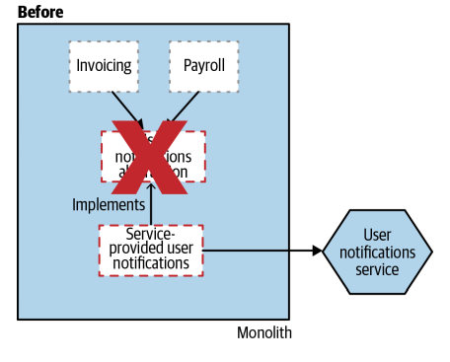 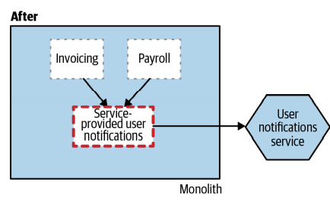

**As a Fallback Mechanism**

The ability for us to switch back to our previous implementation if our new service isn’t behaving is useful, but is there a way we could do that automatically? Steve Smith details a variation of the branch by abstraction pattern called verify branch by abstraction that also implements a live verification step—we can see an example of this in Figure 3-29. The idea is that if calls to the new implementation fail, then the old implementation could be used instead.

|  |  |
| --- | --- |
|  | * This clearly adds some complexity, not only in terms of code but also in terms of reasoning about the system. Effectively, both implementations might be active at any given point in time, which can make understanding system behavior more difficult. If the two implementations are in anyway stateful, then we also have data consistency to consider. Although data consistency is a challenge in any situation where we are switching between implementations, The verify branch by abstraction pattern allows for us to switch back and forth between implementations on a request-by-request basis, which means you’ll need a consistent shared set of data that both implementations can access. We’ll explore this idea in more detail in just a moment when we look at the more generic parallel run pattern. |

**Where to Use It**

Branch by abstraction is a fairly general-purpose pattern, useful in any situation where changes to the existing codebase are likely going to take time to carry out, but where you want to avoid disrupting your colleagues too much. In my opinion, it is a better option than the use of long-lived code branches in nearly all circumstances. For migration to a microservice architecture, I’d nearly always look to use a strangler fig pattern first, as it’s simpler in many regards. However, there are some situations, as with Notifications here, where that just isn’t possible. This pattern also assumes that you can change the code of the existing system. If you can’t, for whatever reason, you may need to look at other options, some of which we explore in the rest of this chapter.

**Pattern: Parallel Run**

There is only so much testing you can do of your new implementation before you deploy it. You’ll do your best to ensure that your prerelease verification of your new microservice is done in as production-like a way as possible as part of a normal testing process, but we all understand that it isn’t always possible to think of every scenario that could occur in a production setting. But there are other techniques available to us.

Both the strangler fig pattern and branch by abstraction pattern allow old and new implementations of the same functionality to coexist in production at the same time. Typically, both of these techniques allow us to execute either the old implementation in the monolith or the new microservice-based solution. To mitigate the risk of switching over to the new service-based implementation, these techniques allow us to quickly switch back to the previous implementation.

When using a parallel run, rather than calling either the old or the new implementation, instead we call both, allowing us to compare the results to ensure they are equivalent. Despite calling both implementations, only one is considered the source of truth at any given time. Typically, the old implementation is considered the source of truth until the ongoing verification reveals that we can trust our new implementation. This pattern has been used in different forms for decades, although typically it is used to run two systems in parallel. I’d argue this pattern can be just as useful within a single system, when comparing two implementations of the same functionality.

This technique can be used to verify not just that our new implementation is giving the same answers as the existing implementation, but that it is also operating within acceptable nonfunctional parameters. For example, is our new service responding quickly enough? Are we seeing too many time-outs?

|  |  |
| --- | --- |
| An example of a parallel run—both pricing systems are invoked, with the results compared offline | Many years ago, I was involved in a project to change the platform being used to perform calculations on a type of financial product called credit derivatives. The bank I was working at needed to make sure the various derivatives it was offering would be a sensible deal for them. Would we make money on this trade? Was the trade too risky?  Once issued, market conditions would also change. So they also needed to assess the value of current trades to make sure they weren’t vulnerable to huge losses as market conditions changed. We were almost entirely replacing the existing system that performed these important calculations. Because of the amount of money involved, and the fact that some people’s bonuses were based in part on the value of the trades that had been made, there was a great degree of concern over the changes. We made the decision to run the two sets of calculations side by side and carry out daily comparisons of the results. The pricing events were triggered via events, which were easy to duplicate such that both systems carried out the calculations, as we see in Figure 3-30. |

Each morning, we’d run a batch reconciliation of the results, and would then need to account for any variations in results. We actually wrote a program to perform the reconciliation. We presented the results in an Excel spreadsheet, making it easy to discuss the variations with the experts at the bank. It turned out we did have a few issues that we had to fix, but we also found a larger number of discrepancies caused by bugs in the existing system. This meant that some of the different results were actually correct, but we had to show our work (made much easier due to surfacing the results in Excel). I remember having to sit down with analysts and explain why our results were correct by working things out from first principles.

Eventually, after a month, we switched over to using our system as the source of truth for the calculations, and some time later we retired the old system (we kept it around for a few more months in case we needed to carry out any auditing of calculations done on the old system).

## Domain Driven Design

We cannot just view a software as simply Object and Methods. A great car can’t be viewed as just a collection of engine parts. Plain design at first go will never work, need to have a evolutionary approach towards it.

### Introduction

DDD is a way of looking at the software top down.

Eric Evans – When we are developing a software our focus shouldn’t be primarily on technology, it should be primarily on the business or whatever activity we are trying to assist with the software, the domain.

We approach that by trying to develop models of that domain and make our software conform to that.

|  |  |
| --- | --- |
|  | **What does DDD give us?**  When we develop a software we have a exe/ jar/ zip at the bottom depending on c/ java/ python etc being used. Most developers think on the basis of following.  99% that this would be a service if this is being developed for the web and not being developed as a Desktop application.  We want to go one layer up to the domain, what is above this, we have many services that are part of the wider infrastructure, that are trying to solve the problems at the domain level – Insurance/ Finance/ Ecommerce – these would have their own sub-domains like Product, Customer, Shipping things like that. DDD is a way to look from top to down. We have Domain at the top. |

Domain Driven Design gives us two kinds of tools Strategic Design Tools and Tactical Design Tools. Many software developers would focus on the Tactical design tools instead of the Strategic Design tools. Everyone who is experienced enough will give more importance to Strategic Design Tools.

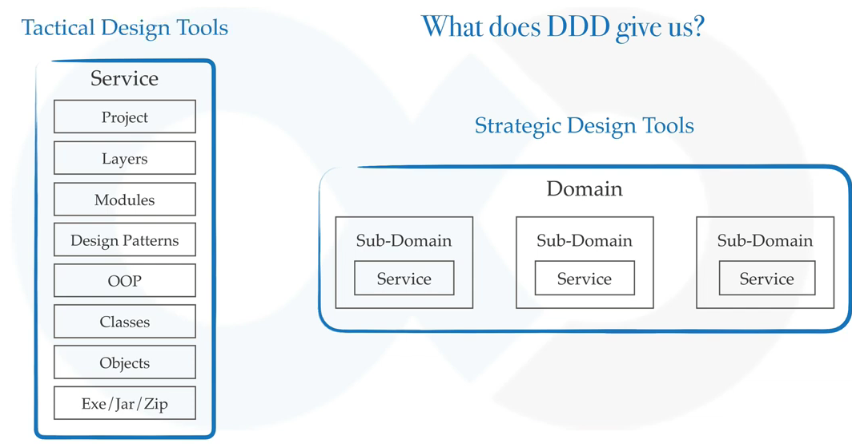

**Why to learn DDD?**

Improve your craft, design things from scratch.

It is not customers job to know what they want – Steve Jobs

Your architecture might be fabulous but it is the customer who decides whether your system is fabulous or not.

A system that does not solve a business problem is of no use, no matter how pretty it looks or how well architected its infrastructure.

### Strategic Design

What is Strategic Design?

OOP – think in terms of Objects

**Strategic Design** – Think in terms of Contexts

**Context** – The setting in which a word or a statement appears that determines its meaning

|  |  |
| --- | --- |
|  | We are not going to talk about the Continous Integration now. We are going to talk about the rest that are part of the Context Map. We only care about three things in the figure now – lets go through them. |

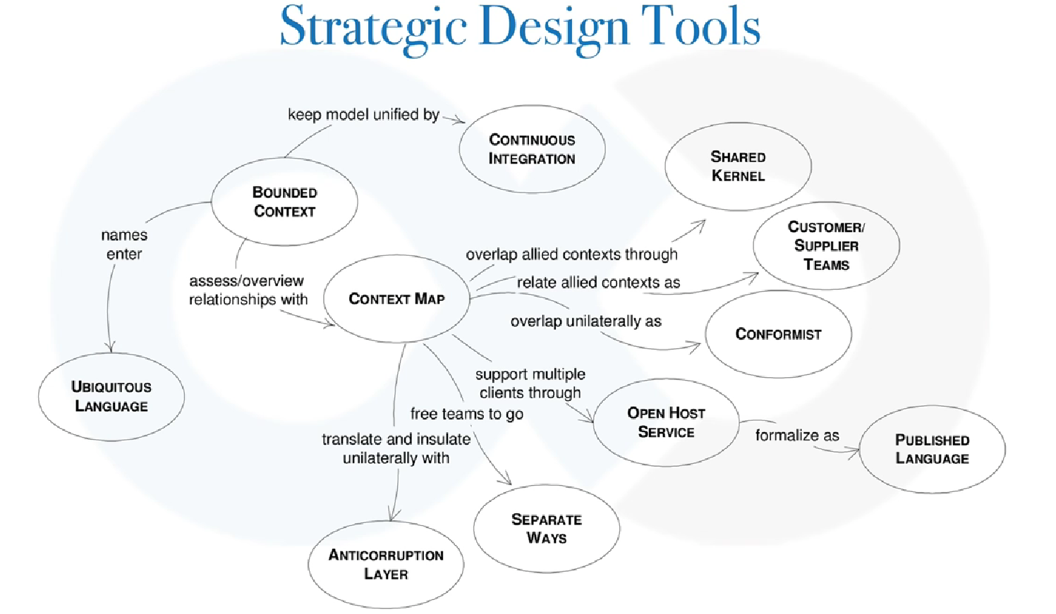

If someone wanted to build a house from you, you would ask what type of a house you want. He would say a farm house for example. You would then talk to a domain expert.

* Domain expert is a person who has a lot of knowledge about that Domain.



You are a person who can develop complex infrastructures but you do not know what kind of a features are available in a farm house. You would like to find out the core features of a farm house – for relaxing, parties, kids etc. You will see what other people have done for it. What are the common patterns around those – what are the good things that others have done for it. You will then create a mental picture for it. You will then come up with a model ( right side )

 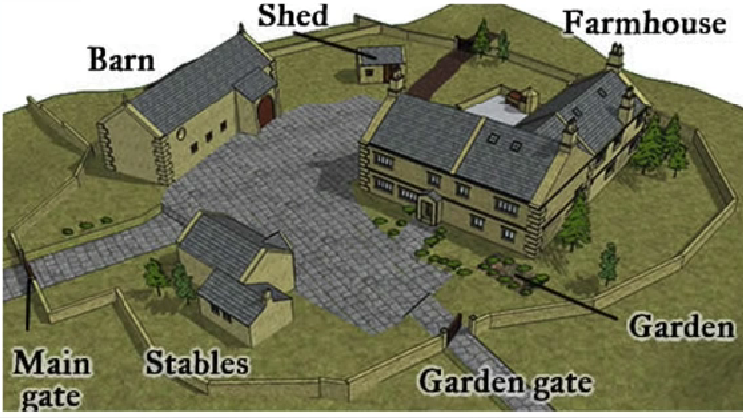

Then we create a detailed picture of the each of the parts of your farm house. The above one is the domain for your farm house. Within this the Barn, Shed, Garden, Garden Gate, Stables, Main Gate are all sub domains.

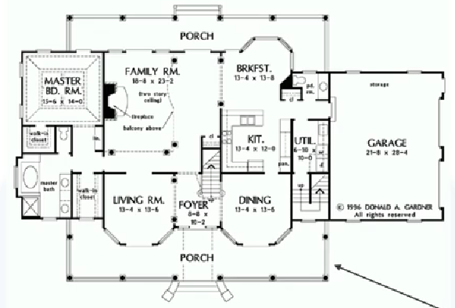

You will create a model for the sub-domain. These detailed models are generally known as Domain Models. The blue parts in the picture below are the Bounded Context – Bounded Context means the context in which we use the terms.

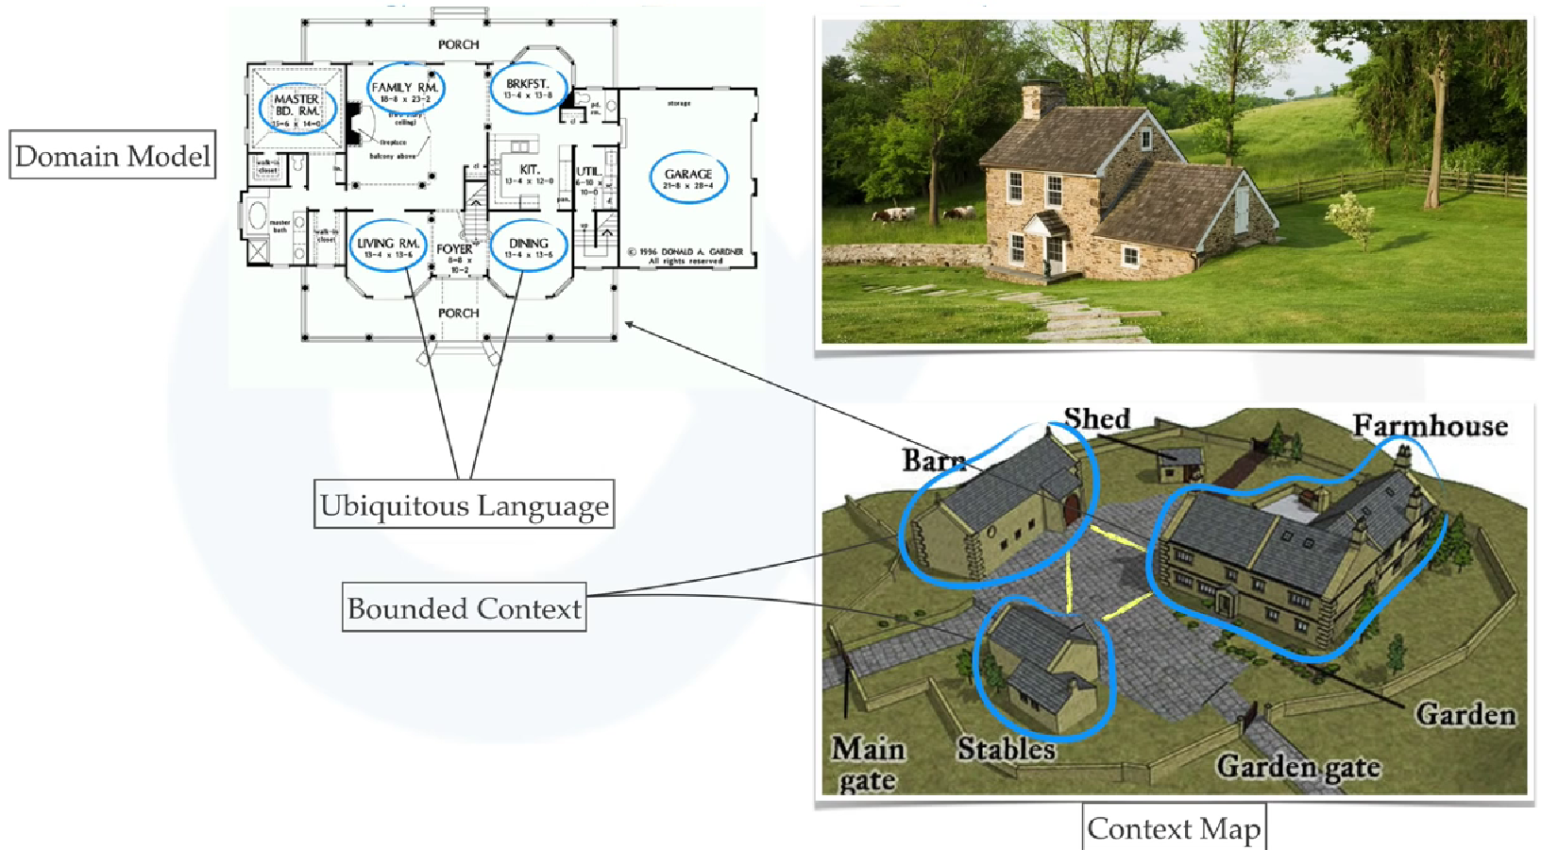

* Bounded Context means the context in which we use the terms.
* These **Bounded contexts** will have a relationship among each other and if you create a diagram of how Bounded Contexts relate to each other that is known as the **Context Map**
* The terms that you see here like Master Bedroom, Family Room, Breakfast Room, Dining Room, Living Room, Garage etc are called as **Ubiquitous Language.**

These are the things we were talking about earlier – Bounded Context, Context Map and Ubiquitous Language

**What is a Domain Model?** Domain Model is to a bounded context what classes are to objects. Domain model refers to the abstraction of the sub domain. It is a interpretation of reality, so not every aspect of the domain can be a part of the model. It is the aspects that are chosen for implementation that become a part of it. The UML diagrams or english sentences could represent the Domain Model.

Bounded Context is called Bounded Context because something that means one thing in that context ( say Barn for example ) could mean something else in another Context ( say Stables ). Example a caretaker could mean different things between Stables and Barn.

**Context Map**- when we draw communication lines between these contexts it is known as context map ( yellow lines above ).

Ubiquitous Language

Everyone should be using the same language – anyone in the room should be talking the same language

Sometimes Developers become more technical than they should be, if you are a civil engineer you might say the north-east wing room should have 4:5 size ratio and total area would be 400 sq. ft. That’s a difficult language for the Domain Expert or the Buyer. Easier to say that the master bedroom would have . . .

|  |  |
| --- | --- |
|  |  |

Bounded Context

**Taking a Ecommerce example.**

If you have a Sales Context a team of Sales people are sitting in a discussion and when they talk about a Customer. For them the customer would be like his ID, his Social interests, likes and dislikes.

For the Support team the Customer is something else, for them the things that matter are purchase history, tickets etc.

For Accounting they need what was the payments made by the customer and what was the mode etc so that it helps them in any repayments to be done.

For the Order team things of interest are his addresses and availability on particular time or not.

We have 4 bounded contexts here, and each of them would have there own Ubiquitous Language.

When someone talks about Sales Context everyone should be able to understand that. Each of these contexts would have their own database and API and user manual and they would confirm to the model that has been developed for these.

**There are 2 spaces – Problem Space and the Solution Space.**

* **Domain is divided into Subdomain** – There are different types of sub-domains like the **Core Sub-Domain, Supporting Sub-Domain** and the **Generic Sub Domains.**
* There is a saying that if the core sub-domain is not the best part of your architecture then the architecture is not yet complete. This means don’t try to be best at everything.
* E.g. Identity and Access management that is not your core sub-domain, it is your generic domain, don’t put too much time over that. For generic sub-domains you would try to buy it from the shelf, from the market.

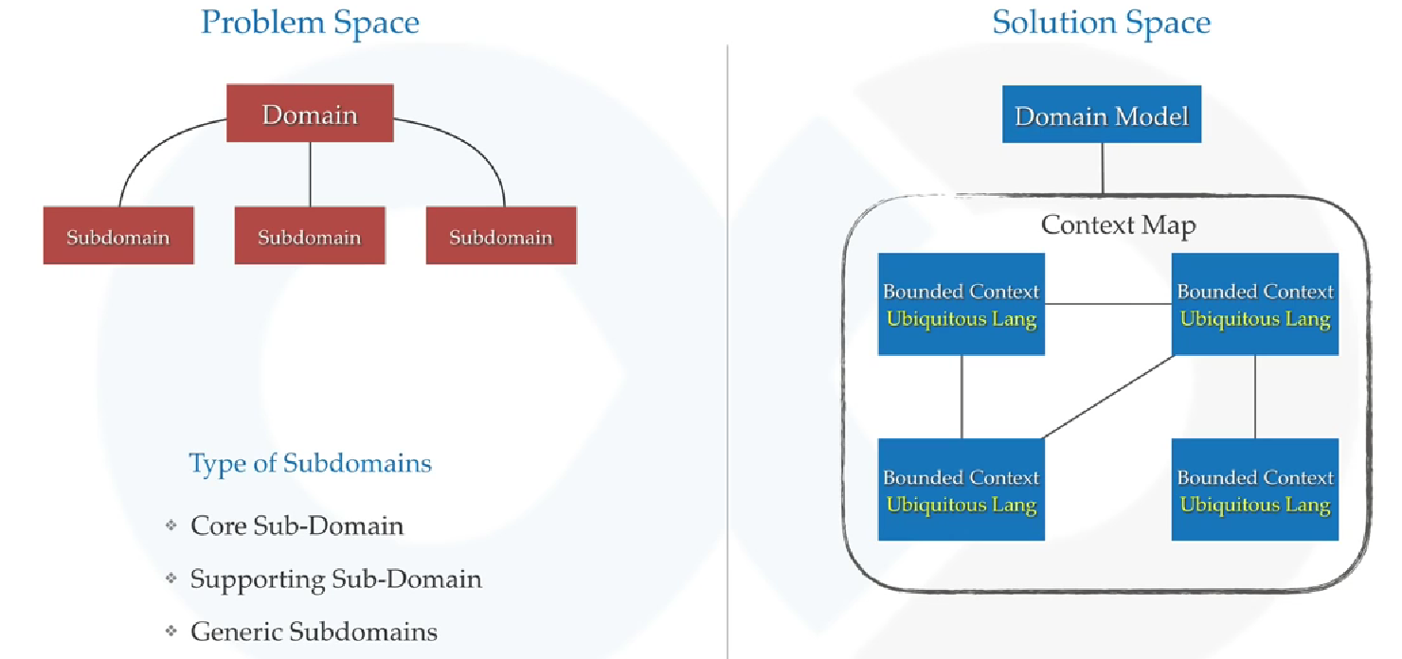

* In Solution space you would have a Domain Model. You will have Bounded Contexts and each Bounded Context would have its own Ubiquitous Language and all of these combined ( when we draw the relationships between them ) form the Context Map.

So we have studied these and now lets look at the highlighted rest of this.

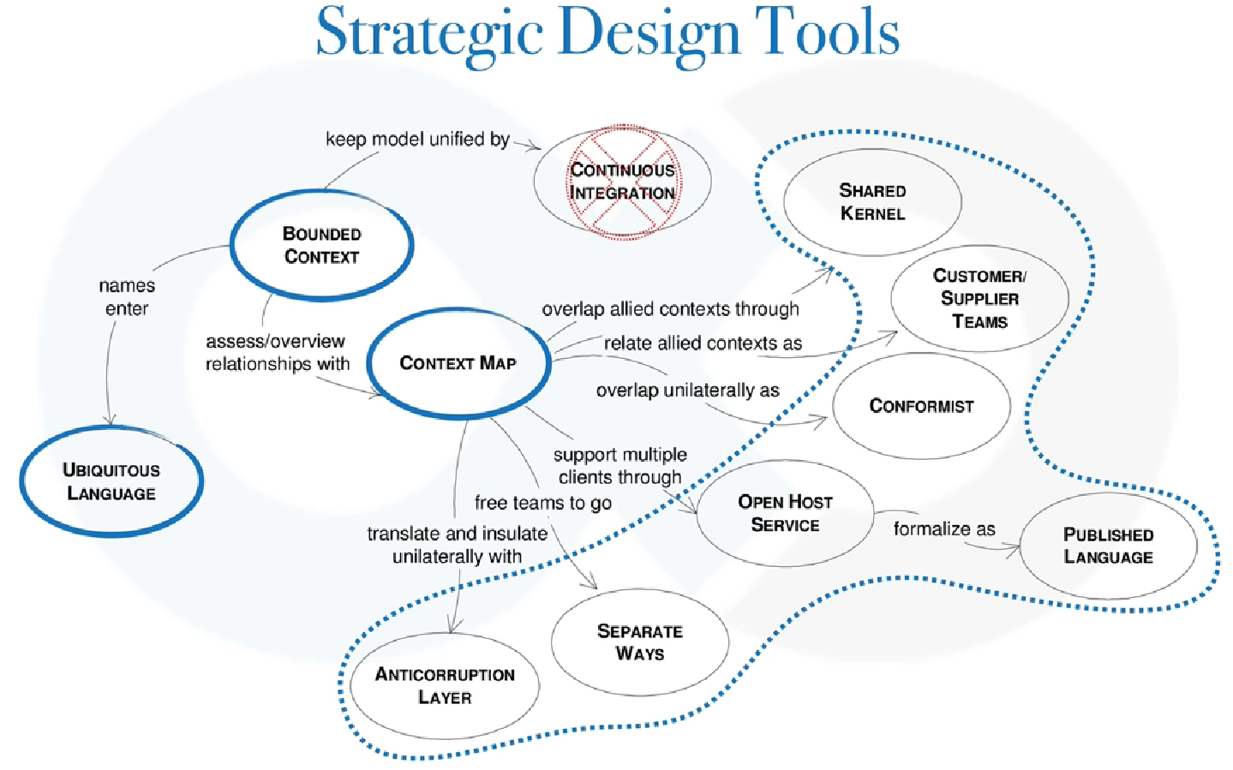

All of these highlighted ones are the types of relationships we have

**Context Relationship Types**

|  |  |
| --- | --- |
| **Published Language** | The interacting Bounded Contexts agree on a common language ( for example a bunch of XML schemas over an enterprise bus ) by which they can interact with each other |
| **Open Host Service** | Bounded Context specifies a protocol ( e.g. a RESTful Web Service ) by which any other Bounded Context can use its services |
| **Shared Kernel** | Two Bounded Contexts use a common kernel of code ( for example a library ) as a common lingua franca, but otherwise do their stuff in their own specific way. |
| **Customer/ Supplier** | One **Bounded Context** uses the service of services of another and is a stakeholder (customer) of that Bounded Context. As such it can influence the services provided by that Bounded Context. |
| **Conformist** | One Bounded Context uses the services of another but is not a stakeholder to that other Bounded Context. As such it uses “as-is” ( confirms to ) the protocols or APIs provided by that Bounded Context |
| **Anti-Corruption Layer** | One Bounded Context uses the services of another and is not a stakeholder, but aims to minimize impact from change in the Bounded Context it depends on by introducing a set of adapters. |

It’s developers understanding , not your knowledge that becomes software

The first job of the developer is not to code, but to understand the domain that he is going to work on. The good thing is that this is technology agnostic, it is not depended on any technology.

### Tactical Design Tools

Tactical Design tools are concerned with implementation details.

It generally takes care of components inside a bounded context. It has become a de facto standard in development world.

You might have heard or used things like services, entities, repositories, factories – they have all been made popular by Domain Driven Design.

* Contrary to strategic design, tactical design would change during the product development.

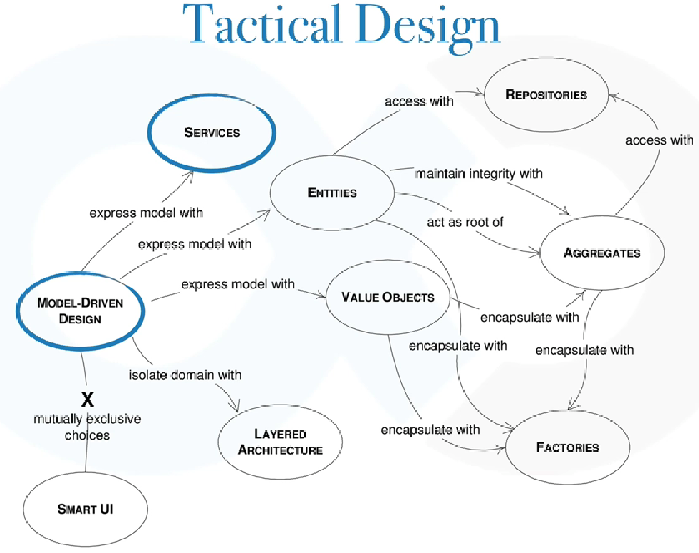

#### Model Driven Design

First lets see what are the Model Driven Designs and Services.

Previously we talking everything about Domain Driven design which was about the domain, whatever business we are trying to assess. Domain has sub domains and every sub domain has its own Bounded Context. Domain model is to a bounded context what classes are to objects.

* SubDomain lives in the problem space and
* we have Bounded Context for this in the Solution Space.
* Every Bounded Context is represented using a Domain Model.

Domain Model is to a Bounded Context what Classes are to Objects. Not every aspect of the domain needs to be a part of the model, it is the aspects that are chosen for implementation that need to be a part of it. Then we have the Ubiquitous language for each Bounded Context.

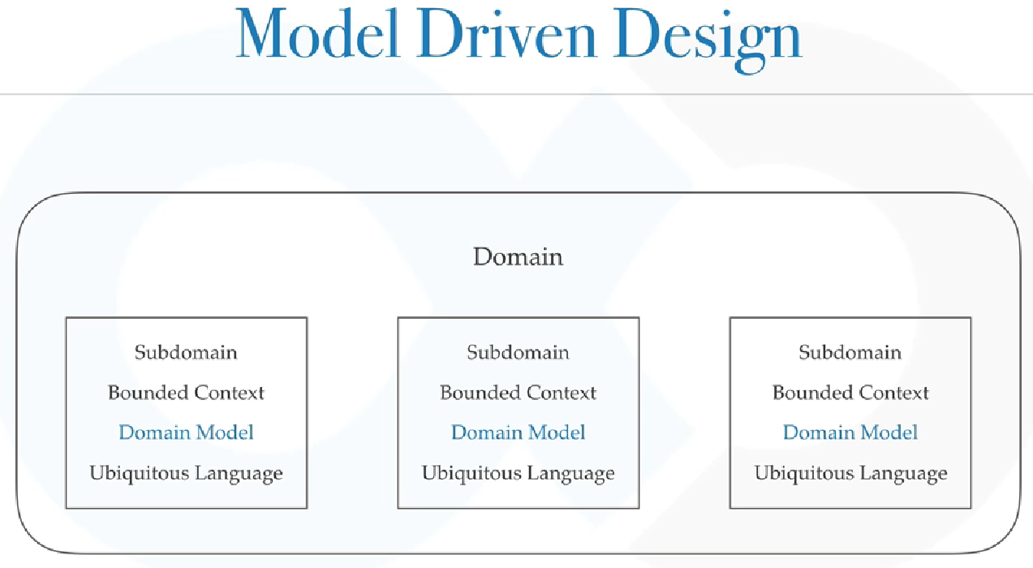

Each Microservice would have its own Bounded Context and that’s why every Bounded Context is expressed with its own Microservice. So now we know Model Driven Design

#### Layered Architecture

We understand what the layered architecture is.

Request Handlers 🡪 Controllers 🡪 Service/ Business Layer 🡪 Persistence Layer

Advantages of a Layered Architecture

* Modularity and clear Interfaces
* Portability
* Scalability
* Flexibility

#### Value Objects

Values Objects are one of the best things and Domain Driven Design emphasizes more on Value Objects.

**What is a String?** It is a general purpose value object designed to handle complexities of char arrays. A lot of string functionalities are provided to you that work over the character array. We cannot imagine life without String.

* Value objects reduce complexities and forces ubiquitous language

Features of Value Objects

* They don’t care about uniqueness
* Always Immutable
* Rich Domain Logic
* Auto Validating
* Strong Equality
* Thread Safe

Entities

* Can be uniquely Identified using an ID
* Consist of Value Objects
* Generally persisted as a row in DB
* Typically mutable
* Generally implements some business logic

**Value Objects vs Entities**

The main difference between entities and value objects lies in the way we compare their instances to each other. The concept of identifier equality refers to entities, whereas the concept of structural equality - to value objects. In other words, entities possess inherent identity while value objects don’t.

In practice it means that value objects don’t have an identifier field and if two value objects have the same set of attributes we can treat them interchangeably. At the same time, if data in two entity instances is the same (except for the Id property), we don’t deem them as equivalent.

**Lifespan:**

Another distinction between the two notions is the lifespan of their instances. Entities live in continuum, so to speak. They have a history (even if we don’t store it) of what happened to them and how they changed during their lifetime.

Value objects, at the same time, have a zero lifespan. We create and destroy them with ease. That’s a corollary of being interchangeable. If this 1 dollar bill is the same as another one, why bother? We can just replace the existing object with the one we just instantiated and forget about it altogether.

**Immutability:**

The next difference is immutability. Value objects should be immutable in a sense that if we need to change such an object, we construct a new instance based on the existing object rather than changing it. On the contrary, entities are almost always mutable.

The question whether or not value objects should always be immutable is a subject of a dispute. Some programmers argue that this rule is not as strict as the previous one, and value objects can indeed be mutable in some cases. I used to adhere to this point of view as well.

**How to recognize a value object in your domain model?**

It’s not always clear if a concept in your domain model is an entity or a value object. And unfortunately, there are no objective attributes you could use to get to know it. Whether or not a notion is a value object fully depends on the problem domain: a concept can be an entity in one domain model and a value object in another.

**Prefer value objects over entities**

When it comes to working with entities and value objects, an important guideline comes into play: always prefer value objects over entities. Value objects are immutable and more lightweight than entities. Because of that, they are extremely easy to work with. Ideally, you should always put most of the business logic into value objects. Entities in this situation would act as wrappers upon them and represent more high-level functionality.

**Summary**

Alright, I think I covered every aspect that regards to the topic of Entity vs Value Object. Let’s summarize it with the following:

Entities have their own intrinsic identity, value objects don’t.

* The notion of identity equality refers to entities; the notion of structural equality refers to value objects; the notion of reference equality refers to both.
* Entities have a history; value objects have a zero lifespan.
* A value object should always belong to one or several entities, it can’t live by its own.
* Value objects should be immutable; entities are almost always mutable.
* To recognize a value object in your domain model, mentally replace it with an integer.
* Value objects shouldn’t have their own tables in the database.
* Always prefer value objects over entities in your domain model.

#### Aggregates

When the Object graph becomes big it becomes very difficult to maintain that

* An Aggregate is a collection of entities and values which comes under a single transaction boundary.

|  |  |
| --- | --- |
|  | Suppose we have a customer with customer info and address. If some customer info is changes you might want to change the Customer object itself.  Suppose you have Order with Order Info and Order Items. If any of the Order changes you might want to change the Order Info as well.  So all these have strict transactional boundaries and they have to be consistent all the time.  An aggregate controls the change. The 3 things together for both of these are aggregates.  An aggregate always has a root entity, for the first one it is Customer and for the second one it is Order. You will always hold reference to the root entity and you will never change any part of this aggregate from outside the aggregate boundary because that will put the root object in inconsistent state. |

An aggregate is always consistent. Domain events are generated to ensure eventual consistency.

Domain events are generated to ensure Eventual Consistency. If Customer has updated his address, it should be passed to Order within the next 30 seconds in order to ensure Eventual Consistency otherwise your address won’t be changed in the Order. So within the highlighted areas there is a strict transaction boundary and should be changed immediately and then you can fire a domain event from Customer to Order so that Order updates the address there as well. So you would have eventual consistency.

Other examples of aggregates can be comments on a post or maybe question and question detail combined together. People who use ORMs like Hibernate already use aggregates a lot. When you use a One-To-Many or Many-To-One relationships you are creating aggregates. This was all about aggregates

#### Factories and Repositories

Factories and Repositories are basically used to handle aggregates. What if you have to create a car with all the parts and if you have to do that again and again. You need a factory that can do this job for you. A car is your aggregate and the parts are your Entities and Values.

* Factory helps you create new Aggregates
* Repositories help you persist the aggregates.

Its observed that if people have 20 entities they have created 20 repositories for them.

* You should only create a repository per aggregate and not for individual entities.
* Repositories are not DAO layers.
* DAO Layers can just fetch raw entities for you but combinign those entities into aggregates is done by a Repository.

If you have used Hibernate then you just use a Annotation and you have your repository with you.

### Implementing DDD

* Event Storming is not the same as Event Sourcing which is also a part of Domain Driven Design. Event Sourcing and CQRS is different.

"Building a software is a learning process, working code is a side effect."

How would you start discussing your understanding with a Domain Expert?

In old days we used to discuss using the Use Case diagrams or the Activity diagrams, Sequence diagrams or ER diagrams. These might not be used too much now a days. All of these are very old ways to discuss the domain with a domain expert. So what else do we have then. The answer is Event Storming

**Event Storming**

* Event Storming is a exercise for creating domain models for strategic design.

Its becoming very popular in recent times. In simple words it is just a brainstroming workshop among domain experts and technology people to understand the events in the system. It is aimed to achieve a common understanding of the domain in which software must operate.

|  |  |
| --- | --- |
|  | 1. First bring the right people in ( Domain Experts and Technical Experts who can ask the right questions ) 2. Take some sticky notes and colour code them to Events, Commands, Policies, Processors, Errors, Roles, Aggregates etc 3. After you have colour coded these notes, take a white-board and start interesting events in sequence. Stock Order was accepted, Stock price was changed, Stake holders were notified. Or in another example Items were Browser, Items purchased, Item Shipped and then Items delivered.  * An event is that something has happened in your system   Generally all of these terms will constitute your Ubiquitous language - Events, Commands, Policies, Processors, Errors, Roles, Aggregates |

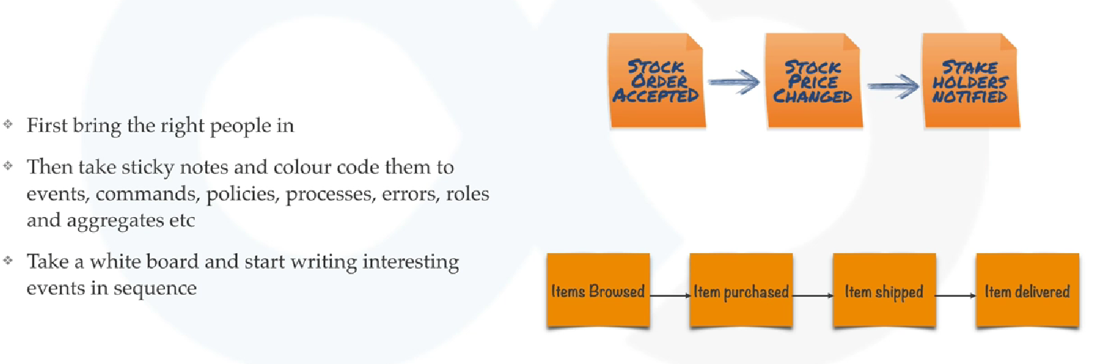

The start adding commands, aggregates and policies etc

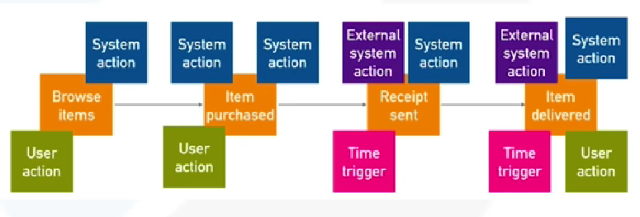

After you are done with the first pass you need to start finding your bounded context, for example in below highlighted areas look like a separate domain – catalog, payments and delivery

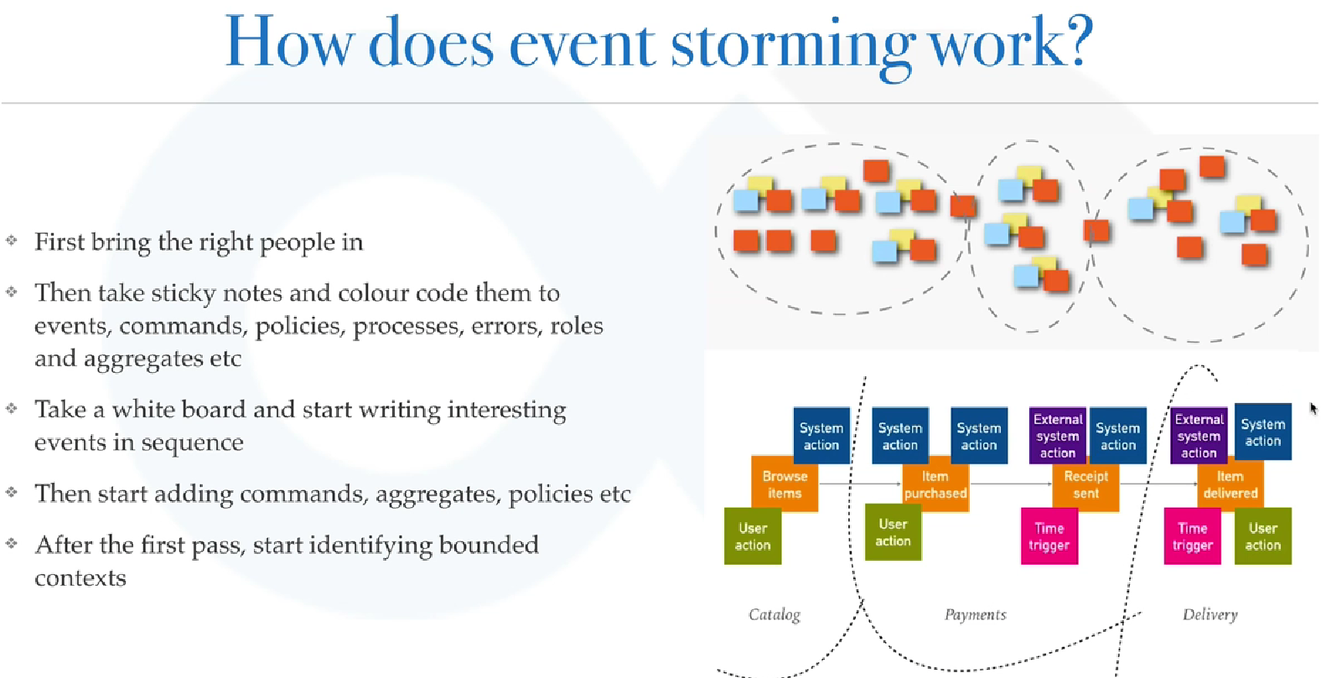

Real life examples

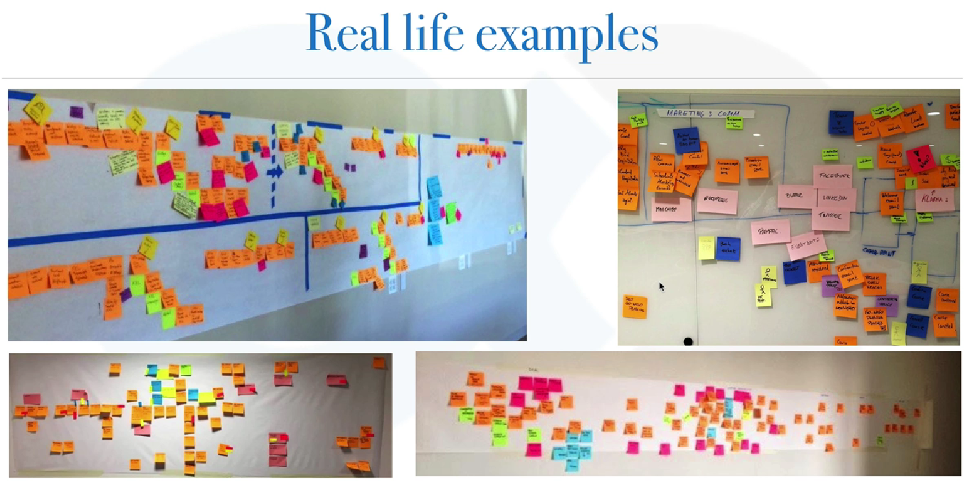

* If you go to google and then find about event storming you will find all this stuff and that means that this technique is very well tested and works 100 percent of the time.

### Implementing DDD in Code

Lets take a analogy of a trade fair. The blue ones here are all the stalls that you have in your trade fair and the yellow ones are for Doctors, Red ones are for mechanical engineers, Blue ones are for software engineers, green ones are for lawyers for example. People can enter from the two gates shown and software engineers can enter only the right blue side portion areas and Doctors can enter the left side yellow areas.

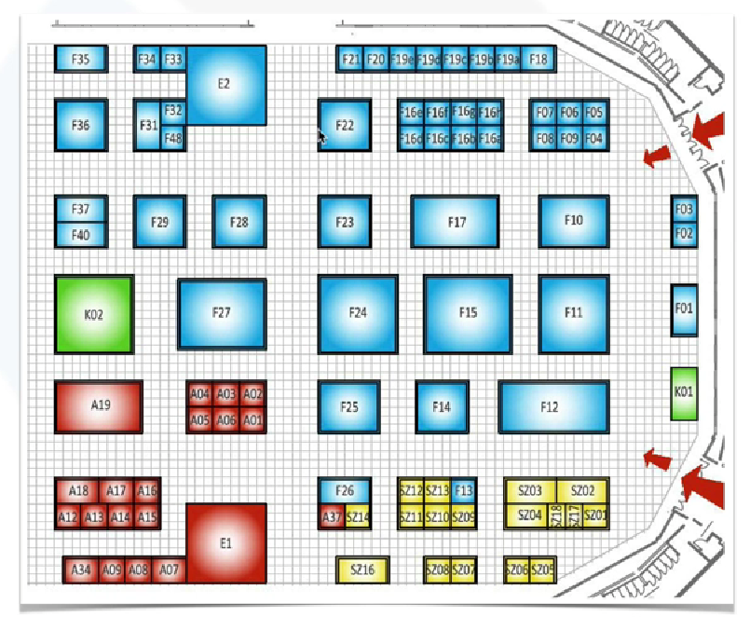

Suppose we only check ticket entry on the main gate, whether they are allowed or not and we do the profession checking in every room when the person enters there. Whether the person is doctor or engineer etc. What is the problem with this approach.

* **Inefficient** – Whenever a person changes from 1 blue room to another blue room the verification repeats for a valid person, so this is inefficient
* **Insecure** – What if the security guard in one of the rooms was lazy and allowed a person to enter by mistake and then he was able to see what he is not supposed to
* **Complex** – It is a complex process, people entering will get frustrated and things will slow down. Its also very hard to maintain – everytime we have to update a process, it needs to be done at multiple places

**What can we do about this?**

Easy process is to do all the checks on the main gate and then color code the bands on the hand and allow as per the band

What does this have to do with DDD?

* This directly implies that whenever you are letting someone in the domain, just do the checks in the start, tag that person somehow and then he can roam around freely and everyone would be satisifed that he is who he says he is. Person is a broad category as compared to a Doctor or a Lawyer. Int and Float are broad categories, as soon as the broad categories enter your domain you need to restrict them, how can we do that.

Value Objects also known as Domain Primitives

public class User { public class User {

String email; ----> Name name;

String name; ----> Email email;

String mobile; ----> PhoneNumber mobile;

. . . . . .

} }

public class Product { public class Product {

int rating; ----> Rating rating;

int quantity; ----> Quantity quantity;

String title; ----> Title title;

String description; ----> Description description;

BigDecimal price; ----> Money price;

. . . . . .

} }

These are very broad categories. In DDD context Strings and Ints and BigDecimals are all primitives. Domain here is Java because Domain is providing all these like String, int, BigDecimal. You need to build upon all these primitives and use your own Primitives. Create a Primitive – create a value object named Name, a value object called Email and a value object called PhoneNumber. Its not like this is just a wrapper around String, this will have all sorts of behaviour as well. Phone Number would have maximum number of digits allowed – that is also a variable. Otherwise if we do checks directly for the Strings in User object above, you will have those value checks inside your User object which does not make sense and that should go to Phone Number for example – it will have all sorts of checks.

Similarly in Product we would need Rating instead of int rating so tomorrow if we wanted how many people gave how much rating, we could keep it in that. We are taking the complexity out of this and design is more extendible then. Similarly to increase or decrease quantity we can keep thread-safe methods there. We can keep restritions on number of characters in Title. We will have limitations for description. And specially money, never ever use BigDecimal directly for Money. If any of us have worked with Big Decimal we would see that it is immutable and we would have to create that again and again and because it doesn’t give you the functionality that you need, you have to create that even more number of times.

The Java developers would complain here that this would require a lot number of classes but we will see some neat ways how we can create all of this with very less amount of code. Lets look at a code snippet now and understand what that code is doing.

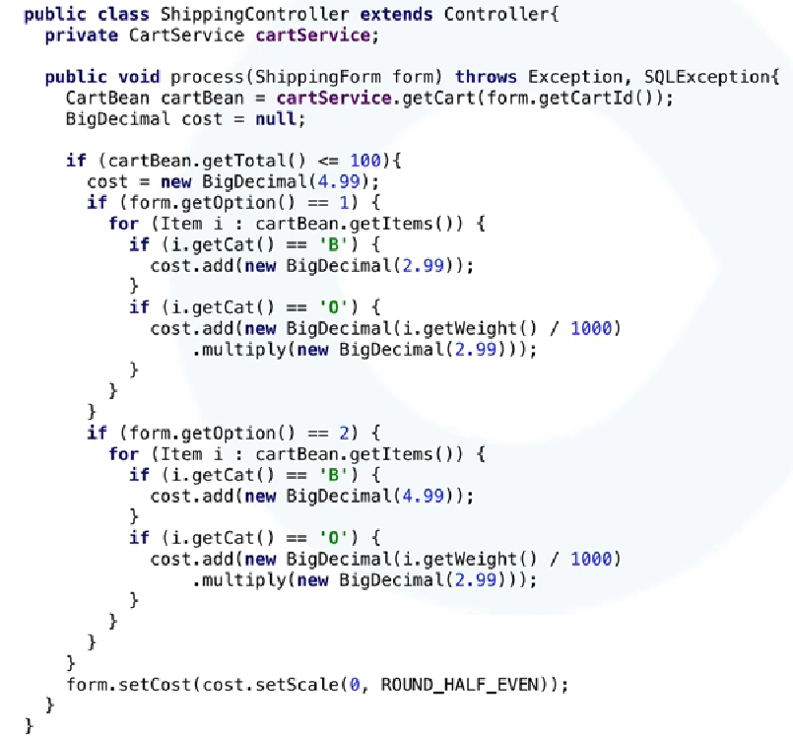

Lets diagnose this ahead.

* Its using too much magic numbers – these are basically the String literals that are used again and again – so for example 100, 2.99 or 4.99 – what do they do and why are they here basically.
* Secondly we are duplicating the code, the figures are change between the two blocks and rest seems to be the same.
* Third is the primitive obsession, in this small code it is repeated 8 times.
* Fourth is Mixed Concerns, maybe SQLException was not caught here and so we are throwing this out of this. The SQLException should not be here in method throws clause.
* Fifth is fuzzy terminology – use of i for example in loops and for conditions. We are using i here and there.

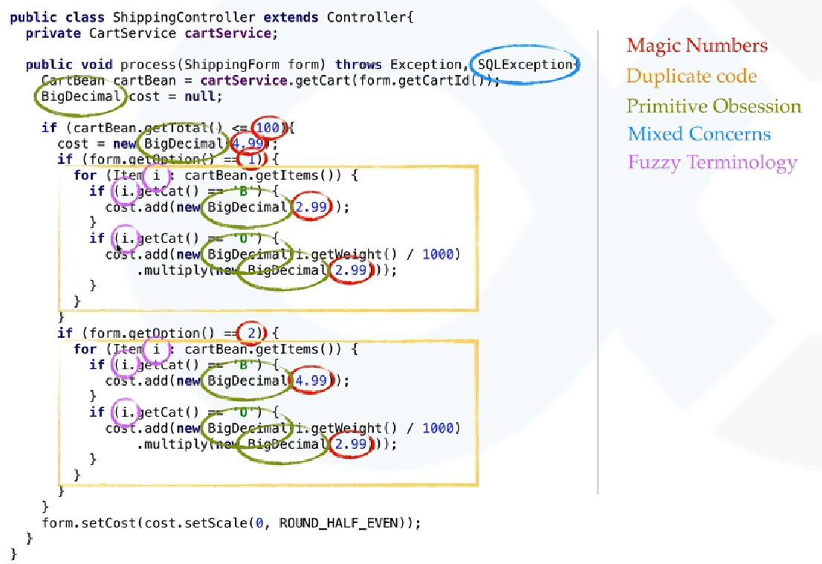

Lets see what are the implict concerns here now

* According to DDD you should make everything in your code explicit.
* Don’t depend on a person to infer it out of the context.

First thing is what does this line do (1) what is the total here and what is 100. What is the fixed shipment cost, what is the 4.99 here and what if we have to change it tomorrow – will changing it just here work or you have to change it at more places than this. For this line (3) what is the currency here, currency has different formatting and round off strategies. Is (4) the weight in gram, why are we dividing this by thousand? What is this option (5) is that a shipping option and what does 2 mean in that case. Why do we have (6) a variable cost per category and that too I am assuming that cat means category here. This is a very convulated code and if a new person comes in, it will be really hard for him to understand this

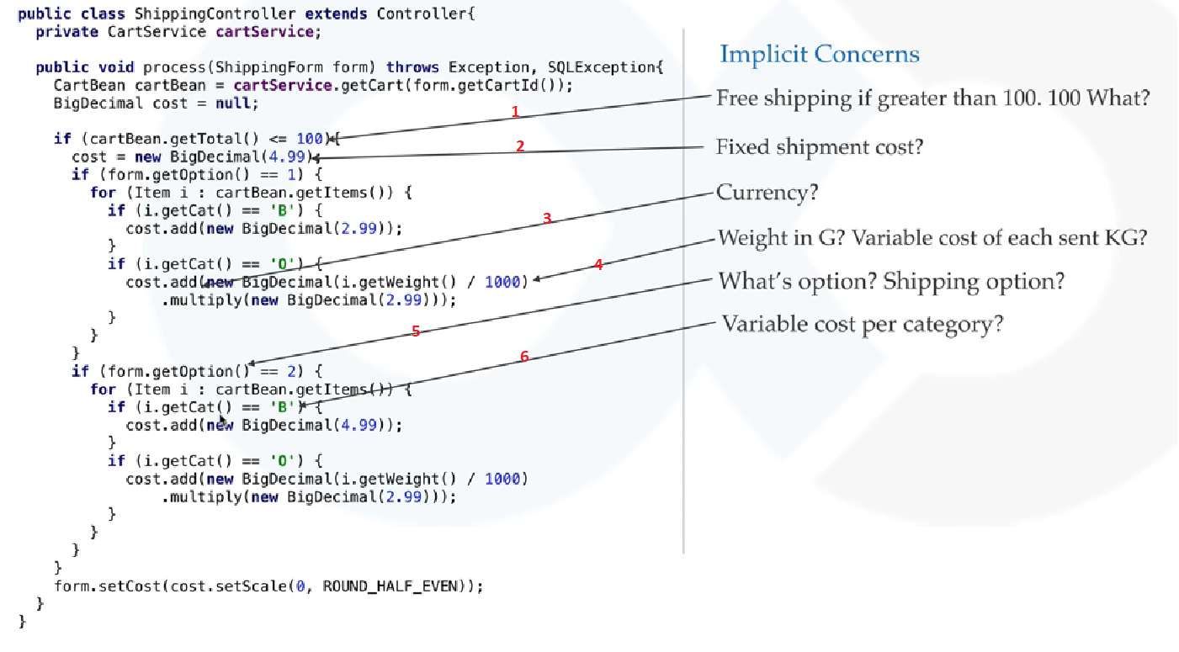

**Lets see a Domain Driven code now**

The interface of the method should look like this – what does process mean, it can mean so many things, a better name is calculateShippingCost. This is also called as a Intention revealing interface. It reveals a lot of things like, it calculates shipping cost. It takes a Cart in and the type of ShippingOption that the person has selected and if you need to see the options then you can go directly in that class and see. The return type should be Money, as long as you can return things it should not ever change the object that we have passed in.

If the total price of the cart is less than THRESHOLD_FOR_SHIPPING – this is almost like english – then getBaseShipmentCost and then maybe this 4.99 would come somewhere from there. Iterate over each of the items in the cart and if the selected option is regular then get regular else get prime shipping cost for that item. Some people might argue that why we haven’t written a method for regular and prime shipping costs for item, why did we write a separate class. This is basically for two reasons, everything related to regular shipping would be in RegularShipping class and everything related to Prime would be in the PrimeShipping class. The constants for calculating the price will go into these classes now.

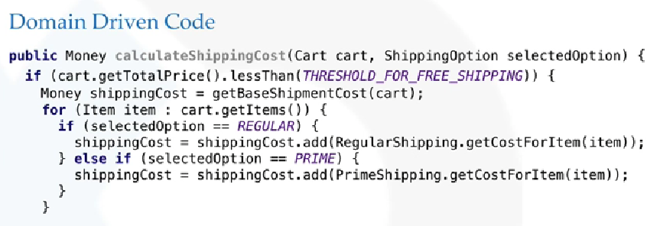

The Money class here is immutable so we are collecting it into a separate variable shippingCost as you can see here. We either return the calculated Shipping cost or if you have already crossed the threshold for free shipping just return Money.ZERO. So here we get a idea of how we can implement Domain Driven code.

### Domain Driven Design ( Summary )

Lets take a analogy and lets try to design a City here

How does a typical city look like. First a person came there and built a house and then followed by another and then in the end you have this big unplanned city. Same happens in software development, someone developed using his own design and then someone else came along and given a feature to implement he designed his own classes and in the end you have this big ball of mud – this is a typical DDD terminology – whenever unplanned changes keep piling up, in the end they all end up with a big ball of mud and on the other side we have a planned city, so whenever you start designing a microservices architecture or any software for that matter we do some planning and we give designated areas to developers and then you have these beautiful microservices which are contained within them and these are bounded contexts and you have your own Ubiquitous language inside this and this is what we aim for when we design our software using DDD.



What are some key points to take away from DDD?

Always design your softwares in Top Down fashion, unless your Domain is trivial. Top down means we first look at strategic domain design and then the tactical domain driven design. Always first think of your Bounded Contexts and your domain and your core sub domains and separate them out and then think about each sub domain separately.

Focus on what distinguishes you from your competitors and what you must excel at

* Always focus all your energy & resources in your core sub-domain. Don’t’t try to be best at everything, at least not at the start.

Don’t chase shiny objects by throwing shiny technology at business problems. First recognize the problem and then look at what can be the solution for it. Don’t keep a technology in mind and throw it as a solution before understanding the problems.

Place emphasis on naming and operations

Important Tips

Don’t work for a company that thinks of software as a cost centre. If your company thinks software is a burden and they are using it because everyone else is, that is really unfortunate and companies that think software gives them a competitive edge are champions in their areas. Air BNB and Uber etc are winning their battle in there verticals and they have grown so big is short amount of time.

* DDD will just like OOP when we get a hang of it.

When some people started learning OOP it really looked unimportant to them and people thought why they are learning it. Now when designing you cannot even think without OOP. Follow a evolutionary approach. Just try to find a bounded context in your architecture and try designing your microservices around that and give some guidelines to your developers to design those architectures for you.

* Don’t create heavy weight blue prints before development, follow an evolutionary approach
* Write your code and documentation so that it represents the Domain.

Developers only know the portion they work on and that is really sad so .

* Build a product for wich you can provide long term warranties.

If we design using DDD it will be much cleaner and organized and you can provide guarantess for your product.

### Monolith and Microservices Ecosystem

Develop a server side enterprise application

It must support a variety of different clients including desktop browsers, mobile browsers and native mobile applications.

It might also integrate with other applications via either web services or a message broker like payment gateways and notification services.

The application handles requests ( HTTP requests and messages ) by executing business logic, accessing a database, exchanging messages with other systems, and returning a JSON response.

Traditional server side App might look like this

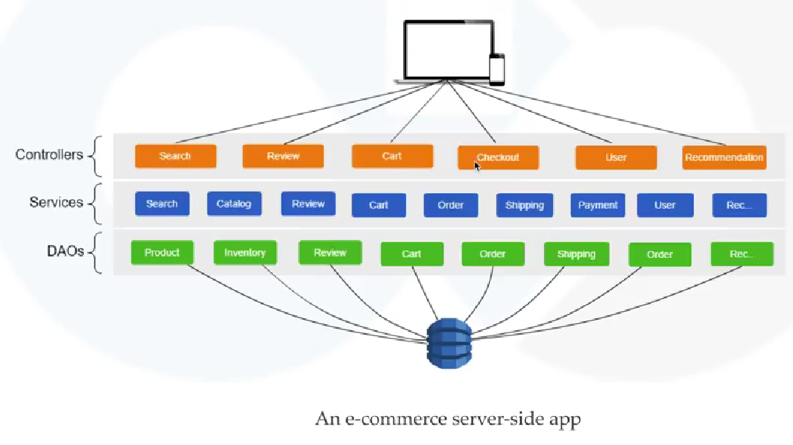

In a similar way if we have a taxi booking server side app, we could have something like this

Traditional Web App

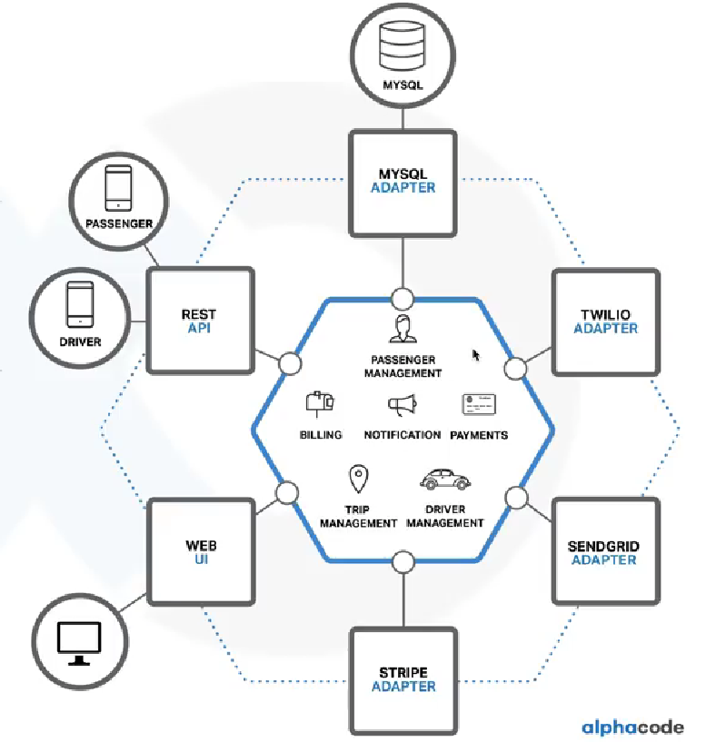

This is taken from Chris Richardsons book, you might see this example somewhere else mentioned as Ubers backend architecture.

This would be your first version of your application. Your app will have a Hexagonal Architecture, we have different modules for trip management, passenger management, driver management, notification, billing and so on. We would have some services co-ordinating with the outside world using adapters ( ref the MySQL Adapter here ). We also have some of the third party servers for OTP and payment gateways and so on. We have a web UI that is serving on the browser for your web content and then we have a REST API that is helping serve on the mobile devices. Passenger Apps are using the REST APIs directly.

This is a monolith because all of your business logic resides inside your single application and also we have a single database. You have a modular architecture and the application is deployed as a single big monolith. Deployment also depends on the language formats – wars for java, exe for c and so on.

Advantages of this architecture

* Simple to Develop
* Easy to Deploy ( you just have one file to manage for deployment )
* Simple to Manage
* Easy to comprehent ( all of the things are there within one project ) – easy to grasp
* Simple to test ( give it to one of your testers, we have predefined APIs and just call them via Unit/ Integration tests )
* Easy to scale upto a certain level ( run multiple copies of it for heavy traffic ). Have one for fail safe purposes

Disadvantages

Applications grow over time and become complex taking 15 to 20 minutes just for deployment

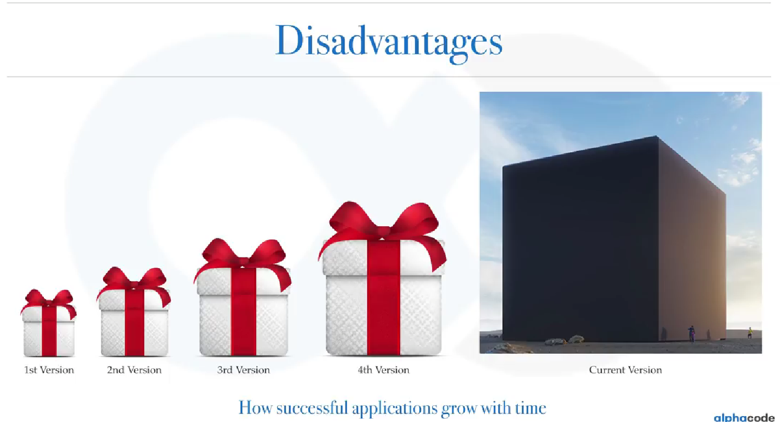

* Language/ Framework lock-in ( might have chosen the best framework at that point of time when the project started but today you are locked in into that technology/ framework ). Even if you have newer languages or frameworks in the market that suit your requirements, you cannot move to them.
* You lack innovation as you are caught up in just managing this application
* Very difficult to digest even for a experienced person who has been working on this application for years
* Difficult to distribute development on this – parts of modules are not autonomous – they have dependencies on each other
* For a bug in any module, you have to deploy the whole unit which might not be feasiable. We wait for significant changes in order to redeploy. Monoliths become a obstacle for frequent releases, instead of frequently deploying small changes we are deploying large changes infrequently.
* Development slows down – code takes minutes to come up – code was in GBs
* Resources are not optimized – suppose you have a image processing task that takes up large memory and you have a task that takes lot of CPU and one that does a lot of IO – how are we going to pick up hardware for such a application. We go for a average one and all of our endpoints suffer. If one endpoint is taking time to load then other endpoints would also suffer. If your monolith is not reactive ( node js or spring 5 or spring boot 2 ) then your endpoints that are slow with other endpoints as well. Scaling becomes difficult – we can’t react to changes faster on auto scaling. Creating a whole new instance of your application even though only 1 particular endpoint requires scaling.

|  |  |
| --- | --- |
|  | We have a successful business enterprise application that has grown into a big monolith that only a few developers understand. Its written using obsolete, unproductive technology and hiring talented developers becomes very difficult. Customers are frustrated and so are the developers and the operations team. Its very difficult for the operations to pin point which module is creating a problem and who to contact. |

Microservices solve these problems although they are not free lunch.

Next Video: Bounded Contexts - Cyrille Martraire - DDD Europe 2019

You need Microservices and you need Bounded Contexts for it, you need this even if you are not in Microservices.

The right models are the ones that you need for each purpose.

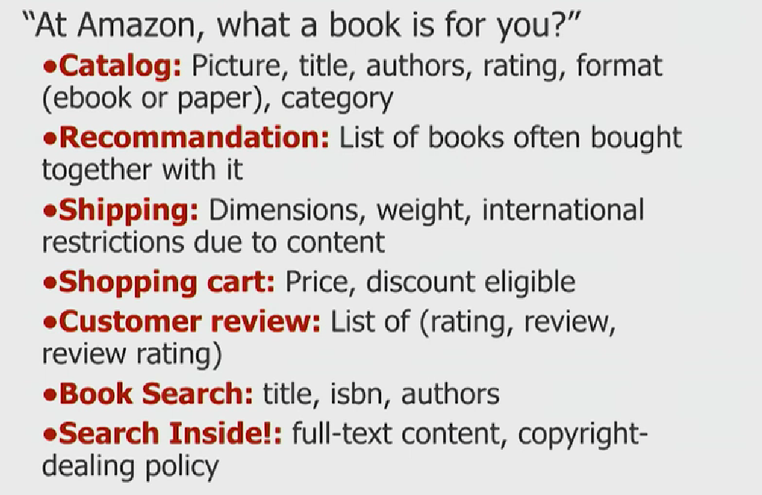 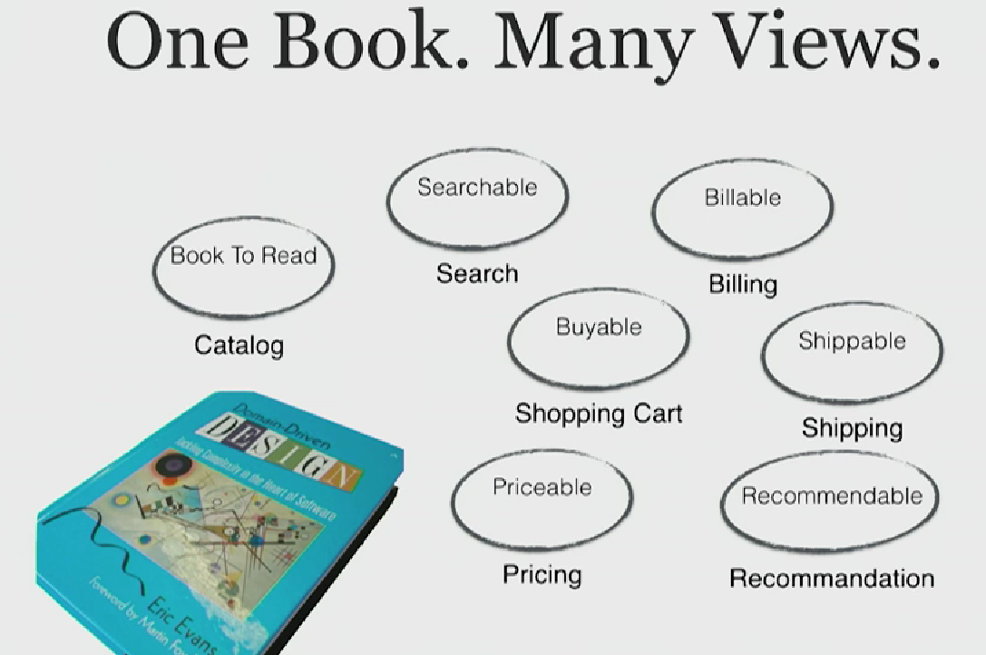

The way you look at things is totally different from one context to the next.

In each context we have different models, in real life things have many many dimensions and we don’t have to model them all and for particular context we just need to focus on subset of them. You never need a full 3d model at once, you might live with one 2d model and another 2d model but never the full 3d at once.

Isolation gives you the freedom to do what you want to do and the best possible job. So this independence is what you have within a boundary which is why we have a context to protect them from the rest of the world.

## BASE

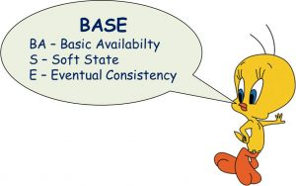

BASE describes database processing germane to a NoSQL database, such as a data lake.

Basically Available: The system is guaranteed to be available in event of failure.

Soft State: The state of the data could change without application interactions due to eventual consistency.

Eventual Consistency: The system will be eventually consistent after the application input. The data will be replicated to different nodes and will eventually reach a consistent state. But the consistency is not guaranteed at a transaction level.

Other Definitions of BASE Include:

“A system allowing horizontal scaling, fault tolerance and high availability at the cost of consistency,” (Akshay Pore)

An alternative to the ACID data processing model. (Dan Pritchett)

A consistency model that values availability with less strict assurance of consistency than in an ACID database model. (Neo4j)

An acronym used to describe the properties of certain databases, usually NoSql. (Stackoverflow)

BASE Case Examples:

Creating a value-based model for a health organization from disparate informational sources

Using shopping cart applications on a website

Uncovering fraud rings and scams

Monitoring network and IT infrastructure security

Managing and reusing document content

Businesses use BASE Database Types to:

Use the object-oriented architecture native to the cloud

Process large amounts of unstructured data very quickly

Support data research

Find patterns, such as fraud

Gain business insights

Manage data from the Internet of Things (IoT)

When it comes to NoSQL databases, data consistency models can sometimes be strikingly different than those used by relational databases (as well as quite different from other NoSQL stores).

The two most common consistency models are known by the acronyms ACID and BASE. While they’re often pitted against each other in a battle for ultimate victory (please someone make a video of that), both consistency models come with advantages – and disadvantages – and neither is always a perfect fit.

The ACID Consistency Model

Many developers are familiar with ACID transactions from working with relational databases. As such, the ACID consistency model has been the norm for some time.

The key ACID guarantee is that it provides a safe environment in which to operate on your data. The ACID acronym stands for:

**Atomic -** All operations in a transaction succeed or every operation is rolled back.

**Consistent -** On the completion of a transaction, the database is structurally sound.

**Isolated -** Transactions do not contend with one another. Contentious access to data is moderated by the database so that transactions appear to run sequentially.

**Durable -** The results of applying a transaction are permanent, even in the presence of failures.

ACID properties mean that once a transaction is complete, its data is consistent (tech lingo: write consistency) and stable on disk, which may involve multiple distinct memory locations.

Write consistency is a wonderful thing for application developers, but it also requires sophisticated locking which is typically a heavyweight pattern for most use cases.

When it comes to NoSQL technologies, most graph databases(including Neo4j) use an ACID consistency model to ensure data is safe and consistently stored.

The BASE Consistency Model

‌NoSQL relies upon a softer model known as the BASE model. BASE (Basically Available, Soft state, Eventual consistency).

For many domains and use cases, ACID transactions are far more pessimistic (i.e., they’re more worried about data safety) than the domain actually requires.

In the NoSQL database world, ACID transactions are less fashionable as some databases have loosened the requirements for immediate consistency, data freshness and accuracy in order to gain other benefits, like scale and resilience.

(Notably, the .NET-based RavenDB has bucked the trend among aggregate stores in supporting ACID transactions.)

Here’s how the BASE acronym breaks down:

**Basic Availability -** The database appears to work most of the time. Guarantees the availability of the data . There will be a response to any request (can be failure too).

**Soft-state -** Stores don’t have to be write-consistent, nor do different replicas have to be mutually consistent all the time. The state of the system could change over time.

**Eventual consistency -** Stores exhibit consistency at some later point (e.g., lazily at read time). The system will eventually become consistent once it stops receiving input.

BASE properties are much looser than ACID guarantees, but there isn’t a direct one-for-one mapping between the two consistency models (a point that probably can’t be overstated).

A BASE data store values availability (since that’s important for scale), but it doesn’t offer guaranteed consistency of replicated data at write time. Overall, the BASE consistency model provides a less strict assurance than ACID: data will be consistent in the future, either at read time (e.g., Riak) or it will always be consistent, but only for certain processed past snapshots (e.g., Datomic).

The BASE consistency model is primarily used by aggregate stores, including column family, key-value and document stores.

**NoSQL**

This is when NoSQL came to the rescue.‌ It is “Not Only SQL” or “Non-relational” databases.

Characteristics of NoSQL:

* Schema free
* Eventually consistent (as in the BASE property)
* Replication of data stores to avoid Single Point of Failure.
* Can handle Data variety and huge amounts of data.

Navigating ACID vs. BASE Trade-offs

There’s no right answer to whether your application needs an ACID versus BASE consistency model. Developers and data architects should select their data consistency trade-offs on a case-by-case basis – not based just on what’s trending or what model was used previously.

Given BASE’s loose consistency, developers need to be more knowledgeable and rigorous about consistent data if they choose a BASE store for their application. It’s essential to be familiar with the BASE behavior of your chosen aggregate store and work within those constraints.

On the other hand, planning around BASE limitations can sometimes be a major disadvantage when compared to the simplicity of ACID transactions. A fully ACID database is the perfect fit for use cases where data reliability and consistency are essential (banking, anyone?).

## CAP Theorem

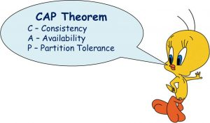

The cap theorem applies to distributed systems that store state. In any networked shared-data system there is a fundamental trade-off between consistency, availability, and partition tolerance. The theorem states that networked shared-data systems can only guarantee/strongly support two of the following three proper ties:

**Consistency** — a guarantee that every node in a distributed cluster returns the same, most recent, successful write. consistency refers to every client having the same view of the data. there are various types of consistency models. consistency in cap (used to prove the theorem) refers to linearizability or sequential consistency, a very strong form of consistency.

**Availability** — every non-failing node returns a response for all read and write requests in a reasonable amount of time. the key word here is every. to be available, every node on (either side of a network partition) must be able to respond in a reasonable amount of time.

**Partition tolerant** — the system continues to function and upholds its consistency guarantees in spite of network partitions. network partitions are a fact of life. distributed systems guaranteeing partition tolerance can gracefully recover from partitions once the partition heals.

The c and a in acid represent different concepts than c and a in the cap theorem.

The cap theorem categorizes systems into three categories:

**CP (consistent and partition tolerant)** — at first glance, the cp category is confusing, i.e., a system that is consistent and partition tolerant but never available. cp is referring to a category of systems where availability is sacrificed only in the case of a network partition.

**CA (consistent and available)** — ca systems are consistent and available systems in the absence of any network partition. often a single node's db servers are categorized as ca systems. single node db servers do not need to deal with partition tolerance and are thus considered ca systems. the only hole in this theory is that single node db systems are not a network of shared data systems and thus do not fall under the preview of cap. [^11]

**AP (available and partition tolerant)** — these are systems that are available and partition tolerant but cannot guarantee consistency.

a venn diagram or a triangle is frequently used to visualize the cap theorem. systems fall into the three categories that depicted using the intersecting circles.

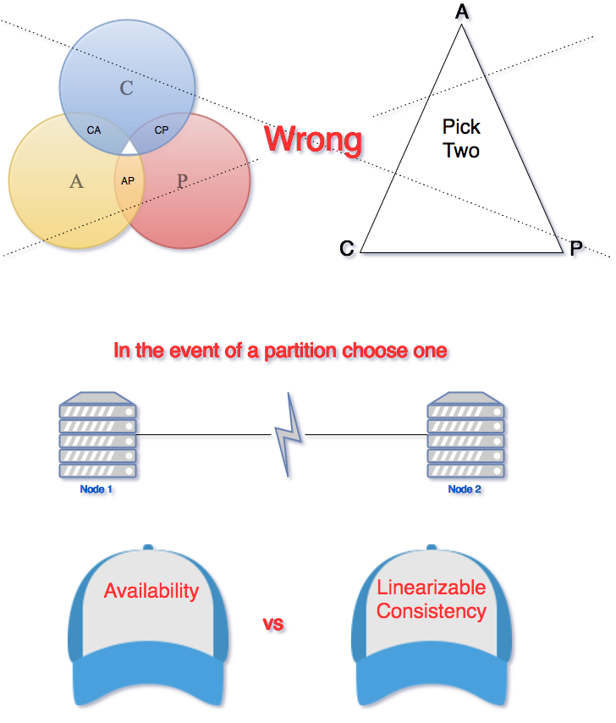

The part where all three sections intersect is white because it is impossible to have all three properties in networked shared-data systems. a ven n diagram or a triangle is an incorrect visualization of the cap. any cap theorem visualization such as a triangle or a venn diagram is misleading. the correct way to think about cap is that in case of a network partition (a rare occurrence) one needs to choose between availability and consistency .

In any networked shared-data systems partition tolerance is a must. network partitions and dropped messages are a fact of life and must be handled appropriately. consequently, system designers must choose between consistency and availability. simplistically speaking, a network partition forces designers to either choose perfect consistency or perfect availability. picking consistency means not being able to answer a client's query as the system cannot guarantee to return the most recent write. this sacrifices availability.

Network partition forces nonfailing nodes to reject clients' requests as these nodes cannot guarantee consistent data. at the opposite end of the spectrum, being available means being able to respond to a client's request but the system cannot guarantee consistency, i.e., the most recent value written. available systems provide the best possible answer under the given circumstance.

During normal operation (lack of network partition) the cap theorem does not impose constraints on availability or consistency.

The cap theorem is responsible for instigating the discussion about the various tradeoffs in a distributed shared data system. it has played a pivotal role in increasing our understanding of shared data systems. nonetheless, the cap theorem is criticized for being too simplistic and often misleading. over a decade after the release of the cap theorem, brewer acknowledges that the cap theorem oversimplified the choices available in the event of a network partition.

According to brewer, the cap theorem prohibits only a “tiny part of the design space: perfect availability and consistency in the presence of partitions, which are rare." system designers have a broad range of options for dealing and recovering from network partitions. the goal of every system must be to “maximize combinations of consistency and availability that make sense for the specific application.”

## SAGAS

We want to explore some of the features a Spring State Machine as to how we can utilize this to coordinate more and more complex transactions and also take that state and state machine and rehydrated from the database so we're gonna be persisting into the database and then rehydrate it. Very important stuff as we move in to the concept of Sagas because we're gonna use state machine to coordinate these long live running transactions with Sagas.

|  |  |
| --- | --- |
|  | Now Sagas is a very important concept of how we coordinate between different microservices. So we've only seen some very simple examples so far so we're gonna explore sagas in this upcoming section. And now because Saga is getting a little more interesting as far as how sequence of events happens we're actually gonna be looking at doing some integration testing I am touched on too much on testing in the course so far but it's important to do integration testing with Sagas and then also we will talk about a very important concept Sagas called Compensating Transactions and that'll be another topic that we will be getting into. But first I know I've probably brought up a lot of questions about what is the Saga and what is a Compensating Transaction. Things like that we are gonna do a deep dive into Sagas and this section of the course and start bringing a lot of stuff together that we've been talking about in the course and you get to see how things like JMS are gonna come into play and these type of messaging systems and we're gonna really wrap things up and you'll see how Spring state machine is gonna help us coordinate a Saga of a series of steps to complete a task with a series of microservices. |

We are gonna talk about the problem with transactions. This isn't a microservice contexts. And first just step back for a little bit and actually talk about transactions specifically and a database concept. So what a database transactions gonna allows you to do is complete a sequence of steps those very important in our programming careers to be able to have multiple database steps happen and then commit those to the database and then having the ability to roll that back or undo those and returning that database to their original state. So if you think about here what we're gonna be doing in this course is gonna be looking at order allocation. So here we're gonna allocate inventory.

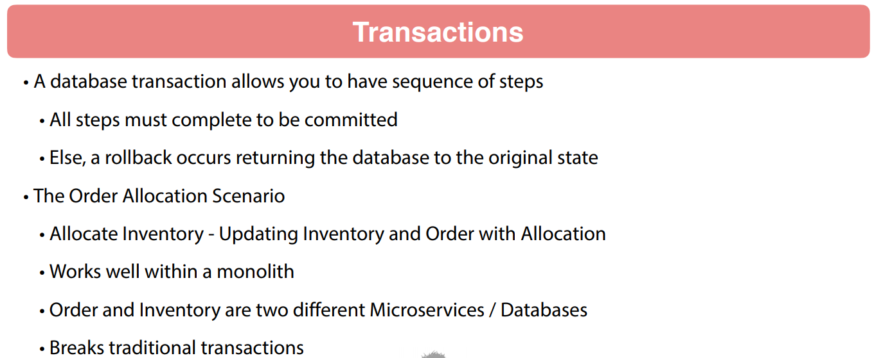

So the scenarios we get an order into the system and we wanna allocate inventory to that order. So what's gonna happen is we're gonna have to update both inventory and order within the allocation process. So within a monolith, this works very well because both of those are within our services in the same database. Everything is happy in our traditional concern. Here if the example that we've been working within the course we have order and inventory in two different microservices. So two independent microservices, two independent databases as well. And this is going to break a traditional database transaction.

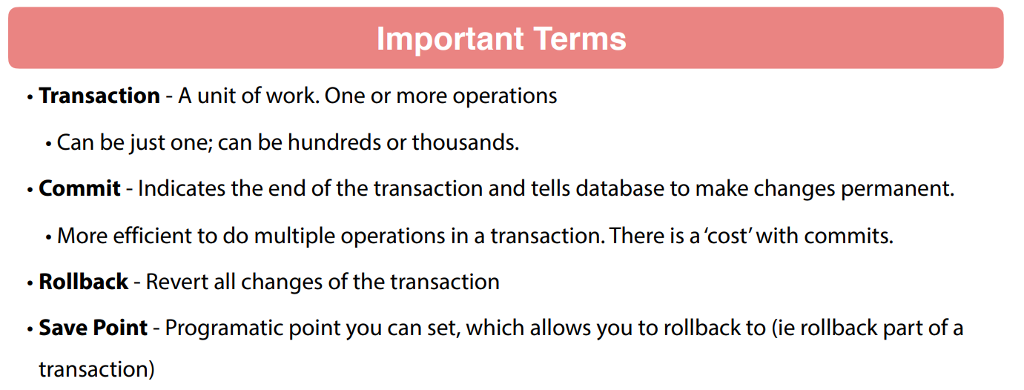

So I'd like to recap some very important terms as we go forward here. Transaction is going to be a unit of work so that's gonna be one or more operations. And keep in mind often when we're doing small stuff like what we see and in typical courses, it's gonna be just one transaction I've actually done tens of thousands of operations inside of a single transaction. Now if you're doing processing bulk data very common to have a lot of transactions if you're going through a large dataset. So the commit is going to tell the database to actually make these changes permanent to the database. And when I mentioned that I can I've done tens of thousands of transactions within a single transaction, it's actually becomes more efficient to do multiple database operations within a single transaction because there is a cost in a relational database system to doing a commit.

A rollback is going to revert all the changes. So rollbacks also can be a little bit expensive when the database has to go back and undo everything. And then some databases relational databases around transactions are very mature and you can actually specify a safe point so you can do three or four steps. And if you get to a condition you're not happy with for some type of program ideologically you can say go back to the safe point. So a lot of capabilities here as far as how we are going to be doing transactions within the context of a database. Very mature technology that's been around for a very long time. And when you start talking about database transactions you get into A.C.I.D and this is a common acronym Atomicity, Consistency, Isolated and Durable.

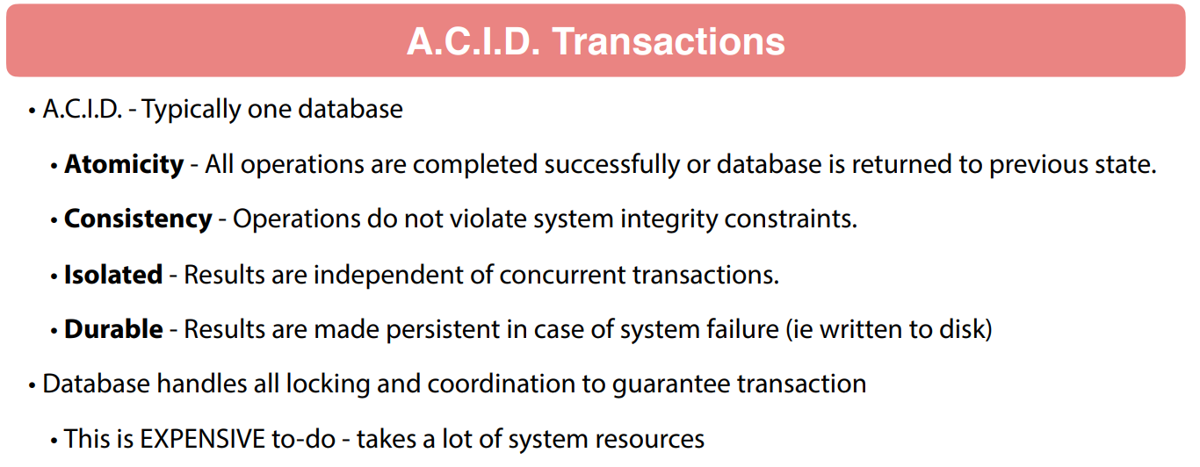

Atomicity, Consistency, these are all very important concepts that ensures the integrity of your transaction.

So the **Atomicity** means that the operations are gonna be completed successfully or the database is returned to the previous state.

**Consistency**: you don't violate system integrity constraints. Isolated: results are independent of concurrent transactions so this is a very very big one.

As far as being **Isolated** I have worked on Oracle databases with thousands of users on that all. Thousands of users transacting, you want that transaction to happen in your little stovepipe of the world. You should start that transaction you should have a view of the data of when your transaction started and that view of the data should not change. So for your changes that should be independent of other transactions. So you want your data changing underneath your feet while you have a transaction happening. So this gets senses very very complex things as far as how your transaction is isolated.

And then finally the D in ACID is **Durable**. Those results were made permanent to the system so you're gonna be committing those to the system. So that is gonna get written to the disk. Now the database is going to handle all this locking in coordination to guarantee that transaction. I've seen some of the underneath stuff that like Oracle does this, gets very expensive to do because you're doing a lot of logs and making sure that things are proper. So there is a cost to doing these transactions within a transactional sense. If you looked at things like MongoDB when it first came out where I was talking about how fast Mongo was. Well Mongo wasn't doing transactions at that time I think they're they've just started to introduce that, but there is a cost to doing all this A.C.I.D stuff to guarantee transaction now we started talking about microservices. Obviously those are gonna be going across multiple nodes.

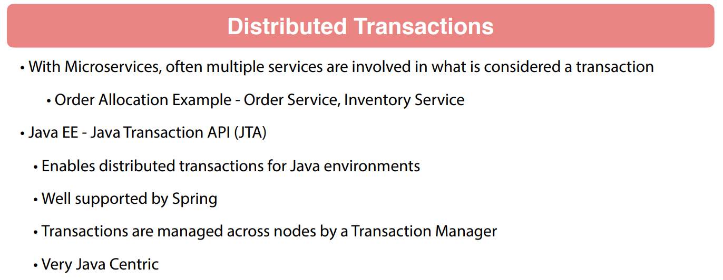

**Two Phase Commit - JTA**

So we're gonna have our Order Allocation service. For example we have our Order Service and Inventory Service, Java Enterprise Edition does have the Java transaction API or JTA. This allows for distributed transactions. But this is primarily for job environments very well supported by Spring. This can be very abstracted so you can have a transaction go across multiple databases multiple services. And these are gonna be managed by a transaction manager but at the end of the day there's a very Java centric. Still has some problems underneath the car because it is expensive and also very complex. My experience with JTA sounds great on paper when you start running in production in a large environment it does become a headache from things I've seen in the past. JTA is also gonna be it's a technology it's gonna be implementing a two phase commit. This is more of a concept and there are different implementations of this but two phase commit, 2 PC this is gonna happen in two phases. Traditionally you're gonna have a transaction coordinator that's gonna go across the nodes of these that are participating in that transaction and it's gonna send out a Voting phase saying hey I wanna do this, Is this okay. Are we happy doing this this piece of the transaction.

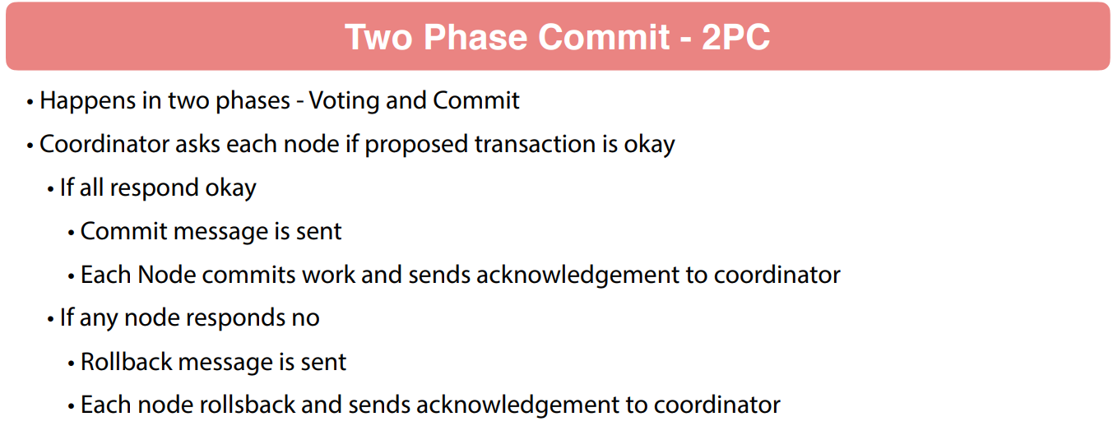

Now each node is gonna respond back yes or no to do it. So the coordinator is gonna wait to hear back from every node and get a consensus among the nodes. And if everybody's happy, the coordinator sends out a transaction, a message so all the node saying go ahead and commit the work. Now if any node responds no, a message is sent out to all the nodes saying to rollback and whether it's OK or not OK. An acknowledgment is expected to be sent back to the coordinator so you can see that there's a lot of coordination is going to happen here. And the problem with two face commits does not scale very well it's very expensive, it is a blocking protocol.

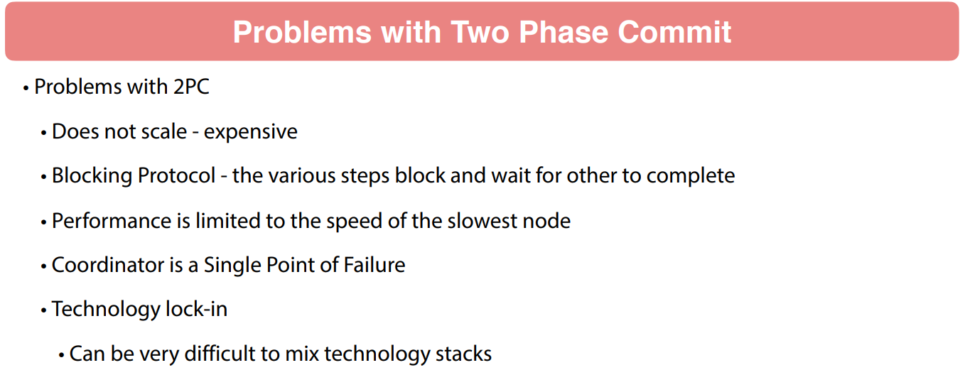

So I described that at very high level what's happening between these nodes and how things are talking back and forth and always voting on whether or not I can do it and then acknowledging this is all blocking because each step is gonna be waiting for the other nodes. So effectively your performance is gonna be limited to the speed of the slowest node and sometimes those nodes don't come back. So or your coordinator the transaction coordinator, If that fails that is a single point of failure. And then from experience you do get into technology and lock in because the two phase commit. What if you're talking if you're in a Java shop and you're talking to .NET or Ruby you're gonna have problems implementing this in a mixed technology stack.

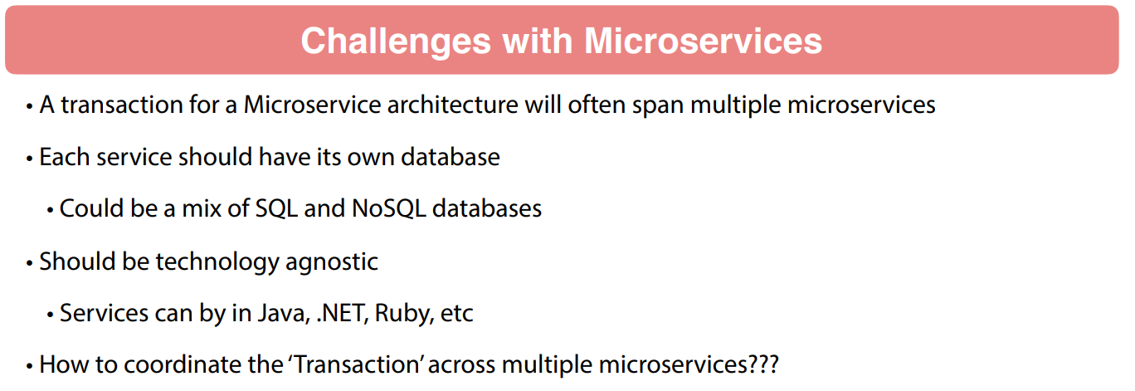

So this is very problematic and I think the industry as a whole you might be in an older organization where this is being used and to be honest I think a lot of people are moving away from it just because of this because it does not scale and it is blocking and it is very problematic when it's up and running in production. Now in the context of microservices, some of the challenges that we're gonna be looking at a transaction and a microservice architecture is often gonna span multiple microservices. So remember each service should have its own database and this could be a mix of different technologies. So that might be MySQL on one node, Oracle on another could be MongoDB an old school database on another node. So a lot of things happen.

And remember when we start talking about the architecture we're trying to stay technology agnostic because a lot of the messaging protocols that we're using could be Java or Ruby or .NET can be a number of different things. So you wanna be able to keep those microservices agnostic in the sense that it doesn't matter what is implemented and as long as you implement a common communication touchpoint other things can talk to it like HTTP Restful interfaces. So these are all very good things widely adopted by a number of different languages and technology stacks. So that is one aspect to it. And then the final bullet point I have here is how do you coordinate that air quotes transaction across multiple microservices. And that is definitely a challenge. And that's what we are gonna be looking at coming up in the next lecture of this course.

### The Need for Sagas

So as are a number of services grows so does complexity. And if you look at some microservices presentations from speaking circuits, there's a number of them available on YouTube. At some point, someone coined the term Death Star and I'm not quite sure who coined it. I'm sure there is a person that came up with it death star as an example of the inner operations between microservices.

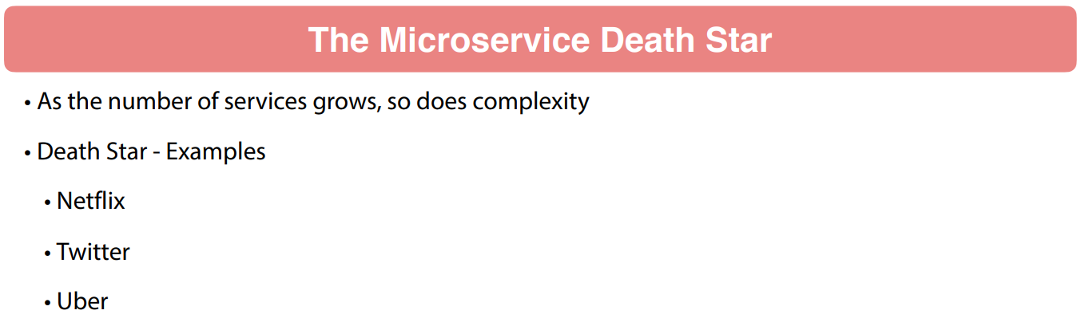

So we're gonna look at microservices at Netflix, Twitter and Uber and these are diagrams that their engineering teams have created. So Netflix obviously one of the forerunners of microservices. This is a diagram that they came up with for their microservices so you can see a lot going on there.

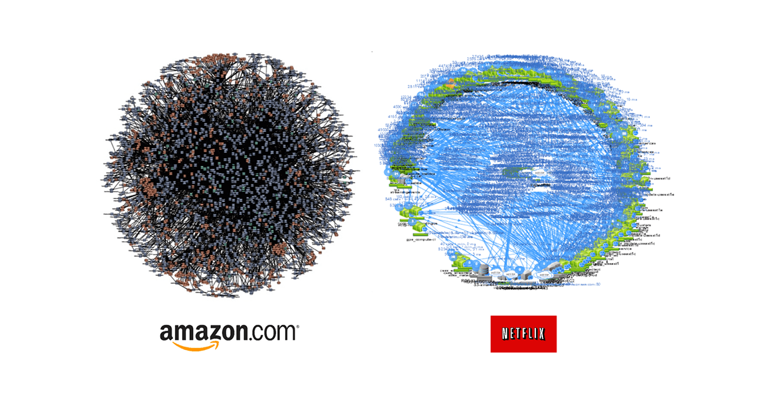

There's a lot of relationships between the microservices of each node as an individual microservice and then the lines represent communications between said microservices. Now up next we're gonna take a look at Twitter. Again this is from their engineering team. You can see a number of microservices and a lot of lines going on there so there's lot of complexity there. And then finally let's take a look at Uber they have been around as long but you can see still a number of microservices and a lot of relationships between those microservices a lot lot going on.

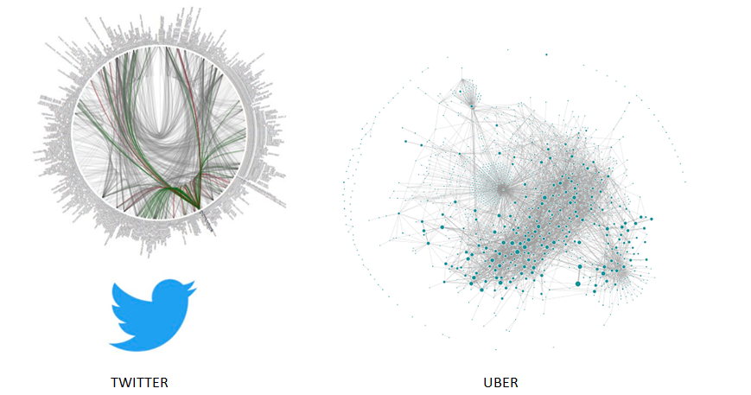

So when we start getting into distributed systems like this we are going to be looking at a number of challenges. So a point in the term business transaction that is often gonna span multiple microservices. So ACID transactions are not an option for this because that's the transactions occur within a database. We are going across multiple nodes multiple databases. So that is not going to do it for us. Now there is the concept of distributed transactions or two phase commits. These are complex and do not scale very well. And again your microservices should be technology agnostic. So if you get into a microservice one run in Java and Spring another one in .NET and your two phase commit is gonna be pretty difficult to implement.

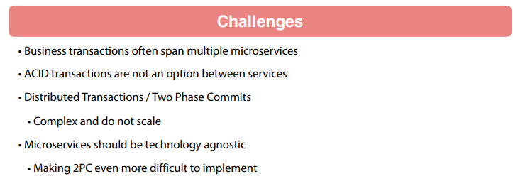

And then also when we start talking about distributed systems CAP theorem kicks in. So if we look at CAP which is Consistency, Availability and Partition Tolerance.

Consistency meaning that year every read is going to have the most recent right to the data store or Availability each read will get a response but not guaranteed that data is the most recent right. And then finally partition tolerance where your system is going to continue in lieu of some type of communication errors or slowness and delays.

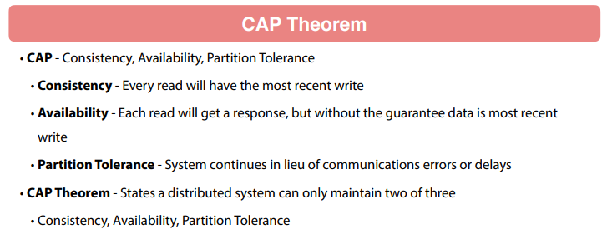

CAP theorem: In a distributed system you can only get two of the three so you can only get Consistency and Availability or Availability and Partition Tolerance but not all three and this diagram helps lay it out so you can envision the some of the relational database technology during and gets Consistency and Availability but not necessarily Partition Tolerance and then you can see how we've laid out other scalable technologies such as Redis or Cassandra they have different characteristics and again CAP theorem states you can only get two out of three there so we do have some things that we need out of that but we can't have all three.

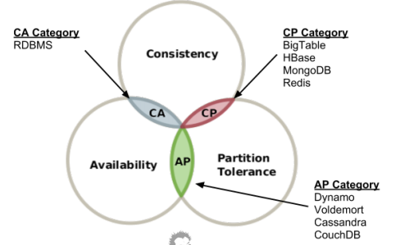

Now also dealing with distributed systems, EBay in 2008 coined the term called BASE and base stands for Basically Available, Soft state, and Eventually consistent. So this is really the opposite of an ACID transaction where it's dealing with a distributed system. So basically available means that you're building the system to support partial failures so you'll lose some functionality but not the total system loss.

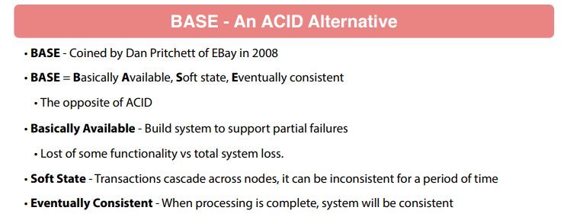

Soft State: this is gonna be where you have a business transaction is gonna go across nodes or microservice of multiple services. So the state and the system could be inconsistent while that is cascading across the nodes eventually consistent means when the processing is complete your system is consistent. So the very important concept when you're dealing with distributed systems. Now another term that has come up and this is fairly recent Feeral Concurrency Control. So this is a paper published in 2015 by Peter and I'm not even gonna attempt the last name because I know I will mispronounce that but Feral Concurrency Control are application level mechanisms for maintaining database or system integrity.

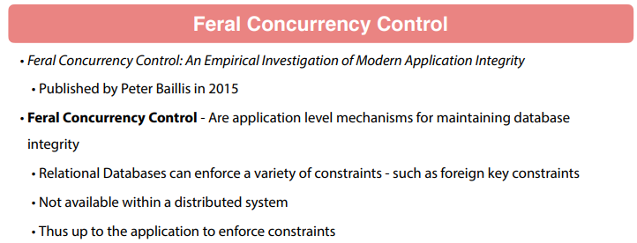

So remember things like relational databases they can enforce a variety constraint such as foreign key constraints to ensure integrity. So you're allowing the database to do that within a distributed system you don't have that. So that responsibility for maintaining integrity bubbles up to the application level so you as the application developer must keep the system maintained system integrity so you have to come up with tools and processes and are ways of maintaining that consistency. Now one thing that we can use with microservices is what's called Sagas. Sagas as a concept that was introduced way back in 1987 at Princeton University a couple of guys wrote a paper about long live transactions and they were focused on a single database and you have to think about when they wrote this paper. It was 1987 and computing resources were fairly scarce.

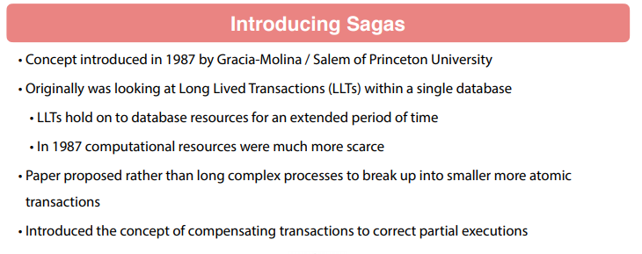

If you're walking around with an iPhone you have exponentially more computing power in that iPhone than what we had on major database servers back in 1987. So you start getting them long live transactions. And these were very intensive on the system resources so this paper what it did is said let's break up these long lived transactions into smaller more atomic transactions to alleviate the stress on the system. And what they did in this paper is they introduced a concept of what they call compensating transactions so you have smaller atomic transactions. If you think about that's gonna be happening in a microservice and then you use compensating transactions to correct any partial execution. So if in the steps your Saga you run into an error you compensate for it. So let's look a little closer at Sagas. Saga is just gonna be very simply just a series of steps to complete a business process it might be one step, it might be five steps, it could be 20 steps depending on your business need and the complexity of the microservice environment that you are in.

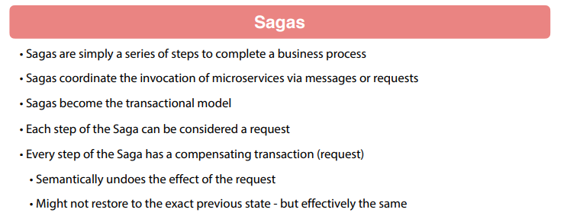

So Sagas are just gonna coordinate invocation of each step, VM messages or request. So your Sagas actually become your transactional model. So each step of the Saga is considered a request and every step of Saga has what's called a compensating transaction. So the compensate transaction that goes semantically undo the effect of a request or a series of requests in the Saga. And what's important to remember is it might not restore the system back to the exact previous date.

So some people think of the common the same transactions as a rollback not necessarily case because something you can't necessarily undo but they are going to compensate and take it to a state of consistency to undo what happened so if you're allocating ordering you get halfway through. Obviously you wanna release that inventory so a compensating transaction wouldn't release inventory if there is a error in order allocations. So a very important concept for these to work that way and it's kind of like a rollback but not exactly because it's not guaranteed to be the exact previous date.

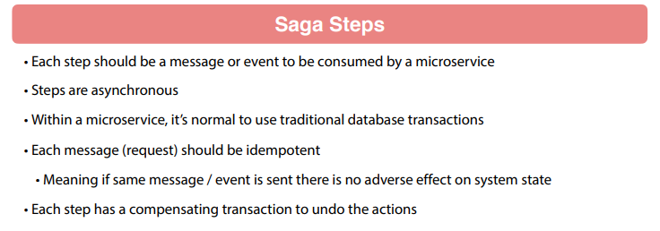

Now the individual Saga steps should be on a message or an event that's consumed by a microservice. So these are gonna be asynchronous actions so kind of launch and let it go within the microservices normal to use traditional database transactions. So the Sagas are gonna be a step above that the database so each message or requests should be idempotent meaning that if the message gets sent again or the call gets made again there is no adverse effect on system state. Then again each step of the Saga must have a compensating transaction to undo actions that happened in that step or the entire Saga depending on your particular use case. Now these compensatory transactions they effectively become your fellow concurrency control.

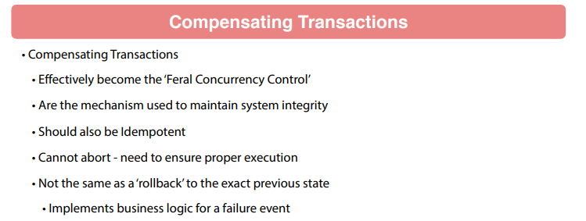

These are the mechanism that are gonna be used to maintain your overall system integrity. So again they should be idempotent so that you could apply the common same transaction more than once and there's no adverse effect on your overall system and they should not be able to abort. So this is very important because if you are going to a compensating transaction your system is gonna be in some type of inconsistent state and that must complete to take the system back to a consistent state. So even a failure condition you want to maintain a you don't wanna have a partially baked transaction to go through your system. The compensating transaction is going to take it to a good state again. Now Sagas are also considered **A C D** or missing that I here so they are gonna be Atomic so each transaction is going to be executed or compensated and then Consistency referential integrity of your data is gonna be maintained with a service by the local database so you can utilize your database constraints just like any other type of system.

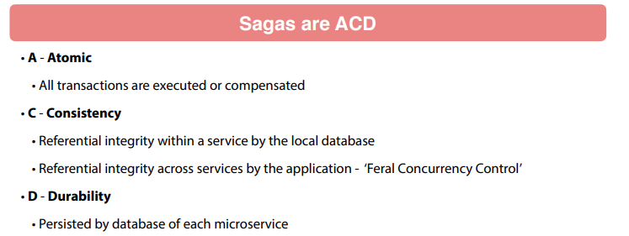

But when you're going across services in the application the, Saga is gonna be maintaining that view compensating transactions and then, of course, the D - Durability. We're gonna have a database in each microservice that it's gonna be persisted to. Now if we combine Sagas with the concept of BASE so Basically Available, Soft state, Eventually consistent.

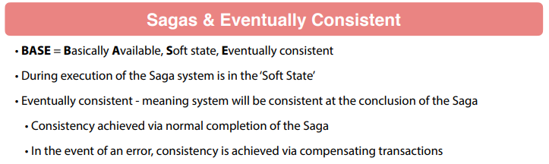

Remember while we're executing that Saga, the system is going to be in a soft state meaning that the state is not consistent. But we are running that Saga so you might have two steps or 10 steps or 20 steps in your Saga. You can get very complex things happening here. But while it's running you're gonna be a Soft state. But when that Saga completes either normally you're gonna be consistent but if there's an error in your Saga consistency is gonna be achieved by compensating transactions. So it's a very important concept here. Now in summary a Saga definition again.

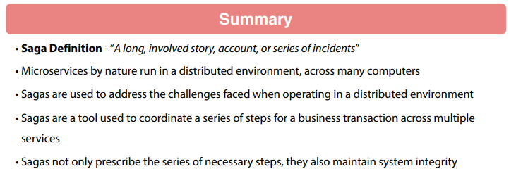

Think of it as "A long, involved story, account, or series of incidents". I think that's the official definition of a Saga from a dictionary. A microservice is by nature run and distribute environments across many computers. So Sagas are something that we can use to address the challenges we face when operating in a distributed environment. And again these are a tool to coordinate a series of steps for a business transaction. And again that transaction can be two microservice calls or it could be 20 microservices calls. So the Saga is gonna define that and the real important takeaway of about understanding Sagas is that they don't only prescribe the necessary steps, they don't say one two three four, they also provide compensating transactions that will maintain system integrity so they include the happy path. And then if there's some type of system failure they also account for that some very important takeaway for Saga said they are really good tool when you're dealing with some type of business transaction is going to span over multiple microservices.

### SAGA Co-ordination

We're gonna be talking about Saga Coordination. So just to recap that Saga is gonna be a long long lived involved story, an account or a series of incidents that's our official definition of it. So basically a series of steps with compensating transactions so that's really the important takeaway of what a Saga is. But how do you define what a Saga is in a distributed environment so you're gonna be working across multiple microservices to implement the Saga. So how do you actually go about implementing that. There's actually two primary approaches for coordinated Sagas. One is gonna be Choreography. So this is gonna be distributed decision making.

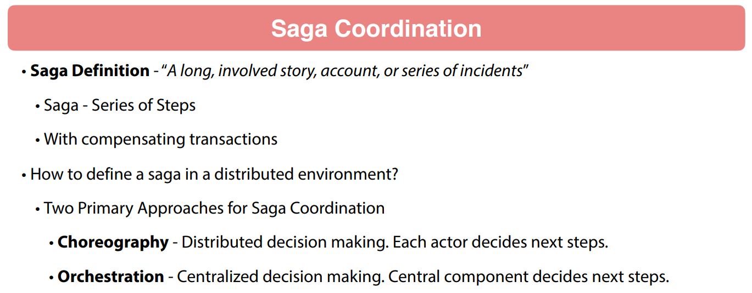

So each actor in the Saga is gonna decide the next steps of that saga. So as the Saga progresses, each component needs to have the logic of what microservice or what step needs to be made next. Now the opposite of that is gonna be Orchestration. This is going to be centralized decision making. So there's a centralized component that decides the next steps and the individual components not just execute the step and report back the result of that execution, but they are not aware of the Saga as a whole the distributed system. Each component knows or is required to know the next step so very important distinction here. So in choreography again that's distributed, we are gonna be making each component is gonna be making the next steps.

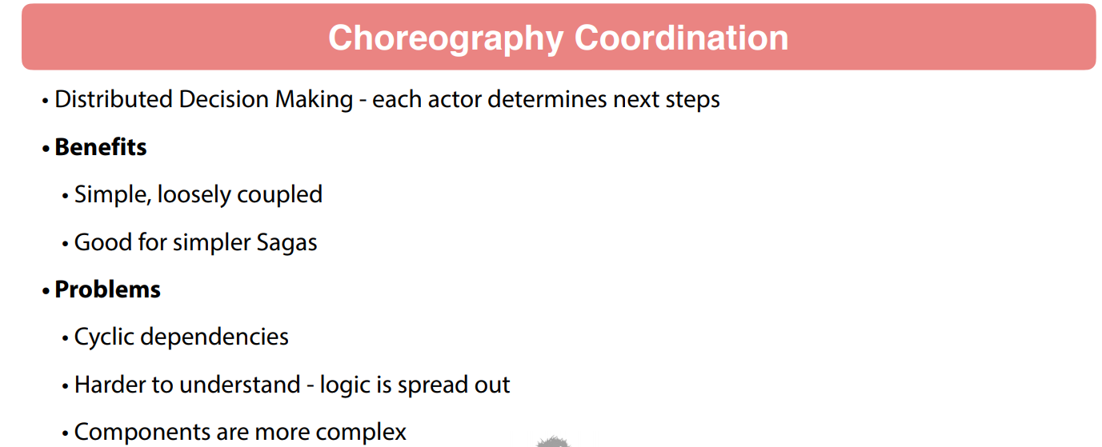

And the benefits of this this can be simple loosely coupled and pretty good for simpler Saga. So if you have a simple use cases ideal for some of the problems with this cyclic dependencies also harder to understand. So if you have a say six steps in a Saga that business logic for completing the Saga is gonna be spread out to each actor in the Saga. So it also makes your components a little more complex because now they need to have business logic of what to do next rather than just completing the task at hand. They also need to have logic about how to proceed. Now the implementation of choreography this is typically gonna be implemented using events so each actor is going to make an event for the next step in the Saga.

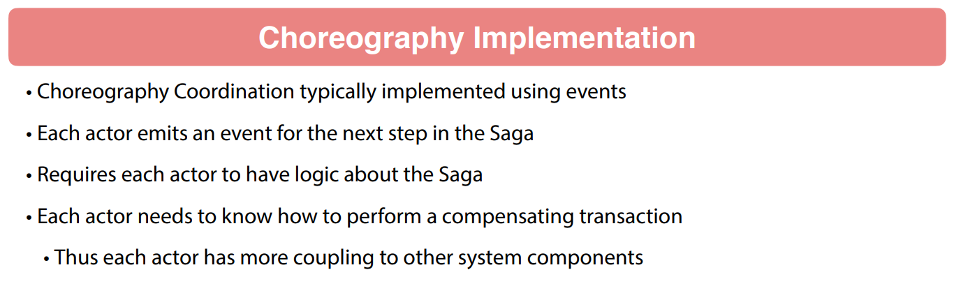

So this requires that actors have logic about the Saga and the actor needs to know how to perform a compensating transaction so if there is a problem in their execution of it they also need to have the business logic to address the compensating transaction. So this is in the choreography. Now the opposite is gonna be Orchestration based coordination.

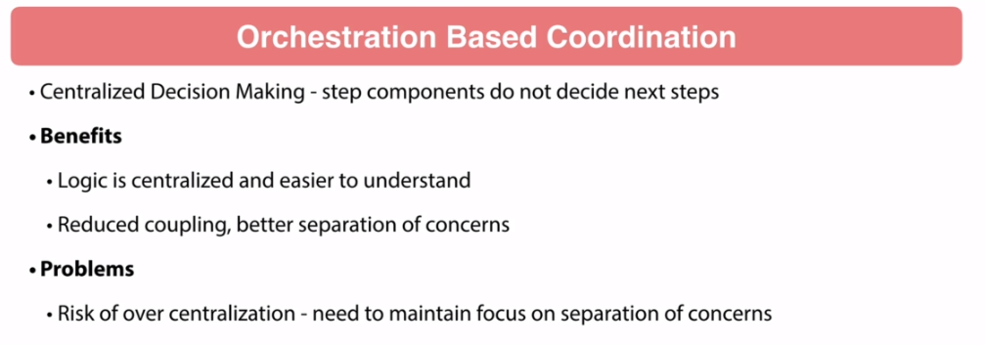

This is a centralized decision making so these components themselves do not decide the next steps. So the logic of the song itself is all centralized and it becomes easier to understand because you do have it in one place. We also get to reduce coupling and separation of concerns. This is one of the things that I like about the orchestration base because your components you have a centralized coordinator so that components function in life is to coordinate the steps of the Saga. The individual components the microservices within participating in the Saga, they are focused on doing that one specific test. So what I like this separation of concerns.

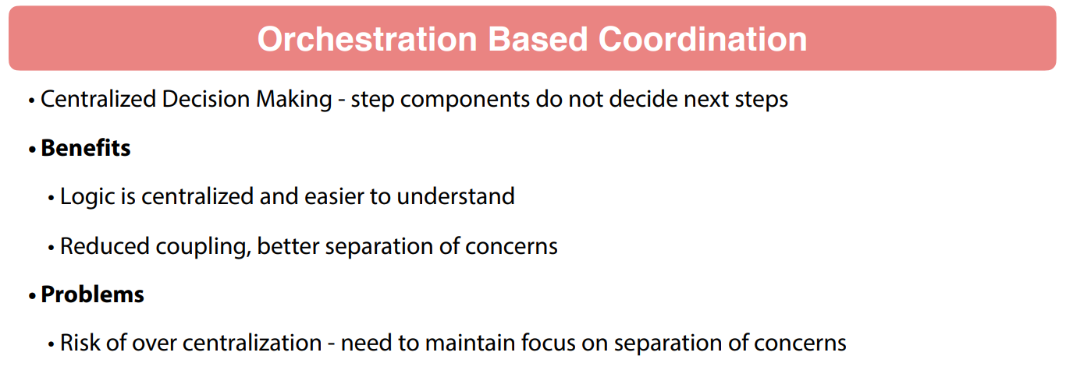

Now one risk is over centralization and this is a risk where you start bringing the actual business logic back into that centralized component where you wind up with very dumb and very simplistic microservices that are basically I mean you can dumb it down to the point of being like air quotes database calls where you just persisting data in microservice. So now you get the services themselves too simple and too dumb where they're not doing anything. And then that centralized component has all the business logic in it not not the ideal situation so kind of a special line that you need to walk here where you wanna focus on that centralized component is going to be focused on handling the steps of the Saga but not the actual business logic of each individual step that should be living inside that microservice.

Now the implementation of orchestratio,n again you're gonna have the simple central component that's gonna be directing the other actors in the Saga. That centralized component is going to need to maintain state for the saga. This can be done with a state machine. A lot of organizations have coined the term Saga Execution Coordinator or SEC.

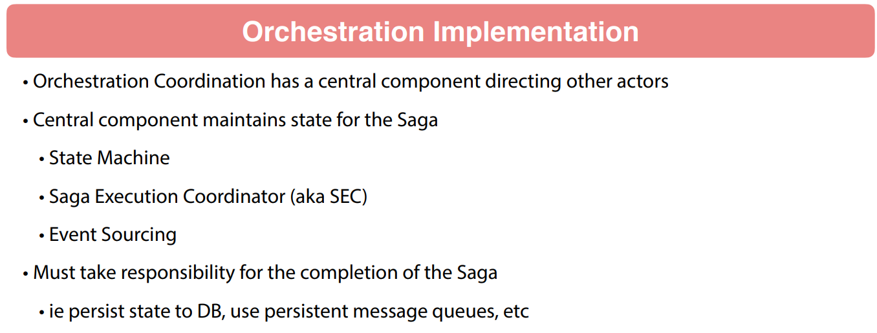

Another way is events sourcing. So these are different techniques but the primary takeaway of this is you need to realize that the orchestration implementation is gonna be maintaining state of the Saga and it also takes responsibility for the completion of the Saga. So that's gonna be the primary component that needs to make sure that is complete that Saga does in fact complete. Typically you're gonna see the Saga being persisted to a database. You'll be using things like persistent message cues to make sure that messages aren't getting lost. So you're gonna take a little more responsibility for completing that orchestration. Make sure that that Saga does in fact get completed.

Now which to use, this is a fairly common question. Choreography is gonna be ideal for smaller and more simple Sagas. So very very few steps. Ideal use case for choreography where you don't have a lot of moving parts. Orchestration coordination, that is gonna be more for larger and complex Sagas. Implementation, right now typically organizations are doing custom solutions so that they're writing the code. So these are design patterns and concepts that we are talking about as to how to implement these. And there's a wide variety of ways of going about this. There's a lot of opinions in here. I'm sure people say we'll be coming back on this video and saying you're wrong about this. So-and-so is doing this way when you say right now there's a lot of opinions around this.

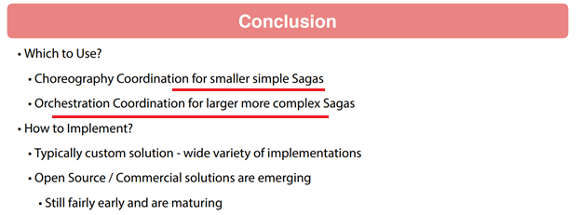

A lot of different ways to implement coordination of Sagas. There are emerging open source and commercial solutions. These are showing some promise. They do look pretty interesting but my take right now is that it's still pretty early and these products are maturing. So the state of the industry for implementing Sagas I'm seeing mostly custom solutions. You do have some very pioneering shops out there that do have larger and more complicated solutions of how they implement things and they found things that work well for their shops. As an industry overall, I'm not seeing any centralized one best practice or best of breed system emerging. Five years down the road, I expect the situation to change because this is a something that is still early and also maturing so a lot of interesting stuff around this. But from this video the main takeaways I wanted to have is to understand the two different types. These are the design patterns that we can use for coordinating a Saga of microservices. So Choreography is gonna be distributed logic where each component is gonna be required to make the next step. Orchestration, you're gonna have a centralized component maintaining state and that is going to be directing the actions of other components within the Saga.

### Order Allocation SAGA

We are gonna be talking about setting up an Order Allocation Saga. So order allocation is the process of assigning inventory to an order. So if you ever worked with the e-commerce type system, this is a pretty common situation. Actually I used to work with the warehouse management system so order allocation itself can become a rather complex topic. Here we're gonna take a very simplified look at order allocation and we wanna use this as an example.

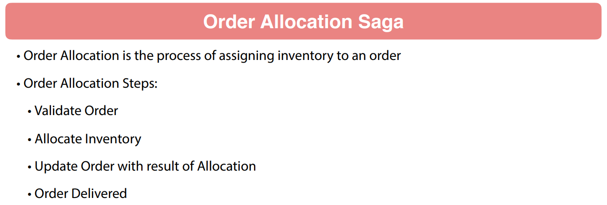

A realistic example to work through a Saga. So if you think about allocating an order the first thing you wanna do is make sure that you have a valid order. Is everything properly formed on that order. Can we proceed with allocation. Then to allocate the inventory, they need to actually make a request to allocate that inventory to the order from the Inventory Service and then we need to update the order with the result of that allocation and at some point that orders are going to go to a delivered status. So that means while we are working on the order so we have the order the customer is asking for it. We need to make sure that's got inventory and then when it is ready the customer can pick it up and that's where it goes delivered and then our little Beer Service is gonna say that order is now gone for the system and now complete the order essentially. So we think about the allocation steps that we need to set up with our Beer Service example.

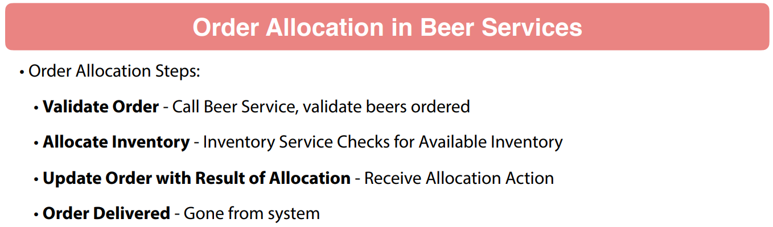

We want to be able to call the Beer Service. Make sure that we have valid beers on the order itself. And then we wanna go through and assign inventory to each of those beers that have been requested on the order and then we wanna update the order with the result of the allocation action. And then finally we wanna allow that order to go delivered meaning that the order is gone from the system. We're not actually gonna delete the order but we wanna change it to the status indicating that order has been completely fulfilled.

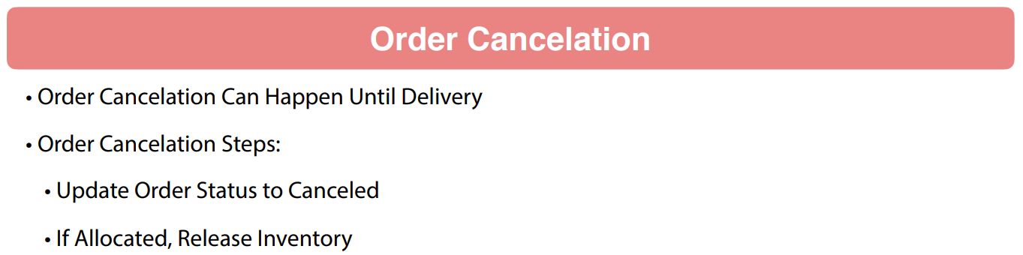

Now the one thing that we wa wanna to be able to do also is allow our customers to cancel the order. So we're gonna say that order cancellation can happen up until delivery. So if you think through the process while our a little virtual breweries processing the order, the customer could call up and say hey I wanna cancel this order and this is gonna allow the system to undo that orders to take it to Cenceled status. So up until the point that we have delivered it we will allow order cancellation to happen and if it's been allocated Of course we need to say hey we need to release that inventory back into the system. So what we need to do is set up a Orchestration Saga. So we've been talking about Sagas in the section of course. And this is going to help us coordinate the sequence of steps with the microservices to perform order allocations. So we wanna accommodate the so-called 'happy path'.

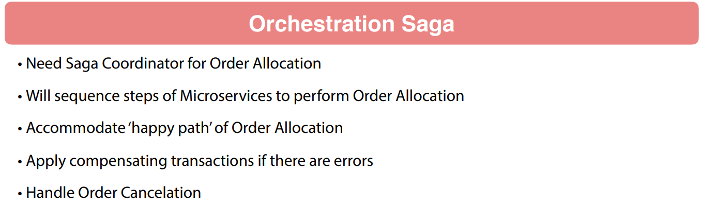

So we have a valid order, we have inventory, customer picks it up no things bad happen but also we wanna apply compensating transactions. So, if there's any problems and we wanna be able to handle an order cancellations giving that capability to the customer to cancel the order. So to help you visualize what's gonna happen is we'll have a new order come in and then we wanna have a step to go and validate that order. This is where we wanna go and call out to the Inventory Service. Now we'll have a Validated Order or we might have a Validation Exception. So we need to handle both of those.

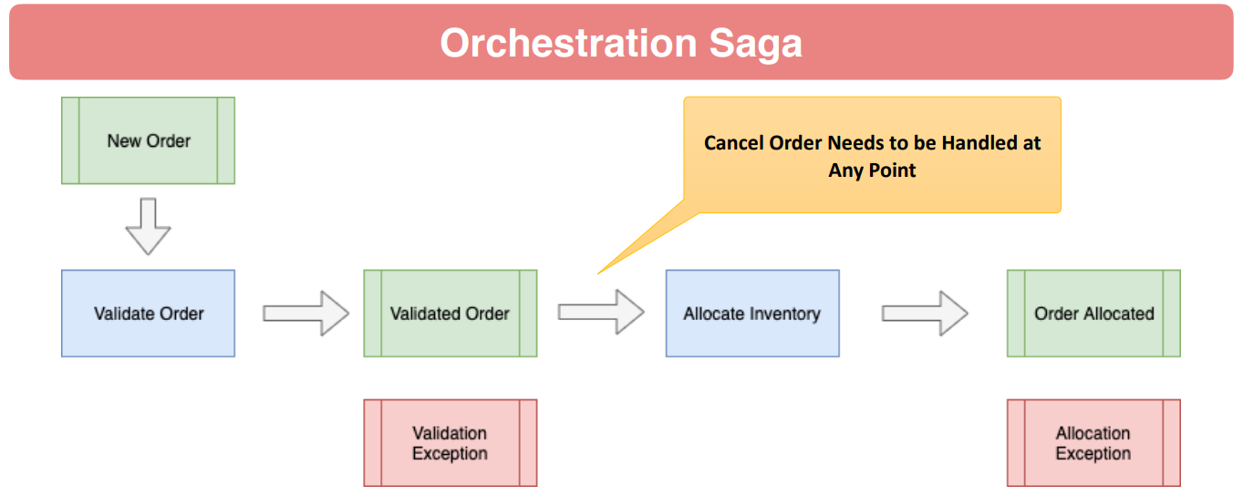

But in the happy path we have a Validated Order and then we wanna go allocate inventory to it. Now we have happy path to be the order becomes allocated. We might have an Allocation Exception to deal with. So we need to handle that as well in our Saga coordinator. And you can see the call out that I have there. We need to handle Cancel Order at any point. So as we're processing the order allocation, we need to handle the cancel order. Now the Saga Execution Coordinator, we're gonna implement those using Spring State Machine.

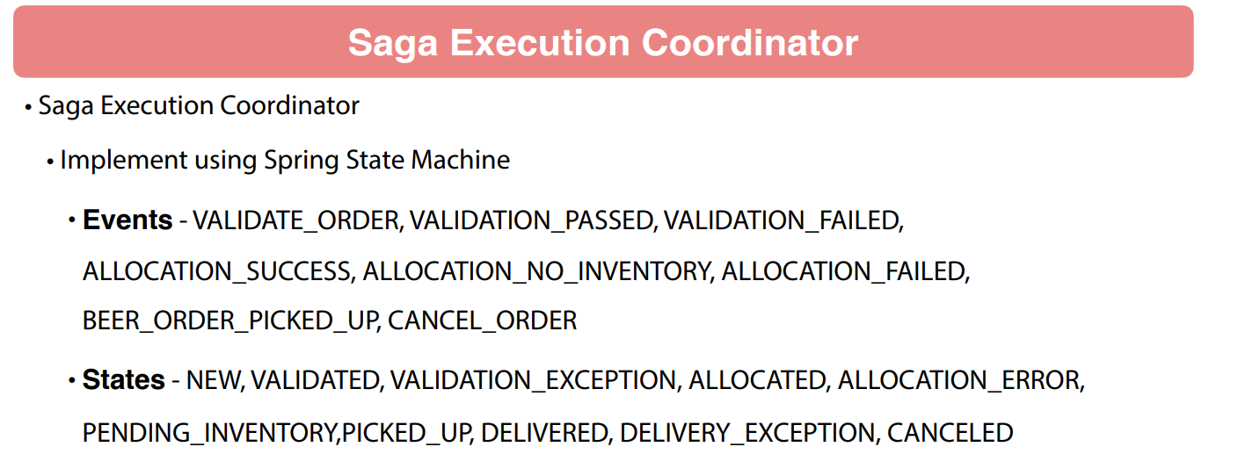

This is gonna go out and validate the order. That's gonna be VALIDATION_PASSED or VALIDATION_FAILED Now we wanna say we have an ALLOCATION_SUCCESS, ALLOCATION_NO_INVENTORY, ALLOCATION_FAILED, BEER_ORDER_PICKED_UP or CANEL_ORDER. So these are different events that we wanna be able to handle. And then the order itself is gonna go through the following states NEW, VALIDATED. We'll have a VALIDATION_EXCEPTION indicating that there is a problem with validation. We'll have ALLOCATED meaning that the order was allocated successfully and ALLOCATION_ERROR or we're gonna throw a caveat on there allowed to go to PENDING_INVENTORY saying that we're gonna brew more beer and fulfill this order so we're allowed to go to a PENDING_INVENTORY status and then we also wanna have PICKED_UP, DELIVERED, DELIVERY_EXCEPTION and CANCELED. So these are some of the states that order can work through. So we're trying to set up a realistic state, a process where we are taking an orders. Order course will be brand new and then go hopefully go validated, allocated, delivered so that that is very very simple process that we wanna go through of allowing our Saga Execution Coordinator go through that and you can see I'm hoping you're able start envisioning the compensating transaction so if something happens if we get like ALLOCATION_FAILED event, we wanna be able to handle that properly with our Saga coordinator. And what I'd like to do right now is start thinking about how we have these three different microservices involved. We have the Order Service, Beer Service and the Inventory Service. We're gonna need to use the tools that we're working with so far in the course. So we wanna build how that Saga coordinator worked with the other microservices and coordinate the execution of allocating an order for our customers.

### State Machine Enumerations

We're gonna go through and start configuring the Spring State Machine for our order allocation Saga. So one of the first things that we need to do is set up the enumeration that we are gonna use for both state and events. I'm gonna toggle over to ontology and start working on that now. So inside of Intellij, I've got the BeerOrder up and we have the OrderStatusEnum and let's go take a look at that. We're gonna refactor this. And the first thing I wanna do is I'm just gonna change the name of it so it's a little more consistent. So I'm gonna come in here I'm doing a right-click I'm gonna click on Refactor and Rename BeerOrderStatusEnum. I'm gonna hit enter and Intellij went through into the refactoring for us and you can see through the refactoring of IntelliJ it automatically changed the instance in BeerOrder. So this is not also got changed in the refactoring. So now let's go ahead and update this. So we still want a NEW and see here we'll do VALIDATED. So this is when we've called the validation or called the Inventory Service and Beer Service made sure that it is a valid order. Now I misspoke. We're only gonna be calling the Beer Service on that and that can come back with an error. So that would be a VALIDATION_EXCEPTION. And then once we call the Inventory Service it will go ALLOCATED but if that errors out, that'll be an ALLOCATION_EXCEPTION. And then remember we also wanna do PENDING_INVENTORY. So there's a situation where we're good but we're waiting for brewing to complete. So we have more inventory to sign to that order. And I don't think we're gonna need ready any more so that would be kind of the equivalent of allocated. So I'm gonna get rid of that and do PICKED_UP not sure if we're gonna need that or not. We will we refactor if we do. And we also want DELIVERED.

public enum BeerOrderStatusEnum {

NEW, VALIDATED, VALIDATION_PENDING, VALIDATION_EXCEPTION,

ALLOCATION_PENDING, ALLOCATED, ALLOCATION_EXCEPTION, CANCELLED,

PENDING_INVENTORY, PICKED_UP, DELIVERED, DELIVERY_EXCEPTION

}

And then also do a DELIVERY_EXCEPTION and we may refactor that and that takes care of the statuses. And now because we're bringing it's Spring state machine we wanna handle events. So let's come in here. Create a new Java class call it BeerOrderEvents. Now some of the events that we wanna do is we're gonna have a validation command. So that's gonna be to validate your order. Next we say VALIDATION_PASSED or VALIDATION_FAILED So that's one of the two things that can come out of validation. Then we have ALLOCATION_SUCCESS, ALLOCATION_NO_INVENTORY or ALLOCATION_FAILED.

public enum BeerOrderEventEnum {

VALIDATE_ORDER, CANCEL_ORDER, VALIDATION_PASSED, VALIDATION_FAILED,

ALLOCATE_ORDER, ALLOCATION_SUCCESS, ALLOCATION_NO_INVENTORY, ALLOCATION_FAILED,

BEERORDER_PICKED_UP

}

So we can have a situation where we don't have any inventory or a failure in allocation some type of error condition happen. And then finally beer order picked up. A typo here let's fix that. And then looking at this you might be wondering why we don't have an allocation of that and really the way that this logic is gonna work is the VALIDATION_PASSED that is gonna be the event that we're tapping into actually do the allocation so we don't need a allocation event to trigger that. So our state machine will be able to run off of that. So optionally we we could air quotes through a allocation event. That would be one way to do it really neither neither is right or wrong. But that's that's the way we proceed here. You might prefer to actually include an allocation of that, that is up to you. But in this case I'm gonna use VALIDATION_PASSED as the event to trigger the allocation process because that's the next step in the sequence of events. I just think it's a little cleaner coded that way. You might think it's a to take the VALIDATION_PASSED and then throw and allocate order event. So that would be an another way of doing it. Arguably a little bit cleaner but I'm gonna proceed down this way. So now complete the task of setting up these two enumeration for Spring state machine and that was for Issue #15. And I'll commit against that issue and close out this issue for this lesson.

### Configure State Machine States

We are going to Setup the Allocation State Machine States. So that's kind of a twisted mouthful to say and basically we need to initialize the state machine configuration with what states are valid for the state machine to transition through. So I'm gonna toggle over it IntelliJ and start setting that up. So the first thing I wanna do is come in here and I'm gonna create a new package for the state machine code. I'm just gonna say Package and simply call that sm for state machine and now let's come up here and we'll start off with a New Java Class say that BeerOrderStateMachineConfig like so and we will be adding that to Git and remember this is gonna extend out the StateMachineConfigureAdapter and that is gonna take in the BeerOrderStatusEnum and the BeerOrderEventEnum so that initializes that and let's come in and add and make this a configuration component and we wanna enable state machine factory. Now one of the first things that we wanna do is come in here and I'm gonna override one of the methods and that is the StateMachineStateConfigure. So that's kind of a mouthful to say but that is the method that we wanna override to start setting things up so go ahead and select that and what we wanna do is states.withStates() do initial and the initial state will be NEW in the states that's gonna be EnumSet that's gonna be the BeerOrderStatusEnum class. Now this is gonna have several terminal states that we need to set and an end state is going to be and that will be DELIVERED if we have a DELIVERY_EXCEPTION that is also gonna be status and then end state would be an allocation. Let's do VALIDATION_EXCEPTION first.

package com.shop.orders.statemachine.config;

import java.util.EnumSet;

import org.springframework.context.annotation.Configuration;

import org.springframework.statemachine.config.EnableStateMachineFactory;

import org.springframework.statemachine.config.StateMachineConfigurerAdapter;

import org.springframework.statemachine.config.builders.StateMachineStateConfigurer;

import org.springframework.statemachine.config.builders.StateMachineTransitionConfigurer;

import com.shop.orders.statemachine.domain.BeerOrderEventEnum;

import com.shop.orders.statemachine.domain.BeerOrderStatusEnum;

import lombok.RequiredArgsConstructor;

@RequiredArgsConstructor

@Configuration

@EnableStateMachineFactory

public class BeerOrderStateMachineConfig extends StateMachineConfigurerAdapter<BeerOrderStatusEnum, BeerOrderEventEnum> {

@Override

public void configure( StateMachineStateConfigurer<BeerOrderStatusEnum,

BeerOrderEventEnum> states) throws Exception {

states.withStates()

.initial(BeerOrderStatusEnum.NEW)

.states(EnumSet.allOf(BeerOrderStatusEnum.class))

.end(BeerOrderStatusEnum.PICKED_UP)

.end(BeerOrderStatusEnum.DELIVERED)

.end(BeerOrderStatusEnum.CANCELLED)

.end(BeerOrderStatusEnum.DELIVERY_EXCEPTION)

.end(BeerOrderStatusEnum.VALIDATION_EXCEPTION)

.end(BeerOrderStatusEnum.ALLOCATION_EXCEPTION);

}

}

So if it fails validation we're not gonna go any further with it. And then also an end state is gonna be ALLOCATION_EXCEPTION. So if it fails either one of those obviously that is these are all gonna be terminal states of it and let's see here I think we also have PICKED_UP also. PICKED_UP would also be a terminal state. So this sets up the states for the Spring state machine configuration. So while we're saying in this we're gonna have our initial state of NEW. Then the states on line 23 this gives it all the range of states. So that's basically a set of states from the BeerOrderStatusEnum and then these several terminal states when it reaches one of these states that it considers a terminal state. So the state machine no longer progresses and I double check that issue number. So that goes against this issue #16. I'll commit into GitHub so you can see all the changes against this issue and that completes this lesson.

**Skipped Video Lesson 224: Fix CI Build Failure**

### Refactor Model to Common Package

We need to do a little bit of refactoring here. I'm gonna say in this video we are going to be refactoring the model to a common package. So by model I mean objects that we're exposing as JSON. So things that we're gonna be sending out as JSON then bring them back in. And the problem that we're facing is we're handling some automation inside of Spring to automatically serialize and de-serialize objects especially in JMS. So Spring makes it very easy for us as Spring developers. We could address this with additional Jackson configuration but I'm doing this to make our lives a little bit easier to refactor to a common package. And this is actually something that you see quite frequently in organizations that have a common set of microservices. Some java shops will actually publish that model as a separate project and then the various services will bring those in as a dependency so that there's a number of different ways about that.

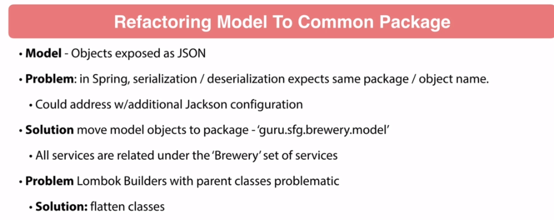

I'm a little hesitant to do that because the purists say that the micro ervices should be completely independent. I could go either way on that one. I'm not gonna die on that hill for that argument but here I'm just making our lives easier as we go forward in the class. So what we wanna do is move all our model objects to the package guru.sfg.brewery.model because all the set of services that we're working under is all under a brewery. So we wanna set that up. And then the other thing I've been seeing in these Lombok builders with parent classes doing that builder to a superclass. That's a little problematic if you go out and search that that has been a thorn in the side of Lombok for a long time and I'm seeing some oddness in that and that kind of threw me some problems so I know people working through the class are definitely gonna encounter this. So I'm just gonna get rid of some of that inheritance. And I'm gonna go through and refactor that now in this video. We'll go through and refactor our three three services to use one common package for all the objects that we are sharing amongst each other that's gonna make our lives easier. That's main reason I'm doing it. We did it some with two of the services but now we're dealing with the Order Service and that also needs refactoring. So just gonna make our lives easier and do the refactoring now and doing it as a separate video because I wanna explain the logic behind doing it and why we're doing it and the problems that we're facing. So I'm gonna jump over to IntelliJ and take care of that now. Okay you can see up on the screen here I have the beer-service up here and that is to refactor the model to a common package. So let me toggle over to IntelliJ and start working on that now. And that's here's the beer-service and let me expand this out. So in this service we already did sfg.common.events. But here let me go ahead and create a new package here so that's the new package that we wanna move over. And here I'm just gonna see here and I just wanna do events take a look at these here. We got a BeerDto and actually we can move these two. So we've got services model so these types are gonna move along with it. So we'll come over here to model like so do the Refactor and then this package actually goes away so I believe that changes setting here I actually wanna take these events into model events. I'm just gonna drag this up to model like so. So IntelliJ does make it pretty easy to do the refactoring here. So now a common has gone so now I have model. And then the events. So I got the events in a separate package so that's kind of pattern that I would be following here. I think that's gonna be a lot cleaner implementation across three different services. Now common is done. So you delete him and let's come down here to your service. I'm gonna do a clean when you do stuff like this when you're doing major refactoring like this always do a clean that will definitely bite you. Make sure that everything compiles. That looks good. So I'm gonna go and package which will force it to package everything up and running tests that we have in here. And that's happening. Let's double check this issue number that is #46 Okay, so we've got a successful built on the beer-service. I'm gonna go ahead and commit that Now it is #46, I'll double check that. Yes, #46 Commit and push that. And that will close up that issue and then for inventory-service is #10. We're here to inventory-service. Let's go and Close All. So here we wanna create that package again where I have that. And I see that we already actually have this and I believe what happened as one I've refactored the other service, IntelliJ also refactor this service. So kind of having everything in one project it looks like IntelliJ pick that up for us. So unintended or unintended feature. So I'm gonna double check. We do have some components out here on the service model so I'm gonna take that BeerInventoryDto and also move that down to the model. So and I'm just gonna go ahead and do the refactor and that model package will go away. I'm gonna delete that. And this common package also can go away so delete that. Now collapse this for the beer-inventory-service. Let's do a clean on that. Like I said when you do a refactoring like this it's always good to do a clean and then let's go ahead and we just need to package. Make sure everything goes okay on this. Well that's building, let me toggle over that is #10. So that did pass. So I'm gonna commit that up to GitHub and we will Commit and Push that so that it's closed and then refactor the beer-order-service so this #20. Let's come back over here, expand this out a little bit and we can collapse the inventory-service and let's go in. Now we have beer brewery model events and under here we have web and everything out of model we want that to be brought under model like so. So I'm gonna refactor to that. Do that refactor and this looks okay. Double check this. That is okay. Let's go ahead and refactor this BaseItem here so I wanna get rid of that. So this is gonna be properties just flatten that. So I've seen some problems with that. So that's gonna replace all of this basically Customer take that in we want to add in that. We don't need that anymore. And get rid of that extension like so Don't need that. But we do need @Builder. We need to do for this one too. I think that's gonna get us set up pretty good. Let's see here OrderStatusUpdate also uses that BaseItem so I'll replace him. See if that is used anymore that is not. So I'm just gonna go ahead and delete that BaseItem. Okay so I think that does everything for the beer-order-service. We can get rid of that package as well. Go ahead and do a clean on this. Okay, so when we're refactoring stuff like this you definitely wanna be doing that clean. Let's take this through a package step and make sure that all our tests are running properly and if everything passes we will go ahead and commit. That was I think 20 yes #20 I'm gonna go back to Compact Middle Packages that's a lot cleaner in my opinion. So I did pass properly so let's go ahead and commit that. That closes out issue #20 So a lot of refactoring was done in this video as far as the model files you can see how using IntelliJ made it a lot less painful as we moved stuff between packages and it's pretty much name the package drag and drop and then IntelliJ went in and updated the source code. So if you go in and look at the commits behind this. A number of classses changed because these are fairly common classes across our entire project for all three microservices. But now that we have those objects in common package, that's gonna make her our lives a lot easier going forward in this project.

### Pattern Implementations

#### Saga Pattern

To demonstrate the use of distributed transactions, we’ll take an example of a railway seat reservation system implemented with microservice architecture. There is a microservice to block the seats, one that accepts payment and another one that allocates the booked seat. Each of these microservices performs a local transaction to implement the individual functionalities:

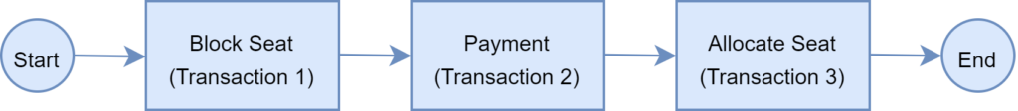

To ensure a successful ticket booking, all three microservices must complete the individual local transactions. If any of the microservice fails to complete its local transaction, all of the completed preceding transactions should roll back to ensure data integrity. This is an example of a distributed transaction as the transaction boundary crosses multiple services and databases.

Challenges of Distributed Transaction

In the previous section, we’ve provided a real-life example of a distributed transaction. Distributed transactions in a microservice architecture pose two key challenges.

The first one is maintaining ACID. To ensure the correctness of a transaction, it must be atomic, consistent, isolated, and durable (ACID). The atomicity ensures that all or none of the steps of a transaction should complete. The consistency takes data from one valid state to another valid state. Isolation guarantees that concurrent transactions should produce the same result that sequentially transactions would have produced. Lastly, durability means that committed transactions remain committed irrespective of any type of system failure. In a distributed transaction scenario, as the transaction spans across several services, it always remains a key concern to ensure ACID.

The second one is managing the transaction isolation level. It specifies the amount of data that is visible in a transaction when the other services access the same data simultaneously. In other words, if one object in one of the microservice is persisted in the database while another request reads the data, should the service return the old or new data?

Understanding Two-Phase Commit

The two-phase commit protocol (2PC) a widely used pattern to implement distributed transactions. We can use this pattern in a microservice architecture to implement distributed transactions.

In a two-phase commit protocol, there is a coordinator component that is responsible for controlling the transaction and contains the logic to manage the transaction. The other component is the participating nodes (e.g., the microservices) that execute their local transactions:

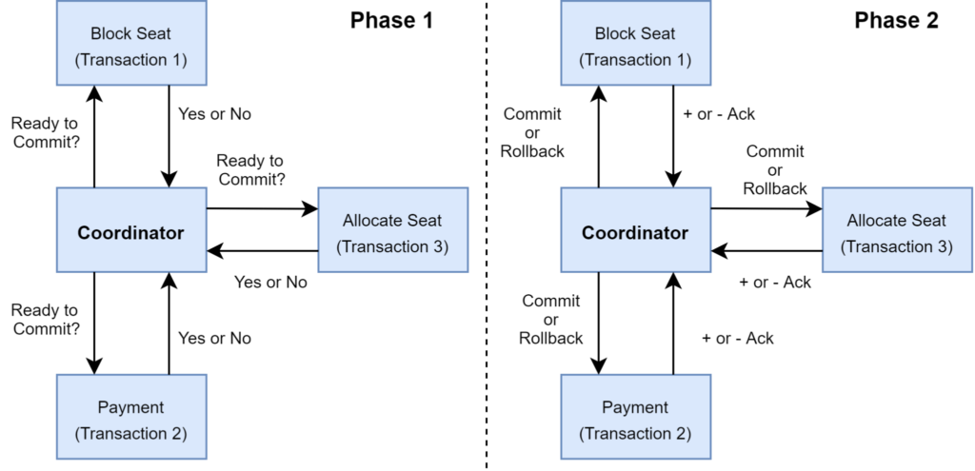

As the name indicates, the two-phase commit protocol executes a distributed transaction in two phases:

1. Prepare Phase: The coordinator asks the participating nodes whether they are ready to commit the transaction. The participants returned with a yes or no
2. Commit Phase: If all the participating node responds affirmatively in phase 1, then the coordinator asks all of them to commit. If at least one node returns negative, the coordinator asks all participants to roll back their local transactions

Problems with 2PC

Although 2PC is useful a means to implement a distributed transaction, it has the following shortcomings:

* The onus of the transaction is on the coordinator node, and it can become the single point of failure
* All other services need to wait until the slowest service finishes its confirmation. Thus, the overall performance of the transaction is bound by the slowest service
* The two-phase commit protocol is slow by design due to the chattiness and dependency on the coordinator. Thus, it can lead to scalability and performance issue in a microservice-based architecture involving multiple services
* Two-phase commit protocol is not supported in NoSQL databases. Thus, in a microservice architecture where one or more services use NoSQL databases, a two-phase commit cannot be applied

What Is Saga Architecture Pattern?

The Saga architecture pattern provides transaction management using a sequence of local transactions. A local transaction is the unit-of-work performed by a saga participant. Every operation that is part of the Saga can be rolled back by a compensating transaction. Further, the Saga pattern guarantees that either all operations complete successfully or the corresponding compensation transactions are run to undo the work previously completed.

In the Saga pattern, a compensating transaction must be idempotent and retryable. These two principles ensure that a transaction can be managed without any manual intervention. The Saga Execution Coordinator (SEC) ensures guarantees these principles:

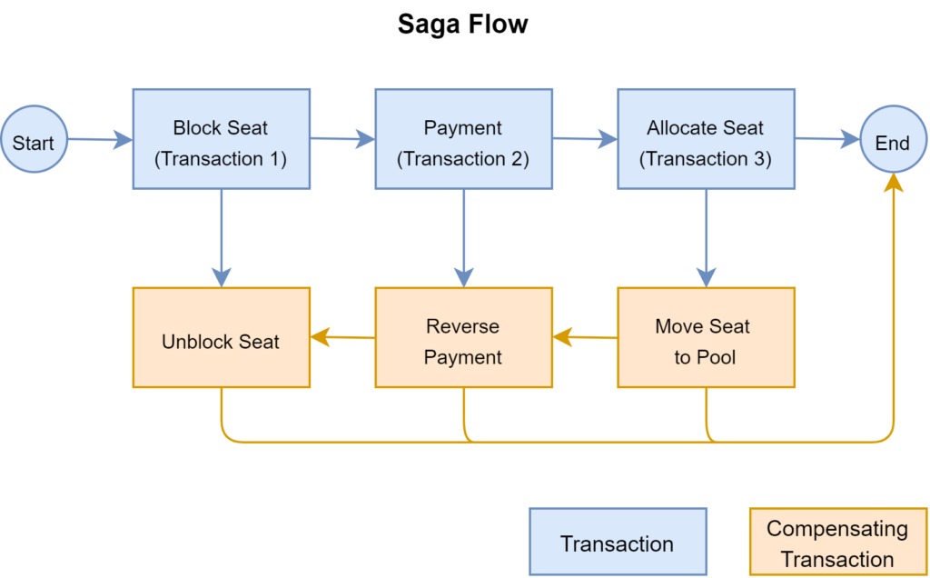

The above diagram shows how to visualize the Saga pattern for the previously discussed railway ticket booking scenario.

The Saga Execution Coordinator

The Saga Execution Coordinator is the central component to implement a Saga flow. It contains a Saga log that captures the sequence of events of a distributed transaction. For any failure, the SEC component inspects the Saga log to identify the components impacted and the sequence in which the compensating transactions should execute.

For any failure in the SEC component, it can read the Saga log once it’s coming back up. It can then identify the transactions successfully rolled back, which ones are pending, and can take appropriate actions:

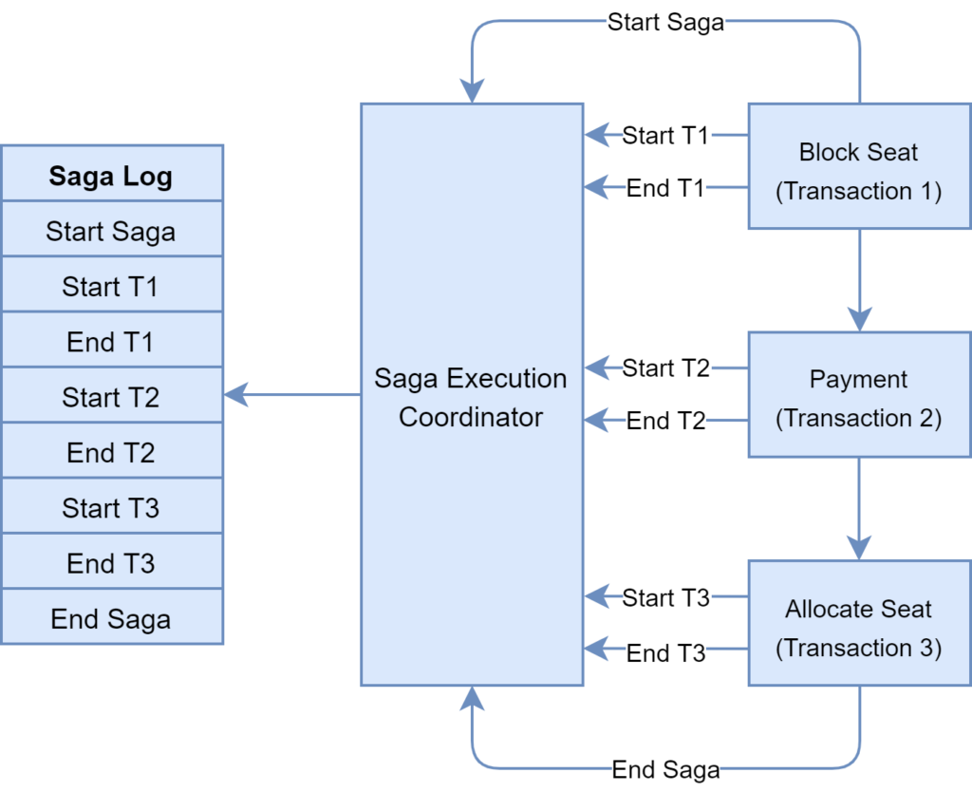

There are two approaches to implement the Saga pattern: choreography and orchestration. Let’s discuss them in the next sections.

Implementing Saga Choreography Pattern

In the Saga Choreography pattern, each microservices that is part of the transaction publishes an event that is processed by the next microservice. To use this pattern, one needs to make a decision whether the microservice will part of the Saga. Accordingly, the microservice needs to use the appropriate framework to implement Saga. In this pattern, the Saga Execution Coordinator is either embedded within the microservice or can be a standalone component.

In the Saga, choreography flow is successful if all the microservices complete their local transaction and there is no failure reported by any of the microservice. The following diagram demonstrates the successful Saga flow for the booking application:

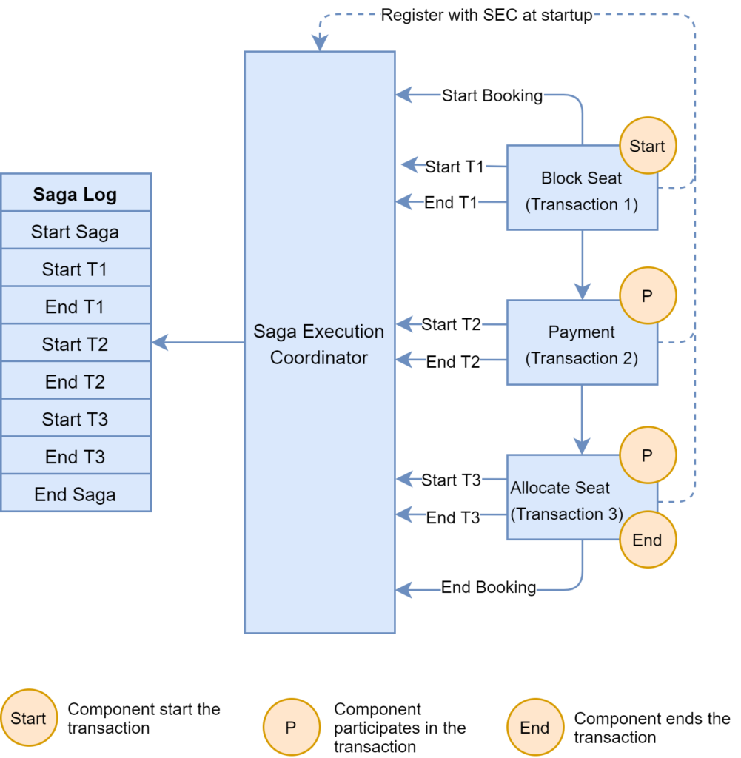

In the event of a failure, the microservice reports the failure to SEC, and it is the responsibility of the SEC to invoke the relevant compensation transactions:

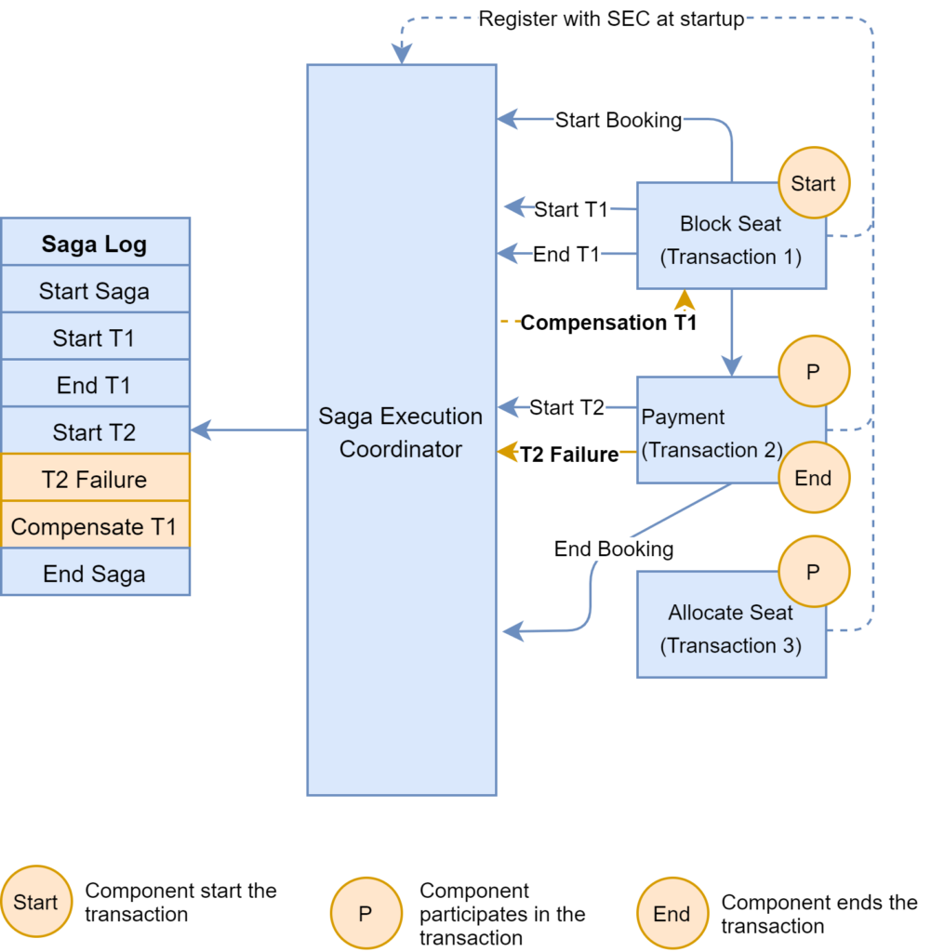

In this example, the Payment microservice reports a failure, and the SEC invokes the compensating transaction to unblock the seat. If the call to the compensating transaction fails, it is the responsibility of the SEC to retry it until it is successfully completed. Recall that in Saga, a compensating transaction must be idempotent and retryable.

* The Choreography pattern is suitable for greenfield microservice application development. Also, this pattern is suitable when there is a fewer participant in the transaction.

Following are a few frameworks available to implement the choreography pattern:

Axon Saga: A lightweight framework and widely used with Spring Boot based microservices

Eclipse MicroProfile LRA: Implementation of distributed transactions in Saga for HTTP transport based on REST principles

Eventuate Tram Saga: Saga orchestration framework for Spring Boot and Micronaut based microservices

Seata: Open source distributed transaction framework with high-performance and easy-to-use distributed transaction services

Implementing Saga Orchestration Pattern

In the Orchestration pattern, a single orchestrator is responsible for managing the overall transaction status. If any of the microservice encounters a failure, then the orchestrator is responsible for invoking the necessary compensating transactions:

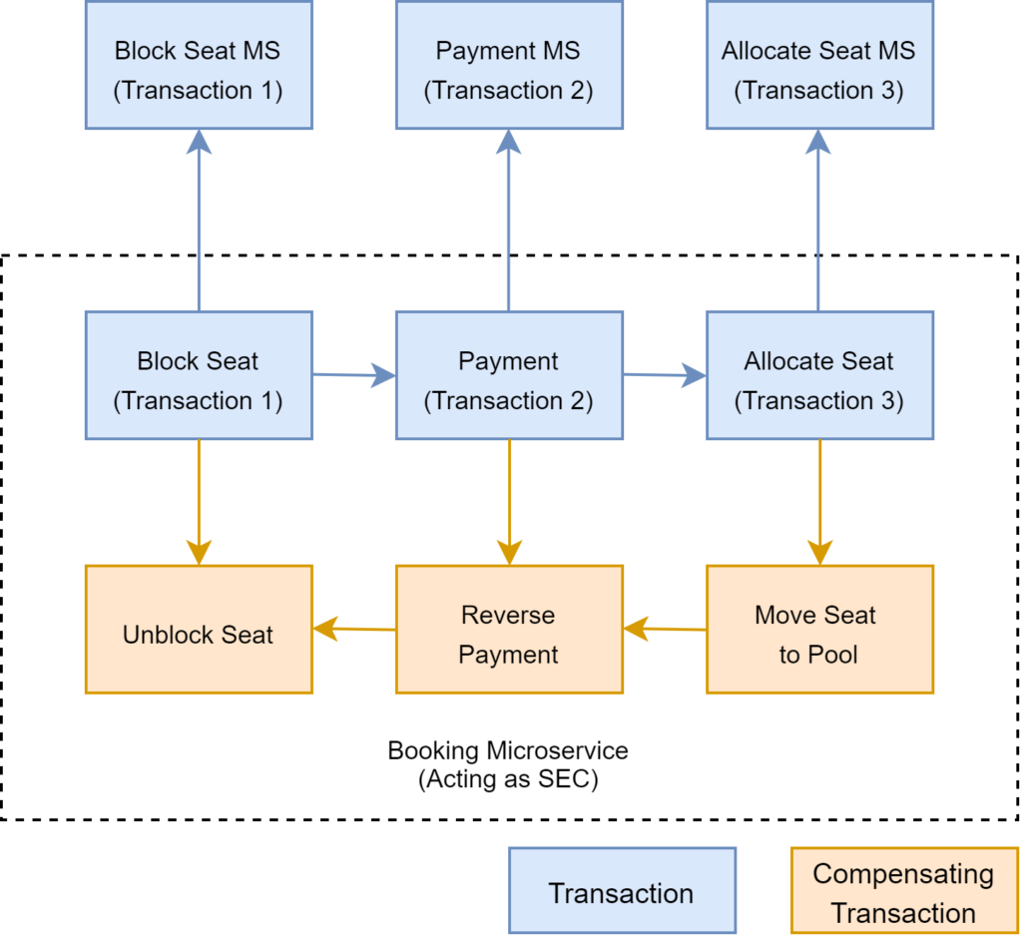

* The Saga orchestration pattern is useful for brownfield microservice application development architecture. In other words, this pattern is suitable if we already have a set of microservices and would like to implement the Saga pattern in the application. We need to define the appropriate compensating transactions to proceed with this pattern.

Following are a few frameworks available to implement the orchestrator pattern:

Camunda: This is a Java-based framework that supports Business Process Model and Notation (BPMN) standard for workflow and process automation.

Apache Camel: Provides the implementation for Saga Enterprise Integration Pattern (EIP)

#### Orchestration - Spring Boot + Kafka

<https://www.vinsguru.com/architectural-pattern-orchestration-saga-pattern-implementation-using-kafka/>

Let’s assume that our business rule says, when an user places an order, order will be fulfilled if the product’s price is within the user’s credit limit/balance & the inventory is available for the product. Otherwise it will not be fulfilled. It looks really simple. This is very easy to implement in a monolith application. The entire workflow can be considered as 1 single transaction. It is easy to commit / rollback when everything is in a single DB. With distributed systems with multiple databases, It is going to be very complex! Lets look at our architecture first to see how to implement this.

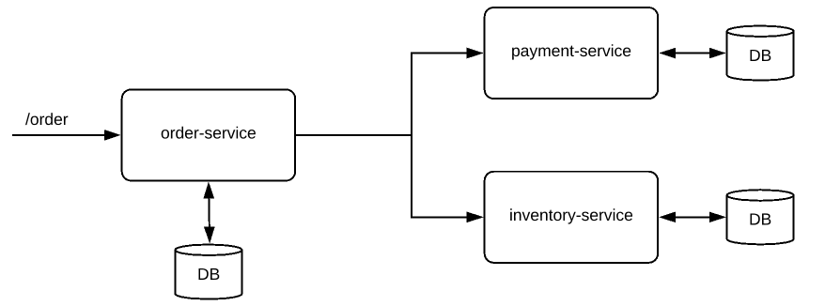

We have below microservices with its own DB.

* order-service
* payment-service
* inventory-service

When the order-service receives the request for the new order, It has to check with the payment-service & inventory-service. We deduct the payment, inventory and fulfill the order finally! What will happen if we deducted payment but if inventory is not available? How to roll back? It is difficult with multiple databases involved.

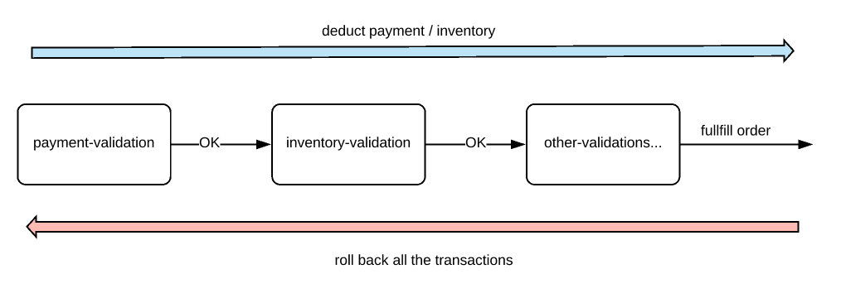

Saga Pattern:

Each business transaction which spans multiple microservices are split into micro-service specific local transactions and they are executed in a sequence to complete the business workflow. It is called Saga. It can be implemented in 2 ways.

Choreography approach

Orchestration approach

In this article, we will be discussing the Orchestration based saga. For more information on Choreography based saga, check here.

**Orchestration:**

In this pattern, we will have an orchestrator, a separate service, which will be coordinating all the transactions among all the microservices. If things are fine, it makes the order-request as complete, otherwise marks that as cancelled.

Lets see how we could implement this. Our sample architecture will be more or less like this.!

In this demo, communication between orchestrator and other services would be a simple HTTP in a non-blocking asynchronous way to make this stateless.

We can also use Kafka topics for this communication. For that we have to use scatter/gather pattern which is more of a stateful style.

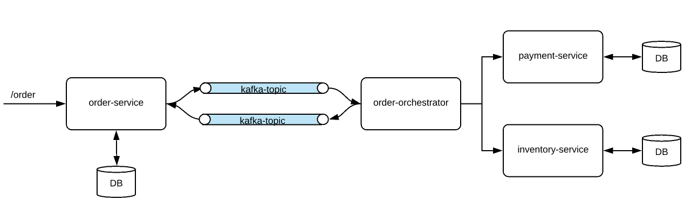

Common DTOs:

First I create a Spring boot multi module maven project as shown below.

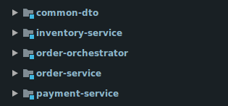

I create common DTOs/models which will be used across all the microservices. (I would suggest you to follow this approach for DTOs)

##### Inventory Service:

Each microservice which will be coordinated by orchestrator is expected to have at least 2 endpoints for each entity! One is deducting and other one is for resetting the transaction. For example. if we deduct inventory first and then later when we come to know that insufficient balance from payment system, we need to add the inventory back.

Note: I used a map as a DB to hold some inventory for few product IDs.

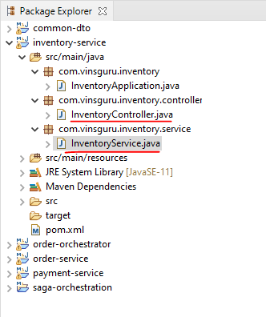

**InventoryService.java**

import com.vinsguru.dto.InventoryRequestDTO;

import com.vinsguru.dto.InventoryResponseDTO;

import com.vinsguru.enums.InventoryStatus;

import org.springframework.stereotype.Service;

import javax.annotation.PostConstruct;

import java.util.HashMap;

import java.util.Map;

@Service

public class InventoryService {

private Map<Integer, Integer> productInventoryMap;

@PostConstruct

private void init(){

this.productInventoryMap = new HashMap<>();

this.productInventoryMap.put(1, 5);

this.productInventoryMap.put(2, 5);

this.productInventoryMap.put(3, 5);

}

public InventoryResponseDTO deductInventory(final InventoryRequestDTO requestDTO){

int quantity = this.productInventoryMap.getOrDefault(requestDTO.getProductId(), 0);

InventoryResponseDTO responseDTO = new InventoryResponseDTO();

responseDTO.setOrderId(requestDTO.getOrderId());

responseDTO.setUserId(requestDTO.getUserId());

responseDTO.setProductId(requestDTO.getProductId());

responseDTO.setStatus(InventoryStatus.UNAVAILABLE);

if(quantity > 0){

responseDTO.setStatus(InventoryStatus.AVAILABLE);

this.productInventoryMap.put(requestDTO.getProductId(), quantity - 1);

}

return responseDTO;

}

public void addInventory(final InventoryRequestDTO requestDTO){

this.productInventoryMap

.computeIfPresent(requestDTO.getProductId(), (k, v) -> v + 1);

}

}

**InventoryController.java**

import com.vinsguru.dto.InventoryRequestDTO;

import com.vinsguru.dto.InventoryResponseDTO;

import com.vinsguru.inventory.service.InventoryService;

import org.springframework.beans.factory.annotation.Autowired;

import org.springframework.web.bind.annotation.PostMapping;

import org.springframework.web.bind.annotation.RequestBody;

import org.springframework.web.bind.annotation.RequestMapping;

import org.springframework.web.bind.annotation.RestController;

@RestController

@RequestMapping("inventory")

public class InventoryController {

@Autowired

private InventoryService service;

@PostMapping("/deduct")

public InventoryResponseDTO deduct(@RequestBody final InventoryRequestDTO requestDTO){

return this.service.deductInventory(requestDTO);

}

@PostMapping("/add")

public void add(@RequestBody final InventoryRequestDTO requestDTO){

this.service.addInventory(requestDTO);

}

}

**application.properties**

server.port=8081

**InventoryApplication.java**

import org.springframework.boot.SpringApplication;

import org.springframework.boot.autoconfigure.SpringBootApplication;

@SpringBootApplication

public class InventoryApplication {

public static void main(String[] args) {

SpringApplication.run(InventoryApplication.class, args);

}

}

**pom.xml**

<?xml version="1.0" encoding="UTF-8"?>

<project xmlns="http://maven.apache.org/POM/4.0.0"

xmlns:xsi="http://www.w3.org/2001/XMLSchema-instance"

xsi:schemaLocation="http://maven.apache.org/POM/4.0.0 http://maven.apache.org/xsd/maven-4.0.0.xsd">

<parent>

<artifactId>saga-orchestration</artifactId>

<groupId>com.vinsguru</groupId>

<version>0.0.1-SNAPSHOT</version>

</parent>

<modelVersion>4.0.0</modelVersion>

<artifactId>inventory-service</artifactId>

<dependencies>

<dependency>

<groupId>com.vinsguru</groupId>

<artifactId>common-dto</artifactId>

<version>0.0.1-SNAPSHOT</version>

</dependency>

</dependencies>

</project>

##### Payment Service

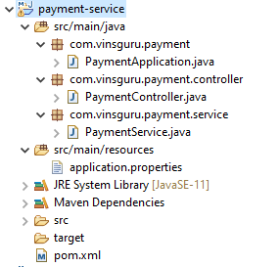

**PaymentService.java**

import com.vinsguru.dto.PaymentRequestDTO;

import com.vinsguru.dto.PaymentResponseDTO;

import com.vinsguru.enums.PaymentStatus;

import org.springframework.stereotype.Service;

import javax.annotation.PostConstruct;

import java.util.HashMap;

import java.util.Map;

@Service

public class PaymentService {

private Map<Integer, Double> userBalanceMap;

@PostConstruct

private void init(){

this.userBalanceMap = new HashMap<>();

this.userBalanceMap.put(1, 1000d);

this.userBalanceMap.put(2, 1000d);

this.userBalanceMap.put(3, 1000d);

}

public PaymentResponseDTO debit(final PaymentRequestDTO requestDTO) {

double balance = this.userBalanceMap.getOrDefault( requestDTO.getUserId(), 0d );

PaymentResponseDTO responseDTO = new PaymentResponseDTO();

responseDTO.setAmount( requestDTO.getAmount() );

responseDTO.setUserId( requestDTO.getUserId() );

responseDTO.setOrderId( requestDTO.getOrderId() );

responseDTO.setStatus( PaymentStatus.PAYMENT_REJECTED );

if(balance >= requestDTO.getAmount()){

responseDTO.setStatus( PaymentStatus.PAYMENT_APPROVED );

this.userBalanceMap.put( requestDTO.getUserId(), balance - requestDTO.getAmount() );

}

return responseDTO;

}

public void credit(final PaymentRequestDTO requestDTO) {

this.userBalanceMap.computeIfPresent( requestDTO.getUserId(),

(k, v) -> v + requestDTO.getAmount());

}

}

**PaymentController.java**

import com.vinsguru.dto.PaymentRequestDTO;

import com.vinsguru.dto.PaymentResponseDTO;

import com.vinsguru.payment.service.PaymentService;

import org.springframework.beans.factory.annotation.Autowired;

import org.springframework.web.bind.annotation.PostMapping;

import org.springframework.web.bind.annotation.RequestBody;

import org.springframework.web.bind.annotation.RequestMapping;

import org.springframework.web.bind.annotation.RestController;

@RestController

@RequestMapping("payment")

public class PaymentController {

@Autowired

private PaymentService service;

@PostMapping("/debit")

public PaymentResponseDTO debit(@RequestBody PaymentRequestDTO requestDTO){

return this.service.debit(requestDTO);

}

@PostMapping("/credit")

public void credit(@RequestBody PaymentRequestDTO requestDTO){

this.service.credit(requestDTO);

}

}

**PaymentApplication.java**

import org.springframework.boot.SpringApplication;

import org.springframework.boot.autoconfigure.SpringBootApplication;

@SpringBootApplication

public class PaymentApplication {

public static void main(String[] args) {

SpringApplication.run(PaymentApplication.class, args);

}

}

**application.properties**

server.port=8082

**pom.xml**

<?xml version="1.0" encoding="UTF-8"?>

<project xmlns="http://maven.apache.org/POM/4.0.0"

xmlns:xsi="http://www.w3.org/2001/XMLSchema-instance"

xsi:schemaLocation="http://maven.apache.org/POM/4.0.0 http://maven.apache.org/xsd/maven-4.0.0.xsd">

<parent>

<artifactId>saga-orchestration</artifactId>

<groupId>com.vinsguru</groupId>

<version>0.0.1-SNAPSHOT</version>

</parent>

<modelVersion>4.0.0</modelVersion>

<artifactId>payment-service</artifactId>

<dependencies>

<dependency>

<groupId>com.vinsguru</groupId>

<artifactId>common-dto</artifactId>

<version>0.0.1-SNAPSHOT</version>

</dependency>

</dependencies>

</project>

##### Order Service

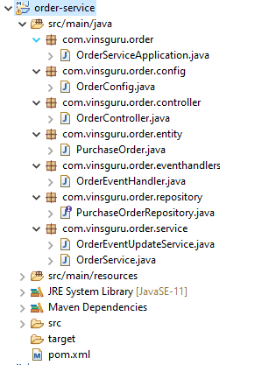

**OrderController.java**

import com.vinsguru.dto.OrderRequestDTO;

import com.vinsguru.dto.OrderResponseDTO;

import com.vinsguru.order.entity.PurchaseOrder;

import com.vinsguru.order.service.OrderService;

import org.springframework.beans.factory.annotation.Autowired;

import org.springframework.web.bind.annotation.*;

import java.util.List;

import java.util.UUID;

@RestController

@RequestMapping("order")

public class OrderController {

@Autowired

private OrderService service;

@PostMapping("/create")

public PurchaseOrder createOrder(@RequestBody OrderRequestDTO requestDTO){

requestDTO.setOrderId(UUID.randomUUID());

return this.service.createOrder(requestDTO);

}

@GetMapping("/all")

public List<OrderResponseDTO> getOrders(){

return this.service.getAll();

}

}

**OrderServiceApplication.java**

import org.springframework.boot.SpringApplication;

import org.springframework.boot.autoconfigure.SpringBootApplication;

@SpringBootApplication

public class OrderServiceApplication {

public static void main(String[] args) {

SpringApplication.run(OrderServiceApplication.class, args);

}

}

**PurchaseOrder.java**

import com.vinsguru.enums.OrderStatus;

import lombok.Data;

import lombok.ToString;

import javax.persistence.Entity;

import javax.persistence.Id;

import java.util.UUID;

@Data

@Entity

@ToString

public class PurchaseOrder {

@Id

private UUID id;

private Integer userId;

private Integer productId;

private Double price;

private OrderStatus status;

}

**OrderEventHandler.java**

import com.vinsguru.dto.OrchestratorRequestDTO;

import com.vinsguru.dto.OrchestratorResponseDTO;

import com.vinsguru.order.service.OrderEventUpdateService;

import org.springframework.beans.factory.annotation.Autowired;

import org.springframework.context.annotation.Bean;

import org.springframework.context.annotation.Configuration;

import reactor.core.publisher.DirectProcessor;

import reactor.core.publisher.Flux;

import java.util.function.Consumer;

import java.util.function.Supplier;

@Configuration

public class OrderEventHandler {

@Autowired

private DirectProcessor<OrchestratorRequestDTO> source;

@Autowired

private OrderEventUpdateService service;

@Bean

public Supplier<Flux<OrchestratorRequestDTO>> supplier(){

return () -> Flux.from(source);

};

@Bean

public Consumer<Flux<OrchestratorResponseDTO>> consumer(){

return (flux) -> flux

.subscribe(responseDTO -> this.service.updateOrder(responseDTO));

};

}

**OrderConfig.java**

import com.vinsguru.dto.OrchestratorRequestDTO;

import org.springframework.context.annotation.Bean;

import org.springframework.context.annotation.Configuration;

import reactor.core.publisher.DirectProcessor;

import reactor.core.publisher.FluxSink;

@Configuration

public class OrderConfig {

@Bean

public DirectProcessor<OrchestratorRequestDTO> publisher(){

return DirectProcessor.create();

}

@Bean

public FluxSink<OrchestratorRequestDTO> sink(DirectProcessor<OrchestratorRequestDTO>

publisher){

return publisher.sink();

}

}

**OrderService.java**

import com.vinsguru.dto.OrchestratorRequestDTO;

import com.vinsguru.dto.OrderRequestDTO;

import com.vinsguru.dto.OrderResponseDTO;

import com.vinsguru.enums.OrderStatus;

import com.vinsguru.order.entity.PurchaseOrder;

import com.vinsguru.order.repository.PurchaseOrderRepository;

import org.springframework.beans.factory.annotation.Autowired;

import org.springframework.stereotype.Service;

import reactor.core.publisher.FluxSink;

import java.util.List;

import java.util.Map;

import java.util.stream.Collectors;

@Service

public class OrderService {

// product price map

private static final Map<Integer, Double> PRODUCT_PRICE = Map.of(

1, 100d,

2, 200d,

3, 300d

);

@Autowired

private PurchaseOrderRepository purchaseOrderRepository;

@Autowired

private FluxSink<OrchestratorRequestDTO> sink;

public PurchaseOrder createOrder(OrderRequestDTO orderRequestDTO){

PurchaseOrder purchaseOrder = this.purchaseOrderRepository.save(

this.dtoToEntity(orderRequestDTO) );

this.sink.next(this.getOrchestratorRequestDTO(orderRequestDTO));

return purchaseOrder;

}

public List<OrderResponseDTO> getAll() {

return this.purchaseOrderRepository.findAll()

.stream()

.map(this::entityToDto)

.collect(Collectors.toList());

}

private PurchaseOrder dtoToEntity(final OrderRequestDTO dto) {

PurchaseOrder purchaseOrder = new PurchaseOrder();

purchaseOrder.setId(dto.getOrderId());

purchaseOrder.setProductId(dto.getProductId());

purchaseOrder.setUserId(dto.getUserId());

purchaseOrder.setStatus(OrderStatus.ORDER_CREATED);

purchaseOrder.setPrice(PRODUCT_PRICE.get(purchaseOrder.getProductId()));

return purchaseOrder;

}

private OrderResponseDTO entityToDto(final PurchaseOrder purchaseOrder) {

OrderResponseDTO dto = new OrderResponseDTO();

dto.setOrderId(purchaseOrder.getId());

dto.setProductId(purchaseOrder.getProductId());

dto.setUserId(purchaseOrder.getUserId());

dto.setStatus(purchaseOrder.getStatus());

dto.setAmount(purchaseOrder.getPrice());

return dto;

}

public OrchestratorRequestDTO getOrchestratorRequestDTO(OrderRequestDTO orderRequestDTO) {

OrchestratorRequestDTO requestDTO = new OrchestratorRequestDTO();

requestDTO.setUserId(orderRequestDTO.getUserId());

requestDTO.setAmount(PRODUCT_PRICE.get(orderRequestDTO.getProductId()));

requestDTO.setOrderId(orderRequestDTO.getOrderId());

requestDTO.setProductId(orderRequestDTO.getProductId());

return requestDTO;

}

}

**OrderEventUpdateService.java**

import com.vinsguru.dto.OrchestratorResponseDTO;

import com.vinsguru.order.repository.PurchaseOrderRepository;

import org.springframework.beans.factory.annotation.Autowired;

import org.springframework.stereotype.Service;

import javax.transaction.Transactional;

@Service

public class OrderEventUpdateService {

@Autowired

private PurchaseOrderRepository repository;

@Transactional

public void updateOrder(final OrchestratorResponseDTO responseDTO){

this.repository

.findById(responseDTO.getOrderId())

.ifPresent(po -> {

po.setStatus(responseDTO.getStatus());

this.repository.save(po);

});

}

}

**application.yaml**

server:

port: 8080

spring.cloud.stream:

function:

definition: supplier;consumer

bindings:

supplier-out-0:

destination: order-created

consumer-in-0:

destination: order-updated

**pom.xml**

<?xml version="1.0" encoding="UTF-8"?>

<project xmlns="http://maven.apache.org/POM/4.0.0"

xmlns:xsi="http://www.w3.org/2001/XMLSchema-instance"

xsi:schemaLocation="http://maven.apache.org/POM/4.0.0 http://maven.apache.org/xsd/maven-4.0.0.xsd">

<parent>

<artifactId>saga-orchestration</artifactId>

<groupId>com.vinsguru</groupId>

<version>0.0.1-SNAPSHOT</version>

</parent>

<modelVersion>4.0.0</modelVersion>

<artifactId>order-service</artifactId>

<dependencies>

<dependency>

<groupId>org.springframework.boot</groupId>

<artifactId>spring-boot-starter-data-jpa</artifactId>

</dependency>

<dependency>

<groupId>com.h2database</groupId>

<artifactId>h2</artifactId>

<scope>runtime</scope>

</dependency>

<dependency>

<groupId>com.vinsguru</groupId>

<artifactId>common-dto</artifactId>

<version>0.0.1-SNAPSHOT</version>

</dependency>

</dependencies>

</project>

##### common-dto project

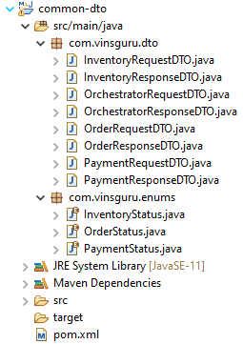

|  |  |
| --- | --- |
| **InventoryRequestDTO.java**  import lombok.Data;  import java.util.UUID;  @Data  public class InventoryRequestDTO {  private Integer userId;  private Integer productId;  private UUID orderId;  } | **InventoryResponseDTO.java**  import com.vinsguru.enums.InventoryStatus;  import lombok.Data;  import java.util.UUID;  @Data  public class InventoryResponseDTO {  private UUID orderId;  private Integer userId;  private Integer productId;  private InventoryStatus status;  } |
| **OrchestratorRequestDTO.java**  import lombok.Data;  import java.util.UUID;  @Data  public class OrchestratorRequestDTO {  private Integer userId;  private Integer productId;  private UUID orderId;  private Double amount;  } | **OrchestratorResponseDTO.java**  import com.vinsguru.enums.OrderStatus;  import lombok.Data;  import java.util.UUID;  @Data  public class OrchestratorResponseDTO {  private Integer userId;  private Integer productId;  private UUID orderId;  private Double amount;  private OrderStatus status;  } |
| **OrderRequestDTO.java**  import lombok.Data;  import java.util.UUID;  @Data  public class OrderRequestDTO {  private Integer userId;  private Integer productId;  private UUID orderId;  } | **OrderResponseDTO.java**  import com.vinsguru.enums.OrderStatus;  import lombok.Data;  import java.util.UUID;  @Data  public class OrderResponseDTO {  private UUID orderId;  private Integer userId;  private Integer productId;  private Double amount;  private OrderStatus status;  } |
| **PaymentRequestDTO.java**  import lombok.Data;  import java.util.UUID;  @Data  public class PaymentRequestDTO {  private Integer userId;  private UUID orderId;  private Double amount;  } | **PaymentResponseDTO.java**  import com.vinsguru.enums.PaymentStatus;  import lombok.Data;  import java.util.UUID;  @Data  public class PaymentResponseDTO {  private Integer userId;  private UUID orderId;  private Double amount;  private PaymentStatus status;  } |
| **InventoryStatus.java**  public enum InventoryStatus {  AVAILABLE,  UNAVAILABLE;  } | **OrderStatus.java**  public enum OrderStatus {  ORDER_CREATED,  ORDER_CANCELLED,  ORDER_COMPLETED  } |
| **PaymentStatus.java**  public enum PaymentStatus {  PAYMENT_APPROVED,  PAYMENT_REJECTED;  } |  |

**pom.xml**

<?xml version="1.0" encoding="UTF-8"?>

<project xmlns="http://maven.apache.org/POM/4.0.0"

xmlns:xsi="http://www.w3.org/2001/XMLSchema-instance"

xsi:schemaLocation="http://maven.apache.org/POM/4.0.0 http://maven.apache.org/xsd/maven-4.0.0.xsd">

<parent>

<artifactId>saga-orchestration</artifactId>

<groupId>com.vinsguru</groupId>

<version>0.0.1-SNAPSHOT</version>

</parent>

<modelVersion>4.0.0</modelVersion>

<properties>

<spring-boot.repackage.skip>true</spring-boot.repackage.skip>

</properties>

<artifactId>common-dto</artifactId>

</project>

##### Order Orchestration

This is a microservice which is responsible for coordinating all the transactions. It listens to order-created topic. As and when a new order is created, It immediately builds separate request to each service like payment-service/inventory-service etc and validates the responses. If they are OK, fulfills the order. If one of them is not, cancels the oder. It also tries to reset any of local transactions which happened in any of the microservices.

We consider all the local transactions as 1 single workflow. A workflow will contain multiple workflow steps.

Workflow step

**OrchestratorApplication.java**

import org.springframework.boot.SpringApplication;

import org.springframework.boot.autoconfigure.SpringBootApplication;

@SpringBootApplication

public class OrchestratorApplication {

public static void main(String[] args) {

SpringApplication.run(OrchestratorApplication.class, args);

}

}

**OrchestratorConfig.java**

import com.vinsguru.dto.OrchestratorRequestDTO;

import com.vinsguru.dto.OrchestratorResponseDTO;

import com.vinsguru.saga.service.OrchestratorService;

import org.springframework.beans.factory.annotation.Autowired;

import org.springframework.context.annotation.Bean;

import org.springframework.context.annotation.Configuration;

import reactor.core.publisher.Flux;

import java.util.function.Function;

@Configuration

public class OrchestratorConfig {

@Autowired

private OrchestratorService orchestratorService;

@Bean

public Function<Flux<OrchestratorRequestDTO>, Flux<OrchestratorResponseDTO>> processor(){

return flux -> flux

.flatMap(dto -> this.orchestratorService.orderProduct(dto))

.doOnNext(dto -> System.out.println("Status : " + dto.getStatus()));

}

}

**WebClientConfig.java**

import org.springframework.beans.factory.annotation.Qualifier;

import org.springframework.beans.factory.annotation.Value;

import org.springframework.context.annotation.Bean;

import org.springframework.context.annotation.Configuration;

import org.springframework.web.reactive.function.client.WebClient;

@Configuration

public class WebClientConfig {

@Bean

@Qualifier("payment")

public WebClient paymentClient(@Value("${service.endpoints.payment}") String endpoint){

return WebClient.builder()

.baseUrl(endpoint)

.build();

}

@Bean

@Qualifier("inventory")

public WebClient inventoryClient(@Value("${service.endpoints.inventory}") String endpoint){

return WebClient.builder()

.baseUrl(endpoint)

.build();

}

}

In our case, for the Order workflow, we have 2 steps. Each implementation should know how to do local transaction and how to reset.

Inventory step

**InventoryStep.java**

import com.vinsguru.dto.InventoryRequestDTO;

import com.vinsguru.dto.InventoryResponseDTO;

import com.vinsguru.enums.InventoryStatus;

import com.vinsguru.saga.service.WorkflowStep;

import com.vinsguru.saga.service.WorkflowStepStatus;

import org.springframework.web.reactive.function.BodyInserters;

import org.springframework.web.reactive.function.client.WebClient;

import reactor.core.publisher.Mono;

public class InventoryStep implements WorkflowStep {

private final WebClient webClient;

private final InventoryRequestDTO requestDTO;

private WorkflowStepStatus stepStatus = WorkflowStepStatus.PENDING;

public InventoryStep(WebClient webClient, InventoryRequestDTO requestDTO) {

this.webClient = webClient;

this.requestDTO = requestDTO;

}

@Override

public WorkflowStepStatus getStatus() {

return this.stepStatus;

}

@Override

public Mono<Boolean> process() {

return this.webClient

.post()

.uri("/inventory/deduct")

.body(BodyInserters.fromValue(this.requestDTO))

.retrieve()

.bodyToMono(InventoryResponseDTO.class)

.map(r -> r.getStatus().equals(InventoryStatus.AVAILABLE))

.doOnNext(b -> this.stepStatus = b ? WorkflowStepStatus.COMPLETE : WorkflowStepStatus.FAILED);

}

@Override

public Mono<Boolean> revert() {

return this.webClient

.post()

.uri("/inventory/add")

.body(BodyInserters.fromValue(this.requestDTO))

.retrieve()

.bodyToMono(Void.class)

.map(r ->true)

.onErrorReturn(false);

}

}

Payment step

**PaymentStep.java**

import com.vinsguru.dto.PaymentRequestDTO;

import com.vinsguru.dto.PaymentResponseDTO;

import com.vinsguru.enums.PaymentStatus;

import com.vinsguru.saga.service.WorkflowStep;

import com.vinsguru.saga.service.WorkflowStepStatus;

import org.springframework.web.reactive.function.BodyInserters;

import org.springframework.web.reactive.function.client.WebClient;

import reactor.core.publisher.Mono;

public class PaymentStep implements WorkflowStep {

private final WebClient webClient;

private final PaymentRequestDTO requestDTO;

private WorkflowStepStatus stepStatus = WorkflowStepStatus.PENDING;

public PaymentStep(WebClient webClient, PaymentRequestDTO requestDTO) {

this.webClient = webClient;

this.requestDTO = requestDTO;

}

@Override

public WorkflowStepStatus getStatus() {

return this.stepStatus;

}

@Override

public Mono<Boolean> process() {

return this.webClient

.post()

.uri("/payment/debit")

.body(BodyInserters.fromValue(this.requestDTO))

.retrieve()

.bodyToMono(PaymentResponseDTO.class)

.map(r -> r.getStatus().equals(PaymentStatus.PAYMENT_APPROVED))

.doOnNext(b -> this.stepStatus = b ? WorkflowStepStatus.COMPLETE : WorkflowStepStatus.FAILED);

}

@Override

public Mono<Boolean> revert() {

return this.webClient

.post()

.uri("/payment/credit")

.body(BodyInserters.fromValue(this.requestDTO))

.retrieve()

.bodyToMono(Void.class)

.map(r -> true)

.onErrorReturn(false);

}

}

service / coordinator

**OrchestratorService.java**

import com.vinsguru.dto.InventoryRequestDTO;

import com.vinsguru.dto.OrchestratorRequestDTO;

import com.vinsguru.dto.OrchestratorResponseDTO;

import com.vinsguru.dto.PaymentRequestDTO;

import com.vinsguru.enums.OrderStatus;

import com.vinsguru.saga.service.steps.InventoryStep;

import com.vinsguru.saga.service.steps.PaymentStep;

import org.springframework.beans.factory.annotation.Autowired;

import org.springframework.beans.factory.annotation.Qualifier;

import org.springframework.stereotype.Service;

import org.springframework.web.reactive.function.client.WebClient;

import reactor.core.publisher.Flux;

import reactor.core.publisher.Mono;

import java.util.List;

@Service

public class OrchestratorService {

@Autowired

@Qualifier("payment")

private WebClient paymentClient;

@Autowired

@Qualifier("inventory")

private WebClient inventoryClient;

public Mono<OrchestratorResponseDTO> orderProduct(final OrchestratorRequestDTO requestDTO) {

Workflow orderWorkflow = this.getOrderWorkflow(requestDTO);

return Flux.fromStream(() -> orderWorkflow.getSteps().stream())

.flatMap(WorkflowStep::process)

.handle(((aBoolean, synchronousSink) -> {

if(aBoolean)

synchronousSink.next(true);

else

synchronousSink.error(new WorkflowException("create order failed!"));

}))

.then(Mono.fromCallable(() -> getResponseDTO(requestDTO, OrderStatus.ORDER_COMPLETED)))

.onErrorResume(ex -> this.revertOrder(orderWorkflow, requestDTO));

}

private Mono<OrchestratorResponseDTO> revertOrder(final Workflow workflow, final OrchestratorRequestDTO requestDTO) {

return Flux.fromStream(() -> workflow.getSteps().stream())

.filter(wf -> wf.getStatus().equals(WorkflowStepStatus.COMPLETE))

.flatMap(WorkflowStep::revert)

.retry(3)

.then(Mono.just(this.getResponseDTO(requestDTO, OrderStatus.ORDER_CANCELLED)));

}

private Workflow getOrderWorkflow(OrchestratorRequestDTO requestDTO) {

WorkflowStep paymentStep = new PaymentStep(this.paymentClient, this.getPaymentRequestDTO(requestDTO));

WorkflowStep inventoryStep = new InventoryStep(this.inventoryClient, this.getInventoryRequestDTO(requestDTO));

return new OrderWorkflow(List.of(paymentStep, inventoryStep));

}

private OrchestratorResponseDTO getResponseDTO(OrchestratorRequestDTO requestDTO, OrderStatus status) {

OrchestratorResponseDTO responseDTO = new OrchestratorResponseDTO();

responseDTO.setOrderId(requestDTO.getOrderId());

responseDTO.setAmount(requestDTO.getAmount());

responseDTO.setProductId(requestDTO.getProductId());

responseDTO.setUserId(requestDTO.getUserId());

responseDTO.setStatus(status);

return responseDTO;

}

private PaymentRequestDTO getPaymentRequestDTO(OrchestratorRequestDTO requestDTO) {

PaymentRequestDTO paymentRequestDTO = new PaymentRequestDTO();

paymentRequestDTO.setUserId(requestDTO.getUserId());

paymentRequestDTO.setAmount(requestDTO.getAmount());

paymentRequestDTO.setOrderId(requestDTO.getOrderId());

return paymentRequestDTO;

}

private InventoryRequestDTO getInventoryRequestDTO(OrchestratorRequestDTO requestDTO) {

InventoryRequestDTO inventoryRequestDTO = new InventoryRequestDTO();

inventoryRequestDTO.setUserId(requestDTO.getUserId());

inventoryRequestDTO.setProductId(requestDTO.getProductId());

inventoryRequestDTO.setOrderId(requestDTO.getOrderId());

return inventoryRequestDTO;

}

}

**OrderWorkflow.java**

import java.util.List;

public class OrderWorkflow implements Workflow {

private final List<WorkflowStep> steps;

public OrderWorkflow(List<WorkflowStep> steps) {

this.steps = steps;

}

@Override

public List<WorkflowStep> getSteps() {

return this.steps;

}

}

**Workflow.java**

import java.util.List;

public interface Workflow {

List<WorkflowStep> getSteps();

}

**WorkflowException.java**

public class WorkflowException extends RuntimeException {

public WorkflowException(String message) {

super(message);

}

}

**WorkflowStep.java**

import reactor.core.publisher.Mono;

public interface WorkflowStep {

WorkflowStepStatus getStatus();

Mono<Boolean> process();

Mono<Boolean> revert();

}

**WorkflowStepStatus.java**

public enum WorkflowStepStatus {

PENDING,

COMPLETE,

FAILED;

}

**application.yaml**

server:

port: 8083

---

spring.cloud.stream:

function:

definition: processor

bindings:

processor-in-0:

destination: order-created

processor-out-0:

destination: order-updated

---

service:

endpoints:

inventory: http://localhost:8081

payment: http://localhost:8082

**pom.xml**

<?xml version="1.0" encoding="UTF-8"?>

<project xmlns="http://maven.apache.org/POM/4.0.0"

xmlns:xsi="http://www.w3.org/2001/XMLSchema-instance"

xsi:schemaLocation="http://maven.apache.org/POM/4.0.0 http://maven.apache.org/xsd/maven-4.0.0.xsd">

<parent>

<artifactId>saga-orchestration</artifactId>

<groupId>com.vinsguru</groupId>

<version>0.0.1-SNAPSHOT</version>

</parent>

<modelVersion>4.0.0</modelVersion>

<artifactId>order-orchestrator</artifactId>

<dependencies>

<dependency>

<groupId>com.vinsguru</groupId>

<artifactId>common-dto</artifactId>

<version>0.0.1-SNAPSHOT</version>

</dependency>

</dependencies>

</project>

I have provided only high level details here. For the complete source, check [here](https://github.com/vinsguru/vinsguru-blog-code-samples/tree/master/architectural-pattern/saga-orchestration).

Demo:

Once all the services are up and running, I send a POST request to create order. I get the order created status.

Do note that user 1 tries to order product id 3 which costs $300

The user’s credit limit is $1000

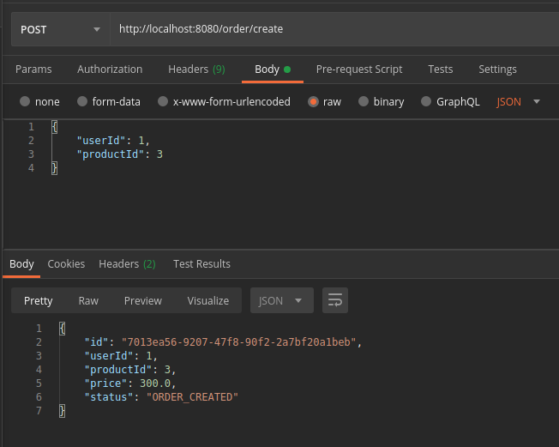

I sent 4 requests. So 3 requests were fulfilled. Not the 4th one as the user would have only $100 left and we can not fulfill the 4th order. So the payment service would have declined.

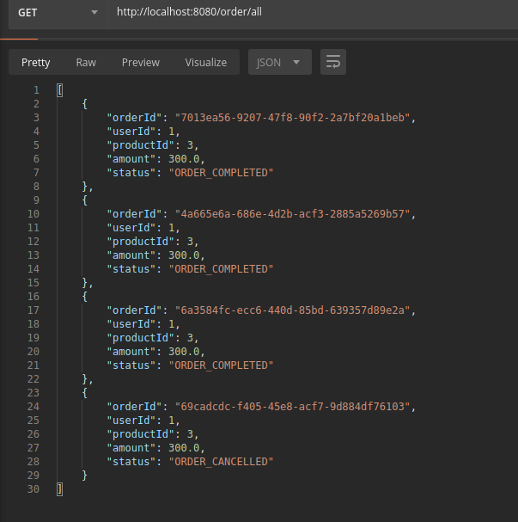

The user 1 with this available balance $100, he can buy product id 1 as it costs only $100.

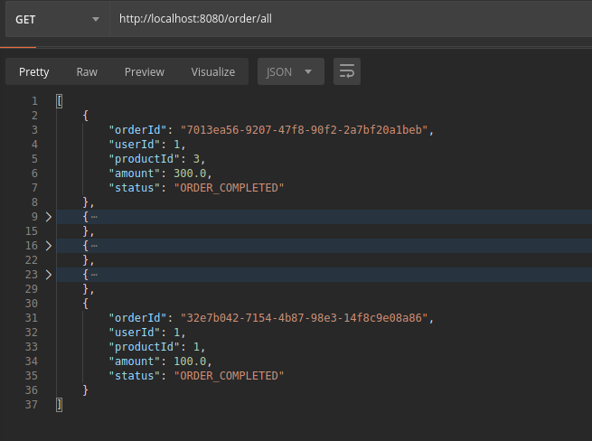 Summary:

Handling transactions and maintaining data consistency among all the microservices are difficult in general. When multiple services are involved like payment, inventory, fraud check, shipping check…..etc it would be very difficult to manage such a complex workflow with multiple steps without a coordinator. By introducing a separate service for coordinator, order-service is freed up from these responsibilities. We are also not introducing any cyclic dependencies.

Check the project source code [here](https://github.com/vinsguru/vinsguru-blog-code-samples/tree/master/architectural-pattern/saga-orchestration).

#### Choreography – SAGA Pattern

<https://www.vinsguru.com/choreography-saga-pattern-with-spring-boot/>

In this tutorial, I would like to show you a simple implementation of Choreography Saga Pattern with Spring Boot.

Over the years, Microservices have become very popular. Microservices are distributed systems. They are smaller, modular, easy to deploy and scale etc. Developing a single microservice application might be interesting! But handling a business transaction which spans across multiple Microservices is not fun! In order to complete an application workflow / a task, multiple Microservices might have to work together.

Lets see how difficult it could be in dealing with transactions / data consistency in the distributed systems in this article.

A Simple Transaction:

Let’s assume that our business rule says, when an user places an order, order will be fulfilled if the product’s price is within the user’s credit limit/balance. Otherwise it will not be fulfilled. It looks really simple.

This is very easy to implement in a monolith application. The entire workflow can be considered as 1 single transaction. It is easy to commit / rollback when everything is in a single DB. With distributed systems with multiple databases, It is going to be very complex! Lets look at our architecture first to see how to implement this.

We have an order-service with its own database which is responsible for order management. Similarly we also have payment-service which is responsible for managing payments. So the order-service receives the request and checks with the payment-service if the user has the balance. If the payment-service responds OK, order-service completes the order and payment-service deducts the payment. Otherwise, the order-service cancels the order. For a very simple business requirement, here we have to send multiple requests across the network.

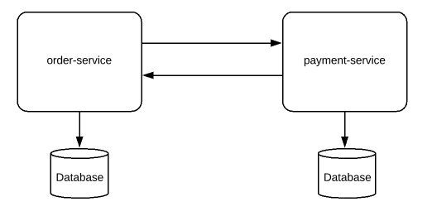

What if we also need to check with inventory-service for the availability of inventory before making the order as complete! Now you see the problem?

In the traditional system design approach, order-service simply sends a HTTP request to get the information about the user’s credit balance. The problem with this approach is order-service assumes that payment-service will be up and running always. Any network issue or performance issue at the payment-service will be propagated to the order-service. It could lead to poor user-experience & we also might lose revenue. Let’s see how we could handle transactions in the distributed systems with loose coupling by using a pattern called Saga Pattern with Event Sourcing approach.

Saga Pattern:

Each business transaction which spans multiple Microservices are split into Microservice specific local transactions and they are executed in a sequence to complete the business workflow. It is called Saga. It can be implemented in 2 ways.

Choreography approach

In this article, we will be discussing the choreography based approach by using event-sourcing. For orchestration based Saga, check [here](http://www.vinsguru.com/architectural-pattern-orchestration-saga-pattern-implementation-using-kafka/).

Event Sourcing:

In this approach every change to the state of an application is captured as an event. This event is stored in the database /event store (for tracking purposes) and is also published in the event-bus for other parties to consume.

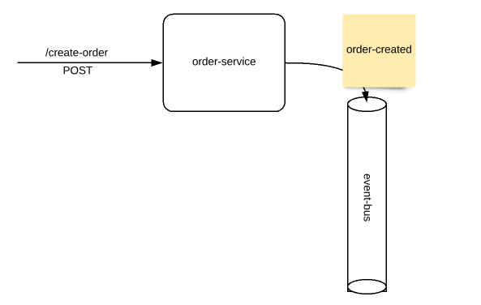

The order-service receives a command to create a new order. This request is processed and raised as an order-created event. Couple of things to note here.

1. Order created event basically informs that a new order request has been received and kept in the PENDING/CREATED status by order-service. It is not yet fulfilled.
2. The event object will be named in the past tense always as it already happened!

Now the payment-service/inventory-service could be interested in listening to those events and reserve/reject payment/inventory. Even these could be treated as an event. Payment reserved/rejected event. Order-service might listen to these events and fulfill / cancel the order request it had originally received.

This approach has many advantages.

There is no service dependency. payment-service/inventory-service do not have to be up and running always.

* Loose coupling
* Horizontal scaling
* Fault tolerant

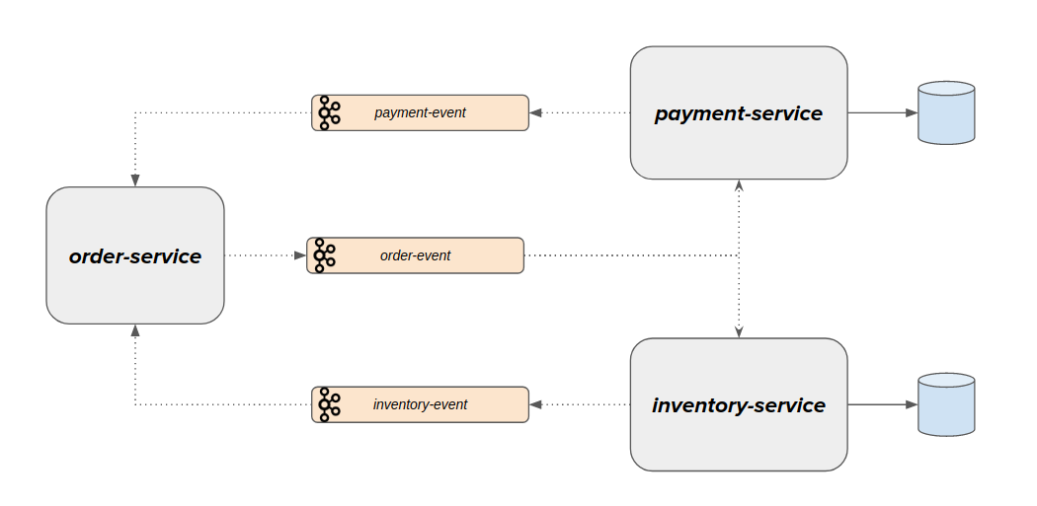

The business workflow is implemented as shown here.

* order-services receives a POST request for a new order
* It places an order request in the DB in the ORDER_CREATED state and raises an event
* payment-service listens to the event, confirms about the credit reservation
* inventory-service also listens to the order-event and conforms the inventory reservation
* order-service fulfills order or rejects the order based on the credit & inventory reservation status.

Implementation:

I created a simple Spring Boot project using kafka-cloud-stream. I have basic project structure which looks like this.

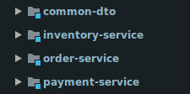

* My common-dto package is as shown below.
  + It contains the basic DTOs, Enums and Event objects.

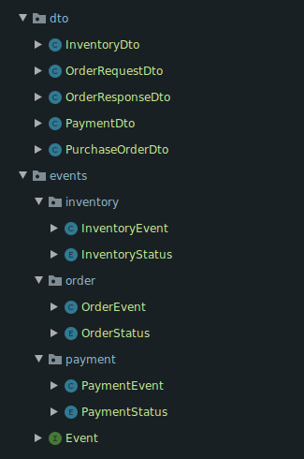

##### Payment Service:

The payment service consumes order-events from a kafka topic and returns the corresponding payment-event. Take a look at the GitHub link at the end of this article for the complete working project.

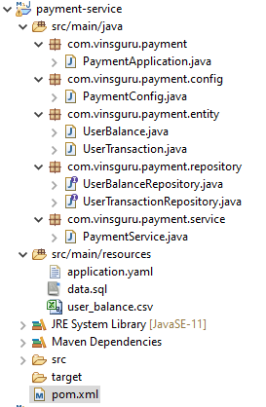

**PaymentConfig.java**

import com.vinsguru.events.order.OrderEvent;

import com.vinsguru.events.order.OrderStatus;

import com.vinsguru.events.payment.PaymentEvent;

import com.vinsguru.payment.service.PaymentService;

import org.springframework.beans.factory.annotation.Autowired;

import org.springframework.context.annotation.Bean;

import org.springframework.context.annotation.Configuration;

import reactor.core.publisher.Flux;

import reactor.core.publisher.Mono;

import java.util.function.Function;

@Configuration

public class PaymentConfig {

@Autowired

private PaymentService service;

@Bean

public Function<Flux<OrderEvent>, Flux<PaymentEvent>> paymentProcessor() {

return flux -> flux.flatMap(this::processPayment);

}

private Mono<PaymentEvent> processPayment(OrderEvent event){

if(event.getOrderStatus().equals(OrderStatus.ORDER_CREATED)){

return Mono.fromSupplier(() -> this.service.newOrderEvent(event));

}else{

return Mono.fromRunnable(() -> this.service.cancelOrderEvent(event));

}

}

}

**PaymentApplication.java**

import org.springframework.boot.SpringApplication;

import org.springframework.boot.autoconfigure.SpringBootApplication;

@SpringBootApplication

public class PaymentApplication {

public static void main(String[] args) {

SpringApplication.run(PaymentApplication.class, args);

}

}

**PaymentService.java**

import com.vinsguru.dto.PaymentDto;

import com.vinsguru.events.order.OrderEvent;

import com.vinsguru.events.payment.PaymentEvent;

import com.vinsguru.events.payment.PaymentStatus;

import com.vinsguru.payment.entity.UserTransaction;

import com.vinsguru.payment.repository.UserBalanceRepository;

import com.vinsguru.payment.repository.UserTransactionRepository;

import org.springframework.beans.factory.annotation.Autowired;

import org.springframework.stereotype.Service;

import org.springframework.transaction.annotation.Transactional;

@Service

public class PaymentService {

@Autowired

private UserBalanceRepository balanceRepository;

@Autowired

private UserTransactionRepository transactionRepository;

@Transactional

public PaymentEvent newOrderEvent(OrderEvent orderEvent){

var purchaseOrder = orderEvent.getPurchaseOrder();

var dto = PaymentDto.of(purchaseOrder.getOrderId(), purchaseOrder.getUserId(), purchaseOrder.getPrice());

return this.balanceRepository.findById(purchaseOrder.getUserId())

.filter(ub -> ub.getBalance() >= purchaseOrder.getPrice())

.map(ub -> {

ub.setBalance(ub.getBalance() - purchaseOrder.getPrice());

this.transactionRepository.save(

UserTransaction.of(purchaseOrder.getOrderId(), purchaseOrder.getUserId(), purchaseOrder.getPrice()));

return new PaymentEvent(dto, PaymentStatus.RESERVED);

})

.orElse(new PaymentEvent(dto, PaymentStatus.REJECTED));

}

@Transactional

public void cancelOrderEvent(OrderEvent orderEvent){

this.transactionRepository.findById(orderEvent.getPurchaseOrder().getOrderId())

.ifPresent(ut -> {

this.transactionRepository.delete(ut);

this.balanceRepository.findById(ut.getUserId())

.ifPresent(ub -> ub.setBalance(ub.getBalance() + ut.getAmount()));

});

}

}

**UserBalanceRepository.java**

import com.vinsguru.payment.entity.UserBalance;

import org.springframework.data.jpa.repository.JpaRepository;

import org.springframework.stereotype.Repository;

@Repository

public interface UserBalanceRepository extends JpaRepository<UserBalance, Integer> {

}

**UserTransactionRepository.java**

import com.vinsguru.payment.entity.UserTransaction;

import org.springframework.data.jpa.repository.JpaRepository;

import org.springframework.stereotype.Repository;

import java.util.UUID;

@Repository

public interface UserTransactionRepository extends JpaRepository<UserTransaction, UUID> {

}

|  |  |  |
| --- | --- | --- |
| **UserBalance.java**  import lombok.AllArgsConstructor;  import lombok.Data;  import lombok.NoArgsConstructor;  import javax.persistence.Entity;  import javax.persistence.Id;  @Data  @Entity  @NoArgsConstructor  @AllArgsConstructor  public class UserBalance {  @Id  private int userId;  private int balance;  } | **UserTransaction.java**  import lombok.AllArgsConstructor;  import lombok.Data;  import lombok.NoArgsConstructor;  import javax.persistence.Entity;  import javax.persistence.Id;  import java.util.UUID;  @Data  @Entity  @NoArgsConstructor  @AllArgsConstructor(staticName = "of")  public class UserTransaction {  @Id  private UUID orderId;  private int userId;  private int amount;  } | **application.yml**  spring.cloud.stream:  function:  definition: paymentProcessor  bindings:  paymentProcessor-in-0:  destination: order-event  paymentProcessor-out-0:  destination: payment-event |

**data.sql**

DROP TABLE IF EXISTS user_balance;

CREATE TABLE user_balance AS SELECT * FROM CSVREAD('classpath:user_balance.csv');

**user_balance.csv**

user_id,balance

1,1000

2,1000

3,1000

**pom.xml**

<?xml version="1.0" encoding="UTF-8"?>

<project xmlns="http://maven.apache.org/POM/4.0.0" xmlns:xsi="http://www.w3.org/2001/XMLSchema-instance"

xsi:schemaLocation="http://maven.apache.org/POM/4.0.0 http://maven.apache.org/xsd/maven-4.0.0.xsd">

<parent>

<artifactId>saga-choreography</artifactId>

<groupId>com.vinsguru</groupId>

<version>0.0.1-SNAPSHOT</version>

</parent>

<modelVersion>4.0.0</modelVersion>

<artifactId>payment-service</artifactId>

<dependencies>

<dependency>

<groupId>com.vinsguru</groupId>

<artifactId>common-dto</artifactId>

<version>0.0.1-SNAPSHOT</version>

</dependency>

<dependency>

<groupId>org.springframework.boot</groupId>

<artifactId>spring-boot-starter-data-jpa</artifactId>

</dependency>

<dependency>

<groupId>org.springframework.cloud</groupId>

<artifactId>spring-cloud-stream</artifactId>

</dependency>

<dependency>

<groupId>org.springframework.cloud</groupId>

<artifactId>spring-cloud-stream-binder-kafka</artifactId>

</dependency>

<dependency>

<groupId>org.springframework.kafka</groupId>

<artifactId>spring-kafka</artifactId>

</dependency>

<dependency>

<groupId>com.h2database</groupId>

<artifactId>h2</artifactId>

<scope>runtime</scope>

</dependency>

</dependencies>

</project>

##### Inventory Service:

We also have inventory-service which consumes order-events and returns inventory-events.

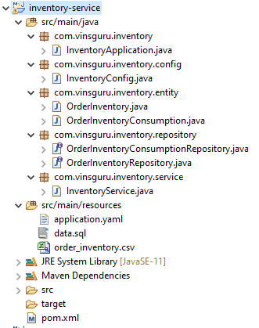

**pom.xml**

<?xml version="1.0" encoding="UTF-8"?>

<project xmlns="http://maven.apache.org/POM/4.0.0" xmlns:xsi="http://www.w3.org/2001/XMLSchema-instance"

xsi:schemaLocation="http://maven.apache.org/POM/4.0.0 http://maven.apache.org/xsd/maven-4.0.0.xsd">

<parent>

<artifactId>saga-choreography</artifactId>

<groupId>com.vinsguru</groupId>

<version>0.0.1-SNAPSHOT</version>

</parent>

<modelVersion>4.0.0</modelVersion>

<artifactId>inventory-service</artifactId>

<dependencies>

<dependency>

<groupId>org.springframework.boot</groupId>

<artifactId>spring-boot-starter-data-jpa</artifactId>

</dependency>

<dependency>

<groupId>org.springframework.cloud</groupId>

<artifactId>spring-cloud-stream</artifactId>

</dependency>

<dependency>

<groupId>org.springframework.cloud</groupId>

<artifactId>spring-cloud-stream-binder-kafka</artifactId>

</dependency>

<dependency>

<groupId>org.springframework.kafka</groupId>

<artifactId>spring-kafka</artifactId>

</dependency>

<dependency>

<groupId>com.h2database</groupId>

<artifactId>h2</artifactId>

<scope>runtime</scope>

</dependency>

<dependency>

<groupId>com.vinsguru</groupId>

<artifactId>common-dto</artifactId>

<version>0.0.1-SNAPSHOT</version>

</dependency>

</dependencies>

</project>

**InventoryApplication.java**

import org.springframework.boot.SpringApplication;

import org.springframework.boot.autoconfigure.SpringBootApplication;

@SpringBootApplication

public class InventoryApplication {

public static void main(String[] args) {

SpringApplication.run(InventoryApplication.class, args);

}

}

**InventoryConfig.java**

import com.vinsguru.events.inventory.InventoryEvent;

import com.vinsguru.events.order.OrderEvent;

import com.vinsguru.events.order.OrderStatus;

import com.vinsguru.inventory.service.InventoryService;

import org.springframework.beans.factory.annotation.Autowired;

import org.springframework.context.annotation.Bean;

import org.springframework.context.annotation.Configuration;

import reactor.core.publisher.Flux;

import reactor.core.publisher.Mono;

import java.util.function.Function;

@Configuration

public class InventoryConfig {

@Autowired

private InventoryService service;

@Bean

public Function<Flux<OrderEvent>, Flux<InventoryEvent>> inventoryProcessor() {

return flux -> flux.flatMap(this::processInventory);

}

private Mono<InventoryEvent> processInventory(OrderEvent event){

if(event.getOrderStatus().equals(OrderStatus.ORDER_CREATED)){

return Mono.fromSupplier(() -> this.service.newOrderInventory(event));

}

return Mono.fromRunnable(() -> this.service.cancelOrderInventory(event));

}

}

|  |  |  |
| --- | --- | --- |
| **OrderInventory.java**  import lombok.AllArgsConstructor;  import lombok.Data;  import lombok.NoArgsConstructor;  import javax.persistence.Entity;  import javax.persistence.Id;  @Data  @Entity  @NoArgsConstructor  @AllArgsConstructor(staticName = "of")  public class OrderInventory {  @Id  private int productId;  private int availableInventory;  } | **OrderInventoryConsumption.java**  import lombok.AllArgsConstructor;  import lombok.Data;  import lombok.NoArgsConstructor;  import javax.persistence.Entity;  import javax.persistence.Id;  import java.util.UUID;  @Data  @Entity  @NoArgsConstructor  @AllArgsConstructor(staticName = "of")  public class OrderInventoryConsumption {  @Id  private UUID orderId;  private int productId;  private int quantityConsumed;  } | **application.yaml**  spring.cloud.stream:  function:  definition: inventoryProcessor  bindings:  inventoryProcessor-in-0:  destination: order-event  inventoryProcessor-out-0:  destination: inventory-event |

**InventoryService.java**

import com.vinsguru.dto.InventoryDto;

import com.vinsguru.events.inventory.InventoryEvent;

import com.vinsguru.events.inventory.InventoryStatus;

import com.vinsguru.events.order.OrderEvent;

import com.vinsguru.inventory.entity.OrderInventoryConsumption;

import com.vinsguru.inventory.repository.OrderInventoryConsumptionRepository;

import com.vinsguru.inventory.repository.OrderInventoryRepository;

import org.springframework.beans.factory.annotation.Autowired;

import org.springframework.stereotype.Service;

import org.springframework.transaction.annotation.Transactional;

@Service

public class InventoryService {

@Autowired

private OrderInventoryRepository inventoryRepository;

@Autowired

private OrderInventoryConsumptionRepository consumptionRepository;

@Transactional

public InventoryEvent newOrderInventory(OrderEvent orderEvent){

InventoryDto dto = InventoryDto.of( orderEvent.getPurchaseOrder().getOrderId(),

orderEvent.getPurchaseOrder().getProductId() );

return inventoryRepository.findById(orderEvent.getPurchaseOrder().getProductId())

.filter(i -> i.getAvailableInventory() > 0 )

.map(i -> {

i.setAvailableInventory(i.getAvailableInventory() - 1);

consumptionRepository.save( OrderInventoryConsumption.of( orderEvent.getPurchaseOrder().getOrderId(),

orderEvent.getPurchaseOrder().getProductId(), 1) );

return new InventoryEvent(dto, InventoryStatus.RESERVED);

})

.orElse(new InventoryEvent(dto, InventoryStatus.REJECTED));

}

@Transactional

public void cancelOrderInventory(OrderEvent orderEvent){

consumptionRepository.findById(orderEvent.getPurchaseOrder().getOrderId())

.ifPresent(ci -> {

inventoryRepository.findById(ci.getProductId())

.ifPresent(i ->

i.setAvailableInventory(i.getAvailableInventory() + ci.getQuantityConsumed())

);

consumptionRepository.delete(ci);

});

}

}

**OrderInventoryConsumptionRepository.java**

import com.vinsguru.inventory.entity.OrderInventoryConsumption;

import org.springframework.data.jpa.repository.JpaRepository;

import org.springframework.stereotype.Repository;

import java.util.UUID;

@Repository

public interface OrderInventoryConsumptionRepository extends JpaRepository<OrderInventoryConsumption, UUID> {

}

**OrderInventoryRepository.java**

import com.vinsguru.inventory.entity.OrderInventory;

import org.springframework.data.jpa.repository.JpaRepository;

import org.springframework.stereotype.Repository;

@Repository

public interface OrderInventoryRepository extends JpaRepository<OrderInventory, Integer> {

}

**data.sql**

DROP TABLE IF EXISTS order_inventory;

CREATE TABLE order_inventory AS SELECT * FROM CSVREAD('classpath:order_inventory.csv');

**order_inventory.csv**

product_id,available_inventory

1,5

2,5

3,5

##### common dto

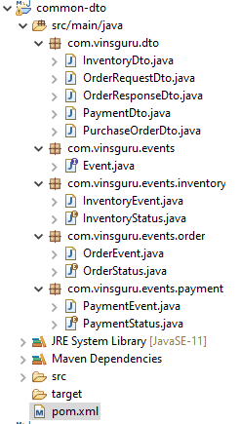

|  |  |  |
| --- | --- | --- |
| **InventoryDto.java**  import lombok.AllArgsConstructor;  import lombok.Data;  import lombok.NoArgsConstructor;  import java.util.UUID;  @Data  @NoArgsConstructor  @AllArgsConstructor(staticName = "of")  public class InventoryDto {  private UUID orderId;  private Integer productId;  } | **OrderRequestDto.java**  import lombok.Data;  import java.util.UUID;  @Data  public class OrderRequestDto {  private Integer userId;  private Integer productId;  private UUID orderId;  } | **OrderResponseDto.java**  import com.vinsguru.events.order.OrderStatus;  import lombok.AllArgsConstructor;  import lombok.Data;  import lombok.NoArgsConstructor;  import java.util.UUID;  @Data  @NoArgsConstructor  @AllArgsConstructor(staticName = "of")  public class OrderResponseDto {  private UUID orderId;  private Integer userId;  private Integer productId;  private Integer amount;  private OrderStatus status;  } |
| **PaymentDto.java**  import lombok.AllArgsConstructor;  import lombok.Data;  import lombok.NoArgsConstructor;  import java.util.UUID;  @Data  @NoArgsConstructor  @AllArgsConstructor(staticName = "of")  public class PaymentDto {  private UUID orderId;  private Integer userId;  private Integer amount;  } | **PurchaseOrderDto.java**  import lombok.AllArgsConstructor;  import lombok.Data;  import lombok.NoArgsConstructor;  import java.util.UUID;  @Data  @NoArgsConstructor  @AllArgsConstructor(staticName = "of")  public class PurchaseOrderDto {  private UUID orderId;  private Integer productId;  private Integer price;  private Integer userId;  } | **Event.java**  import java.util.Date;  import java.util.UUID;  public interface Event {  UUID getEventId();  Date getDate();  } |
| **InventoryEvent.java**  import com.vinsguru.dto.InventoryDto;  import com.vinsguru.events.Event;  import lombok.Data;  import java.util.Date;  import java.util.UUID;  @Data  public class InventoryEvent implements Event {  private final UUID eventId = UUID.randomUUID();  private final Date date = new Date();  private InventoryDto inventory;  private InventoryStatus status;  public InventoryEvent() { }  public InventoryEvent(InventoryDto inventory, InventoryStatus status) {  this.inventory = inventory;  this.status = status;  }  @Override  public UUID getEventId() { return this.eventId; }  @Override  public Date getDate() { return this.date; }  public InventoryDto getInventory() { return inventory; }  public InventoryStatus getStatus() { return status; }  } | | **InventoryStatus.java**  public enum InventoryStatus {  RESERVED,  REJECTED;  } |
| **OrderEvent.java**  import com.vinsguru.dto.PurchaseOrderDto;  import com.vinsguru.events.Event;  import lombok.Data;  import java.util.Date;  import java.util.UUID;  @Data  public class OrderEvent implements Event {  private final UUID eventId = UUID.randomUUID();  private final Date date = new Date();  private PurchaseOrderDto purchaseOrder;  private OrderStatus orderStatus;  public OrderEvent() {  }  public OrderEvent(PurchaseOrderDto purchaseOrder, OrderStatus orderStatus) {  this.purchaseOrder = purchaseOrder;  this.orderStatus = orderStatus;  }  @Override  public UUID getEventId() {  return this.eventId;  }  @Override  public Date getDate() {  return this.date;  }  public PurchaseOrderDto getPurchaseOrder() {  return purchaseOrder;  }  public OrderStatus getOrderStatus() {  return orderStatus;  }  } | | **OrderStatus.java**  public enum OrderStatus {  ORDER_CREATED,  ORDER_CANCELLED,  ORDER_COMPLETED  } |
| **PaymentEvent.java**  import com.vinsguru.dto.PaymentDto;  import com.vinsguru.events.Event;  import lombok.Data;  import java.util.Date;  import java.util.UUID;  @Data  public class PaymentEvent implements Event {  private final UUID eventId = UUID.randomUUID();  private final Date date = new Date();  private PaymentDto payment;  private PaymentStatus paymentStatus;  public PaymentEvent() {  }  public PaymentEvent(PaymentDto payment, PaymentStatus status) {  this.payment = payment;  this.paymentStatus = status;  }  @Override  public UUID getEventId() { return this.eventId; }  @Override  public Date getDate() { return this.date; }  public PaymentDto getPayment() { return payment; }  public PaymentStatus getPaymentStatus() { return paymentStatus; }  } | | **PaymentStatus.java**  public enum PaymentStatus {  RESERVED,  REJECTED;  } |

**pom.xml**

<?xml version="1.0" encoding="UTF-8"?>

<project xmlns="http://maven.apache.org/POM/4.0.0"

xmlns:xsi="http://www.w3.org/2001/XMLSchema-instance"

xsi:schemaLocation="http://maven.apache.org/POM/4.0.0 http://maven.apache.org/xsd/maven-4.0.0.xsd">

<parent>

<artifactId>saga-choreography</artifactId>

<groupId>com.vinsguru</groupId>

<version>0.0.1-SNAPSHOT</version>

</parent>

<modelVersion>4.0.0</modelVersion>

<properties>

<spring-boot.repackage.skip>true</spring-boot.repackage.skip>

</properties>

<artifactId>common-dto</artifactId>

</project>

##### Order Service

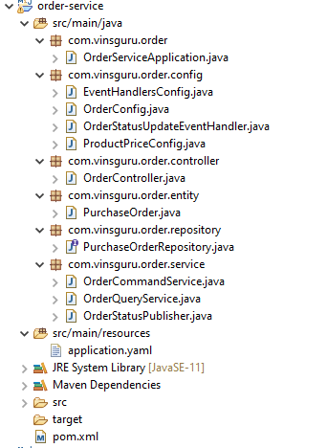

**pom.xml**

<?xml version="1.0" encoding="UTF-8"?>

<project xmlns="http://maven.apache.org/POM/4.0.0"

xmlns:xsi="http://www.w3.org/2001/XMLSchema-instance"

xsi:schemaLocation="http://maven.apache.org/POM/4.0.0 http://maven.apache.org/xsd/maven-4.0.0.xsd">

<parent>

<artifactId>saga-choreography</artifactId>

<groupId>com.vinsguru</groupId>

<version>0.0.1-SNAPSHOT</version>

</parent>

<modelVersion>4.0.0</modelVersion>

<artifactId>order-service</artifactId>

<dependencies>

<dependency>

<groupId>org.springframework.boot</groupId>

<artifactId>spring-boot-starter-webflux</artifactId>

</dependency>

<dependency>

<groupId>org.springframework.boot</groupId>

<artifactId>spring-boot-starter-data-jpa</artifactId>

</dependency>

<dependency>

<groupId>org.springframework.cloud</groupId>

<artifactId>spring-cloud-stream</artifactId>

</dependency>

<dependency>

<groupId>org.springframework.cloud</groupId>

<artifactId>spring-cloud-stream-binder-kafka</artifactId>

</dependency>

<dependency>

<groupId>org.springframework.kafka</groupId>

<artifactId>spring-kafka</artifactId>

</dependency>

<dependency>

<groupId>com.h2database</groupId>

<artifactId>h2</artifactId>

<scope>runtime</scope>

</dependency>

<dependency>

<groupId>com.vinsguru</groupId>

<artifactId>common-dto</artifactId>

<version>0.0.1-SNAPSHOT</version>

</dependency>

</dependencies>

</project>

**OrderServiceApplication.java**

import org.springframework.boot.SpringApplication;

import org.springframework.boot.autoconfigure.SpringBootApplication;

@SpringBootApplication

public class OrderServiceApplication {

public static void main(String[] args) {

SpringApplication.run(OrderServiceApplication.class, args);

}

}

**EventHandlersConfig.java**

import com.vinsguru.events.inventory.InventoryEvent;

import com.vinsguru.events.payment.PaymentEvent;

import org.springframework.beans.factory.annotation.Autowired;

import org.springframework.context.annotation.Bean;

import org.springframework.context.annotation.Configuration;

import java.util.function.Consumer;

@Configuration

public class EventHandlersConfig {

@Autowired

private OrderStatusUpdateEventHandler orderEventHandler;

@Bean

public Consumer<PaymentEvent> paymentEventConsumer(){

return pe -> {

orderEventHandler.updateOrder(pe.getPayment().getOrderId(), po -> {

po.setPaymentStatus(pe.getPaymentStatus());

});

};

}

@Bean

public Consumer<InventoryEvent> inventoryEventConsumer(){

return ie -> {

orderEventHandler.updateOrder(ie.getInventory().getOrderId(), po -> {

po.setInventoryStatus(ie.getStatus());

});

};

}

}

**OrderConfig.java**

import com.vinsguru.events.order.OrderEvent;

import org.springframework.context.annotation.Bean;

import org.springframework.context.annotation.Configuration;

import reactor.core.publisher.Flux;

import reactor.core.publisher.Sinks;

import java.util.function.Supplier;

@Configuration

public class OrderConfig {

@Bean

public Sinks.Many<OrderEvent> orderSink(){

return Sinks.many().unicast().onBackpressureBuffer();

}

@Bean

public Supplier<Flux<OrderEvent>> orderSupplier(Sinks.Many<OrderEvent> sink){

return sink::asFlux;

}

}

**OrderStatusUpdateEventHandler.java**

import com.vinsguru.events.inventory.InventoryStatus;

import com.vinsguru.events.order.OrderStatus;

import com.vinsguru.events.payment.PaymentStatus;

import com.vinsguru.order.entity.PurchaseOrder;

import com.vinsguru.order.repository.PurchaseOrderRepository;

import com.vinsguru.order.service.OrderStatusPublisher;

import org.springframework.beans.factory.annotation.Autowired;

import org.springframework.stereotype.Service;

import javax.transaction.Transactional;

import java.util.Objects;

import java.util.UUID;

import java.util.function.Consumer;

@Service

public class OrderStatusUpdateEventHandler {

@Autowired

private PurchaseOrderRepository repository;

@Autowired

private OrderStatusPublisher publisher;

@Transactional

public void updateOrder(final UUID id, Consumer<PurchaseOrder> consumer){

this.repository

.findById(id)

.ifPresent(consumer.andThen(this::updateOrder));

}

private void updateOrder(PurchaseOrder purchaseOrder){

if(Objects.isNull(purchaseOrder.getInventoryStatus()) || Objects.isNull(purchaseOrder.getPaymentStatus()))

return;

var isComplete = PaymentStatus.RESERVED.equals( purchaseOrder.getPaymentStatus()) &&

InventoryStatus.RESERVED.equals(purchaseOrder.getInventoryStatus() );

var orderStatus = isComplete ? OrderStatus.ORDER_COMPLETED : OrderStatus.ORDER_CANCELLED;

purchaseOrder.setOrderStatus(orderStatus);

if (!isComplete){

this.publisher.raiseOrderEvent(purchaseOrder, orderStatus);

}

}

}

**ProductPriceConfig.java**

import org.springframework.context.annotation.Bean;

import org.springframework.context.annotation.Configuration;

import java.util.Map;

@Configuration

public class ProductPriceConfig {

// product price map

@Bean

public Map<Integer, Integer> productPrice() {

return Map.of(

1, 100,

2, 200,

3, 300

);

};

}

**OrderController.java**

import com.vinsguru.dto.OrderRequestDto;

import com.vinsguru.order.entity.PurchaseOrder;

import com.vinsguru.order.service.OrderCommandService;

import com.vinsguru.order.service.OrderQueryService;

import org.springframework.beans.factory.annotation.Autowired;

import org.springframework.web.bind.annotation.*;

import java.util.List;

import java.util.UUID;

@RestController

@RequestMapping("order")

public class OrderController {

@Autowired

private OrderCommandService commandService;

@Autowired

private OrderQueryService queryService;

@PostMapping("/create")

public PurchaseOrder createOrder(@RequestBody OrderRequestDto requestDTO){

requestDTO.setOrderId(UUID.randomUUID());

return this.commandService.createOrder(requestDTO);

}

@GetMapping("/all")

public List<PurchaseOrder> getOrders(){

return this.queryService.getAll();

}

}

**PurchaseOrder.java**

import com.vinsguru.events.inventory.InventoryStatus;

import com.vinsguru.events.order.OrderStatus;

import com.vinsguru.events.payment.PaymentStatus;

import lombok.Data;

import lombok.ToString;

import javax.persistence.Entity;

import javax.persistence.Id;

import javax.persistence.Version;

import java.util.UUID;

@Data

@Entity

@ToString

public class PurchaseOrder {

@Id

private UUID id;

private Integer userId;

private Integer productId;

private Integer price;

private OrderStatus orderStatus;

private PaymentStatus paymentStatus;

private InventoryStatus inventoryStatus;

@Version

private int version;

}

**PurchaseOrderRepository.java**

import com.vinsguru.order.entity.PurchaseOrder;

import org.springframework.data.jpa.repository.JpaRepository;

import org.springframework.stereotype.Repository;

import java.util.UUID;

@Repository

public interface PurchaseOrderRepository extends JpaRepository<PurchaseOrder, UUID> {

}

**OrderCommandService.java**

import com.vinsguru.dto.OrderRequestDto;

import com.vinsguru.events.order.OrderStatus;

import com.vinsguru.order.entity.PurchaseOrder;

import com.vinsguru.order.repository.PurchaseOrderRepository;

import org.springframework.beans.factory.annotation.Autowired;

import org.springframework.stereotype.Service;

import org.springframework.transaction.annotation.Transactional;

import java.util.Map;

@Service

public class OrderCommandService {

@Autowired

private Map<Integer, Integer> productPriceMap;

@Autowired

private PurchaseOrderRepository purchaseOrderRepository;

@Autowired

private OrderStatusPublisher publisher;

@Transactional

public PurchaseOrder createOrder(OrderRequestDto orderRequestDTO){

PurchaseOrder purchaseOrder =

this.purchaseOrderRepository.save(this.dtoToEntity(orderRequestDTO));

this.publisher.raiseOrderEvent(purchaseOrder, OrderStatus.ORDER_CREATED);

return purchaseOrder;

}

private PurchaseOrder dtoToEntity(final OrderRequestDto dto){

PurchaseOrder purchaseOrder = new PurchaseOrder();

purchaseOrder.setId(dto.getOrderId());

purchaseOrder.setProductId(dto.getProductId());

purchaseOrder.setUserId(dto.getUserId());

purchaseOrder.setOrderStatus(OrderStatus.ORDER_CREATED);

purchaseOrder.setPrice(productPriceMap.get(purchaseOrder.getProductId()));

return purchaseOrder;

}

}

**OrderQueryService.java**

import com.vinsguru.order.entity.PurchaseOrder;

import com.vinsguru.order.repository.PurchaseOrderRepository;

import org.springframework.beans.factory.annotation.Autowired;

import org.springframework.stereotype.Service;

import java.util.List;

@Service

public class OrderQueryService {

@Autowired

private PurchaseOrderRepository purchaseOrderRepository;

public List<PurchaseOrder> getAll() {

return this.purchaseOrderRepository.findAll();

}

}

**OrderStatusPublisher.java**

import com.vinsguru.dto.PurchaseOrderDto;

import com.vinsguru.events.order.OrderEvent;

import com.vinsguru.events.order.OrderStatus;

import com.vinsguru.order.entity.PurchaseOrder;

import org.springframework.beans.factory.annotation.Autowired;

import org.springframework.stereotype.Service;

import reactor.core.publisher.Sinks;

@Service

public class OrderStatusPublisher {

@Autowired

private Sinks.Many<OrderEvent> orderSink;

public void raiseOrderEvent(final PurchaseOrder purchaseOrder, OrderStatus orderStatus){

var dto = PurchaseOrderDto.of(

purchaseOrder.getId(),

purchaseOrder.getProductId(),

purchaseOrder.getPrice(),

purchaseOrder.getUserId()

);

var orderEvent = new OrderEvent(dto, orderStatus);

this.orderSink.tryEmitNext(orderEvent);

}

}

**application.yaml**

server:

port: 8080

spring.cloud.stream:

function:

definition: orderSupplier;paymentEventConsumer;inventoryEventConsumer

bindings:

orderSupplier-out-0:

destination: order-event

paymentEventConsumer-in-0:

destination: payment-event

inventoryEventConsumer-in-0:

destination: inventory-event

### CR – Eventuate.io framework

Video: <https://youtu.be/kyNL7yCvQQc>

#### Choreography – SAGA Pattern

<https://chrisrichardson.net/post/sagas/2019/08/15/developing-sagas-part-3.html>

The choreography-based Create Order saga

In a choreography-based saga, the saga participants collaborate by exchanging events. Each step of a choreography-based saga updates the database (e.g. an aggregate) and publishes a domain event. The first step of a saga is initiated by a command that’s invoked by an external request, such an HTTP POST. Each subsequent step is triggered by an event emitted by a previous step.

Here is the definition of the choreography-based version of the Create Order saga:

|  |  |  |  |  |
| --- | --- | --- | --- | --- |
| **Step** | **Triggering event** | **Participant** | **Command** | **Events** |
| 1 | - | Order Service | createPendingOrder() | OrderCreated |
| 2 | OrderCreated | Customer Service  Exceeded | reserveCredit() | Credit Reserved, Credit Limit |
| 3a | Credit Reserved | Order Service | approveOrder() | - |
| 3b | Credit Limit Exceeded | Order Service | rejectOrder() | - |

Each step, except of first, has a triggering event. The step of the saga executes a command, which updates its data and emits an event. Since step 2 can emit one of two possible events, the saga can branch, resulting in steps 3a and 3b.

The following diagram shows the flow:

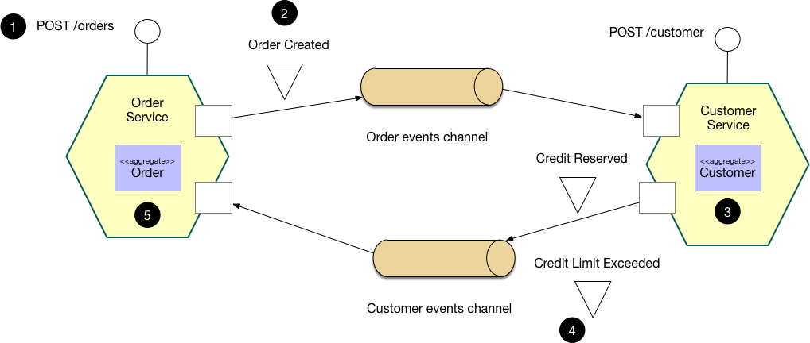

The flow is as follows:

1. The Order Service receives the POST /orders request and creates an Order in a PENDING state
2. It then emits an Order Created event
3. The Customer Service’s event handler attempts to reserve credit
4. It then emits an event indicating the outcome
5. The OrderService’s event handler either approves or rejects the Order

Implementing a choreography-based saga

Let’s take a look at how the Order Service and Customer Service implement the choreography-based Create Order saga. This example code is developed using Eventuate Tram, which is a platform that solves the distributed data management problems inherent in a microservice architecture. The complete example code is in the eventuate-tram-examples-customers-and-orders Github repository.

|  |  |
| --- | --- |
|  |  |

OrderEventConsumer and CustomerEventConsumer are the classes that define the DomainEventsBuilder for aggregate type of Order and Customer respectively.

CustomerEventConsumer is defined in the order service project and OrderEventConsumer is defined in the Customer Service Project.

reserveCredit / releaseCredit are methods that get triggered once the Order is created depending on balance availability. See the OrderEventConsumer.domainEventHandlers() that ties the OrderEventConsumer.handleOrderCreatedEvent() and OrderEventConsumer. handleOrderCancelledEvent() method to the events for OrderCreatedEvent.class and OrderCancelledEvent.class respectively.

##### Order Service

**OrderController.java**

import io.eventuate.common.json.mapper.JSonMapper;

import io.eventuate.examples.tram.ordersandcustomers.orders.domain.events.OrderDetails;

import io.eventuate.examples.tram.ordersandcustomers.orders.domain.OrderRepository;

import io.eventuate.examples.tram.ordersandcustomers.orders.service.OrderService;

import io.eventuate.examples.tram.ordersandcustomers.orders.webapi.CreateOrderResponse;

import io.eventuate.examples.tram.ordersandcustomers.orders.webapi.GetOrderResponse;

import io.eventuate.examples.tram.ordersandcustomers.orders.domain.Order;

import io.eventuate.examples.tram.ordersandcustomers.orders.webapi.CreateOrderRequest;

import io.eventuate.tram.viewsupport.rebuild.DomainSnapshotExportService;

import org.springframework.beans.factory.annotation.Autowired;

import org.springframework.http.HttpStatus;

import org.springframework.http.ResponseEntity;

import org.springframework.web.bind.annotation.*;

@RestController

public class **OrderController** {

private **OrderService** orderService;

private **OrderRepository** orderRepository;

private **DomainSnapshotExportService**<**Order**> domainSnapshotExportService;

@Autowired

public OrderController(OrderService orderService,

OrderRepository orderRepository,

DomainSnapshotExportService<Order> domainSnapshotExportService) {

this.orderService = orderService;

this.orderRepository = orderRepository;

this.domainSnapshotExportService = domainSnapshotExportService;

}

@RequestMapping(value = "/orders", method = RequestMethod.POST)

public CreateOrderResponse **createOrder(**@RequestBody CreateOrderRequest createOrderRequest**)** {

Order order = orderService.createOrder(new OrderDetails(createOrderRequest.getCustomerId(), createOrderRequest.getOrderTotal()));

return new CreateOrderResponse(order.getId());

}

@RequestMapping(value="/orders/{orderId}", method= RequestMethod.GET)

public ResponseEntity<GetOrderResponse> **getOrder(**@PathVariable Long orderId**)** {

return orderRepository

.findById(orderId)

.map(this::makeSuccessfulResponse)

.orElseGet(() -> new ResponseEntity<>(HttpStatus.NOT_FOUND));

}

@RequestMapping(value="/orders/{orderId}/cancel", method= RequestMethod.POST)

public ResponseEntity<GetOrderResponse> **cancelOrder(**@PathVariable Long orderId**)** {

Order order = orderService.cancelOrder(orderId);

return makeSuccessfulResponse(order);

}

@RequestMapping(value = "/orders/make-snapshot", method = RequestMethod.POST)

public String **makeSnapshot()** {

return JSonMapper.toJson(domainSnapshotExportService.exportSnapshots());

}

private ResponseEntity<GetOrderResponse> **makeSuccessfulResponse(**Order order**)** {

return new ResponseEntity<>(new GetOrderResponse(order.getId(), order.getState()), HttpStatus.OK);

}

}

The saga is initiated in the Order Service when the client makes a POST /orders request. The @Controller that handles the request calls OrderService.createOrder().

**OrderService.java**

import io.eventuate.examples.tram.ordersandcustomers.orders.domain.events.OrderApprovedEvent;

import io.eventuate.examples.tram.ordersandcustomers.orders.domain.events.OrderCancelledEvent;

import io.eventuate.examples.tram.ordersandcustomers.orders.domain.events.OrderDetails;

import io.eventuate.examples.tram.ordersandcustomers.orders.domain.events.OrderRejectedEvent;

import io.eventuate.examples.tram.ordersandcustomers.orders.domain.Order;

import io.eventuate.examples.tram.ordersandcustomers.orders.domain.OrderRepository;

import io.eventuate.tram.events.publisher.DomainEventPublisher;

import io.eventuate.tram.events.publisher.ResultWithEvents;

import org.springframework.transaction.annotation.Transactional;

import static java.util.Collections.singletonList;

public class **OrderService** {

private final DomainEventPublisher domainEventPublisher;

private final OrderRepository orderRepository;

public OrderService(DomainEventPublisher domainEventPublisher, OrderRepository orderRepository) {

this.domainEventPublisher = domainEventPublisher;

this.orderRepository = orderRepository;

}

@Transactional

public Order **createOrder**(OrderDetails orderDetails) {

ResultWithEvents<Order> orderWithEvents = Order.createOrder(orderDetails);

Order order = orderWithEvents.result;

orderRepository.save(order);

domainEventPublisher.publish(Order.class, order.getId(), orderWithEvents.events);

return order;

}

public void **approveOrder**(Long orderId) {

Order order = orderRepository

.findById( orderId )

.orElseThrow( () -> new IllegalArgumentException( String.format("order with id %s not found", orderId) ) );

order.noteCreditReserved();

domainEventPublisher.publish(Order.class, orderId, singletonList( new OrderApprovedEvent(order.getOrderDetails()) ) );

}

public void **rejectOrder**(Long orderId) {

Order order = orderRepository

.findById( orderId )

.orElseThrow( () -> new IllegalArgumentException( String.format("order with id %s not found", orderId)) );

order.noteCreditReservationFailed();

domainEventPublisher.publish(Order.class, orderId, singletonList( new OrderRejectedEvent(order.getOrderDetails()) ) );

}

@Transactional

public Order **cancelOrder**(Long orderId) {

Order order = orderRepository

.findById(orderId)

.orElseThrow(() -> new IllegalArgumentException( String.format("order with id %s not found", orderId) ) );

order.cancel();

domainEventPublisher.publish(Order.class, orderId, singletonList( new OrderCancelledEvent(order.getOrderDetails()) ) );

return order;

}

}

**CustomerEventConsumer.java**

import io.eventuate.examples.tram.ordersandcustomers.customers.domain.events.CustomerCreditReservationFailedEvent;

import io.eventuate.examples.tram.ordersandcustomers.customers.domain.events.CustomerCreditReservedEvent;

import io.eventuate.examples.tram.ordersandcustomers.customers.domain.events.CustomerValidationFailedEvent;

import io.eventuate.tram.events.subscriber.DomainEventEnvelope;

import io.eventuate.tram.events.subscriber.DomainEventHandlers;

import io.eventuate.tram.events.subscriber.DomainEventHandlersBuilder;

import org.springframework.beans.factory.annotation.Autowired;

public class CustomerEventConsumer {

@Autowired

private **OrderService** orderService;

public **DomainEventHandlers** domainEventHandlers() {

return DomainEventHandlersBuilder

.forAggregateType( "*io.eventuate.examples.tram.ordersandcustomers.customers.domain.Customer*" )

.onEvent( CustomerCreditReservedEvent.class, this::**handleCustomerCreditReservedEvent** )

.onEvent( CustomerCreditReservationFailedEvent.class, this::**handleCustomerCreditReservationFailedEvent** )

.onEvent( CustomerValidationFailedEvent.class, this::**handleCustomerValidationFailedEvent** )

.build();

}

private void **handleCustomerCreditReservedEvent**( DomainEventEnvelope<CustomerCreditReservedEvent> domainEventEnvelope) {

orderService.approveOrder( domainEventEnvelope.getEvent().getOrderId() );

}

private void **handleCustomerCreditReservationFailedEvent**( DomainEventEnvelope<CustomerCreditReservationFailedEvent> domainEventEnvelope) {

orderService.rejectOrder( domainEventEnvelope.getEvent().getOrderId() );

}

private void **handleCustomerValidationFailedEvent**( DomainEventEnvelope<CustomerValidationFailedEvent> domainEventEnvelope) {

orderService.rejectOrder( domainEventEnvelope.getEvent().getOrderId() );

}

}

**Order.java**

import io.eventuate.examples.tram.ordersandcustomers.orders.domain.events.OrderCreatedEvent;

import io.eventuate.examples.tram.ordersandcustomers.orders.domain.events.OrderDetails;

import io.eventuate.examples.tram.ordersandcustomers.orders.domain.events.OrderState;

import io.eventuate.tram.events.publisher.ResultWithEvents;

import javax.persistence.*;

import static java.util.Collections.singletonList;

@Entity

@Table(name="orders")

@Access(AccessType.FIELD)

public class **Order** {

@Id

@GeneratedValue(strategy = GenerationType.IDENTITY)

private Long id;

@Enumerated(EnumType.STRING)

private OrderState state;

@Embedded

private OrderDetails orderDetails;

@Version

private Long version;

public Order() { }

public Order(OrderDetails orderDetails) {

this.orderDetails = orderDetails;

this.state = OrderState.PENDING;

}

public static ResultWithEvents<Order> **createOrder**(OrderDetails orderDetails) {

Order order = new Order(orderDetails);

OrderCreatedEvent orderCreatedEvent = new OrderCreatedEvent(orderDetails);

return new ResultWithEvents<>(order, singletonList(orderCreatedEvent));

}

public Long getId() { return id; }

public void noteCreditReserved() {

this.state = OrderState.APPROVED;

}

public void noteCreditReservationFailed() {

this.state = OrderState.REJECTED;

}

public OrderState getState() { return state; }

public OrderDetails getOrderDetails() { return orderDetails; }

public void cancel() {

switch (state) {

case PENDING:

throw new PendingOrderCantBeCancelledException();

case APPROVED:

this.state = OrderState.CANCELLED;

return;

default:

throw new UnsupportedOperationException("Can't cancel in this state: " + state);

}

}

}

|  |  |
| --- | --- |
| **OrderCreatedEvent.java**  public class **OrderCreatedEvent** implements OrderEvent {  private OrderDetails orderDetails;  public OrderCreatedEvent() { }  public OrderCreatedEvent(OrderDetails orderDetails) {  this.orderDetails = orderDetails;  }  public OrderDetails getOrderDetails() {  return orderDetails;  }  } | **OrderEvent.java**  import io.eventuate.tram.events.common.DomainEvent;  public interface OrderEvent extends DomainEvent {  }  ( DomainEvent from the jar eventuate-tram-events-0.29.0.RELEASE-sources.jar  see <https://eventuate.io/> ) |
| **PendingOrderCantBeCancelledException.java**  public class PendingOrderCantBeCancelledException  extends RuntimeException {  } |  |

**ResultWithEvents.java** ( from the jar eventuate-tram-events-0.29.0.RELEASE-sources.jar see <https://eventuate.io/> )

import io.eventuate.tram.events.common.DomainEvent;

import java.util.Arrays;

import java.util.List;

public class ResultWithEvents<T> {

public final T result;

public final List<DomainEvent> events;

public ResultWithEvents(T result, List<DomainEvent> events) {

this.result = result;

this.events = events;

}

public ResultWithEvents(T result, DomainEvent... events) {

this.result = result;

this.events = Arrays.asList(events);

}

}

The createOrder() method, which is executed within a Spring-managed transaction persists the newly created Order in the database using Spring Data for JPA and publishes an OrderCreated event using the DomainEventPublisher.

The DomainEventPublisher class is provided by the Eventuate Tram framework. It implements the Transactional Outbox pattern and inserts serialized events into a MESSAGE table. The Eventuate CDC service then publishes those events to the message broker using either transaction log tailing or polling.

Here is one of the @Configuration classes for the Order Service:

**OrderConfiguration.java**

import io.eventuate.examples.tram.ordersandcustomers.orders.domain.events.OrderSnapshotEvent;

import io.eventuate.examples.tram.ordersandcustomers.orders.domain.Order;

import io.eventuate.examples.tram.ordersandcustomers.orders.domain.OrderRepository;

import io.eventuate.examples.tram.ordersandcustomers.orders.service.CustomerEventConsumer;

import io.eventuate.examples.tram.ordersandcustomers.orders.service.OrderService;

import io.eventuate.tram.events.common.DomainEvent;

import io.eventuate.tram.events.publisher.DomainEventPublisher;

import io.eventuate.tram.events.subscriber.DomainEventDispatcher;

import io.eventuate.tram.events.subscriber.DomainEventDispatcherFactory;

import io.eventuate.tram.spring.optimisticlocking.OptimisticLockingDecoratorConfiguration;

import io.eventuate.tram.viewsupport.rebuild.*;

import org.springframework.boot.autoconfigure.EnableAutoConfiguration;

import org.springframework.context.annotation.Bean;

import org.springframework.context.annotation.Configuration;

import org.springframework.context.annotation.Import;

import org.springframework.data.jpa.repository.config.EnableJpaRepositories;

@Configuration

@EnableJpaRepositories

@EnableAutoConfiguration

@Import({OptimisticLockingDecoratorConfiguration.class, SnapshotConfiguration.class}) // these two are from eventuate jar file

public class OrderConfiguration {

@Bean

public OrderService orderService(DomainEventPublisher domainEventPublisher, OrderRepository orderRepository) {

return new OrderService(domainEventPublisher, orderRepository);

}

@Bean

public CustomerEventConsumer orderEventConsumer() {

return new CustomerEventConsumer();

}

@Bean

public DomainEventDispatcher domainEventDispatcher( CustomerEventConsumer customerEventConsumer,

DomainEventDispatcherFactory domainEventDispatcherFactory) {

return domainEventDispatcherFactory.make("customerServiceEvents", customerEventConsumer.domainEventHandlers());

}

@Bean

public DomainSnapshotExportService<Order> domainSnapshotExportService(OrderRepository orderRepository,

DomainSnapshotExportServiceFactory<Order> domainSnapshotExportServiceFactory) {

return domainSnapshotExportServiceFactory.make(

Order.class,

orderRepository,

order -> {

DomainEvent domainEvent = new OrderSnapshotEvent(order.getId(),

order.getOrderDetails().getCustomerId(),

order.getOrderDetails().getOrderTotal(),

order.getState());

return new DomainEventWithEntityId(order.getId(), domainEvent);

},

new DBLockService.TableSpec("orders", "order0_"),

"MySqlReader");

}

}

**OrderWebConfiguration.java**

import io.eventuate.examples.tram.ordersandcustomers.commonswagger.CommonSwaggerConfiguration;

import org.springframework.boot.autoconfigure.http.HttpMessageConverters;

import org.springframework.context.annotation.Bean;

import org.springframework.context.annotation.ComponentScan;

import org.springframework.context.annotation.Configuration;

import org.springframework.context.annotation.Import;

import org.springframework.http.converter.HttpMessageConverter;

import org.springframework.http.converter.json.MappingJackson2HttpMessageConverter;

@Configuration

@Import(CommonSwaggerConfiguration.class)

@ComponentScan

public class OrderWebConfiguration {

@Bean

public HttpMessageConverters customConverters() {

HttpMessageConverter<?> additional = new MappingJackson2HttpMessageConverter();

return new HttpMessageConverters(additional);

}

}

**CommonSwaggerConfiguration.java**

import io.eventuate.util.spring.swagger.EventuateSwaggerConfig;

import org.springframework.context.annotation.Bean;

import org.springframework.context.annotation.Configuration;

@Configuration

public class **CommonSwaggerConfiguration** {

@Bean

public EventuateSwaggerConfig eventuateSwaggerConfig() {

return () -> "io.eventuate.examples.tram.ordersandcustomers";

}

}

**OrderRepository.java**

import org.springframework.data.repository.PagingAndSortingRepository;

public interface **OrderRepository** extends PagingAndSortingRepository<Order, Long> {

}

**DomainEventPublisher.java** ( from the jar eventuate-tram-events-0.29.0.RELEASE-sources.jar see <https://eventuate.io/> )

import io.eventuate.tram.events.common.DomainEvent;

import java.util.List;

import java.util.Map;

public interface **DomainEventPublisher** {

void publish(String aggregateType, Object aggregateId, List<DomainEvent> domainEvents);

void publish(String aggregateType, Object aggregateId, Map<String, String> headers, List<DomainEvent> domainEvents);

default void publish(Class<?> aggregateType, Object aggregateId, List<DomainEvent> domainEvents) {

publish(aggregateType.getName(), aggregateId, domainEvents);

}

}

**OrderServiceMain.java**

import io.eventuate.examples.tram.ordersandcustomers.orders.web.OrderWebConfiguration;

import org.springframework.boot.SpringApplication;

import org.springframework.boot.autoconfigure.SpringBootApplication;

import org.springframework.context.annotation.ComponentScan;

import org.springframework.context.annotation.Configuration;

import org.springframework.context.annotation.Import;

@SpringBootApplication

@Import({OrderWebConfiguration.class, OrderConfiguration.class})

public class **OrderServiceMain** {

public static void main(String[] args) {

SpringApplication.run(OrderServiceMain.class, args);

}

}

This @Configuration class @Imports the required Eventuate Tram @Configuration classes and enables Spring Data for JPA repositories. It also defines the orderService @Bean.

The Order Service also has event handlers for Customer Service events. But rather than look at those, let’s look at the event handlers for the Customer Service, which are more interesting.

**Dockerfile**

ARG baseImageVersion

FROM eventuateio/eventuate-examples-docker-images-java-example-base-image:$baseImageVersion

COPY build/libs/order-service-*.jar service.jar

**Dockerfile-maven**

FROM openjdk:8u252-slim-buster

RUN apt-get update && apt-get install -y curl

HEALTHCHECK --start-period=30s --interval=5s CMD curl -f http://localhost:8080/actuator/health || exit 1

CMD java ${JAVA_OPTS} -jar order-service-0.1.0-SNAPSHOT.jar

COPY ./target/order-service-0.1.0-SNAPSHOT.jar .

**application.properties**

spring.application.name=order-service

spring.jpa.generate-ddl=true

eventuatelocal.kafka.bootstrap.servers=${DOCKER_HOST_IP:localhost}:9092

spring.datasource.url=jdbc:mysql://${DOCKER_HOST_IP:localhost}/eventuate

spring.datasource.username=mysqluser

spring.datasource.password=mysqlpw

spring.datasource.driver-class-name=com.mysql.jdbc.Driver

cdc.service.url: http://localhost:8099

spring.sleuth.enabled=true

spring.sleuth.sampler.probability=1

spring.zipkin.base.url=http://${DOCKER_HOST_IP:localhost}:9411/

management.endpoints.web.exposure.include=*

##### Customer Service

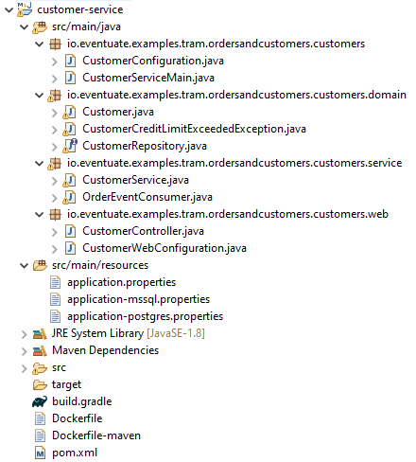

**CustomerController.java**

import io.eventuate.common.json.mapper.JSonMapper;

import io.eventuate.examples.tram.ordersandcustomers.customers.webapi.CreateCustomerRequest;

import io.eventuate.examples.tram.ordersandcustomers.customers.webapi.CreateCustomerResponse;

import io.eventuate.examples.tram.ordersandcustomers.customers.domain.Customer;

import io.eventuate.examples.tram.ordersandcustomers.customers.service.CustomerService;

import io.eventuate.tram.viewsupport.rebuild.DomainSnapshotExportService;

import org.springframework.beans.factory.annotation.Autowired;

import org.springframework.web.bind.annotation.RequestBody;

import org.springframework.web.bind.annotation.RequestMapping;

import org.springframework.web.bind.annotation.RequestMethod;

import org.springframework.web.bind.annotation.RestController;

@RestController

public class **CustomerController** {

private CustomerService customerService;

private DomainSnapshotExportService<Customer> domainSnapshotExportService;

@Autowired

public CustomerController(CustomerService customerService,

DomainSnapshotExportService<Customer> domainSnapshotExportService) {

this.customerService = customerService;

this.domainSnapshotExportService = domainSnapshotExportService;

}

@RequestMapping(value = "/customers", method = RequestMethod.POST)

public CreateCustomerResponse **createCustomer**(@RequestBody CreateCustomerRequest createCustomerRequest) {

Customer customer = customerService.createCustomer(createCustomerRequest.getName(), createCustomerRequest.getCreditLimit());

return new CreateCustomerResponse(customer.getId());

}

@RequestMapping(value = "/customers/make-snapshot", method = RequestMethod.POST)

public String **makeSnapshot()** {

return JSonMapper.toJson(domainSnapshotExportService.exportSnapshots());

}

}

The Customer Service subscribes to events published by the Order Service. It has event handlers for Order events including Order Created and Order Cancelled. The following listing shows the event handler for the Order Created event:

**OrderEventConsumer.java**

import io.eventuate.examples.tram.ordersandcustomers.orders.domain.events.OrderCancelledEvent;

import io.eventuate.examples.tram.ordersandcustomers.orders.domain.events.OrderCreatedEvent;

import io.eventuate.tram.events.subscriber.DomainEventEnvelope;

import io.eventuate.tram.events.subscriber.DomainEventHandlers;

import io.eventuate.tram.events.subscriber.DomainEventHandlersBuilder;

import org.slf4j.Logger;

import org.slf4j.LoggerFactory;

public class **OrderEventConsumer** {

private Logger logger = LoggerFactory.getLogger(getClass());

private CustomerService customerService;

public OrderEventConsumer(CustomerService customerService) {

this.customerService = customerService;

}

public DomainEventHandlers **domainEventHandlers**() {

return DomainEventHandlersBuilder

.forAggregateType("io.eventuate.examples.tram.ordersandcustomers.orders.domain.Order")

.onEvent (OrderCreatedEvent.class, this::handleOrderCreatedEvent )

.onEvent( OrderCancelledEvent.class, this::handleOrderCancelledEvent )

.build();

}

public void **handleOrderCreatedEvent**(DomainEventEnvelope<OrderCreatedEvent> domainEventEnvelope) {

OrderCreatedEvent event = domainEventEnvelope.getEvent();

customerService.reserveCredit( Long.parseLong(domainEventEnvelope.getAggregateId()),

event.getOrderDetails().getCustomerId(), event.getOrderDetails().getOrderTotal());

}

public void **handleOrderCancelledEvent**(DomainEventEnvelope<OrderCancelledEvent> domainEventEnvelope) {

customerService.releaseCredit( Long.parseLong( domainEventEnvelope.getAggregateId() ),

domainEventEnvelope.getEvent().getOrderDetails().getCustomerId() );

}

}

The event handler:

1. Attempts to retrieve the Customer from the database and reserve credit
2. If the Customer is not found, it publishes a CustomerValidationFailedEvent
3. If credit is successfully reserved, it publishes a CustomerCreditReservedEvent
4. Otherwise, if the credit limit is exceeded it publishes a CustomerCreditReservationFailedEvent

Here is the Spring @Configuration class that configures the event handlers.

**CustomerConfiguration.java**

import io.eventuate.examples.tram.ordersandcustomers.customers.domain.Customer;

import io.eventuate.examples.tram.ordersandcustomers.customers.domain.CustomerRepository;

import io.eventuate.examples.tram.ordersandcustomers.customers.domain.events.CustomerSnapshotEvent;

import io.eventuate.examples.tram.ordersandcustomers.customers.service.CustomerService;

import io.eventuate.examples.tram.ordersandcustomers.customers.service.OrderEventConsumer;

import io.eventuate.tram.events.common.DomainEvent;

import io.eventuate.tram.events.publisher.DomainEventPublisher;

import io.eventuate.tram.events.subscriber.DomainEventDispatcher;

import io.eventuate.tram.events.subscriber.DomainEventDispatcherFactory;

import io.eventuate.tram.spring.optimisticlocking.OptimisticLockingDecoratorConfiguration;

import io.eventuate.tram.viewsupport.rebuild.*;

import org.springframework.boot.autoconfigure.EnableAutoConfiguration;

import org.springframework.context.annotation.Bean;

import org.springframework.context.annotation.Configuration;

import org.springframework.context.annotation.Import;

import org.springframework.data.jpa.repository.config.EnableJpaRepositories;

@Configuration

@Import({OptimisticLockingDecoratorConfiguration.class, SnapshotConfiguration.class})

@EnableJpaRepositories

@EnableAutoConfiguration

public class **CustomerConfiguration** {

@Bean

public OrderEventConsumer orderEventConsumer(CustomerService customerService) {

return new OrderEventConsumer(customerService);

}

@Bean

public DomainEventDispatcher domainEventDispatcher(OrderEventConsumer orderEventConsumer,

DomainEventDispatcherFactory domainEventDispatcherFactory) {

return domainEventDispatcherFactory.make("orderServiceEvents", orderEventConsumer.domainEventHandlers());

}

@Bean

public CustomerService customerService(CustomerRepository customerRepository, DomainEventPublisher domainEventPublisher) {

return new CustomerService(customerRepository, domainEventPublisher);

}

@Bean

public DomainSnapshotExportService<Customer> domainSnapshotExportService(CustomerRepository customerRepository,

DomainSnapshotExportServiceFactory<Customer> domainSnapshotExportServiceFactory) {

return domainSnapshotExportServiceFactory.make(

Customer.class,

customerRepository,

customer -> {

DomainEvent domainEvent = new CustomerSnapshotEvent(customer.getId(), customer.getName(), customer.getCreditLimit());

return new DomainEventWithEntityId(customer.getId(), domainEvent);

},

new DBLockService.TableSpec("customer", "customer0_"),

"MySqlReader");

}

}

This @Configuration class’s primary responsibility is to subscribe to the Order domain events. It does that using the DomainEventDispatcherFactory, which is provided by Eventuate Tram.

**CustomerServiceMain.java**

import io.eventuate.examples.tram.ordersandcustomers.customers.web.CustomerWebConfiguration;

import org.springframework.boot.SpringApplication;

import org.springframework.boot.autoconfigure.SpringBootApplication;

import org.springframework.context.annotation.Import;

@SpringBootApplication

@Import({CustomerConfiguration.class, CustomerWebConfiguration.class})

public class CustomerServiceMain {

public static void main(String[] args) {

SpringApplication.run(CustomerServiceMain.class, args);

}

}

**CustomerWebConfiguration.java**

import io.eventuate.examples.tram.ordersandcustomers.commonswagger.CommonSwaggerConfiguration;

import org.springframework.boot.autoconfigure.http.HttpMessageConverters;

import org.springframework.context.annotation.Bean;

import org.springframework.context.annotation.ComponentScan;

import org.springframework.context.annotation.Configuration;

import org.springframework.context.annotation.Import;

import org.springframework.http.converter.HttpMessageConverter;

import org.springframework.http.converter.json.MappingJackson2HttpMessageConverter;

@Configuration

@ComponentScan

@Import(CommonSwaggerConfiguration.class)

public class CustomerWebConfiguration {

@Bean

public HttpMessageConverters customConverters() {

HttpMessageConverter<?> additional = new MappingJackson2HttpMessageConverter();

return new HttpMessageConverters(additional);

}

}

As you have just seen, the Create Order saga is implemented by a simple exchange of events between the Order Service and the Customer Service. However, while this example is quite straightforward, choreography-based sagas have several drawbacks. For example, the implementation of the saga is scattered around the participating services, which can make more complex sagas difficult to understand. Please see my book for a more detailed explanation of the choreography-based sagas.

**CustomerService.java**

import io.eventuate.examples.tram.ordersandcustomers.common.domain.Money;

import io.eventuate.examples.tram.ordersandcustomers.customers.domain.Customer;

import io.eventuate.examples.tram.ordersandcustomers.customers.domain.CustomerCreditLimitExceededException;

import io.eventuate.examples.tram.ordersandcustomers.customers.domain.CustomerRepository;

import io.eventuate.examples.tram.ordersandcustomers.customers.domain.events.CustomerCreditReservationFailedEvent;

import io.eventuate.examples.tram.ordersandcustomers.customers.domain.events.CustomerCreditReservedEvent;

import io.eventuate.examples.tram.ordersandcustomers.customers.domain.events.CustomerValidationFailedEvent;

import io.eventuate.tram.events.publisher.DomainEventPublisher;

import io.eventuate.tram.events.publisher.ResultWithEvents;

import org.slf4j.Logger;

import org.slf4j.LoggerFactory;

import org.springframework.beans.factory.annotation.Autowired;

import javax.transaction.Transactional;

import java.util.Collections;

import java.util.Optional;

public class **CustomerService** {

private Logger logger = LoggerFactory.getLogger(getClass());

private **CustomerRepository** customerRepository;

private **DomainEventPublisher** domainEventPublisher;

public CustomerService(CustomerRepository customerRepository, DomainEventPublisher domainEventPublisher) {

this.customerRepository = customerRepository;

this.domainEventPublisher = domainEventPublisher;

}

@Transactional

public Customer **createCustomer**(String name, Money creditLimit) {

ResultWithEvents<Customer> customerWithEvents = Customer.create(name, creditLimit);

Customer customer = customerRepository.save(customerWithEvents.result);

domainEventPublisher.publish(Customer.class, customer.getId(), customerWithEvents.events);

return customer;

}

void **reserveCredit**(long orderId, long customerId, Money orderTotal) {

Optional<Customer> possibleCustomer = customerRepository.findById(customerId);

if (!possibleCustomer.isPresent()) {

logger.info("Non-existent customer: {}", customerId);

domainEventPublisher.publish( Customer.class, customerId, Collections.singletonList(new CustomerValidationFailedEvent(orderId)));

return;

}

Customer customer = possibleCustomer.get();

try {

customer.reserveCredit(orderId, orderTotal);

CustomerCreditReservedEvent customerCreditReservedEvent = new CustomerCreditReservedEvent(orderId);

domainEventPublisher.publish( Customer.class, customer.getId(), Collections.singletonList(customerCreditReservedEvent));

} catch (CustomerCreditLimitExceededException e) {

CustomerCreditReservationFailedEvent customerCreditReservationFailedEvent =

new CustomerCreditReservationFailedEvent(orderId);

domainEventPublisher.publish(Customer.class, customer.getId(), Collections.singletonList(customerCreditReservationFailedEvent));

}

}

void **releaseCredit**(long orderId, long customerId) {

Customer customer = customerRepository.findById(customerId).get();

customer.unreserveCredit(orderId);

}

}

**application.properties**

spring.application.name=customer-service

spring.jpa.generate-ddl=true

spring.datasource.hikari.connectionTimeout=10000

spring.datasource.hikari.idleTimeout=10000

spring.datasource.hikari.maximumPoolSize=100

spring.datasource.hikari.minimumIdle=3

eventuatelocal.kafka.bootstrap.servers=${DOCKER_HOST_IP:localhost}:9092

spring.datasource.url=jdbc:mysql://${DOCKER_HOST_IP:localhost}/eventuate

spring.datasource.username=mysqluser

spring.datasource.password=mysqlpw

spring.datasource.driver-class-name=com.mysql.jdbc.Driver

cdc.service.url: http://localhost:8099

spring.sleuth.enabled=true

spring.sleuth.sampler.probability=1

spring.zipkin.base.url=http://${DOCKER_HOST_IP:localhost}:9411/

management.endpoints.web.exposure.include=*

**application-mssql.properties**

spring.datasource.url=jdbc:sqlserver://${DOCKER_HOST_IP:localhost}:1433;databaseName=eventuate

spring.datasource.username=sa

spring.datasource.password=Eventuate123!

spring.datasource.driver-class-name=com.microsoft.sqlserver.jdbc.SQLServerDriver

**application-postgres.properties**

spring.datasource.url=jdbc:postgresql://${DOCKER_HOST_IP:localhost}/eventuate

spring.datasource.username=eventuate

spring.datasource.password=eventuate

spring.datasource.driver-class-name=org.postgresql.Driver

**Dockerfile**

ARG baseImageVersion

FROM eventuateio/eventuate-examples-docker-images-java-example-base-image:$baseImageVersion

COPY build/libs/customer-service-*.jar service.jar

**Dockerfile-maven**

FROM openjdk:8u252-slim-buster

RUN apt-get update && apt-get install -y curl

HEALTHCHECK --start-period=30s --interval=5s CMD curl -f http://localhost:8080/actuator/health || exit 1

CMD java ${JAVA_OPTS} -jar customer-service-0.1.0-SNAPSHOT.jar

COPY ./target/customer-service-0.1.0-SNAPSHOT.jar .

**pom.xml**

<project xmlns="http://maven.apache.org/POM/4.0.0" xmlns:xsi="http://www.w3.org/2001/XMLSchema-instance"

xsi:schemaLocation="http://maven.apache.org/POM/4.0.0 http://maven.apache.org/maven-v4_0_0.xsd">

<parent>

<groupId>io.eventuate.tram.examples.customers.and.orders</groupId>

<artifactId>eventuate-tram-examples-customers-and-orders</artifactId>

<version>0.1.0-SNAPSHOT</version>

</parent>

<modelVersion>4.0.0</modelVersion>

<artifactId>customer-service</artifactId>

<packaging>jar</packaging>

<name>customer-service</name>

<dependencies>

<dependency>

<groupId>io.eventuate.messaging.kafka</groupId>

<artifactId>eventuate-messaging-kafka-spring-producer</artifactId>

<version>${eventuateMessagingKafkaVersion}</version>

</dependency>

<dependency>

<groupId>javax.xml.bind</groupId>

<artifactId>jaxb-api</artifactId>

<version>2.3.1</version>

</dependency>

<dependency>

<groupId>org.springframework.boot</groupId>

<artifactId>spring-boot-starter-jdbc</artifactId>

<version>${springBootVersion}</version>

</dependency>

<dependency>

<groupId>io.eventuate.tram.examples.customers.and.orders</groupId>

<artifactId>common-swagger</artifactId>

<version>0.1.0-SNAPSHOT</version>

</dependency>

<dependency>

<groupId>io.eventuate.tram.examples.customers.and.orders</groupId>

<artifactId>customer-service-api-messaging</artifactId>

<version>0.1.0-SNAPSHOT</version>

</dependency>

<dependency>

<groupId>io.eventuate.tram.examples.customers.and.orders</groupId>

<artifactId>order-service-api-messaging</artifactId>

<version>0.1.0-SNAPSHOT</version>

</dependency>

<dependency>

<groupId>io.eventuate.tram.core</groupId>

<artifactId>eventuate-tram-spring-jdbc-kafka</artifactId>

</dependency>

<dependency>

<groupId>io.eventuate.tram.core</groupId>

<artifactId>eventuate-tram-spring-events</artifactId>

</dependency>

<dependency>

<groupId>io.eventuate.tram.core</groupId>

<artifactId>eventuate-tram-spring-optimistic-locking</artifactId>

</dependency>

<dependency>

<groupId>io.eventuate.tram.core</groupId>

<artifactId>eventuate-tram-spring-events-starter</artifactId>

</dependency>

<dependency>

<groupId>mysql</groupId>

<artifactId>mysql-connector-java</artifactId>

<version>5.1.36</version>

</dependency>

<dependency>

<groupId>org.postgresql</groupId>

<artifactId>postgresql</artifactId>

<version>9.4-1200-jdbc41</version>

<exclusions>

<exclusion>

<groupId>org.slf4j</groupId>

<artifactId>slf4j-simple</artifactId>

</exclusion>

</exclusions>

</dependency>

<dependency>

<groupId>com.google.guava</groupId>

<artifactId>guava</artifactId>

<version>20.0</version>

</dependency>

<dependency>

<groupId>org.springframework.retry</groupId>

<artifactId>spring-retry</artifactId>

<exclusions>

<exclusion>

<groupId>org.springframework</groupId>

<artifactId>spring-core</artifactId>

</exclusion>

</exclusions>

</dependency>

<dependency>

<groupId>org.springframework.boot</groupId>

<artifactId>spring-boot-starter-data-jpa</artifactId>

<version>${springBootVersion}</version>

</dependency>

<dependency>

<groupId>io.eventuate.tram.view.support</groupId>

<artifactId>eventuate-tram-view-support-rebuild</artifactId>

<version>${eventuateTramViewSupportVersion}</version>

</dependency>

<dependency>

<groupId>io.eventuate.tram.examples.customers.and.orders</groupId>

<artifactId>customer-service-api-web</artifactId>

<version>0.1.0-SNAPSHOT</version>

</dependency>

<dependency>

<groupId>org.springframework.boot</groupId>

<artifactId>spring-boot-starter</artifactId>

<version>${springBootVersion}</version>

</dependency>

<dependency>

<groupId>org.springframework.boot</groupId>

<artifactId>spring-boot-starter-actuator</artifactId>

<version>${springBootVersion}</version>

</dependency>

<dependency>

<groupId>org.springframework.boot</groupId>

<artifactId>spring-boot-starter-web</artifactId>

<version>${springBootVersion}</version>

</dependency>

<dependency>

<groupId>com.fasterxml.jackson.core</groupId>

<artifactId>jackson-core</artifactId>

<version>2.10.2</version>

</dependency>

<dependency>

<groupId>com.fasterxml.jackson.core</groupId>

<artifactId>jackson-databind</artifactId>

<version>2.10.2</version>

</dependency>

</dependencies>

<build>

<plugins>

<plugin>

<groupId>org.springframework.boot</groupId>

<artifactId>spring-boot-maven-plugin</artifactId>

<version>${springBootVersion}</version>

<executions>

<execution>

<goals>

<goal>repackage</goal>

</goals>

</execution>

</executions>

</plugin>

<plugin>

<groupId>org.apache.maven.plugins</groupId>

<artifactId>maven-compiler-plugin</artifactId>

<configuration>

<source>${java.version}</source>

<target>${java.version}</target>

</configuration>

</plugin>

</plugins>

</build>

</project>

##### Order Service Api Messaging

|  |  |  |
| --- | --- | --- |
| public class **OrderApprovedEvent**  implements OrderEvent {  private OrderDetails orderDetails;  public OrderApprovedEvent() {  }  public OrderApprovedEvent(OrderDetails orderDetails) {  this.orderDetails = orderDetails;  }  public OrderDetails getOrderDetails() {  return orderDetails;  }  } | public class **OrderCancelConfirmedEvent**  implements OrderEvent {  private OrderDetails orderDetails;  public OrderCancelConfirmedEvent() {  }  public OrderCancelConfirmedEvent(  OrderDetails orderDetails) {  this.orderDetails = orderDetails;  }  public OrderDetails getOrderDetails() {  return orderDetails;  }  } | public class **OrderCancelledEvent**  implements OrderEvent {  private OrderDetails orderDetails;  public OrderCancelledEvent() {  }  public OrderCancelledEvent(  OrderDetails orderDetails) {  this.orderDetails = orderDetails;  }  public OrderDetails getOrderDetails() {  return orderDetails;  }  } |
| public class **OrderCreatedEvent**  implements OrderEvent {  private OrderDetails orderDetails;  public OrderCreatedEvent() {  }  public OrderCreatedEvent(OrderDetails  orderDetails) {  this.orderDetails = orderDetails;  }  public OrderDetails getOrderDetails() {  return orderDetails;  }  }  public enum **OrderState** {  PENDING, APPROVED, REJECTED, CANCELLED  } | import io.eventuate.examples.tram  .ordersandcustomers.common.domain.Money;  import javax.persistence.Embeddable;  import javax.persistence.Embedded;  @Embeddable  public class **OrderDetails** {  private Long customerId;  @Embedded  private Money orderTotal;  public OrderDetails() {  }  public OrderDetails(Long customerId,  Money orderTotal) {  this.customerId = customerId;  this.orderTotal = orderTotal;  }  public Long getCustomerId() {  return customerId;  }  public Money getOrderTotal() {  return orderTotal;  }  } | import io.eventuate.tram.events  .common.DomainEvent;  public interface **OrderEvent**  extends DomainEvent {  }  public class **OrderRejectedEvent**  implements OrderEvent {  private OrderDetails orderDetails;  public OrderRejectedEvent() {  }  public OrderRejectedEvent(OrderDetails  orderDetails) {  this.orderDetails = orderDetails;  }  public OrderDetails getOrderDetails() {  return orderDetails;  }  } |
| **OrderSnapshotEvent.java**  import io.eventuate.examples.tram  .ordersandcustomers.common.domain.Money;  import io.eventuate.tram.events  .common.DomainEvent;  public class OrderSnapshotEvent implements DomainEvent {  private Long id;  private Long customerId;  private Money orderTotal;  private OrderState orderState;  public OrderSnapshotEvent() {  }  public OrderSnapshotEvent(Long id,  Long customerId, Money orderTotal,  OrderState orderState) {  this.id = id;  this.customerId = customerId;  this.orderTotal = orderTotal;  this.orderState = orderState;  }  public Long getId() {  return id;  }  public void setId(Long id) {  this.id = id;  }  public Long getCustomerId() {  return customerId;  }  public void setCustomerId(Long customerId) {  this.customerId = customerId;  }  public Money getOrderTotal() {  return orderTotal;  }  public void setOrderTotal(Money orderTotal) {  this.orderTotal = orderTotal;  }  public OrderState getOrderState() {  return orderState;  }  public void setOrderState(OrderState  orderState) {  this.orderState = orderState;  }  } | **pom.xml**  <project xmlns="http://maven.apache.org/POM/4.0.0" xmlns:xsi="http://www.w3.org/2001/XMLSchema-instance"  xsi:schemaLocation="http://maven.apache.org/POM/4.0.0 http://maven.apache.org/maven-v4_0_0.xsd">  <parent>  <groupId>io.eventuate.tram.examples.customers.and.orders</groupId>  <artifactId>eventuate-tram-examples-customers-and-orders</artifactId>  <version>0.1.0-SNAPSHOT</version>  </parent>  <modelVersion>4.0.0</modelVersion>  <artifactId>order-service-api-messaging</artifactId>  <packaging>jar</packaging>  <dependencies>  <dependency>  <groupId>io.eventuate.tram.examples.customers.and.orders</groupId>  <artifactId>common</artifactId>  <version>0.1.0-SNAPSHOT</version>  </dependency>  </dependencies>  <build>  <plugins>  <plugin>  <groupId>org.apache.maven.plugins</groupId>  <artifactId>maven-compiler-plugin</artifactId>  <configuration>  <source>${java.version}</source>  <target>${java.version}</target>  </configuration>  </plugin>  </plugins>  </build>  </project> | |

##### Order Service Api Web

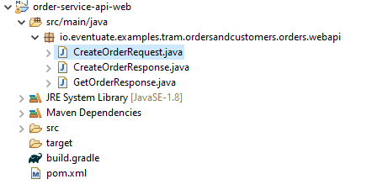

**CreateOrderRequest.java**

import io.eventuate.examples.tram.ordersandcustomers.common.domain.Money;

public class CreateOrderRequest {

private Money orderTotal;

private Long customerId;

public CreateOrderRequest() { }

public CreateOrderRequest(Long customerId, Money orderTotal) {

this.customerId = customerId;

this.orderTotal = orderTotal;

}

public Money getOrderTotal() { return orderTotal; }

public Long getCustomerId() { return customerId; }

}

**CreateOrderResponse.java**

public class CreateOrderResponse {

private Long orderId;

public CreateOrderResponse() { }

public CreateOrderResponse(Long orderId) {

this.orderId = orderId;

}

public Long getOrderId() {

return orderId;

}

}

**GetOrderResponse.java**

import io.eventuate.examples.tram.ordersandcustomers.orders.domain.events.OrderState;

public class GetOrderResponse {

private Long orderId;

private OrderState orderState;

public GetOrderResponse() { }

public GetOrderResponse(Long orderId, OrderState orderState) {

this.orderId = orderId;

this.orderState = orderState;

}

public Long getOrderId() { return orderId; }

public void setOrderId(Long orderId) { this.orderId = orderId; }

public OrderState getOrderState() { return orderState; }

public void setOrderState(OrderState orderState) { this.orderState = orderState; }

}

##### Customer Service Api Messaging

|  |  |
| --- | --- |
|  | **pom.xml**  <project xmlns="http://maven.apache.org/POM/4.0.0" . . .>  <parent>  <groupId>io.eventuate.tram.examples.customers.and.orders</groupId>  <artifactId>eventuate-tram-examples-customers-and-orders</artifactId>  <version>0.1.0-SNAPSHOT</version>  </parent>  <modelVersion>4.0.0</modelVersion>  <artifactId>order-service-api-messaging</artifactId>  <packaging>jar</packaging>  <dependencies>  <dependency>  <groupId>io.eventuate.tram.examples.customers.and.orders</groupId>  <artifactId>common</artifactId>  <version>0.1.0-SNAPSHOT</version>  </dependency>  </dependencies>  <build>  <plugins>  <plugin>  <groupId>org.apache.maven.plugins</groupId>  <artifactId>maven-compiler-plugin</artifactId>  <configuration>  <source>${java.version}</source>  <target>${java.version}</target>  </configuration>  </plugin>  </plugins>  </build>  </project> |
| public abstract class **AbstractCustomerOrderEvent**  implements CustomerEvent {  protected Long orderId;  protected AbstractCustomerOrderEvent(Long orderId) {  this.orderId = orderId;  }  protected AbstractCustomerOrderEvent() {  }  public Long getOrderId() {  return orderId;  }  public void setOrderId(Long orderId) {  this.orderId = orderId;  }  }  public class **CustomerCreditReleasedEvent**  extends AbstractCustomerOrderEvent {  public CustomerCreditReleasedEvent() {  }  public CustomerCreditReleasedEvent(Long orderId) {  super(orderId);  }  } | import io.eventuate.examples.tram.ordersandcustomers  .common.domain.Money;  public class **CustomerCreatedEvent** implements CustomerEvent {  private String name;  private Money creditLimit;  public CustomerCreatedEvent() {  }  public CustomerCreatedEvent(String name,  Money creditLimit) {  this.name = name;  this.creditLimit = creditLimit;  }  public String getName() {  return name;  }  public void setName(String name) {  this.name = name;  }  public Money getCreditLimit() {  return creditLimit;  }  public void setCreditLimit(Money  creditLimit) {  this.creditLimit = creditLimit;  }  } |
| public class **CustomerCreditReservationFailedEvent**  extends AbstractCustomerOrderEvent {  public CustomerCreditReservationFailedEvent() {  }  public CustomerCreditReservationFailedEvent(Long  orderId) {  super(orderId);  }  }  public class **CustomerCreditReservedEvent**  extends AbstractCustomerOrderEvent {  public CustomerCreditReservedEvent() {  }  public CustomerCreditReservedEvent(Long orderId) {  super(orderId);  }  }  import io.eventuate.tram.events.common.DomainEvent;  public interface **CustomerEvent** extends DomainEvent {  }  public class CustomerValidationFailedEvent  **extends AbstractCustomerOrderEvent** {  public CustomerValidationFailedEvent(Long orderId) {  super(orderId);  }  public CustomerValidationFailedEvent() {  }  } | import io.eventuate.examples.tram.ordersandcustomers.common.domain.Money;  import io.eventuate.tram.events.common.DomainEvent;  public class CustomerSnapshotEvent implements DomainEvent {  private Long id;  private String name;  private Money creditLimit;  public CustomerSnapshotEvent() {  }  public CustomerSnapshotEvent(Long id, String name, Money creditLimit) {  this.id = id;  this.name = name;  this.creditLimit = creditLimit;  }  public Long getId() { return id; }  public void setId(Long id) { this.id = id; }  public String getName() { return name; }  public void setName(String name) { this.name = name; }  public Money getCreditLimit() { return creditLimit; }  public void setCreditLimit(Money creditLimit) { this.creditLimit = creditLimit; }  } |

##### Customer Service Api Web

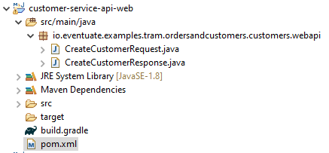

**CreateCustomerRequest.java**

import io.eventuate.examples.tram.ordersandcustomers.common.domain.Money;

public class CreateCustomerRequest {

private String name;

private Money creditLimit;

public CreateCustomerRequest() {

}

public CreateCustomerRequest(String name, Money creditLimit) {

this.name = name;

this.creditLimit = creditLimit;

}

public String getName() {

return name;

}

public Money getCreditLimit() {

return creditLimit;

}

}

**CreateCustomerResponse.java**

public class CreateCustomerResponse {

private Long customerId;

public CreateCustomerResponse() { }

public CreateCustomerResponse(Long customerId) {

this.customerId = customerId;

}

public Long getCustomerId() {

return customerId;

}

public void setCustomerId(Long customerId) {

this.customerId = customerId;

}

}

#### Orchestration – SAGA Pattern

As I described in part 2, an orchestration-based saga has an orchestrator that tells the saga’s participants what to do. The saga orchestrator communicates with the participants using request/asynchronous response-style interaction. To execute a saga step, it sends a command message to a participant telling it what operation to perform. After the saga participant has performed the operation, it sends a reply message to the orchestrator. The orchestrator then processes the reply message and determines which saga step to perform next.

For example, the following diagram shows the flow for the orchestration-based Create Order Saga.

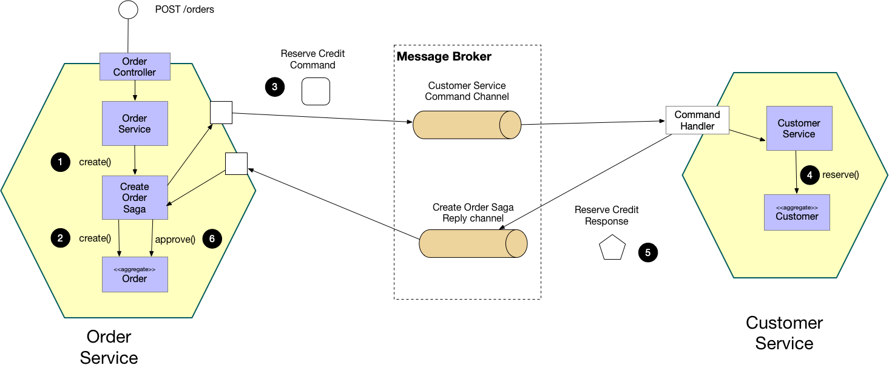

The flow is as follows:

1. The Order Service handles the POST /orders request by creating the Create Order Saga orchestrator
2. The saga orchestrator creates an Order in the PENDING state
3. It then sends a Reserve Credit command to the Customer Service
4. The Customer Service attempts to reserve credit
5. It then sends back a reply message indicating the outcome
6. The saga orchestrator either approves or rejects the Order

Implementing an orchestration-based saga

Let’s take a look at how the Order Service and Customer Service implement the orchestration version of the Create Order Saga. The complete example code is in the eventuate-tram-sagas-examples-customers-and-orders Github repository.

Design overview

The Order Service defines CreateOrderSaga class, which orchestrates the saga. The Customer Service implements a command handler, which process the command message sent by the Create Order Saga. The following diagram shows the design:

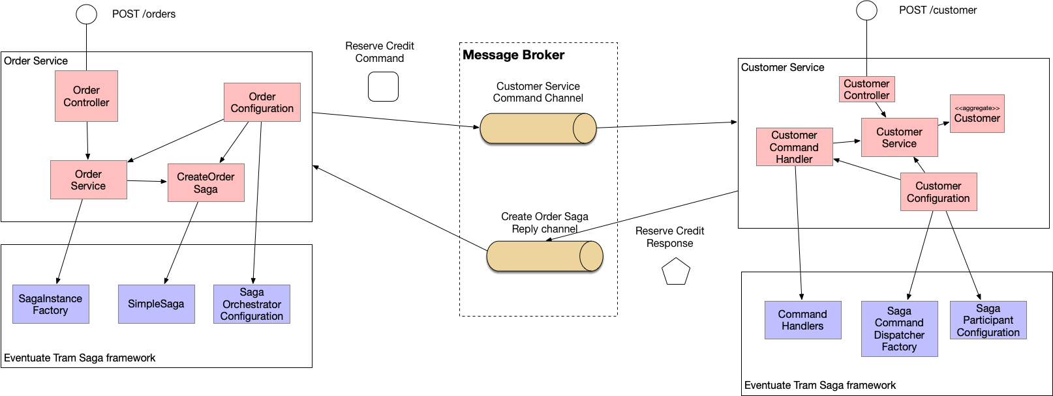

About the Eventuate Tram Saga framework

This example code is developed using using Eventuate Tram Sagas, which is a framework for implementing orchestration-based sagas. This framework has three main features:

Provides a DSL for defining saga orchestrators

Provides an API for defining command message handlers in saga participants

Manages the execution of sagas including persisting their state in the database and communicating with saga participants

Let’s first look at how this framework is used by the Order Service.

##### Order Service

The Order Service consists of the following key classes:

* OrderController - handles the POST /order request
* OrderService - creates the Create Order Saga
* SagaInstanceFactory - provided by the Eventuate Tram Saga framework and used by the OrderService to instantiate a Create Order Saga
* CreateOrderSaga - a singleton @Bean that defines the flow of the Create Order Saga
* CreateOrderSagaData - the Create Order Saga’s persistent data

As with the choreography-based version, the Create Order Saga is initiated in the Order Service when the client makes a POST /orders request. The OrderController @Controller invokes OrderService.createOrder(). But rather than creating an Order and publishing an event, this version of that method creates an instance of the saga orchestrator:

|  |  |
| --- | --- |
|  |  |

**OrderService.java**

import io.eventuate.examples.tram.sagas.ordersandcustomers.orders.api.messaging.common.OrderDetails;

import io.eventuate.examples.tram.sagas.ordersandcustomers.orders.api.messaging.common.RejectionReason;

import io.eventuate.examples.tram.sagas.ordersandcustomers.orders.domain.Order;

import io.eventuate.examples.tram.sagas.ordersandcustomers.orders.domain.OrderRepository;

import org.springframework.beans.factory.annotation.Autowired;

public class **OrderService** {

@Autowired

private OrderRepository orderRepository;

public OrderService(**OrderRepository** orderRepository) {

this.orderRepository = orderRepository;

}

public Order **createOrder**(OrderDetails orderDetails) {

Order order = Order.createOrder(orderDetails);

orderRepository.save(order);

return order;

}

public void **approveOrder**(Long orderId) {

orderRepository.findById(orderId).get().approve();

}

public void **rejectOrder**(Long orderId, RejectionReason rejectionReason) {

orderRepository.findById(orderId).get().reject(rejectionReason);

}

}

**OrderRepository.java**

import org.springframework.data.repository.CrudRepository;

import java.util.List;

public interface **OrderRepository** extends CrudRepository<Order, Long> {

List<Order> findAllByOrderDetailsCustomerId(Long customerId);

}

The createOrder() method first creates an CreateOrderSagaData initialized with the order’s details. Next, it creates and starts an instance of the Create Order Saga by calling SagaInstanceFactory.create(), which is provided by the Eventuate Tram Saga framework. Finally, createOrder() method retrieves the Order created by the first step of the saga.

The CreateOrderSaga class

The CreateOrderSaga class defines the flow of the Create Order Saga. The following listing shows the key part of this class:

**CreateOrderSaga.java**

import io.eventuate.examples.tram.sagas.ordersandcustomers.commondomain.Money;

import io.eventuate.examples.tram.sagas.ordersandcustomers.customers.api.messaging.commands.ReserveCreditCommand;

import io.eventuate.examples.tram.sagas.ordersandcustomers.customers.api.messaging.replies.CustomerCreditLimitExceeded;

import io.eventuate.examples.tram.sagas.ordersandcustomers.customers.api.messaging.replies.CustomerNotFound;

import io.eventuate.examples.tram.sagas.ordersandcustomers.orders.api.messaging.sagas.createorder.CreateOrderSagaData;

import io.eventuate.examples.tram.sagas.ordersandcustomers.orders.api.messaging.common.RejectionReason;

import io.eventuate.examples.tram.sagas.ordersandcustomers.orders.domain.Order;

import io.eventuate.tram.commands.consumer.CommandWithDestination;

import io.eventuate.tram.sagas.orchestration.SagaDefinition;

import io.eventuate.tram.sagas.simpledsl.SimpleSaga;

import static io.eventuate.tram.commands.consumer.CommandWithDestinationBuilder.send;

public class **CreateOrderSaga** implements SimpleSaga<CreateOrderSagaData> {

private OrderService orderService;

public CreateOrderSaga(OrderService orderService) {

this.orderService = orderService;

}

private SagaDefinition<CreateOrderSagaData> sagaDefinition =

step()

.invokeLocal(this::**create**)

.withCompensation(this::**reject**)

.step()

.invokeParticipant(this::**reserveCredit**)

.onReply(CustomerNotFound.class, this::**handleCustomerNotFound**)

.onReply(CustomerCreditLimitExceeded.class, this::**handleCustomerCreditLimitExceeded**)

.step()

.invokeLocal(this::**approve**)

.build();

private void handleCustomerNotFound(CreateOrderSagaData data, CustomerNotFound reply) {

data.setRejectionReason(RejectionReason.UNKNOWN_CUSTOMER);

}

private void handleCustomerCreditLimitExceeded(CreateOrderSagaData data, CustomerCreditLimitExceeded reply) {

data.setRejectionReason(RejectionReason.INSUFFICIENT_CREDIT);

}

@Override

public SagaDefinition<CreateOrderSagaData> getSagaDefinition() {

return this.sagaDefinition;

}

private void **create**(CreateOrderSagaData data) {

Order order = orderService.createOrder(data.getOrderDetails());

data.setOrderId(order.getId());

}

private CommandWithDestination **reserveCredit**(CreateOrderSagaData data) {

long orderId = data.getOrderId();

Long customerId = data.getOrderDetails().getCustomerId();

Money orderTotal = data.getOrderDetails().getOrderTotal();

return send(new ReserveCreditCommand(customerId, orderId, orderTotal))

.to("customerService")

.build();

}

private void **approve**(CreateOrderSagaData data) {

orderService.approveOrder(data.getOrderId());

}

private void **reject**(CreateOrderSagaData data) {

orderService.rejectOrder(data.getOrderId(), data.getRejectionReason());

}

}

This saga defines three steps, which mirror the definition of the Create Order Saga in part 1. Each step consists of a transaction and possibly a compensating transaction. The Eventuate Tram saga orchestration framework executes the transactions in top to bottom order. If a transaction fails, it then executes the compensating transactions in bottom to top order. Before looking at each of the steps in detail, let’s first examine the CreateOrderSagaData class.

The CreateOrderSagaData class defines the persistent state of the Create Order Saga:

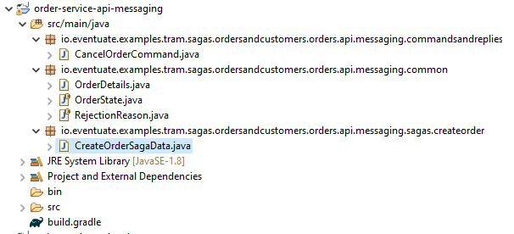

**CreateOrderSagaData.java**

import io.eventuate.examples.tram.sagas.ordersandcustomers.orders.api.messaging.common.OrderDetails;

import io.eventuate.examples.tram.sagas.ordersandcustomers.orders.api.messaging.common.RejectionReason;

public class **CreateOrderSagaData** {

private OrderDetails orderDetails;

private Long orderId;

private RejectionReason rejectionReason;

public CreateOrderSagaData(OrderDetails orderDetails) {

this.orderDetails = orderDetails;

}

public CreateOrderSagaData() {

}

public Long getOrderId() {

return orderId;

}

public OrderDetails getOrderDetails() {

return orderDetails;

}

public void setOrderId(Long orderId) {

this.orderId = orderId;

}

public void setRejectionReason(RejectionReason rejectionReason) {

this.rejectionReason = rejectionReason;

}

public RejectionReason getRejectionReason() {

return rejectionReason;

}

}

The OrderService creates a CreateOrderSagaData containing the order’s details. The orderId and rejectionReason fields are updated during the execution of the saga. There is one instance of this class for each instance of the Create Order Saga. The Eventuate Tram Saga framework persists each CreateOrderSagaData instance in the database.

As noted above, the CreateOrderSaga class defines a saga consisting of three steps. The first and third steps of the saga perform local updates in the Order Service. The first step consists of a transaction that creates an Order and a compensating transaction that rejects the Order:

public class CreateOrderSaga

private SagaDefinition<CreateOrderSagaData> sagaDefinition =

step()

.invokeLocal(this::create)

.withCompensation(this::reject)

...;

private void create(CreateOrderSagaData data) {

Order order = Order.createOrder(data.getOrderDetails());

orderRepository.save(order);

data.setOrderId(order.getId());

}

public void reject(CreateOrderSagaData data) {

orderRepository.findById(data.getOrderId()).get().reject(data.getRejectionReason());

}

The create() method creates an Order, saves it in the database and records its ID in the CreateOrderSagaData. The reject() method rejects the order and records the reason for its rejection.

The third step of the saga approves the Order:

public class CreateOrderSaga

private SagaDefinition<CreateOrderSagaData> sagaDefinition =

...

.step()

.invokeLocal(this::approve)

.build();

private void approve(CreateOrderSagaData data) {

orderRepository.findById(data.getOrderId()).get().approve();

}

...

The approve() method loads the Order and calls its approve() method.

The second step of the Create Order Saga consists of a transaction that reserves credit. It sends a ReserveCredit command to the Customer Service:

public class CreateOrderSaga

private SagaDefinition<CreateOrderSagaData> sagaDefinition =

...

.step()

.invokeParticipant(this::reserveCredit)

.onReply(CustomerNotFound.class, this::handleCustomerNotFound)

.onReply(CustomerCreditLimitExceeded.class, this::handleCustomerCreditLimitExceeded)

... ;

private CommandWithDestination reserveCredit(CreateOrderSagaData data) {

long orderId = data.getOrderId();

Long customerId = data.getOrderDetails().getCustomerId();

Money orderTotal = data.getOrderDetails().getOrderTotal();

return send(new ReserveCreditCommand(customerId, orderId, orderTotal))

.to("customerService")

.build();

}

private void handleCustomerNotFound(CreateOrderSagaData data,

CustomerNotFound reply) {

data.setRejectionReason(RejectionReason.UNKNOWN_CUSTOMER);

}

private void handleCustomerCreditLimitExceeded(

CreateOrderSagaData data, CustomerCreditLimitExceeded reply) {

data.setRejectionReason(RejectionReason.INSUFFICIENT_CREDIT);

}

The reserveCredit() method returns a CommandWithDestination, which tells the Eventuate Tram Saga framework which command message so send and to where. This step of the saga defines two reply handlers, which are invoked by the framework when it receives a reply to the command message. These methods record why the credit reservation attempt failed.

Here is the @Configuration class that configures the Create Order Saga:

@Configuration

...

@Import(SagaOrchestratorConfiguration.class)

public class OrderConfiguration {

@Bean

public OrderService orderService(OrderRepository orderRepository,

SagaInstanceFactory sagaInstanceFactory, CreateOrderSaga createOrderSaga) {

return new OrderService(orderRepository, sagaInstanceFactory, createOrderSaga);

}

@Bean

public CreateOrderSaga createOrderSaga() {

return new CreateOrderSaga();

}

}

This @Configuration class @Imports the Eventuate Tram Saga @Configuration class that configures the @Beans for a saga orchestration. It also defines the orderService and the createOrderSaga @Beans. Let’s now look at how the Customer Service participates in the Create Order Saga

Complete Code

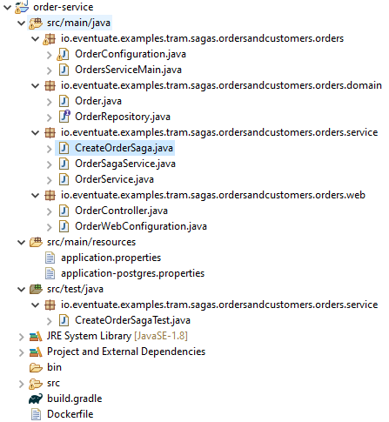

**OrderController.java**

import io.eventuate.examples.tram.sagas.ordersandcustomers.orders.api.messaging.common.OrderDetails;

import io.eventuate.examples.tram.sagas.ordersandcustomers.orders.domain.Order;

import io.eventuate.examples.tram.sagas.ordersandcustomers.orders.domain.OrderRepository;

import io.eventuate.examples.tram.sagas.ordersandcustomers.orders.service.OrderSagaService;

import io.eventuate.examples.tram.sagas.ordersandcustomers.orders.api.web.CreateOrderRequest;

import io.eventuate.examples.tram.sagas.ordersandcustomers.orders.api.web.CreateOrderResponse;

import io.eventuate.examples.tram.sagas.ordersandcustomers.orders.api.web.GetOrderResponse;

import org.springframework.beans.factory.annotation.Autowired;

import org.springframework.http.HttpStatus;

import org.springframework.http.ResponseEntity;

import org.springframework.web.bind.annotation.*;

import java.util.List;

import java.util.stream.Collectors;

@RestController

public class OrderController {

private OrderSagaService orderSagaService;

private OrderRepository orderRepository;

@Autowired

public OrderController(OrderSagaService orderSagaService, OrderRepository orderRepository) {

this.orderSagaService = orderSagaService;

this.orderRepository = orderRepository;

}

@RequestMapping(value = "/orders", method = RequestMethod.POST)

public CreateOrderResponse createOrder(@RequestBody CreateOrderRequest createOrderRequest) {

Order order = orderSagaService.createOrder(new OrderDetails(createOrderRequest.getCustomerId(), createOrderRequest.getOrderTotal()));

return new CreateOrderResponse(order.getId());

}

@RequestMapping(value="/orders/{orderId}", method= RequestMethod.GET)

public ResponseEntity<GetOrderResponse> getOrder(@PathVariable Long orderId) {

return orderRepository

.findById(orderId)

.map(o -> new ResponseEntity<>(new GetOrderResponse(o.getId(), o.getState(), o.getRejectionReason()), HttpStatus.OK))

.orElse(new ResponseEntity<>(HttpStatus.NOT_FOUND));

}

@RequestMapping(value="/orders/customer/{customerId}", method= RequestMethod.GET)

public ResponseEntity<List<GetOrderResponse>> getOrdersByCustomerId(@PathVariable Long customerId) {

return new ResponseEntity<List<GetOrderResponse>>(orderRepository

.findAllByOrderDetailsCustomerId(customerId)

.stream()

.map(o -> new GetOrderResponse(o.getId(), o.getState(), o.getRejectionReason()))

.collect(Collectors.toList()), HttpStatus.OK);

}

}

**OrderService.java**

import io.eventuate.examples.tram.sagas.ordersandcustomers.orders.api.messaging.common.OrderDetails;

import io.eventuate.examples.tram.sagas.ordersandcustomers.orders.api.messaging.common.RejectionReason;

import io.eventuate.examples.tram.sagas.ordersandcustomers.orders.domain.Order;

import io.eventuate.examples.tram.sagas.ordersandcustomers.orders.domain.OrderRepository;

import org.springframework.beans.factory.annotation.Autowired;

public class OrderService {

@Autowired

private OrderRepository orderRepository;

public OrderService(OrderRepository orderRepository) {

this.orderRepository = orderRepository;

}

public Order createOrder(OrderDetails orderDetails) {

Order order = Order.createOrder(orderDetails);

orderRepository.save(order);

return order;

}

public void approveOrder(Long orderId) {

orderRepository.findById(orderId).get().approve();

}

public void rejectOrder(Long orderId, RejectionReason rejectionReason) {

orderRepository.findById(orderId).get().reject(rejectionReason);

}

}

**OrderSagaService.java**

import io.eventuate.examples.tram.sagas.ordersandcustomers.orders.api.messaging.common.OrderDetails;

import io.eventuate.examples.tram.sagas.ordersandcustomers.orders.domain.Order;

import io.eventuate.examples.tram.sagas.ordersandcustomers.orders.domain.OrderRepository;

import io.eventuate.examples.tram.sagas.ordersandcustomers.orders.api.messaging.sagas.createorder.CreateOrderSagaData;

import io.eventuate.tram.sagas.orchestration.SagaInstanceFactory;

import org.springframework.beans.factory.annotation.Autowired;

import org.springframework.transaction.annotation.Transactional;

public class OrderSagaService {

@Autowired

private OrderRepository orderRepository;

@Autowired

private SagaInstanceFactory sagaInstanceFactory;

@Autowired

private CreateOrderSaga createOrderSaga;

public OrderSagaService(OrderRepository orderRepository, SagaInstanceFactory sagaInstanceFactory, CreateOrderSaga createOrderSaga) {

this.orderRepository = orderRepository;

this.sagaInstanceFactory = sagaInstanceFactory;

this.createOrderSaga = createOrderSaga;

}

@Transactional

public Order createOrder(OrderDetails orderDetails) {

CreateOrderSagaData data = new CreateOrderSagaData(orderDetails);

sagaInstanceFactory.create(createOrderSaga, data);

return orderRepository.findById(data.getOrderId()).get();

}

}

**CreateOrderSaga.java**

import io.eventuate.examples.tram.sagas.ordersandcustomers.commondomain.Money;

import io.eventuate.examples.tram.sagas.ordersandcustomers.customers.api.messaging.commands.ReserveCreditCommand;

import io.eventuate.examples.tram.sagas.ordersandcustomers.customers.api.messaging.replies.CustomerCreditLimitExceeded;

import io.eventuate.examples.tram.sagas.ordersandcustomers.customers.api.messaging.replies.CustomerNotFound;

import io.eventuate.examples.tram.sagas.ordersandcustomers.orders.api.messaging.sagas.createorder.CreateOrderSagaData;

import io.eventuate.examples.tram.sagas.ordersandcustomers.orders.api.messaging.common.RejectionReason;

import io.eventuate.examples.tram.sagas.ordersandcustomers.orders.domain.Order;

import io.eventuate.tram.commands.consumer.CommandWithDestination;

import io.eventuate.tram.sagas.orchestration.SagaDefinition;

import io.eventuate.tram.sagas.simpledsl.SimpleSaga;

import static io.eventuate.tram.commands.consumer.CommandWithDestinationBuilder.send;

public class CreateOrderSaga implements SimpleSaga<CreateOrderSagaData> {

private OrderService orderService;

public CreateOrderSaga(OrderService orderService) {

this.orderService = orderService;

}

private SagaDefinition<CreateOrderSagaData> sagaDefinition =

step()

.invokeLocal(this::create)

.withCompensation(this::reject)

.step()

.invokeParticipant(this::reserveCredit)

.onReply(CustomerNotFound.class, this::handleCustomerNotFound)

.onReply(CustomerCreditLimitExceeded.class, this::handleCustomerCreditLimitExceeded)

.step()

.invokeLocal(this::approve)

.build();

private void handleCustomerNotFound(CreateOrderSagaData data, CustomerNotFound reply) {

data.setRejectionReason(RejectionReason.UNKNOWN_CUSTOMER);

}

private void handleCustomerCreditLimitExceeded(CreateOrderSagaData data, CustomerCreditLimitExceeded reply) {

data.setRejectionReason(RejectionReason.INSUFFICIENT_CREDIT);

}

@Override

public SagaDefinition<CreateOrderSagaData> getSagaDefinition() {

return this.sagaDefinition;

}

private void create(CreateOrderSagaData data) {

Order order = orderService.createOrder(data.getOrderDetails());

data.setOrderId(order.getId());

}

private CommandWithDestination reserveCredit(CreateOrderSagaData data) {

long orderId = data.getOrderId();

Long customerId = data.getOrderDetails().getCustomerId();

Money orderTotal = data.getOrderDetails().getOrderTotal();

return send(new ReserveCreditCommand(customerId, orderId, orderTotal))

.to("customerService")

.build();

}

private void approve(CreateOrderSagaData data) {

orderService.approveOrder(data.getOrderId());

}

private void reject(CreateOrderSagaData data) {

orderService.rejectOrder(data.getOrderId(), data.getRejectionReason());

}

}

**OrderRepository.java**

import org.springframework.data.repository.CrudRepository;

import java.util.List;

public interface OrderRepository extends CrudRepository<Order, Long> {

List<Order> findAllByOrderDetailsCustomerId(Long customerId);

}

**Order.java**

import io.eventuate.examples.tram.sagas.ordersandcustomers.orders.api.messaging.common.OrderDetails;

import io.eventuate.examples.tram.sagas.ordersandcustomers.orders.api.messaging.common.OrderState;

import io.eventuate.examples.tram.sagas.ordersandcustomers.orders.api.messaging.common.RejectionReason;

import javax.persistence.*;

@Entity

@Table(name="orders")

@Access(AccessType.FIELD)

public class Order {

@Id

@GeneratedValue(strategy = GenerationType.IDENTITY)

private Long id;

@Enumerated(EnumType.STRING)

private OrderState state;

@Embedded

private OrderDetails orderDetails;

@Enumerated(EnumType.STRING)

private RejectionReason rejectionReason;

@Version

private Long version;

public Order() {

}

public Order(OrderDetails orderDetails) {

this.orderDetails = orderDetails;

this.state = OrderState.PENDING;

}

public static Order createOrder(OrderDetails orderDetails) {

return new Order(orderDetails);

}

public Long getId() {

return id;

}

public void setId(long id) {

this.id = id;

}

public void approve() {

this.state = OrderState.APPROVED;

}

public void reject(RejectionReason rejectionReason) {

this.state = OrderState.REJECTED;

this.rejectionReason = rejectionReason;

}

public OrderState getState() {

return state;

}

public RejectionReason getRejectionReason() {

return rejectionReason;

}

}

**OrderWebConfiguration.java**

import io.eventuate.examples.tram.sagas.ordersandcustomers.commonswagger.CommonSwaggerConfiguration;

import org.springframework.boot.autoconfigure.http.HttpMessageConverters;

import org.springframework.context.annotation.Bean;

import org.springframework.context.annotation.ComponentScan;

import org.springframework.context.annotation.Configuration;

import org.springframework.context.annotation.Import;

import org.springframework.http.converter.HttpMessageConverter;

import org.springframework.http.converter.json.MappingJackson2HttpMessageConverter;

@Configuration

@Import(CommonSwaggerConfiguration.class)

@ComponentScan

public class OrderWebConfiguration {

@Bean

public HttpMessageConverters customConverters() {

HttpMessageConverter<?> additional = new MappingJackson2HttpMessageConverter();

return new HttpMessageConverters(additional);

}

}

**OrderConfiguration.java**

import io.eventuate.examples.tram.sagas.ordersandcustomers.orders.service.CreateOrderSaga;

import io.eventuate.examples.tram.sagas.ordersandcustomers.orders.service.OrderSagaService;

import io.eventuate.examples.tram.sagas.ordersandcustomers.orders.domain.OrderRepository;

import io.eventuate.examples.tram.sagas.ordersandcustomers.orders.service.OrderService;

import io.eventuate.tram.sagas.orchestration.SagaInstanceFactory;

import io.eventuate.tram.sagas.spring.orchestration.SagaOrchestratorConfiguration;

import io.eventuate.tram.spring.optimisticlocking.OptimisticLockingDecoratorConfiguration;

import org.springframework.boot.autoconfigure.EnableAutoConfiguration;

import org.springframework.context.annotation.Bean;

import org.springframework.context.annotation.Configuration;

import org.springframework.context.annotation.Import;

import org.springframework.data.jpa.repository.config.EnableJpaRepositories;

@Configuration

@EnableJpaRepositories

@EnableAutoConfiguration

@Import( OptimisticLockingDecoratorConfiguration.class )

public class OrderConfiguration {

@Bean

public OrderSagaService orderSagaService(OrderRepository orderRepository, SagaInstanceFactory sagaInstanceFactory, CreateOrderSaga createOrderSaga) {

return new OrderSagaService(orderRepository, sagaInstanceFactory, createOrderSaga);

}

@Bean

public OrderService orderService(OrderRepository orderRepository) {

return new OrderService(orderRepository);

}

@Bean

public CreateOrderSaga createOrderSaga(OrderService orderService) {

return new CreateOrderSaga(orderService);

}

}

**application.properties**

spring.application.name=order-service

spring.jpa.generate-ddl=true

logging.level.org.springframework.orm.jpa=INFO

logging.level.org.hibernate.SQL=DEBUG

logging.level.io.eventuate=DEBUG

eventuatelocal.kafka.bootstrap.servers=${DOCKER_HOST_IP:localhost}:9092

eventuatelocal.zookeeper.connection.string=${DOCKER_HOST_IP:localhost}:2181

spring.datasource.url=jdbc:mysql://${DOCKER_HOST_IP:localhost}/eventuate

spring.datasource.username=mysqluser

spring.datasource.password=mysqlpw

spring.datasource.driver-class-name=com.mysql.jdbc.Driver

spring.sleuth.enabled=true

spring.sleuth.sampler.probability=1

spring.zipkin.base.url=http://${DOCKER_HOST_IP:localhost}:9411/

**application-postgres.properties**

spring.datasource.url=jdbc:postgresql://${DOCKER_HOST_IP:localhost}/eventuate

spring.datasource.username=eventuate

spring.datasource.password=eventuate

spring.datasource.driver-class-name=org.postgresql.Driver

**build.gradle**

apply plugin: ServicePlugin

dependencies {

compile project(":common-swagger")

compile project(":order-service-api-messaging")

compile project(":order-service-api-web")

compile "io.eventuate.tram.core:eventuate-tram-spring-optimistic-locking"

compile "io.eventuate.tram.core:eventuate-tram-spring-jdbc-kafka"

compile "io.eventuate.tram.sagas:eventuate-tram-sagas-spring-orchestration-simple-dsl-starter"

compile "org.springframework.boot:spring-boot-starter-web:$springBootVersion"

compile "org.springframework.boot:spring-boot-starter-data-jpa:$springBootVersion"

compile "org.springframework.boot:spring-boot-starter-actuator"

compile 'mysql:mysql-connector-java:5.1.36'

compile ('org.postgresql:postgresql:9.4-1200-jdbc41') {

exclude group: "org.slf4j", module: "slf4j-simple"

}

testCompile "io.eventuate.tram.sagas:eventuate-tram-sagas-spring-testing-support"

testCompile "junit:junit:4.12"

testCompile "org.mockito:mockito-core:2.23.0"

}

**Dockerfile**

ARG baseImageVersion

FROM eventuateio/eventuate-examples-docker-images-java-example-base-image:$baseImageVersion

COPY build/libs/order-service-*.jar service.jar

**CreateOrderSagaTest.java**

import io.eventuate.examples.tram.sagas.ordersandcustomers.commondomain.Money;

import io.eventuate.examples.tram.sagas.ordersandcustomers.customers.api.messaging.commands.ReserveCreditCommand;

import io.eventuate.examples.tram.sagas.ordersandcustomers.customers.api.messaging.replies.CustomerCreditLimitExceeded;

import io.eventuate.examples.tram.sagas.ordersandcustomers.orders.api.messaging.common.OrderDetails;

import io.eventuate.examples.tram.sagas.ordersandcustomers.orders.api.messaging.sagas.createorder.CreateOrderSagaData;

import io.eventuate.examples.tram.sagas.ordersandcustomers.orders.domain.Order;

import io.eventuate.examples.tram.sagas.ordersandcustomers.orders.domain.OrderRepository;

import io.eventuate.examples.tram.sagas.ordersandcustomers.orders.api.messaging.common.OrderState;

import io.eventuate.examples.tram.sagas.ordersandcustomers.orders.api.messaging.common.RejectionReason;

import org.junit.Before;

import org.junit.Test;

import org.mockito.stubbing.Answer;

import java.util.Optional;

import static io.eventuate.tram.sagas.testing.SagaUnitTestSupport.given;

import static org.junit.Assert.*;

import static org.mockito.ArgumentMatchers.any;

import static org.mockito.Mockito.mock;

import static org.mockito.Mockito.when;

public class CreateOrderSagaTest {

private OrderRepository orderRepository;

private OrderService orderService;

private Long customerId = 102L;

private Money orderTotal = new Money("12.34");

private OrderDetails orderDetails = new OrderDetails(customerId, orderTotal);

private Long orderId = 103L;

private CreateOrderSaga makeCreateOrderSaga() {

return new CreateOrderSaga(orderService);

}

@Before

public void setUp() {

orderRepository = mock(OrderRepository.class);

orderService = new OrderService(orderRepository);

}

private Order order;

@Test

public void shouldCreateOrder() {

when(orderRepository.save(any(Order.class))).then((Answer<Order>) invocation -> {

order = invocation.getArgument(0);

order.setId(orderId);

return order;

});

when(orderRepository.findById(orderId)).then(invocation -> Optional.of(order));

given()

.saga(makeCreateOrderSaga(),

new CreateOrderSagaData(orderDetails)).

expect().

command(new ReserveCreditCommand(customerId, orderId, orderTotal))

.to("customerService")

.andGiven()

.successReply()

.expectCompletedSuccessfully();

assertEquals(OrderState.APPROVED, order.getState());

}

@Test

public void shouldRejectCreateOrder() {

when(orderRepository.save(any(Order.class))).then((Answer<Order>) invocation -> {

order = invocation.getArgument(0);

order.setId(orderId);

return order;

});

when(orderRepository.findById(orderId)).then(invocation -> Optional.of(order));

CreateOrderSagaData data = new CreateOrderSagaData(orderDetails);

given()

.saga(makeCreateOrderSaga(),

data).

expect().

command(new ReserveCreditCommand(customerId, orderId, orderTotal))

.to("customerService")

.andGiven()

.failureReply(new CustomerCreditLimitExceeded())

.expectRolledBack()

.assertSagaData(sd -> {

assertEquals(RejectionReason.INSUFFICIENT_CREDIT, sd.getRejectionReason());

});

assertEquals(OrderState.REJECTED, order.getState());

assertEquals(RejectionReason.INSUFFICIENT_CREDIT, order.getRejectionReason());

}

}

##### Customer Service

The Customer Service participates in the Create Order Saga by processing Reserve Credit commands. The CustomerCommandHandler class defines the handler for this command:

**CustomerCommandHandler.java**

import io.eventuate.examples.tram.sagas.ordersandcustomers.customers.api.messaging.commands.ReserveCreditCommand;

import io.eventuate.examples.tram.sagas.ordersandcustomers.customers.api.messaging.replies.CustomerCreditLimitExceeded;

import io.eventuate.examples.tram.sagas.ordersandcustomers.customers.api.messaging.replies.CustomerCreditReserved;

import io.eventuate.examples.tram.sagas.ordersandcustomers.customers.api.messaging.replies.CustomerNotFound;

import io.eventuate.examples.tram.sagas.ordersandcustomers.customers.domain.CustomerCreditLimitExceededException;

import io.eventuate.examples.tram.sagas.ordersandcustomers.customers.domain.CustomerNotFoundException;

import io.eventuate.tram.commands.consumer.CommandHandlers;

import io.eventuate.tram.commands.consumer.CommandMessage;

import io.eventuate.tram.messaging.common.Message;

import io.eventuate.tram.sagas.participant.SagaCommandHandlersBuilder;

import static io.eventuate.tram.commands.consumer.CommandHandlerReplyBuilder.withFailure;

import static io.eventuate.tram.commands.consumer.CommandHandlerReplyBuilder.withSuccess;

public class CustomerCommandHandler {

private CustomerService customerService;

public CustomerCommandHandler(CustomerService customerService) {

this.customerService = customerService;

}

public CommandHandlers commandHandlerDefinitions() {

return SagaCommandHandlersBuilder

.fromChannel("customerService")

.onMessage(ReserveCreditCommand.class, this::reserveCredit)

.build();

}

public Message reserveCredit(CommandMessage<ReserveCreditCommand> cm) {

ReserveCreditCommand cmd = cm.getCommand();

try {

customerService.reserveCredit(cmd.getCustomerId(), cmd.getOrderId(), cmd.getOrderTotal());

return withSuccess(new CustomerCreditReserved());

} catch (CustomerNotFoundException e) {

return withFailure(new CustomerNotFound());

} catch (CustomerCreditLimitExceededException e) {

return withFailure(new CustomerCreditLimitExceeded());

}

}

}

The reserveCredit() method invokes the CustomerService to reserve credit. It returns one of three possible reply messages describing the outcome:

* CustomerCreditReserved - if credit was reserved
* CustomerCreditLimitExceeded - if insufficient credit was available
* CustomerNotFound - if the customer was not found

Here is the @Configuration class that configures the command handler.

**CustomerConfiguration.java**

import io.eventuate.examples.tram.sagas.ordersandcustomers.customers.domain.CustomerRepository;

import io.eventuate.examples.tram.sagas.ordersandcustomers.customers.service.CustomerCommandHandler;

import io.eventuate.examples.tram.sagas.ordersandcustomers.customers.service.CustomerService;

import io.eventuate.tram.commands.consumer.CommandDispatcher;

import io.eventuate.tram.sagas.participant.SagaCommandDispatcherFactory;

import io.eventuate.tram.spring.optimisticlocking.OptimisticLockingDecoratorConfiguration;

import org.springframework.boot.autoconfigure.EnableAutoConfiguration;

import org.springframework.context.annotation.Bean;

import org.springframework.context.annotation.Configuration;

import org.springframework.context.annotation.Import;

import org.springframework.data.jpa.repository.config.EnableJpaRepositories;

@Configuration

@Import(OptimisticLockingDecoratorConfiguration.class)

@EnableJpaRepositories

@EnableAutoConfiguration

public class CustomerConfiguration {

@Bean

public CustomerService customerService(CustomerRepository customerRepository) {

return new CustomerService(customerRepository);

}

@Bean

public CustomerCommandHandler customerCommandHandler(CustomerService customerService) {

return new CustomerCommandHandler(customerService);

}

// TODO Exception handler for CustomerCreditLimitExceededException

@Bean

public CommandDispatcher consumerCommandDispatcher(CustomerCommandHandler target,

SagaCommandDispatcherFactory sagaCommandDispatcherFactory) {

return sagaCommandDispatcherFactory.make("customerCommandDispatcher", target.commandHandlerDefinitions());

}

}

The customerCommandHandler @Bean instantiates the CustomerCommandHandler class. Thee consumerCommandDispatcher @Bean instantiates a CommandDispatcher using the the SagaCommandDispatcherFactory @Bean.

The CommandDispatcher and CommandDispatcher classes are provided by the Eventuate Tram Saga framework. The CommandDispatcher subscribes to the specified channel, dispatches each command message to the appropriate handler and sends back the reply message.

Full Code

**CustomerCommandHandler.java**

import io.eventuate.examples.tram.sagas.ordersandcustomers.customers.api.messaging.commands.ReserveCreditCommand;

import io.eventuate.examples.tram.sagas.ordersandcustomers.customers.api.messaging.replies.CustomerCreditLimitExceeded;

import io.eventuate.examples.tram.sagas.ordersandcustomers.customers.api.messaging.replies.CustomerCreditReserved;

import io.eventuate.examples.tram.sagas.ordersandcustomers.customers.api.messaging.replies.CustomerNotFound;

import io.eventuate.examples.tram.sagas.ordersandcustomers.customers.domain.CustomerCreditLimitExceededException;

import io.eventuate.examples.tram.sagas.ordersandcustomers.customers.domain.CustomerNotFoundException;

import io.eventuate.tram.commands.consumer.CommandHandlers;

import io.eventuate.tram.commands.consumer.CommandMessage;

import io.eventuate.tram.messaging.common.Message;

import io.eventuate.tram.sagas.participant.SagaCommandHandlersBuilder;

import static io.eventuate.tram.commands.consumer.CommandHandlerReplyBuilder.withFailure;

import static io.eventuate.tram.commands.consumer.CommandHandlerReplyBuilder.withSuccess;

public class CustomerCommandHandler {

private CustomerService customerService;

public CustomerCommandHandler(CustomerService customerService) {

this.customerService = customerService;

}

public CommandHandlers commandHandlerDefinitions() {

return SagaCommandHandlersBuilder

.fromChannel("customerService")

.onMessage(ReserveCreditCommand.class, this::reserveCredit)

.build();

}

public Message reserveCredit(CommandMessage<ReserveCreditCommand> cm) {

ReserveCreditCommand cmd = cm.getCommand();

try {

customerService.reserveCredit(cmd.getCustomerId(), cmd.getOrderId(), cmd.getOrderTotal());

return withSuccess(new CustomerCreditReserved());

} catch (CustomerNotFoundException e) {

return withFailure(new CustomerNotFound());

} catch (CustomerCreditLimitExceededException e) {

return withFailure(new CustomerCreditLimitExceeded());

}

}

}

**CustomerService.java**

import io.eventuate.examples.tram.sagas.ordersandcustomers.commondomain.Money;

import io.eventuate.examples.tram.sagas.ordersandcustomers.customers.domain.Customer;

import io.eventuate.examples.tram.sagas.ordersandcustomers.customers.domain.CustomerCreditLimitExceededException;

import io.eventuate.examples.tram.sagas.ordersandcustomers.customers.domain.CustomerNotFoundException;

import io.eventuate.examples.tram.sagas.ordersandcustomers.customers.domain.CustomerRepository;

import javax.transaction.Transactional;

import static io.eventuate.tram.commands.consumer.CommandHandlerReplyBuilder.withFailure;

import static io.eventuate.tram.commands.consumer.CommandHandlerReplyBuilder.withSuccess;

public class CustomerService {

private CustomerRepository customerRepository;

public CustomerService(CustomerRepository customerRepository) {

this.customerRepository = customerRepository;

}

@Transactional

public Customer createCustomer(String name, Money creditLimit) {

Customer customer = new Customer(name, creditLimit);

return customerRepository.save(customer);

}

public void reserveCredit(long customerId, long orderId, Money orderTotal) throws CustomerCreditLimitExceededException {

Customer customer = customerRepository.findById(customerId).orElseThrow(CustomerNotFoundException::new);

customer.reserveCredit(orderId, orderTotal);

}

}

**CustomerController.java**

import io.eventuate.examples.tram.sagas.ordersandcustomers.customers.domain.Customer;

import io.eventuate.examples.tram.sagas.ordersandcustomers.customers.domain.CustomerRepository;

import io.eventuate.examples.tram.sagas.ordersandcustomers.customers.service.CustomerService;

import io.eventuate.examples.tram.sagas.ordersandcustomers.customers.api.web.CreateCustomerRequest;

import io.eventuate.examples.tram.sagas.ordersandcustomers.customers.api.web.CreateCustomerResponse;

import io.eventuate.examples.tram.sagas.ordersandcustomers.customers.api.web.GetCustomerResponse;

import org.springframework.beans.factory.annotation.Autowired;

import org.springframework.http.HttpStatus;

import org.springframework.http.ResponseEntity;

import org.springframework.web.bind.annotation.*;

@RestController

public class CustomerController {

private CustomerService customerService;

private CustomerRepository customerRepository;

@Autowired

public CustomerController(CustomerService customerService, CustomerRepository customerRepository) {

this.customerService = customerService;

this.customerRepository = customerRepository;

}

@RequestMapping(value = "/customers", method = RequestMethod.POST)

public CreateCustomerResponse createCustomer(@RequestBody CreateCustomerRequest createCustomerRequest) {

Customer customer = customerService.createCustomer(createCustomerRequest.getName(), createCustomerRequest.getCreditLimit());

return new CreateCustomerResponse(customer.getId());

}

@RequestMapping(value="/customers/{customerId}", method= RequestMethod.GET)

public ResponseEntity<GetCustomerResponse> getCustomer(@PathVariable Long customerId) {

return customerRepository

.findById(customerId)

.map(c -> new ResponseEntity<>(new GetCustomerResponse(c.getId(), c.getName(), c.getCreditLimit()), HttpStatus.OK))

.orElse(new ResponseEntity<>(HttpStatus.NOT_FOUND));

}

}

**CustomerWebConfiguration.java**

import io.eventuate.examples.tram.sagas.ordersandcustomers.commonswagger.CommonSwaggerConfiguration;

import org.springframework.boot.autoconfigure.http.HttpMessageConverters;

import org.springframework.context.annotation.Bean;

import org.springframework.context.annotation.ComponentScan;

import org.springframework.context.annotation.Configuration;

import org.springframework.context.annotation.Import;

import org.springframework.http.converter.HttpMessageConverter;

import org.springframework.http.converter.json.MappingJackson2HttpMessageConverter;

@Configuration

@ComponentScan

@Import(CommonSwaggerConfiguration.class)

public class CustomerWebConfiguration {

@Bean

public HttpMessageConverters customConverters() {

HttpMessageConverter<?> additional = new MappingJackson2HttpMessageConverter();

return new HttpMessageConverters(additional);

}

}

**CustomerConfiguration.java**

import io.eventuate.examples.tram.sagas.ordersandcustomers.customers.domain.CustomerRepository;

import io.eventuate.examples.tram.sagas.ordersandcustomers.customers.service.CustomerCommandHandler;

import io.eventuate.examples.tram.sagas.ordersandcustomers.customers.service.CustomerService;

import io.eventuate.tram.commands.consumer.CommandDispatcher;

import io.eventuate.tram.sagas.participant.SagaCommandDispatcherFactory;

import io.eventuate.tram.spring.optimisticlocking.OptimisticLockingDecoratorConfiguration;

import org.springframework.boot.autoconfigure.EnableAutoConfiguration;

import org.springframework.context.annotation.Bean;

import org.springframework.context.annotation.Configuration;

import org.springframework.context.annotation.Import;

import org.springframework.data.jpa.repository.config.EnableJpaRepositories;

@Configuration

@Import(OptimisticLockingDecoratorConfiguration.class)

@EnableJpaRepositories

@EnableAutoConfiguration

public class CustomerConfiguration {

@Bean

public CustomerService customerService(CustomerRepository customerRepository) {

return new CustomerService(customerRepository);

}

@Bean

public CustomerCommandHandler customerCommandHandler(CustomerService customerService) {

return new CustomerCommandHandler(customerService);

}

// TODO Exception handler for CustomerCreditLimitExceededException

@Bean

public CommandDispatcher consumerCommandDispatcher(CustomerCommandHandler target,

SagaCommandDispatcherFactory sagaCommandDispatcherFactory) {

return sagaCommandDispatcherFactory.make("customerCommandDispatcher", target.commandHandlerDefinitions());

}

}

**CustomersServiceMain.java**

import io.eventuate.examples.tram.sagas.ordersandcustomers.customers.web.CustomerWebConfiguration;

import org.springframework.boot.SpringApplication;

import org.springframework.boot.autoconfigure.SpringBootApplication;

import org.springframework.context.annotation.Configuration;

import org.springframework.context.annotation.Import;

@SpringBootApplication

@Configuration

@Import({CustomerConfiguration.class, CustomerWebConfiguration.class})

public class CustomersServiceMain {

public static void main(String[] args) {

SpringApplication.run(CustomersServiceMain.class, args);

}

}

**Customer.java**

import io.eventuate.examples.tram.sagas.ordersandcustomers.commondomain.Money;

import javax.persistence.*;

import java.util.Collections;

import java.util.Map;

@Entity

@Table(name="Customer")

@Access(AccessType.FIELD)

public class Customer {

@Id

@GeneratedValue(strategy = GenerationType.IDENTITY)

private Long id;

private String name;

@Embedded

private Money creditLimit;

@ElementCollection

private Map<Long, Money> creditReservations;

@Version

private Long version;

Money availableCredit() {

return creditLimit.subtract(creditReservations.values().stream().reduce(Money.ZERO, Money::add));

}

public Customer() {

}

public Customer(String name, Money creditLimit) {

this.name = name;

this.creditLimit = creditLimit;

this.creditReservations = Collections.emptyMap();

}

public Long getId() {

return id;

}

public String getName() {

return name;

}

public Money getCreditLimit() {

return creditLimit;

}

public void reserveCredit(Long orderId, Money orderTotal) {

if (availableCredit().isGreaterThanOrEqual(orderTotal)) {

creditReservations.put(orderId, orderTotal);

} else

throw new CustomerCreditLimitExceededException();

}

}

**CustomerCreditLimitExceededException.java**

public class CustomerCreditLimitExceededException extends RuntimeException {

}

**CustomerNotFoundException.java**

public class CustomerNotFoundException extends RuntimeException {

}

**CustomerRepository.java**

import org.springframework.data.repository.CrudRepository;

public interface CustomerRepository extends CrudRepository<Customer, Long> {

}

**application.properties**

spring.application.name=customer-service

spring.jpa.generate-ddl=true

logging.level.org.springframework.orm.jpa=INFO

logging.level.org.hibernate.SQL=DEBUG

logging.level.io.eventuate=DEBUG

eventuatelocal.kafka.bootstrap.servers=${DOCKER_HOST_IP:localhost}:9092

eventuatelocal.zookeeper.connection.string=${DOCKER_HOST_IP:localhost}:2181

spring.datasource.url=jdbc:mysql://${DOCKER_HOST_IP:localhost}/eventuate

spring.datasource.username=mysqluser

spring.datasource.password=mysqlpw

spring.datasource.driver-class-name=com.mysql.jdbc.Driver

spring.sleuth.enabled=true

spring.sleuth.sampler.probability=1

spring.zipkin.base.url=http://${DOCKER_HOST_IP:localhost}:9411/

**application-postgres.properties**

spring.datasource.url=jdbc:postgresql://${DOCKER_HOST_IP:localhost}/eventuate

spring.datasource.username=eventuate

spring.datasource.password=eventuate

spring.datasource.driver-class-name=org.postgresql.Driver

**Dockerfile**

ARG baseImageVersion

FROM eventuateio/eventuate-examples-docker-images-java-example-base-image:$baseImageVersion

COPY build/libs/customer-service-*.jar service.jar

**build.gradle**

apply plugin: ServicePlugin

dependencies {

compile project(":common")

compile project(":common-swagger")

compile project(":customer-service-api-web")

compile project(":customer-service-api-messaging")

compile "io.eventuate.tram.core:eventuate-tram-spring-jdbc-kafka"

compile "io.eventuate.tram.sagas:eventuate-tram-sagas-spring-participant-starter"

compile "io.eventuate.tram.core:eventuate-tram-spring-optimistic-locking"

compile 'mysql:mysql-connector-java:5.1.36'

compile ('org.postgresql:postgresql:9.4-1200-jdbc41') {

exclude group: "org.slf4j", module: "slf4j-simple"

}

compile "org.springframework.boot:spring-boot-starter-data-jpa:$springBootVersion"

compile "org.springframework.boot:spring-boot-starter-actuator"

compile "org.springframework.boot:spring-boot-starter-web"

}

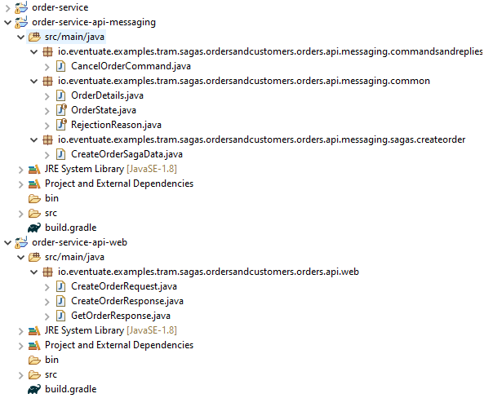

##### Order Service Api Messaging

**CreateOrderSagaData.java**

import io.eventuate.examples.tram.sagas.ordersandcustomers.orders.api.messaging.common.OrderDetails;

import io.eventuate.examples.tram.sagas.ordersandcustomers.orders.api.messaging.common.RejectionReason;

public class CreateOrderSagaData {

private OrderDetails orderDetails;

private Long orderId;

private RejectionReason rejectionReason;

public CreateOrderSagaData(OrderDetails orderDetails) {

this.orderDetails = orderDetails;

}

public CreateOrderSagaData() {

}

public Long getOrderId() {

return orderId;

}

public OrderDetails getOrderDetails() {

return orderDetails;

}

public void setOrderId(Long orderId) {

this.orderId = orderId;

}

public void setRejectionReason(RejectionReason rejectionReason) {

this.rejectionReason = rejectionReason;

}

public RejectionReason getRejectionReason() {

return rejectionReason;

}

}

**CancelOrderCommand.java**

import io.eventuate.tram.commands.common.Command;

public class CancelOrderCommand implements Command {

}

**OrderDetails.java**

import io.eventuate.examples.tram.sagas.ordersandcustomers.commondomain.Money;

import javax.persistence.Embeddable;

import javax.persistence.Embedded;

@Embeddable

public class OrderDetails {

private Long customerId;

@Embedded

private Money orderTotal;

public OrderDetails() {

}

public OrderDetails(Long customerId, Money orderTotal) {

this.customerId = customerId;

this.orderTotal = orderTotal;

}

public Long getCustomerId() {

return customerId;

}

public Money getOrderTotal() {

return orderTotal;

}

}

**OrderState.java**

public enum OrderState { PENDING, APPROVED, REJECTED }

**RejectionReason.java**

public enum RejectionReason { INSUFFICIENT_CREDIT, UNKNOWN_CUSTOMER}

**build.gradle**

dependencies {

compile project(":common")

compile project(":customer-service-api-messaging")

}

##### Order Service Api Web

**CreateOrderRequest.java**

import io.eventuate.examples.tram.sagas.ordersandcustomers.commondomain.Money;

public class CreateOrderRequest {

private Money orderTotal;

private Long customerId;

public CreateOrderRequest() {

}

public CreateOrderRequest(Long customerId, Money orderTotal) {

this.customerId = customerId;

this.orderTotal = orderTotal;

}

public Money getOrderTotal() {

return orderTotal;

}

public Long getCustomerId() {

return customerId;

}

}

**CreateOrderResponse.java**

public class CreateOrderResponse {

private long orderId;

public CreateOrderResponse() {

}

public CreateOrderResponse(long orderId) {

this.orderId = orderId;

}

public long getOrderId() {

return orderId;

}

}

**GetOrderResponse.java**

import io.eventuate.examples.tram.sagas.ordersandcustomers.orders.api.messaging.common.OrderState;

import io.eventuate.examples.tram.sagas.ordersandcustomers.orders.api.messaging.common.RejectionReason;

public class GetOrderResponse {

private Long orderId;

private OrderState orderState;

private RejectionReason rejectionReason;

public GetOrderResponse() {

}

public GetOrderResponse(Long orderId, OrderState orderState, RejectionReason rejectionReason) {

this.orderId = orderId;

this.orderState = orderState;

this.rejectionReason = rejectionReason;

}

public Long getOrderId() {

return orderId;

}

public void setOrderId(Long orderId) {

this.orderId = orderId;

}

public OrderState getOrderState() {

return orderState;

}

public void setOrderState(OrderState orderState) {

this.orderState = orderState;

}

public RejectionReason getRejectionReason() {

return rejectionReason;

}

public void setRejectionReason(RejectionReason rejectionReason) {

this.rejectionReason = rejectionReason;

}

}

**build.gradle**

dependencies {

compile project(":common")

compile project(":order-service-api-messaging")

}

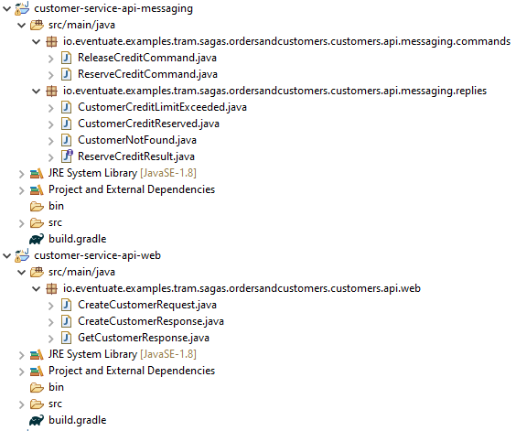

##### Customer Service Api Messaging

**ReleaseCreditCommand.java**

import io.eventuate.tram.commands.common.Command;

public class ReleaseCreditCommand implements Command {

}

**ReserveCreditCommand.java**

import io.eventuate.examples.tram.sagas.ordersandcustomers.commondomain.Money;

import io.eventuate.tram.commands.common.Command;

public class ReserveCreditCommand implements Command {

private Long orderId;

private Money orderTotal;

private long customerId;

public ReserveCreditCommand() {

}

public ReserveCreditCommand(Long customerId, Long orderId, Money orderTotal) {

this.customerId = customerId;

this.orderId = orderId;

this.orderTotal = orderTotal;

}

public Money getOrderTotal() {

return orderTotal;

}

public void setOrderTotal(Money orderTotal) {

this.orderTotal = orderTotal;

}

public Long getOrderId() {

return orderId;

}

public void setOrderId(Long orderId) {

this.orderId = orderId;

}

public long getCustomerId() {

return customerId;

}

public void setCustomerId(long customerId) {

this.customerId = customerId;

}

}

**CustomerCreditLimitExceeded.java**

public class CustomerCreditLimitExceeded implements ReserveCreditResult {

}

**CustomerCreditReserved.java**

public class CustomerCreditReserved implements ReserveCreditResult {

}

**CustomerNotFound.java**

public class CustomerNotFound implements ReserveCreditResult {

}

**ReserveCreditResult.java**

public interface ReserveCreditResult {

}

**build.gradle**

dependencies {

compile project(":common")

compile "io.eventuate.tram.core:eventuate-tram-spring-commands"

}

##### Customer Service Api Web

**CreateCustomerRequest.java**

import io.eventuate.examples.tram.sagas.ordersandcustomers.commondomain.Money;

public class CreateCustomerRequest {

private String name;

private Money creditLimit;

public CreateCustomerRequest() {

}

public CreateCustomerRequest(String name, Money creditLimit) {

this.name = name;

this.creditLimit = creditLimit;

}

public String getName() {

return name;

}

public Money getCreditLimit() {

return creditLimit;

}

}

**CreateCustomerResponse.java**

public class CreateCustomerResponse {

private Long customerId;

public CreateCustomerResponse() {

}

public CreateCustomerResponse(Long customerId) {

this.customerId = customerId;

}

public Long getCustomerId() {

return customerId;

}

public void setCustomerId(Long customerId) {

this.customerId = customerId;

}

}

**GetCustomerResponse.java**

import io.eventuate.examples.tram.sagas.ordersandcustomers.commondomain.Money;

public class GetCustomerResponse {

private Long customerId;

private String name;

private Money creditLimit;

public GetCustomerResponse() {

}

public GetCustomerResponse(Long customerId, String name, Money creditLimit) {

this.customerId = customerId;

this.name = name;

this.creditLimit = creditLimit;

}

public Long getCustomerId() {

return customerId;

}

public void setCustomerId(Long customerId) {

this.customerId = customerId;

}

public String getName() {

return name;

}

public void setName(String name) {

this.name = name;

}

public Money getCreditLimit() {

return creditLimit;

}

public void setCreditLimit(Money creditLimit) {

this.creditLimit = creditLimit;

}

}

**build.gradle**

dependencies {

compile project(":common")

}

### SAGA and related Patterns

State Management

How the state is managed

How state is modelled

Monolithic Architecture

* **Centralized Data Store** – The monolithic applications are generally using centralized data store with a single point of reference for data management – single enterprise wide data model.
* **ACID Transactions**
* A – Atomicity – guarantee ensuring all the updations within the scope of a transaction will succeed or fail as a unit.
* C – Consistency - Data correctness guarantee – updates from a transaction do not violate the invariants of the data. Data stays in a valid state example you do not put a –ve number as age of a person. You cannot assign a future birth date, things like that. Data should not be left in a logically invalid state.
* **I** – Isolation – Its about concurrency control, serializability. The result of concurrently executing a transaction is the same as the result of executing it sequentially.
* **D** – It’s the reliability guarantee that ensures that the changes would be persisted inspite of any cross failure.
* **Low degree of essential complexity**
* A whole lot is taken for granted

These semantics are not easy to achive on distributed applications, but then again not all use cases call for distributed architectures. For most part going with Monolithic Architectures makes it so much easier to achieve a ACID transactional model. Also it will cut down a lot of complexity for achieving similar effect in distributed systems. Many RDBMSs come with support for ACID transactions, and what that means is that developers leveraging those get to leverage the ACID transactions support for free. A lot of complexity is taken away from them and handled behind the scenes.

More About Transactions

Transaction – An atomic unit of work for making changes to state in a system.

Transaction – An all or nothing unit of work for storing and managing state in a datastore in a logically consistent manner.

Lets take a example of a ATM transaction

Atomicity - The operation needs to be atomic, needs clear markers of when it begins and when it ends. Begins when we enter a valid pin for example and ends once we take out our card out of the machine. It must be a all or nothing opration. It the pin fails the validation check then I should not be allowed to do any other operation, it should abort the transaction then and there.

Concurrency Control – Outstanding payments should be allowed to process at the same time that we are doing a withdrawal without affecting the validity of the balance in my account. It should support the strong consistency model. Any withdrawals must operate on the most up-to-date state of the account. Avoiding errors like withdrawing more than funds that we have, not allowing to withdraw funds that we do have.

Reliability – Any ATM withdrawals needs to be tracked, they should not be lost.

Rollbacks – In the midst of all of this it should support rollbacks. If any of the steps of this multi step process would fail it should undo all of these things.

**Distributed Architecture Challenges**

* Unreliable network – network could be slow
* Challenges related to Infrastructure
* Challenges related to Integration
* Challenges related to Data ( complexity of Transactional guarantees that are generally abstracted away from the Developer. Here they have to consider this – gets into consensus protocol, scalable walking protocols, end to end fault tolerance and weak consistency model and so on.
* Challenges for Modern Use Cases – RT, NRT, Big Data, Fast Data ( Reactive, Streams ), Heteregeneous Clusters to be integrated

Then there is a joke which is like a JAB at Microservices

**Now-a-days it doesn’t matter what the problem is, the answer seems to be microservices**

Handling State in Microservices

* Decentralized Data – there should be little or not dependencies at all in order for the microservices to be decoupled. Each microservice stores its own data in its own datastore. Its own Bounded Context – could be its own database table, schema etc. Its encapsulated by that Microservice, other services cannot bypass this API to reach that database. This is opposite to what is done in Monolith Apps
* Polyglot Architecture –
* Supports distributed and dynamic environments

### Challenges

Eventual Consistency

Eventual consistency is a model of consistency that guarantees that all the components of a distributed system will eventually the see the latest updates to the resources as long as no new updates are applied to it.

Eventual consistency is a consistency model used in distributed computing to achieve high availability that informally guarantees that, if no new updates are made to a given data item, eventually all accesses to that item will return the last updated value.

<https://queue.acm.org/detail.cfm?id=2462076>

Failure Detection

Eventual increase of failure with each remote service that we add, so microservices need to be designed for resiliency and fault tolerance which means they should be able to detect failure – crash failures, network delay failures that can be healed. System should be able to handle these different type of failures differently. You can try to control this with policies, retries but these are at best in approximations and there are precise ways of dealing with the problems. Eventual consistency also could lead to data loss, by the time a customer will see the data it is possible that newer updates were applied. It is possible to experience data loss in the system.

Data Completeness

There is also the problem of ensuring data completeness with streaming systems, when dealing with streams we are dealing with unbounded systems – we are dealing with data sets that have infinite cardinality – unbounded sets of data, so in order to process them they need to be partitioned in finite windows. Events can arrive late, events can fall into the wrong windows, so all this needs to be taken care of.

Event Ordering

Eventual Consistency causes the problem of out of order event processing, there is no guarantee in a eventually consistent model that events would be processed in the actual order that they happened, that introduces its own set of problems

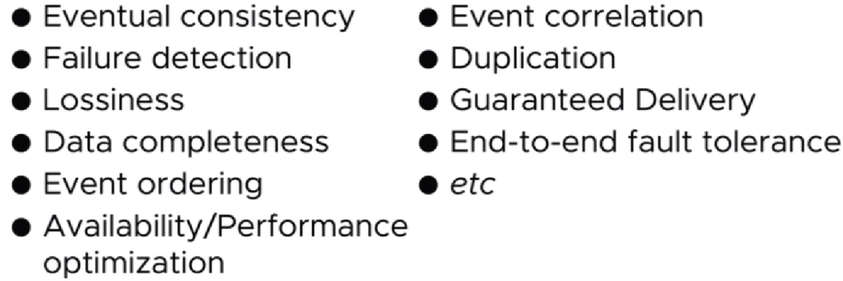

Immediate consistency ( used by RDBMSs ) is in contrast to the Eventual Consistency model that we discussed. This is easy to implement in a monolithic architecture – data is located at a central location on a single node and all customers have the same view of the data. With distributed systems this is difficult to achieve. It involves the overhead of synchronous replication, co-ordination to reach consensus – these are costly and difficult to achieve.

Consistency Models

<https://www.cs.columbia.edu/~du/ds/assets/lectures/lecture12.pdf>

### Fallacies of a Distributed System

<https://dzone.com/articles/understanding-the-8-fallacies-of-distributed-syste>

Are you working on a distributed system? Microservices, Web APIs, SOA, web server, application server, database server, cache server, load balancer - if these describe components in your system's design, then the answer is yes. Distributed systems are comprised of many computers that coordinate to achieve a common goal.

More than 20 years ago Peter Deutsch and James Gosling defined the 8 fallacies of distributed computing. These are false assumptions that many developers make about distributed systems. These are usually proven wrong in the long run, leading to hard to fix bugs.

The 8 fallacies are:

1. The network is reliable.
2. Latency is zero.
3. Bandwidth is infinite.
4. The network is secure.
5. Topology doesn't change.
6. There is one administrator.
7. Transport cost is zero.
8. The network is homogeneous.

Let's go through each fallacy, discussing the problem and potential solutions.

#### 1. The Network Is Reliable

**The Problem**

**Calls over a network will fail.**

Most of the systems today make calls to other systems. Are you integrating with 3rd party systems (payment gateways, accounting systems, CRMs)? Are you doing web service calls? What happens if a call fails? If you're querying data, a simple retry will do. But what happens if you're sending a command? Let's take a simple example:

var creditCardProcessor = new CreditCardPaymentService();

creditCardProcessor.Charge(chargeRequest);

What happens if we receive an HTTP timeout exception? If the server did not process the request, then we can retry. But, if it did process the request, we need to make sure we are not double charging the customer. You can do this by making the server idempotent. This means that if you call it 10 times with the same charge request, the customer will be charged only once. If you're not properly handling these errors, you're system is nondeterministic. Handling all these cases can get quite complex really fast.

**Solutions**

So, if calls over a network can fail, what can we do? Well, we could **automatically retry**. Queuing systems are very good at this. They usually use a pattern called store and forward. They store a message locally, before forwarding it to the recipient. If the recipient is offline, the queuing system will retry sending the message. [MSMQ](http://www.simpleorientedarchitecture.com/msmq-basics/) is an example of such a queuing system.

But this change will have a big impact on the design of your system. You are moving from a request/response model to fire and forget. Since you are not waiting for a response anymore, you need to change the user journeys through your system. You cannot just replace each web service call with a queue send.

**Conclusion**

You might say that networks are more reliable these days - and they are. But stuff happens. Hardware and software can fail - power supplies, routers, failed updates or patches, weak wireless signals, network congestion, rodents or sharks. Yes, sharks: [Google is reinforcing undersea data cables with Kevlar after a series of shark bites](https://www.theguardian.com/technology/2014/aug/14/google-undersea-fibre-optic-cables-shark-attacks).

And there's also the people side. People can start DDOS attacks or they can sabotage physical equipment.

Does this mean that you need to drop your current technology stack and use a messaging system? Probably not! You need to weigh the risk of failure with the investment that you need to make. You can minimize the chance of failure by investing in infrastructure and software. In many cases, failure is an option. But you do need to consider failure when designing distributed systems.

#### 2. Latency Is Zero

**The Problem**

**Calls over a network are not instant.**

There is a seven-orders-of-magnitude difference between in-memory calls and calls over the internet. Your application should be network aware. This means you should clearly separate local calls from remote calls. Let's look over an example that I've seen in a codebase:

var viewModel = new ViewModel();

var documents = new DocumentsCollection();

foreach (var document in documents) {

var snapshot = document.GetSnapshot();

viewModel.Add(snapshot);

}

Without further inspection, this looks fine. But, there are two remote calls. Line 2 makes one call to get a list of document summaries. At line 5 there is another call that retrieves more information about each document. This is a classic [Select n+1 problem](https://stackoverflow.com/questions/97197/what-is-n1-select-query-issue). In order to account for the network latency, you should return all the required data in one call. The general advice is that local calls can be fine-grained, but remote calls should be more coarse-grained. This is why the idea of distributed objects and "network transparency" died. But, even though everybody agrees that distributed objects are a bad idea, some people still think that lazy loading is always a good idea:

var employee = EmployeeRepository.GetBy(someCriteria)

var department = employee.Department;

var manager = department.Manager;

foreach (var peer in manager.Employees;) {

// do something

}

You wouldn't expect a property getter to do a network call. But, each "." call in the code above can actually trigger a trip to the database.

**Solutions**

**Bring Back All the Data You Might Need**

If you do a remote call, ensure that you **bring back all the data you might need**. Network communication should not be chatty.

**Move the Data Closer to the Clients**

Another possible solution is to **move the data closer to the clients**. If you're using the cloud, choose availability zone carefully, depending on your client's location. Caching can also help minimize the number of network calls. For static content, Content Delivery Networks (CDNs) are another good option.

**Invert the Flow of Data**

Another option for removing the remote calls is to **invert the flow of data**. Instead of querying other services, we can use Pub/Sub and store the data locally. This way, we'll have the data when we need it. Of course, this introduces some complexity, but it can be a good tool in the toolbox.

**Conclusion**

Although latency might not be an issue in LANs, when you move to WANs or the Internet, you'll notice the delay. This is why it's important for network calls to be clearly separated from in-memory calls. You should keep this in mind when adopting the microservices architectural pattern. You shouldn't just replace local calls with remote calls. Chances are this will turn your system into a distributed big ball of mud.

#### 3. Bandwidth Is Infinite

**The Problem**

**Bandwidth is limited.**

Bandwidth is the capacity of a network to send data over a period of time. Up until now, I've not found it to be a problem, but I can see why it could be an issue in certain conditions. Although bandwidth has improved over time, the amount of data that we send has increased too. Video streaming or VoIP will need more bandwidth than apps that are passing simple DTOs over the network. Bandwidth is even more important for mobile apps, so developers need to think about it when designing their backend APIs.

Using an ORM incorrectly can hurt too. I've seen examples of developers calling .ToList() too early in a query, thus loading an entire table in memory.

**Solutions**

**Domain-Driven Design Patterns**

So how can we make sure we don't bring too much data? Domain-Driven Design patterns can help:

* First, you should not strive for a single, enterprise-wide domain model. You should **partition your domain into**[**bounded contexts.**](https://martinfowler.com/bliki/BoundedContext.html)
* To avoid large and complex object graphs inside a bounded context, you could use the [Aggregate](https://martinfowler.com/bliki/DDD_Aggregate.html) pattern. Aggregates ensure consistency and define transactional boundaries.

**Command and Query Responsibility Segregation**

We sometimes load complex object graphs because we need to display parts of it on a screen. If we do this in lots of places, we end up with a large and complicated model that is suboptimal for both writing and reading. Another approach could be to**use Command and Query Responsibility Segregation** - CQRS. This means splitting the domain model in two:

* The **write model** will ensure invariant hold true and the data is consistent. Since the write model doesn't care about view concerns, it can be kept small and focused.
* The **read model** is optimized for view concerns, so we can retrieve all the data that is required for a specific view (e.g. a screen in our app).

**Conclusion**

There is a tension between the second fallacy, **latency is not 0**, and the third fallacy,**bandwidth is infinite**. You should transfer more data to minimize the number of network round trips. You should transfer less data to minimize bandwidth usage. You need to balance these two forces and find the *right* amount of data to send over the wire.

Although you might not hit the bandwidth limitation often, thinking about the data that you transfer is important. Less data is easier to understand. Less data means less coupling. So transfer only the data that you might need.

#### 4. The Network Is Secure

**The Problem**

**The network is insecure.**

This is one assumption that gets more media coverage than the others. Your system is only as secure as your weakest link. The bad news is that there are a lot of links in a distributed system. You're using HTTPS, except when communicating with that 3rd party legacy system that doesn't support it. You're reviewing your own code, looking for security issues, but are using open source libraries that might be a risk. An [OpenSSL vulnerability](http://heartbleed.com/) allowed people to steal data protected by SSL/TLS. A [bug in Apache Struts](https://thehackernews.com/2017/03/apache-struts-framework.html) allowed attackers to execute code on the server. Even if you're protecting against all of that, there still is the human factor. A malicious DBA can "misplace" a database backup. The attackers of today have a lot of computing power in their hands and a lot of patience. So the question is not **if** they're going to attack your system, but **when**.

**Solutions**

**Defense in Depth**

You should use a layered approach to secure your system . You need different security checks at the network, infrastructure and application level.

**Security Mindset**

Keep security in mind when designing your system. [The top ten vulnerabilities](https://www.owasp.org/index.php/Category:OWASP_Top_Ten_Project) list [has not changed that much in the last 5 years](http://resources.infosecinstitute.com/owasp-2017-top-10-vs-2013-top-10). You should follow best practices for secure software design and review code for common security flaws. You should regularly search 3rd party libraries for new vulnerabilities. The list of [Common Vulnerabilities and Exposures](https://cve.mitre.org/index.html) can help.

**Threat Modeling**

Threat modeling is a systematic approach of identifying possible security threats in a system. You first identify all the assets in your system (user data in the database, files, etc) and how they are accessed. After that, you identify possible attacks and start executing them. I recommend reading Chapter 2 in [Advanced API Security](http://www.simpleorientedarchitecture.com/book-review-advanced-api-security/) for a good overview of Threat Modelling.

**Conclusion**

[The only secure system is one that is powered off, not connected to any network (and ideally cast in a block of concrete](https://en.wikiquote.org/wiki/Gene_Spafford)). What a useful system that it! The truth is that security is hard and expensive. There are a lot of components and links in a distributed system and each one of them is a possible target for malicious users. The business needs to balance the risk and probability of an attack with the cost of implementing prevention mechanisms.

Attackers have a lot of patience and computing power at their hands. We can prevent certain types of attacks by using threat modeling, but we can't guarantee 100% security. So it's a good idea to make this clear to the business, decide together how much to invest in security and have a plan for when a security breach does happen.

#### 5. Topology Doesn't Change

**The Problem**

**Network topologies change constantly.**

Network topology changes all the time. Sometimes it changes for accidental reasons - when your app server goes down and you need to replace it. Many times it's deliberate — adding new processes on a new server. Nowadays, with cloud and containers on a rise, this is even more visible. Elastic scaling - the ability to add or remove servers depending on the workload - requires a certain degree of network agility.

**Solutions**

**Abstract the Physical Structure of the Network**

The first thing you need to do is to abstract the physical structure of the network. There are several ways in which you can do that:

* Stop hardcoding IPs - You should prefer using hostnames. By using URIs we are relying on the DNS to resolve the hostname to an IP.
* [When DNS is not enough](http://progrium.com/blog/2014/07/29/understanding-modern-service-discovery-with-docker/) (e.g. when you need to map an IP and a port), then use discovery services.
* Service Bus frameworks can also provide location transparency.

**Cattle, Not Pets**

By treating your servers as [cattle, not pets](http://cloudscaling.com/blog/cloud-computing/the-history-of-pets-vs-cattle/) you are ensuring that no server is irreplaceable. This bit of wisdom helps you get into the right mindset: any server can fail (thus changing the topology), so you should automate as much as you can.

**Test**

One last piece of advice is to test your assumptions. Stop a service or shut down a server and see if your system is still up and running. Tools like Netflix's [Chaos Monkey](https://github.com/Netflix/chaosmonkey) take this up a notch, by randomly shutting down VMs or containers in your production environment. By bringing the pain forward, you are more motivated to build a more resilient system that can handle topology changes.

**Conclusion**

Ten years ago, most topologies didn't change that often. But when it did, it probably happened in production and introduced some downtime. Nowadays, with cloud and containers on the rise, it's hard to ignore this fallacy. You need to be prepared for failure and test for it. Don't wait for it to happen in production!

#### 6. There Is One Administrator

**The Problem**

**There is no one person who knows everything.**

Well, this one seems obvious. Of course, there is no one person who knows everything. Is this a problem? As long as the application runs smoothly, it isn't. But, when something goes wrong, you'll need to fix it. Because so many people touched the app, the one who knows how to fix the problem might not be there.

There are many things that could go wrong. One example is configuration. Today's applications store configurations in multiple stores: config files, environment variables, database, command line arguments. There is no one person that knows what is the effect of every possible config value.

Another thing that could go wrong is system upgrades. A distributed application has many moving parts and you need to make sure they are synchronized. For example, you need to make sure that the current version of the code works with the current version of the database. Nowadays there is a focus on DevOps and Continuous Delivery. But supporting zero downtime deployment is no easy feat.

But, at least these things are under your control. Many apps interact with 3rd party systems. This means that, if they go down, there isn't much that you can do. So, even if you had one administrator for your system, you still can't control 3rd party systems.

**Solutions**

**Everyone Should Be Responsible for the Release Process**

This means involving Ops people or system administrators from the start. Ideally, they would be part of the team. Keeping the system administrator informed of your progress early on can help you spot constraints. For example, the production environment might have different configurations, security restrictions, firewall rules or available ports than a development environment.

**Logging and Monitoring**

The systems administrators should have the right tools for error reporting and managing issues. You should think about monitoring from the start. Distributed systems should have centralized logging. Accessing logs on ten different servers to investigate an issue is not an acceptable approach.

**Decoupling**

You should strive for the least amount of downtime during system upgrades. This means you should be able to upgrade different parts of the system independently. By making the components backward-compatible, you can update the server and the clients at different times.

By putting queues between components, you temporally decouple them. This means that, for example, the web server can still accept requests, even if the backend is down.

**Isolate Third-Party Dependencies**

You should treat systems that are outside of your control differently than components that you own. This means making your system more resilient to 3rd party failures. You can reduce the impact of an outside dependency by introducing an abstraction layer. This means that when a 3rd party system fails, you'll have fewer places to look for bugs.

**Conclusion**

To work around this fallacy, you need to make your system easy to manage. DevOps, logging and monitoring can help. You also need to think about the upgrade process of your system. You cannot deploy each sprint if the upgrade requires hours of downtime. There is no one administrator so everybody should be responsible for the release process.

#### 7. Transport Cost Is Zero

**The Problem**

**Transport cost is *not* zero.**

This fallacy is related to the second fallacy, that**latency is zero**. Transporting stuff over the network has a price, in both time and resources. If the second fallacy discussed the time aspect, fallacy #7 tackles resource consumption.

There are two different sides of this fallacy:

**The Cost of the Networking Infrastructure**

The networking infrastructure has a cost. Servers, SANs, network switches, load balancers and the people who take care of this equipment — all of these cost money. If your system is deployed on-premise, then you pay this price up front. If you're using the cloud, then you pay only for what you use, but you're still paying for it.

**The Cost of Serialization/Deserialization**

The second aspect of this fallacy is the cost of transferring data between the transport level and the application level. Serialization and deserialization consume CPU time, so it costs money. If your app is deployed on-premise, this cost is somewhat hidden if you don't actively monitor resource consumption. But if your app is deployed in the cloud, this cost is painfully visible, since you're paying for what you use.

**Solutions**

There isn't much you can do about the cost of infrastructure. You can only make sure that you're using it as efficiently as possible. SOAP or XML is more expensive than JSON. JSON is more expensive than binary protocols like Google's Protocol Buffers. Depending on the type of system, this can be more or less important. For example, the transport cost is much more important for apps that have to do with video streaming or VoIP.

**Conclusion**

You should be mindful of the transport cost and how much serialization and deserialization your app is doing. This doesn't mean that you should optimize unless there is a need for it. You should benchmark and monitor resource consumption and decide if transport cost is a problem for you.

#### 8. The Network Is Homogeneous

**The Problem**

**The network is *not* homogenous.**

A homogenous network is a network of computers using similar configurations and the same communication protocol. Having computers with similar configurations is a hard task to achieve. For example, you have little control over what mobile devices can connect to your app. This is why it's important to focus on standard protocols.

**Solutions**

You should choose standard formats in order to avoid vendor lock-in. This might mean XML, JSON or Protocol Buffers. There are plenty of options to choose from.

**Conclusion**

You need to ensure that the system's components can talk with each other. Using proprietary protocols will damage your app's interoperability.

**Designing Distributed Systems Is Hard**

These fallacies were published more than 20 years ago. But they still hold true today, some of them more than others. I think that many developers today know them, but the code that we write doesn't show this.

We must accept these as facts: the network is unreliable, insecure and costs money. Bandwidth is limited. The network's topology will change. Its components are not configured the same way. Being aware of these limitations will help us design better distributed systems.

## Spring State Machine

### Overview

As you can see using JMS to communicate between microservices is a very important concept in technology. We're specifically looking at JMS inside this course. This is just one very popular messaging technology. Really you could plug and play just about any type of messaging technology in place of JMS if you needed to go to something different like Kafka. That's very popular right now. But the primary concept is how we want to be decoupling these services and allowing them to asynchronously send and consume messages so that there's no real dependencies coupling between these services. You're going to see how we build upon this concept as we come in to doing Sagas. But first, we're gonna have to talk about Spring State Machine because we're gonna be using that as a Saga Coordinator. I know these terms are probably a little confusing at this point in time. But first we are going to dive into Spring State Machine which is really cool technology. You might not even know what a state machine is. Don't worry we're gonna explain that in this section of the course and then we're going to get into using Spring State Machine for Sagas and then some integration testing with Sagas. So but first, we're in transition away from JMS and into the world at Spring State Machine.

|  |  |
| --- | --- |
|  |  |

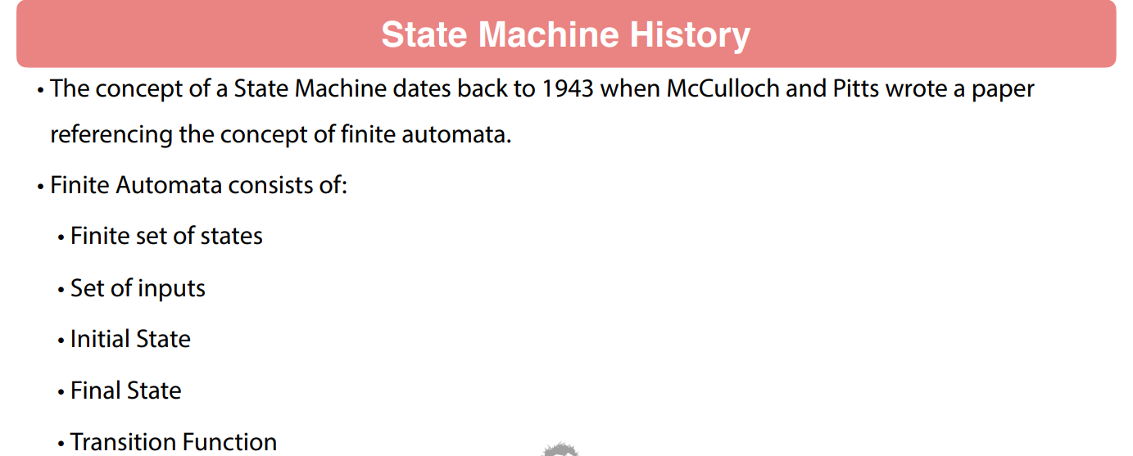

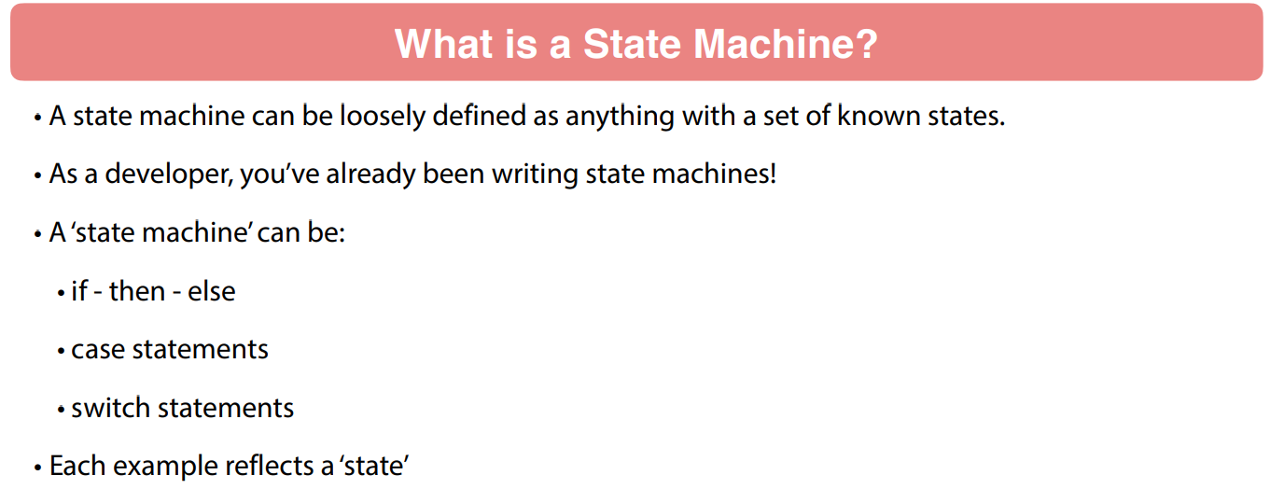

Basically this is a fancy term that means that there is a finite set of states, there is a set of inputs, there is an initial state, there is a final state and there's some type of function to transition state. So again this all conceptual stuff. Now back in 19 early 1940s, computing really wasn't that big then.

So this concept has been around for a very very long time so it's nothing really all that new to the software community but it is something that's been around for a long time and they're a very good use cases to actually go in and use a state machine. So some of these use cases might be where you have event-based applications. So think about a long lived entity such as an order. You're going to get a new order, eventually, pay for that order, you're going to ship that order. So, that is all a set of states and there's gonna be events around that.

Another case could be you have an application where the state changes and you need to publish an event so that that is a great use case for state machines. UI applications, very common to use state machines there. Think about just having a Caps Lock On, Caps Lock Off. The behavior of the application is gonna need to change based on some type of toggle type behavior. So really it's gonna be anywhere you're gonna have application behavior-changing based on known states or some type of events.

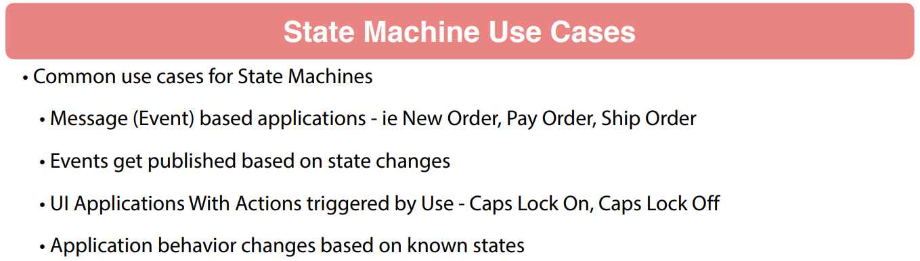

Now let's look at some of the terminology of state machines. State again that is a specific state of the state machine. So this is gonna be a finite set of values and predetermined. Typically you're gonna see a lot of times going beyond just the Java community you're gonna see this defined in some type of enumeration.

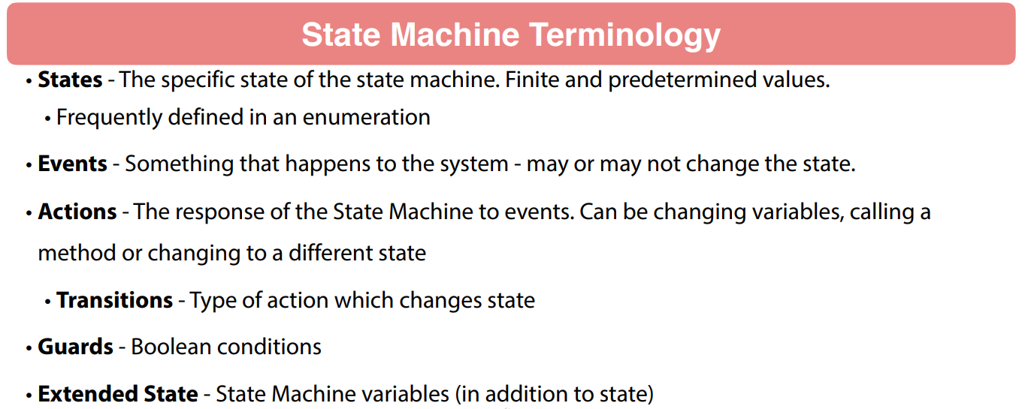

Very common way to do that. And then states are gonna work in conjunction with that. So conceptually an event is something that happens to the system. A user clicking on a button or some type of option or system receiving a message could be all different types of events. Now, actions are gonna be the response of the state machine to events. So this could be an action where we would be changing variables, calling a method, my need to send off a different message or something. So there's a lot of different things you can do within the action and it can even change the state of the state machine. Now this transition that is a type of action which actually changes the state of state machine.

Then you have guards. These are boolean conditions where you can set up to allow an event to happen or an action to happen or transition to action. So these are remember a guard is a boolean condition that is going to allow or disallow something to happen. And then state is traditionally thought of as a single variable that is gonna represent the state of the state machine. You have accounts of called extended state so you may need additional attributes to the state machine like an order is gonna have an order state. An extended state might have like the order id in it so extended state is gonna be more robust information about state machine itself where state is going to be just the state of the state machine. Now you might be wondering why you wanna use a state machine. Now I go through that. It can really help you clean up your code.

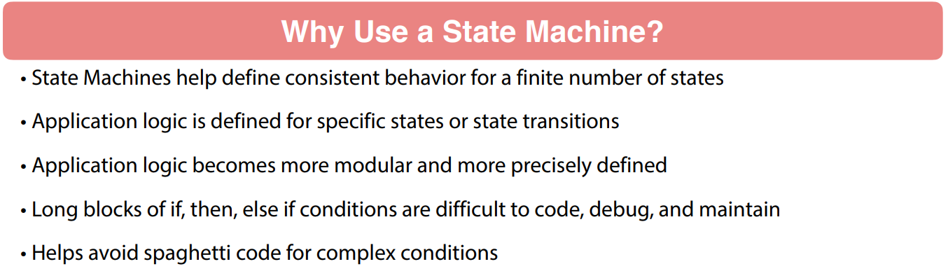

So what it's gonna do is cause you to think about the specific behavior of your application and get that into your thoughts into a finite number of states. Application logic is gonna be defined for each state or state transition. So, your application logic becomes more modular and more precisely defined. I've seen a lot of code in my days and these long blocks of if, then, else if conditions. I've seen these nested to literally thousands of lines of code. I'm not joking. Literally thousands of lines of code. And it is an absolute nightmare to deal with this because this code is typically if you get into something like this you're gonna have long conditions, you're gonna have a single entry point, a single exit point, and if you're trying to unit test something like this is a nightmare. Absolutely nightmare. I remember a story where I was told a 2000 line block of code was could unit test just fine. And like that's impossible.

So when you start using a state machine your code becomes more precise and what it's gonna do is help you avoid spaghetti code for complex condition. So, when you see a 2000 line method that's a kind of a red flag that something is very wrong with the code. A lot of times that code could be made much better through the use of a state machine. So we wanna talk specifically about Spring State Machine. So this is a mature Spring Framework project. It is currently being maintained. It was originally released back in October 2015. So it hasn't been around that long back in 2015 was the 1.0.0.0 release we are now on 2.1.3.

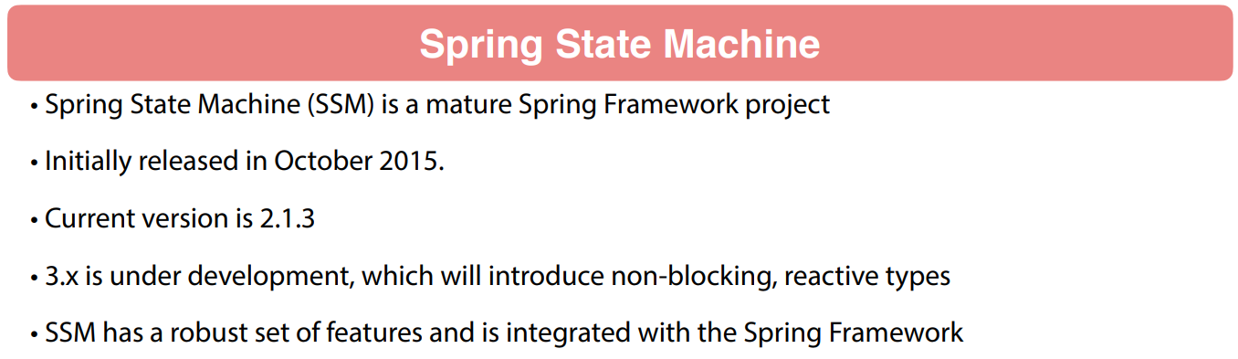

They are working on 2.1.4 so that should be out pretty quick and they do have version 3 under development. I'm not sure the timeline of that but the biggest change under version 3 is going to have a non blocking state machine that will support reactive type. So that'll be a nice addition to it. SSM Spring State Machine is very robust. There's a lot of features to it. In this section and of course we are only gonna get into an introductory there's a lot of features that we are not gonna get into because it is a fairly robust project but we will definitely get our hands on it and learn how to configure it. So I wanna show you a couple of examples here.

This is a UML diagram and these two diagrams here on this slide on the next slide. I took right out the Spring Framework Spring State Machine documentation so give those guys credit for it. But I just want you to vision this example here. We have a washing machine. So, you can see the square blocks or the rectangular blocks and these are different states of the machine. So WASHING, RINSING, DRYING, POWEROFF that is another state.

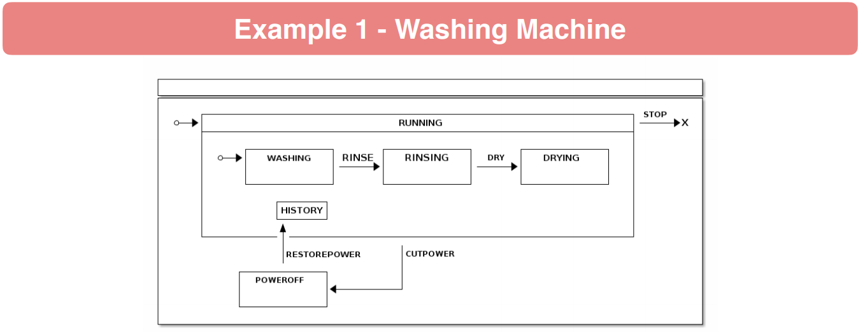

But then you also see there's the events. So you have CUTPOWER, RESTOREPOWER, RINSE, DRY. So these are various events that have happened within state machine. So again start thinking about states and events as we start talking about state machines because you're gonna have a specific state. An event is going to cause that state state machine to move to a different state. And here's another example from the Spring State Machine documentation of a web checkout. So can see we have the states of LANDING, ITEMS, CART, PAYMENT.

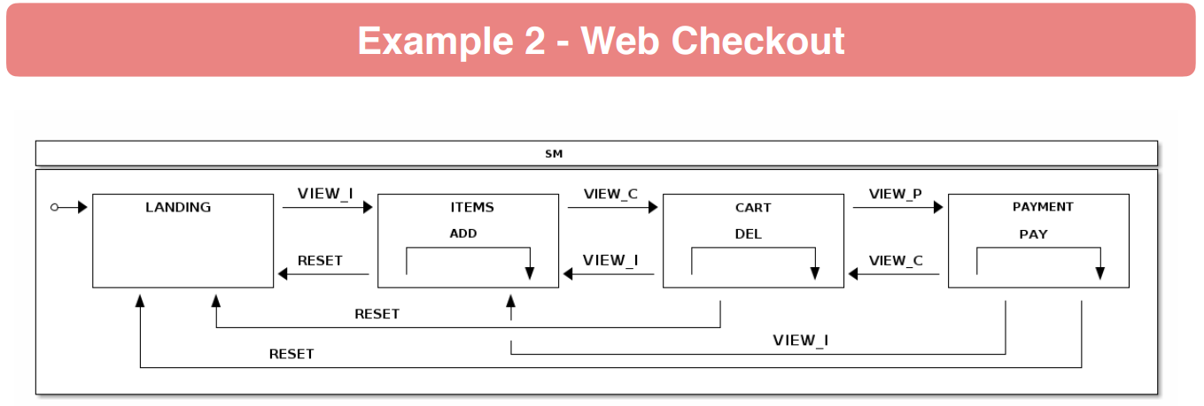

And then we can see the different events here. So again this is UML from modeling a state machine. It looks like there's a couple some actions going on here. So, state machines can get very very robust. You can have components of that are some state machines so it can get pretty pretty interesting to set things up. But again, becomes very modular in your code and it does help you organize and develop your code better.

### Credit Card Payment State Machine Overview

We are going to be talking about a Credit Card Payment State Machine. Do a general overview of it. So if you think about credit card processing with a number of vendors, you have the option to pre-authorize a charge. So a great example especially here in the US, I'm not sure if this happens all around the world. But when you're using a credit card to buy gas, you typically will go and swipe the card and in the background they're gonna pre-authorize the charge so that they'll be you're probably charge like a put $100 hold against your card through a pre-authorization.

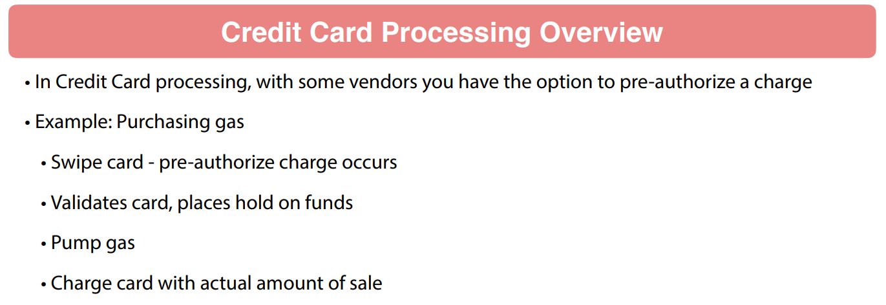

That's gonna validate the card and place a hold to make sure that they can get paid when you actually pay for the gas. So, then the pumping a gas occurs and then we know the actual amount of sale. And then they do a charge against the card for the actual amount of the purchase. It's a very common scenario in terms of payments. So a number of things are happening here. So, if we start thinking in various states that credit card payment, we would have a new payment. Then we could have the pre authorized so that's gonna happen after the credit card processor authorizes it or that pre-authorization transaction could fail so that card to be rejected. And then of course, we're gonna have authorized so the charge can be approved by the processor or that charge could be rejected by the processor.

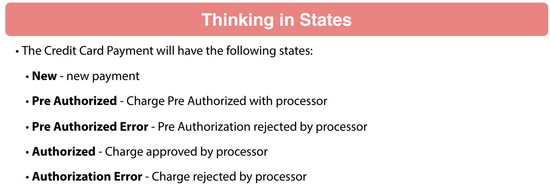

So, these are different states that credit card payment can be in. So, just a handful of states there and you can see how that process is gonna go through. And then if we think in events the different things that we're gonna have happen, we could have that pre-authorized charge. So we want to do that pre-authorized. That is gonna be a transaction.

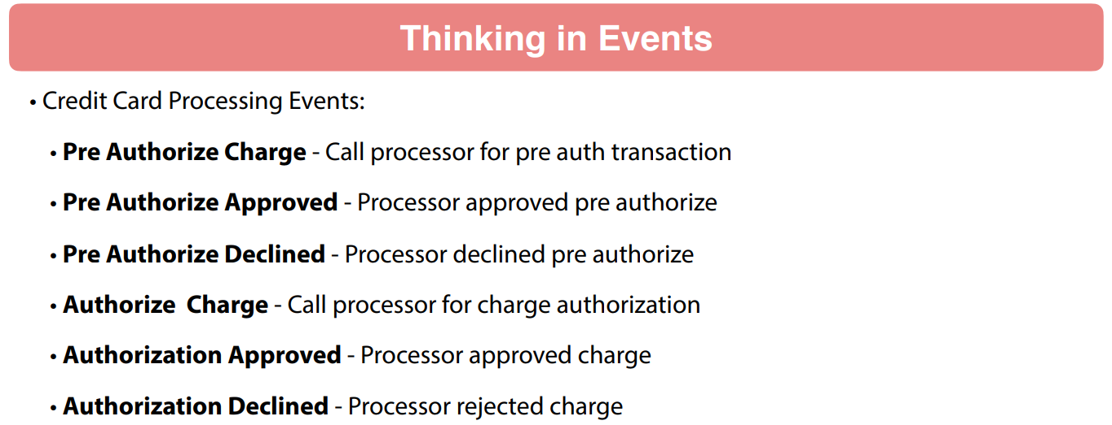

Now, that transaction is gonna return one of two events. It's either gonna be approved or declined. So, that those are two events that we have to handle. And then we also wanna authorize that charge so that that call processor due to authorization and then that authorization can be approved or declined. So, that's two different events there as well. So, to help you envision the State Machine, the ideal state machine at the top row there, I have the happy pass so to speak so we would go from state of NEW to PRE_AUTH and then AUTH. So, we'll start off a NEW, then we'll do a pre authorize event, and then we wanna do an authorization event and that will transition the State Machine through these various states.

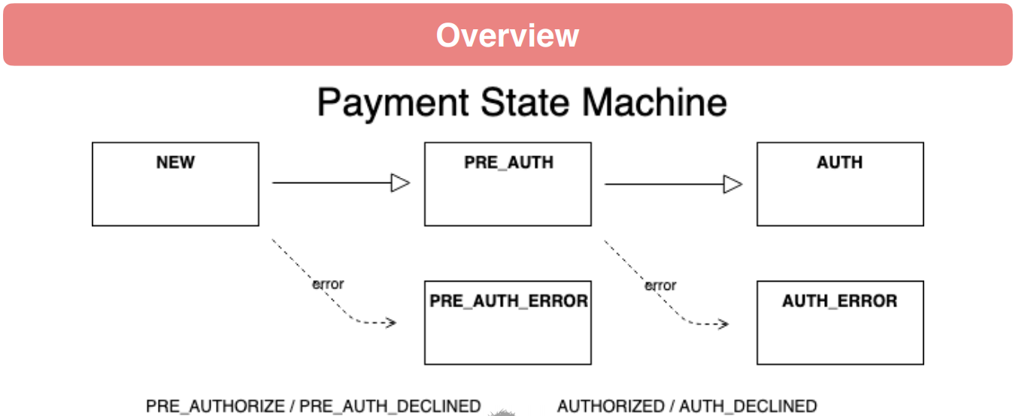

So, kind of a neat model here that we can work with. It's a simple model but it will allow us to play with configuring Spring State Machine. So coming up in this section of the course, what we are gonna do is we will create a brand new project for us to work with Spring State Machine. And then these states and events, we want to define those into Java enumerations. So, we'll work with a enumeration sets one configuration model for working on Spring State Machine and then also we wanted to find a JPA entity for payments. And of course, we'll set up a repository for it.

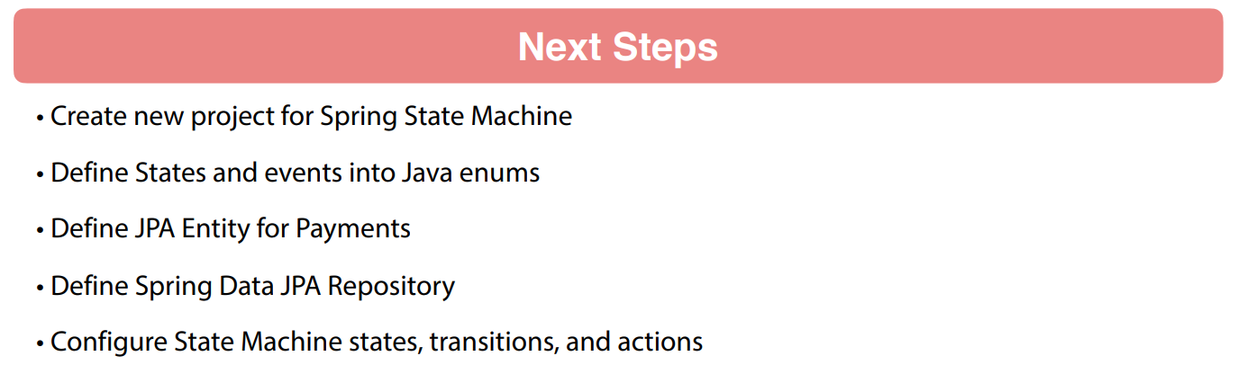

And then we'll get into the details of configuring Spring State Machine with the various states and transactions and actions that we need to support our credit card authorization processing. So, got some neat stuff coming up here and we'll go through this step-by-step. The configuration of Spring State Machine kind of comes off as a little complex at first. But once you start getting your hands-on, I think it'll definitely click and start making sense so. But coming up, we will first do the define the enumerations then set up the data persistence because we wanna be saving this payment as a typical entity. And then we'll create events and transition this our payment to the various states and transitions.

### Initial Project

Lets create a project for this

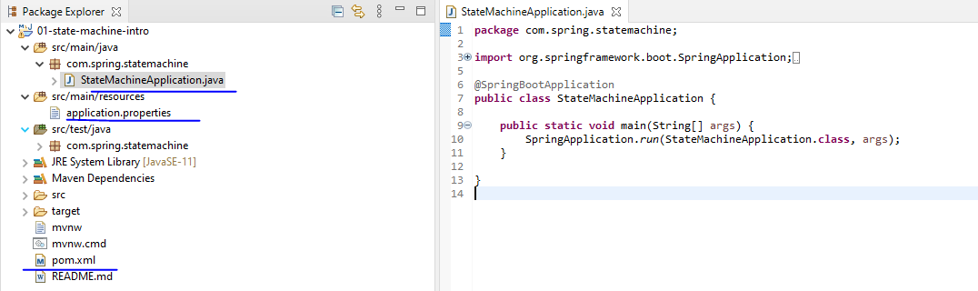

**pom.xml**

<?xml version="1.0" encoding="UTF-8"?>

<project xmlns="http://maven.apache.org/POM/4.0.0" xmlns:xsi=<http://www.w3.org/2001/XMLSchema-instance> xsi:schemaLocation="http://maven.apache.org/POM/4.0.0 http://maven.apache.org/xsd/maven-4.0.0.xsd">

<modelVersion>4.0.0</modelVersion>

<parent>

<groupId>org.springframework.boot</groupId>

<artifactId>spring-boot-starter-parent</artifactId>

<version>2.5.1</version>

<relativePath/> <!-- lookup parent from repository -->

</parent>

<groupId>guru.springframework</groupId>

<artifactId>mssc-ssm</artifactId>

<version>0.0.1-SNAPSHOT</version>

<name>mssc-ssm</name>

<description>Example Project for Spring State Machine</description>

<properties>

<java.version>11</java.version>

</properties>

<dependencies>

<dependency>

<groupId>org.springframework.boot</groupId>

<artifactId>spring-boot-starter-data-jpa</artifactId>

</dependency>

<dependency>

<groupId>org.springframework.boot</groupId>

<artifactId>spring-boot-starter-web</artifactId>

</dependency>

<dependency>

<groupId>org.springframework.statemachine</groupId>

<artifactId>spring-statemachine-core</artifactId>

<version>2.1.3.RELEASE</version>

</dependency>

<dependency>

<groupId>org.springframework.boot</groupId>

<artifactId>spring-boot-devtools</artifactId>

<scope>runtime</scope>

<optional>true</optional>

</dependency>

<dependency>

<groupId>com.h2database</groupId>

<artifactId>h2</artifactId>

<scope>runtime</scope>

</dependency>

<dependency>

<groupId>org.projectlombok</groupId>

<artifactId>lombok</artifactId>

<optional>true</optional>

</dependency>

<dependency>

<groupId>org.springframework.boot</groupId>

<artifactId>spring-boot-starter-test</artifactId>

<scope>test</scope>

<exclusions>

<exclusion>

<groupId>org.junit.vintage</groupId>

<artifactId>junit-vintage-engine</artifactId>

</exclusion>

<exclusion>

<groupId>junit</groupId>

<artifactId>junit</artifactId>

</exclusion>

</exclusions>

</dependency>

</dependencies>

<build>

<plugins>

<plugin>

<groupId>org.springframework.boot</groupId>

<artifactId>spring-boot-maven-plugin</artifactId>

</plugin>

</plugins>

</build>

<repositories>

<repository>

<id>spring-snapshots</id>

<name>Spring Snapshots</name>

<url>https://repo.spring.io/snapshot</url>

<snapshots>

<enabled>true</enabled>

</snapshots>

</repository>

<repository>

<id>spring-milestones</id>

<name>Spring Milestones</name>

<url>https://repo.spring.io/milestone</url>

</repository>

</repositories>

<pluginRepositories>

<pluginRepository>

<id>spring-snapshots</id>

<name>Spring Snapshots</name>

<url>https://repo.spring.io/snapshot</url>

<snapshots>

<enabled>true</enabled>

</snapshots>

</pluginRepository>

<pluginRepository>

<id>spring-milestones</id>

<name>Spring Milestones</name>

<url>https://repo.spring.io/milestone</url>

</pluginRepository>

</pluginRepositories>

</project>

### State Machine Enumerations

Create a new package and a new class for our states

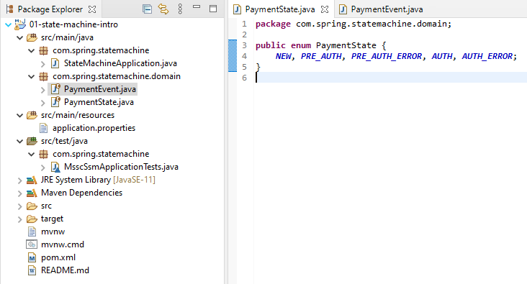

I don't need to get very fancy with the enumeration. Its just a plain old Enum. It's gonna be perfectly fine for our purposes. So, in this case, remember the different states that we wanna be supporting, so there's NEW, PRE_AUTH, PRE_AUTH_ERROR. So that's the state where it goes into an error, AUTH and AUTH_ERROR. So, remember as we move the payment along, we want to go from a new payment to pre-authorized to auth. But both pre-authorized and auth could have ERROR so we have the PRE_AUTH_ERROR and the AUTH_ERROR. So, different states of our state machine so that that will take care of the states.

**PaymentState.java**

package com.spring.statemachine.domain;

public enum PaymentState {

NEW, PRE_AUTH, PRE_AUTH_ERROR, AUTH, AUTH_ERROR;

}

And now, what we're gonna do is we'll come in and create another class and call that PaymentEvent like so. Again this is gonna be an enumeration. Go ahead and add that. Click that and let's see here. So, I will do PRE_AUTHORIZE. So remember this is gonna be the event that will trigger us to call the credit card processor to pre authorize a transaction and PRE_AUTH is upon successful pre-authorization. Now we'll call that PRE_AUTH_APPROVED. We can do a PRE_AUTH_DECLINED so if the credit card processors wants to decline our pre auth and then we want AUTHORIZE. That is gonna be an event that says, hey authorize this payment so take it from a pre auth and authorized state. And then we can do AUTH_APPROVED and AUTH_DECLINED.

**PaymentEvent.java**

package com.spring.statemachine.domain;

public enum PaymentEvent {

PRE_AUTHORIZE, PRE_AUTH_APPROVED, PRE_AUTH_DECLINED, AUTHORIZE, AUTH_APPROVED, AUTH_DECLINED;

}

So, these are all different events that would be setting into the state machine. So again, what we did in this video is we created two enumerations and packaged called domain. The first enumeration was for the state. So, these are gonna be the various states of the state machine that we're gonna be dealing with throughout this lesson. And then the second is gonna be the events that the state machine is gonna be reacting to. These two enumerations are what we'll use to configure the Spring State Machine in upcoming videos.

### Payment Domain Object

We're gonna go ahead and configure the Payment object, the Payment domain object. So this is the identity that we wanna persist the payment data into the database with. And what we'll be doing is we'll persist that it to the database. When we have another event come through, we'll retrieve it from the database, reset the state machine to the state of the entity and then do our work as far as processing any events that occur.

|  |  |
| --- | --- |
|  | So, the first thing we need to do is actually create that domain object. So, let's come up here say New Java Class and we will just call this Payment. So, nothing too complicated there. And, let's come in here and we will say @Entity. So, that is the standard Java API for that. Let's do private and we'll make the id a long value. Call that id like so. And then obviously, this is going to need the state, so PaymentsState. We just call that state like so. And I prefer to use @Enumerated and by going to see EnumType.STRING.  What this is gonna do is it's gonna tell Hibernate to create a varchar and the database for this and the actual name of the enumeration will be there. Off the top of my head if I remember correctly, if you don't do this, you're gonna get a numbered value for the enumeration. So, I prefer seeing the actual enumeration value in the database. I think that brings a little more value than what we have here. And then also, we wanna do private BigDecimal and we'll just call that amount. So, we're gonna have a fairly simple entity class here. So, we don't need a lot of complexity to demonstrate the functionality of processing the payment states. And then of course, let's bring in some Project Lombok goodness. |

**Payment.java**

package com.spring.statemachine.domain;

import java.math.BigDecimal;

import javax.persistence.Entity;

import javax.persistence.EnumType;

import javax.persistence.Enumerated;

import javax.persistence.GeneratedValue;

import javax.persistence.Id;

import lombok.AllArgsConstructor;

import lombok.Builder;

import lombok.Data;

import lombok.NoArgsConstructor;

@Data

@NoArgsConstructor

@AllArgsConstructor

@Builder

@Entity

public class Payment {

@Id

@GeneratedValue

private Long id;

@Enumerated(EnumType.STRING)

private PaymentState state;

private BigDecimal amount;

}

You can say it @Data and of course @Builder pattern or my favorites @NoArgsConstructor and @AllArgsConstructor. So,that allows Project Lombok to go ahead and enhance our class with these constructors, builder pattern and getters sitters and nice to string method will come from the data.

**PaymentRepository.java**

package com.spring.statemachine.repository;

import org.springframework.data.jpa.repository.JpaRepository;

import com.spring.statemachine.domain.Payment;

public interface PaymentRepository extends JpaRepository<Payment, Long>{

}

And then let's come in and create a New Package repository and we'll create a New Java Class. That will be an Interface like so. That's gonna stand the JpaRepository and type will be Payment and then the id value is a Long like so. So, that will set up the Spring Data JPA Repository. So, just to recap what we created here, we already had the domain package for the enumerations. But we did add into the Payment class of standard JPA entity. We have a Long id and oops I almost forgot. That id value would not be happy if we did not do an id and allow that to be generated. So, if I had forgotten those, that would have definitely caused an error in a future video. But I'm glad I caught those. So, this is just a standard JPA entity that will be managed by Hibernate to the database for us. again we have the H2 in-memory database on our class path so that's what we'll be using for the purposes of this section of course. This sets up the entity and then we added in a repository. We're using the JpaRepository to work with Spring Data JPA that will give us access to and from the persistence layer.

### Configuring the State Machine

We're going to actually start configuring the state machine. So, I'm going to come in here and I'm going to create a new package. We'll just call that config like so and let's create a new Java class. Call it StateMachineConfig. Nothing too fancy there. And what we want to do here is this is going to be a actual configuration so they'll tell Spring to pick that up via that stereotype and then we also need to say @EnabledStateMachineFactory. So, what this is going to do is it tells Spring to go through this and it's going to scan this and by enabling the state machine factory, we'll have a component to generate state machine. So, that it's effectively what that is going to do. And while I'm up here, I'm just going to do a Project Lombok so we'll be able to have a logger injected there. And then we want to do extends StateMachineConfigureAdapter. So, we want this guy right here. And the first paren is going to be the state machine, the states and then the payment events. And let's take a quick drill into the so we have the state machine adapter here.

**StateMachineConfig**

package com.spring.statemachine.config;

import org.springframework.context.annotation.Configuration;

import org.springframework.statemachine.config.EnableStateMachineFactory;

import org.springframework.statemachine.config.StateMachineConfigurerAdapter;

import com.spring.statemachine.domain.PaymentEvent;

import com.spring.statemachine.domain.PaymentState;

import lombok.extern.slf4j.Slf4j;

@Configuration

@EnableStateMachineFactory

@Slf4j

public class StateMachineConfig extends StateMachineConfigurerAdapter<PaymentState, PaymentEvent> {

}

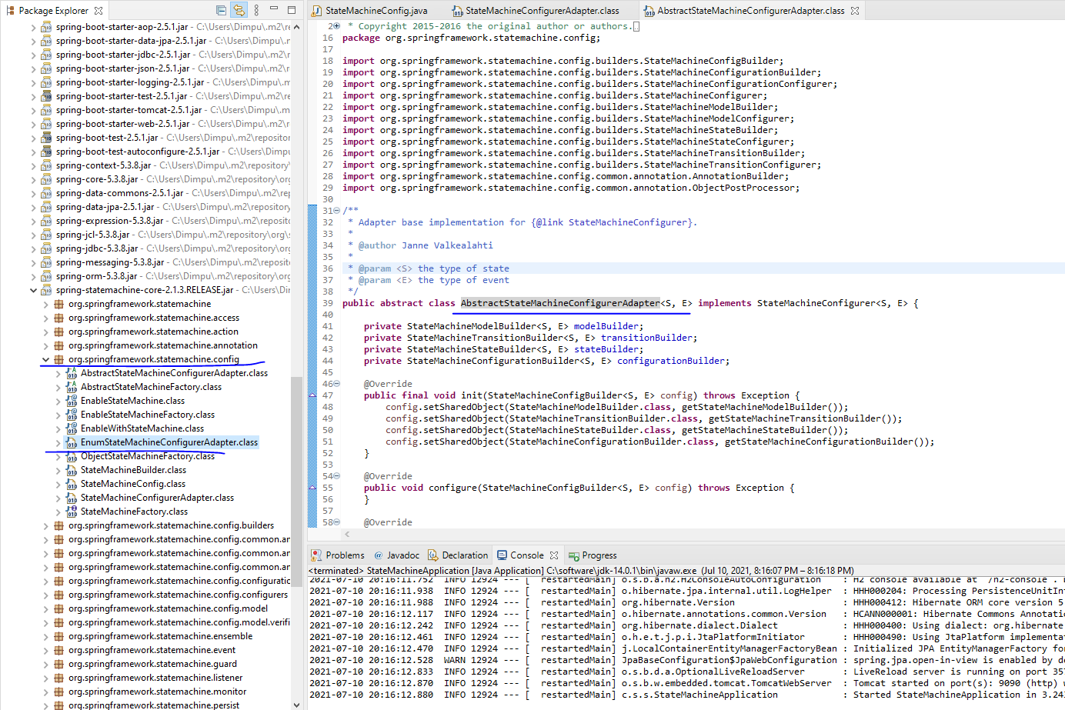

<https://spring.io/blog/2019/08/08/spring-statemachine-goes-reactive-with-3-0-0-m1>

So, this is the base implementation on straight a state machine configure adapter. Now, if I come in here and hit a little target button here that drill into the package. You will see the state machine configure adapter and then also there's an enum configure adapter. The way we're set up, we're doing enumerations. Technically you can use either one here. Either one will work. I'm just using the the base one because I effectively do the same thing.

Now, the one thing I'm not going to be showing this there's actually a builder pattern to configure state machines where you can setup a builder that will generate the state machine factory. I'm going with the configure adapter so if you wanna learn more about the state machine builder pattern, consult the documentation. I'm not gonna have time to dig through every feature of the state machine here. Now, with that implemented, I want to go ahead and implement override method. Let's see here. State machine state. In here, it's a little hard to see that these are all very similarly named. Here, I want the state machine state configure so I'm gonna go ahead and say okay on that. And I don't need to call the super on that. But what I do want to do is take these states like so. And what we are doing here is that we are telling the state machine configuration about the state machine. So we want to say with states initial payment state and that is going to be new like so. And now we can configure all the states that we have and you want the plural one. And here we're gonna do enum set. Let's say all of payment state dot class like so. So that is doing effectively. It's getting a list of the enumerations from payment state and it's loading that up into all the states. Now, the state machine is going to have what's called a terminal state where the state machine is going to be done.

**StateMachineConfig.java**

package com.spring.statemachine.config;

import java.util.EnumSet;

import org.springframework.context.annotation.Configuration;

import org.springframework.statemachine.config.EnableStateMachineFactory;

import org.springframework.statemachine.config.StateMachineConfigurerAdapter;

import org.springframework.statemachine.config.builders.StateMachineStateConfigurer;

import com.spring.statemachine.domain.PaymentEvent;

import com.spring.statemachine.domain.PaymentState;

import lombok.extern.slf4j.Slf4j;

@Configuration

@EnableStateMachineFactory

@Slf4j

public class StateMachineConfig extends StateMachineConfigurerAdapter<PaymentState, PaymentEvent> {

@Override

public void configure(StateMachineStateConfigurer<PaymentState, PaymentEvent> states)

throws Exception {

states.withStates()

.initial(PaymentState.NEW)

.states(EnumSet.allOf(PaymentState.class))

.end(PaymentState.AUTH)

.end(PaymentState.PRE_AUTH_ERROR)

.end(PaymentState.AUTH_ERROR);

}

}

And here, we are going to add it in an end payment state and the first one is going to be auth. So, once we go through the process remember we start auth new pre auth auth so that'd be an end state. But also if we do, we can chain these. We get a an error pre auth error that would be a termination state and then also an end of payment state of an auth error like so. So, that configures the states of the state machine. So, just to recap here, what we did in this video is we added in the state machine config under a package called configuration. Line 17 is enabling state state machine factory. That is a very important configuration. If you don't do that, things don't work. And then we are extending the state machine configure adapter. This gets in value called States state machine configure for States. And now, we want to say with States. The initial state of the state machine is going to be new. The second line there in line 25, we are loading out all the states from that enumeration of states and then we have the happy path on line 26 which is authorized and then we have two terminal error States. So, once we hit an error with the credit card processor, our state machines can be done. So, this configuration right here, this only addresses the states we have not done transitions. We will be configuring those in the next video. So, we'll set up the various state transitions which are going to be triggered based on events.

### Transition Configuration

We're going to go ahead and start setting up some state transitions. So, I'm going to come in here and we need to override another method of our configure adapter. And here we want the transition configure so this one right here. So, got to read these carefully with what we have here. So, I'm gonna go ahead and bring that in. We don't need this guy but we do need transitions and what we are going to say is with external so this is going to be an external configuration. The first one, the source that that is going to be the beginning state so payment state of new. And remember as I said, the events can cause a state to remain. It doesn't necessarily cause a state change. So, let's configure that one first. So we're gonna say target payment state of new like so and we will say the event is going to be payment event of pre authorize. So, remember that that is our action to tell it to go ahead and pre-authorize. And remember that that is going to be calling out to our virtual credit card processor. So, when we run pre-authorize, we are not doing a state change at that point because it will remain in a new state.

package com.spring.statemachine.config;

import java.util.EnumSet;

import org.springframework.context.annotation.Configuration;

import org.springframework.statemachine.config.EnableStateMachineFactory;

import org.springframework.statemachine.config.StateMachineConfigurerAdapter;

import org.springframework.statemachine.config.builders.StateMachineStateConfigurer;

import org.springframework.statemachine.config.builders.StateMachineTransitionConfigurer;

import com.spring.statemachine.domain.PaymentEvent;

import com.spring.statemachine.domain.PaymentState;

import lombok.extern.slf4j.Slf4j;

@Configuration

@EnableStateMachineFactory

@Slf4j

public class StateMachineConfig extends StateMachineConfigurerAdapter<PaymentState, PaymentEvent> {

@Override

public void configure(StateMachineStateConfigurer<PaymentState, PaymentEvent> states)

throws Exception {

states.withStates()

.initial( PaymentState.NEW )

.states( EnumSet.allOf(PaymentState.class) )

.end( PaymentState.AUTH )

.end( PaymentState.PRE_AUTH_ERROR )

.end( PaymentState.AUTH_ERROR );

}

@Override

public void configure(StateMachineTransitionConfigurer<PaymentState,

PaymentEvent> transitions) throws Exception {

transitions.withExternal().source( PaymentState.**NEW** )

.target( PaymentState.**NEW** )

.event( PaymentEvent.**PRE_AUTHORIZE** )

.and()

.withExternal().source( PaymentState.**NEW** )

.target( PaymentState.**PRE_AUTH** )

.event( PaymentEvent.**PRE_AUTH_APPROVED** )

.and()

.withExternal().source( PaymentState.**NEW** )

.target( PaymentState.**PRE_AUTH_ERROR** )

.event( PaymentEvent.**PRE_AUTH_DECLINED** );

}

}

Now, we can say and like so and we can do with external source payment state of new target Now I say pre auth and we can say event. We can say pre auth approved. And remember, we have this. I'm just gonna copy this here and we say payment state pre auth error and pre auth declined. So, what's going on here is I'm saying I start auth in a new state and the state's gonna remain the same. I'm gonna call a pre-authorized event so that is an event that does not cause a state transition. However, on the next line on line 36, I'm going from new to pre auth in the event of pre-authorization approved and then finally, I am going from new to pre auth error when I get a pre auth decline. So, these are different state transitions that are being triggered by events.

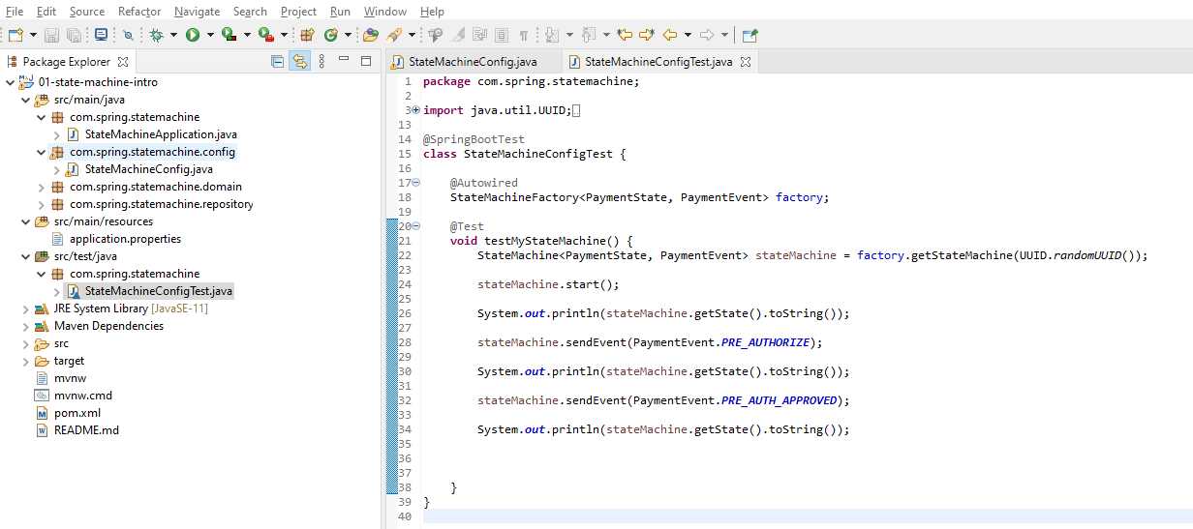

**Test Case**

Now, let's come up here and I'm going to create a test for this. And I'm not gonna do these methods specifically. I don't think we're going to need a set up on this. And here, I do need the Spring Boot Context so I'm going to bring in @SpringBootTest. And now if I come in and say I want the StateMachineFactory. So, I'm gonna say state machine factory, payment state, payment event like so. I'm going to say that @Autowired so I'm telling Spring Boot to go ahead and check that. IntelliJ is throw a little could not auto wire. It's not picking up the context for the state machine so that is actually going to be there. Now, if I come in and create a test method. I'm using unit tests here. I'm not doing official unit tests there's more to exercise the state machine. So, I'm gonna grab this like so. And let me actually make this a state machine not a state machine factory. We'll just call that sm equals factory.getStateMachine. I will pass in a random UUID for the state machine ID and I think that is optional. Don't hold me to that. I think that value is optional. Now we want to do a state machine start. So, that's important. Because what happens is the state machine allows you to bring it up and you can do configuration options on it and you can set some things and you can work with it and not start a state. But when you start it that may trigger action. So, that is what's going to get the state machine and air quotes running.

So, let's do a system out and we'll say state machine get state. So, we'll just do a two string on the state and if I do a state machine send event and let's do it the pre authorize. So, you can see that it's not going to send transition this state. Let me copy this and go do that and then sm send event. And, will do a pre auth approved like so. And we'll do a system out as well. So now, let's go ahead and run this and examine the console output. And with the full context coming of, it does take a little bit longer. But here we can see this is my first system out so I just started the machine and it is in a new status. Second one remember that does not transition it. But when I do a pre auth approved, you can see that the state machine now transitions to a pre auth status. So, just to recap there. We set up three transitions or three actions. I guess you would say it four events so three different events so we'll start off at new. We'll stay in new on the pre-authorized event and what we'll start auth at new and go from to pre auth when the pre auth is approved or to pre auth error if the pre auth has declined. So, these are very specific states and events and transitions that we've set up for these. And then over here on the test, I am bringing a state machine factory. I'm asking Spring context for that.

package com.spring.statemachine;

import java.util.UUID;

import org.junit.jupiter.api.Test;

import org.springframework.beans.factory.annotation.Autowired;

import org.springframework.boot.test.context.SpringBootTest;

import org.springframework.statemachine.StateMachine;

import org.springframework.statemachine.config.StateMachineFactory;

import com.spring.statemachine.domain.PaymentEvent;

import com.spring.statemachine.domain.PaymentState;

@SpringBootTest

class StateMachineConfigTest {

@Autowired

StateMachineFactory<PaymentState, PaymentEvent> factory;

@Test

void testMyStateMachine() {

StateMachine<PaymentState, PaymentEvent> stateMachine =

factory.getStateMachine( UUID.randomUUID() );

stateMachine.start();

System.out.println( stateMachine.getState().toString() );

stateMachine.sendEvent( PaymentEvent.PRE_AUTHORIZE );

System.out.println( stateMachine.getState().toString() );

stateMachine.sendEvent( PaymentEvent.PRE_AUTH_APPROVED );

System.out.println( stateMachine.getState().toString() );

}

}

**Console Output on running this**

2021-07-11 07:20:16.016 INFO 14832 --- [ main] c.s.statemachine.StateMachineConfigTest : Starting StateMachineConfigTest using Java 14.0.1 on DESKTOP-784UGM5 with PID 14832 (started by Dimpu in D:\3-workspace\microservices\state-machine-example\01-state-machine-intro)

2021-07-11 07:20:16.019 INFO 14832 --- [ main] c.s.statemachine.StateMachineConfigTest : No active profile set, falling back to default profiles: default

2021-07-11 07:20:17.644 INFO 14832 --- [ main] .s.d.r.c.RepositoryConfigurationDelegate : Bootstrapping Spring Data JPA repositories in DEFAULT mode.

2021-07-11 07:20:17.730 INFO 14832 --- [ main] .s.d.r.c.RepositoryConfigurationDelegate : Finished Spring Data repository scanning in 77 ms. Found 1 JPA repository interfaces.

2021-07-11 07:20:18.048 INFO 14832 --- [ main] trationDelegate$BeanPostProcessorChecker : Bean 'org.springframework.statemachine.config.configuration.StateMachineAnnotationPostProcessorConfiguration' of type [org.springframework.statemachine.config.configuration.StateMachineAnnotationPostProcessorConfiguration$$EnhancerBySpringCGLIB$$235ce935] is not eligible for getting processed by all BeanPostProcessors (for example: not eligible for auto-proxying)

2021-07-11 07:20:18.245 INFO 14832 --- [ main] com.zaxxer.hikari.HikariDataSource : HikariPool-1 - Starting...

2021-07-11 07:20:18.464 INFO 14832 --- [ main] com.zaxxer.hikari.HikariDataSource : HikariPool-1 - Start completed.

2021-07-11 07:20:18.772 INFO 14832 --- [ main] o.hibernate.jpa.internal.util.LogHelper : HHH000204: Processing PersistenceUnitInfo [name: default]

2021-07-11 07:20:18.864 INFO 14832 --- [ main] org.hibernate.Version : HHH000412: Hibernate ORM core version 5.4.32.Final

2021-07-11 07:20:19.114 INFO 14832 --- [ main] o.hibernate.annotations.common.Version : HCANN000001: Hibernate Commons Annotations {5.1.2.Final}

2021-07-11 07:20:19.264 INFO 14832 --- [ main] org.hibernate.dialect.Dialect : HHH000400: Using dialect: org.hibernate.dialect.H2Dialect

2021-07-11 07:20:20.018 INFO 14832 --- [ main] o.h.e.t.j.p.i.JtaPlatformInitiator : HHH000490: Using JtaPlatform implementation: [org.hibernate.engine.transaction.jta.platform.internal.NoJtaPlatform]

2021-07-11 07:20:20.027 INFO 14832 --- [ main] j.LocalContainerEntityManagerFactoryBean : Initialized JPA EntityManagerFactory for persistence unit 'default'

2021-07-11 07:20:20.433 WARN 14832 --- [ main] JpaBaseConfiguration$JpaWebConfiguration : spring.jpa.open-in-view is enabled by default. Therefore, database queries may be performed during view rendering. Explicitly configure spring.jpa.open-in-view to disable this warning

2021-07-11 07:20:21.457 INFO 14832 --- [ main] c.s.statemachine.StateMachineConfigTest : Started StateMachineConfigTest in 5.874 seconds (JVM running for 7.869)

2021-07-11 07:20:21.756 INFO 14832 --- [ main] o.s.s.support.LifecycleObjectSupport : started org.springframework.statemachine.support.DefaultStateMachineExecutor@5400db7e

2021-07-11 07:20:21.757 INFO 14832 --- [ main] o.s.s.support.LifecycleObjectSupport : started PRE_AUTH_ERROR NEW PRE_AUTH AUTH AUTH_ERROR / NEW / uuid=8fc3be5d-4c8b-42ad-9d3a-a77f6e3160b2 / id=null

ObjectState [getIds()=[NEW], getClass()=class org.springframework.statemachine.state.ObjectState, hashCode()=600825762, toString()=AbstractState [id=NEW, pseudoState=org.springframework.statemachine.state.DefaultPseudoState@1e09c0b, deferred=[], entryActions=[], exitActions=[], stateActions=[], regions=[], submachine=null]]

ObjectState [getIds()=[NEW], getClass()=class org.springframework.statemachine.state.ObjectState, hashCode()=600825762, toString()=AbstractState [id=NEW, pseudoState=org.springframework.statemachine.state.DefaultPseudoState@1e09c0b, deferred=[], entryActions=[], exitActions=[], stateActions=[], regions=[], submachine=null]]

ObjectState [getIds()=[PRE_AUTH], getClass()=class org.springframework.statemachine.state.ObjectState, hashCode()=645994590, toString()=AbstractState [id=PRE_AUTH, pseudoState=null, deferred=[], entryActions=[], exitActions=[], stateActions=[], regions=[], submachine=null]]

[INFO] Tests run: 1, Failures: 0, Errors: 0, Skipped: 0, Time elapsed: 7.435 s - in com.spring.statemachine.StateMachineConfigTest

2021-07-11 07:20:21.798 INFO 14832 --- [ionShutdownHook] j.LocalContainerEntityManagerFactoryBean : Closing JPA EntityManagerFactory for persistence unit 'default'

2021-07-11 07:20:21.799 INFO 14832 --- [ionShutdownHook] .SchemaDropperImpl$DelayedDropActionImpl : HHH000477: Starting delayed evictData of schema as part of SessionFactory shut-down'

2021-07-11 07:20:21.807 INFO 14832 --- [ionShutdownHook] com.zaxxer.hikari.HikariDataSource : HikariPool-1 - Shutdown initiated...

2021-07-11 07:20:21.809 INFO 14832 --- [ionShutdownHook] com.zaxxer.hikari.HikariDataSource : HikariPool-1 - Shutdown completed.

The console logs show how the state changed based on the events

So, remember the Spring Boot test that is going to bring up with Spring context. We can see all the chatter and the log there. I am asking for that state machine starting it. Imagine if I put it into the new status because of the configuration and then I'm sending an event of pre-authorize and then pre authorize approved. So, we can see that these different transactions are working as expected and if I actually were to send a pre auth disapproved, or declined at this point. Because I don't have a transition set up from pre auth nothing would happen. So, if I try to go from pre auth to decline, it would not work because it's in a pre auth state. Because I don't have any transitions to find the way the state machine is working. It's going to be like a very rigid so if you try to do a state transition that is not defined, it doesn't do anything. I don't think it set up doesn't error. So, actually let me demonstrate that. So, let's copy this so I'll do pre auth declined. And here it's going to be in that authorized state so let's go ahead and run this and take a look at the output. It should not error and stay in a pre auth state.

@SpringBootTest

class StateMachineConfigTest {

@Autowired

StateMachineFactory<PaymentState, PaymentEvent> factory;

@Test

void testMyStateMachine() {

StateMachine<PaymentState, PaymentEvent> stateMachine

= factory.getStateMachine( UUID.randomUUID() );

stateMachine.start();

System.out.println( stateMachine.getState().toString() );

stateMachine.sendEvent( PaymentEvent.PRE_AUTHORIZE );

System.out.println(stateMachine.getState().toString());

stateMachine.sendEvent( PaymentEvent.PRE_AUTH_APPROVED );

System.out.println( stateMachine.getState().toString() );

stateMachine.sendEvent( PaymentEvent.PRE_AUTH_DECLINED );

System.out.println( stateMachine.getState().toString() );

}

}

And you can see here no error. I did send it to that event. I send the pre auth declined. You can see there, it did stay in pre auth because I have not set up a state transition for that. So, the state machine does know what we're talking about it. Just ignore that event without complaining about it.

### Event Listener

Now, one of the things that Springs State Machine supports is event listeners. And in this video, I'm going to configure a listener so that we can observe the state machine transitions and we're just going to set up a simple logger. But you could do a number of different things inside of a listener as far as the business logic that you need to implement. In this video, I just want to make you aware of that this feature does exist and it's gonna be handy for us. Because as we evolve the state machine, we'll be able to see to the console the actual state transitions. So, I am going to come in and set up a new configuration option here. So, I'm gonna override a method like so. You got to be careful here because you have these configure methods and they're all similar name. I'm gonna admit, I'm not a huge fan of how they did this because it's real easy to make mistake. There's very similarly named. So it here, we want the config state machine configuration configurer.

package com.spring.statemachine.config;

import java.util.EnumSet;

import org.springframework.context.annotation.Configuration;

import org.springframework.statemachine.config.EnableStateMachineFactory;

import org.springframework.statemachine.config.StateMachineConfigurerAdapter;

import org.springframework.statemachine.config.builders.StateMachineConfigurationConfigurer;

import org.springframework.statemachine.config.builders.StateMachineStateConfigurer;

import org.springframework.statemachine.config.builders.StateMachineTransitionConfigurer;

import com.spring.statemachine.domain.PaymentEvent;

import com.spring.statemachine.domain.PaymentState;

import lombok.extern.slf4j.Slf4j;

@Configuration

@EnableStateMachineFactory

@Slf4j

public class StateMachineConfig extends StateMachineConfigurerAdapter<PaymentState, PaymentEvent> {

@Override

public void configure(**StateMachineStateConfigurer**<PaymentState, PaymentEvent> states)

throws Exception {

states.withStates()

.initial(PaymentState.NEW)

.states(EnumSet.allOf(PaymentState.class))

.end(PaymentState.AUTH)

.end(PaymentState.PRE_AUTH_ERROR)

.end(PaymentState.AUTH_ERROR);

}

@Override

public void configure(**StateMachineTransitionConfigurer**< PaymentState,

PaymentEvent> transitions) throws Exception {

transitions.withExternal().source( PaymentState.NEW ).target( PaymentState.NEW )

.event( PaymentEvent.PRE_AUTHORIZE )

.and()

.withExternal().source( PaymentState.NEW ).target( PaymentState.PRE_AUTH )

.event( PaymentEvent.PRE_AUTH_APPROVED )

.and()

.withExternal().source( PaymentState.NEW )

.target( PaymentState.PRE_AUTH_ERROR )

.event( PaymentEvent.PRE_AUTH_DECLINED );

}

@Override

public void configure( StateMachineConfigurationConfigurer<PaymentState,

PaymentEvent> config) throws Exception {

. . .

}

}

So that's kind of a mouthful to say. So, we'll go ahead and implement that. And here what we want to do is add into the configuration so we want to set up some type of listener and here what we want to do is add in a state machine listener adapter like this. We'll go ahead set up the generics on that so that's going to take any payment state, payment event like so or two enumerations. We'll just call that an adapter. And here we want and this is actually a interface. We'll create an implementation here in line like so. What we want to do is override one of the methods in it. We want to get the state change. We're look at the state changed event specifically. And, I gotta cheat a little bit. I copied this to my clipboard out of my notes so a simple logging statement. I'll explain what's going on here.

package com.spring.statemachine.config;

import java.util.EnumSet;

import org.springframework.context.annotation.Configuration;

import org.springframework.statemachine.config.EnableStateMachineFactory;

import org.springframework.statemachine.config.StateMachineConfigurerAdapter;

import org.springframework.statemachine.config.builders.StateMachineConfigurationConfigurer;

import org.springframework.statemachine.config.builders.StateMachineStateConfigurer;

import org.springframework.statemachine.config.builders.StateMachineTransitionConfigurer;

import org.springframework.statemachine.listener.StateMachineListenerAdapter;

import org.springframework.statemachine.state.State;

import com.spring.statemachine.domain.PaymentEvent;

import com.spring.statemachine.domain.PaymentState;

import lombok.extern.slf4j.Slf4j;

@Configuration

@EnableStateMachineFactory

@Slf4j

public class StateMachineConfig extends StateMachineConfigurerAdapter<PaymentState, PaymentEvent> {

@Override

public void configure(StateMachineStateConfigurer<PaymentState, PaymentEvent> states)

throws Exception {

states.withStates()

.initial( PaymentState.NEW )

.states( EnumSet.allOf( PaymentState.class ))

.end( PaymentState.AUTH )

.end( PaymentState.PRE_AUTH_ERROR )

.end( PaymentState.AUTH_ERROR );

}

@Override

public void configure(StateMachineTransitionConfigurer<PaymentState, PaymentEvent> transitions)

throws Exception {

transitions.withExternal().source( PaymentState.NEW )

.target( PaymentState.NEW )

.event( PaymentEvent.PRE_AUTHORIZE )

.and()

.withExternal().source( PaymentState.NEW )

.target( PaymentState.PRE_AUTH )

.event( PaymentEvent.PRE_AUTH_APPROVED )

.and()

.withExternal().source( PaymentState.NEW )

.target( PaymentState.PRE_AUTH_ERROR )

.event( PaymentEvent.PRE_AUTH_DECLINED );

}

@Override

public void configure( StateMachineConfigurationConfigurer<PaymentState, PaymentEvent> config)

throws Exception {

StateMachineListenerAdapter<PaymentState, PaymentEvent> adapter =

new StateMachineListenerAdapter<PaymentState, PaymentEvent>() {

@Override

public void stateChanged( State<PaymentState, PaymentEvent> from,

State<PaymentState, PaymentEvent> to) {

log.info(String.format("State changed from : ", from, "to", to + "."));

};

};

}

}

So, we have log info string format state changed from to and I don't think we need this. So I'm going to get rid of that. So, what this is going to do in the string format, it's going to bind these two parameters to the from and to. So, the method the way it works, it's going to take in a payment event from and to so we'll log those both in these states. So, I'll go along the states so from and to to the Console. And again, this is being brought in by Project Lombok. So, we got our logger configured by Lombok. So, this sets up the adapter which is not being used yet so we want to take the config that is being passed in and we are going to do with configuration listener and we're going to just configure this adapter to that just like so. So, that sets up that. And again, we're using the info log level. And now if I come over here to my test, let's go ahead and run this. We'll see information being output to the council from Spring State Machine itself. I bring this up a little bit. So you can see here, this is my log output. We could get this state machine state change from to. So you can see the information there so we're getting that information outputted. And let's see here. So, here's another state changed, state change and we could enhance us a little bit as far as how it is being outputted.

2021-07-11 20:59:09.616 INFO 5344 --- [ main] c.s.statemachine.StateMachineConfigTest : Started StateMachineConfigTest in 4.19 seconds (JVM running for 5.066)

2021-07-11 20:59:09.851 INFO 5344 --- [ main] c.s.s.config.StateMachineConfig : ******** State changed from : null to: ObjectState [getIds()=[NEW], getClass()=class org.springframework.statemachine.state.ObjectState, hashCode()=193023523, toString()=AbstractState [id=NEW, pseudoState=org.springframework.statemachine.state.DefaultPseudoState@5f81507a, deferred=[], entryActions=[], exitActions=[], stateActions=[], regions=[], submachine=null]]

2021-07-11 20:59:09.853 INFO 5344 --- [ main] o.s.s.support.LifecycleObjectSupport : started org.springframework.statemachine.support.DefaultStateMachineExecutor@16732340

2021-07-11 20:59:09.853 INFO 5344 --- [ main] o.s.s.support.LifecycleObjectSupport : started AUTH PRE_AUTH_ERROR NEW AUTH_ERROR PRE_AUTH / NEW / uuid=fe6599bc-d1a9-4687-a30f-ad107590432c / id=null

ObjectState [getIds()=[NEW], getClass()=class org.springframework.statemachine.state.ObjectState, hashCode()=193023523, toString()=AbstractState [id=NEW, pseudoState=org.springframework.statemachine.state.DefaultPseudoState@5f81507a, deferred=[], entryActions=[], exitActions=[], stateActions=[], regions=[], submachine=null]]

2021-07-11 20:59:09.857 INFO 5344 --- [ main] c.s.s.config.StateMachineConfig : ******** State changed from : ObjectState [getIds()=[NEW], getClass()=class org.springframework.statemachine.state.ObjectState, hashCode()=193023523, toString()=AbstractState [id=NEW, pseudoState=org.springframework.statemachine.state.DefaultPseudoState@5f81507a, deferred=[], entryActions=[], exitActions=[], stateActions=[], regions=[], submachine=null]] to: ObjectState [getIds()=[NEW], getClass()=class org.springframework.statemachine.state.ObjectState, hashCode()=193023523, toString()=AbstractState [id=NEW, pseudoState=org.springframework.statemachine.state.DefaultPseudoState@5f81507a, deferred=[], entryActions=[], exitActions=[], stateActions=[], regions=[], submachine=null]]

ObjectState [getIds()=[NEW], getClass()=class org.springframework.statemachine.state.ObjectState, hashCode()=193023523, toString()=AbstractState [id=NEW, pseudoState=org.springframework.statemachine.state.DefaultPseudoState@5f81507a, deferred=[], entryActions=[], exitActions=[], stateActions=[], regions=[], submachine=null]]

2021-07-11 20:59:09.858 INFO 5344 --- [ main] c.s.s.config.StateMachineConfig : ******** State changed from : ObjectState [getIds()=[NEW], getClass()=class org.springframework.statemachine.state.ObjectState, hashCode()=193023523, toString()=AbstractState [id=NEW, pseudoState=org.springframework.statemachine.state.DefaultPseudoState@5f81507a, deferred=[], entryActions=[], exitActions=[], stateActions=[], regions=[], submachine=null]] to: ObjectState [getIds()=[PRE_AUTH], getClass()=class org.springframework.statemachine.state.ObjectState, hashCode()=2103491930, toString()=AbstractState [id=PRE_AUTH, pseudoState=null, deferred=[], entryActions=[], exitActions=[], stateActions=[], regions=[], submachine=null]]

ObjectState [getIds()=[PRE_AUTH], getClass()=class org.springframework.statemachine.state.ObjectState, hashCode()=2103491930, toString()=AbstractState [id=PRE_AUTH, pseudoState=null, deferred=[], entryActions=[], exitActions=[], stateActions=[], regions=[], submachine=null]]

ObjectState [getIds()=[PRE_AUTH], getClass()=class org.springframework.statemachine.state.ObjectState, hashCode()=2103491930, toString()=AbstractState [id=PRE_AUTH, pseudoState=null, deferred=[], entryActions=[], exitActions=[], stateActions=[], regions=[], submachine=null]]

2021-07-11 20:59:09.880 INFO 5344 --- [ionShutdownHook] j.LocalContainerEntityManagerFactoryBean : Closing JPA EntityManagerFactory for persistence unit 'default'

2021-07-11 20:59:09.881 INFO 5344 --- [ionShutdownHook] .SchemaDropperImpl$DelayedDropActionImpl : HHH000477: Starting delayed evictData of schema as part of SessionFactory shut-down'

2021-07-11 20:59:09.887 INFO 5344 --- [ionShutdownHook] com.zaxxer.hikari.HikariDataSource : HikariPool-1 - Shutdown initiated...

2021-07-11 20:59:09.890 INFO 5344 --- [ionShutdownHook] com.zaxxer.hikari.HikariDataSource : HikariPool-1 - Shutdown completed.

But the main thing I wanted to teach in this lesson was setting up that listener. So now, we have a listener set up. I get rid of that. We'll do a quick review so what we did is we implemented this configure method which brings in this configurer and we are creating in line here an adapter and all the adapter does is put out a statement, state changed using the string format and then the important part here is to say with configuration. Let's clean that up a little bit with configuration listener adapter. I like it looks better that way. There's really no official guideline on formatting like this. I think that's just personally a little easier to read like like that. But key takeaway is setting up this configurer and that can be a separate component altogether. Here, we just defined it in mind and then we're saying config with configuration to set that listener and then there's other things that you could configure with the Spring State Machine configuration to.

### Payment Service

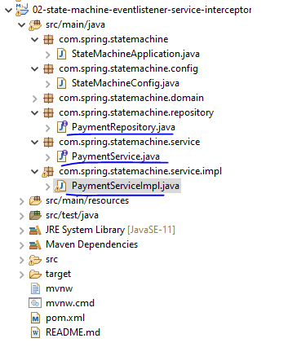

**PaymentService.java**

package com.spring.statemachine.service;

import org.springframework.statemachine.StateMachine;

import com.spring.statemachine.domain.Payment;

import com.spring.statemachine.domain.PaymentEvent;

import com.spring.statemachine.domain.PaymentState;

public **interface** PaymentService {

**Payment** newPayment(**Payment** payment);

**StateMachine**<**PaymentState**, **PaymentEvent**> **preAuth**(Long paymentId);

**StateMachine**<**PaymentState**, **PaymentEvent**> **authorizePayment**(Long paymentId);

**StateMachine**<**PaymentState**, **PaymentEvent**> **declineAuth**(Long paymentId);

}

**PaymentServiceImpl.java**

package com.spring.statemachine.service.impl;

import org.springframework.statemachine.StateMachine;

import org.springframework.statemachine.config.StateMachineFactory;

import org.springframework.stereotype.Service;

import com.spring.statemachine.domain.Payment;

import com.spring.statemachine.domain.PaymentEvent;

import com.spring.statemachine.domain.PaymentState;

import com.spring.statemachine.repository.PaymentRepository;

import com.spring.statemachine.service.PaymentService;

import lombok.RequiredArgsConstructor;

@Service

@RequiredArgsConstructor

public class **PaymentServiceImpl** implements PaymentService {

private final PaymentRepository paymentRepository;

private final StateMachineFactory<PaymentState, PaymentEvent> stateMachineFactory;

@Override

public Payment newPayment(Payment payment) {

payment.setState(PaymentState.NEW);

return paymentRepository.save(payment);

}

@Override

public StateMachine<PaymentState, PaymentEvent> preAuth(Long paymentId) {

return null;

}

@Override

public StateMachine<PaymentState, PaymentEvent> authorizePayment(Long paymentId) {

return null;

}

@Override

public StateMachine<PaymentState, PaymentEvent> declineAuth(Long paymentId) {

return null;

}

}

**PaymentRepository.java**

import org.springframework.data.jpa.repository.JpaRepository;

import com.spring.statemachine.domain.Payment;

public interface PaymentRepository extends JpaRepository<Payment, Long>{

}

### Initialize State Machine from the Database

We are going to go over how to restore the state machine from the database. So, our use case that I'm setting up in this scenario here, it's like we're running some microservices and we need to persist the state of the state machine to the database and then rehydrate it, reset it from the object in the database. And this kind of a use case where we're gonna have separate processes running and they'll be running over time. So, there's gonna be some time between the pre-authorization and the authorization of the payment. So, that's a use case and it could be one minute, it could be ten minutes, it could be an hour. We honestly don't know. But, what we want to do here is bring that state machine back out of the database and rehydrate it to the proper state. I'm gonna show you that in this video. Frequently, this is considered a an expensive process to restore the state machine. There is some cost to this. A lot of times you're gonna see more complex processing and you might not even persist a state machine to a database. But for our use case, we want to be doing this to set up that state machine coming back from the database.

So, I'm gonna show you how to set that up. It's a little cumbersome but it's not too bad. Because basically, we want to get the object out of the database and then set up a state machine for in that state of that object. So here, what I'm going to do is I'm gonna create a new private method and this method is going to return back a state machine. That's going to be a payment state and a payment event. I'll just call this build and this is going to take in a long. It's going to be a payment ID. So the first thing we want to do is get the payment on the database by that ID. So, it's going to fish that payment ID at that payment object out of the database using Spring data JPA. So, let's go ahead and get our state machine. And here, what we can do is that's going to be payment state, payment event what we call as sm and we're gonna be asking the state machine factory for an instance of it. So, state machine factory and we're gonna say get state machine and we want to give it a key. So, we're going to do a long two string.

private StateMachine<PaymentState, PaymentEvent> build(Long paymentId) {

Payment **payment** = paymentRepository.getOne(paymentId);

StateMachine<PaymentState, PaymentEvent> **stateMachine** =

stateMachineFactory.getStateMachine( Long.toString( payment.getId() ) );

**stateMachine**.stop();

stateMachine.getStateMachineAccessor()

.doWithAllRegions( stateMachineAccessor -> {

stateMachineAccessor.resetStateMachine( new

DefaultStateMachineContext( **payment**.getState(), null, null, null ));

});

stateMachine.start();

return stateMachine;

}

I'm going to use the payment object to get the ID off of that. So, we'd be working with that. So, this is going to ask the state machine for an instance of that and then we need to tell it to stop so it's not active. This is where it gets a little bit tricky. We're gonna say state machine, get state machine accessor. Now, we're just gonna say do with all regions. So, this will look might feel a little little strange and we are going to do a state machine accessor. So, we're saying do with all regions. We're gonna get what's called a state machine accessor and then we want to say sma reset state machine. We're going to say new default state machine context. This is going to say payment get states so that's gonna be the enum of the state. And then it's actually one. There's a context so we're setting up. We don't need pass an event. We don't need event headers or extended state. So, that sets all that up for us. So, that line there, I just want to be clear the line on 54. Basically, we are telling them state machine to stop and we are setting it to the specific state of the payment and the database or that we retrieves no database. So now, we want to say state machine start so we're going to restart it and then simply return it. So, this is a code that's going to do that.

import org.springframework.statemachine.StateMachine;

import org.springframework.statemachine.config.StateMachineFactory;

import org.springframework.statemachine.support.DefaultStateMachineContext;

import org.springframework.stereotype.Service;

import com.spring.statemachine.domain.Payment;

import com.spring.statemachine.domain.PaymentEvent;

import com.spring.statemachine.domain.PaymentState;

import com.spring.statemachine.repository.PaymentRepository;

import com.spring.statemachine.service.PaymentService;

import lombok.RequiredArgsConstructor;

@Service

@RequiredArgsConstructor

public class PaymentServiceImpl implements PaymentService {

private final PaymentRepository paymentRepository;

private final StateMachineFactory<PaymentState, PaymentEvent> stateMachineFactory;

@Override

public Payment newPayment(Payment payment) {

StateMachine<PaymentState, PaymentEvent> stateMachine = build(payment.getId());

payment.setState(PaymentState.NEW);

return paymentRepository.save(payment);

}

@Override

public StateMachine<PaymentState, PaymentEvent> preAuth(Long paymentId) {

StateMachine<PaymentState, PaymentEvent> stateMachine = build(paymentId);

return null;

}

@Override

public StateMachine<PaymentState, PaymentEvent> authorizePayment(Long paymentId) {

StateMachine<PaymentState, PaymentEvent> stateMachine = build(paymentId);

return null;

}

@Override

public StateMachine<PaymentState, PaymentEvent> declineAuth(Long paymentId) {

StateMachine<PaymentState, PaymentEvent> stateMachine = build(paymentId);

return null;

}

private StateMachine<PaymentState, PaymentEvent> **build(**Long paymentId) {

Payment payment = paymentRepository.getOne(paymentId);

StateMachine<PaymentState, PaymentEvent> stateMachine =

stateMachineFactory.getStateMachine(Long.toString(payment.getId()));

stateMachine.stop();

stateMachine.getStateMachineAccessor()

.doWithAllRegions( stateMachineAccessor -> {

stateMachineAccessor.resetStateMachine(

new DefaultStateMachineContext( payment.getState(), null,

null, null ));

});

stateMachine.start();

return stateMachine;

}

}

Gets it from the database, gets a state machine, stops it, sets it to the the status from the database, starts it and then returns it. And each one of these methods is going to need access to that state machine. So, let's come in here and say state machine a payment state payment event. Now, we can say state machine and this is gonna be build. We'll pass in that payment ID. So, I know each one of these methods is going to need that so I'm just gonna copy this on over. We'll add those like so. So, that sets all it all that up. For future videos, we'll be covering the context of each one of these in future videos. But the primary thing I want to go over in this video was to use Spring state machine to rehydrate that from the database. So again, just to recap. What we did here on line 52, we're going out to the database, getting a payment, then we are asking the state machine factory for an instance of the state machine. We stopped it, we use an accessor to go in and set it to the state that's from the database or a payment from the database. We restart the state machine and then we return it. And this is a common method that we're going to use for each one of our methods that is going to work with the state machine.

### Sending Events to the State Machine

Lets see how to send events into the state machine and one nice feature about the state machine is that it does support the Spring message infrastructure. So, what I'm going to do in this video is I'm gonna send the state machine a standard Spring message that's going to contain information about the event. So, all these methods are going to need to send events to the state machine. So, I am going to create a new method here and I am just gonna call, it doesn't need to return anything but I'm just gonna say to send an event to the state machine and it's going to take in a payment ID, the state machine itself and then a payment event.

So, I'm going to create a message and use a Spring Framework and just call the MSG and use a message builder. We'll use with payload. That payload is going to be the event itself. We want to set a header on this with the ID and you'll see that how this comes into play later. But this is going to be important to get the payment ID. And for that, let's create a variable for that. And that should be a string clearly. So, down here I'm gonna say payment ID header and then the payment ID and we'll say build like so. Then on the state machine, we want to send that message. So, you can see there we can either send the payment event itself or we can actually send a message. So, I'm going to send the message itself. The reason I'm doing it this way is because I want to send in to the state machine not only the actual event, the enum event but up enriching it. So, I'm actually adding in data here so I want the state machine to be aware of the payment ID. So remember, right now, our state machines fairly fairly dumb. It doesn't know very much. It just knows the states and the events. But we're gonna be working with the state machine further and I'm going to add in an additional logic where it's going to need to know the payment ID. So, that's why I'm setting up the header there to have enriched the message with data about financial payment ID that we are working with. All this is going to do is send out that event.

private void sendEvent(Long paymentId, StateMachine<PaymentState, PaymentEvent> stateMachine, PaymentEvent paymentEvent) {

// Enrich data before sending the message

Message msg = MessageBuilder.withPayload( paymentEvent )

.setHeader(PAYMENT_ID_HEADER, paymentId)

.build();

stateMachine.sendEvent(msg);

}

So, now for pre auth, what I can do is come up here and say send event. That's going to be a payment ID, state machine, payment event and we are going to do pre-authorize like so. So, I'm building up this method here. We're not not done yet. We still have a few things to do but what we want to do here under pre auth, we're gonna go get the state machine. We're gonna restore that from the database and then we are going to send an event into that state machine. We're saying that with the pre auth method it is going to send a payment event of pre-authorized to the state machine. So, we still have a few things to do here. Let's see. We can actually implement the other ones while we're here. So, we can say send event, payment ID sm and this is going to be a payment event of and this is going to be authorized, authorized approved. Let's just grab this and we can also do it for this guy here. This gonna be the authorization declined. So these are different events that we can send into the state machine. So now, these three methods. They look pretty similar but they are calling specific events and each of the three basically is going to go get the state machine from the database and then send in an event message.

import org.springframework.messaging.Message;

import org.springframework.messaging.support.MessageBuilder;

import org.springframework.statemachine.StateMachine;

import org.springframework.statemachine.config.StateMachineFactory;

import org.springframework.statemachine.support.DefaultStateMachineContext;

import org.springframework.stereotype.Service;

import com.spring.statemachine.domain.Payment;

import com.spring.statemachine.domain.PaymentEvent;

import com.spring.statemachine.domain.PaymentState;

import com.spring.statemachine.repository.PaymentRepository;

import com.spring.statemachine.service.PaymentService;

import lombok.RequiredArgsConstructor;

@Service

@RequiredArgsConstructor

public class PaymentServiceImpl implements PaymentService {

public static final String PAYMENT_ID_HEADER = "payment_id";

private final PaymentRepository paymentRepository;

private final StateMachineFactory<PaymentState, PaymentEvent> stateMachineFactory;

@Override

public Payment **newPayment**(Payment payment) {

StateMachine<PaymentState, PaymentEvent> stateMachine = build(payment.getId());

payment.setState(PaymentState.NEW);

return paymentRepository.save(payment);

}

@Override

public StateMachine<PaymentState, PaymentEvent> **preAuth**(Long paymentId) {

StateMachine<PaymentState, PaymentEvent> stateMachine = build(paymentId);

sendEvent(paymentId, stateMachine, PaymentEvent.PRE_AUTHORIZE);

return null;

}

@Override

public StateMachine<PaymentState, PaymentEvent> **authorizePayment**(Long paymentId) {

StateMachine<PaymentState, PaymentEvent> stateMachine = build(paymentId);

sendEvent(paymentId, stateMachine, PaymentEvent.PRE_AUTH_APPROVED);

return null;

}

@Override

public StateMachine<PaymentState, PaymentEvent> **declineAuth**(Long paymentId) {

StateMachine<PaymentState, PaymentEvent> stateMachine = build( paymentId );

sendEvent(paymentId, stateMachine, PaymentEvent.AUTH_DECLINED);

return null;

}

private void **sendEvent(** Long paymentId, StateMachine<PaymentState, PaymentEvent> stateMachine,

PaymentEvent paymentEvent) {

// Enrich data before sending the message

Message msg = MessageBuilder.withPayload( paymentEvent )

.setHeader(PAYMENT_ID_HEADER, paymentId)

.build();

stateMachine.sendEvent( msg );

}

private StateMachine<PaymentState, PaymentEvent> **build**(Long paymentId) {

Payment payment = paymentRepository.getOne( paymentId );

StateMachine<PaymentState, PaymentEvent> stateMachine =

stateMachineFactory.getStateMachine(Long.toString(payment.getId()));

stateMachine.stop();

stateMachine.getStateMachineAccessor()

.doWithAllRegions(stateMachineAccessor -> {

stateMachineAccessor.resetStateMachine(

new DefaultStateMachineContext(payment.getState(), null, null, null ) );

});

stateMachine.start();

return stateMachine;

}

}

And now, what we need to do next is have the state machine react to these events. But I'm going to do that in a separate video. I will actually do that in the next video here. So, just to recap here, the send event, I'm sending in a message and remember, I'm enriching this message with the payment ID because I'm going to need to do that when I tell the state machine to react to this event, I need that payment ID awareness and we'll cover that in the next video.

### State Change Interceptor

We went through and we set up a method to send the state machine events. So now, the state machine is getting that event and what we want to do is react to that event. Rather than just transition the state machine, we actually want to intercept that. And because we are changing this the state, we want to go ahead and persist that change to the database. So remember, we're transitioning that payment and we're using the state machine to handle that and when we are going to change the state that needs to be saved to the database. So, we're going to set up an interceptor to do that and you can see here on the screen, I have the spring state machine state interceptor.

**Spring State Machine Interceptor interface code.**

import org.springframework.messaging.Message;

import org.springframework.statemachine.StateContext;

import org.springframework.statemachine.StateMachine;

import org.springframework.statemachine.state.State;

import org.springframework.statemachine.transition.Transition;

/**

* Interface which can be registered with a state machine and can be used to intercept and break a state change chain.

*

* @author Janne Valkealahti

*

* @param <S> the type of state

* @param <E> the type of event

*/

public interface StateMachineInterceptor<S, E> {

/**

* Called before message is sent to processing. Throwing exception or returning null will skip the message.

*

* @param message the message

* @param stateMachine the state machine

* @return the intercepted message

*/

Message<E> preEvent(Message<E> message, StateMachine<S, E> stateMachine);

/**

* Called prior of a state change. Throwing an exception from this method will stop a state change logic.

*

* @param state the state

* @param message the message

* @param transition the transition

* @param stateMachine the state machine

*/

void preStateChange(State<S, E> state, Message<E> message, Transition<S, E> transition, StateMachine<S, E> stateMachine);

/**

* Called prior of a state change. Throwing an exception from this method will stop a state change logic.

*

* @param state the state

* @param message the message

* @param transition the transition

* @param stateMachine the state machine

* @param rootStateMachine the root state machine

*/

void preStateChange(State<S, E> state, Message<E> message, Transition<S, E> transition,

StateMachine<S, E> stateMachine, StateMachine<S, E> rootStateMachine);

/**

* Called after a state change.

*

* @param state the state

* @param message the message

* @param transition the transition

* @param stateMachine the state machine

*/

void postStateChange(State<S, E> state, Message<E> message, Transition<S, E> transition,

StateMachine<S, E> stateMachine);

/**

* Called after a state change.

*

* @param state the state

* @param message the message

* @param transition the transition

* @param stateMachine the state machine

* @param rootStateMachine the root state machine

*/

void postStateChange(State<S, E> state, Message<E> message, Transition<S, E> transition,

StateMachine<S, E> stateMachine, StateMachine<S, E> rootStateMachine);

/**

* Called prior of a start of a transition. Returning

* {@code null} from this method will break the transtion

* chain.

*

* @param stateContext the state context

* @return the state context

*/

StateContext<S, E> preTransition(StateContext<S, E> stateContext);

/**

* Called after of a transition if transition happened.

*

* @param stateContext the state context

* @return the state context

*/

StateContext<S, E> postTransition(StateContext<S, E> stateContext);

/**

* State when state machine is about to enter error it can't recover.

*

* @param stateMachine the state machine

* @param exception the exception

* @return the exception

*/

Exception stateMachineError(StateMachine<S, E> stateMachine, Exception exception);

}

We're going to provide an implementation of this to go ahead and detect a state change and then save that. And what we're going to do is use this pre state change. So, before the state machine transitions, we'll go ahead and save it to the database and then allow the state machine to complete the transition. So, what I want want to do here is I'm going to create a new implementation of that something I say New Java Class, call this PaymentStateChange. Payment state change listener will add that into Github and we want that to extend the state machine interceptor adapter and that is going to take in payment state and payment event. We'll register this as a spring component. We'll do require args constructor on it because we are going to need the payment repository.

Now, what we want to do is override a method and just want to make sure that I grabbed a proper one there oh uh refactor rename. Got a paint event rather than payment. Sorry about that guys. Maybe you should just recreate those. Now in this, what I want to do is let's come in here and say you so much Java 8 features Of nullable and we'll say message. And if that message is present, what we can do is work with that. I'll say of nullable long And that the problem is we don't know exactly what's coming off the message because that that's just going to have an object type so we're going to say and remember I said that string to be public because I know I was going to reuse it here. Now, we can say if present. And here, I'm going to go get it from the repository a repository. So, this is gonna fetch the payment from the database. Now, we want to say payment set state. We're going to say state and get ID. So, that's going to be our payment state there and then we simply tell her the payment repository to save it.

import java.util.Optional;

import org.springframework.messaging.Message;

import org.springframework.statemachine.StateMachine;

import org.springframework.statemachine.state.State;

import org.springframework.statemachine.support.StateMachineInterceptorAdapter;

import org.springframework.statemachine.transition.Transition;

import org.springframework.stereotype.Component;

import com.spring.statemachine.domain.Payment;

import com.spring.statemachine.domain.PaymentEvent;

import com.spring.statemachine.domain.PaymentState;

import com.spring.statemachine.repository.PaymentRepository;

import lombok.RequiredArgsConstructor;

@RequiredArgsConstructor

@Component

public class PaymentStateChangeInterceptor

extends StateMachineInterceptorAdapter<PaymentState, PaymentEvent> {

private final PaymentRepository paymentRepository;

@Override

public void preStateChange( State<PaymentState, PaymentEvent> state, Message<PaymentEvent> message,

Transition<PaymentState, PaymentEvent> transition,

StateMachine<PaymentState, PaymentEvent> stateMachine) {

Optional.ofNullable( message ).ifPresent( msg -> {

Optional.ofNullable( Long.class.cast( message.getHeaders()

.getOrDefault(PaymentServiceImpl.PAYMENT_ID_HEADER, -1L)) )

.ifPresent(

paymentId -> {

Payment payment = paymentRepository.getOne( paymentId );

payment.setState(state.getId());

paymentRepository.save( payment );

});

});

}

}

**PaymentServiceImpl.java**

import org.springframework.messaging.Message;

import org.springframework.messaging.support.MessageBuilder;

import org.springframework.statemachine.StateMachine;

import org.springframework.statemachine.config.StateMachineFactory;

import org.springframework.statemachine.support.DefaultStateMachineContext;

import org.springframework.stereotype.Service;

import com.spring.statemachine.domain.Payment;

import com.spring.statemachine.domain.PaymentEvent;

import com.spring.statemachine.domain.PaymentState;

import com.spring.statemachine.repository.PaymentRepository;

import lombok.RequiredArgsConstructor;

@Service

@RequiredArgsConstructor

public class PaymentServiceImpl implements PaymentService {

public static final String PAYMENT_ID_HEADER = "payment_id";

private final PaymentRepository paymentRepository;

private final StateMachineFactory<PaymentState, PaymentEvent> stateMachineFactory;

private final PaymentStateChangeInterceptor paymentInterceptor;

@Override

public Payment newPayment(Payment payment) {

StateMachine<PaymentState, PaymentEvent> stateMachine = build(payment.getId());

payment.setState(PaymentState.NEW);

return paymentRepository.save(payment);

}

@Override

public StateMachine<PaymentState, PaymentEvent> preAuth(Long paymentId) {

StateMachine<PaymentState, PaymentEvent> stateMachine = build(paymentId);

sendEvent(paymentId, stateMachine, PaymentEvent.PRE_AUTHORIZE);

return null;

}

@Override

public StateMachine<PaymentState, PaymentEvent> authorizePayment(Long paymentId) {

StateMachine<PaymentState, PaymentEvent> stateMachine = build(paymentId);

sendEvent(paymentId, stateMachine, PaymentEvent.PRE_AUTH_APPROVED);

return null;

}

@Override

public StateMachine<PaymentState, PaymentEvent> declineAuth(Long paymentId) {

StateMachine<PaymentState, PaymentEvent> stateMachine = build(paymentId);

sendEvent(paymentId, stateMachine, PaymentEvent.AUTH_DECLINED);

return null;

}

private void sendEvent(Long paymentId, StateMachine<PaymentState, PaymentEvent> stateMachine,

PaymentEvent paymentEvent) {

// Enrich data before sending the message

Message msg = MessageBuilder.withPayload( paymentEvent )

.setHeader(PAYMENT_ID_HEADER, paymentId)

.build();

stateMachine.sendEvent(msg);

}

private StateMachine<PaymentState, PaymentEvent> build(Long paymentId) {

Payment payment = paymentRepository.getOne(paymentId);

StateMachine<PaymentState, PaymentEvent> stateMachine =

stateMachineFactory.getStateMachine(Long.toString(payment.getId()));

stateMachine.stop();

stateMachine.getStateMachineAccessor()

.doWithAllRegions(stateMachineAccessor -> {

stateMachineAccessor.addStateMachineInterceptor( paymentInterceptor );

stateMachineAccessor.resetStateMachine(

new DefaultStateMachineContext<PaymentState,

PaymentEvent>(payment.getState(), null, null, null ));

});

stateMachine.start();

return stateMachine;

}

}

So just to recap, what we're doing here in all this fancy code, we're basically saying before a state change, we are going to say if a message is present, we'll get the payment ID off the header and pass that and so if we do find it, you will go to the payment repository and get the payment. We'll set the state from the state being passed in to the method and then save it and that this is what's going to persist this state changes. Now, the one thing that we also need to do here. Let's get rid of that paint event, is a come over here to the service implementation. So, we set this up as a spring component so I'm going to come over here to the service and we'll add that in. We're going to add in that listener and then remember where we're restoring the state machine. What we're going to do is we'll go ahead and add that in We want to add in a interceptor And project called that state interceptor. So, bad naming on my part. Could refactor that. Let's go ahead and actually refactor that. ... will listener try to stay with the proper terminology that changes that. Let's come over here and That's a little bit cleaner. So, that adds in the state payment state machine interceptor. And now, what's going to happen is as we go through these events, we're gonna send send that event and that's gonna go into the state machine and then the interceptors gonna kick in. So, whenever we send this, it's going to go and get that payment out of the database. Set it to the state of the event and then let's persist it back to the database. So, this consolidates all our logic into one spot based on the actions of event and then let's persist it back to the database. So, this consolidates all our logic into one spot based on the actions of the state machine.

### Progressing State from New to Pre-Auth

We're gonna actually go ahead and start working with the state machine service that we set up our implementation. And one thing I've done here is in application.properties, I'm setting up the Spring Data JPA to show SQL and the log. So, that will tell us that things are actually being persisted at database. I wanted to demonstrate that. So, let's come over here to the payment service implementation and I am going to create a test for that and let's we'll test a pre-authorization. JUnit 5 and We'll do a before statement on this as well. So, let's go ahead and do that and this is going to be a Spring Boot test as we are going to bring out the full context. And here, what we can do is inject that payment service. So, we'll do a payment service and we will auto wire that in. Set up a common payment object for ourselves and we'll initialize that payment and then before each method. And then let's actually work with this. So, for the payment service will say payment. So, we're just going to ask it to save that payment. Now, on the saved payment, what we want to do is also say to pre authorize it. So, that's going to go ahead and save that payment and let's do payment and what we want to do is get it back out of the database after we call a state machine. So, we are going to say actually I'm gonna need that payment repository as well. And let's just do a sys out here. We're writing a real test. We'd want to do some assertions here but I just want to run this to demonstrate the output.

import java.math.BigDecimal;

import org.junit.jupiter.api.BeforeEach;

import org.junit.jupiter.api.Test;

import org.springframework.beans.factory.annotation.Autowired;

import org.springframework.boot.test.context.SpringBootTest;

import org.springframework.transaction.annotation.Transactional;

import com.spring.statemachine.domain.Payment;

import com.spring.statemachine.repository.PaymentRepository;

import com.spring.statemachine.service.PaymentService;

@SpringBootTest

public class PaymentServiceImplTest {

@Autowired

PaymentService paymentService;

@Autowired

PaymentRepository paymentRepository;

Payment payment;

@BeforeEach

void setUp() {

payment = Payment.builder().amount(new BigDecimal("12.99")).build();

}

@Test

void preAuth() {

Payment savedPayment = paymentService.newPayment( payment );

paymentService.preAuth( savedPayment.getId() );

Payment preAuthedPayment = paymentRepository.getOne( savedPayment.getId() );

System.out.println(preAuthedPayment);

}

}

So, let's go ahead and run this now and I expect we're gonna see some problems. And here, you can see a lazy initialization error and this is because effectively what we're doing is we're working outside of a transactional context. So, let's come back here and this is working with a state machine and what we want to do for each one of these methods. New payment doesn't going to need it. These guys will will make these transactional so we'll wrap everything in a transactional context. And just as a reminder, what's happening is Spring Data JPA creates for every reaction inside of Spring Data JPA. If you're not doing a transaction or explicitly saying transactional like I am here, what happens is it does a transaction but that transaction won't boundaries is within the action of the method call for Spring Data JPA. Here, we can see that we're doing stuff outside of the transactional boundaries because we didn't wrap the method in a transactional. So, by wrapping these up and met transactional that says the transactional context will still be able to work with hibernate and we won't get that a lazy initialization error.

org.hibernate.LazyInitializationException: could not initialize proxy [com.spring.statemachine.domain.Payment#1] - no Session

at org.hibernate.proxy.AbstractLazyInitializer.initialize(AbstractLazyInitializer.java:170)

at org.hibernate.proxy.AbstractLazyInitializer.getImplementation(AbstractLazyInitializer.java:310)

at org.hibernate.proxy.pojo.bytebuddy.ByteBuddyInterceptor.intercept(ByteBuddyInterceptor.java:45)

at org.hibernate.proxy.ProxyConfiguration$InterceptorDispatcher.intercept(ProxyConfiguration.java:95)

at com.spring.statemachine.domain.Payment$HibernateProxy$5FpAz7Rm.toString(Unknown Source)

at java.base/java.lang.String.valueOf(String.java:3388)

at java.base/java.io.PrintStream.println(PrintStream.java:1047)

at com.spring.statemachine.PaymentServiceImplTest.preAuth(PaymentServiceImplTest.java:42)

at java.base/jdk.internal.reflect.NativeMethodAccessorImpl.invoke0(Native Method)

at java.base/jdk.internal.reflect.NativeMethodAccessorImpl.invoke(NativeMethodAccessorImpl.java:62)

at java.base/jdk.internal.reflect.DelegatingMethodAccessorImpl.invoke(DelegatingMethodAccessorImpl.java:43)

at java.base/java.lang.reflect.Method.invoke(Method.java:564)

at org.junit.platform.commons.util.ReflectionUtils.invokeMethod(ReflectionUtils.java:688)

at org.junit.jupiter.engine.execution.MethodInvocation.proceed(MethodInvocation.java:60)

at org.junit.jupiter.engine.execution.InvocationInterceptorChain$ValidatingInvocation.proceed(InvocationInterceptorChain.java:131)

at org.junit.jupiter.engine.extension.TimeoutExtension.intercept(TimeoutExtension.java:149)

at org.junit.jupiter.engine.extension.TimeoutExtension.interceptTestableMethod(TimeoutExtension.java:140)

at org.junit.jupiter.engine.extension.TimeoutExtension.interceptTestMethod(TimeoutExtension.java:84)

at

So, we've got null pointer there. So, that would have to been auto saved payment. That's interesting. Let's run this in the debugger and debug this. Oh I know I did wrong. We don't need to do that. When you set up a new repository, you need to tell Spring to auto wire that in. I forgot to hit the auto wire annotation on the repository so that's what happened there. So now, let's go ahead and run this. We are getting another. So, we're getting another lazy initialization error and that is based on the pre-authorization. So, what's happening underneath the covers is Project Lombok. We have this annotated Project Lombok. It did a a two string and the two string method on that accesses all the properties of this object and we have some lazily and initially initialized properties so I need to make my tests transactional as well. So, I'll get the transactional boundaries without that. So, let's go ahead and run this again.

import java.math.BigDecimal;

import org.junit.jupiter.api.BeforeEach;

import org.junit.jupiter.api.Test;

import org.springframework.beans.factory.annotation.Autowired;

import org.springframework.boot.test.context.SpringBootTest;

import org.springframework.transaction.annotation.Transactional;

import com.spring.statemachine.domain.Payment;

import com.spring.statemachine.repository.PaymentRepository;

import com.spring.statemachine.service.PaymentService;

@SpringBootTest

public class PaymentServiceImplTest {

@Autowired

PaymentService paymentService;

@Autowired

PaymentRepository paymentRepository;

Payment payment;

@BeforeEach

void setUp() {

payment = Payment.builder().amount(new BigDecimal("12.99")).build();

}

@Test

**@Transactional**

void preAuth() {

Payment savedPayment = paymentService.newPayment( payment );

paymentService.preAuth( savedPayment.getId() );

Payment preAuthedPayment = paymentRepository.getOne( savedPayment.getId() );

System.out.println(preAuthedPayment);

}

}

So, we can see that we got a clean run and let me expand this up. So now, we can see we get to Hibernate logging here and you can see that begin transaction and it saves all of it. So, we see the in the transaction logging here, we are getting action in the database. We can see that a payment state has not, it did actually transition or no, I'm trying to see.

package com.spring.statemachine.service;

import org.springframework.messaging.Message;

import org.springframework.messaging.support.MessageBuilder;

import org.springframework.statemachine.StateMachine;

import org.springframework.statemachine.config.StateMachineFactory;

import org.springframework.statemachine.support.DefaultStateMachineContext;

import org.springframework.stereotype.Service;

import org.springframework.transaction.annotation.Transactional;

import com.spring.statemachine.domain.Payment;

import com.spring.statemachine.domain.PaymentEvent;

import com.spring.statemachine.domain.PaymentState;

import com.spring.statemachine.repository.PaymentRepository;

import lombok.RequiredArgsConstructor;

@Service

@RequiredArgsConstructor

public class PaymentServiceImpl implements PaymentService {

public static final String PAYMENT_ID_HEADER = "payment_id";

private final PaymentRepository paymentRepository;

private final StateMachineFactory<PaymentState, PaymentEvent> stateMachineFactory;

private final PaymentStateChangeInterceptor paymentInterceptor;

@Override

public Payment newPayment(Payment payment) {

payment.setState(PaymentState.NEW);

return paymentRepository.save(payment);

}

@Override

@Transactional

public StateMachine<PaymentState, PaymentEvent> preAuth(Long paymentId) {

StateMachine<PaymentState, PaymentEvent> stateMachine = build(paymentId);

sendEvent(paymentId, stateMachine, PaymentEvent.PRE_AUTHORIZE);

return null;

}

@Override

@Transactional

public StateMachine<PaymentState, PaymentEvent> authorizePayment(Long paymentId) {

StateMachine<PaymentState, PaymentEvent> stateMachine = build(paymentId);

sendEvent(paymentId, stateMachine, PaymentEvent.PRE_AUTH_APPROVED);

return null;

}

@Override

@Transactional

public StateMachine<PaymentState, PaymentEvent> declineAuth(Long paymentId) {

StateMachine<PaymentState, PaymentEvent> stateMachine = build(paymentId);

sendEvent(paymentId, stateMachine, PaymentEvent.AUTH_DECLINED);

return null;

}

private void sendEvent(Long paymentId, StateMachine<PaymentState, PaymentEvent> stateMachine,

PaymentEvent paymentEvent) {

// Enrich data before sending the message

Message msg = MessageBuilder.withPayload( paymentEvent )

.setHeader(PAYMENT_ID_HEADER, paymentId)

.build();

stateMachine.sendEvent(msg);

}

private StateMachine<PaymentState, PaymentEvent> build(Long paymentId) {

Payment payment = paymentRepository.getOne( paymentId );

StateMachine<PaymentState, PaymentEvent> stateMachine =

stateMachineFactory.getStateMachine(Long.toString(payment.getId()));

stateMachine.stop();

stateMachine.getStateMachineAccessor()

.doWithAllRegions(stateMachineAccessor -> {

stateMachineAccessor.addStateMachineInterceptor( paymentInterceptor );

stateMachineAccessor.resetStateMachine(

new DefaultStateMachineContext<PaymentState,

PaymentEvent>(payment.getState(), null, null, null ));

});

stateMachine.start();

return stateMachine;

}

}

So, let's just review things real quick. First thing I did is I added in the Spring Data JPA to get the SQL output so we can see some of the chatter there. And then also here we created a new test and in the test it's a Spring Boot test. So, we'll bring up the entire context auto wiring in the service in the repository. We have it before each. It's going to be a helper to set up the payment. And I'm going through. I'm using our payment service to create a new payment and then getting a state machine and I'm sending I'm pulling the pre-authorized. So, I'm saying that this transaction and this payment has been pre-authorized. That goes into our payment service. And I had an error here. I was sending the wrong payment event so pre auth approved is what is going to cause the state change transition. So, I'll go back over to my test.

import java.math.BigDecimal;

import org.junit.jupiter.api.BeforeEach;

import org.junit.jupiter.api.Test;

import org.springframework.beans.factory.annotation.Autowired;

import org.springframework.boot.test.context.SpringBootTest;

import org.springframework.transaction.annotation.Transactional;

import com.spring.statemachine.domain.Payment;

import com.spring.statemachine.repository.PaymentRepository;

import com.spring.statemachine.service.PaymentService;

@SpringBootTest

public class PaymentServiceImplTest {

@Autowired

PaymentService paymentService;

@Autowired

PaymentRepository paymentRepository;

Payment payment;

@BeforeEach

void setUp() {

payment = Payment.builder().amount(new BigDecimal("12.99")).build();

}

@Test

@Transactional

void preAuth() {

Payment savedPayment = paymentService.newPayment( payment );

paymentService.preAuth( savedPayment.getId() );

Payment preAuthedPayment = paymentRepository.getOne( savedPayment.getId() );

System.out.println(preAuthedPayment);

}

}

2021-07-12 07:47:12.886 INFO 8012 --- [ main] c.s.statemachine.PaymentServiceImplTest : Starting PaymentServiceImplTest using Java 14.0.1 on DESKTOP-784UGM5 with PID 8012 (started by Dimpu in D:\3-workspace\microservices\state-machine-example\02-state-machine-eventlistener-service-interceptor)

2021-07-12 07:47:12.888 INFO 8012 --- [ main] c.s.statemachine.PaymentServiceImplTest : No active profile set, falling back to default profiles: default

2021-07-12 07:47:13.625 INFO 8012 --- [ main] .s.d.r.c.RepositoryConfigurationDelegate : Bootstrapping Spring Data JPA repositories in DEFAULT mode.

2021-07-12 07:47:13.681 INFO 8012 --- [ main] .s.d.r.c.RepositoryConfigurationDelegate : Finished Spring Data repository scanning in 48 ms. Found 1 JPA repository interfaces.

2021-07-12 07:47:14.008 INFO 8012 --- [ main] trationDelegate$BeanPostProcessorChecker : Bean 'org.springframework.statemachine.config.configuration.StateMachineAnnotationPostProcessorConfiguration' of type [org.springframework.statemachine.config.configuration.StateMachineAnnotationPostProcessorConfiguration$$EnhancerBySpringCGLIB$$8ab59a7e] is not eligible for getting processed by all BeanPostProcessors (for example: not eligible for auto-proxying)

2021-07-12 07:47:14.190 INFO 8012 --- [ main] com.zaxxer.hikari.HikariDataSource : HikariPool-1 - Starting...

2021-07-12 07:47:14.366 INFO 8012 --- [ main] com.zaxxer.hikari.HikariDataSource : HikariPool-1 - Start completed.

2021-07-12 07:47:14.552 INFO 8012 --- [ main] o.hibernate.jpa.internal.util.LogHelper : HHH000204: Processing PersistenceUnitInfo [name: default]

2021-07-12 07:47:14.617 INFO 8012 --- [ main] org.hibernate.Version : HHH000412: Hibernate ORM core version 5.4.32.Final

2021-07-12 07:47:14.769 INFO 8012 --- [ main] o.hibernate.annotations.common.Version : HCANN000001: Hibernate Commons Annotations {5.1.2.Final}

2021-07-12 07:47:14.911 INFO 8012 --- [ main] org.hibernate.dialect.Dialect : HHH000400: Using dialect: org.hibernate.dialect.H2Dialect

Hibernate: drop table if exists payment CASCADE

Hibernate: drop sequence if exists hibernate_sequence

Hibernate: create sequence hibernate_sequence start with 1 increment by 1

Hibernate: create table payment (id bigint not null, amount decimal(19,2), state varchar(255), primary key (id))

2021-07-12 07:47:15.466 INFO 8012 --- [ main] o.h.e.t.j.p.i.JtaPlatformInitiator : HHH000490: Using JtaPlatform implementation: [org.hibernate.engine.transaction.jta.platform.internal.NoJtaPlatform]

2021-07-12 07:47:15.473 INFO 8012 --- [ main] j.LocalContainerEntityManagerFactoryBean : Initialized JPA EntityManagerFactory for persistence unit 'default'

2021-07-12 07:47:16.139 WARN 8012 --- [ main] JpaBaseConfiguration$JpaWebConfiguration : spring.jpa.open-in-view is enabled by default. Therefore, database queries may be performed during view rendering. Explicitly configure spring.jpa.open-in-view to disable this warning

2021-07-12 07:47:16.830 INFO 8012 --- [ main] c.s.statemachine.PaymentServiceImplTest : Started PaymentServiceImplTest in 4.223 seconds (JVM running for 5.179)

2021-07-12 07:47:16.862 INFO 8012 --- [ main] o.s.t.c.transaction.TransactionContext : Began transaction (1) for test context [DefaultTestContext@7cbd9d24 testClass = PaymentServiceImplTest, testInstance = com.spring.statemachine.PaymentServiceImplTest@6885f3f7, testMethod = preAuth@PaymentServiceImplTest, testException = [null], mergedContextConfiguration = [WebMergedContextConfiguration@1672fe87 testClass = PaymentServiceImplTest, locations = '{}', classes = '{class com.spring.statemachine.StateMachineApplication}', contextInitializerClasses = '[]', activeProfiles = '{}', propertySourceLocations = '{}', propertySourceProperties = '{org.springframework.boot.test.context.SpringBootTestContextBootstrapper=true}', contextCustomizers = set[org.springframework.boot.test.context.filter.ExcludeFilterContextCustomizer@21b2e768, org.springframework.boot.test.json.DuplicateJsonObjectContextCustomizerFactory$DuplicateJsonObjectContextCustomizer@2118cddf, org.springframework.boot.test.mock.mockito.MockitoContextCustomizer@0, org.springframework.boot.test.web.client.TestRestTemplateContextCustomizer@50caa560, org.springframework.boot.test.autoconfigure.actuate.metrics.MetricsExportContextCustomizerFactory$DisableMetricExportContextCustomizer@28975c28, org.springframework.boot.test.autoconfigure.properties.PropertyMappingContextCustomizer@0, org.springframework.boot.test.autoconfigure.web.servlet.WebDriverContextCustomizerFactory$Customizer@7e9131d5, org.springframework.boot.test.context.SpringBootTestArgs@1, org.springframework.boot.test.context.SpringBootTestWebEnvironment@2f686d1f], resourceBasePath = 'src/main/webapp', contextLoader = 'org.springframework.boot.test.context.SpringBootContextLoader', parent = [null]], attributes = map['org.springframework.test.context.web.ServletTestExecutionListener.activateListener' -> true, 'org.springframework.test.context.web.ServletTestExecutionListener.populatedRequestContextHolder' -> true, 'org.springframework.test.context.web.ServletTestExecutionListener.resetRequestContextHolder' -> true, 'org.springframework.test.context.event.ApplicationEventsTestExecutionListener.recordApplicationEvents' -> false]]; transaction manager [org.springframework.orm.jpa.JpaTransactionManager@71e409f]; rollback [true]

Hibernate: call next value for hibernate_sequence

2021-07-12 07:47:17.158 INFO 8012 --- [ main] o.s.s.support.LifecycleObjectSupport : started ObjectState [getIds()=[NEW], getClass()=class org.springframework.statemachine.state.ObjectState, hashCode()=1550187113, toString()=AbstractState [id=NEW, pseudoState=org.springframework.statemachine.state.DefaultPseudoState@38d308e7, deferred=[], entryActions=[], exitActions=[], stateActions=[], regions=[], submachine=null]]

2021-07-12 07:47:17.160 INFO 8012 --- [ main] o.s.s.support.LifecycleObjectSupport : started org.springframework.statemachine.support.DefaultStateMachineExecutor@64d42d3d

2021-07-12 07:47:17.164 INFO 8012 --- [ main] o.s.s.support.LifecycleObjectSupport : started NEW PRE_AUTH AUTH AUTH_ERROR PRE_AUTH_ERROR / NEW / uuid=b1e79bae-a0f9-4a65-8444-f40d1ce4f0a3 / id=null

2021-07-12 07:47:17.173 INFO 8012 --- [ main] c.s.s.config.StateMachineConfig : ******** State changed from : ObjectState [getIds()=[NEW], getClass()=class org.springframework.statemachine.state.ObjectState, hashCode()=1550187113, toString()=AbstractState [id=NEW, pseudoState=org.springframework.statemachine.state.DefaultPseudoState@38d308e7, deferred=[], entryActions=[], exitActions=[], stateActions=[], regions=[], submachine=null]] to: ObjectState [getIds()=[NEW], getClass()=class org.springframework.statemachine.state.ObjectState, hashCode()=1550187113, toString()=AbstractState [id=NEW, pseudoState=org.springframework.statemachine.state.DefaultPseudoState@38d308e7, deferred=[], entryActions=[], exitActions=[], stateActions=[], regions=[], submachine=null]]

Payment(id=1, state=NEW, amount=12.99)

2021-07-12 07:47:17.185 INFO 8012 --- [ main] o.s.t.c.transaction.TransactionContext : Rolled back transaction for test: [DefaultTestContext@7cbd9d24 testClass = PaymentServiceImplTest, testInstance = com.spring.statemachine.PaymentServiceImplTest@6885f3f7, testMethod = preAuth@PaymentServiceImplTest, testException = [null], mergedContextConfiguration = [WebMergedContextConfiguration@1672fe87 testClass = PaymentServiceImplTest, locations = '{}', classes = '{class com.spring.statemachine.StateMachineApplication}', contextInitializerClasses = '[]', activeProfiles = '{}', propertySourceLocations = '{}', propertySourceProperties = '{org.springframework.boot.test.context.SpringBootTestContextBootstrapper=true}', contextCustomizers = set[org.springframework.boot.test.context.filter.ExcludeFilterContextCustomizer@21b2e768, org.springframework.boot.test.json.DuplicateJsonObjectContextCustomizerFactory$DuplicateJsonObjectContextCustomizer@2118cddf, org.springframework.boot.test.mock.mockito.MockitoContextCustomizer@0, org.springframework.boot.test.web.client.TestRestTemplateContextCustomizer@50caa560, org.springframework.boot.test.autoconfigure.actuate.metrics.MetricsExportContextCustomizerFactory$DisableMetricExportContextCustomizer@28975c28, org.springframework.boot.test.autoconfigure.properties.PropertyMappingContextCustomizer@0, org.springframework.boot.test.autoconfigure.web.servlet.WebDriverContextCustomizerFactory$Customizer@7e9131d5, org.springframework.boot.test.context.SpringBootTestArgs@1, org.springframework.boot.test.context.SpringBootTestWebEnvironment@2f686d1f], resourceBasePath = 'src/main/webapp', contextLoader = 'org.springframework.boot.test.context.SpringBootContextLoader', parent = [null]], attributes = map['org.springframework.test.context.web.ServletTestExecutionListener.activateListener' -> true, 'org.springframework.test.context.web.ServletTestExecutionListener.populatedRequestContextHolder' -> true, 'org.springframework.test.context.web.ServletTestExecutionListener.resetRequestContextHolder' -> true, 'org.springframework.test.context.event.ApplicationEventsTestExecutionListener.recordApplicationEvents' -> false]]

2021-07-12 07:47:17.199 INFO 8012 --- [ionShutdownHook] j.LocalContainerEntityManagerFactoryBean : Closing JPA EntityManagerFactory for persistence unit 'default'

2021-07-12 07:47:17.199 INFO 8012 --- [ionShutdownHook] .SchemaDropperImpl$DelayedDropActionImpl : HHH000477: Starting delayed evictData of schema as part of SessionFactory shut-down'

Hibernate: drop table if exists payment CASCADE

Hibernate: drop sequence if exists hibernate_sequence

2021-07-12 07:47:17.205 INFO 8012 --- [ionShutdownHook] com.zaxxer.hikari.HikariDataSource : HikariPool-1 - Shutdown initiated...

2021-07-12 07:47:17.208 INFO 8012 --- [ionShutdownHook] com.zaxxer.hikari.HikariDataSource : HikariPool-1 - Shutdown completed.

So, we do have a problem here. So, payment state did not transactional. Let me pause this and troubleshoot it. So, I looked at it a little closer. I don't have a solution yet but I did realized I do have a mistake in my code and I want to work with that. So, I'm going to do, I forgot to return back the actual state machine and these methods. So, we want definitely be doing that. So, we'll fix that and then what I want to do is get a hold of the state machine and the test and inspect that. Because this last line here, the transactional context, this is the end of the test. So, it's actually rolling it back. So, before that happens I want to get a hold the state machine and let's see it's gonna be this.

**PaymentServiceImpl.java**

@Service

@RequiredArgsConstructor

public class PaymentServiceImpl implements PaymentService {

public static final String PAYMENT_ID_HEADER = "payment_id";

private final PaymentRepository paymentRepository;

private final StateMachineFactory<PaymentState, PaymentEvent> stateMachineFactory;

private final PaymentStateChangeInterceptor paymentInterceptor;

@Override

public Payment newPayment(Payment payment) {

payment.setState(PaymentState.NEW);

return paymentRepository.save(payment);

}

@Override

@Transactional

public StateMachine<PaymentState, PaymentEvent> preAuth(Long paymentId) {

StateMachine<PaymentState, PaymentEvent> stateMachine = build(paymentId);

sendEvent(paymentId, stateMachine, PaymentEvent.PRE_AUTHORIZE);

return stateMachine;

}

@Override

@Transactional

public StateMachine<PaymentState, PaymentEvent> authorizePayment(Long paymentId) {

StateMachine<PaymentState, PaymentEvent> stateMachine = build(paymentId);

sendEvent(paymentId, stateMachine, PaymentEvent.PRE_AUTH_APPROVED);

return stateMachine;

}

@Override

@Transactional

public StateMachine<PaymentState, PaymentEvent> declineAuth(Long paymentId) {

StateMachine<PaymentState, PaymentEvent> stateMachine = build(paymentId);

sendEvent(paymentId, stateMachine, PaymentEvent.AUTH_DECLINED);

return stateMachine;

}

. . .

}

**PaymentServiceImplTest.java**

@SpringBootTest

public class PaymentServiceImplTest {

@Autowired

PaymentService paymentService;

@Autowired

PaymentRepository paymentRepository;

Payment payment;

@BeforeEach

void setUp() {

payment = Payment.builder().amount(new BigDecimal("12.99")).build();

}

@Test

@Transactional

void preAuth() {

Payment savedPayment = paymentService.newPayment( payment );

StateMachine<PaymentState, PaymentEvent> stateMachine =

paymentService.preAuth( savedPayment.getId() );

Payment preAuthedPayment = paymentRepository.getOne( savedPayment.getId() );

System.out.println(preAuthedPayment);

}

}

And now let's do a system out, sm, get state and that will be the payment state so that it's expecting that to be authorized. So, let's go ahead and run this. And we are staying in a new state . So, let me pause this again and see if I can figure out the problem. So, I found the source of the error. I had to actually get it in the debugger and run through that but a simple error. It had to go back and look at the configuration that we set up. So, I have new new for pre-authorized which is exactly what's supposed to happen then we have the pre auth approved event. That's what's going to transition the state. So, this is in our configuration. So I made a mistake here and rather than pre-authorized event, there should be pre auth approved and that will do the actual transition. So now, let's try to run this again and we should see a different result. So now, that's much better. Now, we are actually getting in the pre-authorized state saved to the database so exactly what we wanted.

import org.springframework.messaging.Message;

import org.springframework.messaging.support.MessageBuilder;

import org.springframework.statemachine.StateMachine;

import org.springframework.statemachine.config.StateMachineFactory;

import org.springframework.statemachine.support.DefaultStateMachineContext;

import org.springframework.stereotype.Service;

import org.springframework.transaction.annotation.Transactional;

import com.spring.statemachine.domain.Payment;

import com.spring.statemachine.domain.PaymentEvent;

import com.spring.statemachine.domain.PaymentState;

import com.spring.statemachine.repository.PaymentRepository;

import lombok.RequiredArgsConstructor;

@Service

@RequiredArgsConstructor

public class PaymentServiceImpl implements PaymentService {

public static final String PAYMENT_ID_HEADER = "payment_id";

private final PaymentRepository paymentRepository;

private final StateMachineFactory<PaymentState, PaymentEvent> stateMachineFactory;

private final PaymentStateChangeInterceptor paymentInterceptor;

@Override

public Payment newPayment(Payment payment) {

payment.setState(PaymentState.NEW);

return paymentRepository.save(payment);

}

@Override

@Transactional

public StateMachine<PaymentState, PaymentEvent> preAuth(Long paymentId) {

StateMachine<PaymentState, PaymentEvent> stateMachine = build(paymentId);

sendEvent(paymentId, stateMachine, PaymentEvent.PRE_AUTH_APPROVED);

return stateMachine;

}

@Override

@Transactional

public StateMachine<PaymentState, PaymentEvent> authorizePayment(Long paymentId) {

StateMachine<PaymentState, PaymentEvent> stateMachine = build(paymentId);

sendEvent(paymentId, stateMachine, PaymentEvent.**AUTH_APPROVED**);

return stateMachine;

}

@Override

@Transactional

public StateMachine<PaymentState, PaymentEvent> declineAuth(Long paymentId) {

StateMachine<PaymentState, PaymentEvent> stateMachine = build(paymentId);

sendEvent(paymentId, stateMachine, PaymentEvent.AUTH_DECLINED);

return stateMachine;

}

private void sendEvent(Long paymentId, StateMachine<PaymentState, PaymentEvent> stateMachine,

PaymentEvent paymentEvent) {

// Enrich data before sending the message

Message msg = MessageBuilder.withPayload( paymentEvent )

.setHeader(PAYMENT_ID_HEADER, paymentId)

.build();

stateMachine.sendEvent(msg);

}

private StateMachine<PaymentState, PaymentEvent> build(Long paymentId) {

Payment payment = paymentRepository.getOne( paymentId );

StateMachine<PaymentState, PaymentEvent> stateMachine =

stateMachineFactory.getStateMachine(Long.toString(payment.getId()));

stateMachine.stop();

stateMachine.getStateMachineAccessor()

.doWithAllRegions(stateMachineAccessor -> {

stateMachineAccessor.addStateMachineInterceptor( paymentInterceptor );

stateMachineAccessor.resetStateMachine(

new DefaultStateMachineContext<PaymentState,

PaymentEvent>(payment.getState(), null, null, null ));

});

stateMachine.start();

return stateMachine;

}

}

2021-07-12 08:03:29.569 INFO 5276 --- [ main] org.hibernate.dialect.Dialect : HHH000400: Using dialect: org.hibernate.dialect.H2Dialect

Hibernate: drop table if exists payment CASCADE

Hibernate: drop sequence if exists hibernate_sequence

Hibernate: create sequence hibernate_sequence start with 1 increment by 1

Hibernate: create table payment (id bigint not null, amount decimal(19,2), state varchar(255), primary key (id))

2021-07-12 08:03:30.217 INFO 5276 --- [ main] o.h.e.t.j.p.i.JtaPlatformInitiator : HHH000490: Using JtaPlatform implementation: [org.hibernate.engine.transaction.jta.platform.internal.NoJtaPlatform]

2021-07-12 08:03:30.225 INFO 5276 --- [ main] j.LocalContainerEntityManagerFactoryBean : Initialized JPA EntityManagerFactory for persistence unit 'default'

2021-07-12 08:03:30.963 WARN 5276 --- [ main] JpaBaseConfiguration$JpaWebConfiguration : spring.jpa.open-in-view is enabled by default. Therefore, database queries may be performed during view rendering. Explicitly configure spring.jpa.open-in-view to disable this warning

2021-07-12 08:03:31.683 INFO 5276 --- [ main] c.s.statemachine.PaymentServiceImplTest : Started PaymentServiceImplTest in 4.602 seconds (JVM running for 5.564)

2021-07-12 08:03:31.720 INFO 5276 --- [ main] o.s.t.c.transaction.TransactionContext : Began transaction (1) for test context [DefaultTestContext@b978d10 testClass = PaymentServiceImplTest, testInstance = com.spring.statemachine.PaymentServiceImplTest@64e3bc2, testMethod = preAuth@PaymentServiceImplTest, testException = [null], mergedContextConfiguration = [WebMergedContextConfiguration@5b7a8434 testClass = PaymentServiceImplTest, locations = '{}', classes = '{class com.spring.statemachine.StateMachineApplication}', contextInitializerClasses = '[]', activeProfiles = '{}', propertySourceLocations = '{}', propertySourceProperties = '{org.springframework.boot.test.context.SpringBootTestContextBootstrapper=true}', contextCustomizers = set[org.springframework.boot.test.context.filter.ExcludeFilterContextCustomizer@548e6d58, org.springframework.boot.test.json.DuplicateJsonObjectContextCustomizerFactory$DuplicateJsonObjectContextCustomizer@175b9425, org.springframework.boot.test.mock.mockito.MockitoContextCustomizer@0, org.springframework.boot.test.web.client.TestRestTemplateContextCustomizer@55740540, org.springframework.boot.test.autoconfigure.actuate.metrics.MetricsExportContextCustomizerFactory$DisableMetricExportContextCustomizer@1d8bd0de, org.springframework.boot.test.autoconfigure.properties.PropertyMappingContextCustomizer@0, org.springframework.boot.test.autoconfigure.web.servlet.WebDriverContextCustomizerFactory$Customizer@8317c52, org.springframework.boot.test.context.SpringBootTestArgs@1, org.springframework.boot.test.context.SpringBootTestWebEnvironment@271053e1], resourceBasePath = 'src/main/webapp', contextLoader = 'org.springframework.boot.test.context.SpringBootContextLoader', parent = [null]], attributes = map['org.springframework.test.context.web.ServletTestExecutionListener.activateListener' -> true, 'org.springframework.test.context.web.ServletTestExecutionListener.populatedRequestContextHolder' -> true, 'org.springframework.test.context.web.ServletTestExecutionListener.resetRequestContextHolder' -> true, 'org.springframework.test.context.event.ApplicationEventsTestExecutionListener.recordApplicationEvents' -> false]]; transaction manager [org.springframework.orm.jpa.JpaTransactionManager@2761156e]; rollback [true]

Hibernate: call next value for hibernate_sequence

Getting Payment State - should be new -> NEW

2021-07-12 08:03:31.971 INFO 5276 --- [ main] o.s.s.support.LifecycleObjectSupport : started ObjectState [getIds()=[NEW], getClass()=class org.springframework.statemachine.state.ObjectState, hashCode()=1541263681, toString()=AbstractState [id=NEW, pseudoState=org.springframework.statemachine.state.DefaultPseudoState@4d6027be, deferred=[], entryActions=[], exitActions=[], stateActions=[], regions=[], submachine=null]]

2021-07-12 08:03:31.973 INFO 5276 --- [ main] o.s.s.support.LifecycleObjectSupport : started org.springframework.statemachine.support.DefaultStateMachineExecutor@20a18cc9

2021-07-12 08:03:31.975 INFO 5276 --- [ main] o.s.s.support.LifecycleObjectSupport : started NEW AUTH_ERROR PRE_AUTH_ERROR AUTH PRE_AUTH / NEW / uuid=191ca3af-0995-4438-9afd-5e51c3e15dff / id=null

2021-07-12 08:03:31.983 INFO 5276 --- [ main] c.s.s.config.StateMachineConfig : ******** State changed from : ObjectState [getIds()=[NEW], getClass()=class org.springframework.statemachine.state.ObjectState, hashCode()=1541263681, toString()=AbstractState [id=NEW, pseudoState=org.springframework.statemachine.state.DefaultPseudoState@4d6027be, deferred=[], entryActions=[], exitActions=[], stateActions=[], regions=[], submachine=null]] to: ObjectState [getIds()=[PRE_AUTH], getClass()=class org.springframework.statemachine.state.ObjectState, hashCode()=1384923987, toString()=AbstractState [id=PRE_AUTH, pseudoState=null, deferred=[], entryActions=[], exitActions=[], stateActions=[], regions=[], submachine=null]]

Getting Payment State - should be PRE-AUTH -> PRE_AUTH

Payment(id=1, state=PRE_AUTH, amount=12.99)

2021-07-12 08:03:31.995 INFO 5276 --- [ main] o.s.t.c.transaction.TransactionContext : Rolled back transaction for test: [DefaultTestContext@b978d10 testClass = PaymentServiceImplTest, testInstance = com.spring.statemachine.PaymentServiceImplTest@64e3bc2, testMethod = preAuth@PaymentServiceImplTest, testException = [null], mergedContextConfiguration = [WebMergedContextConfiguration@5b7a8434 testClass = PaymentServiceImplTest, locations = '{}', classes = '{class com.spring.statemachine.StateMachineApplication}', contextInitializerClasses = '[]', activeProfiles = '{}', propertySourceLocations = '{}', propertySourceProperties = '{org.springframework.boot.test.context.SpringBootTestContextBootstrapper=true}', contextCustomizers = set[org.springframework.boot.test.context.filter.ExcludeFilterContextCustomizer@548e6d58, org.springframework.boot.test.json.DuplicateJsonObjectContextCustomizerFactory$DuplicateJsonObjectContextCustomizer@175b9425, org.springframework.boot.test.mock.mockito.MockitoContextCustomizer@0, org.springframework.boot.test.web.client.TestRestTemplateContextCustomizer@55740540, org.springframework.boot.test.autoconfigure.actuate.metrics.MetricsExportContextCustomizerFactory$DisableMetricExportContextCustomizer@1d8bd0de, org.springframework.boot.test.autoconfigure.properties.PropertyMappingContextCustomizer@0, org.springframework.boot.test.autoconfigure.web.servlet.WebDriverContextCustomizerFactory$Customizer@8317c52, org.springframework.boot.test.context.SpringBootTestArgs@1, org.springframework.boot.test.context.SpringBootTestWebEnvironment@271053e1], resourceBasePath = 'src/main/webapp', contextLoader = 'org.springframework.boot.test.context.SpringBootContextLoader', parent = [null]], attributes = map['org.springframework.test.context.web.ServletTestExecutionListener.activateListener' -> true, 'org.springframework.test.context.web.ServletTestExecutionListener.populatedRequestContextHolder' -> true, 'org.springframework.test.context.web.ServletTestExecutionListener.resetRequestContextHolder' -> true, 'org.springframework.test.context.event.ApplicationEventsTestExecutionListener.recordApplicationEvents' -> false]]

2021-07-12 08:03:32.016 INFO 5276 --- [ionShutdownHook] j.LocalContainerEntityManagerFactoryBean : Closing JPA EntityManagerFactory for persistence unit 'default'

2021-07-12 08:03:32.016 INFO 5276 --- [ionShutdownHook] .SchemaDropperImpl$DelayedDropActionImpl : HHH000477: Starting delayed evictData of schema as part of SessionFactory shut-down'

Hibernate: drop table if exists payment CASCADE

Hibernate: drop sequence if exists hibernate_sequence

2021-07-12 08:03:32.023 INFO 5276 --- [ionShutdownHook] com.zaxxer.hikari.HikariDataSource : HikariPool-1 - Shutdown initiated...

2021-07-12 08:03:32.026 INFO 5276 --- [ionShutdownHook] com.zaxxer.hikari.HikariDataSource : HikariPool-1 - Shutdown completed.

So, we send that in and then my tests, what it's doing I'm using the service to send the event on line 39 and then on line 41, I am getting that payment back from the payment repository. So, I'm asking for it from the database to verify that that and did in fact happen and we can see here I got line 43 and 44 that I can prove here. I'm highlighting it down in the log that the state of the payment transition from new to pre auth. And see here, we've run this one more time. I'm gonna come up here and say sys out and we want saved payment and..should. So, I hope to see the logs. Let's go on this one more time just to demonstrate everything that's going on here. So you can see, I got that should be new. It is new. It should be pre auth and it is pre auth. So, we now know that our state machine is transitioning properly as we expect it and it's also interacting with the databases persisting in the state of the payment back to the database for so exactly how we want this functioning.

### State Machine Actions

We changed from sending the pre event to sending pre auth approved. And, that was a change because I hadn't shown you how to implement actions yet. So, if we look at our events, we actually want to send a pre-authorized event in our service so I'm going to change this back to that. So, that's going to be a pre-authorized event and what we want use is an action to progress this state machine. I'm gonna show you how to implement that right now. So, I'm gonna come in here like so and we say public which I don't think us it needs to be public at all but we'll let that go for now. We're gonna say payment state, payment event and we'll call this pre auth action like so. And then we could provide an implementation that so we can say return. Sure, got the right action. I do not not the action we wanted, not definitely not out of Java swing state machine action and that should work better now, context like so. So, we'll use a Lambda expression and this allows us to run an action. So, you have a lot of versatility in these action handlers. You can really do whatever you need to do to react to some type of state machine event. It could be maybe sending a message, do some type of business logic, right out to the database called web server. So, there's a lot of stuff that you could do in here to react to a state machine event.

So, let's come in here and we'll initially let's do a simple pre we just do pre authorized called and I'm gonna say if next and bound up to 10 and say if it's less than 8, we're gonna say approved so with the system out And then what I'm doing is I'm setting up a randomness of. Some we'll get approved, some won't get approved in our pre-authorized action. So now, what I want you to say context, get state machine, send event, message builder with payload. We're gonna say payment event, pre auth approved, we got payment service header and then what we want to do is come here and we're gonna say else. And we want to do just the opposite. So, you decline no credit. So, that should be about 20% of cases we are going to get declined. Let's make this a little more readable like so and I'm just gonna copy this, save a lot of typing. So let's see here. We want to say pre auth declined. Now, to actually implement this logic, what we want to do is come up here. So, we are going to be working of the pre-authorize event. So, we have new new pre-authorized and now what we want to say action preauth action. So, we're going to configure it in like that. I make that a little more readable for us. So, we can see here on line 41 what I'm saying is when we have a payment state of new, we're still in a target of new and we are going to call the pre-authorize event and what this action is going to do is when this transition happens. So, when this event does happen we are going to fall into this business logic here and all I did is I set up. So, 80% of the time, it's going to get authorized. 20% of the time, it's going to get declined and based on that, we are going to send an event to the state machine and we are going to say either pre auth approved or pre auth declined. So, let's go ahead and run this now.

package com.spring.statemachine.config;

import java.util.EnumSet;

import java.util.Random;

import org.springframework.context.annotation.Configuration;

import org.springframework.messaging.support.MessageBuilder;

import org.springframework.statemachine.action.Action;

import org.springframework.statemachine.config.EnableStateMachineFactory;

import org.springframework.statemachine.config.StateMachineConfigurerAdapter;

import org.springframework.statemachine.config.builders.StateMachineConfigurationConfigurer;

import org.springframework.statemachine.config.builders.StateMachineStateConfigurer;

import org.springframework.statemachine.config.builders.StateMachineTransitionConfigurer;

import org.springframework.statemachine.listener.StateMachineListenerAdapter;

import org.springframework.statemachine.state.State;

import com.spring.statemachine.domain.PaymentEvent;

import com.spring.statemachine.domain.PaymentState;

import com.spring.statemachine.service.PaymentServiceImpl;

import lombok.extern.slf4j.Slf4j;

@Configuration

@EnableStateMachineFactory

@Slf4j

public class StateMachineConfig extends StateMachineConfigurerAdapter<PaymentState, PaymentEvent> {

@Override

public void configure(StateMachineStateConfigurer<PaymentState, PaymentEvent> states)

throws Exception {

states.withStates()

.initial(PaymentState.NEW)

.states(EnumSet.allOf(PaymentState.class))

.end(PaymentState.AUTH)

.end(PaymentState.PRE_AUTH_ERROR)

.end(PaymentState.AUTH_ERROR);

}

@Override

public void configure(StateMachineTransitionConfigurer<PaymentState, PaymentEvent> transitions)

throws Exception {

transitions.withExternal().source( PaymentState.NEW )

.target( PaymentState.NEW )

.event( PaymentEvent.PRE_AUTHORIZE )

.action( preAuthAction() )

.and()

.withExternal().source( PaymentState.NEW )

.target( PaymentState.PRE_AUTH )

.event( PaymentEvent.PRE_AUTH_APPROVED )

.and()

.withExternal().source( PaymentState.NEW )

.target( PaymentState.PRE_AUTH_ERROR )

.event( PaymentEvent.PRE_AUTH_DECLINED );

}

@Override

public void configure(StateMachineConfigurationConfigurer<PaymentState, PaymentEvent> config)

throws Exception {

StateMachineListenerAdapter<PaymentState, PaymentEvent> adapter =

new StateMachineListenerAdapter<PaymentState, PaymentEvent>() {

@Override

public void stateChanged( State<PaymentState, PaymentEvent> from,

State<PaymentState, PaymentEvent> to) {

log.info(String.format("******** State changed from : %s to: %s ", from, to ));

};

};

config.withConfiguration()

.listener(adapter);

}

public Action<PaymentState, PaymentEvent> preAuthAction() {

return context -> {

System.out.println("PreAuth was called");

if ( new Random().nextInt(10) < 8 ) {

System.out.println("Approved");

context.getStateMachine()

.sendEvent(

MessageBuilder.withPayload( PaymentEvent.PRE_AUTH_APPROVED )

.setHeader( PaymentServiceImpl.PAYMENT_ID_HEADER,

context.getMessageHeader(

PaymentServiceImpl.PAYMENT_ID_HEADER))

.build());

} else {

System.out.println("Declined, No Credit !!!!!!!!!!!!!!");

context.getStateMachine()

.sendEvent( MessageBuilder.withPayload( PaymentEvent.PRE_AUTH_DECLINED )

.setHeader( PaymentServiceImpl.PAYMENT_ID_HEADER,

context.getMessageHeader(PaymentServiceImpl.PAYMENT_ID_HEADER))

.build());

}

};

}

}

*Console log*

Hibernate: create sequence hibernate_sequence start with 1 increment by 1

Hibernate: create table payment (id bigint not null, amount decimal(19,2), state varchar(255), primary key (id))

2021-07-12 15:58:21.709 INFO 14144 --- [ main] o.h.e.t.j.p.i.JtaPlatformInitiator : HHH000490: Using JtaPlatform implementation: [org.hibernate.engine.transaction.jta.platform.internal.NoJtaPlatform]

2021-07-12 15:58:21.716 INFO 14144 --- [ main] j.LocalContainerEntityManagerFactoryBean : Initialized JPA EntityManagerFactory for persistence unit 'default'

2021-07-12 15:58:22.364 WARN 14144 --- [ main] JpaBaseConfiguration$JpaWebConfiguration : spring.jpa.open-in-view is enabled by default. Therefore, database queries may be performed during view rendering. Explicitly configure spring.jpa.open-in-view to disable this warning

2021-07-12 15:58:23.030 INFO 14144 --- [ main] c.s.statemachine.StateMachineConfigTest : Started StateMachineConfigTest in 4.243 seconds (JVM running for 5.134)

2021-07-12 15:58:23.266 INFO 14144 --- [ main] c.s.s.config.StateMachineConfig : ******** State changed from : null to: ObjectState [getIds()=[NEW], getClass()=class org.springframework.statemachine.state.ObjectState, hashCode()=1595169036, toString()=AbstractState [id=NEW, pseudoState=org.springframework.statemachine.state.DefaultPseudoState@46051269, deferred=[], entryActions=[], exitActions=[], stateActions=[], regions=[], submachine=null]]

2021-07-12 15:58:23.267 INFO 14144 --- [ main] o.s.s.support.LifecycleObjectSupport : started org.springframework.statemachine.support.DefaultStateMachineExecutor@1ce8084a

2021-07-12 15:58:23.267 INFO 14144 --- [ main] o.s.s.support.LifecycleObjectSupport : started AUTH PRE_AUTH AUTH_ERROR PRE_AUTH_ERROR NEW / NEW / uuid=ecec2aaf-c36b-4c39-a4ff-5710817d4085 / id=null

ObjectState [getIds()=[NEW], getClass()=class org.springframework.statemachine.state.ObjectState, hashCode()=1595169036, toString()=AbstractState [id=NEW, pseudoState=org.springframework.statemachine.state.DefaultPseudoState@46051269, deferred=[], entryActions=[], exitActions=[], stateActions=[], regions=[], submachine=null]]

PreAuth was called

Approved

2021-07-12 15:58:23.272 INFO 14144 --- [ main] c.s.s.config.StateMachineConfig : ******** State changed from : ObjectState [getIds()=[NEW], getClass()=class org.springframework.statemachine.state.ObjectState, hashCode()=1595169036, toString()=AbstractState [id=NEW, pseudoState=org.springframework.statemachine.state.DefaultPseudoState@46051269, deferred=[], entryActions=[], exitActions=[], stateActions=[], regions=[], submachine=null]] to: ObjectState [getIds()=[NEW], getClass()=class org.springframework.statemachine.state.ObjectState, hashCode()=1595169036, toString()=AbstractState [id=NEW, pseudoState=org.springframework.statemachine.state.DefaultPseudoState@46051269, deferred=[], entryActions=[], exitActions=[], stateActions=[], regions=[], submachine=null]]

2021-07-12 15:58:23.272 INFO 14144 --- [ main] c.s.s.config.StateMachineConfig : ******** State changed from : ObjectState [getIds()=[NEW], getClass()=class org.springframework.statemachine.state.ObjectState, hashCode()=1595169036, toString()=AbstractState [id=NEW, pseudoState=org.springframework.statemachine.state.DefaultPseudoState@46051269, deferred=[], entryActions=[], exitActions=[], stateActions=[], regions=[], submachine=null]] to: ObjectState [getIds()=[PRE_AUTH], getClass()=class org.springframework.statemachine.state.ObjectState, hashCode()=1938841087, toString()=AbstractState [id=PRE_AUTH, pseudoState=null, deferred=[], entryActions=[], exitActions=[], stateActions=[], regions=[], submachine=null]]

ObjectState [getIds()=[PRE_AUTH], getClass()=class org.springframework.statemachine.state.ObjectState, hashCode()=1938841087, toString()=AbstractState [id=PRE_AUTH, pseudoState=null, deferred=[], entryActions=[], exitActions=[], stateActions=[], regions=[], submachine=null]]

ObjectState [getIds()=[PRE_AUTH], getClass()=class org.springframework.statemachine.state.ObjectState, hashCode()=1938841087, toString()=AbstractState [id=PRE_AUTH, pseudoState=null, deferred=[], entryActions=[], exitActions=[], stateActions=[], regions=[], submachine=null]]

ObjectState [getIds()=[PRE_AUTH], getClass()=class org.springframework.statemachine.state.ObjectState, hashCode()=1938841087, toString()=AbstractState [id=PRE_AUTH, pseudoState=null, deferred=[], entryActions=[], exitActions=[], stateActions=[], regions=[], submachine=null]]

2021-07-12 15:58:23.295 INFO 14144 --- [ionShutdownHook] j.LocalContainerEntityManagerFactoryBean : Closing JPA EntityManagerFactory for persistence unit 'default'

2021-07-12 15:58:23.296 INFO 14144 --- [ionShutdownHook] .SchemaDropperImpl$DelayedDropActionImpl : HHH000477: Starting delayed evictData of schema as part of SessionFactory shut-down'

Hibernate: drop table if exists payment CASCADE

Hibernate: drop sequence if exists hibernate_sequence

2021-07-12 15:58:23.302 INFO 14144 --- [ionShutdownHook] com.zaxxer.hikari.HikariDataSource : HikariPool-1 - Shutdown initiated...

2021-07-12 15:58:23.305 INFO 14144 --- [ionShutdownHook] com.zaxxer.hikari.HikariDataSource : HikariPool-1 - Shutdown completed.

So again, that important to change this. So, definitely don't miss that step so we are going back to the pre-authorize event. So, let's come in here and we'll run that. And scroll down here to the bottom and you can see here we got a decline so that did progress and now we can see should be auth and I'm going to change that make sure of that. You can see the status pre auth now. So, let's go ahead and run this again. And again, 80% of time should get authorized. So, it's nice nature of randomness and so we had another preauth error. Let's see if we can get a third time. Let's make sure that authorization is in fact working. And there's where pre auth was actually approved. So, we got approved so we had two errors in a row, then an authorization kicked in even though most the time we should be getting authorized. So just to recap. What I did in this video, the first thing is we went back to using the pre-authorized event. So, when we call pre auth in the service, this is going to call the pre-authorized event and now we configured this to use an action. So we set up the pre auth action here on line 42. So, that is going to be calling this method to return back in action context and implement that using a Lambda and we can see that we are calling pre auth. It's just a whole system out and then I set up a random. So, 80% of the time, it should get approved. 20% of time, it's going to get declined and we can see here we are sending out and auth approved or an auth declined. Finally, I do want to reiterate that your actions can be very versatile so they could send a message different system call some type of web service right out to the database. It depends on what needs to happen with that state machine. It just be some business logic that you need to implement. Here a very simple example where I'm trying to simulate our authorization service either authorizing the transaction or declining the transaction. So, just a very simple test but again keep in the back of your mind, these state machine actions, you have a ton of versatility as what you can do with them.

### State Machine Guards

Lets talk about state machine guards. Guards are basically a way to add into the state machine the ability to approve an action. And if you look at our logic here, you can see the way we've set things up. Let's bring up the listener. One of the problems here is if this payment ID header is null, if it's not present, it'll definitely cause problems for us and a payment would not be found obviously in that case.

import java.util.Optional;

import org.springframework.messaging.Message;

import org.springframework.statemachine.StateMachine;

import org.springframework.statemachine.state.State;

import org.springframework.statemachine.support.StateMachineInterceptorAdapter;

import org.springframework.statemachine.transition.Transition;

import org.springframework.stereotype.Component;

import com.spring.statemachine.domain.Payment;

import com.spring.statemachine.domain.PaymentEvent;

import com.spring.statemachine.domain.PaymentState;

import com.spring.statemachine.repository.PaymentRepository;

import lombok.RequiredArgsConstructor;

@RequiredArgsConstructor

@Component

public class **PaymentStateChangeInterceptor**

extends StateMachineInterceptorAdapter<PaymentState, PaymentEvent> {

private final PaymentRepository paymentRepository;

@Override

public void **preStateChange**( State<PaymentState, PaymentEvent> state, Message<PaymentEvent> message,

Transition<PaymentState, PaymentEvent> transition,

StateMachine<PaymentState, PaymentEvent> stateMachine) {

Optional.ofNullable( message ).ifPresent( msg -> {

Optional.ofNullable(

Long.class.cast( message.getHeaders()

.getOrDefault(PaymentServiceImpl.PAYMENT_ID_HEADER, -1L)) )

.ifPresent(

paymentId -> {

Payment payment =

paymentRepository.getOne( paymentId );

payment.setState( state.getId() );

paymentRepository.save( payment );

});

});

}

}

And the code at the Service Impl level

import org.springframework.messaging.Message;

import org.springframework.messaging.support.MessageBuilder;

import org.springframework.statemachine.StateMachine;

import org.springframework.statemachine.config.StateMachineFactory;

import org.springframework.statemachine.support.DefaultStateMachineContext;

import org.springframework.stereotype.Service;

import org.springframework.transaction.annotation.Transactional;

import com.spring.statemachine.domain.Payment;

import com.spring.statemachine.domain.PaymentEvent;

import com.spring.statemachine.domain.PaymentState;

import com.spring.statemachine.repository.PaymentRepository;

import lombok.RequiredArgsConstructor;

@Service

@RequiredArgsConstructor

public class **PaymentServiceImpl** implements PaymentService {

public static final String PAYMENT_ID_HEADER = "payment_id";

private final PaymentRepository paymentRepository;

private final StateMachineFactory<PaymentState, PaymentEvent> stateMachineFactory;

private final PaymentStateChangeInterceptor paymentInterceptor;

@Override

public Payment **newPayment**(Payment payment) {

payment.setState(PaymentState.NEW);

return paymentRepository.save(payment);

}

@Override

@Transactional

public StateMachine<PaymentState, PaymentEvent> **preAuth**(Long paymentId) {

StateMachine<PaymentState, PaymentEvent> stateMachine = build(paymentId);

sendEvent(paymentId, stateMachine, PaymentEvent.PRE_AUTH_APPROVED);

return stateMachine;

}

@Override

@Transactional

public StateMachine<PaymentState, PaymentEvent> **authorizePayment**(Long paymentId) {

StateMachine<PaymentState, PaymentEvent> stateMachine = build(paymentId);

sendEvent(paymentId, stateMachine, PaymentEvent.AUTH_APPROVED);

return stateMachine;

}

@Override

@Transactional

public StateMachine<PaymentState, PaymentEvent> **declineAuth**(Long paymentId) {

StateMachine<PaymentState, PaymentEvent> stateMachine = build(paymentId);

sendEvent(paymentId, stateMachine, PaymentEvent.AUTH_DECLINED);

return stateMachine;

}

private void **sendEvent**(Long paymentId, StateMachine<PaymentState, PaymentEvent> stateMachine,

PaymentEvent paymentEvent) {

// Enrich data before sending the message

Message msg = MessageBuilder.withPayload( paymentEvent )

.setHeader(PAYMENT_ID_HEADER, paymentId)

.build();

stateMachine.sendEvent(msg);

}

private StateMachine<PaymentState, PaymentEvent> **build**(Long paymentId) {

Payment payment = paymentRepository.getOne( paymentId );

StateMachine<PaymentState, PaymentEvent> stateMachine =

stateMachineFactory.getStateMachine( Long.toString(payment.getId()) );

stateMachine.stop();

stateMachine.getStateMachineAccessor()

.doWithAllRegions(stateMachineAccessor -> {

stateMachineAccessor.addStateMachineInterceptor( paymentInterceptor );

stateMachineAccessor.resetStateMachine(

new DefaultStateMachineContext<PaymentState, PaymentEvent>(

payment.getState(), null, null, null ));

});

stateMachine.start();

return stateMachine;

}

}

So, I'm gonna go through and step up a guard to require that our state machine have a payment ID header on it and if not, we will disable the actions. So, what we want do here is come over to our state machine configuration and I am going to come up here and create a new guard and it will say public and arguably this could be private and this is going to be a guard and make sure that we grab the proper guard here. Payment state and payment event. And we can implement this kind of like what we did with the action. So, we say return context and we'll use the Lambda statement and here what we can do is say return context dot get message header. Remember the payment service implementation, that's where we have that string defined and also not equal null, so double-check that. So basically, we're gonna return back that value so if this is null, we'll get back a false. If it is true then, we'll get back a true value. And IntelliJ give me a hint to clean that up a little bit. But that is going to be good enough for right now for our purposes in this demonstration. So, this defines that guard so if our state machine that is missing a payment header, we will not proceed. So, what we can do is come up here and in the action you can say guard, payment ID guard like so and that's going to configure the guard. You can actually change these.

import java.util.EnumSet;

import java.util.Random;

import org.springframework.context.annotation.Configuration;

import org.springframework.messaging.support.MessageBuilder;

import org.springframework.statemachine.action.Action;

import org.springframework.statemachine.config.EnableStateMachineFactory;

import org.springframework.statemachine.config.StateMachineConfigurerAdapter;

import org.springframework.statemachine.config.builders.StateMachineConfigurationConfigurer;

import org.springframework.statemachine.config.builders.StateMachineStateConfigurer;

import org.springframework.statemachine.config.builders.StateMachineTransitionConfigurer;

import org.springframework.statemachine.guard.Guard;

import org.springframework.statemachine.listener.StateMachineListenerAdapter;

import org.springframework.statemachine.state.State;

import com.spring.statemachine.domain.PaymentEvent;

import com.spring.statemachine.domain.PaymentState;

import com.spring.statemachine.service.PaymentServiceImpl;

import lombok.extern.slf4j.Slf4j;

@Configuration

@EnableStateMachineFactory

@Slf4j

public class StateMachineConfig **extends** **StateMachineConfigurerAdapter**<PaymentState, PaymentEvent> {

@Override

public void **configure**(**StateMachineStateConfigurer**<PaymentState, PaymentEvent> states)

throws Exception {

states.withStates()

.initial(PaymentState.NEW)

.states(EnumSet.allOf(PaymentState.class))

.end(PaymentState.AUTH)

.end(PaymentState.PRE_AUTH_ERROR)

.end(PaymentState.AUTH_ERROR);

}

@Override

public void **configure**(**StateMachineTransitionConfigurer**<PaymentState, PaymentEvent> transitions)

throws Exception {

transitions.withExternal().source( PaymentState.NEW )

.target( PaymentState.NEW )

.event( PaymentEvent.PRE_AUTHORIZE )

.action( preAuthAction() )

.guard( paymentIdGuard() )

.and()

.withExternal().source( PaymentState.NEW )

.target( PaymentState.PRE_AUTH )

.event( PaymentEvent.PRE_AUTH_APPROVED )

.and()

.withExternal().source( PaymentState.NEW )

.target( PaymentState.PRE_AUTH_ERROR )

.event( PaymentEvent.PRE_AUTH_DECLINED );

}

@Override

public void **configure**(**StateMachineConfigurationConfigurer**<PaymentState, PaymentEvent> config)

throws Exception {

StateMachineListenerAdapter<PaymentState, PaymentEvent> adapter =

new StateMachineListenerAdapter<PaymentState, PaymentEvent>() {

@Override

public void stateChanged( State<PaymentState, PaymentEvent> from,

State<PaymentState, PaymentEvent> to) {

log.info(String.format("******** State changed from : %s to: %s ", from, to ));

};

};

config.withConfiguration()

.listener(adapter);

}

public **Action**<**PaymentState**, **PaymentEvent**> preAuthAction() {

return context -> {

System.out.println("PreAuth was called");

if ( new Random().nextInt(10) < 8 ) {

System.out.println("Approved");

**context**.**getStateMachine()**.**sendEvent**( **MessageBuilder**.**withPayload**( **PaymentEvent**.**PRE**_**AUTH**_**APPROVED** )

.**setHeader**( **PaymentServiceImpl**.**PAYMENT**_**ID**_**HEADER**,

**context**.**getMessageHeader**(**PaymentServiceImpl**.**PAYMENT**_**ID**_**HEADER**))

.**build()**);

} else {

System.out.println("Declined, there is not credit");

**context**.**getStateMachine**().**sendEvent**( **MessageBuilder**.**withPayload**( **PaymentEvent**.**PRE**_**AUTH**_**DECLINED** )

.**setHeader**( **PaymentServiceImpl**.**PAYMENT**_ID_**HEADER**,

**context**.**getMessageHeader**(**PaymentServiceImpl**.**PAYMENT**_**ID**_**HEADER**))

.**build()**);

}

};

}

public **Guard**<**PaymentState**, **PaymentEvent**> paymentIdGuard() {

return **context** -> {

return **context**.**getMessageHeader**( **PaymentServiceImpl**.**PAYMENT**_**ID**_**HEADER**) != null;

};

}

}

So, if there's multiple conditions I could add in multiple guards whether or not. So again, you can also add in multiple actions and multiple guards. So, there's a lot of versatility you have with the setup here of how you configure this. I'm just giving a very simple example. There's a number of different things you can do within a guard. Setup a lot of conditions business logic like I might want to make sure that the payment has greater than $1. That could be a business role that I don't wanna implement. So, a lot of versatility here between actions and guards and how you can configure the behavior of your state machine.

And let's go ahead and this should still work. So, I am going to come into the test and let's just go ahead and run this repeated test one more time. Make sure that everything is still functional. And naturally, if this is true system under test that I wasn't just demonstrating, I would be writing it much more detailed test. So, we can see that things are still functioning. We're getting random awesome declines just as before so exactly what we wanted and something like this. Let's come back to the state machine configuration. I only added the guard in on this first transition. In theory, for what it's doing, I could add that as a condition to each step because that payment ID should always be there. So arguably, we could go in and reuse that in multiple spots inside the state machine.

The primary thing I want to get across in this video was the concept of having state machine guards to protect transactions and also how to set it up. So, you can see here on line 43, I made a small change to bring in the guard method and that is calling this method here for the payment ID guard and we are providing that. And just making sure that we have a payment ID header value that that is not equal to null. So, its very simple logic for our use case again. You could add in a lot more complex business logic. In here I do want to point out that I'm just using a method to provide an instance of that guard. I could create a Spring Bean, inject that into this class and utilize that . So, number different ways I could evolve this using guards and both actions. Actions could do the same thing.

Those could be defined to Spring Beans and inject it into this class and then set up that way. So, a number of different options here. Very versatile. Hopefully, you can see just how much versatility you did get was Spring State Machine. By defining it like this, you can see how we've evolved in there. Our business code is now very very targeted. We have small defined objects with very small and precisely defined logic. Took a fairly complex scenario of authorizing credit card payments and defined our logic into very precise response inside the code. So, we don't have anything that's doing a lot but the components are doing very specific things which is exactly what we want when we're producing clean code.

### Event Sourcing

When dealing with microservices, there is a design pattern called event sourcing and what event sourcing is in a nutshell, you're going to have events stored in some type of data store. Could be a relational database, could be MongoDB, whatever. It's going to be coming out of data store and what you're going to do is replay those events in order to reestablish state. Event sourcing is something that's starting to gain some traction and popularity and could be used possibly with Spring State Machine. What you saw me demonstrate in this section of the course is I was rehydrating this state machine with a state persisted inside the database and this is one technique. Event sourcing is another. Effectively, we would have, we would configure a state machine and then we would get the events out of the database or the data store and then replay those rather repost those events in sequence to re-establish the state of that state machine rather than what I did is where I reset the state machine to the state that I had on a persisted object in the database. So, two different techniques. Alright! There's merits to arguing which is right which is wrong.

Right now, with the event sourcing pattern, there are some niche players out there, starting to gain some traction. The project's really aren't that mature. They're fairly new and recent. Don't have a huge audience. They are getting some notoriety especially in papers and conferences but the enterprises as a large are not adopting this pattern very widely yet. I think the tooling is still catching up, it's still maturing and to be honest, I don't know. I'm not sure where this is going to go. There's not a clear market leader with event sourcing and it is very very niche right now. Not a lot of people are adopting it. Like I said there are some companies out that that are starting to make some headways in this and to be honest, I don't know where this is going to go. It might gain large adoption but it might only be in certain very specific use cases where really gains a lot of traction. So, I decided not to include event sourcing in this class just because it's not a mature and widely adopted design pattern at this point in time.

Now, I do want to offer you one forecast of my own personal opinion. What I could see happening with all the buzz around 'blockchain'. There's a lot of a lot of stuff going on with blockchain right now. It seems like everybody's writing their own blockchain. The company I work for were writing their own blockchain. It's gonna be better than everybody else of course. We'll see how that pans out. But there's a lot of competition in blockchain space. You might not understand blockchain in a nutshell. It's a database but it's a very secure database. The most important thing about blockchain is once a transaction has been committed into the blockchain that's kind of like chiseled in stone that that was the actual transaction. A relational database obviously, you can go back and change that database at any point in time and you may not be able to see the exact state over the transitions. So, what I could see happening in a few years down the road possibly is a combining blockchain with event sourcing and a state machine and have your transactions, your events stored inside the blockchain then rehydrating your state machine from the blockchain. Maybe we'll see that. I'm not sure. That's just my own personal prediction because what you saw in this section of the course, we were mimicking a credit card transaction. Think about like a loan application or something that's a little more complex. If you're like applying for a credit card or going out and getting credit histories and whatnot, that might all be stuff that you don't put into the blockchain to preserve that state and be able to rehydrate a state machine to have that have confidence that the transactions that are making up the current state have not been tampered with.

So, anything that falls into that use case I could see something like that happening where we get a combination of event sourcing, blockchain, a state machine. So, I'm gonna be curious to see how in the next three to five years things play out. I actually don't know. That's just my own humble prediction. We'll probably see more of this. I think event sourcing will continue to mature and blackchain is also a bogey out there, that technology. There's a lot of buzz but not a lot of adaptation right now. Everybody's excited about blockchain. Very few people are actually using blockchain. So, I think these technologies are likely to converge at some point in time now. That is just my own personal opinion. But again I wanted you to understand what event sourcing is. It is a design pattern around microservices and right now, I'm not including it in the course just because it's not widely adapted and to be honest, the companies that there are a couple frameworks out there a round event sourcing but they're still maturing. So, kind of a moving target. I'm not sure which way the industry's ultimately is going to go on its adaptation of event sourcing.

## Design Patterns

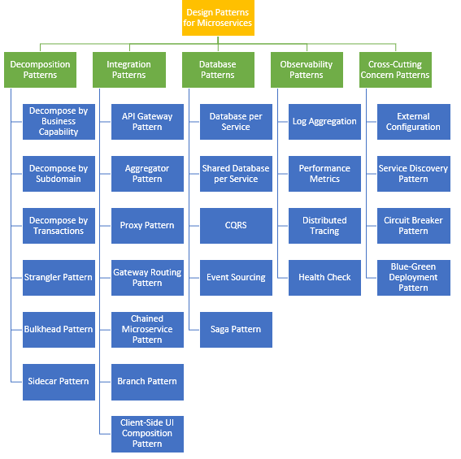

### Refactoring to microservices patterns

<https://microservices.io/patterns/microservices.html>

<https://docs.microsoft.com/en-us/azure/architecture/microservices/design/patterns>

<https://dzone.com/articles/design-patterns-for-microservices>

The goal of microservices is to increase the velocity of application releases, by decomposing the application into small autonomous services that can be deployed independently. A microservices architecture also brings some challenges. The design patterns shown here can help mitigate these challenges.

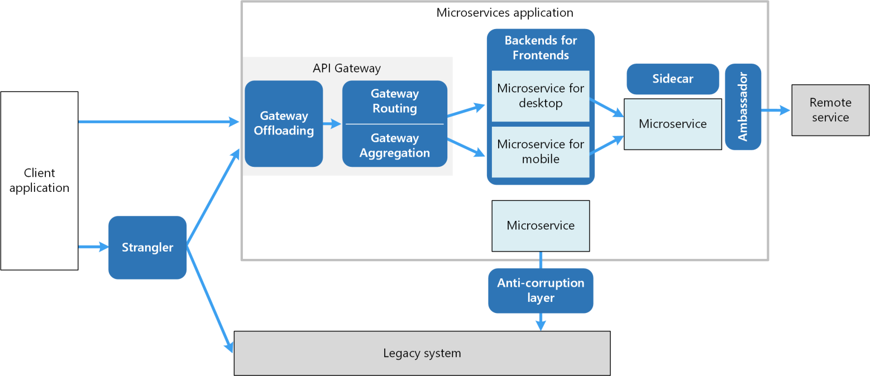

### Monolith Decomposition Patterns

#### Strangler Fig

Incrementally migrate a legacy system by gradually replacing specific pieces of functionality with new applications and services. As features from the legacy system are replaced, the new system eventually replaces all of the old system's features, strangling the old system and allowing you to decommission it.

**Context and problem**

As systems age, the development tools, hosting technology, and even system architectures they were built on can become increasingly obsolete. As new features and functionality are added, the complexity of these applications can increase dramatically, making them harder to maintain or add new features to.

Completely replacing a complex system can be a huge undertaking. Often, you will need a gradual migration to a new system, while keeping the old system to handle features that haven't been migrated yet. However, running two separate versions of an application means that clients have to know where particular features are located. Every time a feature or service is migrated, clients need to be updated to point to the new location.

**Solution**

Incrementally replace specific pieces of functionality with new applications and services. Create a façade that intercepts requests going to the backend legacy system. The façade routes these requests either to the legacy application or the new services. Existing features can be migrated to the new system gradually, and consumers can continue using the same interface, unaware that any migration has taken place.

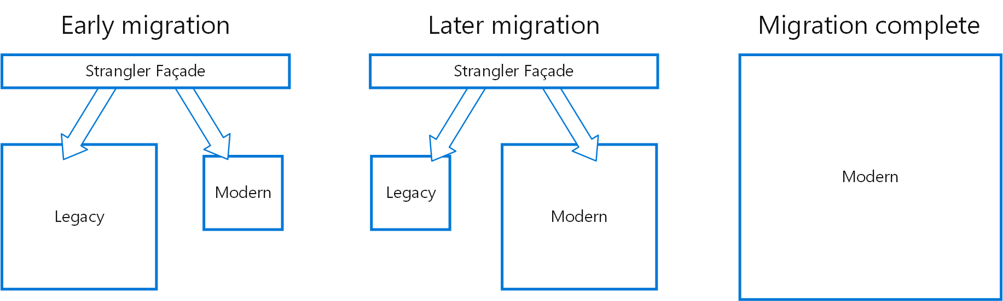

This pattern helps to minimize risk from the migration, and spread the development effort over time. With the façade safely routing users to the correct application, you can add functionality to the new system at whatever pace you like, while ensuring the legacy application continues to function. Over time, as features are migrated to the new system, the legacy system is eventually "strangled" and is no longer necessary. Once this process is complete, the legacy system can safely be retired.

**Issues and considerations**

* Consider how to handle services and data stores that are potentially used by both new and legacy systems. Make sure both can access these resources side-by-side.
* Structure new applications and services in a way that they can easily be intercepted and replaced in future strangler fig migrations.
* At some point, when the migration is complete, the strangler fig façade will either go away or evolve into an adaptor for legacy clients.
* Make sure the façade keeps up with the migration.
* Make sure the façade doesn't become a single point of failure or a performance bottleneck.

**When to use this pattern**

Use this pattern when gradually migrating a back-end application to a new architecture.

This pattern may not be suitable:

* When requests to the back-end system cannot be intercepted.
* For smaller systems where the complexity of wholesale replacement is low.

### Ambassador

Create helper services that send network requests on behalf of a consumer service or application.

An ambassador service can be thought of as an out-of-process proxy that is co-located with the client.

This pattern can be useful for offloading common client connectivity tasks such as monitoring, logging, routing, security (such as TLS), and [resiliency patterns](https://docs.microsoft.com/en-us/azure/architecture/framework/resiliency/reliability-patterns) in a language agnostic way. It is often used with legacy applications, or other applications that are difficult to modify, in order to extend their networking capabilities. It can also enable a specialized team to implement those features.

Context and problem

Resilient cloud-based applications require features such as circuit breaking, routing, metering and monitoring, and the ability to make network-related configuration updates. It may be difficult or impossible to update legacy applications or existing code libraries to add these features, because the code is no longer maintained or can't be easily modified by the development team.

Network calls may also require substantial configuration for connection, authentication, and authorization. If these calls are used across multiple applications, built using multiple languages and frameworks, the calls must be configured for each of these instances. In addition, network and security functionality may need to be managed by a central team within your organization. With a large code base, it can be risky for that team to update application code they aren't familiar with.

Solution

Put client frameworks and libraries into an external process that acts as a proxy between your application and external services. Deploy the proxy on the same host environment as your application to allow control over routing, resiliency, security features, and to avoid any host-related access restrictions. You can also use the ambassador pattern to standardize and extend instrumentation. The proxy can monitor performance metrics such as latency or resource usage, and this monitoring happens in the same host environment as the application.

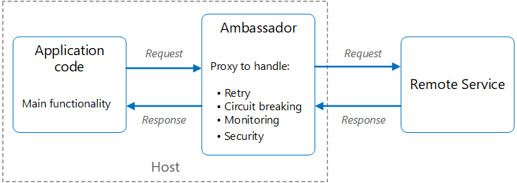

Features that are offloaded to the ambassador can be managed independently of the application. You can update and modify the ambassador without disturbing the application's legacy functionality. It also allows for separate, specialized teams to implement and maintain security, networking, or authentication features that have been moved to the ambassador.

Ambassador services can be deployed as a [sidecar](https://docs.microsoft.com/en-us/azure/architecture/patterns/sidecar) to accompany the lifecycle of a consuming application or service. Alternatively, if an ambassador is shared by multiple separate processes on a common host, it can be deployed as a daemon or Windows service. If the consuming service is containerized, the ambassador should be created as a separate container on the same host, with the appropriate links configured for communication.

Issues and considerations

The proxy adds some latency overhead. Consider whether a client library, invoked directly by the application, is a better approach.

Consider the possible impact of including generalized features in the proxy. For example, the ambassador could handle retries, but that might not be safe unless all operations are idempotent.

Consider a mechanism to allow the client to pass some context to the proxy, as well as back to the client. For example, include HTTP request headers to opt out of retry or specify the maximum number of times to retry.

Consider how you will package and deploy the proxy.

Consider whether to use a single shared instance for all clients or an instance for each client.

When to use this pattern

Use this pattern when you:

* Need to build a common set of client connectivity features for multiple languages or frameworks.
* Need to offload cross-cutting client connectivity concerns to infrastructure developers or other more specialized teams.
* Need to support cloud or cluster connectivity requirements in a legacy application or an application that is difficult to modify.

This pattern may not be suitable:

* When network request latency is critical. A proxy will introduce some overhead, although minimal, and in some cases this may affect the application.
* When client connectivity features are consumed by a single language. In that case, a better option might be a client library that is distributed to the development teams as a package.
* When connectivity features cannot be generalized and require deeper integration with the client application.

Example

The following diagram shows an application making a request to a remote service via an ambassador proxy. The ambassador provides routing, circuit breaking, and logging. It calls the remote service and then returns the response to the client application:

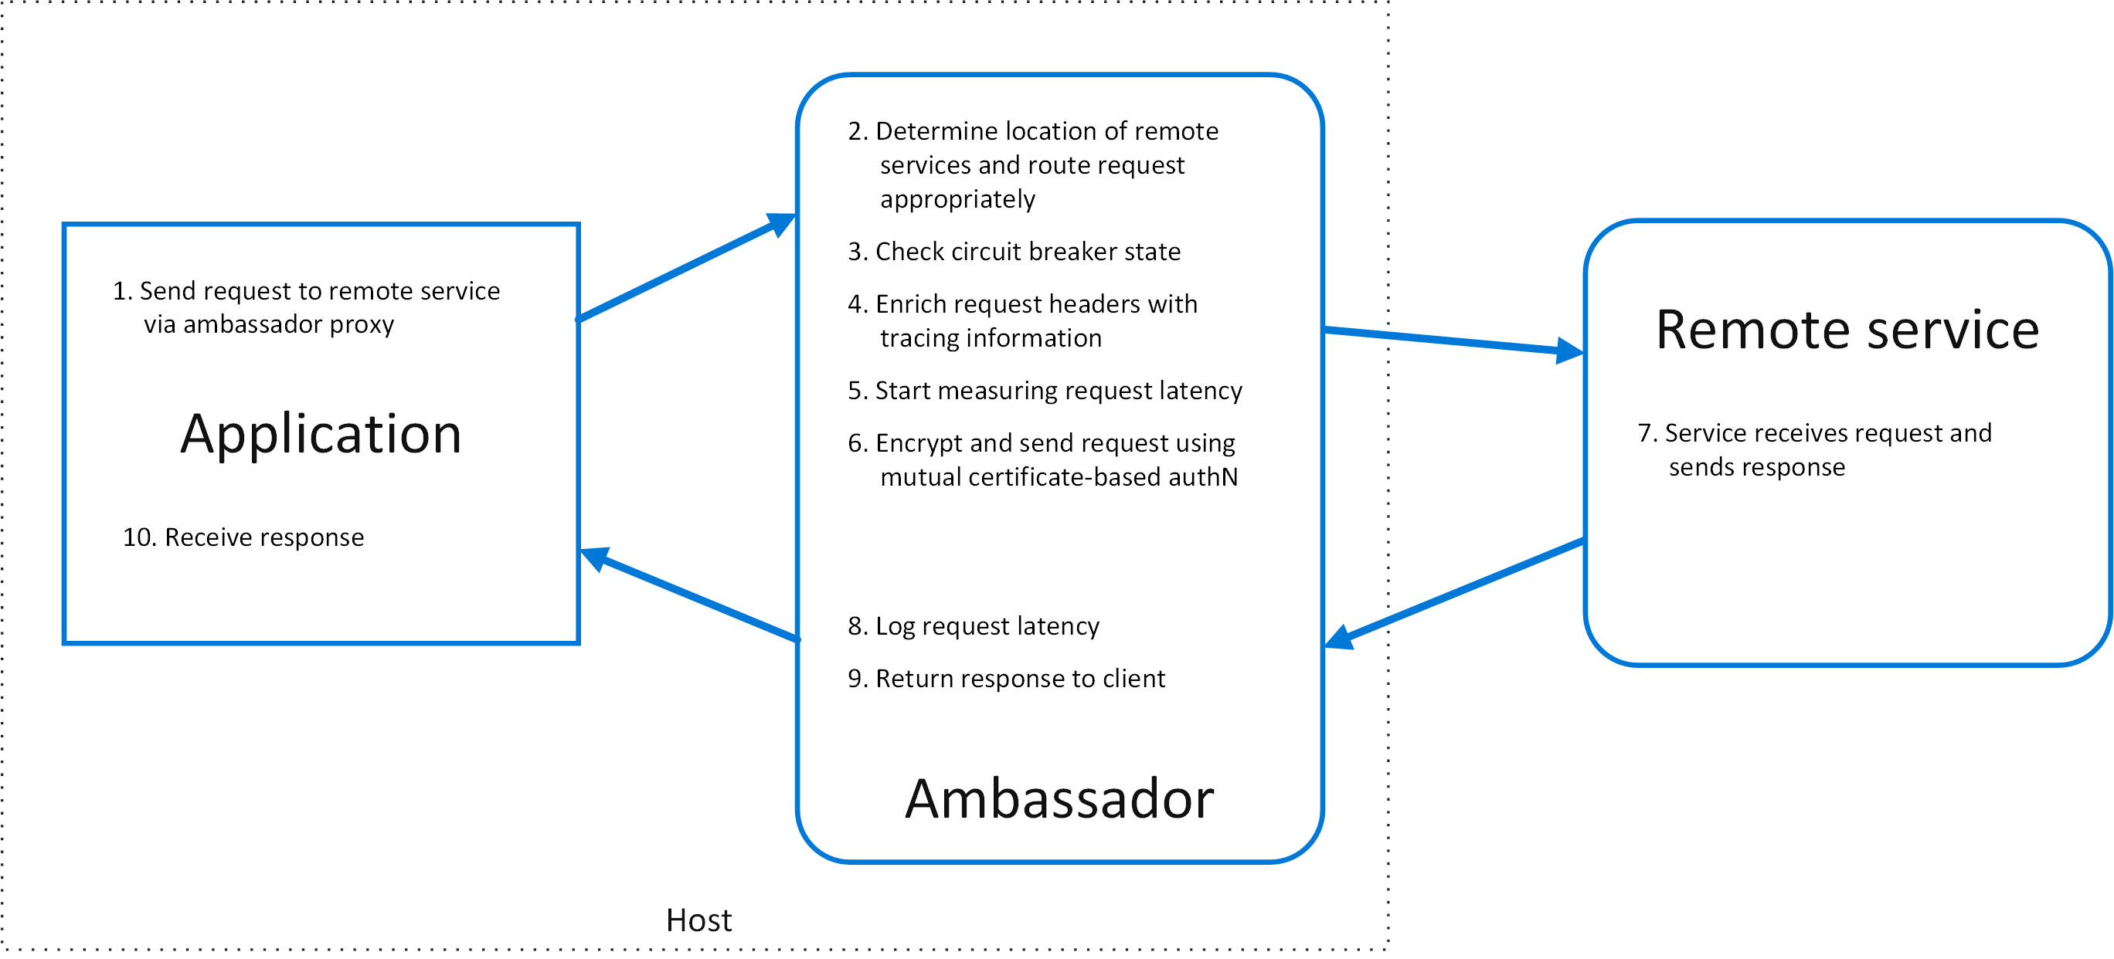

### Sidecar

Deploy components of an application into a separate process or container to provide isolation and encapsulation. This pattern can also enable applications to be composed of heterogeneous components and technologies.

This pattern is named *Sidecar* because it resembles a sidecar attached to a motorcycle. In the pattern, the sidecar is attached to a parent application and provides supporting features for the application. The sidecar also shares the same lifecycle as the parent application, being created and retired alongside the parent. The sidecar pattern is sometimes referred to as the sidekick pattern and is a decomposition pattern.

**Context and Problem**

Applications and services often require related functionality, such as monitoring, logging, configuration, and networking services. These peripheral tasks can be implemented as separate components or services.

If they are tightly integrated into the application, they can run in the same process as the application, making efficient use of shared resources. However, this also means they are not well isolated, and an outage in one of these components can affect other components or the entire application. Also, they usually need to be implemented using the same language as the parent application. As a result, the component and the application have close interdependence on each other.

If the application is decomposed into services, then each service can be built using different languages and technologies. While this gives more flexibility, it means that each component has its own dependencies and requires language-specific libraries to access the underlying platform and any resources shared with the parent application. In addition, deploying these features as separate services can add latency to the application. Managing the code and dependencies for these language-specific interfaces can also add considerable complexity, especially for hosting, deployment, and management.

**Solution**

Co-locate a cohesive set of tasks with the primary application, but place them inside their own process or container, providing a homogeneous interface for platform services across languages.

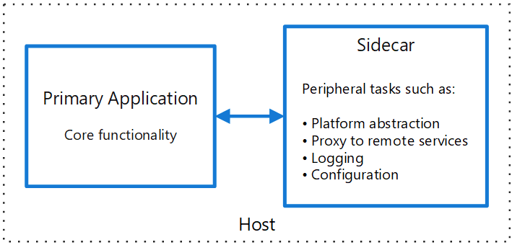

A sidecar service is not necessarily part of the application, but is connected to it. It goes wherever the parent application goes. Sidecars are supporting processes or services that are deployed with the primary application. On a motorcycle, the sidecar is attached to one motorcycle, and each motorcycle can have its own sidecar. In the same way, a sidecar service shares the fate of its parent application. For each instance of the application, an instance of the sidecar is deployed and hosted alongside it.

Advantages of using a sidecar pattern include:

* A sidecar is independent from its primary application in terms of runtime environment and programming language, so you don't need to develop one sidecar per language.
* The sidecar can access the same resources as the primary application. For example, a sidecar can monitor system resources used by both the sidecar and the primary application.
* Because of its proximity to the primary application, there’s no significant latency when communicating between them.
* Even for applications that don’t provide an extensibility mechanism, you can use a sidecar to extend functionality by attaching it as its own process in the same host or sub-container as the primary application.

The sidecar pattern is often used with containers and referred to as a sidecar container or sidekick container.

**Issues and Considerations**

* Consider the deployment and packaging format you will use to deploy services, processes, or containers. Containers are particularly well suited to the sidecar pattern.
* When designing a sidecar service, carefully decide on the interprocess communication mechanism. Try to use language- or framework-agnostic technologies unless performance requirements make that impractical.
* Before putting functionality into a sidecar, consider whether it would work better as a separate service or a more traditional daemon.
* Also consider whether the functionality could be implemented as a library or using a traditional extension mechanism. Language-specific libraries may have a deeper level of integration and less network overhead.

**When to Use this Pattern**

Use this pattern when:

* Your primary application uses a heterogeneous set of languages and frameworks. A component located in a sidecar service can be consumed by applications written in different languages using different frameworks.
* A component is owned by a remote team or a different organization.
* A component or feature must be co-located on the same host as the application
* You need a service that shares the overall lifecycle of your main application, but can be independently updated.
* You need fine-grained control over resource limits for a particular resource or component. For example, you may want to restrict the amount of memory a specific component uses. You can deploy the component as a sidecar and manage memory usage independently of the main application.

This pattern may not be suitable:

* When interprocess communication needs to be optimized. Communication between a parent application and sidecar services includes some overhead, notably latency in the calls. This may not be an acceptable trade-off for chatty interfaces.
* For small applications where the resource cost of deploying a sidecar service for each instance is not worth the advantage of isolation.
* When the service needs to scale differently than or independently from the main applications. If so, it may be better to deploy the feature as a separate service.

**Example**

The sidecar pattern is applicable to many scenarios. Some common examples:

* Infrastructure API. The infrastructure development team creates a service that's deployed alongside each application, instead of a language-specific client library to access the infrastructure. The service is loaded as a sidecar and provides a common layer for infrastructure services, including logging, environment data, configuration store, discovery, health checks, and watchdog services. The sidecar also monitors the parent application's host environment and process (or container) and logs the information to a centralized service.
* Manage NGINX/HAProxy. Deploy NGINX with a sidecar service that monitors environment state, then updates the NGINX configuration file and recycles the process when a change in state is needed.
* Ambassador sidecar. Deploy an [ambassador](https://docs.microsoft.com/en-us/azure/architecture/patterns/ambassador) service as a sidecar. The application calls through the ambassador, which handles request logging, routing, circuit breaking, and other connectivity related features.
* Offload proxy. Place an NGINX proxy in front of a node.js service instance, to handle serving static file content for the service.

|  |  |
| --- | --- |
| Ambassador Pattern | Ambassador pattern is almost the same as sidecar pattern the difference is that in ambassador pattern every interaction to the world goes through the ambassador container. Here the containers are coupled means without ambassador pattern, the application cannot contact the outside world.  Example: Proxy where all the requests to the container go through an ambassador running alongside it. The main container can be accessed by the ambassador using local interfaces like the localhost.  These are two very famous design patterns that are used in container deployments. |

See: <https://matthewpalmer.net/kubernetes-app-developer/articles/multi-container-pod-design-patterns.html>

### Anti-Corruption Layer

Implement a façade or adapter layer between different subsystems that don't share the same semantics. This layer translates requests that one subsystem makes to the other subsystem. Use this pattern to ensure that an application's design is not limited by dependencies on outside subsystems. This pattern was first described by Eric Evans in *Domain-Driven Design*.

**Context and problem**

Most applications rely on other systems for some data or functionality. For example, when a legacy application is migrated to a modern system, it may still need existing legacy resources. New features must be able to call the legacy system. This is especially true of gradual migrations, where different features of a larger application are moved to a modern system over time.

Often these legacy systems suffer from quality issues such as convoluted data schemas or obsolete APIs. The features and technologies used in legacy systems can vary widely from more modern systems. To interoperate with the legacy system, the new application may need to support outdated infrastructure, protocols, data models, APIs, or other features that you wouldn't otherwise put into a modern application.

Maintaining access between new and legacy systems can force the new system to adhere to at least some of the legacy system's APIs or other semantics. When these legacy features have quality issues, supporting them "corrupts" what might otherwise be a cleanly designed modern application.

Similar issues can arise with any external system that your development team doesn't control, not just legacy systems.

**Solution**

Isolate the different subsystems by placing an anti-corruption layer between them. This layer translates communications between the two systems, allowing one system to remain unchanged while the other can avoid compromising its design and technological approach.

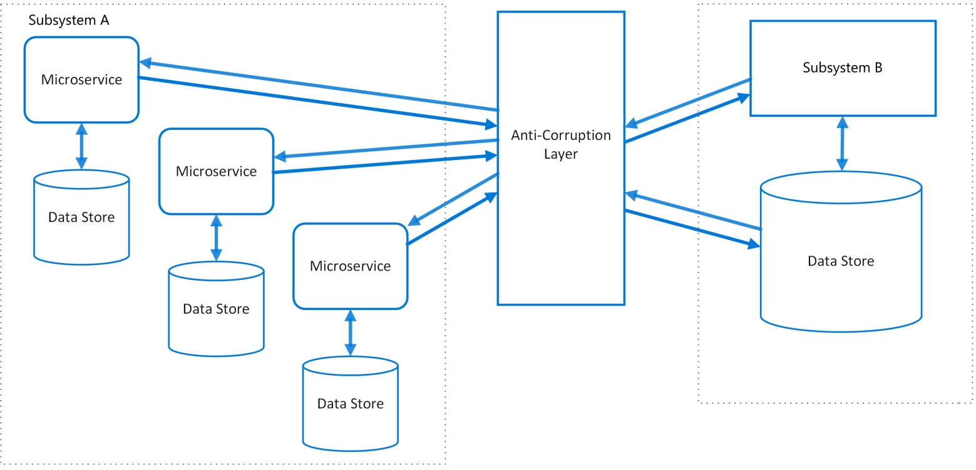

The diagram above shows an application with two subsystems. Subsystem A calls to subsystem B through an anti-corruption layer. Communication between subsystem A and the anti-corruption layer always uses the data model and architecture of subsystem A. Calls from the anti-corruption layer to subsystem B conform to that subsystem's data model or methods. The anti-corruption layer contains all of the logic necessary to translate between the two systems. The layer can be implemented as a component within the application or as an independent service.

**Issues and considerations**

* The anti-corruption layer may add latency to calls made between the two systems.
* The anti-corruption layer adds an additional service that must be managed and maintained.
* Consider how your anti-corruption layer will scale.
* Consider whether you need more than one anti-corruption layer. You may want to decompose functionality into multiple services using different technologies or languages, or there may be other reasons to partition the anti-corruption layer.
* Consider how the anti-corruption layer will be managed in relation with your other applications or services. How will it be integrated into your monitoring, release, and configuration processes?
* Make sure transaction and data consistency are maintained and can be monitored.
* Consider whether the anti-corruption layer needs to handle all communication between different subsystems, or just a subset of features.
* If the anti-corruption layer is part of an application migration strategy, consider whether it will be permanent, or will be retired after all legacy functionality has been migrated.

**When to use this pattern**

Use this pattern when:

* A migration is planned to happen over multiple stages, but integration between new and legacy systems needs to be maintained.
* Two or more subsystems have different semantics, but still need to communicate.

This pattern may not be suitable if there are no significant semantic differences between new and legacy systems.

**Asynchronous Request-Reply pattern**

Decouple backend processing from a frontend host, where backend processing needs to be asynchronous, but the frontend still needs a clear response.

**Context and problem**

In modern application development, it's normal for client applications — often code running in a web-client (browser) — to depend on remote APIs to provide business logic and compose functionality. These APIs may be directly related to the application or may be shared services provided by a third party. Commonly these API calls take place over the HTTP(S) protocol and follow REST semantics.

In most cases, APIs for a client application are designed to respond quickly, on the order of 100 ms or less. Many factors can affect the response latency, including:

* An application's hosting stack.
* Security components.
* The relative geographic location of the caller and the backend.
* Network infrastructure.
* Current load.
* The size of the request payload.
* Processing queue length.
* The time for the backend to process the request.

Any of these factors can add latency to the response. Some can be mitigated by scaling out the backend. Others, such as network infrastructure, are largely out of the control of the application developer. Most APIs can respond quickly enough for responses to arrive back over the same connection. Application code can make a synchronous API call in a non-blocking way, giving the appearance of asynchronous processing, which is recommended for I/O-bound operations.

In some scenarios, however, the work done by backend may be long-running, on the order of seconds, or might be a background process that is executed in minutes or even hours. In that case, it isn't feasible to wait for the work to complete before responding to the request. This situation is a potential problem for any synchronous request-reply pattern.

Some architectures solve this problem by using a message broker to separate the request and response stages. This separation is often achieved by use of the [Queue-Based Load Leveling pattern](https://docs.microsoft.com/en-us/azure/architecture/patterns/queue-based-load-leveling). This separation can allow the client process and the backend API to scale independently. But this separation also brings additional complexity when the client requires success notification, as this step needs to become asynchronous.

Many of the same considerations discussed for client applications also apply for server-to-server REST API calls in distributed systems — for example, in a microservices architecture.

**Solution**

One solution to this problem is to use HTTP polling. Polling is useful to client-side code, as it can be hard to provide call-back endpoints or use long running connections. Even when callbacks are possible, the extra libraries and services that are required can sometimes add too much extra complexity.

* The client application makes a synchronous call to the API, triggering a long-running operation on the backend.
* The API responds synchronously as quickly as possible. It returns an HTTP 202 (Accepted) status code, acknowledging that the request has been received for processing.

**Note**

The API should validate both the request and the action to be performed before starting the long running process. If the request is invalid, reply immediately with an error code such as HTTP 400 (Bad Request).

* The response holds a location reference pointing to an endpoint that the client can poll to check for the result of the long running operation.
* The API offloads processing to another component, such as a message queue.
* While the work is still pending, the status endpoint returns HTTP 202. Once the work is complete, the status endpoint can either return a resource that indicates completion, or redirect to another resource URL. For example, if the asynchronous operation creates a new resource, the status endpoint would redirect to the URL for that resource.

The following diagram shows a typical flow:

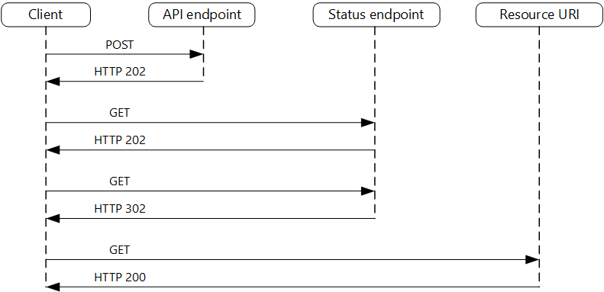

1. The client sends a request and receives an HTTP 202 (Accepted) response.
2. The client sends an HTTP GET request to the status endpoint. The work is still pending, so this call also returns HTTP 202.
3. At some point, the work is complete and the status endpoint returns 302 (Found) redirecting to the resource.
4. The client fetches the resource at the specified URL.

**Issues and considerations**

* There are a number of possible ways to implement this pattern over HTTP and not all upstream services have the same semantics. For example, most services won't return an HTTP 202 response back from a GET method when a remote process hasn't finished. Following pure REST semantics, they should return HTTP 404 (Not Found). This response makes sense when you consider the result of the call isn't present yet.
* An HTTP 202 response should indicate the location and frequency that the client should poll for the response. It should have the following additional headers:

| **TABLE 1** | | |
| --- | --- | --- |
| **Header** | **Description** | **Notes** |
| Location | A URL the client should poll for a response status. | This URL could be a SAS token with the [Valet Key Pattern](https://docs.microsoft.com/en-us/azure/architecture/patterns/valet-key) being appropriate if this location needs access control. The valet key pattern is also valid when response polling needs offloading to another backend |
| Retry-After | An estimate of when processing will complete | This header is designed to prevent polling clients from overwhelming the back-end with retries. |

* You may need to use a processing proxy or facade to manipulate the response headers or payload depending on the underlying services used.
* If the status endpoint redirects on completion, either [HTTP 302](https://tools.ietf.org/html/rfc7231#section-6.4.3) or [HTTP 303](https://tools.ietf.org/html/rfc7231#section-6.4.4) are appropriate return codes, depending on the exact semantics you support.
* Upon successful processing, the resource specified by the Location header should return an appropriate HTTP response code such as 200 (OK), 201 (Created), or 204 (No Content).
* If an error occurs during processing, persist the error at the resource URL described in the Location header and ideally return an appropriate response code to the client from that resource (4xx code).
* Not all solutions will implement this pattern in the same way and some services will include additional or alternate headers. For example, Azure Resource Manager uses a modified variant of this pattern. For more information, see [Azure Resource Manager Async Operations](https://docs.microsoft.com/en-us/azure/azure-resource-manager/resource-manager-async-operations).
* Legacy clients might not support this pattern. In that case, you might need to place a facade over the asynchronous API to hide the asynchronous processing from the original client. For example, Azure Logic Apps supports this pattern natively can be used as an integration layer between an asynchronous API and a client that makes synchronous calls. See [Perform long-running tasks with the webhook action pattern](https://docs.microsoft.com/en-us/azure/logic-apps/logic-apps-create-api-app#perform-long-running-tasks-with-the-webhook-action-pattern).
* In some scenarios, you might want to provide a way for clients to cancel a long-running request. In that case, the backend service must support some form of cancellation instruction.

**When to use this pattern**

Use this pattern for:

* Client-side code, such as browser applications, where it's difficult to provide call-back endpoints, or the use of long-running connections adds too much additional complexity.
* Service calls where only the HTTP protocol is available and the return service can't fire callbacks because of firewall restrictions on the client-side.
* Service calls that need to be integrated with legacy architectures that don't support modern callback technologies such as WebSockets or webhooks.

This pattern might not be suitable when:

* You can use a service built for asynchronous notifications instead, such as Azure Event Grid.
* Responses must stream in real time to the client.
* The client needs to collect many results, and received latency of those results is important. Consider a service bus pattern instead.
* You can use server-side persistent network connections such as WebSockets or SignalR. These services can be used to notify the caller of the result.
* The network design allows you to open up ports to receive asynchronous callbacks or webhooks.

**Example**

The following code shows excerpts from an application that uses Azure Functions to implement this pattern. There are three functions in the solution:

* The asynchronous API endpoint.
* The status endpoint.
* A backend function that takes queued work items and executes them.

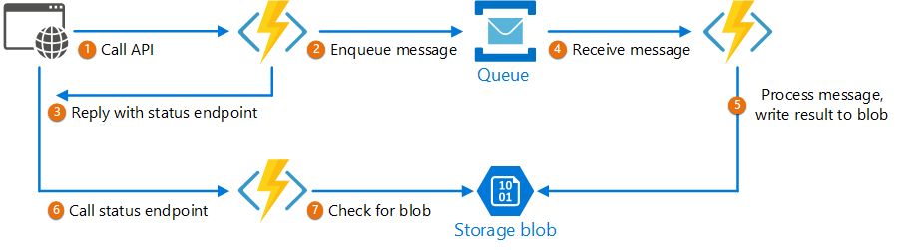

### Saga distributed transactions

The *saga* design pattern is a way to manage data consistency across microservices in distributed transaction scenarios. A saga is a sequence of transactions that updates each service and publishes a message or event to trigger the next transaction step. If a step fails, the saga executes compensating transactions that counteract the preceding transactions.

**Context and problem**

A *transaction* is a single unit of logic or work, sometimes made up of multiple operations. Within a transaction, an *event* is a state change that occurs to an entity, and a *command* encapsulates all information needed to perform an action or trigger a later event.

Transactions must be *atomic, consistent, isolated, and durable (ACID)*. Transactions within a single service are ACID, but cross-service data consistency requires a cross-service transaction management strategy.

In multiservices architectures:

* *Atomicity* is an indivisible and irreducible set of operations that must all occur or none occur.
* *Consistency* means the transaction brings the data only from one valid state to another valid state.
* *Isolation* guarantees that concurrent transactions produce the same data state that sequentially executed transactions would have produced.
* *Durability* ensures that committed transactions remain committed even in case of system failure or power outage.

A [database-per-microservice](https://docs.microsoft.com/en-us/dotnet/architecture/cloud-native/distributed-data#database-per-microservice-why) model provides many benefits for microservices architectures. Encapsulating domain data lets each service use its best data store type and schema, scale its own data store as necessary, and be insulated from other services' failures. However, ensuring data consistency across service-specific databases poses challenges.

Distributed transactions like the [two-phase commit (2PC)](https://en.wikipedia.org/wiki/Two-phase_commit_protocol) protocol require all participants in a transaction to commit or roll back before the transaction can proceed. However some participant implementations, such as NoSQL databases and message brokering, don't support this model.

Another distributed transaction limitation is [interprocess communication (IPC)](https://en.wikipedia.org/wiki/Inter-process_communication) synchronicity and availability. Operating system-provided IPC allows separate processes to share data. For distributed transactions to commit, all participating services must be available, potentially reducing overall system availability. Architectural implementations with IPC or transaction limitations are candidates for the saga pattern.

**Solution**

The saga pattern provides transaction management using a sequence of *local transactions*. A local transaction is the atomic work effort performed by a saga participant. Each local transaction updates the database and publishes a message or event to trigger the next local transaction in the saga. If a local transaction fails, the saga executes a series of *compensating transactions* that undo the changes that were made by the preceding local transactions.

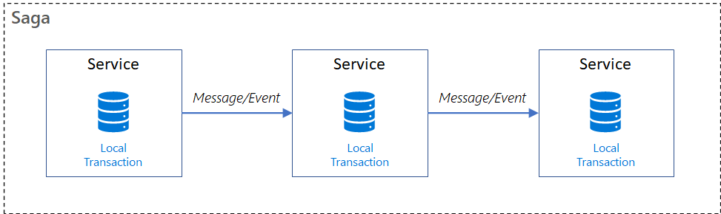

In saga patterns:

* *Compensable transactions* are transactions that can potentially be reversed by processing another transaction with the opposite effect.
* A *pivot transaction* is the go/no-go point in a saga. If the pivot transaction commits, the saga runs until completion. A pivot transaction can be a transaction that is neither compensable nor retryable, or it can be the last compensable transaction or the first retryable transaction in the saga.
* *Retryable transactions* are transactions that follow the pivot transaction and are guaranteed to succeed.

There are two common saga implementation approaches, *choreography* and *orchestration*. Each approach has its own set of challenges and technologies to coordinate the workflow.

**Choreography**

Choreography is a way to coordinate sagas where participants exchange events without a centralized point of control. With choreography, each local transaction publishes domain events that trigger local transactions in other services.

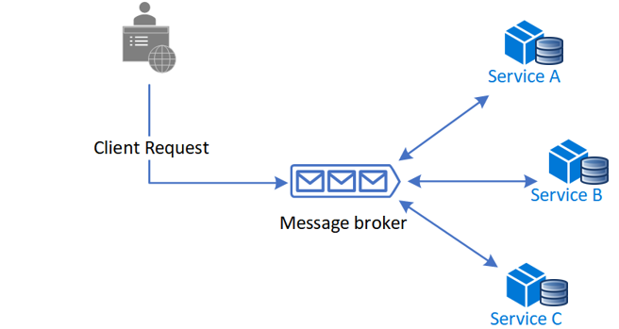

**Benefits**

* Good for simple workflows that require few participants and don't need a coordination logic.
* Doesn't require additional service implementation and maintenance.
* Doesn't introduce a single point of failure, since the responsibilities are distributed across the saga participants.

**Drawbacks**

* Workflow can become confusing when adding new steps, as it's difficult to track which saga participants listen to which commands.
* There's a risk of cyclic dependency between saga participants because they have to consume each other's commands.
* Integration testing is difficult because all services must be running to simulate a transaction.

**Orchestration**

Orchestration is a way to coordinate sagas where a centralized controller tells the saga participants what local transactions to execute. The saga orchestrator handles all the transactions and tells the participants which operation to perform based on events. The orchestrator executes saga requests, stores and interprets the states of each task, and handles failure recovery with compensating transactions.

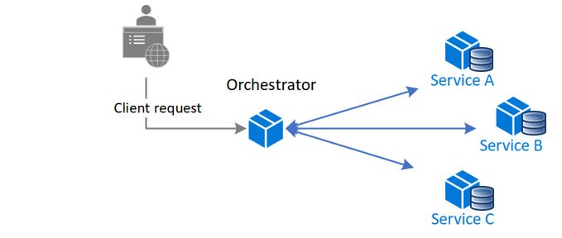

**Benefits**

* Good for complex workflows involving many participants or new participants added over time.
* Suitable when there is control over every participant in the process, and control over the flow of activities.
* Doesn't introduce cyclical dependencies, because the orchestrator unilaterally depends on the saga participants.
* Saga participants don't need to know about commands for other participants. Clear separation of concerns simplifies business logic.

**Drawbacks**

* Additional design complexity requires an implementation of a coordination logic.
* There's an additional point of failure, because the orchestrator manages the complete workflow.

**Issues and considerations**

Consider the following points when implementing the saga pattern:

* The saga pattern may initially be challenging, as it requires a new way of thinking on how to coordinate a transaction and maintain data consistency for a business process spanning multiple microservices.
* The saga pattern is particularly hard to debug, and the complexity grows as participants increase.
* Data can't be rolled back, because saga participants commit changes to their local databases.
* The implementation must be capable of handling a set of potential transient failures, and provide idempotence for reducing side-effects and ensuring data consistency. Idempotence means that the same operation can be repeated multiple times without changing the initial result.
* It's best to implement observability to monitor and track the saga workflow.
* The lack of participant data isolation imposes durability challenges. The saga implementation must include countermeasures to reduce anomalies.

The following anomalies can happen without proper measures:

* *Lost updates*, when one saga writes without reading changes made by another saga.
* *Dirty reads*, when a transaction or a saga reads updates made by a saga that has not yet completed those updates.
* *Fuzzy/nonrepeatable reads*, when different saga steps read different data because a data update occurs between the reads.

**Suggested countermeasures to reduce or prevent anomalies include:**

* *Semantic lock*, an application-level lock where a saga's compensable transaction uses a semaphore to indicate an update is in progress.
* *Commutative updates* that can be executed in any order and produce the same result.
* *Pessimistic view:* It's possible for one saga to read dirty data, while another saga is running a compensable transaction to roll back the operation. Pessimistic view reorders the saga so the underlying data updates in a retryable transaction, which eliminates the possibility of a dirty read.
* *Reread value* verifies that data is unchanged, and then updates the record. If the record has changed, the steps abort and the saga may restart.
* A *version file* records the operations on a record as they arrive, and then executes them in the correct order.
* *By value* uses each request's business risk to dynamically select the concurrency mechanism. Low-risk requests favor sagas, while high-risk requests favor distributed transactions.

**When to use this pattern**

Use the saga pattern when you need to:

* Ensure data consistency in a distributed system without tight coupling.
* Roll back or compensate if one of the operations in the sequence fails.

The saga pattern is less suitable for:

* Tightly coupled transactions.
* Compensating transactions that occur in earlier participants.
* Cyclic dependencies.

**Example**

[Orchestration-based Saga on Serverless](https://github.com/Azure-Samples/saga-orchestration-serverless) is a saga implementation reference using the orchestration approach that simulates a money transfer scenario with successful and failed workflows.

**Related patterns**

The following patterns might also be useful when implementing this pattern:

* [Choreography](https://docs.microsoft.com/en-us/azure/architecture/patterns/choreography) has each component of the system participate in the decision-making process about the workflow of a business transaction, instead of relying on a central point of control.
* [Compensating transactions](https://docs.microsoft.com/en-us/azure/architecture/patterns/compensating-transaction) undo work performed by a series of steps, and eventually define a consistent operation if one or more steps fail. Cloud-hosted applications that implement complex business processes and workflows often follow this *eventual consistency model*.
* [Retry](https://docs.microsoft.com/en-us/azure/architecture/patterns/retry) lets an application handle transient failures when it tries to connect to a service or network resource, by transparently retrying the failed operation. Retry can improve the stability of the application.
* [Circuit breaker](https://docs.microsoft.com/en-us/azure/architecture/patterns/circuit-breaker) handles faults that take a variable amount of time to recover from, when connecting to a remote service or resource. Circuit breaker can improve the stability and resiliency of an application.
* [Health endpoint monitoring](https://docs.microsoft.com/en-us/azure/architecture/patterns/health-endpoint-monitoring) implements functional checks in an application that external tools can access through exposed endpoints at regular intervals. Health endpoint monitoring can help verify that applications and services are performing correctly.

### Backends for Frontends

Create separate backend services to be consumed by specific frontend applications or interfaces. This pattern is useful when you want to avoid customizing a single backend for multiple interfaces. This pattern was first described by Sam Newman.

**Context and problem**

|  |  |
| --- | --- |
| Context-and-problem diagram of the Backends for Frontends pattern | An application may initially be targeted at a desktop web UI. Typically, a backend service is developed in parallel that provides the features needed for that UI. As the application's user base grows, a mobile application is developed that must interact with the same backend. The backend service becomes a general-purpose backend, serving the requirements of both the desktop and mobile interfaces.  But the capabilities of a mobile device differ significantly from a desktop browser, in terms of screen size, performance, and display limitations. As a result, the requirements for a mobile application backend differ from the desktop web UI.  These differences result in competing requirements for the backend. The backend requires regular and significant changes to serve both the desktop web UI and the mobile application. Often, separate interface teams work on each frontend, causing the backend to become a bottleneck in the development process. Conflicting update requirements, and the need to keep the service working for both frontends, can result in spending a lot of effort on a single deployable resource. |

As the development activity focuses on the backend service, a separate team may be created to manage and maintain the backend. Ultimately, this results in a disconnect between the interface and backend development teams, placing a burden on the backend team to balance the competing requirements of the different UI teams. When one interface team requires changes to the backend, those changes must be validated with other interface teams before they can be integrated into the backend.

**Solution**

Create one backend per user interface. Fine-tune the behavior and performance of each backend to best match the needs of the frontend environment, without worrying about affecting other frontend experiences.

|  |  |
| --- | --- |
| Diagram of the Backends for Frontends pattern | Because each backend is specific to one interface, it can be optimized for that interface. As a result, it will be smaller, less complex, and likely faster than a generic backend that tries to satisfy the requirements for all interfaces.  Each interface team has autonomy to control their own backend and doesn't rely on a centralized backend development team. This gives the interface team flexibility in language selection, release cadence, prioritization of workload, and feature integration in their backend. |

**Issues and considerations**

* Consider how many backends to deploy.
* If different interfaces (such as mobile clients) will make the same requests, consider whether it is necessary to implement a backend for each interface, or if a single backend will suffice.
* Code duplication across services is highly likely when implementing this pattern.
* Frontend-focused backend services should only contain client-specific logic and behavior. General business logic and other global features should be managed elsewhere in your application.
* Think about how this pattern might be reflected in the responsibilities of a development team.
* Consider how long it will take to implement this pattern. Will the effort of building the new backends incur technical debt, while you continue to support the existing generic backend?

**When to use this pattern**

Use this pattern when:

* A shared or general purpose backend service must be maintained with significant development overhead.
* You want to optimize the backend for the requirements of specific client interfaces.
* Customizations are made to a general-purpose backend to accommodate multiple interfaces.
* An alternative language is better suited for the backend of a different user interface.

This pattern may not be suitable:

* When interfaces make the same or similar requests to the backend.
* When only one interface is used to interact with the backend.

### Data Management patterns

Data management is the key element of cloud applications, and influences most of the quality attributes. Data is typically hosted in different locations and across multiple servers for reasons such as performance, scalability or availability, and this can present a range of challenges. For example, data consistency must be maintained, and data will typically need to be synchronized across different locations.

Additionally data should be protected at rest, in transit, and via authorized access mechanisms to maintain security assurances of confidentiality, integrity, and availability. Refer to the Azure Security Benchmark [Data Protection Control](https://docs.microsoft.com/en-us/azure/security/benchmarks/security-controls-v2-data-protection) for more information.

| **DATA MANAGEMENT PATTERNS** | |
| --- | --- |
| **Pattern** | **Summary** |
| [Cache-Aside](https://docs.microsoft.com/en-us/azure/architecture/patterns/cache-aside) | Load data on demand into a cache from a data store |
| [CQRS](https://docs.microsoft.com/en-us/azure/architecture/patterns/cqrs) | Segregate operations that read data from operations that update data by using separate interfaces. |
| [Event Sourcing](https://docs.microsoft.com/en-us/azure/architecture/patterns/event-sourcing) | Use an append-only store to record the full series of events that describe actions taken on data in a domain. |
| [Index Table](https://docs.microsoft.com/en-us/azure/architecture/patterns/index-table) | Create indexes over the fields in data stores that are frequently referenced by queries. |
| [Materialized View](https://docs.microsoft.com/en-us/azure/architecture/patterns/materialized-view) | Generate prepopulated views over the data in one or more data stores when the data isn't ideally formatted for required query operations. |
| [Sharding](https://docs.microsoft.com/en-us/azure/architecture/patterns/sharding) | Divide a data store into a set of horizontal partitions or shards. |
| [Static Content Hosting](https://docs.microsoft.com/en-us/azure/architecture/patterns/static-content-hosting) | Deploy static content to a cloud-based storage service that can deliver them directly to the client. |
| [Valet Key](https://docs.microsoft.com/en-us/azure/architecture/patterns/valet-key) | Use a token or key that provides clients with restricted direct access to a specific resource or service. |

#### Database Patterns – Video

<https://www.youtube.com/watch?v=a_XMsSNdUQA>

#### Database per Microservice

Once a company replaces the large monolithic system with many smaller microservices, the most important decision it faces is regarding the Database. In a monolithic architecture, a large, central database is used. Many architects favor keeping the database as it is, even when they move to microservice architecture. While it gives some short-term benefit, it is an anti-pattern, especially in a large-scale system, as the microservices will be tightly coupled in the database layer. The whole object of moving to microservice will fail (e.g., team empowerment, independent development).

A better approach is to provide every Microservice its own Data store, so that there is no strong-coupling between services in the database layer. Here I am using the term database to show a logical separation of data, i.e., the Microservices can share the same physical database, but they should use separate Schema/collection/table. It will also ensure that the Microservices are correctly segregated according to the Domain-Driven-Design.

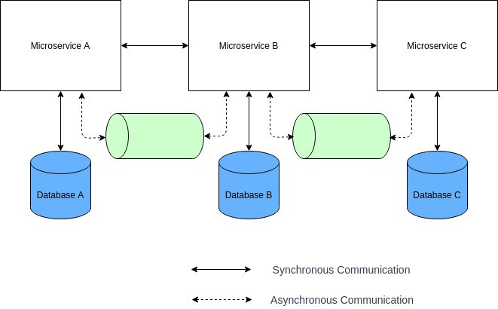

Pros

Complete ownership of Data to a Service.

Loose coupling among teams developing the services.

Cons

Sharing data among services becomes challenging.

Giving application-wide ACID transactional guarantee becomes a lot harder.

Decomposing the Monolith database to smaller parts need careful design and is a challenging task.

When to use Database per Microservice

In large-scale enterprise applications.

When the team needs complete ownership of their Microservices for development scaling and development velocity.

When not to use Database per Microservice

In small-scale applications.

If one team develops all the Microservices.

Enabling Technology Examples

All SQL, NoSQL databases offer logical separation of data (e.g., separate tables, collections, schemas, databases).

#### Cache-Aside pattern

Load data on demand into a cache from a data store. This can improve performance and also helps to maintain consistency between data held in the cache and data in the underlying data store.

**Context and problem**

Applications use a cache to improve repeated access to information held in a data store. However, it's impractical to expect that cached data will always be completely consistent with the data in the data store. Applications should implement a strategy that helps to ensure that the data in the cache is as up-to-date as possible, but can also detect and handle situations that arise when the data in the cache has become stale.

**Solution**

Many commercial caching systems provide read-through and write-through/write-behind operations. In these systems, an application retrieves data by referencing the cache. If the data isn't in the cache, it's retrieved from the data store and added to the cache. Any modifications to data held in the cache are automatically written back to the data store as well.

For caches that don't provide this functionality, it's the responsibility of the applications that use the cache to maintain the data.

An application can emulate the functionality of read-through caching by implementing the cache-aside strategy. This strategy loads data into the cache on demand. The figure illustrates using the Cache-Aside pattern to store data in the cache.

If an application updates information, it can follow the write-through strategy by making the modification to the data store, and by invalidating the corresponding item in the cache.

When the item is next required, using the cache-aside strategy will cause the updated data to be retrieved from the data store and added back into the cache.

**Issues and considerations**

Consider the following points when deciding how to implement this pattern:

**Lifetime of cached data**. Many caches implement an expiration policy that invalidates data and removes it from the cache if it's not accessed for a specified period. For cache-aside to be effective, ensure that the expiration policy matches the pattern of access for applications that use the data. Don't make the expiration period too short because this can cause applications to continually retrieve data from the data store and add it to the cache. Similarly, don't make the expiration period so long that the cached data is likely to become stale. Remember that caching is most effective for relatively static data, or data that is read frequently.

**Evicting data**. Most caches have a limited size compared to the data store where the data originates, and they'll evict data if necessary. Most caches adopt a least-recently-used policy for selecting items to evict, but this might be customizable. Configure the global expiration property and other properties of the cache, and the expiration property of each cached item, to ensure that the cache is cost effective. It isn't always appropriate to apply a global eviction policy to every item in the cache. For example, if a cached item is very expensive to retrieve from the data store, it can be beneficial to keep this item in the cache at the expense of more frequently accessed but less costly items.

**Priming the cache**. Many solutions prepopulate the cache with the data that an application is likely to need as part of the startup processing. The Cache-Aside pattern can still be useful if some of this data expires or is evicted.

**Consistency**. Implementing the Cache-Aside pattern doesn't guarantee consistency between the data store and the cache. An item in the data store can be changed at any time by an external process, and this change might not be reflected in the cache until the next time the item is loaded. In a system that replicates data across data stores, this problem can become serious if synchronization occurs frequently.

**Local (in-memory) caching**. A cache could be local to an application instance and stored in-memory. Cache-aside can be useful in this environment if an application repeatedly accesses the same data. However, a local cache is private and so different application instances could each have a copy of the same cached data. This data could quickly become inconsistent between caches, so it might be necessary to expire data held in a private cache and refresh it more frequently. In these scenarios, consider investigating the use of a shared or a distributed caching mechanism.

**When to use this pattern**

Use this pattern when:

* A cache doesn't provide native read-through and write-through operations.
* Resource demand is unpredictable. This pattern enables applications to load data on demand. It makes no assumptions about which data an application will require in advance.

This pattern might not be suitable:

* When the cached data set is static. If the data will fit into the available cache space, prime the cache with the data on startup and apply a policy that prevents the data from expiring.
* For caching session state information in a web application hosted in a web farm. In this environment, you should avoid introducing dependencies based on client-server affinity.

**Example**

In Microsoft Azure you can use Azure Cache for Redis to create a distributed cache that can be shared by multiple instances of an application.

This following code examples use the [StackExchange.Redis](https://github.com/StackExchange/StackExchange.Redis) client, which is a Redis client library written for .NET. To connect to an Azure Cache for Redis instance, call the static ConnectionMultiplexer.Connect method and pass in the connection string. The method returns a ConnectionMultiplexer that represents the connection. One approach to sharing a ConnectionMultiplexer instance in your application is to have a static property that returns a connected instance, similar to the following example. This approach provides a thread-safe way to initialize only a single connected instance.

C#

private static ConnectionMultiplexer Connection;

// Redis connection string information

private static Lazy<ConnectionMultiplexer> lazyConnection = new Lazy<ConnectionMultiplexer>(() =>

{

string cacheConnection = ConfigurationManager.AppSettings["CacheConnection"].ToString();

return ConnectionMultiplexer.Connect(cacheConnection);

});

public static ConnectionMultiplexer Connection => lazyConnection.Value;

The GetMyEntityAsync method in the following code example shows an implementation of the Cache-Aside pattern. This method retrieves an object from the cache using the read-through approach.

An object is identified by using an integer ID as the key. The GetMyEntityAsync method tries to retrieve an item with this key from the cache. If a matching item is found, it's returned. If there's no match in the cache, the GetMyEntityAsync method retrieves the object from a data store, adds it to the cache, and then returns it. The code that actually reads the data from the data store is not shown here, because it depends on the data store. Note that the cached item is configured to expire to prevent it from becoming stale if it's updated elsewhere.

C#

// Set five minute expiration as a default

private const double DefaultExpirationTimeInMinutes = 5.0;

public async Task<MyEntity> GetMyEntityAsync(int id)

{

// Define a unique key for this method and its parameters.

var key = $"MyEntity:{id}";

var cache = Connection.GetDatabase();

// Try to get the entity from the cache.

var json = await cache.StringGetAsync(key).ConfigureAwait(false);

var value = string.IsNullOrWhiteSpace(json)

? default(MyEntity)

: JsonConvert.DeserializeObject<MyEntity>(json);

if (value == null) // Cache miss

{

// If there's a cache miss, get the entity from the original store and cache it.

// Code has been omitted because it is data store dependent.

value = ...;

// Avoid caching a null value.

if (value != null)

{

// Put the item in the cache with a custom expiration time that

// depends on how critical it is to have stale data.

await cache.StringSetAsync(key, JsonConvert.SerializeObject(value)).ConfigureAwait(false);

await cache.KeyExpireAsync(key, TimeSpan.FromMinutes(DefaultExpirationTimeInMinutes)).ConfigureAwait(false);

}

}

return value;

}

The examples use Azure Cache for Redis to access the store and retrieve information from the cache. For more information, see [Using Azure Cache for Redis](https://docs.microsoft.com/en-us/azure/redis-cache/cache-dotnet-how-to-use-azure-redis-cache) and [How to create a Web App with Azure Cache for Redis](https://docs.microsoft.com/en-us/azure/redis-cache/cache-web-app-howto).

The UpdateEntityAsync method shown below demonstrates how to invalidate an object in the cache when the value is changed by the application. The code updates the original data store and then removes the cached item from the cache.

C#

public async Task UpdateEntityAsync(MyEntity entity)

{

// Update the object in the original data store.

await this.store.UpdateEntityAsync(entity).ConfigureAwait(false);

// Invalidate the current cache object.

var cache = Connection.GetDatabase();

var id = entity.Id;

var key = $"MyEntity:{id}"; // The key for the cached object.

await cache.KeyDeleteAsync(key).ConfigureAwait(false); // Delete this key from the cache.

}

**Note**

The order of the steps is important. Update the data store *before* removing the item from the cache. If you remove the cached item first, there is a small window of time when a client might fetch the item before the data store is updated. That will result in a cache miss (because the item was removed from the cache), causing the earlier version of the item to be fetched from the data store and added back into the cache. The result will be stale cache data.

Caching Best Practices: <https://docs.microsoft.com/en-us/azure/architecture/best-practices/caching>

Data Consistency Primer: <https://docs.microsoft.com/en-us/previous-versions/msp-n-p/dn589800(v=pandp.10)>

#### Command and Query Responsibility Segregation (CQRS) pattern

The Command and Query Responsibility Segregation (CQRS) pattern separates read and update operations for a data store. Implementing CQRS in your application can maximize its performance, scalability, and security. The flexibility created by migrating to CQRS allows a system to better evolve over time and prevents update commands from causing merge conflicts at the domain level.

**The problem**

In traditional architectures, the same data model is used to query and update a database. That's simple and works well for basic CRUD operations. In more complex applications, however, this approach can become unwieldy. For example, on the read side, the application may perform many different queries, returning data transfer objects (DTOs) with different shapes. Object mapping can become complicated. On the write side, the model may implement complex validation and business logic. As a result, you can end up with an overly complex model that does too much.

Read and write workloads are often asymmetrical, with very different performance and scale requirements.

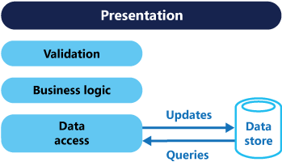

* There is often a mismatch between the read and write representations of the data, such as additional columns or properties that must be updated correctly even though they aren't required as part of an operation.
* Data contention can occur when operations are performed in parallel on the same set of data.
* The traditional approach can have a negative effect on performance due to load on the data store and data access layer, and the complexity of queries required to retrieve information.
* Managing security and permissions can become complex, because each entity is subject to both read and write operations, which might expose data in the wrong context.

**Solution**

CQRS separates reads and writes into different models, using **commands** to update data, and **queries** to read data.

* Commands should be task based, rather than data centric. ("Book hotel room", not "set ReservationStatus to Reserved").
* Commands may be placed on a queue for asynchronous processing, rather than being processed synchronously.
* Queries never modify the database. A query returns a DTO that does not encapsulate any domain knowledge.

The models can then be isolated, as shown in the following diagram, although that's not an absolute requirement.

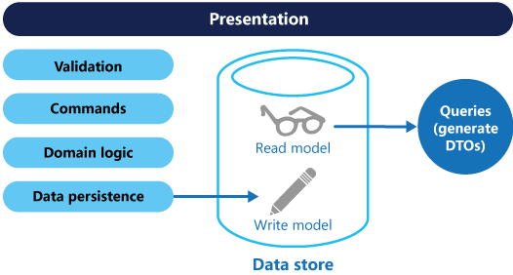

Having separate query and update models simplifies the design and implementation. However, one disadvantage is that CQRS code can't automatically be generated from a database schema using scaffolding mechanisms such as O/RM tools.

For greater isolation, you can physically separate the read data from the write data. In that case, the read database can use its own data schema that is optimized for queries. For example, it can store a [materialized view](https://docs.microsoft.com/en-us/azure/architecture/patterns/materialized-view) of the data, in order to avoid complex joins or complex O/RM mappings. It might even use a different type of data store. For example, the write database might be relational, while the read database is a document database.

If separate read and write databases are used, they must be kept in sync. Typically this is accomplished by having the write model publish an event whenever it updates the database. For more information about using events, see [Event-driven architecture style](https://docs.microsoft.com/en-us/azure/architecture/guide/architecture-styles/event-driven). Updating the database and publishing the event must occur in a single transaction.

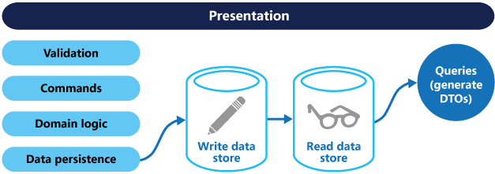

The read store can be a read-only replica of the write store, or the read and write stores can have a different structure altogether. Using multiple read-only replicas can increase query performance, especially in distributed scenarios where read-only replicas are located close to the application instances.

Separation of the read and write stores also allows each to be scaled appropriately to match the load. For example, read stores typically encounter a much higher load than write stores.

Some implementations of CQRS use the Event Sourcing pattern. With this pattern, application state is stored as a sequence of events. Each event represents a set of changes to the data. The current state is constructed by replaying the events. In a CQRS context, one benefit of Event Sourcing is that the same events can be used to notify other components — in particular, to notify the read model. The read model uses the events to create a snapshot of the current state, which is more efficient for queries. However, Event Sourcing adds complexity to the design.

Benefits of CQRS include:

* **Independent scaling**. CQRS allows the read and write workloads to scale independently, and may result in fewer lock contentions.
* **Optimized data schemas**. The read side can use a schema that is optimized for queries, while the write side uses a schema that is optimized for updates.
* **Security**. It's easier to ensure that only the right domain entities are performing writes on the data.
* **Separation of concerns**. Segregating the read and write sides can result in models that are more maintainable and flexible. Most of the complex business logic goes into the write model. The read model can be relatively simple.
* **Simpler queries**. By storing a materialized view in the read database, the application can avoid complex joins when querying.

**Implementation issues and considerations**

Some challenges of implementing this pattern include:

* **Complexity**. The basic idea of CQRS is simple. But it can lead to a more complex application design, especially if they include the Event Sourcing pattern.
* **Messaging**. Although CQRS does not require messaging, it's common to use messaging to process commands and publish update events. In that case, the application must handle message failures or duplicate messages. See the guidance on [Priority Queues](https://docs.microsoft.com/en-us/azure/architecture/patterns/priority-queue) for dealing with commands having different priorities.
* **Eventual consistency**. If you separate the read and write databases, the read data may be stale. The read model store must be updated to reflect changes to the write model store, and it can be difficult to detect when a user has issued a request based on stale read data.

**When to use this pattern**

Consider CQRS for the following scenarios:

* Collaborative domains where many users access the same data in parallel. CQRS allows you to define commands with enough granularity to minimize merge conflicts at the domain level, and conflicts that do arise can be merged by the command.
* Task-based user interfaces where users are guided through a complex process as a series of steps or with complex domain models. The write model has a full command-processing stack with business logic, input validation, and business validation. The write model may treat a set of associated objects as a single unit for data changes (an aggregate, in DDD terminology) and ensure that these objects are always in a consistent state. The read model has no business logic or validation stack, and just returns a DTO for use in a view model. The read model is eventually consistent with the write model.
* Scenarios where performance of data reads must be fine tuned separately from performance of data writes, especially when the number of reads is much greater than the number of writes. In this scenario, you can scale out the read model, but run the write model on just a few instances. A small number of write model instances also helps to minimize the occurrence of merge conflicts.
* Scenarios where one team of developers can focus on the complex domain model that is part of the write model, and another team can focus on the read model and the user interfaces.
* Scenarios where the system is expected to evolve over time and might contain multiple versions of the model, or where business rules change regularly.
* Integration with other systems, especially in combination with event sourcing, where the temporal failure of one subsystem shouldn't affect the availability of the others.

This pattern isn't recommended when:

* The domain or the business rules are simple.
* A simple CRUD-style user interface and data access operations are sufficient.

Consider applying CQRS to limited sections of your system where it will be most valuable.

**Event Sourcing and CQRS**

The CQRS pattern is often used along with the Event Sourcing pattern. CQRS-based systems use separate read and write data models, each tailored to relevant tasks and often located in physically separate stores. When used with the Event Sourcing pattern, the store of events is the write model, and is the official source of information. The read model of a CQRS-based system provides materialized views of the data, typically as highly denormalized views. These views are tailored to the interfaces and display requirements of the application, which helps to maximize both display and query performance.  
  
Using the stream of events as the write store, rather than the actual data at a point in time, avoids update conflicts on a single aggregate and maximizes performance and scalability. The events can be used to asynchronously generate materialized views of the data that are used to populate the read store.  
  
Because the event store is the official source of information, it is possible to delete the materialized views and replay all past events to create a new representation of the current state when the system evolves, or when the read model must change. The materialized views are in effect a durable read-only cache of the data.

When using CQRS combined with the Event Sourcing pattern, consider the following:

* As with any system where the write and read stores are separate, systems based on this pattern are only eventually consistent. There will be some delay between the event being generated and the data store being updated.
* The pattern adds complexity because code must be created to initiate and handle events, and assemble or update the appropriate views or objects required by queries or a read model. The complexity of the CQRS pattern when used with the Event Sourcing pattern can make a successful implementation more difficult, and requires a different approach to designing systems. However, event sourcing can make it easier to model the domain, and makes it easier to rebuild views or create new ones because the intent of the changes in the data is preserved.
* Generating materialized views for use in the read model or projections of the data by replaying and handling the events for specific entities or collections of entities can require significant processing time and resource usage. This is especially true if it requires summation or analysis of values over long periods, because all the associated events might need to be examined. Resolve this by implementing snapshots of the data at scheduled intervals, such as a total count of the number of a specific action that have occurred, or the current state of an entity.

**Example**

The following code shows some extracts from an example of a CQRS implementation that uses different definitions for the read and the write models. The model interfaces don't dictate any features of the underlying data stores, and they can evolve and be fine-tuned independently because these interfaces are separated.

The following code shows the read model definition.

// Query interface

namespace ReadModel

{

public interface ProductsDao

{

ProductDisplay FindById(int productId);

ICollection<ProductDisplay> FindByName(string name);

ICollection<ProductInventory> FindOutOfStockProducts();

ICollection<ProductDisplay> FindRelatedProducts(int productId);

}

public class ProductDisplay

{

public int Id { get; set; }

public string Name { get; set; }

public string Description { get; set; }

public decimal UnitPrice { get; set; }

public bool IsOutOfStock { get; set; }

public double UserRating { get; set; }

}

public class ProductInventory

{

public int Id { get; set; }

public string Name { get; set; }

public int CurrentStock { get; set; }

}

}

The system allows users to rate products. The application code does this using the RateProduct command shown in the following code.

public interface ICommand

{

Guid Id { get; }

}

public class RateProduct : ICommand

{

public RateProduct()

{

this.Id = Guid.NewGuid();

}

public Guid Id { get; set; }

public int ProductId { get; set; }

public int Rating { get; set; }

public int UserId {get; set; }

}

The system uses the ProductsCommandHandler class to handle commands sent by the application. Clients typically send commands to the domain through a messaging system such as a queue. The command handler accepts these commands and invokes methods of the domain interface. The granularity of each command is designed to reduce the chance of conflicting requests. The following code shows an outline of the ProductsCommandHandler class.

public class ProductsCommandHandler :

ICommandHandler<AddNewProduct>,

ICommandHandler<RateProduct>,

ICommandHandler<AddToInventory>,

ICommandHandler<ConfirmItemShipped>,

ICommandHandler<UpdateStockFromInventoryRecount>

{

private readonly IRepository<Product> repository;

public ProductsCommandHandler (IRepository<Product> repository)

{

this.repository = repository;

}

void Handle (AddNewProduct command)

{

...

}

void Handle (RateProduct command)

{

var product = repository.Find(command.ProductId);

if (product != null)

{

product.RateProduct(command.UserId, command.Rating);

repository.Save(product);

}

}

void Handle (AddToInventory command)

{

...

}

void Handle (ConfirmItemsShipped command)

{

...

}

void Handle (UpdateStockFromInventoryRecount command)

{

...

}

}

#### Event Sourcing pattern

Instead of storing just the current state of the data in a domain, use an append-only store to record the full series of actions taken on that data. The store acts as the system of record and can be used to materialize the domain objects. This can simplify tasks in complex domains, by avoiding the need to synchronize the data model and the business domain, while improving performance, scalability, and responsiveness. It can also provide consistency for transactional data, and maintain full audit trails and history that can enable compensating actions.

**Context and problem**

Most applications work with data, and the typical approach is for the application to maintain the current state of the data by updating it as users work with it. For example, in the traditional create, read, update, and delete (CRUD) model a typical data process is to read data from the store, make some modifications to it, and update the current state of the data with the new values—often by using transactions that lock the data.

The CRUD approach has some limitations:

* CRUD systems perform update operations directly against a data store, which can slow down performance and responsiveness, and limit scalability, due to the processing overhead it requires.
* In a collaborative domain with many concurrent users, data update conflicts are more likely because the update operations take place on a single item of data.
* Unless there's an additional auditing mechanism that records the details of each operation in a separate log, history is lost.

**Solution**

The Event Sourcing pattern defines an approach to handling operations on data that's driven by a sequence of events, each of which is recorded in an append-only store. Application code sends a series of events that imperatively describe each action that has occurred on the data to the event store, where they're persisted. Each event represents a set of changes to the data (such as AddedItemToOrder).

The events are persisted in an event store that acts as the system of record (the authoritative data source) about the current state of the data. The event store typically publishes these events so that consumers can be notified and can handle them if needed. Consumers could, for example, initiate tasks that apply the operations in the events to other systems, or perform any other associated action that's required to complete the operation. Notice that the application code that generates the events is decoupled from the systems that subscribe to the events.

Typical uses of the events published by the event store are to maintain materialized views of entities as actions in the application change them, and for integration with external systems. For example, a system can maintain a materialized view of all customer orders that's used to populate parts of the UI. As the application adds new orders, adds or removes items on the order, and adds shipping information, the events that describe these changes can be handled and used to update the [materialized view](https://docs.microsoft.com/en-us/azure/architecture/patterns/materialized-view).

In addition, at any point it's possible for applications to read the history of events, and use it to materialize the current state of an entity by playing back and consuming all the events related to that entity. This can occur on demand to materialize a domain object when handling a request, or through a scheduled task so that the state of the entity can be stored as a materialized view to support the presentation layer.

The figure shows an overview of the pattern, including some of the options for using the event stream such as creating a materialized view, integrating events with external applications and systems, and replaying events to create projections of the current state of specific entities.

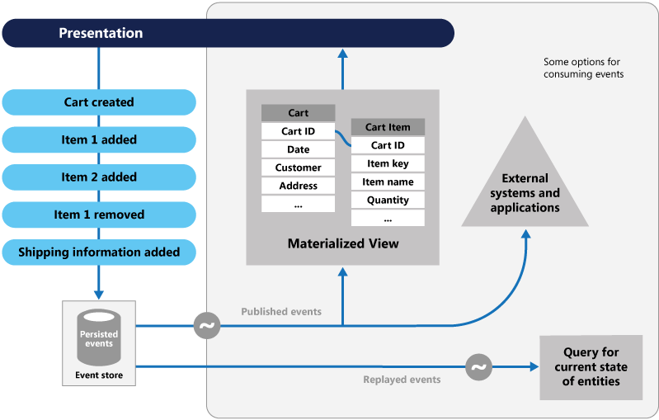

The Event Sourcing pattern provides the following advantages:

* Events are immutable and can be stored using an append-only operation. The user interface, workflow, or process that initiated an event can continue, and tasks that handle the events can run in the background. This, combined with the fact that there's no contention during the processing of transactions, can vastly improve performance and scalability for applications, especially for the presentation level or user interface.
* Events are simple objects that describe some action that occurred, together with any associated data required to describe the action represented by the event. Events don't directly update a data store. They're simply recorded for handling at the appropriate time. This can simplify implementation and management.
* Events typically have meaning for a domain expert, whereas object-relational impedance mismatch can make complex database tables hard to understand. Tables are artificial constructs that represent the current state of the system, not the events that occurred.
* Event sourcing can help prevent concurrent updates from causing conflicts because it avoids the requirement to directly update objects in the data store. However, the domain model must still be designed to protect itself from requests that might result in an inconsistent state.
* The append-only storage of events provides an audit trail that can be used to monitor actions taken against a data store, regenerate the current state as materialized views or projections by replaying the events at any time, and assist in testing and debugging the system. In addition, the requirement to use compensating events to cancel changes provides a history of changes that were reversed, which wouldn't be the case if the model simply stored the current state. The list of events can also be used to analyze application performance and detect user behavior trends, or to obtain other useful business information.
* The event store raises events, and tasks perform operations in response to those events. This decoupling of the tasks from the events provides flexibility and extensibility. Tasks know about the type of event and the event data, but not about the operation that triggered the event. In addition, multiple tasks can handle each event. This enables easy integration with other services and systems that only listen for new events raised by the event store. However, the event sourcing events tend to be very low level, and it might be necessary to generate specific integration events instead.

Event sourcing is commonly combined with the CQRS pattern by performing the data management tasks in response to the events, and by materializing views from the stored events.

**Issues and considerations**

Consider the following points when deciding how to implement this pattern:

The system will only be eventually consistent when creating materialized views or generating projections of data by replaying events. There's some delay between an application adding events to the event store as the result of handling a request, the events being published, and consumers of the events handling them. During this period, new events that describe further changes to entities might have arrived at the event store.

**Note**

See the [**Data Consistency Primer**](https://docs.microsoft.com/en-us/previous-versions/msp-n-p/dn589800(v=pandp.10)) for information about eventual consistency.

The event store is the permanent source of information, and so the event data should never be updated. The only way to update an entity to undo a change is to add a compensating event to the event store. If the format (rather than the data) of the persisted events needs to change, perhaps during a migration, it can be difficult to combine existing events in the store with the new version. It might be necessary to iterate through all the events making changes so they're compliant with the new format, or add new events that use the new format. Consider using a version stamp on each version of the event schema to maintain both the old and the new event formats.

Multi-threaded applications and multiple instances of applications might be storing events in the event store. The consistency of events in the event store is vital, as is the order of events that affect a specific entity (the order that changes occur to an entity affects its current state). Adding a timestamp to every event can help to avoid issues. Another common practice is to annotate each event resulting from a request with an incremental identifier. If two actions attempt to add events for the same entity at the same time, the event store can reject an event that matches an existing entity identifier and event identifier.

There's no standard approach, or existing mechanisms such as SQL queries, for reading the events to obtain information. The only data that can be extracted is a stream of events using an event identifier as the criteria. The event ID typically maps to individual entities. The current state of an entity can be determined only by replaying all of the events that relate to it against the original state of that entity.

The length of each event stream affects managing and updating the system. If the streams are large, consider creating snapshots at specific intervals such as a specified number of events. The current state of the entity can be obtained from the snapshot and by replaying any events that occurred after that point in time. For more information about creating snapshots of data, see [Primary-Subordinate Snapshot Replication](https://docs.microsoft.com/en-us/previous-versions/msp-n-p/ff650012(v=pandp.10)).

Even though event sourcing minimizes the chance of conflicting updates to the data, the application must still be able to deal with inconsistencies that result from eventual consistency and the lack of transactions. For example, an event that indicates a reduction in stock inventory might arrive in the data store while an order for that item is being placed, resulting in a requirement to reconcile the two operations either by advising the customer or creating a back order.

Event publication might be "at least once," and so consumers of the events must be idempotent. They must not reapply the update described in an event if the event is handled more than once. For example, if multiple instances of a consumer maintain and aggregate an entity's property, such as the total number of orders placed, only one must succeed in incrementing the aggregate when an order placed event occurs. While this isn't a key characteristic of event sourcing, it's the usual implementation decision.

**When to use this pattern**

Use this pattern in the following scenarios:

* When you want to capture intent, purpose, or reason in the data. For example, changes to a customer entity can be captured as a series of specific event types such as *Moved home*, *Closed account*, or *Deceased*.
* When it's vital to minimize or completely avoid the occurrence of conflicting updates to data.
* When you want to record events that occur, and be able to replay them to restore the state of a system, roll back changes, or keep a history and audit log. For example, when a task involves multiple steps you might need to execute actions to revert updates and then replay some steps to bring the data back into a consistent state.
* When using events is a natural feature of the operation of the application, and requires little additional development or implementation effort.
* When you need to decouple the process of inputting or updating data from the tasks required to apply these actions. This might be to improve UI performance, or to distribute events to other listeners that take action when the events occur. For example, integrating a payroll system with an expense submission website so that events raised by the event store in response to data updates made in the website are consumed by both the website and the payroll system.
* When you want flexibility to be able to change the format of materialized models and entity data if requirements change, or—when used in conjunction with CQRS—you need to adapt a read model or the views that expose the data.
* When used in conjunction with CQRS, and eventual consistency is acceptable while a read model is updated, or the performance impact of rehydrating entities and data from an event stream is acceptable.

This pattern might not be useful in the following situations:

* Small or simple domains, systems that have little or no business logic, or nondomain systems that naturally work well with traditional CRUD data management mechanisms.
* Systems where consistency and real-time updates to the views of the data are required.
* Systems where audit trails, history, and capabilities to roll back and replay actions are not required.
* Systems where there's only a very low occurrence of conflicting updates to the underlying data. For example, systems that predominantly add data rather than updating it.

**Example**

A conference management system needs to track the number of completed bookings for a conference so that it can check whether there are seats still available when a potential attendee tries to make a booking. The system could store the total number of bookings for a conference in at least two ways:

* The system could store the information about the total number of bookings as a separate entity in a database that holds booking information. As bookings are made or canceled, the system could increment or decrement this number as appropriate. This approach is simple in theory, but can cause scalability issues if a large number of attendees are attempting to book seats during a short period of time. For example, in the last day or so prior to the booking period closing.
* The system could store information about bookings and cancellations as events held in an event store. It could then calculate the number of seats available by replaying these events. This approach can be more scalable due to the immutability of events. The system only needs to be able to read data from the event store, or append data to the event store. Event information about bookings and cancellations is never modified.

The following diagram illustrates how the seat reservation subsystem of the conference management system might be implemented using event sourcing.

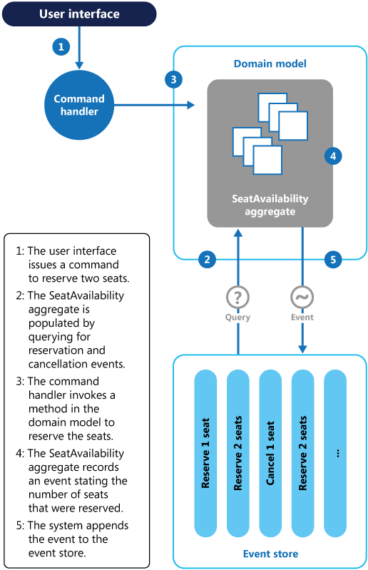

The sequence of actions for reserving two seats is as follows:

1. The user interface issues a command to reserve seats for two attendees. The command is handled by a separate command handler. A piece of logic that is decoupled from the user interface and is responsible for handling requests posted as commands.
2. An aggregate containing information about all reservations for the conference is constructed by querying the events that describe bookings and cancellations. This aggregate is called SeatAvailability, and is contained within a domain model that exposes methods for querying and modifying the data in the aggregate.

Some optimizations to consider are using snapshots (so that you don’t need to query and replay the full list of events to obtain the current state of the aggregate), and maintaining a cached copy of the aggregate in memory.

1. The command handler invokes a method exposed by the domain model to make the reservations.
2. The SeatAvailability aggregate records an event containing the number of seats that were reserved. The next time the aggregate applies events, all the reservations will be used to compute how many seats remain.
3. The system appends the new event to the list of events in the event store.

If a user cancels a seat, the system follows a similar process except the command handler issues a command that generates a seat cancellation event and appends it to the event store.

As well as providing more scope for scalability, using an event store also provides a complete history, or audit trail, of the bookings and cancellations for a conference. The events in the event store are the accurate record. There is no need to persist aggregates in any other way because the system can easily replay the events and restore the state to any point in time.

You can find more information about this example in [Introducing Event Sourcing](https://docs.microsoft.com/en-us/previous-versions/msp-n-p/jj591559(v=pandp.10)).

#### Materialized View

Generate prepopulated views over the data in one or more data stores when the data isn't ideally formatted for required query operations. This can help support efficient querying and data extraction, and improve application performance.

**Context and problem**

When storing data, the priority for developers and data administrators is often focused on how the data is stored, as opposed to how it's read. The chosen storage format is usually closely related to the format of the data, requirements for managing data size and data integrity, and the kind of store in use. For example, when using NoSQL document store, the data is often represented as a series of aggregates, each containing all of the information for that entity.

However, this can have a negative effect on queries. When a query only needs a subset of the data from some entities, such as a summary of orders for several customers without all of the order details, it must extract all of the data for the relevant entities in order to obtain the required information.

**Solution**

To support efficient querying, a common solution is to generate, in advance, a view that materializes the data in a format suited to the required results set. The Materialized View pattern describes generating prepopulated views of data in environments where the source data isn't in a suitable format for querying, where generating a suitable query is difficult, or where query performance is poor due to the nature of the data or the data store.

These materialized views, which only contain data required by a query, allow applications to quickly obtain the information they need. In addition to joining tables or combining data entities, materialized views can include the current values of calculated columns or data items, the results of combining values or executing transformations on the data items, and values specified as part of the query. A materialized view can even be optimized for just a single query.

A key point is that a materialized view and the data it contains is completely disposable because it can be entirely rebuilt from the source data stores. A materialized view is never updated directly by an application, and so it's a specialized cache.

When the source data for the view changes, the view must be updated to include the new information. You can schedule this to happen automatically, or when the system detects a change to the original data. In some cases it might be necessary to regenerate the view manually. The figure shows an example of how the Materialized View pattern might be used.

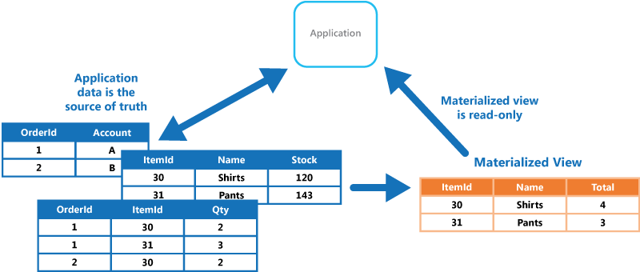

**Issues and considerations**

Consider the following points when deciding how to implement this pattern:

How and when the view will be updated. Ideally it'll regenerate in response to an event indicating a change to the source data, although this can lead to excessive overhead if the source data changes rapidly. Alternatively, consider using a scheduled task, an external trigger, or a manual action to regenerate the view.

In some systems, such as when using the Event Sourcing pattern to maintain a store of only the events that modified the data, materialized views are necessary. Prepopulating views by examining all events to determine the current state might be the only way to obtain information from the event store. If you're not using Event Sourcing, you need to consider whether a materialized view is helpful or not. Materialized views tend to be specifically tailored to one, or a small number of queries. If many queries are used, materialized views can result in unacceptable storage capacity requirements and storage cost.

Consider the impact on data consistency when generating the view, and when updating the view if this occurs on a schedule. If the source data is changing at the point when the view is generated, the copy of the data in the view won't be fully consistent with the original data.

Consider where you'll store the view. The view doesn't have to be located in the same store or partition as the original data. It can be a subset from a few different partitions combined.

A view can be rebuilt if lost. Because of that, if the view is transient and is only used to improve query performance by reflecting the current state of the data, or to improve scalability, it can be stored in a cache or in a less reliable location.

When defining a materialized view, maximize its value by adding data items or columns to it based on computation or transformation of existing data items, on values passed in the query, or on combinations of these values when appropriate.

Where the storage mechanism supports it, consider indexing the materialized view to further increase performance. Most relational databases support indexing for views, as do big data solutions based on Apache Hadoop.

**When to use this pattern**

This pattern is useful when:

* Creating materialized views over data that's difficult to query directly, or where queries must be very complex to extract data that's stored in a normalized, semi-structured, or unstructured way.
* Creating temporary views that can dramatically improve query performance, or can act directly as source views or data transfer objects for the UI, for reporting, or for display.
* Supporting occasionally connected or disconnected scenarios where connection to the data store isn't always available. The view can be cached locally in this case.
* Simplifying queries and exposing data for experimentation in a way that doesn't require knowledge of the source data format. For example, by joining different tables in one or more databases, or one or more domains in NoSQL stores, and then formatting the data to fit its eventual use.
* Providing access to specific subsets of the source data that, for security or privacy reasons, shouldn't be generally accessible, open to modification, or fully exposed to users.
* Bridging different data stores, to take advantage of their individual capabilities. For example, using a cloud store that's efficient for writing as the reference data store, and a relational database that offers good query and read performance to hold the materialized views.

This pattern isn't useful in the following situations:

* The source data is simple and easy to query.
* The source data changes very quickly, or can be accessed without using a view. In these cases, you should avoid the processing overhead of creating views.
* Consistency is a high priority. The views might not always be fully consistent with the original data.
* When using microservices. Microservices typically have well defined boundries aligning to [domain driven design (DDD)](https://docs.microsoft.com/en-us/azure/architecture/microservices/model/tactical-ddd).

**Example**

The following figure shows an example of using the Materialized View pattern to generate a summary of sales. Data in the Order, OrderItem, and Customer tables in separate partitions in an Azure storage account are combined to generate a view containing the total sales value for each product in the Electronics category, along with a count of the number of customers who made purchases of each item.

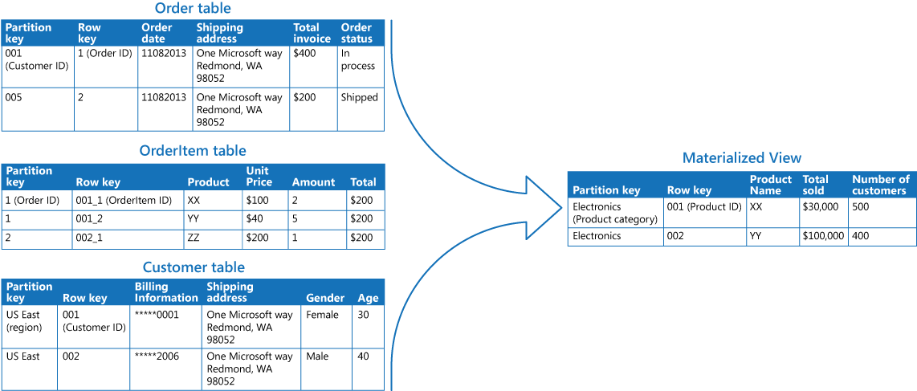

Creating this materialized view requires complex queries. However, by exposing the query result as a materialized view, users can easily obtain the results and use them directly or incorporate them in another query. The view is likely to be used in a reporting system or dashboard, and can be updated on a scheduled basis such as weekly.

Although this example uses Azure table storage, many relational database management systems also provide native support for materialized views.

#### Static Content Hosting pattern

Deploy static content to a cloud-based storage service that can deliver them directly to the client. This can reduce the need for potentially expensive compute instances.

**Context and problem**

Web applications typically include some elements of static content. This static content might include HTML pages and other resources such as images and documents that are available to the client, either as part of an HTML page (such as inline images, style sheets, and client-side JavaScript files) or as separate downloads (such as PDF documents).

Although web servers are optimized for dynamic rendering and output caching, they still have to handle requests to download static content. This consumes processing cycles that could often be put to better use.

**Solution**

In most cloud hosting environments, you can put some of an application's resources and static pages in a storage service. The storage service can serve requests for these resources, reducing load on the compute resources that handle other web requests. The cost for cloud-hosted storage is typically much less than for compute instances.

When hosting some parts of an application in a storage service, the main considerations are related to deployment of the application and to securing resources that aren't intended to be available to anonymous users.

**Issues and considerations**

Consider the following points when deciding how to implement this pattern:

* The hosted storage service must expose an HTTP endpoint that users can access to download the static resources. Some storage services also support HTTPS, so it's possible to host resources in storage services that require SSL.
* For maximum performance and availability, consider using a content delivery network (CDN) to cache the contents of the storage container in multiple datacenters around the world. However, you'll likely have to pay for using the CDN.
* Storage accounts are often geo-replicated by default to provide resiliency against events that might affect a datacenter. This means that the IP address might change, but the URL will remain the same.
* When some content is located in a storage account and other content is in a hosted compute instance, it becomes more challenging to deploy and update the application. You might have to perform separate deployments, and version the application and content to manage it more easily—especially when the static content includes script files or UI components. However, if only static resources have to be updated, they can simply be uploaded to the storage account without needing to redeploy the application package.
* Storage services might not support the use of custom domain names. In this case it's necessary to specify the full URL of the resources in links because they'll be in a different domain from the dynamically-generated content containing the links.
* The storage containers must be configured for public read access, but it's vital to ensure that they aren't configured for public write access to prevent users being able to upload content.
* Consider using a valet key or token to control access to resources that shouldn't be available anonymously. See the [Valet Key pattern](https://docs.microsoft.com/en-us/azure/architecture/patterns/valet-key) for more information.

**When to use this pattern**

This pattern is useful for:

* Minimizing the hosting cost for websites and applications that contain some static resources.
* Minimizing the hosting cost for websites that consist of only static content and resources. Depending on the capabilities of the hosting provider's storage system, it might be possible to entirely host a fully static website in a storage account.
* Exposing static resources and content for applications running in other hosting environments or on-premises servers.
* Locating content in more than one geographical area using a content delivery network that caches the contents of the storage account in multiple datacenters around the world.
* Monitoring costs and bandwidth usage. Using a separate storage account for some or all of the static content allows the costs to be more easily separated from hosting and runtime costs.

This pattern might not be useful in the following situations:

* The application needs to perform some processing on the static content before delivering it to the client. For example, it might be necessary to add a timestamp to a document.
* The volume of static content is very small. The overhead of retrieving this content from separate storage can outweigh the cost benefit of separating it out from the compute resource.

**Example**

Azure Storage supports serving static content directly from a storage container. Files are served through anonymous access requests. By default, files have a URL in a subdomain of core.windows.net, such as https://contoso.z4.web.core.windows.net/image.png. You can configure a custom domain name, and use Azure CDN to access the files over HTTPS. For more information, see [Static website hosting in Azure Storage](https://docs.microsoft.com/en-us/azure/storage/blobs/storage-blob-static-website).

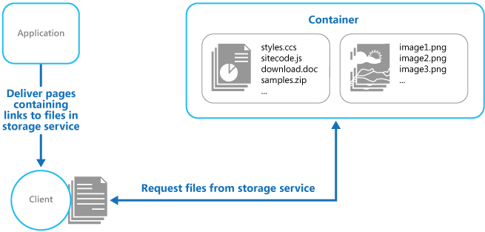

Static website hosting makes the files available for anonymous access. If you need to control who can access the files, you can store files in Azure blob storage and then generate [shared access signatures](https://docs.microsoft.com/en-us/azure/storage/common/storage-dotnet-shared-access-signature-part-1) to limit access.

The links in the pages delivered to the client must specify the full URL of the resource. If the resource is protected with a valet key, such as a shared access signature, this signature must be included in the URL.

A sample application that demonstrates using external storage for static resources is available on [GitHub](https://github.com/mspnp/cloud-design-patterns/tree/master/static-content-hosting). This sample uses configuration files to specify the storage account and container that holds the static content.

<Setting name="StaticContent.StorageConnectionString"

value="UseDevelopmentStorage=true" />

<Setting name="StaticContent.Container" value="static-content" />

The Settings class in the file Settings.cs of the StaticContentHosting.Web project contains methods to extract these values and build a string value containing the cloud storage account container URL.

public class Settings

{

public static string StaticContentStorageConnectionString {

get

{

return RoleEnvironment.GetConfigurationSettingValue(

"StaticContent.StorageConnectionString");

}

}

public static string StaticContentContainer

{

get

{

return RoleEnvironment.GetConfigurationSettingValue("StaticContent.Container");

}

}

public static string StaticContentBaseUrl

{

get

{

var blobServiceClient = new BlobServiceClient(StaticContentStorageConnectionString);

return string.Format("{0}/{1}", blobServiceClient.Uri.ToString().TrimEnd('/'), StaticContentContainer.TrimStart('/'));

}

}

}

The StaticContentUrlHtmlHelper class in the file StaticContentUrlHtmlHelper.cs exposes a method named StaticContentUrl that generates a URL containing the path to the cloud storage account if the URL passed to it starts with the ASP.NET root path character (~).

public static class StaticContentUrlHtmlHelper

{

public static string StaticContentUrl(this HtmlHelper helper, string contentPath)

{

if (contentPath.StartsWith("~"))

{

contentPath = contentPath.Substring(1);

}

contentPath = string.Format("{0}/{1}", Settings.StaticContentBaseUrl.TrimEnd('/'),

contentPath.TrimStart('/'));

var url = new UrlHelper(helper.ViewContext.RequestContext);

return url.Content(contentPath);

}

}

The file Index.cshtml in the Views\Home folder contains an image element that uses the StaticContentUrl method to create the URL for its src attribute.

<img src="@Html.StaticContentUrl("~/media/orderedList1.png")" alt="Test Image" />

#### Valet Key pattern

Use a token that provides clients with restricted direct access to a specific resource, in order to offload data transfer from the application. This is particularly useful in applications that use cloud-hosted storage systems or queues, and can minimize cost and maximize scalability and performance.

**Context and problem**

Client programs and web browsers often need to read and write files or data streams to and from an application’s storage. Typically, the application will handle the movement of the data — either by fetching it from storage and streaming it to the client, or by reading the uploaded stream from the client and storing it in the data store. However, this approach absorbs valuable resources such as compute, memory, and bandwidth.

Data stores have the ability to handle upload and download of data directly, without requiring that the application perform any processing to move this data. But, this typically requires the client to have access to the security credentials for the store. This can be a useful technique to minimize data transfer costs and the requirement to scale out the application, and to maximize performance. It means, though, that the application is no longer able to manage the security of the data. After the client has a connection to the data store for direct access, the application can't act as the gatekeeper. It's no longer in control of the process and can't prevent subsequent uploads or downloads from the data store.

This isn't a realistic approach in distributed systems that need to serve untrusted clients. Instead, applications must be able to securely control access to data in a granular way, but still reduce the load on the server by setting up this connection and then allowing the client to communicate directly with the data store to perform the required read or write operations.

**Solution**

You need to resolve the problem of controlling access to a data store where the store can't manage authentication and authorization of clients. One typical solution is to restrict access to the data store’s public connection and provide the client with a key or token that the data store can validate.

This key or token is usually referred to as a valet key. It provides time-limited access to specific resources and allows only predefined operations such as reading and writing to storage or queues, or uploading and downloading in a web browser. Applications can create and issue valet keys to client devices and web browsers quickly and easily, allowing clients to perform the required operations without requiring the application to directly handle the data transfer. This removes the processing overhead, and the impact on performance and scalability, from the application and the server.

The client uses this token to access a specific resource in the data store for only a specific period, and with specific restrictions on access permissions, as shown in the figure. After the specified period, the key becomes invalid and won't allow access to the resource.

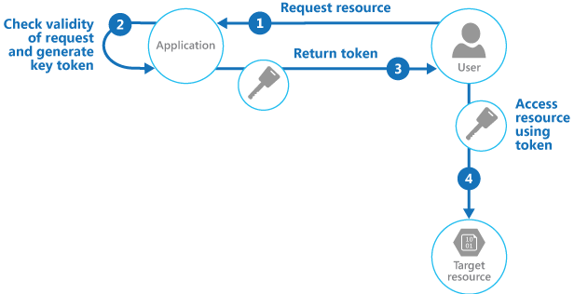

It's also possible to configure a key that has other dependencies, such as the scope of the data. For example, depending on the data store capabilities, the key can specify a complete table in a data store, or only specific rows in a table. In cloud storage systems the key can specify a container, or just a specific item within a container.

The key can also be invalidated by the application. This is a useful approach if the client notifies the server that the data transfer operation is complete. The server can then invalidate that key to prevent further access.

Using this pattern can simplify managing access to resources because there's no requirement to create and authenticate a user, grant permissions, and then remove the user again. It also makes it easy to limit the location, the permission, and the validity period—all by simply generating a key at runtime. The important factors are to limit the validity period, and especially the location of the resource, as tightly as possible so that the recipient can only use it for the intended purpose.

**Issues and considerations**

Consider the following points when deciding how to implement this pattern:

**Manage the validity status and period of the key**. If leaked or compromised, the key effectively unlocks the target item and makes it available for malicious use during the validity period. A key can usually be revoked or disabled, depending on how it was issued. Server-side policies can be changed or, the server key it was signed with can be invalidated. Specify a short validity period to minimize the risk of allowing unauthorized operations to take place against the data store. However, if the validity period is too short, the client might not be able to complete the operation before the key expires. Allow authorized users to renew the key before the validity period expires if multiple accesses to the protected resource are required.

**Control the level of access the key will provide**. Typically, the key should allow the user to only perform the actions necessary to complete the operation, such as read-only access if the client shouldn't be able to upload data to the data store. For file uploads, it's common to specify a key that provides write-only permission, as well as the location and the validity period. It's critical to accurately specify the resource or the set of resources to which the key applies.

**Consider how to control users’ behavior**. Implementing this pattern means some loss of control over the resources users are granted access to. The level of control that can be exerted is limited by the capabilities of the policies and permissions available for the service or the target data store. For example, it's usually not possible to create a key that limits the size of the data to be written to storage, or the number of times the key can be used to access a file. This can result in huge unexpected costs for data transfer, even when used by the intended client, and might be caused by an error in the code that causes repeated upload or download. To limit the number of times a file can be uploaded, where possible, force the client to notify the application when one operation has completed. For example, some data stores raise events the application code can use to monitor operations and control user behavior. However, it's hard to enforce quotas for individual users in a multi-tenant scenario where the same key is used by all the users from one tenant.

**Validate, and optionally sanitize, all uploaded data**. A malicious user that gains access to the key could upload data designed to compromise the system. Alternatively, authorized users might upload data that's invalid and, when processed, could result in an error or system failure. To protect against this, ensure that all uploaded data is validated and checked for malicious content before use.

**Audit all operations**. Many key-based mechanisms can log operations such as uploads, downloads, and failures. These logs can usually be incorporated into an audit process, and also used for billing if the user is charged based on file size or data volume. Use the logs to detect authentication failures that might be caused by issues with the key provider, or accidental removal of a stored access policy.

**Deliver the key securely**. It can be embedded in a URL that the user activates in a web page, or it can be used in a server redirection operation so that the download occurs automatically. Always use HTTPS to deliver the key over a secure channel.

**Protect sensitive data in transit**. Sensitive data delivered through the application will usually take place using SSL or TLS, and this should be enforced for clients accessing the data store directly.

Other issues to be aware of when implementing this pattern are:

* If the client doesn't, or can't, notify the server of completion of the operation, and the only limit is the expiration period of the key, the application won't be able to perform auditing operations such as counting the number of uploads or downloads, or preventing multiple uploads or downloads.
* The flexibility of key policies that can be generated might be limited. For example, some mechanisms only allow the use of a timed expiration period. Others aren't able to specify a sufficient granularity of read/write permissions.
* If the start time for the key or token validity period is specified, ensure that it's a little earlier than the current server time to allow for client clocks that might be slightly out of synchronization. The default, if not specified, is usually the current server time.
* The URL containing the key will be recorded in server log files. While the key will typically have expired before the log files are used for analysis, ensure that you limit access to them. If log data is transmitted to a monitoring system or stored in another location, consider implementing a delay to prevent leakage of keys until after their validity period has expired.
* If the client code runs in a web browser, the browser might need to support cross-origin resource sharing (CORS) to enable code that executes within the web browser to access data in a different domain from the one that served the page. Some older browsers and some data stores don't support CORS, and code that runs in these browsers might not be able to use a valet key to provide access to data in a different domain, such as a cloud storage account.

**When to use this pattern**

This pattern is useful for the following situations:

* To minimize resource loading and maximize performance and scalability. Using a valet key doesn't require the resource to be locked, no remote server call is required, there's no limit on the number of valet keys that can be issued, and it avoids a single point of failure resulting from performing the data transfer through the application code. Creating a valet key is typically a simple cryptographic operation of signing a string with a key.
* To minimize operational cost. Enabling direct access to stores and queues is resource and cost efficient, can result in fewer network round trips, and might allow for a reduction in the number of compute resources required.
* When clients regularly upload or download data, particularly where there's a large volume or when each operation involves large files.
* When the application has limited compute resources available, either due to hosting limitations or cost considerations. In this scenario, the pattern is even more helpful if there are many concurrent data uploads or downloads because it relieves the application from handling the data transfer.
* When the data is stored in a remote data store or a different datacenter. If the application was required to act as a gatekeeper, there might be a charge for the additional bandwidth of transferring the data between datacenters, or across public or private networks between the client and the application, and then between the application and the data store.

This pattern might not be useful in the following situations:

* If the application must perform some task on the data before it's stored or before it's sent to the client. For example, if the application needs to perform validation, log access success, or execute a transformation on the data. However, some data stores and clients are able to negotiate and carry out simple transformations such as compression and decompression (for example, a web browser can usually handle GZip formats).
* If the design of an existing application makes it difficult to incorporate the pattern. Using this pattern typically requires a different architectural approach for delivering and receiving data.
* If it's necessary to maintain audit trails or control the number of times a data transfer operation is executed, and the valet key mechanism in use doesn't support notifications that the server can use to manage these operations.
* If it's necessary to limit the size of the data, especially during upload operations. The only solution to this is for the application to check the data size after the operation is complete, or check the size of uploads after a specified period or on a scheduled basis.

**Example**

Azure supports shared access signatures on Azure Storage for granular access control to data in blobs, tables, and queues, and for Service Bus queues and topics. A shared access signature token can be configured to provide specific access rights such as read, write, update, and delete to a specific table; a key range within a table; a queue; a blob; or a blob container. The validity can be a specified time period or with no time limit.

Azure shared access signatures also support server-stored access policies that can be associated with a specific resource such as a table or blob. This feature provides additional control and flexibility compared to application-generated shared access signature tokens, and should be used whenever possible. Settings defined in a server-stored policy can be changed and are reflected in the token without requiring a new token to be issued, but settings defined in the token can't be changed without issuing a new token. This approach also makes it possible to revoke a valid shared access signature token before it's expired.

For more information, see [Introducing Table SAS (Shared Access Signature), Queue SAS and update to Blob SAS](https://blogs.msdn.microsoft.com/windowsazurestorage/2012/06/12/introducing-table-sas-shared-access-signature-queue-sas-and-update-to-blob-sas/) and [Using Shared Access Signatures](https://docs.microsoft.com/en-us/azure/storage/common/storage-dotnet-shared-access-signature-part-1) on MSDN.

The following code shows how to create a shared access signature token that's valid for five minutes. The GetSharedAccessReferenceForUpload method returns a shared access signatures token that can be used to upload a file to Azure Blob Storage.

C#Copy

public class ValuesController : ApiController

{

private readonly BlobServiceClient blobServiceClient;

private readonly string blobContainer;

...

/// <summary>

/// Return a limited access key that allows the caller to upload a file

/// to this specific destination for a defined period of time.

/// </summary>

private StorageEntitySas GetSharedAccessReferenceForUpload(string blobName)

{

var blob = blobServiceClient.GetBlobContainerClient(this.blobContainer).GetBlobClient(blobName);

var storageSharedKeyCredential = new StorageSharedKeyCredential(blobServiceClient.AccountName, ConfigurationManager.AppSettings["AzureStorageEmulatorAccountKey"]);

var blobSasBuilder = new BlobSasBuilder

{

BlobContainerName = this.blobContainer,

BlobName = blobName,

Resource = "b",

StartsOn = DateTimeOffset.UtcNow.AddMinutes(-5),

ExpiresOn = DateTimeOffset.UtcNow.AddMinutes(5)

};

policy.SetPermissions(BlobSasPermissions.Write);

var sas = policy.ToSasQueryParameters(storageSharedKeyCredential).ToString();

return new StorageEntitySas

{

BlobUri = blob.Uri,

Credentials = sas

};

}

public struct StorageEntitySas

{

public string Credentials;

public Uri BlobUri;

}

}

The complete sample is available in the ValetKey solution available for download from [GitHub](https://github.com/mspnp/cloud-design-patterns/tree/master/valet-key). The ValetKey.Web project in this solution contains a web application that includes the ValuesController class shown above. A sample client application that uses this web application to retrieve a shared access signatures key and upload a file to blob storage is available in the ValetKey.Client project.

#### Sharding pattern

Divide a data store into a set of horizontal partitions or shards. This can improve scalability when storing and accessing large volumes of data.

**Context and problem**

A data store hosted by a single server might be subject to the following limitations:

* **Storage space**. A data store for a large-scale cloud application is expected to contain a huge volume of data that could increase significantly over time. A server typically provides only a finite amount of disk storage, but you can replace existing disks with larger ones, or add further disks to a machine as data volumes grow. However, the system will eventually reach a limit where it isn't possible to easily increase the storage capacity on a given server.
* **Computing resources**. A cloud application is required to support a large number of concurrent users, each of which run queries that retrieve information from the data store. A single server hosting the data store might not be able to provide the necessary computing power to support this load, resulting in extended response times for users and frequent failures as applications attempting to store and retrieve data time out. It might be possible to add memory or upgrade processors, but the system will reach a limit when it isn't possible to increase the compute resources any further.
* **Network bandwidth**. Ultimately, the performance of a data store running on a single server is governed by the rate the server can receive requests and send replies. It's possible that the volume of network traffic might exceed the capacity of the network used to connect to the server, resulting in failed requests.
* **Geography**. It might be necessary to store data generated by specific users in the same region as those users for legal, compliance, or performance reasons, or to reduce latency of data access. If the users are dispersed across different countries or regions, it might not be possible to store the entire data for the application in a single data store.

Scaling vertically by adding more disk capacity, processing power, memory, and network connections can postpone the effects of some of these limitations, but it's likely to only be a temporary solution. A commercial cloud application capable of supporting large numbers of users and high volumes of data must be able to scale almost indefinitely, so vertical scaling isn't necessarily the best solution.

**Solution**

Divide the data store into horizontal partitions or shards. Each shard has the same schema, but holds its own distinct subset of the data. A shard is a data store in its own right (it can contain the data for many entities of different types), running on a server acting as a storage node.

This pattern has the following benefits:

* You can scale the system out by adding further shards running on additional storage nodes.
* A system can use off-the-shelf hardware rather than specialized and expensive computers for each storage node.
* You can reduce contention and improve performance by balancing the workload across shards.
* In the cloud, shards can be located physically close to the users that'll access the data.

When dividing a data store up into shards, decide which data should be placed in each shard. A shard typically contains items that fall within a specified range determined by one or more attributes of the data. These attributes form the shard key (sometimes referred to as the partition key). The shard key should be static. It shouldn't be based on data that might change.

Sharding physically organizes the data. When an application stores and retrieves data, the sharding logic directs the application to the appropriate shard. This sharding logic can be implemented as part of the data access code in the application, or it could be implemented by the data storage system if it transparently supports sharding.

Abstracting the physical location of the data in the sharding logic provides a high level of control over which shards contain which data. It also enables data to migrate between shards without reworking the business logic of an application if the data in the shards need to be redistributed later (for example, if the shards become unbalanced). The tradeoff is the additional data access overhead required in determining the location of each data item as it's retrieved.

To ensure optimal performance and scalability, it's important to split the data in a way that's appropriate for the types of queries that the application performs. In many cases, it's unlikely that the sharding scheme will exactly match the requirements of every query. For example, in a multi-tenant system an application might need to retrieve tenant data using the tenant ID, but it might also need to look up this data based on some other attribute such as the tenant’s name or location. To handle these situations, implement a sharding strategy with a shard key that supports the most commonly performed queries.

If queries regularly retrieve data using a combination of attribute values, you can likely define a composite shard key by linking attributes together. Alternatively, use a pattern such as [Index Table](https://docs.microsoft.com/en-us/azure/architecture/patterns/index-table) to provide fast lookup to data based on attributes that aren't covered by the shard key.

**Sharding strategies**

Three strategies are commonly used when selecting the shard key and deciding how to distribute data across shards. Note that there doesn't have to be a one-to-one correspondence between shards and the servers that host them—a single server can host multiple shards. The strategies are:

**The Lookup strategy**. In this strategy the sharding logic implements a map that routes a request for data to the shard that contains that data using the shard key. In a multi-tenant application all the data for a tenant might be stored together in a shard using the tenant ID as the shard key. Multiple tenants might share the same shard, but the data for a single tenant won't be spread across multiple shards. The figure illustrates sharding tenant data based on tenant IDs.

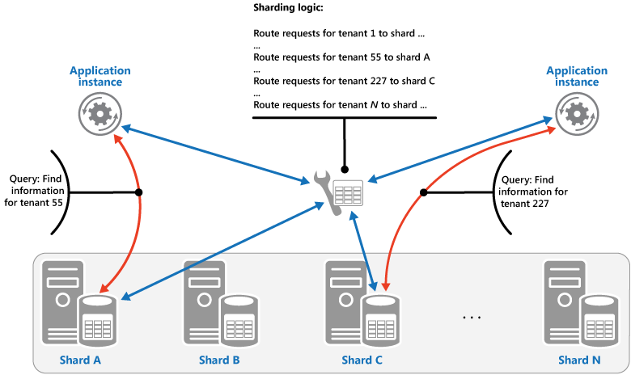

The mapping between the shard key and the physical storage can be based on physical shards where each shard key maps to a physical partition. Alternatively, a more flexible technique for rebalancing shards is virtual partitioning, where shard keys map to the same number of virtual shards, which in turn map to fewer physical partitions. In this approach, an application locates data using a shard key that refers to a virtual shard, and the system transparently maps virtual shards to physical partitions. The mapping between a virtual shard and a physical partition can change without requiring the application code be modified to use a different set of shard keys.

**The Range strategy**. This strategy groups related items together in the same shard, and orders them by shard key—the shard keys are sequential. It's useful for applications that frequently retrieve sets of items using range queries (queries that return a set of data items for a shard key that falls within a given range). For example, if an application regularly needs to find all orders placed in a given month, this data can be retrieved more quickly if all orders for a month are stored in date and time order in the same shard. If each order was stored in a different shard, they'd have to be fetched individually by performing a large number of point queries (queries that return a single data item). The next figure illustrates storing sequential sets (ranges) of data in shard.

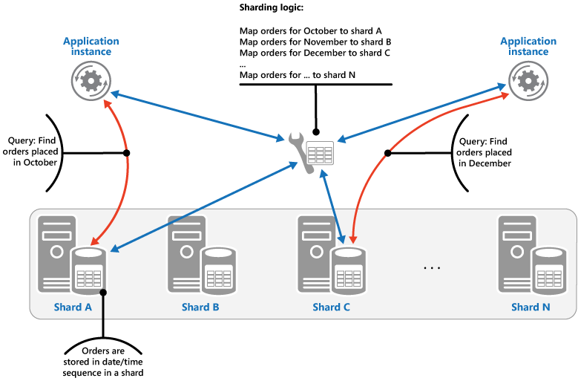

In this example, the shard key is a composite key containing the order month as the most significant element, followed by the order day and the time. The data for orders is naturally sorted when new orders are created and added to a shard. Some data stores support two-part shard keys containing a partition key element that identifies the shard and a row key that uniquely identifies an item in the shard. Data is usually held in row key order in the shard. Items that are subject to range queries and need to be grouped together can use a shard key that has the same value for the partition key but a unique value for the row key.

**The Hash strategy**. The purpose of this strategy is to reduce the chance of hotspots (shards that receive a disproportionate amount of load). It distributes the data across the shards in a way that achieves a balance between the size of each shard and the average load that each shard will encounter. The sharding logic computes the shard to store an item in based on a hash of one or more attributes of the data. The chosen hashing function should distribute data evenly across the shards, possibly by introducing some random element into the computation. The next figure illustrates sharding tenant data based on a hash of tenant IDs.

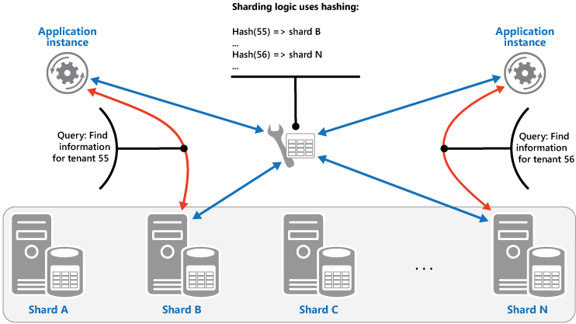

To understand the advantage of the Hash strategy over other sharding strategies, consider how a multi-tenant application that enrolls new tenants sequentially might assign the tenants to shards in the data store. When using the Range strategy, the data for tenants 1 to n will all be stored in shard A, the data for tenants n+1 to m will all be stored in shard B, and so on. If the most recently registered tenants are also the most active, most data activity will occur in a small number of shards, which could cause hotspots. In contrast, the Hash strategy allocates tenants to shards based on a hash of their tenant ID. This means that sequential tenants are most likely to be allocated to different shards, which will distribute the load across them. The previous figure shows this for tenants 55 and 56.

The three sharding strategies have the following advantages and considerations:

* **Lookup**. This offers more control over the way that shards are configured and used. Using virtual shards reduces the impact when rebalancing data because new physical partitions can be added to even out the workload. The mapping between a virtual shard and the physical partitions that implement the shard can be modified without affecting application code that uses a shard key to store and retrieve data. Looking up shard locations can impose an additional overhead.
* **Range**. This is easy to implement and works well with range queries because they can often fetch multiple data items from a single shard in a single operation. This strategy offers easier data management. For example, if users in the same region are in the same shard, updates can be scheduled in each time zone based on the local load and demand pattern. However, this strategy doesn't provide optimal balancing between shards. Rebalancing shards is difficult and might not resolve the problem of uneven load if the majority of activity is for adjacent shard keys.
* **Hash**. This strategy offers a better chance of more even data and load distribution. Request routing can be accomplished directly by using the hash function. There's no need to maintain a map. Note that computing the hash might impose an additional overhead. Also, rebalancing shards is difficult.

Most common sharding systems implement one of the approaches described above, but you should also consider the business requirements of your applications and their patterns of data usage. For example, in a multi-tenant application:

* You can shard data based on workload. You could segregate the data for highly volatile tenants in separate shards. The speed of data access for other tenants might be improved as a result.
* You can shard data based on the location of tenants. You can take the data for tenants in a specific geographic region offline for backup and maintenance during off-peak hours in that region, while the data for tenants in other regions remains online and accessible during their business hours.
* High-value tenants could be assigned their own private, high performing, lightly loaded shards, whereas lower-value tenants might be expected to share more densely-packed, busy shards.
* The data for tenants that need a high degree of data isolation and privacy can be stored on a completely separate server.

**Scaling and data movement operations**

Each of the sharding strategies implies different capabilities and levels of complexity for managing scale in, scale out, data movement, and maintaining state.

The Lookup strategy permits scaling and data movement operations to be carried out at the user level, either online or offline. The technique is to suspend some or all user activity (perhaps during off-peak periods), move the data to the new virtual partition or physical shard, change the mappings, invalidate or refresh any caches that hold this data, and then allow user activity to resume. Often this type of operation can be centrally managed. The Lookup strategy requires state to be highly cacheable and replica friendly.

The Range strategy imposes some limitations on scaling and data movement operations, which must typically be carried out when a part or all of the data store is offline because the data must be split and merged across the shards. Moving the data to rebalance shards might not resolve the problem of uneven load if the majority of activity is for adjacent shard keys or data identifiers that are within the same range. The Range strategy might also require some state to be maintained in order to map ranges to the physical partitions.

The Hash strategy makes scaling and data movement operations more complex because the partition keys are hashes of the shard keys or data identifiers. The new location of each shard must be determined from the hash function, or the function modified to provide the correct mappings. However, the Hash strategy doesn't require maintenance of state.

**Issues and considerations**

Consider the following points when deciding how to implement this pattern:

* Sharding is complementary to other forms of partitioning, such as vertical partitioning and functional partitioning. For example, a single shard can contain entities that have been partitioned vertically, and a functional partition can be implemented as multiple shards. For more information about partitioning, see the [Data Partitioning Guidance](https://docs.microsoft.com/en-us/previous-versions/msp-n-p/dn589795(v=pandp.10)).
* Keep shards balanced so they all handle a similar volume of I/O. As data is inserted and deleted, it's necessary to periodically rebalance the shards to guarantee an even distribution and to reduce the chance of hotspots. Rebalancing can be an expensive operation. To reduce the necessity of rebalancing, plan for growth by ensuring that each shard contains sufficient free space to handle the expected volume of changes. You should also develop strategies and scripts you can use to quickly rebalance shards if this becomes necessary.
* Use stable data for the shard key. If the shard key changes, the corresponding data item might have to move between shards, increasing the amount of work performed by update operations. For this reason, avoid basing the shard key on potentially volatile information. Instead, look for attributes that are invariant or that naturally form a key.
* Ensure that shard keys are unique. For example, avoid using autoincrementing fields as the shard key. Is some systems, autoincremented fields can't be coordinated across shards, possibly resulting in items in different shards having the same shard key.

Autoincremented values in other fields that are not shard keys can also cause problems. For example, if you use autoincremented fields to generate unique IDs, then two different items located in different shards might be assigned the same ID.

* It might not be possible to design a shard key that matches the requirements of every possible query against the data. Shard the data to support the most frequently performed queries, and if necessary create secondary index tables to support queries that retrieve data using criteria based on attributes that aren't part of the shard key. For more information, see the [Index Table pattern](https://docs.microsoft.com/en-us/azure/architecture/patterns/index-table).
* Queries that access only a single shard are more efficient than those that retrieve data from multiple shards, so avoid implementing a sharding system that results in applications performing large numbers of queries that join data held in different shards. Remember that a single shard can contain the data for multiple types of entities. Consider denormalizing your data to keep related entities that are commonly queried together (such as the details of customers and the orders that they have placed) in the same shard to reduce the number of separate reads that an application performs.

If an entity in one shard references an entity stored in another shard, include the shard key for the second entity as part of the schema for the first entity. This can help to improve the performance of queries that reference related data across shards.

* If an application must perform queries that retrieve data from multiple shards, it might be possible to fetch this data by using parallel tasks. Examples include fan-out queries, where data from multiple shards is retrieved in parallel and then aggregated into a single result. However, this approach inevitably adds some complexity to the data access logic of a solution.
* For many applications, creating a larger number of small shards can be more efficient than having a small number of large shards because they can offer increased opportunities for load balancing. This can also be useful if you anticipate the need to migrate shards from one physical location to another. Moving a small shard is quicker than moving a large one.
* Make sure the resources available to each shard storage node are sufficient to handle the scalability requirements in terms of data size and throughput. For more information, see the section “Designing Partitions for Scalability” in the [Data Partitioning Guidance](https://docs.microsoft.com/en-us/previous-versions/msp-n-p/dn589795(v=pandp.10)).
* Consider replicating reference data to all shards. If an operation that retrieves data from a shard also references static or slow-moving data as part of the same query, add this data to the shard. The application can then fetch all of the data for the query easily, without having to make an additional round trip to a separate data store.

If reference data held in multiple shards changes, the system must synchronize these changes across all shards. The system can experience a degree of inconsistency while this synchronization occurs. If you do this, you should design your applications to be able to handle it.

* It can be difficult to maintain referential integrity and consistency between shards, so you should minimize operations that affect data in multiple shards. If an application must modify data across shards, evaluate whether complete data consistency is actually required. Instead, a common approach in the cloud is to implement eventual consistency. The data in each partition is updated separately, and the application logic must take responsibility for ensuring that the updates all complete successfully, as well as handling the inconsistencies that can arise from querying data while an eventually consistent operation is running. For more information about implementing eventual consistency, see the [Data Consistency Primer](https://docs.microsoft.com/en-us/previous-versions/msp-n-p/dn589800(v=pandp.10)).
* Configuring and managing a large number of shards can be a challenge. Tasks such as monitoring, backing up, checking for consistency, and logging or auditing must be accomplished on multiple shards and servers, possibly held in multiple locations. These tasks are likely to be implemented using scripts or other automation solutions, but that might not completely eliminate the additional administrative requirements.
* Shards can be geolocated so that the data that they contain is close to the instances of an application that use it. This approach can considerably improve performance, but requires additional consideration for tasks that must access multiple shards in different locations.

**When to use this pattern**

Use this pattern when a data store is likely to need to scale beyond the resources available to a single storage node, or to improve performance by reducing contention in a data store.

**Note**

The primary focus of sharding is to improve the performance and scalability of a system, but as a by-product it can also improve availability due to how the data is divided into separate partitions. A failure in one partition doesn't necessarily prevent an application from accessing data held in other partitions, and an operator can perform maintenance or recovery of one or more partitions without making the entire data for an application inaccessible. For more information, see the [**Data Partitioning Guidance**](https://docs.microsoft.com/en-us/previous-versions/msp-n-p/dn589795(v=pandp.10)).

**Example**

The following example in C# uses a set of SQL Server databases acting as shards. Each database holds a subset of the data used by an application. The application retrieves data that's distributed across the shards using its own sharding logic (this is an example of a fan-out query). The details of the data that's located in each shard is returned by a method called GetShards. This method returns an enumerable list of ShardInformation objects, where the ShardInformation type contains an identifier for each shard and the SQL Server connection string that an application should use to connect to the shard (the connection strings aren't shown in the code example).

private IEnumerable<ShardInformation> GetShards()

{

// This retrieves the connection information from a shard store

// (commonly a root database).

return new[]

{

new ShardInformation

{

Id = 1,

ConnectionString = ...

},

new ShardInformation

{

Id = 2,

ConnectionString = ...

}

};

}

The code below shows how the application uses the list of ShardInformation objects to perform a query that fetches data from each shard in parallel. The details of the query aren't shown, but in this example the data that's retrieved contains a string that could hold information such as the name of a customer if the shards contain the details of customers. The results are aggregated into a ConcurrentBag collection for processing by the application.

// Retrieve the shards as a ShardInformation[] instance.

var shards = GetShards();

var results = new ConcurrentBag<string>();

// Execute the query against each shard in the shard list.

// This list would typically be retrieved from configuration

// or from a root/primary shard store.

Parallel.ForEach(shards, shard =>

{

// NOTE: Transient fault handling isn't included,

// but should be incorporated when used in a real world application.

using (var con = new SqlConnection(shard.ConnectionString))

{

con.Open();

var cmd = new SqlCommand("SELECT ... FROM ...", con);

Trace.TraceInformation("Executing command against shard: {0}", shard.Id);

var reader = cmd.ExecuteReader();

// Read the results in to a thread-safe data structure.

while (reader.Read())

{

results.Add(reader.GetString(0));

}

}

});

Trace.TraceInformation("Fanout query complete - Record Count: {0}",

results.Count);

### Pipes and Filters

Decompose a task that performs complex processing into a series of separate elements that can be reused. This can improve performance, scalability, and reusability by allowing task elements that perform the processing to be deployed and scaled independently.

**Context and problem**

An application is required to perform a variety of tasks of varying complexity on the information that it processes. A straightforward but inflexible approach to implementing an application is to perform this processing as a monolithic module. However, this approach is likely to reduce the opportunities for refactoring the code, optimizing it, or reusing it if parts of the same processing are required elsewhere within the application.

The figure illustrates the issues with processing data using the monolithic approach. An application receives and processes data from two sources. The data from each source is processed by a separate module that performs a series of tasks to transform this data, before passing the result to the business logic of the application.

Some of the tasks that the monolithic modules perform are functionally very similar, but the modules have been designed separately. The code that implements the tasks is closely coupled in a module, and has been developed with little or no thought given to reuse or scalability.

However, the processing tasks performed by each module, or the deployment requirements for each task, could change as business requirements are updated. Some tasks might be compute intensive and could benefit from running on powerful hardware, while others might not require such expensive resources. Also, additional processing might be required in the future, or the order in which the tasks performed by the processing could change. A solution is required that addresses these issues, and increases the possibilities for code reuse.

**Solution**

Break down the processing required for each stream into a set of separate components (or filters), each performing a single task. By standardizing the format of the data that each component receives and sends, these filters can be combined together into a pipeline. This helps to avoid duplicating code, and makes it easy to remove, replace, or integrate additional components if the processing requirements change. The next figure shows a solution implemented using pipes and filters.

The time it takes to process a single request depends on the speed of the slowest filter in the pipeline. One or more filters could be a bottleneck, especially if a large number of requests appear in a stream from a particular data source. A key advantage of the pipeline structure is that it provides opportunities for running parallel instances of slow filters, enabling the system to spread the load and improve throughput.

The filters that make up a pipeline can run on different machines, enabling them to be scaled independently and take advantage of the elasticity that many cloud environments provide. A filter that is computationally intensive can run on high-performance hardware, while other less demanding filters can be hosted on less expensive commodity hardware. The filters don't even have to be in the same datacenter or geographic location, which allows each element in a pipeline to run in an environment close to the resources it requires. The next figure shows an example applied to the pipeline for the data from Source 1.

If the input and output of a filter are structured as a stream, it's possible to perform the processing for each filter in parallel. The first filter in the pipeline can start its work and output its results, which are passed directly on to the next filter in the sequence before the first filter has completed its work.

Another benefit is the resiliency that this model can provide. If a filter fails or the machine it's running on is no longer available, the pipeline can reschedule the work that the filter was performing and direct this work to another instance of the component. Failure of a single filter doesn't necessarily result in failure of the entire pipeline.

Using the Pipes and Filters pattern in conjunction with the [Compensating Transaction pattern](https://docs.microsoft.com/en-us/azure/architecture/patterns/compensating-transaction) is an alternative approach to implementing distributed transactions. A distributed transaction can be broken down into separate, compensable tasks, each of which can be implemented by using a filter that also implements the Compensating Transaction pattern. The filters in a pipeline can be implemented as separate hosted tasks running close to the data that they maintain.

**Issues and considerations**

You should consider the following points when deciding how to implement this pattern:

* **Complexity**. The increased flexibility that this pattern provides can also introduce complexity, especially if the filters in a pipeline are distributed across different servers.
* **Reliability**. Use an infrastructure that ensures that data flowing between filters in a pipeline won't be lost.
* **Idempotency**. If a filter in a pipeline fails after receiving a message and the work is rescheduled to another instance of the filter, part of the work might have already been completed. If this work updates some aspect of the global state (such as information stored in a database), the same update could be repeated. A similar issue might occur if a filter fails after posting its results to the next filter in the pipeline, but before indicating that it's completed its work successfully. In these cases, the same work could be repeated by another instance of the filter, causing the same results to be posted twice. This could result in subsequent filters in the pipeline processing the same data twice. Therefore filters in a pipeline should be designed to be idempotent. For more information, see [Idempotency Patterns](https://blog.jonathanoliver.com/idempotency-patterns/) on Jonathan Oliver’s blog.
* **Repeated messages**. If a filter in a pipeline fails after posting a message to the next stage of the pipeline, another instance of the filter might be run, and it'll post a copy of the same message to the pipeline. This could cause two instances of the same message to be passed to the next filter. To avoid this, the pipeline should detect and eliminate duplicate messages.

If you're implementing the pipeline by using message queues (such as Microsoft Azure Service Bus queues), the message queuing infrastructure might provide automatic duplicate message detection and removal.

* **Context and state**. In a pipeline, each filter essentially runs in isolation and shouldn't make any assumptions about how it was invoked. This means that each filter should be provided with sufficient context to perform its work. This context could include a large amount of state information.

**When to use this pattern**

Use this pattern when:

* The processing required by an application can easily be broken down into a set of independent steps.
* The processing steps performed by an application have different scalability requirements.

It's possible to group filters that should scale together in the same process. For more information, see the [Compute Resource Consolidation pattern](https://docs.microsoft.com/en-us/azure/architecture/patterns/compute-resource-consolidation).

* Flexibility is required to allow reordering of the processing steps performed by an application, or the capability to add and remove steps.
* The system can benefit from distributing the processing for steps across different servers.
* A reliable solution is required that minimizes the effects of failure in a step while data is being processed.

This pattern might not be useful when:

* The processing steps performed by an application aren't independent, or they have to be performed together as part of the same transaction.
* The amount of context or state information required by a step makes this approach inefficient. It might be possible to persist state information to a database instead, but don't use this strategy if the additional load on the database causes excessive contention.

**Example**

You can use a sequence of message queues to provide the infrastructure required to implement a pipeline. An initial message queue receives unprocessed messages. A component implemented as a filter task listens for a message on this queue, performs its work, and then posts the transformed message to the next queue in the sequence. Another filter task can listen for messages on this queue, process them, post the results to another queue, and so on until the fully transformed data appears in the final message in the queue. The next figure illustrates implementing a pipeline using message queues.

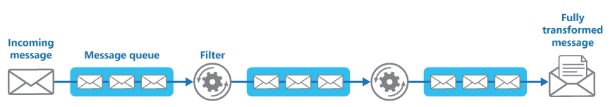

If you're building a solution on Azure you can use Service Bus queues to provide a reliable and scalable queuing mechanism. The ServiceBusPipeFilter class shown below in C# demonstrates how you can implement a filter that receives input messages from a queue, processes these messages, and posts the results to another queue.

The ServiceBusPipeFilter class is defined in the PipesAndFilters.Shared project available from [GitHub](https://github.com/mspnp/cloud-design-patterns/tree/master/pipes-and-filters).

C#Copy

public class ServiceBusPipeFilter

{

...

private readonly string inQueuePath;

private readonly string outQueuePath;

...

private QueueClient inQueue;

private QueueClient outQueue;

...

public ServiceBusPipeFilter(..., string inQueuePath, string outQueuePath = null)

{

...

this.inQueuePath = inQueuePath;

this.outQueuePath = outQueuePath;

}

public void Start()

{

...

// Create the outbound filter queue if it doesn't exist.

...

this.outQueue = QueueClient.CreateFromConnectionString(...);

...

// Create the inbound and outbound queue clients.

this.inQueue = QueueClient.CreateFromConnectionString(...);

}

public void OnPipeFilterMessageAsync(

Func<BrokeredMessage, Task<BrokeredMessage>> asyncFilterTask, ...)

{

...

this.inQueue.OnMessageAsync(

async (msg) =>

{

...

// Process the filter and send the output to the

// next queue in the pipeline.

var outMessage = await asyncFilterTask(msg);

// Send the message from the filter processor

// to the next queue in the pipeline.

if (outQueue != null)

{

await outQueue.SendAsync(outMessage);

}

// Note: There's a chance that the same message could be sent twice

// or that a message gets processed by an upstream or downstream

// filter at the same time.

// This would happen in a situation where processing of a message was

// completed, it was sent to the next pipe/queue, and then failed

// to complete when using the PeekLock method.

// Idempotent message processing and concurrency should be considered

// in a real-world implementation.

},

options);

}

public async Task Close(TimeSpan timespan)

{

// Pause the processing threads.

this.pauseProcessingEvent.Reset();

// There's no clean approach for waiting for the threads to complete

// the processing. This example simply stops any new processing, waits

// for the existing thread to complete, then closes the message pump

// and finally returns.

Thread.Sleep(timespan);

this.inQueue.Close();

...

}

...

}

The Start method in the ServiceBusPipeFilter class connects to a pair of input and output queues, and the Close method disconnects from the input queue. The OnPipeFilterMessageAsync method performs the actual processing of messages, the asyncFilterTask parameter to this method specifies the processing to be performed.

The OnPipeFilterMessageAsync method waits for incoming messages on the input queue, runs the code specified by the asyncFilterTask parameter over each message as it arrives, and posts the results to the output queue. The queues themselves are specified by the constructor.

The sample solution implements filters in a set of worker roles. Each worker role can be scaled independently, depending on the complexity of the business processing that it performs or the resources required for processing. Additionally, multiple instances of each worker role can be run in parallel to improve throughput.

The following code shows an Azure worker role named PipeFilterARoleEntry, defined in the PipeFilterA project in the sample solution.

C#Copy

public class PipeFilterARoleEntry : RoleEntryPoint

{

...

private ServiceBusPipeFilter pipeFilterA;

public override bool OnStart()

{

...

this.pipeFilterA = new ServiceBusPipeFilter(

...,

Constants.QueueAPath,

Constants.QueueBPath);

this.pipeFilterA.Start();

...

}

public override void Run()

{

this.pipeFilterA.OnPipeFilterMessageAsync(async (msg) =>

{

// Clone the message and update it.

// Properties set by the broker (Deliver count, enqueue time, ...)

// aren't cloned and must be copied over if required.

var newMsg = msg.Clone();

await Task.Delay(500); // DOING WORK

Trace.TraceInformation("Filter A processed message:{0} at {1}",

msg.MessageId, DateTime.UtcNow);

newMsg.Properties.Add(Constants.FilterAMessageKey, "Complete");

return newMsg;

});

...

}

...

}

This role contains a ServiceBusPipeFilter object. The OnStart method in the role connects to the queues for receiving input messages and posting output messages (the names of the queues are defined in the Constants class). The Run method invokes the OnPipeFilterMessagesAsync method to perform some processing on each message that's received (in this example, the processing is simulated by waiting for a short period of time). When processing is complete, a new message is constructed containing the results (in this case, the input message has a custom property added), and this message is posted to the output queue.

The sample code contains another worker role named PipeFilterBRoleEntry in the PipeFilterB project. This role is similar to PipeFilterARoleEntry except that it performs different processing in the Run method. In the example solution, these two roles are combined to construct a pipeline, the output queue for the PipeFilterARoleEntry role is the input queue for the PipeFilterBRoleEntry role.

The sample solution also provides two additional roles named InitialSenderRoleEntry (in the InitialSender project) and FinalReceiverRoleEntry (in the FinalReceiver project). The InitialSenderRoleEntry role provides the initial message in the pipeline. The OnStart method connects to a single queue and the Run method posts a method to this queue. This queue is the input queue used by the PipeFilterARoleEntry role, so posting a message to it causes the message to be received and processed by the PipeFilterARoleEntry role. The processed message then passes through the PipeFilterBRoleEntry role.

The input queue for the FinalReceiveRoleEntry role is the output queue for the PipeFilterBRoleEntry role. The Run method in the FinalReceiveRoleEntry role, shown below, receives the message and performs some final processing. Then it writes the values of the custom properties added by the filters in the pipeline to the trace output.

public class FinalReceiverRoleEntry : RoleEntryPoint

{

...

// Final queue/pipe in the pipeline to process data from.

private ServiceBusPipeFilter queueFinal;

public override bool OnStart()

{

...

// Set up the queue.

this.queueFinal = new ServiceBusPipeFilter(...,Constants.QueueFinalPath);

this.queueFinal.Start();

...

}

public override void Run()

{

this.queueFinal.OnPipeFilterMessageAsync(

async (msg) =>

{

await Task.Delay(500); // DOING WORK

// The pipeline message was received.

Trace.TraceInformation(

"Pipeline Message Complete - FilterA:{0} FilterB:{1}",

msg.Properties[Constants.FilterAMessageKey],

msg.Properties[Constants.FilterBMessageKey]);

return null;

});

...

}

...

}

### Publisher-Subscriber

Enable an application to announce events to multiple interested consumers asynchronously, without coupling the senders to the receivers.

**Also called**: Pub/sub messaging

**Context and problem**

In cloud-based and distributed applications, components of the system often need to provide information to other components as events happen.

Asynchronous messaging is an effective way to decouple senders from consumers, and avoid blocking the sender to wait for a response. However, using a dedicated message queue for each consumer does not effectively scale to many consumers. Also, some of the consumers might be interested in only a subset of the information. How can the sender announce events to all interested consumers without knowing their identities?

**Solution**

Introduce an asynchronous messaging subsystem that includes the following:

* An input messaging channel used by the sender. The sender packages events into messages, using a known message format, and sends these messages via the input channel. The sender in this pattern is also called the *publisher*.

**Note**

A *message* is a packet of data. An *event* is a message that notifies other components about a change or an action that has taken place.

* One output messaging channel per consumer. The consumers are known as *subscribers*.
* A mechanism for copying each message from the input channel to the output channels for all subscribers interested in that message. This operation is typically handled by an intermediary such as a message broker or event bus.

The following diagram shows the logical components of this pattern:

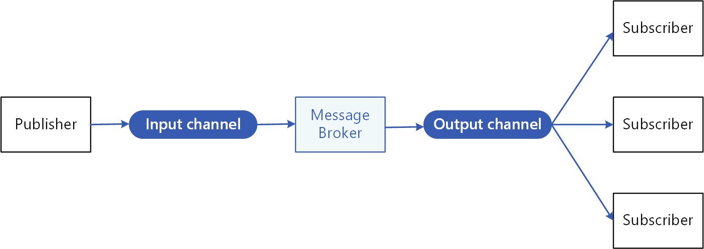

Pub/sub messaging has the following benefits:

* It decouples subsystems that still need to communicate. Subsystems can be managed independently, and messages can be properly managed even if one or more receivers are offline.
* It increases scalability and improves responsiveness of the sender. The sender can quickly send a single message to the input channel, then return to its core processing responsibilities. The messaging infrastructure is responsible for ensuring messages are delivered to interested subscribers.
* It improves reliability. Asynchronous messaging helps applications continue to run smoothly under increased loads and handle intermittent failures more effectively.
* It allows for deferred or scheduled processing. Subscribers can wait to pick up messages until off-peak hours, or messages can be routed or processed according to a specific schedule.
* It enables simpler integration between systems using different platforms, programming languages, or communication protocols, as well as between on-premises systems and applications running in the cloud.
* It facilitates asynchronous workflows across an enterprise.
* It improves testability. Channels can be monitored and messages can be inspected or logged as part of an overall integration test strategy.
* It provides separation of concerns for your applications. Each application can focus on its core capabilities, while the messaging infrastructure handles everything required to reliably route messages to multiple consumers.

**Issues and considerations**

Consider the following points when deciding how to implement this pattern:

* **Existing technologies.** It is strongly recommended to use available messaging products and services that support a publish-subscribe model, rather than building your own. In Azure, consider using [Service Bus](https://docs.microsoft.com/en-us/azure/service-bus-messaging/), [Event Hubs](https://docs.microsoft.com/en-us/azure/event-hubs/) or [Event Grid](https://docs.microsoft.com/en-us/azure/event-grid/). Other technologies that can be used for pub/sub messaging include Redis, RabbitMQ, and Apache Kafka.
* **Subscription handling.** The messaging infrastructure must provide mechanisms that consumers can use to subscribe to or unsubscribe from available channels.
* **Security.** Connecting to any message channel must be restricted by security policy to prevent eavesdropping by unauthorized users or applications.
* **Subsets of messages.** Subscribers are usually only interested in subset of the messages distributed by a publisher. Messaging services often allow subscribers to narrow the set of messages received by:
  + **Topics.** Each topic has a dedicated output channel, and each consumer can subscribe to all relevant topics.
  + **Content filtering.** Messages are inspected and distributed based on the content of each message. Each subscriber can specify the content it is interested in.
* **Wildcard subscribers.** Consider allowing subscribers to subscribe to multiple topics via wildcards.
* **Bi-directional communication.** The channels in a publish-subscribe system are treated as unidirectional. If a specific subscriber needs to send acknowledgment or communicate status back to the publisher, consider using the [Request/Reply Pattern](http://www.enterpriseintegrationpatterns.com/patterns/messaging/RequestReply.html). This pattern uses one channel to send a message to the subscriber, and a separate reply channel for communicating back to the publisher.
* **Message ordering.** The order in which consumer instances receive messages isn't guaranteed, and doesn't necessarily reflect the order in which the messages were created. Design the system to ensure that message processing is idempotent to help eliminate any dependency on the order of message handling.
* **Message priority.** Some solutions may require that messages are processed in a specific order. The [Priority Queue pattern](https://docs.microsoft.com/en-us/azure/architecture/patterns/priority-queue) provides a mechanism for ensuring specific messages are delivered before others.
* **Poison messages.** A malformed message, or a task that requires access to resources that aren't available, can cause a service instance to fail. The system should prevent such messages being returned to the queue. Instead, capture and store the details of these messages elsewhere so that they can be analyzed if necessary.
* **Repeated messages.** The same message might be sent more than once. For example, the sender might fail after posting a message. Then a new instance of the sender might start up and repeat the message. The messaging infrastructure should implement duplicate message detection and removal (also known as de-duping) based on message IDs in order to provide at-most-once delivery of messages.
* **Message expiration.** A message might have a limited lifetime. If it isn't processed within this period, it might no longer be relevant and should be discarded. A sender can specify an expiration time as part of the data in the message. A receiver can examine this information before deciding whether to perform the business logic associated with the message.
* **Message scheduling.** A message might be temporarily embargoed and should not be processed until a specific date and time. The message should not be available to a receiver until this time.

**When to use this pattern**

Use this pattern when:

* An application needs to broadcast information to a significant number of consumers.
* An application needs to communicate with one or more independently-developed applications or services, which may use different platforms, programming languages, and communication protocols.
* An application can send information to consumers without requiring real-time responses from the consumers.
* The systems being integrated are designed to support an eventual consistency model for their data.
* An application needs to communicate information to multiple consumers, which may have different availability requirements or uptime schedules than the sender.

This pattern might not be useful when:

* An application has only a few consumers who need significantly different information from the producing application.
* An application requires near real-time interaction with consumers.

**Example**

The following diagram shows an enterprise integration architecture that uses Service Bus to coordinate workflows, and Event Grid to notify subsystems of events that occur. For more information, see [Enterprise integration on Azure using message queues and events](https://docs.microsoft.com/en-us/azure/architecture/reference-architectures/enterprise-integration/queues-events).

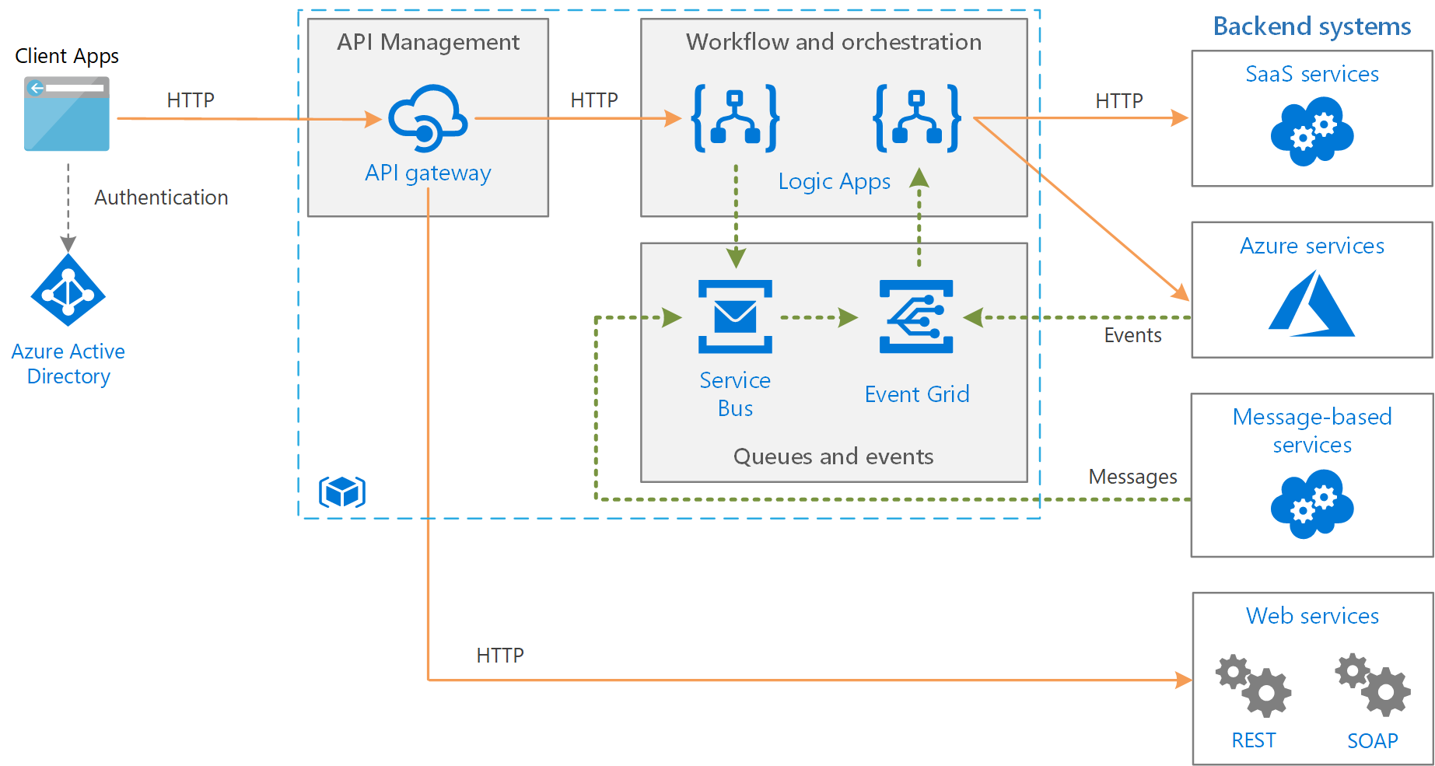

**Queue-Based Load Leveling pattern**

Use a queue that acts as a buffer between a task and a service it invokes in order to smooth intermittent heavy loads that can cause the service to fail or the task to time out. This can help to minimize the impact of peaks in demand on availability and responsiveness for both the task and the service.

**Context and problem**

Many solutions in the cloud involve running tasks that invoke services. In this environment, if a service is subjected to intermittent heavy loads, it can cause performance or reliability issues.

A service could be part of the same solution as the tasks that use it, or it could be a third-party service providing access to frequently used resources such as a cache or a storage service. If the same service is used by a number of tasks running concurrently, it can be difficult to predict the volume of requests to the service at any time.

A service might experience peaks in demand that cause it to overload and be unable to respond to requests in a timely manner. Flooding a service with a large number of concurrent requests can also result in the service failing if it's unable to handle the contention these requests cause.

**Solution**

Refactor the solution and introduce a queue between the task and the service. The task and the service run asynchronously. The task posts a message containing the data required by the service to a queue. The queue acts as a buffer, storing the message until it's retrieved by the service. The service retrieves the messages from the queue and processes them. Requests from a number of tasks, which can be generated at a highly variable rate, can be passed to the service through the same message queue. This figure shows using a queue to level the load on a service.

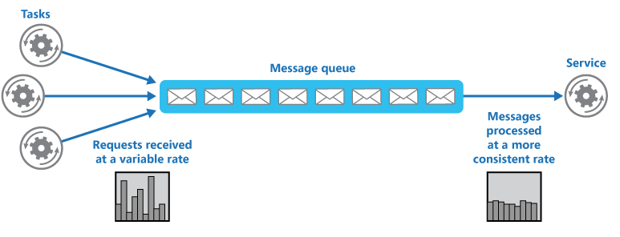

The queue decouples the tasks from the service, and the service can handle the messages at its own pace regardless of the volume of requests from concurrent tasks. Additionally, there's no delay to a task if the service isn't available at the time it posts a message to the queue.

This pattern provides the following benefits:

* It can help to maximize availability because delays arising in services won't have an immediate and direct impact on the application, which can continue to post messages to the queue even when the service isn't available or isn't currently processing messages.
* It can help to maximize scalability because both the number of queues and the number of services can be varied to meet demand.
* It can help to control costs because the number of service instances deployed only have to be adequate to meet average load rather than the peak load.

Some services implement throttling when demand reaches a threshold beyond which the system could fail. Throttling can reduce the functionality available. You can implement load leveling with these services to ensure that this threshold isn't reached.

**Issues and considerations**

Consider the following points when deciding how to implement this pattern:

* It's necessary to implement application logic that controls the rate at which services handle messages to avoid overwhelming the target resource. Avoid passing spikes in demand to the next stage of the system. Test the system under load to ensure that it provides the required leveling, and adjust the number of queues and the number of service instances that handle messages to achieve this.
* Message queues are a one-way communication mechanism. If a task expects a reply from a service, it might be necessary to implement a mechanism that the service can use to send a response. For more information, see the [Asynchronous Messaging Primer](https://docs.microsoft.com/en-us/previous-versions/msp-n-p/dn589781(v=pandp.10)).
* Be careful if you apply autoscaling to services that are listening for requests on the queue. This can result in increased contention for any resources that these services share and diminish the effectiveness of using the queue to level the load.

**When to use this pattern**

This pattern is useful to any application that uses services that are subject to overloading.

This pattern isn't useful if the application expects a response from the service with minimal latency.

**Example**

A web app writes data to an external data store. If a large number of instances of the web app run concurrently, the data store might be unable to respond to requests quickly enough, causing requests to time out, be throttled, or otherwise fail. The following diagram shows a data store being overwhelmed by a large number of concurrent requests from instances of an application.

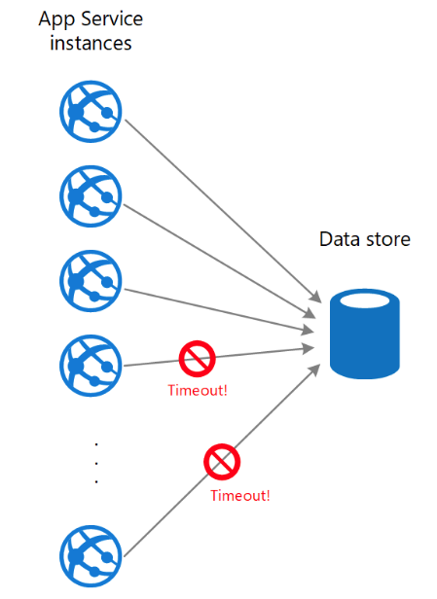

To resolve this, you can use a queue to level the load between the application instances and the data store. An Azure Functions app reads the messages from the queue and performs the read/write requests to the data store. The application logic in the function app can control the rate at which it passes requests to the data store, to prevent the store from being overwhelmed. (Otherwise the function app will just re-introduce the same problem at the back end.)

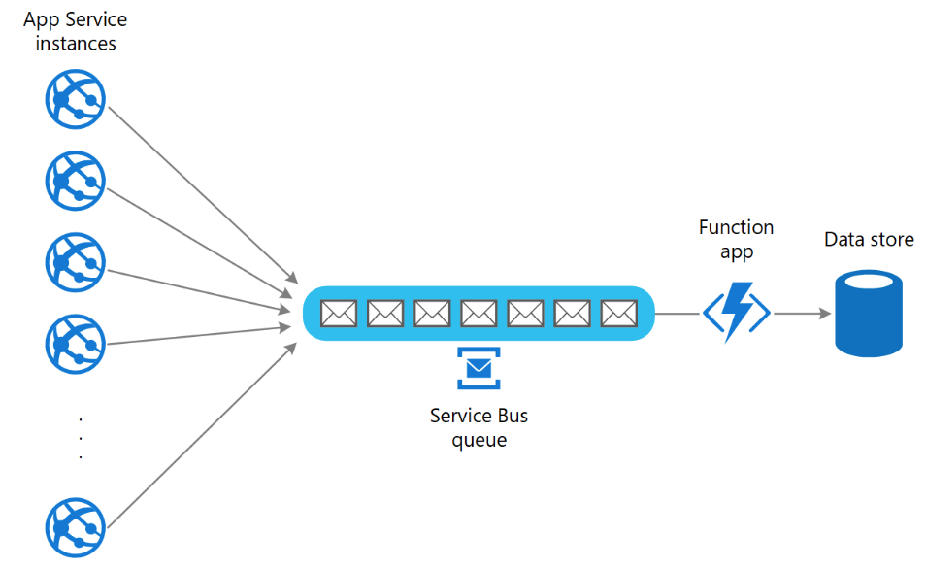

### Bulkhead pattern

The Bulkhead pattern is a type of application design that is tolerant of failure. In a bulkhead architecture, elements of an application are isolated into pools so that if one fails, the others will continue to function. It's named after the sectioned partitions (bulkheads) of a ship's hull. If the hull of a ship is compromised, only the damaged section fills with water, which prevents the ship from sinking.

**Context and problem**

A cloud-based application may include multiple services, with each service having one or more consumers. Excessive load or failure in a service will impact all consumers of the service.

Moreover, a consumer may send requests to multiple services simultaneously, using resources for each request. When the consumer sends a request to a service that is misconfigured or not responding, the resources used by the client's request may not be freed in a timely manner. As requests to the service continue, those resources may be exhausted. For example, the client's connection pool may be exhausted. At that point, requests by the consumer to other services are affected. Eventually the consumer can no longer send requests to other services, not just the original unresponsive service.

The same issue of resource exhaustion affects services with multiple consumers. A large number of requests originating from one client may exhaust available resources in the service. Other consumers are no longer able to consume the service, causing a cascading failure effect.

**Solution**

Partition service instances into different groups, based on consumer load and availability requirements. This design helps to isolate failures, and allows you to sustain service functionality for some consumers, even during a failure.

A consumer can also partition resources, to ensure that resources used to call one service don't affect the resources used to call another service. For example, a consumer that calls multiple services may be assigned a connection pool for each service. If a service begins to fail, it only affects the connection pool assigned for that service, allowing the consumer to continue using the other services.

The benefits of this pattern include:

* Isolates consumers and services from cascading failures. An issue affecting a consumer or service can be isolated within its own bulkhead, preventing the entire solution from failing.
* Allows you to preserve some functionality in the event of a service failure. Other services and features of the application will continue to work.
* Allows you to deploy services that offer a different quality of service for consuming applications. A high-priority consumer pool can be configured to use high-priority services.

The following diagram shows bulkheads structured around connection pools that call individual services. If Service A fails or causes some other issue, the connection pool is isolated, so only workloads using the thread pool assigned to Service A are affected. Workloads that use Service B and C are not affected and can continue working without interruption.

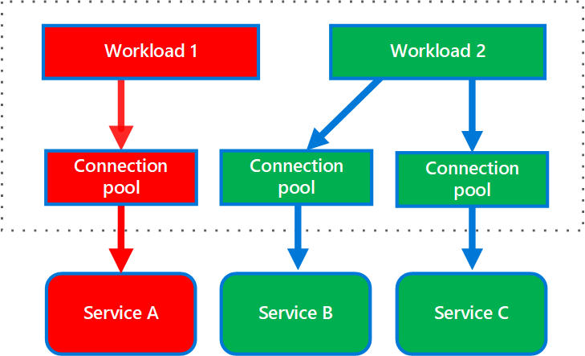

The next diagram shows multiple clients calling a single service. Each client is assigned a separate service instance. Client 1 has made too many requests and overwhelmed its instance. Because each service instance is isolated from the others, the other clients can continue making calls.

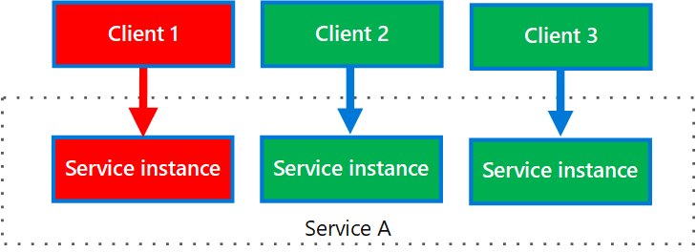

**Issues and considerations**

* Define partitions around the business and technical requirements of the application.
* When partitioning services or consumers into bulkheads, consider the level of isolation offered by the technology as well as the overhead in terms of cost, performance and manageability.
* Consider combining bulkheads with retry, circuit breaker, and throttling patterns to provide more sophisticated fault handling.
* When partitioning consumers into bulkheads, consider using processes, thread pools, and semaphores. Projects like [resilience4j](https://github.com/resilience4j/resilience4j) and [Polly](https://github.com/App-vNext/Polly) offer a framework for creating consumer bulkheads.
* When partitioning services into bulkheads, consider deploying them into separate virtual machines, containers, or processes. Containers offer a good balance of resource isolation with fairly low overhead.
* Services that communicate using asynchronous messages can be isolated through different sets of queues. Each queue can have a dedicated set of instances processing messages on the queue, or a single group of instances using an algorithm to dequeue and dispatch processing.
* Determine the level of granularity for the bulkheads. For example, if you want to distribute tenants across partitions, you could place each tenant into a separate partition, or put several tenants into one partition.
* Monitor each partition’s performance and SLA.

**When to use this pattern**

Use this pattern to:

* Isolate resources used to consume a set of backend services, especially if the application can provide some level of functionality even when one of the services is not responding.
* Isolate critical consumers from standard consumers.
* Protect the application from cascading failures.

This pattern may not be suitable when:

* Less efficient use of resources may not be acceptable in the project.
* The added complexity is not necessary

**Example**

The following Kubernetes configuration file creates an isolated container to run a single service, with its own CPU and memory resources and limits.

Yml

apiVersion: v1

kind: Pod

metadata:

name: drone-management

spec:

containers:

- name: drone-management-container

image: drone-service

resources:

requests:

memory: "64Mi"

cpu: "250m"

limits:

memory: "128Mi"

cpu: "1"

### Scheduler Agent Supervisor

Coordinate a set of distributed actions as a single operation. If any of the actions fail, try to handle the failures transparently, or else undo the work that was performed, so the entire operation succeeds or fails as a whole. This can add resiliency to a distributed system, by enabling it to recover and retry actions that fail due to transient exceptions, long-lasting faults, and process failures.

**Context and problem**

An application performs tasks that include a number of steps, some of which might invoke remote services or access remote resources. The individual steps might be independent of each other, but they are orchestrated by the application logic that implements the task.

Whenever possible, the application should ensure that the task runs to completion and resolve any failures that might occur when accessing remote services or resources. Failures can occur for many reasons. For example, the network might be down, communications could be interrupted, a remote service might be unresponsive or in an unstable state, or a remote resource might be temporarily inaccessible, perhaps due to resource constraints. In many cases the failures will be transient and can be handled by using the [Retry pattern](https://docs.microsoft.com/en-us/azure/architecture/patterns/retry).

If the application detects a more permanent fault it can't easily recover from, it must be able to restore the system to a consistent state and ensure integrity of the entire operation.

**Solution**

The Scheduler Agent Supervisor pattern defines the following actors. These actors orchestrate the steps to be performed as part of the overall task.

* The **Scheduler** arranges for the steps that make up the task to be executed and orchestrates their operation. These steps can be combined into a pipeline or workflow. The Scheduler is responsible for ensuring that the steps in this workflow are performed in the right order. As each step is performed, the Scheduler records the state of the workflow, such as "step not yet started," "step running," or "step completed." The state information should also include an upper limit of the time allowed for the step to finish, called the complete-by time. If a step requires access to a remote service or resource, the Scheduler invokes the appropriate Agent, passing it the details of the work to be performed. The Scheduler typically communicates with an Agent using asynchronous request/response messaging. This can be implemented using queues, although other distributed messaging technologies could be used instead.

The Scheduler performs a similar function to the Process Manager in the [Process Manager pattern](https://www.enterpriseintegrationpatterns.com/patterns/messaging/ProcessManager.html). The actual workflow is typically defined and implemented by a workflow engine that's controlled by the Scheduler. This approach decouples the business logic in the workflow from the Scheduler.

* The **Agent** contains logic that encapsulates a call to a remote service, or access to a remote resource referenced by a step in a task. Each Agent typically wraps calls to a single service or resource, implementing the appropriate error handling and retry logic (subject to a timeout constraint, described later). If the steps in the workflow being run by the Scheduler use several services and resources across different steps, each step might reference a different Agent (this is an implementation detail of the pattern).
* The **Supervisor** monitors the status of the steps in the task being performed by the Scheduler. It runs periodically (the frequency will be system-specific), and examines the status of steps maintained by the Scheduler. If it detects any that have timed out or failed, it arranges for the appropriate Agent to recover the step or execute the appropriate remedial action (this might involve modifying the status of a step). Note that the recovery or remedial actions are implemented by the Scheduler and Agents. The Supervisor should simply request that these actions be performed.

The Scheduler, Agent, and Supervisor are logical components and their physical implementation depends on the technology being used. For example, several logical agents might be implemented as part of a single web service.

The Scheduler maintains information about the progress of the task and the state of each step in a durable data store, called the state store. The Supervisor can use this information to help determine whether a step has failed. The figure illustrates the relationship between the Scheduler, the Agents, the Supervisor, and the state store.

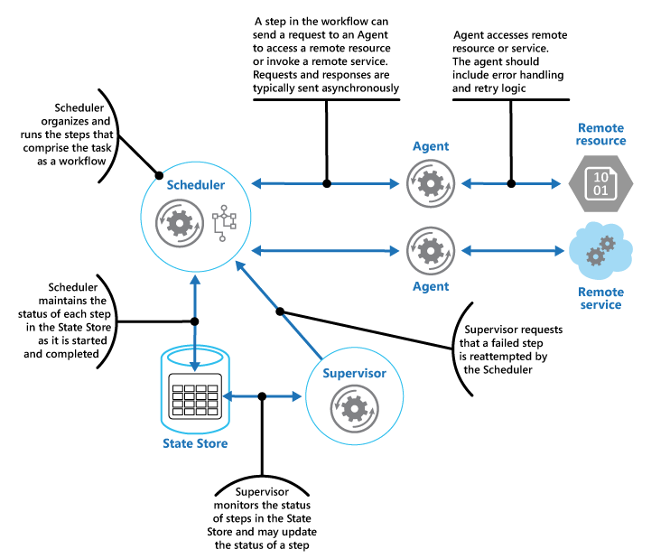

**Note**

This diagram shows a simplified version of the pattern. In a real implementation, there might be many instances of the Scheduler running concurrently, each a subset of tasks. Similarly, the system could run multiple instances of each Agent, or even multiple Supervisors. In this case, Supervisors must coordinate their work with each other carefully to ensure that they don’t compete to recover the same failed steps and tasks. The [**Leader Election pattern**](https://docs.microsoft.com/en-us/azure/architecture/patterns/leader-election) provides one possible solution to this problem.

When the application is ready to run a task, it submits a request to the Scheduler. The Scheduler records initial state information about the task and its steps (for example, step not yet started) in the state store and then starts performing the operations defined by the workflow. As the Scheduler starts each step, it updates the information about the state of that step in the state store (for example, step running).

If a step references a remote service or resource, the Scheduler sends a message to the appropriate Agent. The message contains the information that the Agent needs to pass to the service or access the resource, in addition to the complete-by time for the operation. If the Agent completes its operation successfully, it returns a response to the Scheduler. The Scheduler can then update the state information in the state store (for example, step completed) and perform the next step. This process continues until the entire task is complete.

An Agent can implement any retry logic that's necessary to perform its work. However, if the Agent doesn't complete its work before the complete-by period expires, the Scheduler will assume that the operation has failed. In this case, the Agent should stop its work and not try to return anything to the Scheduler (not even an error message), or try any form of recovery. The reason for this restriction is that, after a step has timed out or failed, another instance of the Agent might be scheduled to run the failing step (this process is described later).

If the Agent fails, the Scheduler won't receive a response. The pattern doesn't make a distinction between a step that has timed out and one that has genuinely failed.

If a step times out or fails, the state store will contain a record that indicates that the step is running, but the complete-by time will have passed. The Supervisor looks for steps like this and tries to recover them. One possible strategy is for the Supervisor to update the complete-by value to extend the time available to complete the step, and then send a message to the Scheduler identifying the step that has timed out. The Scheduler can then try to repeat this step. However, this design requires the tasks to be idempotent.

The Supervisor might need to prevent the same step from being retried if it continually fails or times out. To do this, the Supervisor could maintain a retry count for each step, along with the state information, in the state store. If this count exceeds a predefined threshold the Supervisor can adopt a strategy of waiting for an extended period before notifying the Scheduler that it should retry the step, in the expectation that the fault will be resolved during this period. Alternatively, the Supervisor can send a message to the Scheduler to request the entire task be undone by implementing a [Compensating Transaction pattern](https://docs.microsoft.com/en-us/azure/architecture/patterns/compensating-transaction). This approach will depend on the Scheduler and Agents providing the information necessary to implement the compensating operations for each step that completed successfully.

It isn't the purpose of the Supervisor to monitor the Scheduler and Agents, and restart them if they fail. This aspect of the system should be handled by the infrastructure these components are running in. Similarly, the Supervisor shouldn't have knowledge of the actual business operations that the tasks being performed by the Scheduler are running (including how to compensate should these tasks fail). This is the purpose of the workflow logic implemented by the Scheduler. The sole responsibility of the Supervisor is to determine whether a step has failed and arrange either for it to be repeated or for the entire task containing the failed step to be undone.

If the Scheduler is restarted after a failure, or the workflow being performed by the Scheduler terminates unexpectedly, the Scheduler should be able to determine the status of any inflight task that it was handling when it failed, and be prepared to resume this task from that point. The implementation details of this process are likely to be system-specific. If the task can't be recovered, it might be necessary to undo the work already performed by the task. This might also require implementing a [compensating transaction](https://docs.microsoft.com/en-us/azure/architecture/patterns/compensating-transaction).

The key advantage of this pattern is that the system is resilient in the event of unexpected temporary or unrecoverable failures. The system can be constructed to be self-healing. For example, if an Agent or the Scheduler fails, a new one can be started and the Supervisor can arrange for a task to be resumed. If the Supervisor fails, another instance can be started and can take over from where the failure occurred. If the Supervisor is scheduled to run periodically, a new instance can be automatically started after a predefined interval. The state store can be replicated to reach an even greater degree of resiliency.

**Issues and considerations**

You should consider the following points when deciding how to implement this pattern:

* This pattern can be difficult to implement and requires thorough testing of each possible failure mode of the system.
* The recovery/retry logic implemented by the Scheduler is complex and dependent on state information held in the state store. It might also be necessary to record the information required to implement a compensating transaction in a durable data store.
* How often the Supervisor runs will be important. It should run often enough to prevent any failed steps from blocking an application for an extended period, but it shouldn't run so often that it becomes an overhead.
* The steps performed by an Agent could be run more than once. The logic that implements these steps should be idempotent.

**When to use this pattern**

Use this pattern when a process that runs in a distributed environment, such as the cloud, must be resilient to communications failure and/or operational failure.

This pattern might not be suitable for tasks that don't invoke remote services or access remote resources.

**Example**

A web application that implements an ecommerce system has been deployed on Microsoft Azure. Users can run this application to browse the available products and to place orders. The user interface runs as a web role, and the order processing elements of the application are implemented as a set of worker roles. Part of the order processing logic involves accessing a remote service, and this aspect of the system could be prone to transient or more long-lasting faults. For this reason, the designers used the Scheduler Agent Supervisor pattern to implement the order processing elements of the system.

When a customer places an order, the application constructs a message that describes the order and posts this message to a queue. A separate submission process, running in a worker role, retrieves the message, inserts the order details into the orders database, and creates a record for the order process in the state store. Note that the inserts into the orders database and the state store are performed as part of the same operation. The submission process is designed to ensure that both inserts complete together.

The state information that the submission process creates for the order includes:

* **OrderID**. The ID of the order in the orders database.
* **LockedBy**. The instance ID of the worker role handling the order. There might be multiple current instances of the worker role running the Scheduler, but each order should only be handled by a single instance.
* **CompleteBy**. The time the order should be processed by.
* **ProcessState**. The current state of the task handling the order. The possible states are:
  + **Pending**. The order has been created but processing hasn't yet been started.
  + **Processing**. The order is currently being processed.
  + **Processed**. The order has been processed successfully.
  + **Error**. The order processing has failed.
* **FailureCount**. The number of times that processing has been tried for the order.

In this state information, the OrderID field is copied from the order ID of the new order. The LockedBy and CompleteBy fields are set to null, the ProcessState field is set to Pending, and the FailureCount field is set to 0.

**Note**

In this example, the order handling logic is relatively simple and only has a single step that invokes a remote service. In a more complex multistep scenario, the submission process would likely involve several steps, and so several records would be created in the state store — each one describing the state of an individual step.

The Scheduler also runs as part of a worker role and implements the business logic that handles the order. An instance of the Scheduler polling for new orders examines the state store for records where the LockedBy field is null and the ProcessState field is pending. When the Scheduler finds a new order, it immediately populates the LockedBy field with its own instance ID, sets the CompleteBy field to an appropriate time, and sets the ProcessState field to processing. The code is designed to be exclusive and atomic to ensure that two concurrent instances of the Scheduler can't try to handle the same order simultaneously.

The Scheduler then runs the business workflow to process the order asynchronously, passing it the value in the OrderID field from the state store. The workflow handling the order retrieves the details of the order from the orders database and performs its work. When a step in the order processing workflow needs to invoke the remote service, it uses an Agent. The workflow step communicates with the Agent using a pair of Azure Service Bus message queues acting as a request/response channel. The figure shows a high-level view of the solution.

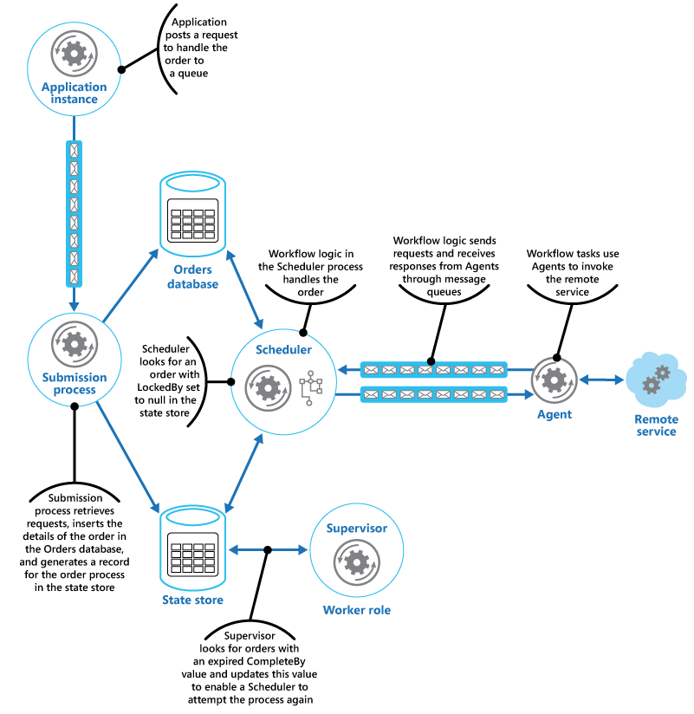

The message sent to the Agent from a workflow step describes the order and includes the complete-by time. If the Agent receives a response from the remote service before the complete-by time expires, it posts a reply message on the Service Bus queue on which the workflow is listening. When the workflow step receives the valid reply message, it completes its processing and the Scheduler sets the ProcessState field of the order state to processed. At this point, the order processing has completed successfully.

If the complete-by time expires before the Agent receives a response from the remote service, the Agent simply halts its processing and terminates handling the order. Similarly, if the workflow handling the order exceeds the complete-by time, it also terminates. In both cases, the state of the order in the state store remains set to processing, but the complete-by time indicates that the time for processing the order has passed and the process is deemed to have failed. Note that if the Agent that's accessing the remote service, or the workflow that's handling the order (or both) terminate unexpectedly, the information in the state store will again remain set to processing and eventually will have an expired complete-by value.

If the Agent detects an unrecoverable, nontransient fault while it's trying to contact the remote service, it can send an error response back to the workflow. The Scheduler can set the status of the order to error and raise an event that alerts an operator. The operator can then try to resolve the reason for the failure manually and resubmit the failed processing step.

The Supervisor periodically examines the state store looking for orders with an expired complete-by value. If the Supervisor finds a record, it increments the FailureCount field. If the failure count value is below a specified threshold value, the Supervisor resets the LockedBy field to null, updates the CompleteBy field with a new expiration time, and sets the ProcessState field to pending. An instance of the Scheduler can pick up this order and perform its processing as before. If the failure count value exceeds a specified threshold, the reason for the failure is assumed to be nontransient. The Supervisor sets the status of the order to error and raises an event that alerts an operator.

In this example, the Supervisor is implemented in a separate worker role. You can use a variety of strategies to arrange for the Supervisor task to be run, including using the Azure Scheduler service (not to be confused with the Scheduler component in this pattern). For more information about the Azure Scheduler service, visit the [Scheduler](https://azure.microsoft.com/services/scheduler/) page.

Although it isn't shown in this example, the Scheduler might need to keep the application that submitted the order informed about the progress and status of the order. The application and the Scheduler are isolated from each other to eliminate any dependencies between them. The application has no knowledge of which instance of the Scheduler is handling the order, and the Scheduler is unaware of which specific application instance posted the order.

To allow the order status to be reported, the application could use its own private response queue. The details of this response queue would be included as part of the request sent to the submission process, which would include this information in the state store. The Scheduler would then post messages to this queue indicating the status of the order (request received, order completed, order failed, and so on). It should include the order ID in these messages so they can be correlated with the original request by the application.

### Sequential Convoy

Process a set of related messages in a defined order, without blocking processing of other groups of messages.

**Context and problem**

Applications often need to process a sequence of messages in the order they arrive, while still being able to scale out to handle increased load. In a distributed architecture, processing these messages in order is not straightforward, because the workers can scale independently and often pull messages independently, using a [Competing Consumers pattern](https://docs.microsoft.com/en-us/azure/architecture/patterns/competing-consumers).

For example, an order tracking system receives a ledger containing orders and the relevant operations on those orders.

These operations could be to create an order, add a transaction to the order, modify a past transaction, or delete an order. In this system, operations must be performed in a first-in-first-out (FIFO) manner, but only at the order level. However, the initial queue receives a ledger containing transactions for many orders, which may be interleaved.

**Solution**

Push related messages into categories within the queuing system, and have the queue listeners lock and pull only from one category, one message at a time.

Here's what the general Sequential Convoy pattern looks like:

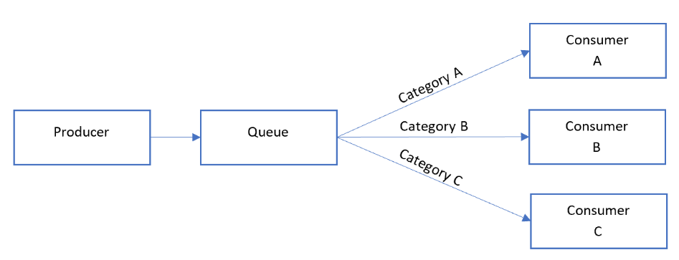

In the queue, messages for different categories may be interleaved, as shown in the following diagram:

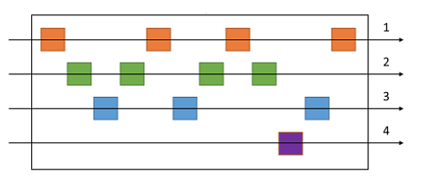

**Issues and considerations**

Consider the following points when deciding how to implement this pattern:

* Category/scale unit. What property of your incoming messages can you scale out on? In the order tracking scenario, this property is the order ID.
* Throughput. What is your target message throughput? If it is very high, you may need to reconsider your FIFO requirements. For example, can you enforce a start/end message, sort by time, then send a batch for processing?
* Service capabilities. Does your choice of message bus allow for one-at-a-time processing of messages within a queue or category of a queue?
* Evolvability. How will you add a new category of message to the system? For example, suppose the ledger system described above is specific one customer. If you needed to onboard a new customer, could you have a set of ledger processors that distribute work per customer ID?
* It's possible that consumers might receive a message out of order, due to variable network latency when sending messages. Consider using sequence numbers to verify ordering. You might also include a special "end of sequence" flag in the last message of a transaction. Stream processing technologies such as Spark or Azure Stream Analytics can process messages in order within a time window.

**When to use this pattern**

Use this pattern when:

* You have messages that arrive in order and must be processed in the same order.
* Arriving messages are or can be "categorized" in such a way that the category becomes a unit of scale for the system.

This pattern might not be suitable for:

* Extremely high throughput scenarios (millions of messages/minute or second), as the FIFO requirement limits the scaling that can be done by the system.

**Example**

On Azure, this pattern can be implemented using Azure Service Bus [message sessions](https://docs.microsoft.com/en-us/azure/service-bus-messaging/message-sessions). For the consumers, you can use either Logic Apps with the [Service Bus peek-lock connector](https://docs.microsoft.com/en-us/azure/connectors/connectors-create-api-servicebus) or Azure Functions with the [Service Bus trigger](https://docs.microsoft.com/en-us/azure/azure-functions/functions-bindings-service-bus).

For the previous order-tracking example, process each ledger message in the order it's received, and send each transaction to another queue where the category is set to the order ID. A transaction will never span multiple orders in this scenario, so consumers process each category in parallel but FIFO within the category.

The ledge processor fan outs the messages by de-batching the content of each message in the first queue:

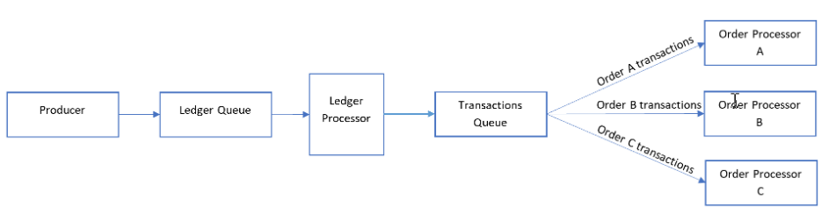

The ledger processor takes care of:

1. Walking the ledger one transaction at a time.
2. Setting the session ID of the message to match the order ID.
3. Sending each ledger transaction to a secondary queue with the session ID set to the order ID.

The consumers listen to the secondary queue where they process all messages with matching order IDs *in order* from the queue. Consumers use [peek-lock](https://docs.microsoft.com/en-us/azure/service-bus-messaging/message-transfers-locks-settlement#peeklock) mode.

When considering scalability, the ledger queue is a primary bottleneck. Different transactions posted to the ledger could reference the same order ID. However, messages can fan out *after* the ledger to the number of orders in a serverless environment.

### Gatekeeper

Protect applications and services by using a dedicated host instance that acts as a broker between clients and the application or service, validates and sanitizes requests, and passes requests and data between them. This can provide an additional layer of security, and limit the attack surface of the system.

**Context and problem**

Applications expose their functionality to clients by accepting and processing requests. In cloud-hosted scenarios, applications expose endpoints clients connect to, and typically include the code to handle the requests from clients. This code performs authentication and validation, some or all request processing, and is likely to accesses storage and other services on behalf of the client.

If a malicious user is able to compromise the system and gain access to the application’s hosting environment, the security mechanisms it uses such as credentials and storage keys, and the services and data it accesses, are exposed. As a result, the malicious user can gain unrestrained access to sensitive information and other services.

**Solution**

To minimize the risk of clients gaining access to sensitive information and services, decouple hosts or tasks that expose public endpoints from the code that processes requests and accesses storage. You can achieve this by using a façade or a dedicated task that interacts with clients and then hands off the request—perhaps through a decoupled interface—to the hosts or tasks that'll handle the request. The figure provides a high-level overview of this pattern.

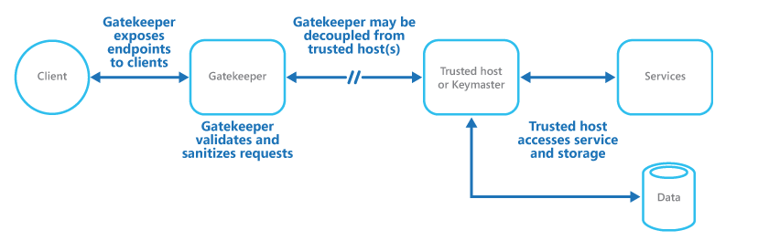

The gatekeeper pattern can be used to simply protect storage, or it can be used as a more comprehensive façade to protect all of the functions of the application. The important factors are:

* **Controlled validation**. The gatekeeper validates all requests, and rejects those that don't meet validation requirements.
* **Limited risk and exposure**. The gatekeeper doesn't have access to the credentials or keys used by the trusted host to access storage and services. If the gatekeeper is compromised, the attacker doesn't get access to these credentials or keys.
* **Appropriate security**. The gatekeeper runs in a limited privilege mode, while the rest of the application runs in the full trust mode required to access storage and services. If the gatekeeper is compromised, it can't directly access the application services or data.

This pattern acts like a firewall in a typical network topography. It allows the gatekeeper to examine requests and make a decision about whether to pass the request on to the trusted host that performs the required tasks. This decision typically requires the gatekeeper to validate and sanitize the request content before passing it on to the trusted host.

**Issues and considerations**

Consider the following points when deciding how to implement this pattern:

* Ensure that the trusted hosts the gatekeeper passes requests to expose only internal or protected endpoints, and connect only to the gatekeeper. The trusted hosts shouldn't expose any external endpoints or interfaces.
* The gatekeeper must run in a limited privilege mode. Typically this means running the gatekeeper and the trusted host in separate hosted services or virtual machines.
* The gatekeeper shouldn't perform any processing related to the application or services, or access any data. Its function is purely to validate and sanitize requests. The trusted hosts might need to perform additional validation of requests, but the core validation should be performed by the gatekeeper.
* Use a secure communication channel (HTTPS, SSL, or TLS) between the gatekeeper and the trusted hosts or tasks where this is possible. However, some hosting environments don't support HTTPS on internal endpoints.
* Adding the extra layer to the application to implement the gatekeeper pattern is likely to have some impact on performance due to the additional processing and network communication it requires.
* The gatekeeper instance could be a single point of failure. To minimize the impact of a failure, consider deploying additional instances and using an autoscaling mechanism to ensure capacity to maintain availability.

**When to use this pattern**

This pattern is useful for:

* Applications that handle sensitive information, expose services that must have a high degree of protection from malicious attacks, or perform mission-critical operations that shouldn't be disrupted.
* Distributed applications where it's necessary to perform request validation separately from the main tasks, or to centralize this validation to simplify maintenance and administration.

**Example**

In a cloud-hosted scenario, this pattern can be implemented by decoupling the gatekeeper role or virtual machine from the trusted roles and services in an application. Do this by using an internal endpoint, a queue, or storage as an intermediate communication mechanism. The figure illustrates using an internal endpoint.

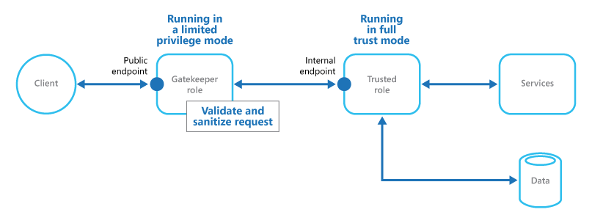

**Gateway Aggregation pattern**

Use a gateway to aggregate multiple individual requests into a single request. This pattern is useful when a client must make multiple calls to different backend systems to perform an operation.

**Context and problem**

To perform a single task, a client may have to make multiple calls to various backend services. An application that relies on many services to perform a task must expend resources on each request. When any new feature or service is added to the application, additional requests are needed, further increasing resource requirements and network calls. This chattiness between a client and a backend can adversely impact the performance and scale of the application. Microservice architectures have made this problem more common, as applications built around many smaller services naturally have a higher amount of cross-service calls.

In the following diagram, the client sends requests to each service (1,2,3). Each service processes the request and sends the response back to the application (4,5,6). Over a cellular network with typically high latency, using individual requests in this manner is inefficient and could result in broken connectivity or incomplete requests. While each request may be done in parallel, the application must send, wait, and process data for each request, all on separate connections, increasing the chance of failure.

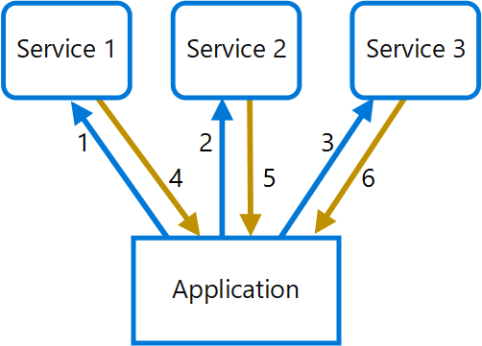

**Solution**

Use a gateway to reduce chattiness between the client and the services. The gateway receives client requests, dispatches requests to the various backend systems, and then aggregates the results and sends them back to the requesting client.

This pattern can reduce the number of requests that the application makes to backend services, and improve application performance over high-latency networks.

In the following diagram, the application sends a request to the gateway (1). The request contains a package of additional requests. The gateway decomposes these and processes each request by sending it to the relevant service (2). Each service returns a response to the gateway (3). The gateway combines the responses from each service and sends the response to the application (4). The application makes a single request and receives only a single response from the gateway.

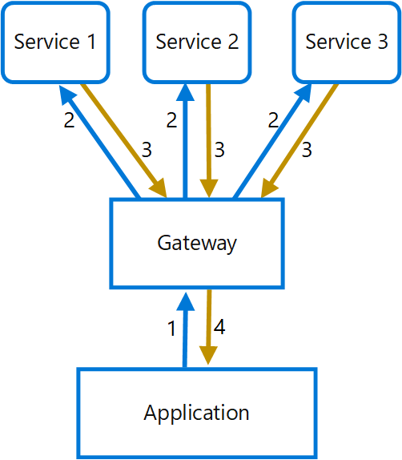

**Issues and considerations**

* The gateway should not introduce service coupling across the backend services.
* The gateway should be located near the backend services to reduce latency as much as possible.
* The gateway service may introduce a single point of failure. Ensure the gateway is properly designed to meet your application's availability requirements.
* The gateway may introduce a bottleneck. Ensure the gateway has adequate performance to handle load and can be scaled to meet your anticipated growth.
* Perform load testing against the gateway to ensure you don't introduce cascading failures for services.
* Implement a resilient design, using techniques such as [bulkheads](https://docs.microsoft.com/en-us/azure/architecture/patterns/bulkhead), [circuit breaking](https://docs.microsoft.com/en-us/azure/architecture/patterns/circuit-breaker), [retry](https://docs.microsoft.com/en-us/azure/architecture/patterns/retry), and timeouts.
* If one or more service calls takes too long, it may be acceptable to timeout and return a partial set of data. Consider how your application will handle this scenario.
* Use asynchronous I/O to ensure that a delay at the backend doesn't cause performance issues in the application.
* Implement distributed tracing using correlation IDs to track each individual call.
* Monitor request metrics and response sizes.
* Consider returning cached data as a failover strategy to handle failures.
* Instead of building aggregation into the gateway, consider placing an aggregation service behind the gateway. Request aggregation will likely have different resource requirements than other services in the gateway and may impact the gateway's routing and offloading functionality.

**When to use this pattern**

Use this pattern when:

* A client needs to communicate with multiple backend services to perform an operation.
* The client may use networks with significant latency, such as cellular networks.

This pattern may not be suitable when:

* You want to reduce the number of calls between a client and a single service across multiple operations. In that scenario, it may be better to add a batch operation to the service.
* The client or application is located near the backend services and latency is not a significant factor.

**Example**

The following example illustrates how to create a simple a gateway aggregation NGINX service using Lua.

worker_processes 4;

events {

worker_connections 1024;

}

http {

server {

listen 80;

location = /batch {

content_by_lua '

ngx.req.read_body()

-- read json body content

local cjson = require "cjson"

local batch = cjson.decode(ngx.req.get_body_data())["batch"]

-- create capture_multi table

local requests = {}

for i, item in ipairs(batch) do

table.insert(requests, {item.relative_url, { method = ngx.HTTP_GET}})

end

-- execute batch requests in parallel

local results = {}

local resps = { ngx.location.capture_multi(requests) }

for i, res in ipairs(resps) do

table.insert(results, {status = res.status, body = cjson.decode(res.body), header = res.header})

end

ngx.say(cjson.encode({results = results}))

';

}

location = /service1 {

default_type application/json;

echo '{"attr1":"val1"}';

}

location = /service2 {

default_type application/json;

echo '{"attr2":"val2"}';

}

}

}

### Gateway Offloading

Offload shared or specialized service functionality to a gateway proxy. This pattern can simplify application development by moving shared service functionality, such as the use of SSL certificates, from other parts of the application into the gateway.

**Context and problem**

Some features are commonly used across multiple services, and these features require configuration, management, and maintenance. A shared or specialized service that is distributed with every application deployment increases the administrative overhead and increases the likelihood of deployment error. Any updates to a shared feature must be deployed across all services that share that feature.

Properly handling security issues (token validation, encryption, SSL certificate management) and other complex tasks can require team members to have highly specialized skills. For example, a certificate needed by an application must be configured and deployed on all application instances. With each new deployment, the certificate must be managed to ensure that it does not expire. Any common certificate that is due to expire must be updated, tested, and verified on every application deployment.

Other common services such as authentication, authorization, logging, monitoring, or [throttling](https://docs.microsoft.com/en-us/azure/architecture/patterns/throttling) can be difficult to implement and manage across a large number of deployments. It may be better to consolidate this type of functionality, in order to reduce overhead and the chance of errors.

**Solution**

Offload some features into a gateway, particularly cross-cutting concerns such as certificate management, authentication, SSL termination, monitoring, protocol translation, or throttling.

The following diagram shows a gateway that terminates inbound SSL connections. It requests data on behalf of the original requestor from any HTTP server upstream of the gateway.

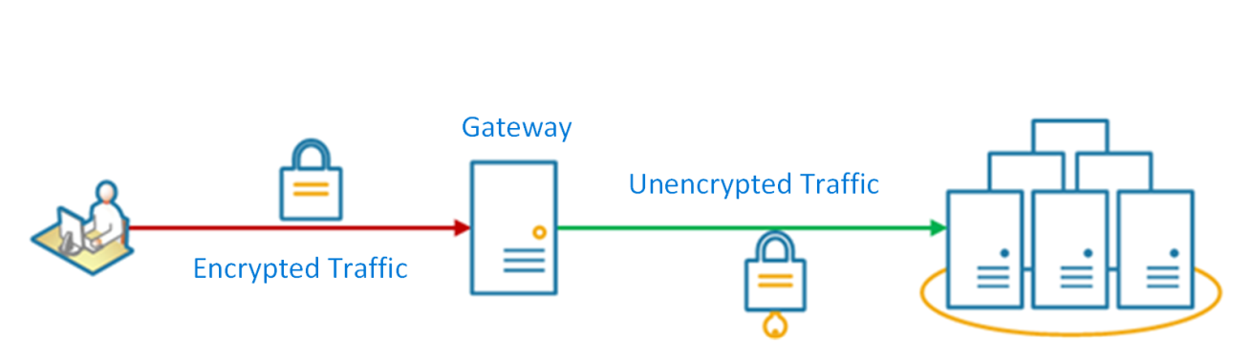

Benefits of this pattern include:

* Simplify the development of services by removing the need to distribute and maintain supporting resources, such as web server certificates and configuration for secure websites. Simpler configuration results in easier management and scalability and makes service upgrades simpler.
* Allow dedicated teams to implement features that require specialized expertise, such as security. This allows your core team to focus on the application functionality, leaving these specialized but cross-cutting concerns to the relevant experts.
* Provide some consistency for request and response logging and monitoring. Even if a service is not correctly instrumented, the gateway can be configured to ensure a minimum level of monitoring and logging.

**Issues and considerations**

* Ensure the gateway is highly available and resilient to failure. Avoid single points of failure by running multiple instances of your gateway.
* Ensure the gateway is designed for the capacity and scaling requirements of your application and endpoints. Make sure the gateway does not become a bottleneck for the application and is sufficiently scalable.
* Only offload features that are used by the entire application, such as security or data transfer.
* Business logic should never be offloaded to the gateway.
* If you need to track transactions, consider generating correlation IDs for logging purposes.

**When to use this pattern**

Use this pattern when:

* An application deployment has a shared concern such as SSL certificates or encryption.
* A feature that is common across application deployments that may have different resource requirements, such as memory resources, storage capacity or network connections.
* You wish to move the responsibility for issues such as network security, throttling, or other network boundary concerns to a more specialized team.

This pattern may not be suitable if it introduces coupling across services.

**Example**

Using Nginx as the SSL offload appliance, the following configuration terminates an inbound SSL connection and distributes the connection to one of three upstream HTTP servers.

upstream iis {

server 10.3.0.10 max_fails=3 fail_timeout=15s;

server 10.3.0.20 max_fails=3 fail_timeout=15s;

server 10.3.0.30 max_fails=3 fail_timeout=15s;

}

server {

listen 443;

ssl on;

ssl_certificate /etc/nginx/ssl/domain.cer;

ssl_certificate_key /etc/nginx/ssl/domain.key;

location / {

set $targ iis;

proxy_pass http://$targ;

proxy_set_header X-Forwarded-For $proxy_add_x_forwarded_for;

proxy_set_header X-Forwarded-Proto https;

proxy_set_header X-Real-IP $remote_addr;

proxy_set_header Host $host;

}

}

### Gateway Routing

Route requests to multiple services using a single endpoint. This pattern is useful when you wish to expose multiple services on a single endpoint and route to the appropriate service based on the request.

**Context and problem**

When a client needs to consume multiple services, setting up a separate endpoint for each service and having the client manage each endpoint can be challenging. For example, an e-commerce application might provide services such as search, reviews, cart, checkout, and order history. Each service has a different API that the client must interact with, and the client must know about each endpoint in order to connect to the services. If an API changes, the client must be updated as well. If you refactor a service into two or more separate services, the code must change in both the service and the client.

**Solution**

Place a gateway in front of a set of applications, services, or deployments. Use application Layer 7 routing to route the request to the appropriate instances.

With this pattern, the client application only needs to know about and communicate with a single endpoint. If a service is consolidated or decomposed, the client does not necessarily require updating. It can continue making requests to the gateway, and only the routing changes.

A gateway also lets you abstract backend services from the clients, allowing you to keep client calls simple while enabling changes in the backend services behind the gateway. Client calls can be routed to whatever service or services need to handle the expected client behavior, allowing you to add, split, and reorganize services behind the gateway without changing the client.

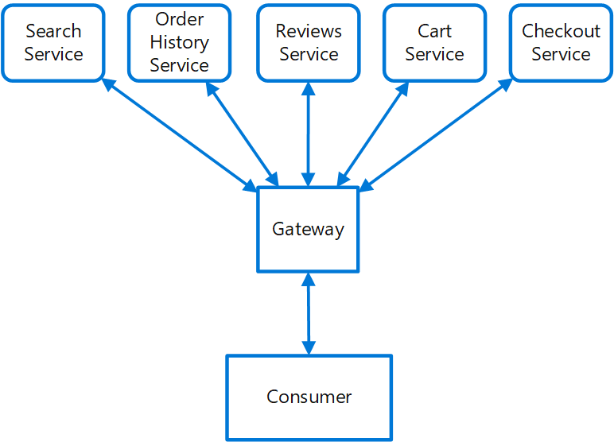

This pattern can also help with deployment, by allowing you to manage how updates are rolled out to users. When a new version of your service is deployed, it can be deployed in parallel with the existing version. Routing lets you control what version of the service is presented to the clients, giving you the flexibility to use various release strategies, whether incremental, parallel, or complete rollouts of updates. Any issues discovered after the new service is deployed can be quickly reverted by making a configuration change at the gateway, without affecting clients.

**Issues and considerations**

* The gateway service may introduce a single point of failure. Ensure it is properly designed to meet your availability requirements. Consider resiliency and fault tolerance capabilities when implementing.
* The gateway service may introduce a bottleneck. Ensure the gateway has adequate performance to handle load and can easily scale in line with your growth expectations.
* Perform load testing against the gateway to ensure you don't introduce cascading failures for services.
* Gateway routing is level 7. It can be based on IP, port, header, or URL.

**When to use this pattern**

Use this pattern when:

* A client needs to consume multiple services that can be accessed behind a gateway.
* You wish to simplify client applications by using a single endpoint.
* You need to route requests from externally addressable endpoints to internal virtual endpoints, such as exposing ports on a VM to cluster virtual IP addresses.

This pattern may not be suitable when you have a simple application that uses only one or two services.

**Example**

Using Nginx as the router, the following is a simple example configuration file for a server that routes requests for applications residing on different virtual directories to different machines at the back end.

server {

listen 80;

server_name domain.com;

location /app1 {

proxy_pass http://10.0.3.10:80;

}

location /app2 {

proxy_pass http://10.0.3.20:80;

}

location /app3 {

proxy_pass http://10.0.3.30:80;

}

}

On Azure, multiple services can be set up behind an [Application Gateway instance](https://docs.microsoft.com/en-us/azure/application-gateway/tutorial-multiple-sites-cli), which provides layer-7 routing.

### Choreography

Have each component of the system participate in the decision-making process about the workflow of a business transaction, instead of relying on a central point of control.

**Context and problem**

In microservices architecture, it’s often the case that a cloud-based application is divided into several small services that work together to process a business transaction end-to-end. To lower coupling between services, each service is responsible for a single business operation. Some benefits include faster development, smaller code base, and scalability. However, designing an efficient and scalable workflow is a challenge and often requires complex interservice communication.

The services communicate with each other by using well-defined APIs. Even a single business operation can result in multiple point-to-point calls among all services. A common pattern for communication is to use a centralized service that acts as the orchestrator. It acknowledges all incoming requests and delegates operations to the respective services. In doing so, it also manages the workflow of the entire business transaction. Each service just completes an operation and is not aware of the overall workflow.

The orchestrator pattern reduces point-to-point communication between services but has some drawbacks because of the tight coupling between the orchestrator and other services that participate in processing of the business transaction. To execute tasks in a sequence, the orchestrator needs to have some domain knowledge about the responsibilities of those services. If you want to add or remove services, existing logic will break, and you'll need to rewire portions of the communication path. While you can configure the workflow, add or remove services easily with a well-designed orchestrator, such an implementation is complex and hard to maintain.

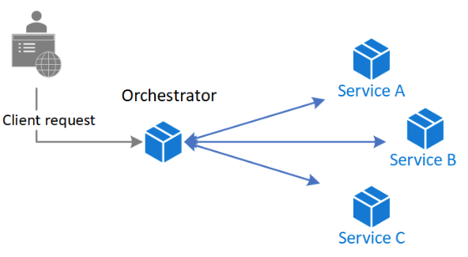

**Solution**

Let each service decide when and how a business operation is processed, instead of depending on a central orchestrator.

One way to implement choreography is to use the [asynchronous messaging pattern](https://docs.microsoft.com/en-us/azure/architecture/patterns/publisher-subscriber) to coordinate the business operations

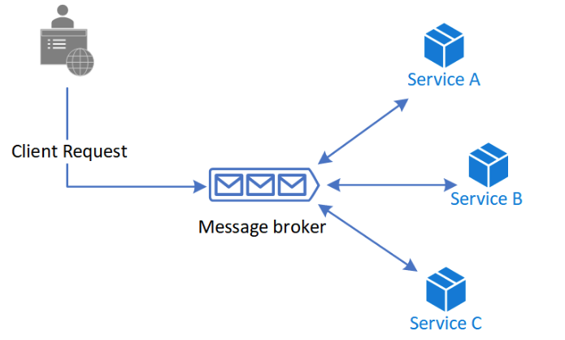

A client request publishes messages to a message queue. As messages arrive, they are pushed to subscribers, or services, interested in that message. Each subscribed service does their operation as indicated by the message and responds to the message queue with success or failure of the operation. In case of success, the service can push a message back to the same queue or a different message queue so that another service can continue the workflow if needed. If an operation fails, the message bus can retry that operation.

This way, the services choreograph the workflow among themselves without depending on an orchestrator or having direct communication between them.

Because there isn't point-to-point communication, this pattern helps reduce coupling between services. Also, it can remove the performance bottleneck caused by the orchestrator when it has to deal with all transactions.

**When to use this pattern**

Use the choreography pattern if you expect to update, remove, or add new services frequently. The entire app can be modified with lesser effort and minimal disruption to existing services.

Consider this pattern if you experience performance bottlenecks in the central orchestrator.

This pattern is a natural model for the serverless architecture where all services can be short lived, or event driven. Services can spin up because of an event, do their task, and are removed when the task is finished.

**Issues and considerations**

Decentralizing the orchestrator can cause issues while managing the workflow.

If a service fails to complete a business operation, it can be difficult to recover from that failure. One way is to have the service indicate failure by firing an event. Another service subscribes to those failed events takes necessary actions such as applying [compensating transactions](https://docs.microsoft.com/en-us/azure/architecture/patterns/compensating-transaction) to undo successful operations in a request. The failed service might also fail to fire an event for the failure. In that case, consider using a retry and, or time out mechanism to recognize that operation as a failure. For an example, see the Example section.

It's simple to implement a workflow when you want to process independent business operations in parallel. You can use a single message bus. However, the workflow can become complicated when choreography needs to occur in a sequence. For instance, Service C can start its operation only after Service A and Service B have completed their operations with success. One approach is to have multiple message buses that get messages in the required order. For more information, see the [Example](https://docs.microsoft.com/en-us/azure/architecture/patterns/choreography#example) section.

The choreography pattern becomes a challenge if the number of services grow rapidly. Given the high number of independent moving parts, the workflow between services tends to get complex. Also, distributed tracing becomes difficult.

The orchestrator centrally manages the resiliency of the workflow and it can become a single point of failure. On the other hand, for choreography, the role is distributed between all services and resiliency becomes less robust.

Each service isn't only responsible for the resiliency of its operation but also the workflow. This responsibility can be burdensome for the service and hard to implement. Each service must retry transient, nontransient, and time-out failures, so that the request terminates gracefully, if needed. Also, the service must be diligent about communicating the success or failure of the operation so that other services can act accordingly.

**Example**

This example shows the choreography pattern with the [Drone Delivery app](https://github.com/mspnp/microservices-reference-implementation). When a client requests a pickup, the app assigns a drone and notifies the client.

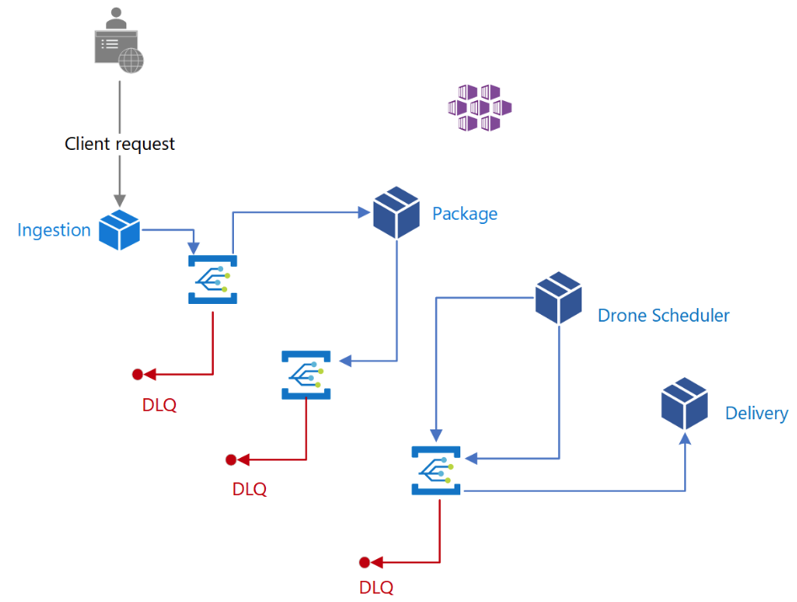

A single client business transaction requires three distinct business operations: creating or updating a package, assigning a drone to deliver the package, and checking the delivery status. Those operations are performed by three microservices: Package, Drone Scheduler, and Delivery services. Instead of a central orchestrator, the services use messaging to collaborate and coordinate the request among themselves.

**Design**

The business transaction is processed in a sequence through multiple hops. Each hop has a message bus and the respective business service.

When a client sends a delivery request through an HTTP endpoint, the Ingestion service receives it, raises an operation event, and sends it to a message bus. The bus invokes the subscribed business service and sends the event in a POST request. On receiving the event, the business service can complete the operation with success, failure, or the request can time out. If successful, the service responds to the bus with the Ok status code, raises a new operation event, and sends it to the message bus of the next hop. In case of a failure or time-out, the service reports failure by sending the BadRequest code to the message bus that sent the original POST request. The message bus retries the operation based on a retry policy. After that period expires, message bus flags the failed operation and further processing of the entire request stops.

This workflow continues until the entire request has been processed.

The design uses multiple message buses to process the entire business transaction. [Microsoft Azure Event Grid](https://docs.microsoft.com/en-us/azure/event-grid/) provides the messaging service. The app is deployed in an [Azure Kubernetes Service (AKS)](https://docs.microsoft.com/en-us/azure/aks/) cluster with [two containers in the same pod](https://kubernetes.io/docs/tasks/access-application-cluster/communicate-containers-same-pod-shared-volume/#creating-a-pod-that-runs-two-containers). One container runs the [ambassador](https://docs.microsoft.com/en-us/azure/architecture/patterns/ambassador) that interacts with Event Grid while the other runs a business service. The approach with two containers in the same pod improves performance and scalability. The ambassador and the business service share the same network allowing for low latency and high throughput.

To avoid cascading retry operations that might lead to multiple efforts, only Event Grid retries an operation instead of the business service. It flags a failed request by sending a messaging to a [dead letter queue (DLQ)](https://docs.microsoft.com/en-us/azure/service-bus-messaging/service-bus-dead-letter-queues).

The business services are idempotent to make sure retry operations don’t result in duplicate resources. For example, the Package service uses upsert operations to add data to the data store.

The example implements a custom solution to correlate calls across all services and Event Grid hops.

### Circuit Breaker

Handle faults that might take a variable amount of time to recover from, when connecting to a remote service or resource. This can improve the stability and resiliency of an application.

**Context and problem**

In a distributed environment, calls to remote resources and services can fail due to transient faults, such as slow network connections, timeouts, or the resources being overcommitted or temporarily unavailable. These faults typically correct themselves after a short period of time, and a robust cloud application should be prepared to handle them by using a strategy such as the [Retry pattern](https://docs.microsoft.com/en-us/azure/architecture/patterns/retry).

However, there can also be situations where faults are due to unanticipated events, and that might take much longer to fix. These faults can range in severity from a partial loss of connectivity to the complete failure of a service. In these situations it might be pointless for an application to continually retry an operation that is unlikely to succeed, and instead the application should quickly accept that the operation has failed and handle this failure accordingly.

Additionally, if a service is very busy, failure in one part of the system might lead to cascading failures. For example, an operation that invokes a service could be configured to implement a timeout, and reply with a failure message if the service fails to respond within this period. However, this strategy could cause many concurrent requests to the same operation to be blocked until the timeout period expires. These blocked requests might hold critical system resources such as memory, threads, database connections, and so on. Consequently, these resources could become exhausted, causing failure of other possibly unrelated parts of the system that need to use the same resources. In these situations, it would be preferable for the operation to fail immediately, and only attempt to invoke the service if it's likely to succeed. Note that setting a shorter timeout might help to resolve this problem, but the timeout shouldn't be so short that the operation fails most of the time, even if the request to the service would eventually succeed.

**Solution**

The Circuit Breaker pattern, popularized by Michael Nygard in his book, [Release It!](https://pragprog.com/titles/mnee2/), can prevent an application from repeatedly trying to execute an operation that's likely to fail. Allowing it to continue without waiting for the fault to be fixed or wasting CPU cycles while it determines that the fault is long lasting. The Circuit Breaker pattern also enables an application to detect whether the fault has been resolved. If the problem appears to have been fixed, the application can try to invoke the operation.

The purpose of the Circuit Breaker pattern is different than the Retry pattern. The Retry pattern enables an application to retry an operation in the expectation that it'll succeed. The Circuit Breaker pattern prevents an application from performing an operation that is likely to fail. An application can combine these two patterns by using the Retry pattern to invoke an operation through a circuit breaker. However, the retry logic should be sensitive to any exceptions returned by the circuit breaker and abandon retry attempts if the circuit breaker indicates that a fault is not transient.

A circuit breaker acts as a proxy for operations that might fail. The proxy should monitor the number of recent failures that have occurred, and use this information to decide whether to allow the operation to proceed, or simply return an exception immediately.

The proxy can be implemented as a state machine with the following states that mimic the functionality of an electrical circuit breaker:

* **Closed**: The request from the application is routed to the operation. The proxy maintains a count of the number of recent failures, and if the call to the operation is unsuccessful the proxy increments this count. If the number of recent failures exceeds a specified threshold within a given time period, the proxy is placed into the **Open** state. At this point the proxy starts a timeout timer, and when this timer expires the proxy is placed into the **Half-Open** state.

The purpose of the timeout timer is to give the system time to fix the problem that caused the failure before allowing the application to try to perform the operation again.

* **Open**: The request from the application fails immediately and an exception is returned to the application.
* **Half-Open**: A limited number of requests from the application are allowed to pass through and invoke the operation. If these requests are successful, it's assumed that the fault that was previously causing the failure has been fixed and the circuit breaker switches to the Closed state (the failure counter is reset). If any request fails, the circuit breaker assumes that the fault is still present so it reverts back to the Open state and restarts the timeout timer to give the system a further period of time to recover from the failure.

The **Half-Open** state is useful to prevent a recovering service from suddenly being flooded with requests. As a service recovers, it might be able to support a limited volume of requests until the recovery is complete, but while recovery is in progress a flood of work can cause the service to time out or fail again.

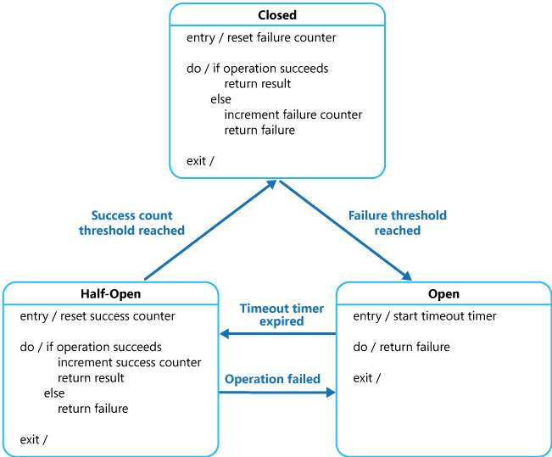

In the figure, the failure counter used by the **Closed** state is time based. It's automatically reset at periodic intervals. This helps to prevent the circuit breaker from entering the **Open** state if it experiences occasional failures. The failure threshold that trips the circuit breaker into the **Open** state is only reached when a specified number of failures have occurred during a specified interval. The counter used by the **Half-Open** state records the number of successful attempts to invoke the operation. The circuit breaker reverts to the **Closed** state after a specified number of consecutive operation invocations have been successful. If any invocation fails, the circuit breaker enters the **Open** state immediately and the success counter will be reset the next time it enters the **Half-Open** state.

How the system recovers is handled externally, possibly by restoring or restarting a failed component or repairing a network connection.

The Circuit Breaker pattern provides stability while the system recovers from a failure and minimizes the impact on performance. It can help to maintain the response time of the system by quickly rejecting a request for an operation that's likely to fail, rather than waiting for the operation to time out, or never return. If the circuit breaker raises an event each time it changes state, this information can be used to monitor the health of the part of the system protected by the circuit breaker, or to alert an administrator when a circuit breaker trips to the **Open** state.

The pattern is customizable and can be adapted according to the type of the possible failure. For example, you can apply an increasing timeout timer to a circuit breaker. You could place the circuit breaker in the **Open** state for a few seconds initially, and then if the failure hasn't been resolved increase the timeout to a few minutes, and so on. In some cases, rather than the **Open** state returning failure and raising an exception, it could be useful to return a default value that is meaningful to the application.

**Issues and considerations**

You should consider the following points when deciding how to implement this pattern:

**Exception Handling**. An application invoking an operation through a circuit breaker must be prepared to handle the exceptions raised if the operation is unavailable. The way exceptions are handled will be application specific. For example, an application could temporarily degrade its functionality, invoke an alternative operation to try to perform the same task or obtain the same data, or report the exception to the user and ask them to try again later.

**Types of Exceptions**. A request might fail for many reasons, some of which might indicate a more severe type of failure than others. For example, a request might fail because a remote service has crashed and will take several minutes to recover, or because of a timeout due to the service being temporarily overloaded. A circuit breaker might be able to examine the types of exceptions that occur and adjust its strategy depending on the nature of these exceptions. For example, it might require a larger number of timeout exceptions to trip the circuit breaker to the **Open** state compared to the number of failures due to the service being completely unavailable.

**Logging**. A circuit breaker should log all failed requests (and possibly successful requests) to enable an administrator to monitor the health of the operation.

**Recoverability**. You should configure the circuit breaker to match the likely recovery pattern of the operation it's protecting. For example, if the circuit breaker remains in the **Open** state for a long period, it could raise exceptions even if the reason for the failure has been resolved. Similarly, a circuit breaker could fluctuate and reduce the response times of applications if it switches from the **Open** state to the **Half-Open** state too quickly.

**Testing Failed Operations**. In the **Open** state, rather than using a timer to determine when to switch to the **Half-Open** state, a circuit breaker can instead periodically ping the remote service or resource to determine whether it's become available again. This ping could take the form of an attempt to invoke an operation that had previously failed, or it could use a special operation provided by the remote service specifically for testing the health of the service, as described by the [Health Endpoint Monitoring pattern](https://docs.microsoft.com/en-us/azure/architecture/patterns/health-endpoint-monitoring).

**Manual Override**. In a system where the recovery time for a failing operation is extremely variable, it's beneficial to provide a manual reset option that enables an administrator to close a circuit breaker (and reset the failure counter). Similarly, an administrator could force a circuit breaker into the **Open** state (and restart the timeout timer) if the operation protected by the circuit breaker is temporarily unavailable.

**Concurrency**. The same circuit breaker could be accessed by a large number of concurrent instances of an application. The implementation shouldn't block concurrent requests or add excessive overhead to each call to an operation.

**Resource Differentiation**. Be careful when using a single circuit breaker for one type of resource if there might be multiple underlying independent providers. For example, in a data store that contains multiple shards, one shard might be fully accessible while another is experiencing a temporary issue. If the error responses in these scenarios are merged, an application might try to access some shards even when failure is highly likely, while access to other shards might be blocked even though it's likely to succeed.

**Accelerated Circuit Breaking**. Sometimes a failure response can contain enough information for the circuit breaker to trip immediately and stay tripped for a minimum amount of time. For example, the error response from a shared resource that's overloaded could indicate that an immediate retry isn't recommended and that the application should instead try again in a few minutes.

**Note**

A service can return HTTP 429 (Too Many Requests) if it is throttling the client, or HTTP 503 (Service Unavailable) if the service is not currently available. The response can include additional information, such as the anticipated duration of the delay.

**Replaying Failed Requests**. In the **Open** state, rather than simply failing quickly, a circuit breaker could also record the details of each request to a journal and arrange for these requests to be replayed when the remote resource or service becomes available.

**Inappropriate Timeouts on External Services**. A circuit breaker might not be able to fully protect applications from operations that fail in external services that are configured with a lengthy timeout period. If the timeout is too long, a thread running a circuit breaker might be blocked for an extended period before the circuit breaker indicates that the operation has failed. In this time, many other application instances might also try to invoke the service through the circuit breaker and tie up a significant number of threads before they all fail.

**When to use this pattern**

Use this pattern:

* To prevent an application from trying to invoke a remote service or access a shared resource if this operation is highly likely to fail.

This pattern isn't recommended:

* For handling access to local private resources in an application, such as in-memory data structure. In this environment, using a circuit breaker would add overhead to your system.
* As a substitute for handling exceptions in the business logic of your applications.

**Example**

In a web application, several of the pages are populated with data retrieved from an external service. If the system implements minimal caching, most hits to these pages will cause a round trip to the service. Connections from the web application to the service could be configured with a timeout period (typically 60 seconds), and if the service doesn't respond in this time the logic in each web page will assume that the service is unavailable and throw an exception.

However, if the service fails and the system is very busy, users could be forced to wait for up to 60 seconds before an exception occurs. Eventually resources such as memory, connections, and threads could be exhausted, preventing other users from connecting to the system, even if they aren't accessing pages that retrieve data from the service.

Scaling the system by adding further web servers and implementing load balancing might delay when resources become exhausted, but it won't resolve the issue because user requests will still be unresponsive and all web servers could still eventually run out of resources.

Wrapping the logic that connects to the service and retrieves the data in a circuit breaker could help to solve this problem and handle the service failure more elegantly. User requests will still fail, but they'll fail more quickly and the resources won't be blocked.

The CircuitBreaker class maintains state information about a circuit breaker in an object that implements the ICircuitBreakerStateStore interface shown in the following code.

C#

interface ICircuitBreakerStateStore

{

CircuitBreakerStateEnum State { get; }

Exception LastException { get; }

DateTime LastStateChangedDateUtc { get; }

void Trip(Exception ex);

void Reset();

void HalfOpen();

bool IsClosed { get; }

}

The State property indicates the current state of the circuit breaker, and will be either **Open**, **HalfOpen**, or **Closed** as defined by the CircuitBreakerStateEnum enumeration. The IsClosed property should be true if the circuit breaker is closed, but false if it's open or half open. The Trip method switches the state of the circuit breaker to the open state and records the exception that caused the change in state, together with the date and time that the exception occurred. The LastException and the LastStateChangedDateUtc properties return this information. The Reset method closes the circuit breaker, and the HalfOpen method sets the circuit breaker to half open.

The InMemoryCircuitBreakerStateStore class in the example contains an implementation of the ICircuitBreakerStateStore interface. The CircuitBreaker class creates an instance of this class to hold the state of the circuit breaker.

The ExecuteAction method in the CircuitBreaker class wraps an operation, specified as an Action delegate. If the circuit breaker is closed, ExecuteAction invokes the Action delegate. If the operation fails, an exception handler calls TrackException, which sets the circuit breaker state to open. The following code example highlights this flow.

C#Copy

public class CircuitBreaker

{

private readonly ICircuitBreakerStateStore stateStore =

CircuitBreakerStateStoreFactory.GetCircuitBreakerStateStore();

private readonly object halfOpenSyncObject = new object ();

...

public bool IsClosed { get { return stateStore.IsClosed; } }

public bool IsOpen { get { return !IsClosed; } }

public void ExecuteAction(Action action)

{

...

if (IsOpen)

{

// The circuit breaker is Open.

... (see code sample below for details)

}

// The circuit breaker is Closed, execute the action.

try

{

action();

}

catch (Exception ex)

{

// If an exception still occurs here, simply

// retrip the breaker immediately.

this.TrackException(ex);

// Throw the exception so that the caller can tell

// the type of exception that was thrown.

throw;

}

}

private void TrackException(Exception ex)

{

// For simplicity in this example, open the circuit breaker on the first exception.

// In reality this would be more complex. A certain type of exception, such as one

// that indicates a service is offline, might trip the circuit breaker immediately.

// Alternatively it might count exceptions locally or across multiple instances and

// use this value over time, or the exception/success ratio based on the exception

// types, to open the circuit breaker.

this.stateStore.Trip(ex);

}

}

The following example shows the code (omitted from the previous example) that is executed if the circuit breaker isn't closed. It first checks if the circuit breaker has been open for a period longer than the time specified by the local OpenToHalfOpenWaitTime field in the CircuitBreaker class. If this is the case, the ExecuteAction method sets the circuit breaker to half open, then tries to perform the operation specified by the Action delegate.

If the operation is successful, the circuit breaker is reset to the closed state. If the operation fails, it is tripped back to the open state and the time the exception occurred is updated so that the circuit breaker will wait for a further period before trying to perform the operation again.

If the circuit breaker has only been open for a short time, less than the OpenToHalfOpenWaitTime value, the ExecuteAction method simply throws a CircuitBreakerOpenException exception and returns the error that caused the circuit breaker to transition to the open state.

Additionally, it uses a lock to prevent the circuit breaker from trying to perform concurrent calls to the operation while it's half open. A concurrent attempt to invoke the operation will be handled as if the circuit breaker was open, and it'll fail with an exception as described later.

C#

...

if (IsOpen)

{

// The circuit breaker is Open. Check if the Open timeout has expired.

// If it has, set the state to HalfOpen. Another approach might be to

// check for the HalfOpen state that had be set by some other operation.

if (stateStore.LastStateChangedDateUtc + OpenToHalfOpenWaitTime < DateTime.UtcNow)

{

// The Open timeout has expired. Allow one operation to execute. Note that, in

// this example, the circuit breaker is set to HalfOpen after being

// in the Open state for some period of time. An alternative would be to set

// this using some other approach such as a timer, test method, manually, and

// so on, and check the state here to determine how to handle execution

// of the action.

// Limit the number of threads to be executed when the breaker is HalfOpen.

// An alternative would be to use a more complex approach to determine which

// threads or how many are allowed to execute, or to execute a simple test

// method instead.

bool lockTaken = false;

try

{

Monitor.TryEnter(halfOpenSyncObject, ref lockTaken);

if (lockTaken)

{

// Set the circuit breaker state to HalfOpen.

stateStore.HalfOpen();

// Attempt the operation.

action();

// If this action succeeds, reset the state and allow other operations.

// In reality, instead of immediately returning to the Closed state, a counter

// here would record the number of successful operations and return the

// circuit breaker to the Closed state only after a specified number succeed.

this.stateStore.Reset();

return;

}

}

catch (Exception ex)

{

// If there's still an exception, trip the breaker again immediately.

this.stateStore.Trip(ex);

// Throw the exception so that the caller knows which exception occurred.

throw;

}

finally

{

if (lockTaken)

{

Monitor.Exit(halfOpenSyncObject);

}

}

}

// The Open timeout hasn't yet expired. Throw a CircuitBreakerOpen exception to

// inform the caller that the call was not actually attempted,

// and return the most recent exception received.

throw new CircuitBreakerOpenException(stateStore.LastException);

}

...

To use a CircuitBreaker object to protect an operation, an application creates an instance of the CircuitBreaker class and invokes the ExecuteAction method, specifying the operation to be performed as the parameter. The application should be prepared to catch the CircuitBreakerOpenException exception if the operation fails because the circuit breaker is open. The following code shows an example:

C#Copy

var breaker = new CircuitBreaker();

try

{

breaker.ExecuteAction(() =>

{

// Operation protected by the circuit breaker.

...

});

}

catch (CircuitBreakerOpenException ex)

{

// Perform some different action when the breaker is open.

// Last exception details are in the inner exception.

...

}

catch (Exception ex)

{

...

}

### Compensating Transaction

Undo the work performed by a series of steps, which together define an eventually consistent operation, if one or more of the steps fail. Operations that follow the eventual consistency model are commonly found in cloud-hosted applications that implement complex business processes and workflows.

**Context and problem**

Applications running in the cloud frequently modify data. This data might be spread across various data sources held in different geographic locations. To avoid contention and improve performance in a distributed environment, an application shouldn't try to provide strong transactional consistency. Rather, the application should implement eventual consistency. In this model, a typical business operation consists of a series of separate steps. While these steps are being performed, the overall view of the system state might be inconsistent, but when the operation has completed and all of the steps have been executed the system should become consistent again.

The [Data Consistency Primer](https://docs.microsoft.com/en-us/previous-versions/msp-n-p/dn589800(v=pandp.10)) provides information about why distributed transactions don't scale well, and the principles of the eventual consistency model.

A challenge in the eventual consistency model is how to handle a step that has failed. In this case it might be necessary to undo all of the work completed by the previous steps in the operation. However, the data can't simply be rolled back because other concurrent instances of the application might have changed it. Even in cases where the data hasn't been changed by a concurrent instance, undoing a step might not simply be a matter of restoring the original state. It might be necessary to apply various business-specific rules (see the travel website described in the Example section).

If an operation that implements eventual consistency spans several heterogeneous data stores, undoing the steps in the operation will require visiting each data store in turn. The work performed in every data store must be undone reliably to prevent the system from remaining inconsistent.

Not all data affected by an operation that implements eventual consistency might be held in a database. In a service oriented architecture (SOA) environment an operation could invoke an action in a service, and cause a change in the state held by that service. To undo the operation, this state change must also be undone. This can involve invoking the service again and performing another action that reverses the effects of the first.

**Solution**

The solution is to implement a compensating transaction. The steps in a compensating transaction must undo the effects of the steps in the original operation. A compensating transaction might not be able to simply replace the current state with the state the system was in at the start of the operation because this approach could overwrite changes made by other concurrent instances of an application. Instead, it must be an intelligent process that takes into account any work done by concurrent instances. This process will usually be application specific, driven by the nature of the work performed by the original operation.

A common approach is to use a workflow to implement an eventually consistent operation that requires compensation. As the original operation proceeds, the system records information about each step and how the work performed by that step can be undone. If the operation fails at any point, the workflow rewinds back through the steps it's completed and performs the work that reverses each step. Note that a compensating transaction might not have to undo the work in the exact reverse order of the original operation, and it might be possible to perform some of the undo steps in parallel.

This approach is similar to the Sagas strategy discussed in [Clemens Vasters’ blog](https://vasters.com/archive/Sagas.html).

A compensating transaction is also an eventually consistent operation and it could also fail. The system should be able to resume the compensating transaction at the point of failure and continue. It might be necessary to repeat a step that's failed, so the steps in a compensating transaction should be defined as idempotent commands. For more information, see [Idempotency Patterns](https://blog.jonathanoliver.com/idempotency-patterns/) on Jonathan Oliver’s blog.

In some cases it might not be possible to recover from a step that has failed except through manual intervention. In these situations the system should raise an alert and provide as much information as possible about the reason for the failure.

**Issues and considerations**

Consider the following points when deciding how to implement this pattern:

It might not be easy to determine when a step in an operation that implements eventual consistency has failed. A step might not fail immediately, but instead could block. It might be necessary to implement some form of time-out mechanism.

-Compensation logic isn't easily generalized. A compensating transaction is application specific. It relies on the application having sufficient information to be able to undo the effects of each step in a failed operation.

You should define the steps in a compensating transaction as idempotent commands. This enables the steps to be repeated if the compensating transaction itself fails.

The infrastructure that handles the steps in the original operation, and the compensating transaction, must be resilient. It must not lose the information required to compensate for a failing step, and it must be able to reliably monitor the progress of the compensation logic.

A compensating transaction doesn't necessarily return the data in the system to the state it was in at the start of the original operation. Instead, it compensates for the work performed by the steps that completed successfully before the operation failed.

The order of the steps in the compensating transaction doesn't necessarily have to be the exact opposite of the steps in the original operation. For example, one data store might be more sensitive to inconsistencies than another, and so the steps in the compensating transaction that undo the changes to this store should occur first.

Placing a short-term timeout-based lock on each resource that's required to complete an operation, and obtaining these resources in advance, can help increase the likelihood that the overall activity will succeed. The work should be performed only after all the resources have been acquired. All actions must be finalized before the locks expire.

Consider using retry logic that is more forgiving than usual to minimize failures that trigger a compensating transaction. If a step in an operation that implements eventual consistency fails, try handling the failure as a transient exception and repeat the step. Only stop the operation and initiate a compensating transaction if a step fails repeatedly or irrecoverably.

Many of the challenges of implementing a compensating transaction are the same as those with implementing eventual consistency. See the section Considerations for Implementing Eventual Consistency in the [Data Consistency Primer](https://docs.microsoft.com/en-us/previous-versions/msp-n-p/dn589800(v=pandp.10)) for more information.

**When to use this pattern**

Use this pattern only for operations that must be undone if they fail. If possible, design solutions to avoid the complexity of requiring compensating transactions.

**Example**

A travel website lets customers book itineraries. A single itinerary might comprise a series of flights and hotels. A customer traveling from Seattle to London and then on to Paris could perform the following steps when creating an itinerary:

1. Book a seat on flight F1 from Seattle to London.
2. Book a seat on flight F2 from London to Paris.
3. Book a seat on flight F3 from Paris to Seattle.
4. Reserve a room at hotel H1 in London.
5. Reserve a room at hotel H2 in Paris.

These steps constitute an eventually consistent operation, although each step is a separate action. Therefore, as well as performing these steps, the system must also record the counter operations necessary to undo each step in case the customer decides to cancel the itinerary. The steps necessary to perform the counter operations can then run as a compensating transaction.

Notice that the steps in the compensating transaction might not be the exact opposite of the original steps, and the logic in each step in the compensating transaction must take into account any business-specific rules. For example, unbooking a seat on a flight might not entitle the customer to a complete refund of any money paid. The figure illustrates generating a compensating transaction to undo a long-running transaction to book a travel itinerary.



**Note**

It might be possible for the steps in the compensating transaction to be performed in parallel, depending on how you've designed the compensating logic for each step.

In many business solutions, failure of a single step doesn't always necessitate rolling the system back by using a compensating transaction. For example, if—after having booked flights F1, F2, and F3 in the travel website scenario—the customer is unable to reserve a room at hotel H1, it's preferable to offer the customer a room at a different hotel in the same city rather than canceling the flights. The customer can still decide to cancel (in which case the compensating transaction runs and undoes the bookings made on flights F1, F2, and F3), but this decision should be made by the customer rather than by the system.

### Claim Check

Split a large message into a claim check and a payload. Send the claim check to the messaging platform and store the payload to an external service. This pattern allows large messages to be processed, while protecting the message bus and the client from being overwhelmed or slowed down. This pattern also helps to reduce costs, as storage is usually cheaper than resource units used by the messaging platform.

This pattern is also known as Reference-Based Messaging, and was originally [described](https://www.enterpriseintegrationpatterns.com/patterns/messaging/StoreInLibrary.html) in the book *Enterprise Integration Patterns*, by Gregor Hohpe and Bobby Woolf.

**Context and problem**

A messaging-based architecture at some point must be able to send, receive, and manipulate large messages. Such messages may contain anything, including images (for example, MRI scans), sound files (for example, call-center calls), text documents, or any kind of binary data of arbitrary size.

Sending such large messages to the message bus directly is not recommended, because they require more resources and bandwidth to be consumed. Large messages can also slow down the entire solution, because messaging platforms are usually fine-tuned to handle huge quantities of small messages. Also, most messaging platforms have limits on message size, so you may need to work around these limits for large messages.

**Solution**

Store the entire message payload into an external service, such as a database. Get the reference to the stored payload, and send just that reference to the message bus. The reference acts like a claim check used to retrieve a piece of luggage, hence the name of the pattern. Clients interested in processing that specific message can use the obtained reference to retrieve the payload, if needed.

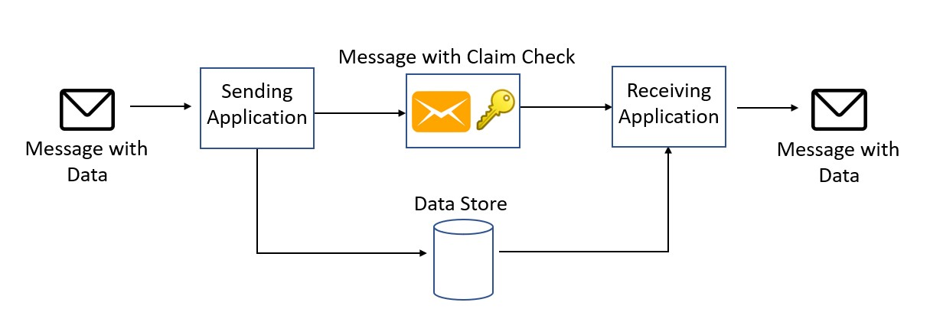

**Issues and considerations**

Consider the following points when deciding how to implement this pattern:

* Consider deleting the message data after consuming it, if you don't need to archive the messages. Although blob storage is relatively cheap, it costs some money in the long run, especially if there is a lot of data. Deleting the message can be done synchronously by the application that receives and processes the message, or asynchronously by a separate dedicated process. The asynchronous approach removes old data with no impact on the throughput and message processing performance of the receiving application.
* Storing and retrieving the message causes some additional overhead and latency. You may want to implement logic in the sending application to use this pattern only when the message size exceeds the data limit of the message bus. The pattern would be skipped for smaller messages. This approach would result in a conditional claim-check pattern.

**When to use this pattern**

This pattern should be used whenever a message cannot fit the supported message limit of the chosen message bus technology. For example, Event Hubs currently has a limit of 256 KB (Basic Tier), while Event Grid supports only 64-KB messages.

The pattern can also be used if the payload should be accessed only by services that are authorized to see it. By offloading the payload to an external resource, stricter authentication and authorization rules can be put in place, to ensure that security is enforced when sensitive data is stored in the payload.

**Examples**

On Azure, this pattern can be implemented in several ways and with different technologies, but there are two main categories. In both cases, the receiver has the responsibility to read the claim check and use it to retrieve the payload.

* **Automatic claim-check generation**. This approach uses [Azure Event Grid](https://docs.microsoft.com/en-us/azure/event-grid/) to automatically generate the claim check and push it into the message bus.
* **Manual claim-check generation**. In this approach, the sender is responsible for managing the payload. The sender stores the payload using the appropriate service, gets or generates the claim check, and sends the claim check to the message bus.

Event Grid is an event routing service and tries to deliver events within a configurable amount of time up to 24 hours. After that, events are either discarded or dead lettered. If you need to archive the event payloads or replay the event stream, you can add an Event Grid subscription to Event Hubs or Queue Storage, where messages can be retained for longer periods and archiving messages is supported. For information about fine tuning Event Grid message delivery and retry, and dead letter configuration, see [Dead letter and retry policies](https://docs.microsoft.com/en-us/azure/event-grid/manage-event-delivery).

**Automatic claim-check generation with Blob Storage and Event Grid**

In this approach, the sender drops the message payload into a designated Azure Blob Storage container. Event Grid automatically generates a tag/reference and sends it to a supported message bus, such as Azure Storage Queues. The receiver can poll the queue, get the message, and then use the stored reference data to download the payload directly from Blob Storage.

The same Event Grid message can be directly consumed by [Azure Functions](https://docs.microsoft.com/en-us/azure/azure-functions/), without needing to go through a message bus. This approach takes full advantage of the serverless nature of both Event Grid and Functions.

You can find example code for this approach [here](https://github.com/mspnp/cloud-design-patterns/tree/master/claim-check/code-samples/sample-1).

**Event Grid with Event Hubs**

Similar to the previous example, Event Grid automatically generates a message when a payload is written to an Azure Blob container. But in this example, the message bus is implemented using Event Hubs. A client can register itself to receive the stream of messages as they are written to the event hub. The event hub can also be configured to archive messages, making them available as an Avro file that can be queried using tools like Apache Spark, Apache Drill, or any of the available Avro libraries.

You can find example code for this approach [here](https://github.com/mspnp/cloud-design-patterns/tree/master/claim-check/code-samples/sample-2).

**Claim check generation with Service Bus**

This solution takes advantage of a specific Service Bus plugin, [ServiceBus.AttachmentPlugin](https://www.nuget.org/packages/ServiceBus.AttachmentPlugin/), which makes the claim-check workflow easy to implement. The plugin converts any message body into an attachment that gets stored in Azure Blob Storage when the message is sent.

**C# Code**

using ServiceBus.AttachmentPlugin;

...

// Getting connection information

var serviceBusConnectionString = Environment.GetEnvironmentVariable("SERVICE_BUS_CONNECTION_STRING");

var queueName = Environment.GetEnvironmentVariable("QUEUE_NAME");

var storageConnectionString = Environment.GetEnvironmentVariable("STORAGE_CONNECTION_STRING");

// Creating config for sending message

var config = new AzureStorageAttachmentConfiguration(storageConnectionString);

// Creating and registering the sender using Service Bus Connection String and Queue Name

var sender = new MessageSender(serviceBusConnectionString, queueName);

sender.RegisterAzureStorageAttachmentPlugin(config);

// Create payload

var payload = new { data = "random data string for testing" };

var serialized = JsonConvert.SerializeObject(payload);

var payloadAsBytes = Encoding.UTF8.GetBytes(serialized);

var message = new Message(payloadAsBytes);

// Send the message

await sender.SendAsync(message);

The Service Bus message acts as a notification queue, which a client can subscribe to. When the consumer receives the message, the plugin makes it possible to directly read the message data from Blob Storage. You can then choose how to process the message further. An advantage of this approach is that it abstracts the claim-check workflow from the sender and receiver.

You can find example code for this approach [here](https://github.com/mspnp/cloud-design-patterns/tree/master/claim-check/code-samples/sample-3).

**Manual claim-check generation with Kafka**

In this example, a Kafka client writes the payload to Azure Blob Storage. Then it sends a notification message using [Kafka-enabled Event Hubs](https://docs.microsoft.com/en-us/azure/event-hubs/event-hubs-quickstart-kafka-enabled-event-hubs). The consumer receives the message and can access the payload from Blob Storage. This example shows how a different messaging protocol can be used to implement the claim-check pattern in Azure. For example, you might need to support existing Kafka clients.

You can find example code for this approach [here](https://github.com/mspnp/cloud-design-patterns/tree/master/claim-check/code-samples/sample-4).

### Health Endpoint Monitoring

Implement functional checks in an application that external tools can access through exposed endpoints at regular intervals. This can help to verify that applications and services are performing correctly.

**Context and problem**

It's a good practice, and often a business requirement, to monitor web applications and back-end services, to ensure they're available and performing correctly. However, it's more difficult to monitor services running in the cloud than it is to monitor on-premises services. For example, you don't have full control of the hosting environment, and the services typically depend on other services provided by platform vendors and others.

There are many factors that affect cloud-hosted applications such as network latency, the performance and availability of the underlying compute and storage systems, and the network bandwidth between them. The service can fail entirely or partially due to any of these factors. Therefore, you must verify at regular intervals that the service is performing correctly to ensure the required level of availability, which might be part of your service level agreement (SLA).

**Solution**

Implement health monitoring by sending requests to an endpoint on the application. The application should perform the necessary checks, and return an indication of its status.

A health monitoring check typically combines two factors:

* The checks (if any) performed by the application or service in response to the request to the health verification endpoint.
* Analysis of the results by the tool or framework that performs the health verification check.

The response code indicates the status of the application and, optionally, any components or services it uses. The latency or response time check is performed by the monitoring tool or framework. The figure provides an overview of the pattern.

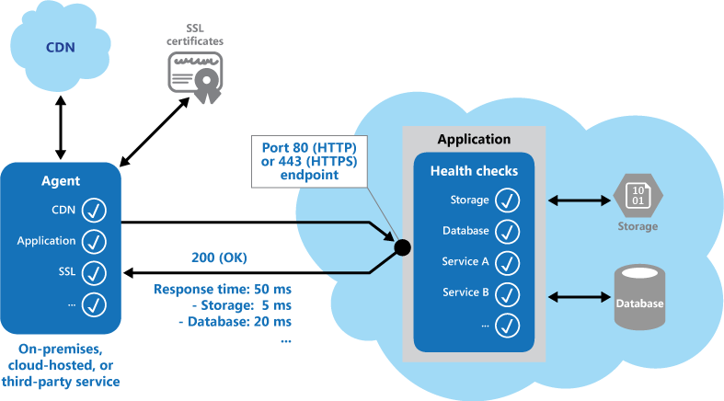

Other checks that might be carried out by the health monitoring code in the application include:

* Checking cloud storage or a database for availability and response time.
* Checking other resources or services located in the application, or located elsewhere but used by the application.

Services and tools are available that monitor web applications by submitting a request to a configurable set of endpoints, and evaluating the results against a set of configurable rules. It's relatively easy to create a service endpoint whose sole purpose is to perform some functional tests on the system.

Typical checks that can be performed by the monitoring tools include:

* Validating the response code. For example, an HTTP response of 200 (OK) indicates that the application responded without error. The monitoring system might also check for other response codes to give more comprehensive results.
* Checking the content of the response to detect errors, even when a 200 (OK) status code is returned. This can detect errors that affect only a section of the returned web page or service response. For example, checking the title of a page or looking for a specific phrase that indicates the correct page was returned.
* Measuring the response time, which indicates a combination of the network latency and the time that the application took to execute the request. An increasing value can indicate an emerging problem with the application or network.
* Checking resources or services located outside the application, such as a content delivery network used by the application to deliver content from global caches.
* Checking for expiration of SSL certificates.
* Measuring the response time of a DNS lookup for the URL of the application to measure DNS latency and DNS failures.
* Validating the URL returned by the DNS lookup to ensure correct entries. This can help to avoid malicious request redirection through a successful attack on the DNS server.

It's also useful, where possible, to run these checks from different on-premises or hosted locations to measure and compare response times. Ideally you should monitor applications from locations that are close to customers to get an accurate view of the performance from each location. In addition to providing a more robust checking mechanism, the results can help you decide on the deployment location for the application—and whether to deploy it in more than one datacenter.

Tests should also be run against all the service instances that customers use to ensure the application is working correctly for all customers. For example, if customer storage is spread across more than one storage account, the monitoring process should check all of these.

**Issues and considerations**

Consider the following points when deciding how to implement this pattern:

How to validate the response. For example, is just a single 200 (OK) status code sufficient to verify the application is working correctly? While this provides the most basic measure of application availability, and is the minimum implementation of this pattern, it provides little information about the operations, trends, and possible upcoming issues in the application.

Make sure that the application correctly returns a 200 (OK) only when the target resource is found and processed. In some scenarios, such as when using a master page to host the target web page, the server sends back a 200 (OK) status code instead of a 404 (Not Found) code, even when the target content page was not found.

The number of endpoints to expose for an application. One approach is to expose at least one endpoint for the core services that the application uses and another for lower priority services, allowing different levels of importance to be assigned to each monitoring result. Also consider exposing more endpoints, such as one for each core service, for additional monitoring granularity. For example, a health verification check might check the database, storage, and an external geocoding service that an application uses, with each requiring a different level of uptime and response time. The application could still be healthy if the geocoding service, or some other background task, is unavailable for a few minutes.

Whether to use the same endpoint for monitoring as is used for general access, but to a specific path designed for health verification checks, for example, /HealthCheck/{GUID}/ on the general access endpoint. This allows some functional tests in the application to be run by the monitoring tools, such as adding a new user registration, signing in, and placing a test order, while also verifying that the general access endpoint is available.

The type of information to collect in the service in response to monitoring requests, and how to return this information. Most existing tools and frameworks look only at the HTTP status code that the endpoint returns. To return and validate additional information, you might have to create a custom monitoring utility or service.

How much information to collect. Performing excessive processing during the check can overload the application and impact other users. The time it takes might exceed the timeout of the monitoring system so it marks the application as unavailable. Most applications include instrumentation such as error handlers and performance counters that log performance and detailed error information, this might be sufficient instead of returning additional information from a health verification check.

Caching the endpoint status. It could be expensive to run the health check too frequently. If the health status is reported through a dashboard, for example, you don't want every request from the dashboard to trigger a health check. Instead, periodically check the system health and cache the status. Expose an endpoint that returns the cached status.

How to configure security for the monitoring endpoints to protect them from public access, which might expose the application to malicious attacks, risk the exposure of sensitive information, or attract denial of service (DoS) attacks. Typically this should be done in the application configuration so that it can be updated easily without restarting the application. Consider using one or more of the following techniques:

* Secure the endpoint by requiring authentication. You can do this by using an authentication security key in the request header or by passing credentials with the request, provided that the monitoring service or tool supports authentication.
  + Use an obscure or hidden endpoint. For example, expose the endpoint on a different IP address to that used by the default application URL, configure the endpoint on a nonstandard HTTP port, and/or use a complex path to the test page. You can usually specify additional endpoint addresses and ports in the application configuration, and add entries for these endpoints to the DNS server if required to avoid having to specify the IP address directly.
  + Expose a method on an endpoint that accepts a parameter such as a key value or an operation mode value. Depending on the value supplied for this parameter, when a request is received the code can perform a specific test or set of tests, or return a 404 (Not Found) error if the parameter value isn't recognized. The recognized parameter values could be set in the application configuration.

DoS attacks are likely to have less impact on a separate endpoint that performs basic functional tests without compromising the operation of the application. Ideally, avoid using a test that might expose sensitive information. If you must return information that might be useful to an attacker, consider how you'll protect the endpoint and the data from unauthorized access. In this case just relying on obscurity isn't enough. You should also consider using an HTTPS connection and encrypting any sensitive data, although this will increase the load on the server.

* How to access an endpoint that's secured using authentication. Not all tools and frameworks can be configured to include credentials with the health verification request. For example, Microsoft Azure built-in health verification features can't provide authentication credentials. Some third-party alternatives are [Pingdom](https://www.pingdom.com/), [Panopta](https://www.panopta.com/), [NewRelic](https://newrelic.com/), and [Statuscake](https://www.statuscake.com/).
* How to ensure that the monitoring agent is performing correctly. One approach is to expose an endpoint that simply returns a value from the application configuration or a random value that can be used to test the agent.

Also ensure that the monitoring system performs checks on itself, such as a self-test and built-in test, to avoid it issuing false positive results.

**When to use this pattern**

This pattern is useful for:

* Monitoring websites and web applications to verify availability.
* Monitoring websites and web applications to check for correct operation.
* Monitoring middle-tier or shared services to detect and isolate a failure that could disrupt other applications.
* Complementing existing instrumentation in the application, such as performance counters and error handlers. Health verification checking doesn't replace the requirement for logging and auditing in the application. Instrumentation can provide valuable information for an existing framework that monitors counters and error logs to detect failures or other issues. However, it can't provide information if the application is unavailable.

**Example**

The following code examples, taken from the HealthCheckController class (a sample that demonstrates this pattern is available on [GitHub](https://github.com/mspnp/cloud-design-patterns/tree/master/health-endpoint-monitoring)), demonstrates exposing an endpoint for performing a range of health checks.

The CoreServices method, shown below in C#, performs a series of checks on services used in the application. If all of the tests run without error, the method returns a 200 (OK) status code. If any of the tests raises an exception, the method returns a 500 (Internal Error) status code. The method could optionally return additional information when an error occurs, if the monitoring tool or framework is able to use it.

C#Copy

public ActionResult CoreServices()

{

try

{

// Run a simple check to ensure the database is available.

DataStore.Instance.CoreHealthCheck();

// Run a simple check on our external service.

MyExternalService.Instance.CoreHealthCheck();

}

catch (Exception ex)

{

Trace.TraceError("Exception in basic health check: {0}", ex.Message);

// This can optionally return different status codes based on the exception.

// Optionally it could return more details about the exception.

// The additional information could be used by administrators who access the

// endpoint with a browser, or using a ping utility that can display the

// additional information.

return new HttpStatusCodeResult((int)HttpStatusCode.InternalServerError);

}

return new HttpStatusCodeResult((int)HttpStatusCode.OK);

}

The ObscurePath method shows how you can read a path from the application configuration and use it as the endpoint for tests. This example, in C#, also shows how you can accept an ID as a parameter and use it to check for valid requests.

C#Copy

public ActionResult ObscurePath(string id)

{

// The id could be used as a simple way to obscure or hide the endpoint.

// The id to match could be retrieved from configuration and, if matched,

// perform a specific set of tests and return the result. If not matched it

// could return a 404 (Not Found) status.

// The obscure path can be set through configuration to hide the endpoint.

var hiddenPathKey = CloudConfigurationManager.GetSetting("Test.ObscurePath");

// If the value passed does not match that in configuration, return 404 (Not Found).

if (!string.Equals(id, hiddenPathKey))

{

return new HttpStatusCodeResult((int)HttpStatusCode.NotFound);

}

// Else continue and run the tests...

// Return results from the core services test.

return this.CoreServices();

}

The TestResponseFromConfig method shows how you can expose an endpoint that performs a check for a specified configuration setting value.

C#Copy

public ActionResult TestResponseFromConfig()

{

// Health check that returns a response code set in configuration for testing.

var returnStatusCodeSetting = CloudConfigurationManager.GetSetting(

"Test.ReturnStatusCode");

int returnStatusCode;

if (!int.TryParse(returnStatusCodeSetting, out returnStatusCode))

{

returnStatusCode = (int)HttpStatusCode.OK;

}

return new HttpStatusCodeResult(returnStatusCode);

}

**Monitoring endpoints in Azure hosted applications**

Some options for monitoring endpoints in Azure applications are:

* Use the built-in monitoring features of Azure.
* Use a third-party service or a framework such as Microsoft System Center Operations Manager.
* Create a custom utility or a service that runs on your own or on a hosted server.

Even though Azure provides a reasonably comprehensive set of monitoring options, you can use additional services and tools to provide extra information. Azure Management Services provides a built-in monitoring mechanism for alert rules. The alerts section of the management services page in the Azure portal allows you to configure up to ten alert rules per subscription for your services. These rules specify a condition and a threshold value for a service such as CPU load, or the number of requests or errors per second, and the service can automatically send email notifications to addresses you define in each rule.

The conditions you can monitor vary depending on the hosting mechanism you choose for your application (such as Web Sites, Cloud Services, Virtual Machines, or Mobile Services), but all of these include the ability to create an alert rule that uses a web endpoint you specify in the settings for your service. This endpoint should respond in a timely way so that the alert system can detect that the application is operating correctly.

Read more information about [creating alert notifications](https://docs.microsoft.com/en-us/azure/azure-monitor/platform/alerts-metric).

If you host your application in Azure Cloud Services web and worker roles or Virtual Machines, you can take advantage of one of the built-in services in Azure called Traffic Manager. Traffic Manager is a routing and load-balancing service that can distribute requests to specific instances of your Cloud Services hosted application based on a range of rules and settings.

In addition to routing requests, Traffic Manager pings a URL, port, and relative path that you specify on a regular basis to determine which instances of the application defined in its rules are active and are responding to requests. If it detects a status code 200 (OK), it marks the application as available. Any other status code causes Traffic Manager to mark the application as offline. You can view the status in the Traffic Manager console, and configure the rule to reroute requests to other instances of the application that are responding.

However, Traffic Manager will only wait ten seconds to receive a response from the monitoring URL. Therefore, you should ensure that your health verification code executes in this time, allowing for network latency for the round trip from Traffic Manager to your application and back again.

Read more information about using [Traffic Manager to monitor your applications](https://docs.microsoft.com/en-us/azure/traffic-manager/). Traffic Manager is also discussed in [Multiple Datacenter Deployment Guidance](https://docs.microsoft.com/en-us/previous-versions/msp-n-p/dn589779(v=pandp.10)).

**Index Table pattern**

Create indexes over the fields in data stores that are frequently referenced by queries. This pattern can improve query performance by allowing applications to more quickly locate the data to retrieve from a data store.

**Context and problem**

Many data stores organize the data for a collection of entities using the primary key. An application can use this key to locate and retrieve data. The figure shows an example of a data store holding customer information. The primary key is the Customer ID. The figure shows customer information organized by the primary key (Customer ID).

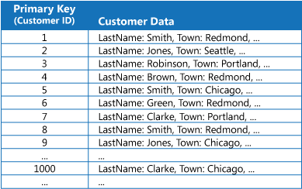

While the primary key is valuable for queries that fetch data based on the value of this key, an application might not be able to use the primary key if it needs to retrieve data based on some other field. In the customers example, an application can't use the Customer ID primary key to retrieve customers if it queries data solely by referencing the value of some other attribute, such as the town in which the customer is located. To perform a query such as this, the application might have to fetch and examine every customer record, which could be a slow process.

Many relational database management systems support secondary indexes. A secondary index is a separate data structure that's organized by one or more nonprimary (secondary) key fields, and it indicates where the data for each indexed value is stored. The items in a secondary index are typically sorted by the value of the secondary keys to enable fast lookup of data. These indexes are usually maintained automatically by the database management system.

You can create as many secondary indexes as you need to support the different queries that your application performs. For example, in a Customers table in a relational database where the Customer ID is the primary key, it's beneficial to add a secondary index over the town field if the application frequently looks up customers by the town where they reside.

However, although secondary indexes are common in relational systems, most NoSQL data stores used by cloud applications don't provide an equivalent feature.

**Solution**

If the data store doesn't support secondary indexes, you can emulate them manually by creating your own index tables. An index table organizes the data by a specified key. Three strategies are commonly used for structuring an index table, depending on the number of secondary indexes that are required and the nature of the queries that an application performs.

The first strategy is to duplicate the data in each index table but organize it by different keys (complete denormalization). The next figure shows index tables that organize the same customer information by Town and LastName.

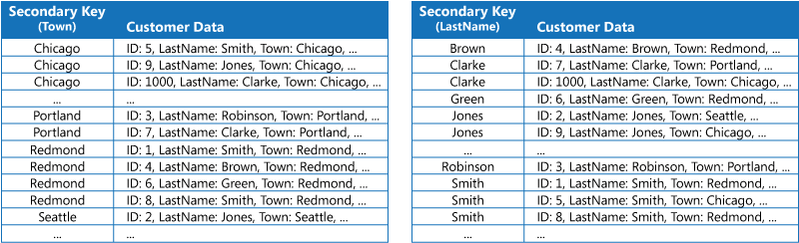

This strategy is appropriate if the data is relatively static compared to the number of times it's queried using each key. If the data is more dynamic, the processing overhead of maintaining each index table becomes too large for this approach to be useful. Also, if the volume of data is very large, the amount of space required to store the duplicate data is significant.

The second strategy is to create normalized index tables organized by different keys and reference the original data by using the primary key rather than duplicating it, as shown in the following figure. The original data is called a fact table.

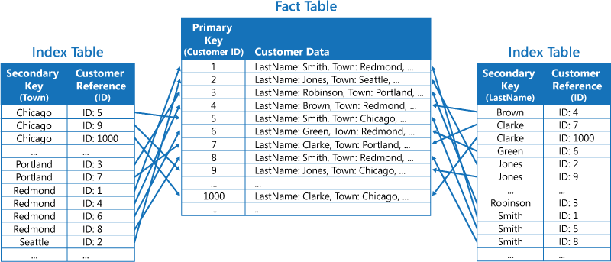

This technique saves space and reduces the overhead of maintaining duplicate data. The disadvantage is that an application has to perform two lookup operations to find data using a secondary key. It has to find the primary key for the data in the index table, and then use the primary key to look up the data in the fact table.

The third strategy is to create partially normalized index tables organized by different keys that duplicate frequently retrieved fields. Reference the fact table to access less frequently accessed fields. The next figure shows how commonly accessed data is duplicated in each index table.

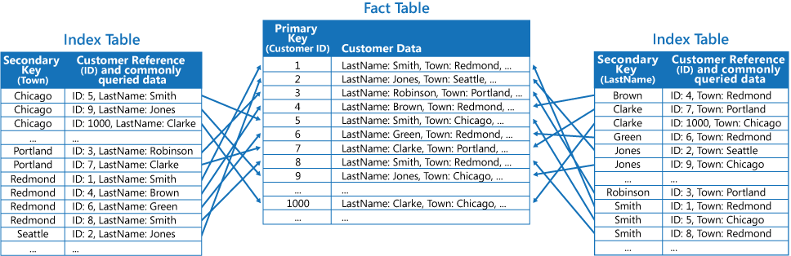

With this strategy, you can strike a balance between the first two approaches. The data for common queries can be retrieved quickly by using a single lookup, while the space and maintenance overhead isn't as significant as duplicating the entire data set.

If an application frequently queries data by specifying a combination of values (for example, “Find all customers that live in Redmond and that have a last name of Smith”), you could implement the keys to the items in the index table as a concatenation of the Town attribute and the LastName attribute. The next figure shows an index table based on composite keys. The keys are sorted by Town, and then by LastName for records that have the same value for Town.

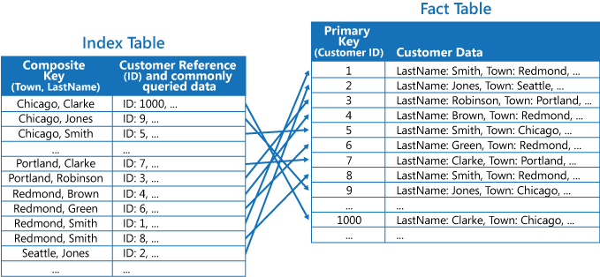

Index tables can speed up query operations over sharded data, and are especially useful where the shard key is hashed. The next figure shows an example where the shard key is a hash of the Customer ID. The index table can organize data by the nonhashed value (Town and LastName), and provide the hashed shard key as the lookup data. This can save the application from repeatedly calculating hash keys (an expensive operation) if it needs to retrieve data that falls within a range, or it needs to fetch data in order of the nonhashed key. For example, a query such as “Find all customers that live in Redmond” can be quickly resolved by locating the matching items in the index table, where they're all stored in a contiguous block. Then, follow the references to the customer data using the shard keys stored in the index table.

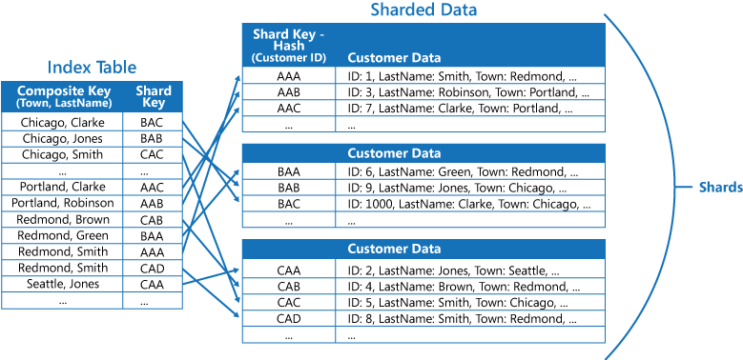

**Issues and considerations**

Consider the following points when deciding how to implement this pattern:

* The overhead of maintaining secondary indexes can be significant. You must analyze and understand the queries that your application uses. Only create index tables when they're likely to be used regularly. Don't create speculative index tables to support queries that an application doesn't perform, or performs only occasionally.
* Duplicating data in an index table can add significant overhead in storage costs and the effort required to maintain multiple copies of data.
* Implementing an index table as a normalized structure that references the original data requires an application to perform two lookup operations to find data. The first operation searches the index table to retrieve the primary key, and the second uses the primary key to fetch the data.
* If a system incorporates a number of index tables over very large data sets, it can be difficult to maintain consistency between index tables and the original data. It might be possible to design the application around the eventual consistency model. For example, to insert, update, or delete data, an application could post a message to a queue and let a separate task perform the operation and maintain the index tables that reference this data asynchronously. For more information about implementing eventual consistency, see the [Data Consistency Primer](https://docs.microsoft.com/en-us/previous-versions/msp-n-p/dn589800(v=pandp.10)).

Microsoft Azure storage tables support transactional updates for changes made to data held in the same partition (referred to as entity group transactions). If you can store the data for a fact table and one or more index tables in the same partition, you can use this feature to help ensure consistency.

* Index tables might themselves be partitioned or sharded.

**When to use this pattern**

Use this pattern to improve query performance when an application frequently needs to retrieve data by using a key other than the primary (or shard) key.

This pattern might not be useful when:

* Data is volatile. An index table can become out of date very quickly, making it ineffective or making the overhead of maintaining the index table greater than any savings made by using it.
* A field selected as the secondary key for an index table is nondiscriminating and can only have a small set of values (for example, gender).
* The balance of the data values for a field selected as the secondary key for an index table are highly skewed. For example, if 90% of the records contain the same value in a field, then creating and maintaining an index table to look up data based on this field might create more overhead than scanning sequentially through the data. However, if queries very frequently target values that lie in the remaining 10%, this index can be useful. You should understand the queries that your application is performing, and how frequently they're performed.

**Example**

Azure storage tables provide a highly scalable key/value data store for applications running in the cloud. Applications store and retrieve data values by specifying a key. The data values can contain multiple fields, but the structure of a data item is opaque to table storage, which simply handles a data item as an array of bytes.

Azure storage tables also support sharding. The sharding key includes two elements, a partition key and a row key. Items that have the same partition key are stored in the same partition (shard), and the items are stored in row key order within a shard. Table storage is optimized for performing queries that fetch data falling within a contiguous range of row key values within a partition. If you're building cloud applications that store information in Azure tables, you should structure your data with this feature in mind.

For example, consider an application that stores information about movies. The application frequently queries movies by genre (action, documentary, historical, comedy, drama, and so on). You could create an Azure table with partitions for each genre by using the genre as the partition key, and specifying the movie name as the row key, as shown in the next figure.

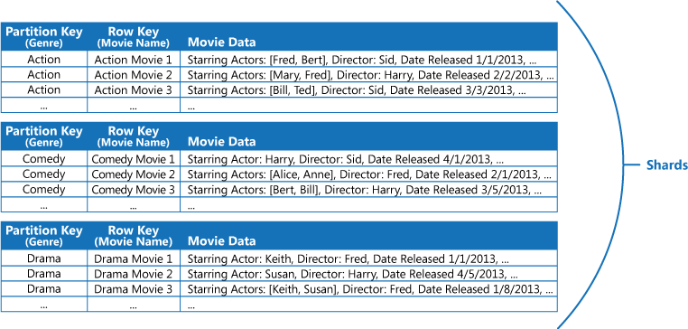

This approach is less effective if the application also needs to query movies by starring actor. In this case, you can create a separate Azure table that acts as an index table. The partition key is the actor and the row key is the movie name. The data for each actor will be stored in separate partitions. If a movie stars more than one actor, the same movie will occur in multiple partitions.

You can duplicate the movie data in the values held by each partition by adopting the first approach described in the Solution section above. However, it's likely that each movie will be replicated several times (once for each actor), so it might be more efficient to partially denormalize the data to support the most common queries (such as the names of the other actors) and enable an application to retrieve any remaining details by including the partition key necessary to find the complete information in the genre partitions. This approach is described by the third option in the Solution section. The next figure shows this approach.

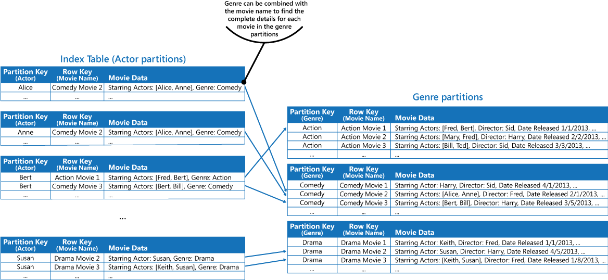

### Competing Consumers

Enable multiple concurrent consumers to process messages received on the same messaging channel. This enables a system to process multiple messages concurrently to optimize throughput, to improve scalability and availability, and to balance the workload.

**Context and problem**

An application running in the cloud is expected to handle a large number of requests. Rather than process each request synchronously, a common technique is for the application to pass them through a messaging system to another service (a consumer service) that handles them asynchronously. This strategy helps to ensure that the business logic in the application isn't blocked while the requests are being processed.

The number of requests can vary significantly over time for many reasons. A sudden increase in user activity or aggregated requests coming from multiple tenants can cause an unpredictable workload. At peak hours a system might need to process many hundreds of requests per second, while at other times the number could be very small. Additionally, the nature of the work performed to handle these requests might be highly variable. Using a single instance of the consumer service can cause that instance to become flooded with requests, or the messaging system might be overloaded by an influx of messages coming from the application. To handle this fluctuating workload, the system can run multiple instances of the consumer service. However, these consumers must be coordinated to ensure that each message is only delivered to a single consumer. The workload also needs to be load balanced across consumers to prevent an instance from becoming a bottleneck.

**Solution**

Use a message queue to implement the communication channel between the application and the instances of the consumer service. The application posts requests in the form of messages to the queue, and the consumer service instances receive messages from the queue and process them. This approach enables the same pool of consumer service instances to handle messages from any instance of the application. The figure illustrates using a message queue to distribute work to instances of a service.

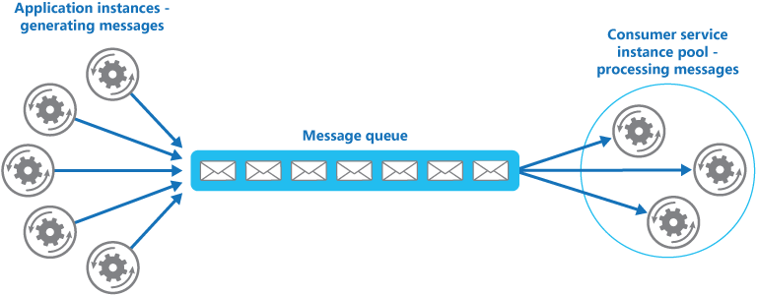

This solution has the following benefits:

* It provides a load-leveled system that can handle wide variations in the volume of requests sent by application instances. The queue acts as a buffer between the application instances and the consumer service instances. This can help to minimize the impact on availability and responsiveness for both the application and the service instances, as described by the [Queue-based Load Leveling pattern](https://docs.microsoft.com/en-us/azure/architecture/patterns/queue-based-load-leveling). Handling a message that requires some long-running processing doesn't prevent other messages from being handled concurrently by other instances of the consumer service.
* It improves reliability. If a producer communicates directly with a consumer instead of using this pattern, but doesn't monitor the consumer, there's a high probability that messages could be lost or fail to be processed if the consumer fails. In this pattern, messages aren't sent to a specific service instance. A failed service instance won't block a producer, and messages can be processed by any working service instance.
* It doesn't require complex coordination between the consumers, or between the producer and the consumer instances. The message queue ensures that each message is delivered at least once.
* It's scalable. The system can dynamically increase or decrease the number of instances of the consumer service as the volume of messages fluctuates.
* It can improve resiliency if the message queue provides transactional read operations. If a consumer service instance reads and processes the message as part of a transactional operation, and the consumer service instance fails, this pattern can ensure that the message will be returned to the queue to be picked up and handled by another instance of the consumer service.

**Issues and considerations**

Consider the following points when deciding how to implement this pattern:

* **Message ordering**. The order in which consumer service instances receive messages isn't guaranteed, and doesn't necessarily reflect the order in which the messages were created. Design the system to ensure that message processing is idempotent because this will help to eliminate any dependency on the order in which messages are handled. For more information, see [Idempotency Patterns](https://blog.jonathanoliver.com/idempotency-patterns/) on Jonathon Oliver’s blog.

Microsoft Azure Service Bus Queues can implement guaranteed first-in-first-out ordering of messages by using message sessions. For more information, see [Messaging Patterns Using Sessions](https://docs.microsoft.com/en-us/archive/msdn-magazine/2012/december/azure-insider-microsoft-azure-service-bus-messaging-patterns-using-sessions).

* **Designing services for resiliency**. If the system is designed to detect and restart failed service instances, it might be necessary to implement the processing performed by the service instances as idempotent operations to minimize the effects of a single message being retrieved and processed more than once.
* **Detecting poison messages**. A malformed message, or a task that requires access to resources that aren't available, can cause a service instance to fail. The system should prevent such messages being returned to the queue, and instead capture and store the details of these messages elsewhere so that they can be analyzed if necessary.
* **Handling results**. The service instance handling a message is fully decoupled from the application logic that generates the message, and they might not be able to communicate directly. If the service instance generates results that must be passed back to the application logic, this information must be stored in a location that's accessible to both. In order to prevent the application logic from retrieving incomplete data the system must indicate when processing is complete.

If you're using Azure, a worker process can pass results back to the application logic by using a dedicated message reply queue. The application logic must be able to correlate these results with the original message. This scenario is described in more detail in the [Asynchronous Messaging Primer](https://docs.microsoft.com/en-us/previous-versions/msp-n-p/dn589781(v=pandp.10)).

* **Scaling the messaging system**. In a large-scale solution, a single message queue could be overwhelmed by the number of messages and become a bottleneck in the system. In this situation, consider partitioning the messaging system to send messages from specific producers to a particular queue, or use load balancing to distribute messages across multiple message queues.
* **Ensuring reliability of the messaging system**. A reliable messaging system is needed to guarantee that after the application enqueues a message it won't be lost. This is essential for ensuring that all messages are delivered at least once.

**When to use this pattern**

Use this pattern when:

* The workload for an application is divided into tasks that can run asynchronously.
* Tasks are independent and can run in parallel.
* The volume of work is highly variable, requiring a scalable solution.
* The solution must provide high availability, and must be resilient if the processing for a task fails.

This pattern might not be useful when:

* It's not easy to separate the application workload into discrete tasks, or there's a high degree of dependence between tasks.
* Tasks must be performed synchronously, and the application logic must wait for a task to complete before continuing.
* Tasks must be performed in a specific sequence.

Some messaging systems support sessions that enable a producer to group messages together and ensure that they're all handled by the same consumer. This mechanism can be used with prioritized messages (if they are supported) to implement a form of message ordering that delivers messages in sequence from a producer to a single consumer.

**Example**

Azure provides Service Bus Queues and Azure Function queue triggers that, when combined, are a direct implementation of this cloud design pattern. Azure Functions integrate with Azure Service Bus via triggers and bindings. Integrating with Service Bus allows you to build functions that consume queue messages sent by publishers. The publishing application(s) will post messages to a queue, and consumers, implemented as Azure Functions, can retrieve messages from this queue and handle them.

For resiliency, a Service Bus queue enables a consumer to use PeekLock mode when it retrieves a message from the queue; this mode doesn't actually remove the message, but simply hides it from other consumers. The Azure Functions runtime receives a message in PeekLock mode, if the function finishes successfully it calls Complete on the message, or it may call Abandon if the function fails, and the message will become visible again, allowing another consumer to retrieve it. If the function runs for a period longer than the PeekLock timeout, the lock is automatically renewed as long as the function is running.

Azure Functions can scale out/in based on the depth of the queue, all acting as competing consumers of the queue. If multiple instances of the functions are created they all compete by independently pulling and processing the messages.

For detailed information on using Azure Service Bus queues, see [Service Bus queues, topics, and subscriptions](https://docs.microsoft.com/en-us/azure/service-bus-messaging/service-bus-queues-topics-subscriptions).

For information on Queue triggered Azure Functions, see [Azure Service Bus trigger for Azure Functions](https://docs.microsoft.com/en-us/azure/azure-functions/functions-bindings-service-bus-trigger).

The following code shows how you can create a new message and send it to a Service Bus Queue by using a QueueClient instance.

C#

private string serviceBusConnectionString = ...;

...

public async Task SendMessagesAsync(CancellationToken ct)

{

try

{

var msgNumber = 0;

var queueClient = new QueueClient(serviceBusConnectionString, "myqueue");

while (!ct.IsCancellationRequested)

{

// Create a new message to send to the queue

string messageBody = $"Message {msgNumber}";

var message = new Message(Encoding.UTF8.GetBytes(messageBody));

// Write the body of the message to the console

this._logger.LogInformation($"Sending message: {messageBody}");

// Send the message to the queue

await queueClient.SendAsync(message);

this._logger.LogInformation("Message successfully sent.");

msgNumber++;

}

}

catch (Exception exception)

{

this._logger.LogException(exception.Message);

}

}

The following code example shows a consumer, written as a C# Azure Function, that reads message metadata and logs a Service Bus Queue message. Note how the ServiceBusTrigger attribute is used to bind it to a Service Bus Queue.

C#

[FunctionName("ProcessQueueMessage")]

public static void Run(

[ServiceBusTrigger("myqueue", Connection = "ServiceBusConnectionString")]

string myQueueItem,

Int32 deliveryCount,

DateTime enqueuedTimeUtc,

string messageId,

ILogger log)

{

log.LogInformation($"C# ServiceBus queue trigger function consumed message: {myQueueItem}");

log.LogInformation($"EnqueuedTimeUtc={enqueuedTimeUtc}");

log.LogInformation($"DeliveryCount={deliveryCount}");

log.LogInformation($"MessageId={messageId}");

}

**Related patterns and guidance**

The following patterns and guidance might be relevant when implementing this pattern:

* [Asynchronous Messaging Primer](https://docs.microsoft.com/en-us/previous-versions/msp-n-p/dn589781(v=pandp.10)). Message queues are an asynchronous communications mechanism. If a consumer service needs to send a reply to an application, it might be necessary to implement some form of response messaging. The Asynchronous Messaging Primer provides information on how to implement request/reply messaging using message queues.
* [Autoscaling Guidance](https://docs.microsoft.com/en-us/previous-versions/msp-n-p/dn589774(v=pandp.10)). It might be possible to start and stop instances of a consumer service since the length of the queue applications post messages on varies. Autoscaling can help to maintain throughput during times of peak processing.
* [Compute Resource Consolidation pattern](https://docs.microsoft.com/en-us/azure/architecture/patterns/compute-resource-consolidation). It might be possible to consolidate multiple instances of a consumer service into a single process to reduce costs and management overhead. The Compute Resource Consolidation pattern describes the benefits and tradeoffs of following this approach.
* [Queue-based Load Leveling pattern](https://docs.microsoft.com/en-us/azure/architecture/patterns/queue-based-load-leveling). Introducing a message queue can add resiliency to the system, enabling service instances to handle widely varying volumes of requests from application instances. The message queue acts as a buffer, which levels the load. The Queue-based Load Leveling pattern describes this scenario in more detail.

### External Configuration Store

Move configuration information out of the application deployment package to a centralized location. This can provide opportunities for easier management and control of configuration data, and for sharing configuration data across applications and application instances.

**Context and problem**

The majority of application runtime environments include configuration information that's held in files deployed with the application. In some cases, it's possible to edit these files to change the application behavior after it's been deployed. However, changes to the configuration require the application be redeployed, often resulting in unacceptable downtime and other administrative overhead.

Local configuration files also limit the configuration to a single application, but sometimes it would be useful to share configuration settings across multiple applications. Examples include database connection strings, UI theme information, or the URLs of queues and storage used by a related set of applications.

It's challenging to manage changes to local configurations across multiple running instances of the application, especially in a cloud-hosted scenario. It can result in instances using different configuration settings while the update is being deployed.

In addition, updates to applications and components might require changes to configuration schemas. Many configuration systems don't support different versions of configuration information.

**Solution**

Store the configuration information in external storage, and provide an interface that can be used to quickly and efficiently read and update configuration settings. The type of external store depends on the hosting and runtime environment of the application. In a cloud-hosted scenario it's typically a cloud-based storage service, but could be a hosted database or other system.

The backing store you choose for configuration information should have an interface that provides consistent and easy-to-use access. It should expose the information in a correctly typed and structured format. The implementation might also need to authorize users’ access in order to protect configuration data, and be flexible enough to allow storage of multiple versions of the configuration (such as development, staging, or production, including multiple release versions of each one).

Many built-in configuration systems read the data when the application starts up, and cache the data in memory to provide fast access and minimize the impact on application performance. Depending on the type of backing store used, and the latency of this store, it might be helpful to implement a caching mechanism within the external configuration store. For more information, see the [Caching Guidance](https://docs.microsoft.com/en-us/previous-versions/msp-n-p/dn589802(v=pandp.10)). The figure illustrates an overview of the External Configuration Store pattern with optional local cache.

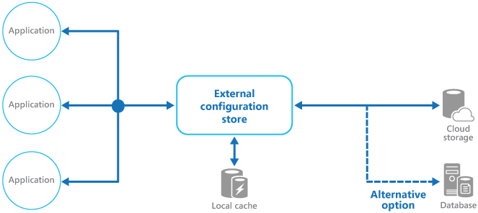

**Issues and considerations**

Consider the following points when deciding how to implement this pattern:

Choose a backing store that offers acceptable performance, high availability, robustness, and can be backed up as part of the application maintenance and administration process. In a cloud-hosted application, using a cloud storage mechanism is usually a good choice to meet these requirements.

Design the schema of the backing store to allow flexibility in the types of information it can hold. Ensure that it provides for all configuration requirements such as typed data, collections of settings, multiple versions of settings, and any other features that the applications using it require. The schema should be easy to extend to support additional settings as requirements change.

Consider the physical capabilities of the backing store, how it relates to the way configuration information is stored, and the effects on performance. For example, storing an XML document containing configuration information will require either the configuration interface or the application to parse the document in order to read individual settings. It'll make updating a setting more complicated, though caching the settings can help to offset slower read performance.

Consider how the configuration interface will permit control of the scope and inheritance of configuration settings. For example, it might be a requirement to scope configuration settings at the organization, application, and the machine level. It might need to support delegation of control over access to different scopes, and to prevent or allow individual applications to override settings.

Ensure that the configuration interface can expose the configuration data in the required formats such as typed values, collections, key/value pairs, or property bags.

Consider how the configuration store interface will behave when settings contain errors, or don't exist in the backing store. It might be appropriate to return default settings and log errors. Also consider aspects such as the case sensitivity of configuration setting keys or names, the storage and handling of binary data, and the ways that null or empty values are handled.

Consider how to protect the configuration data to allow access to only the appropriate users and applications. This is likely a feature of the configuration store interface, but it's also necessary to ensure that the data in the backing store can't be accessed directly without the appropriate permission. Ensure strict separation between the permissions required to read and to write configuration data. Also consider whether you need to encrypt some or all of the configuration settings, and how this'll be implemented in the configuration store interface.

Centrally stored configurations, which change application behavior during runtime, are critically important and should be deployed, updated, and managed using the same mechanisms as deploying application code. For example, changes that can affect more than one application must be carried out using a full test and staged deployment approach to ensure that the change is appropriate for all applications that use this configuration. If an administrator edits a setting to update one application, it could adversely impact other applications that use the same setting.

If an application caches configuration information, the application needs to be alerted if the configuration changes. It might be possible to implement an expiration policy over cached configuration data so that this information is automatically refreshed periodically and any changes picked up (and acted on).

**When to use this pattern**

This pattern is useful for:

* Configuration settings that are shared between multiple applications and application instances, or where a standard configuration must be enforced across multiple applications and application instances.
* A standard configuration system that doesn't support all of the required configuration settings, such as storing images or complex data types.
* As a complementary store for some of the settings for applications, perhaps allowing applications to override some or all of the centrally-stored settings.
* As a way to simplify administration of multiple applications, and optionally for monitoring use of configuration settings by logging some or all types of access to the configuration store.

**Example**

In a Microsoft Azure hosted application, a typical choice for storing configuration information externally is to use Azure Storage. This is resilient, offers high performance, and is replicated three times with automatic failover to offer high availability. Azure Table storage provides a key/value store with the ability to use a flexible schema for the values. Azure Blob storage provides a hierarchical, container-based store that can hold any type of data in individually named blobs.

The following example shows how a configuration store can be implemented over Blob storage to store and expose configuration information. The BlobSettingsStore class abstracts Blob storage for holding configuration information, and implements the ISettingsStore interface shown in the following code.

This code is provided in the *ExternalConfigurationStore.Cloud* project in the *ExternalConfigurationStore* solution, available from [GitHub](https://github.com/mspnp/cloud-design-patterns/tree/master/external-configuration-store).

C#Copy

public interface ISettingsStore

{

Task<ETag> GetVersionAsync();

Task<Dictionary<string, string>> FindAllAsync();

}

This interface defines methods for retrieving and updating configuration settings held in the configuration store, and includes a version number that can be used to detect whether any configuration settings have been modified recently. The BlobSettingsStore class uses the ETag property of the blob to implement versioning. The ETag property is updated automatically each time the blob is written.

By design, this simple solution exposes all configuration settings as string values rather than typed values.

The ExternalConfigurationManager class provides a wrapper around a BlobSettingsStore object. An application can use this class to store and retrieve configuration information. This class uses the Microsoft [Reactive Extensions](https://github.com/dotnet/reactive) library to expose any changes made to the configuration through an implementation of the IObservable interface. If a setting is modified by calling the SetAppSetting method, the Changed event is raised and all subscribers to this event will be notified.

Note that all settings are also cached in a Dictionary object inside the ExternalConfigurationManager class for fast access. The GetSetting method used to retrieve a configuration setting reads the data from the cache. If the setting isn't found in the cache, it's retrieved from the BlobSettingsStore object instead.

The GetSettings method invokes the CheckForConfigurationChanges method to detect whether the configuration information in blob storage has changed. It does this by examining the version number and comparing it with the current version number held by the ExternalConfigurationManager object. If one or more changes have occurred, the Changed event is raised and the configuration settings cached in the Dictionary object are refreshed. This is an application of the [Cache-Aside pattern](https://docs.microsoft.com/en-us/azure/architecture/patterns/cache-aside).

The following code sample shows how the Changed event, the GetSettings method, and the CheckForConfigurationChanges method are implemented:

C#Copy

public class ExternalConfigurationManager : IDisposable

{

// An abstraction of the configuration store.

private readonly ISettingsStore settings;

private readonly ISubject<KeyValuePair<string, string>> changed;

...

private readonly ReaderWriterLockSlim settingsCacheLock = new ReaderWriterLockSlim();

private readonly SemaphoreSlim syncCacheSemaphore = new SemaphoreSlim(1);

...

private Dictionary<string, string> settingsCache;

private ETag currentVersion;

...

public ExternalConfigurationManager(ISettingsStore settings, TimeSpan interval, string environment)

{

this.settings = settings;

this.interval = interval;

this.CheckForConfigurationChangesAsync().Wait();

this.changed = new Subject<KeyValuePair<string, string>>();

this.Environment = environment;

}

...

public IObservable<KeyValuePair<string, string>> Changed => this.changed.AsObservable();

...

public string GetAppSetting(string key)

{

...

// Try to get the value from the settings cache.

// If there's a cache miss, get the setting from the settings store and refresh the settings cache.

string value;

try

{

this.settingsCacheLock.EnterReadLock();

this.settingsCache.TryGetValue(key, out value);

}

finally

{

this.settingsCacheLock.ExitReadLock();

}

return value;

}

...

private void CheckForConfigurationChanges()

{

try

{

// It is assumed that updates are infrequent.

// To avoid race conditions in refreshing the cache, synchronize access to the in-memory cache.

await this.syncCacheSemaphore.WaitAsync();

var latestVersion = await this.settings.GetVersionAsync();

// If the versions are the same, nothing has changed in the configuration.

if (this.currentVersion == latestVersion) return;

// Get the latest settings from the settings store and publish changes.

var latestSettings = await this.settings.FindAllAsync();

// Refresh the settings cache.

try

{

this.settingsCacheLock.EnterWriteLock();

if (this.settingsCache != null)

{

//Notify settings changed

latestSettings.Except(this.settingsCache).ToList().ForEach(kv => this.changed.OnNext(kv));

}

this.settingsCache = latestSettings;

}

finally

{

this.settingsCacheLock.ExitWriteLock();

}

// Update the current version.

this.currentVersion = latestVersion;

}

catch (Exception ex)

{

this.changed.OnError(ex);

}

finally

{

this.syncCacheSemaphore.Release();

}

}

}

The ExternalConfigurationManager class also provides a property named Environment. This property supports varying configurations for an application running in different environments, such as staging and production.

An ExternalConfigurationManager object can also query the BlobSettingsStore object periodically for any changes. In the following code, the StartMonitor method calls CheckForConfigurationChanges at an interval to detect any changes and raise the Changed event, as described earlier.

C#Copy

public class ExternalConfigurationManager : IDisposable

{

...

private readonly ISubject<KeyValuePair<string, string>> changed;

private Dictionary<string, string> settingsCache;

private readonly CancellationTokenSource cts = new CancellationTokenSource();

private Task monitoringTask;

private readonly TimeSpan interval;

private readonly SemaphoreSlim timerSemaphore = new SemaphoreSlim(1);

...

public ExternalConfigurationManager(string environment) : this(new BlobSettingsStore(environment), TimeSpan.FromSeconds(15), environment)

{

}

public ExternalConfigurationManager(ISettingsStore settings, TimeSpan interval, string environment)

{

this.settings = settings;

this.interval = interval;

this.CheckForConfigurationChangesAsync().Wait();

this.changed = new Subject<KeyValuePair<string, string>>();

this.Environment = environment;

}

...

/// <summary>

/// Check to see if the current instance is monitoring for changes

/// </summary>

public bool IsMonitoring => this.monitoringTask != null && !this.monitoringTask.IsCompleted;

/// <summary>

/// Start the background monitoring for configuration changes in the central store

/// </summary>

public void StartMonitor()

{

if (this.IsMonitoring)

return;

try

{

this.timerSemaphore.Wait();

// Check again to make sure we are not already running.

if (this.IsMonitoring)

return;

// Start running our task loop.

this.monitoringTask = ConfigChangeMonitor();

}

finally

{

this.timerSemaphore.Release();

}

}

/// <summary>

/// Loop that monitors for configuration changes

/// </summary>

/// <returns></returns>

public async Task ConfigChangeMonitor()

{

while (!cts.Token.IsCancellationRequested)

{

await this.CheckForConfigurationChangesAsync();

await Task.Delay(this.interval, cts.Token);

}

}

/// <summary>

/// Stop monitoring for configuration changes

/// </summary>

public void StopMonitor()

{

try

{

this.timerSemaphore.Wait();

// Signal the task to stop.

this.cts.Cancel();

// Wait for the loop to stop.

this.monitoringTask.Wait();

this.monitoringTask = null;

}

finally

{

this.timerSemaphore.Release();

}

}

public void Dispose()

{

this.cts.Cancel();

}

...

}

The ExternalConfigurationManager class is instantiated as a singleton instance by the ExternalConfiguration class shown below.

C#Copy

public static class ExternalConfiguration

{

private static readonly Lazy<ExternalConfigurationManager> configuredInstance =

new Lazy<ExternalConfigurationManager>(

() =>

{

var environment = CloudConfigurationManager.GetSetting("environment");

return new ExternalConfigurationManager(environment);

});

public static ExternalConfigurationManager Instance => configuredInstance.Value;

}

The following code is taken from the WorkerRole class in the *ExternalConfigurationStore.Cloud* project. It shows how the application uses the ExternalConfiguration class to read a setting.

C#Copy

public override void Run()

{

// Start monitoring configuration changes.

ExternalConfiguration.Instance.StartMonitor();

// Get a setting.

var setting = ExternalConfiguration.Instance.GetAppSetting("setting1");

Trace.TraceInformation("Worker Role: Get setting1, value: " + setting);

this.completeEvent.WaitOne();

}

The following code, also from the WorkerRole class, shows how the application subscribes to configuration events.

C#Copy

public override bool OnStart()

{

...

// Subscribe to the event.

ExternalConfiguration.Instance.Changed.Subscribe(

m => Trace.TraceInformation("Configuration has changed. Key:{0} Value:{1}",

m.Key, m.Value),

ex => Trace.TraceError("Error detected: " + ex.Message));

...

}

### Retry pattern

Enable an application to handle transient failures when it tries to connect to a service or network resource, by transparently retrying a failed operation. This can improve the stability of the application.

**Context and problem**

An application that communicates with elements running in the cloud has to be sensitive to the transient faults that can occur in this environment. Faults include the momentary loss of network connectivity to components and services, the temporary unavailability of a service, or timeouts that occur when a service is busy.

These faults are typically self-correcting, and if the action that triggered a fault is repeated after a suitable delay it's likely to be successful. For example, a database service that's processing a large number of concurrent requests can implement a throttling strategy that temporarily rejects any further requests until its workload has eased. An application trying to access the database might fail to connect, but if it tries again after a delay it might succeed.

**Solution**

In the cloud, transient faults aren't uncommon and an application should be designed to handle them elegantly and transparently. This minimizes the effects faults can have on the business tasks the application is performing.

If an application detects a failure when it tries to send a request to a remote service, it can handle the failure using the following strategies:

* **Cancel**. If the fault indicates that the failure isn't transient or is unlikely to be successful if repeated, the application should cancel the operation and report an exception. For example, an authentication failure caused by providing invalid credentials is not likely to succeed no matter how many times it's attempted.
* **Retry**. If the specific fault reported is unusual or rare, it might have been caused by unusual circumstances such as a network packet becoming corrupted while it was being transmitted. In this case, the application could retry the failing request again immediately because the same failure is unlikely to be repeated and the request will probably be successful.
* **Retry after delay**. If the fault is caused by one of the more commonplace connectivity or busy failures, the network or service might need a short period while the connectivity issues are corrected or the backlog of work is cleared. The application should wait for a suitable time before retrying the request.

For the more common transient failures, the period between retries should be chosen to spread requests from multiple instances of the application as evenly as possible. This reduces the chance of a busy service continuing to be overloaded. If many instances of an application are continually overwhelming a service with retry requests, it'll take the service longer to recover.

If the request still fails, the application can wait and make another attempt. If necessary, this process can be repeated with increasing delays between retry attempts, until some maximum number of requests have been attempted. The delay can be increased incrementally or exponentially, depending on the type of failure and the probability that it'll be corrected during this time.

The following diagram illustrates invoking an operation in a hosted service using this pattern. If the request is unsuccessful after a predefined number of attempts, the application should treat the fault as an exception and handle it accordingly.

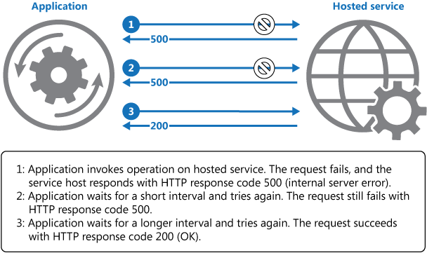

The application should wrap all attempts to access a remote service in code that implements a retry policy matching one of the strategies listed above. Requests sent to different services can be subject to different policies. Some vendors provide libraries that implement retry policies, where the application can specify the maximum number of retries, the time between retry attempts, and other parameters.

An application should log the details of faults and failing operations. This information is useful to operators. That being said, in order to avoid flooding operators with alerts on operations where subsequently retried attempts were successful, it is best to log early failures as *informational entries* and only the failure of the last of the retry attempts as an actual error. Here is an [example of how this logging model would look like](https://docs.particular.net/nservicebus/recoverability/#retry-logging).

If a service is frequently unavailable or busy, it's often because the service has exhausted its resources. You can reduce the frequency of these faults by scaling out the service. For example, if a database service is continually overloaded, it might be beneficial to partition the database and spread the load across multiple servers.

[Microsoft Entity Framework](https://docs.microsoft.com/en-us/ef) provides facilities for retrying database operations. Also, most Azure services and client SDKs include a retry mechanism. For more information, see [Retry guidance for specific services](https://docs.microsoft.com/en-us/azure/architecture/best-practices/retry-service-specific).

**Issues and considerations**

You should consider the following points when deciding how to implement this pattern.

The retry policy should be tuned to match the business requirements of the application and the nature of the failure. For some noncritical operations, it's better to fail fast rather than retry several times and impact the throughput of the application. For example, in an interactive web application accessing a remote service, it's better to fail after a smaller number of retries with only a short delay between retry attempts, and display a suitable message to the user (for example, “please try again later”). For a batch application, it might be more appropriate to increase the number of retry attempts with an exponentially increasing delay between attempts.

An aggressive retry policy with minimal delay between attempts, and a large number of retries, could further degrade a busy service that's running close to or at capacity. This retry policy could also affect the responsiveness of the application if it's continually trying to perform a failing operation.

If a request still fails after a significant number of retries, it's better for the application to prevent further requests going to the same resource and simply report a failure immediately. When the period expires, the application can tentatively allow one or more requests through to see whether they're successful. For more details of this strategy, see the [Circuit Breaker pattern](https://docs.microsoft.com/en-us/azure/architecture/patterns/circuit-breaker).

Consider whether the operation is idempotent. If so, it's inherently safe to retry. Otherwise, retries could cause the operation to be executed more than once, with unintended side effects. For example, a service might receive the request, process the request successfully, but fail to send a response. At that point, the retry logic might re-send the request, assuming that the first request wasn't received.

A request to a service can fail for a variety of reasons raising different exceptions depending on the nature of the failure. Some exceptions indicate a failure that can be resolved quickly, while others indicate that the failure is longer lasting. It's useful for the retry policy to adjust the time between retry attempts based on the type of the exception.

Consider how retrying an operation that's part of a transaction will affect the overall transaction consistency. Fine tune the retry policy for transactional operations to maximize the chance of success and reduce the need to undo all the transaction steps.

Ensure that all retry code is fully tested against a variety of failure conditions. Check that it doesn't severely impact the performance or reliability of the application, cause excessive load on services and resources, or generate race conditions or bottlenecks.

Implement retry logic only where the full context of a failing operation is understood. For example, if a task that contains a retry policy invokes another task that also contains a retry policy, this extra layer of retries can add long delays to the processing. It might be better to configure the lower-level task to fail fast and report the reason for the failure back to the task that invoked it. This higher-level task can then handle the failure based on its own policy.

It's important to log all connectivity failures that cause a retry so that underlying problems with the application, services, or resources can be identified.

Investigate the faults that are most likely to occur for a service or a resource to discover if they're likely to be long lasting or terminal. If they are, it's better to handle the fault as an exception. The application can report or log the exception, and then try to continue either by invoking an alternative service (if one is available), or by offering degraded functionality. For more information on how to detect and handle long-lasting faults, see the [Circuit Breaker pattern](https://docs.microsoft.com/en-us/azure/architecture/patterns/circuit-breaker).

**When to use this pattern**

Use this pattern when an application could experience transient faults as it interacts with a remote service or accesses a remote resource. These faults are expected to be short lived, and repeating a request that has previously failed could succeed on a subsequent attempt.

This pattern might not be useful:

* When a fault is likely to be long lasting, because this can affect the responsiveness of an application. The application might be wasting time and resources trying to repeat a request that's likely to fail.
* For handling failures that aren't due to transient faults, such as internal exceptions caused by errors in the business logic of an application.
* As an alternative to addressing scalability issues in a system. If an application experiences frequent busy faults, it's often a sign that the service or resource being accessed should be scaled up.

**Example**

This example in C# illustrates an implementation of the Retry pattern. The OperationWithBasicRetryAsync method, shown below, invokes an external service asynchronously through the TransientOperationAsync method. The details of the TransientOperationAsync method will be specific to the service and are omitted from the sample code.

C#Copy

private int retryCount = 3;

private readonly TimeSpan delay = TimeSpan.FromSeconds(5);

public async Task OperationWithBasicRetryAsync()

{

int currentRetry = 0;

for (;;)

{

try

{

// Call external service.

await TransientOperationAsync();

// Return or break.

break;

}

catch (Exception ex)

{

Trace.TraceError("Operation Exception");

currentRetry++;

// Check if the exception thrown was a transient exception

// based on the logic in the error detection strategy.

// Determine whether to retry the operation, as well as how

// long to wait, based on the retry strategy.

if (currentRetry > this.retryCount || !IsTransient(ex))

{

// If this isn't a transient error or we shouldn't retry,

// rethrow the exception.

throw;

}

}

// Wait to retry the operation.

// Consider calculating an exponential delay here and

// using a strategy best suited for the operation and fault.

await Task.Delay(delay);

}

}

// Async method that wraps a call to a remote service (details not shown).

private async Task TransientOperationAsync()

{

...

}

The statement that invokes this method is contained in a try/catch block wrapped in a for loop. The for loop exits if the call to the TransientOperationAsync method succeeds without throwing an exception. If the TransientOperationAsync method fails, the catch block examines the reason for the failure. If it's believed to be a transient error the code waits for a short delay before retrying the operation.

The for loop also tracks the number of times that the operation has been attempted, and if the code fails three times the exception is assumed to be more long lasting. If the exception isn't transient or it's long lasting, the catch handler throws an exception. This exception exits the for loop and should be caught by the code that invokes the OperationWithBasicRetryAsync method.

The IsTransient method, shown below, checks for a specific set of exceptions that are relevant to the environment the code is run in. The definition of a transient exception will vary according to the resources being accessed and the environment the operation is being performed in.

C#Copy

private bool IsTransient(Exception ex)

{

// Determine if the exception is transient.

// In some cases this is as simple as checking the exception type, in other

// cases it might be necessary to inspect other properties of the exception.

if (ex is OperationTransientException)

return true;

var webException = ex as WebException;

if (webException != null)

{

// If the web exception contains one of the following status values

// it might be transient.

return new[] {WebExceptionStatus.ConnectionClosed,

WebExceptionStatus.Timeout,

WebExceptionStatus.RequestCanceled }.

Contains(webException.Status);

}

// Additional exception checking logic goes here.

return false;

}

### Throttling pattern

Control the consumption of resources used by an instance of an application, an individual tenant, or an entire service. This can allow the system to continue to function and meet service level agreements, even when an increase in demand places an extreme load on resources.

**Context and problem**

The load on a cloud application typically varies over time based on the number of active users or the types of activities they are performing. For example, more users are likely to be active during business hours, or the system might be required to perform computationally expensive analytics at the end of each month. There might also be sudden and unanticipated bursts in activity. If the processing requirements of the system exceed the capacity of the resources that are available, it'll suffer from poor performance and can even fail. If the system has to meet an agreed level of service, such failure could be unacceptable.

There're many strategies available for handling varying load in the cloud, depending on the business goals for the application. One strategy is to use autoscaling to match the provisioned resources to the user needs at any given time. This has the potential to consistently meet user demand, while optimizing running costs. However, while autoscaling can trigger the provisioning of additional resources, this provisioning isn't immediate. If demand grows quickly, there can be a window of time where there's a resource deficit.

**Solution**

An alternative strategy to autoscaling is to allow applications to use resources only up to a limit, and then throttle them when this limit is reached. The system should monitor how it's using resources so that, when usage exceeds the threshold, it can throttle requests from one or more users. This will enable the system to continue functioning and meet any service level agreements (SLAs) that are in place. For more information on monitoring resource usage, see the [Instrumentation and Telemetry Guidance](https://docs.microsoft.com/en-us/previous-versions/msp-n-p/dn589775(v=pandp.10)).

The system could implement several throttling strategies, including:

* Rejecting requests from an individual user who's already accessed system APIs more than n times per second over a given period of time. This requires the system to meter the use of resources for each tenant or user running an application. For more information, see the [Service Metering Guidance](https://docs.microsoft.com/en-us/previous-versions/msp-n-p/dn589796(v=pandp.10)).
* Disabling or degrading the functionality of selected nonessential services so that essential services can run unimpeded with sufficient resources. For example, if the application is streaming video output, it could switch to a lower resolution.
* Using load leveling to smooth the volume of activity (this approach is covered in more detail by the [Queue-based Load Leveling pattern](https://docs.microsoft.com/en-us/azure/architecture/patterns/queue-based-load-leveling)). In a multi-tenant environment, this approach will reduce the performance for every tenant. If the system must support a mix of tenants with different SLAs, the work for high-value tenants might be performed immediately. Requests for other tenants can be held back, and handled when the backlog has eased. The [Priority Queue pattern](https://docs.microsoft.com/en-us/azure/architecture/patterns/priority-queue) could be used to help implement this approach.
* Deferring operations being performed on behalf of lower priority applications or tenants. These operations can be suspended or limited, with an exception generated to inform the tenant that the system is busy and that the operation should be retried later.

The figure shows an area graph for resource use (a combination of memory, CPU, bandwidth, and other factors) against time for applications that are making use of three features. A feature is an area of functionality, such as a component that performs a specific set of tasks, a piece of code that performs a complex calculation, or an element that provides a service such as an in-memory cache. These features are labeled A, B, and C.

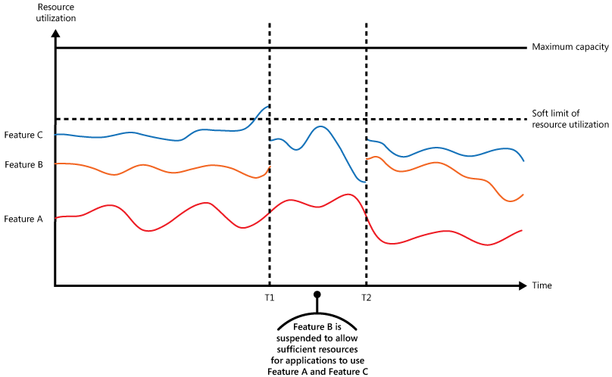

The area immediately below the line for a feature indicates the resources that are used by applications when they invoke this feature. For example, the area below the line for Feature A shows the resources used by applications that are making use of Feature A, and the area between the lines for Feature A and Feature B indicates the resources used by applications invoking Feature B. Aggregating the areas for each feature shows the total resource use of the system.

The previous figure illustrates the effects of deferring operations. Just prior to time T1, the total resources allocated to all applications using these features reach a threshold (the limit of resource use). At this point, the applications are in danger of exhausting the resources available. In this system, Feature B is less critical than Feature A or Feature C, so it's temporarily disabled and the resources that it was using are released. Between times T1 and T2, the applications using Feature A and Feature C continue running as normal. Eventually, the resource use of these two features diminishes to the point when, at time T2, there is sufficient capacity to enable Feature B again.

The autoscaling and throttling approaches can also be combined to help keep the applications responsive and within SLAs. If the demand is expected to remain high, throttling provides a temporary solution while the system scales out. At this point, the full functionality of the system can be restored.

The next figure shows an area graph of the overall resource use by all applications running in a system against time, and illustrates how throttling can be combined with autoscaling.

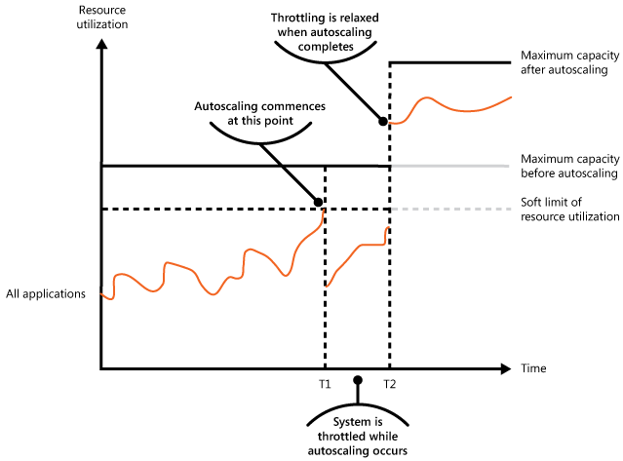

At time T1, the threshold specifying the soft limit of resource use is reached. At this point, the system can start to scale out. However, if the new resources don't become available quickly enough, then the existing resources might be exhausted and the system could fail. To prevent this from occurring, the system is temporarily throttled, as described earlier. When autoscaling has completed and the additional resources are available, throttling can be relaxed.

**Issues and considerations**

You should consider the following points when deciding how to implement this pattern:

* Throttling an application, and the strategy to use, is an architectural decision that impacts the entire design of a system. Throttling should be considered early in the application design process because it isn't easy to add once a system has been implemented.
* Throttling must be performed quickly. The system must be capable of detecting an increase in activity and react accordingly. The system must also be able to revert to its original state quickly after the load has eased. This requires that the appropriate performance data is continually captured and monitored.
* If a service needs to temporarily deny a user request, it should return a specific error code so the client application understands that the reason for the refusal to perform an operation is due to throttling. The client application can wait for a period before retrying the request.
* Throttling can be used as a temporary measure while a system autoscales. In some cases it's better to simply throttle, rather than to scale, if a burst in activity is sudden and isn't expected to be long lived because scaling can add considerably to running costs.
* If throttling is being used as a temporary measure while a system autoscales, and if resource demands grow very quickly, the system might not be able to continue functioning—even when operating in a throttled mode. If this isn't acceptable, consider maintaining larger capacity reserves and configuring more aggressive autoscaling.

**When to use this pattern**

Use this pattern:

* To ensure that a system continues to meet service level agreements.
* To prevent a single tenant from monopolizing the resources provided by an application.
* To handle bursts in activity.
* To help cost-optimize a system by limiting the maximum resource levels needed to keep it functioning.

**Example**

The final figure illustrates how throttling can be implemented in a multi-tenant system. Users from each of the tenant organizations access a cloud-hosted application where they fill out and submit surveys. The application contains instrumentation that monitors the rate at which these users are submitting requests to the application.

In order to prevent the users from one tenant affecting the responsiveness and availability of the application for all other users, a limit is applied to the number of requests per second the users from any one tenant can submit. The application blocks requests that exceed this limit.

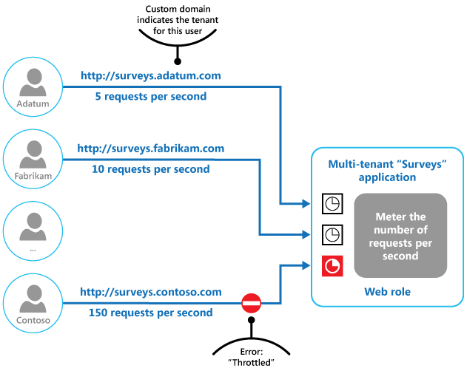

### Federated Identity

Delegate authentication to an external identity provider. This can simplify development, minimize the requirement for user administration, and improve the user experience of the application.

**Context and problem**

Users typically need to work with multiple applications provided and hosted by different organizations they have a business relationship with. These users might be required to use specific (and different) credentials for each one. This can:

* **Cause a disjointed user experience**. Users often forget sign-in credentials when they have many different ones.
* **Expose security vulnerabilities**. When a user leaves the company the account must immediately be deprovisioned. It's easy to overlook this in large organizations.
* **Complicate user management**. Administrators must manage credentials for all of the users, and perform additional tasks such as providing password reminders.

Users typically prefer to use the same credentials for all these applications.

**Solution**

Implement an authentication mechanism that can use federated identity. Separate user authentication from the application code, and delegate authentication to a trusted identity provider. This can simplify development and allow users to authenticate using a wider range of identity providers (IdP) while minimizing the administrative overhead. It also allows you to clearly decouple authentication from authorization.

The trusted identity providers include corporate directories, on-premises federation services, other security token services (STS) provided by business partners, or social identity providers that can authenticate users who have, for example, a Microsoft, Google, Yahoo!, or Facebook account.

The figure illustrates the Federated Identity pattern when a client application needs to access a service that requires authentication. The authentication is performed by an IdP that works in concert with an STS. The IdP issues security tokens that provide information about the authenticated user. This information, referred to as claims, includes the user’s identity, and might also include other information such as role membership and more granular access rights.

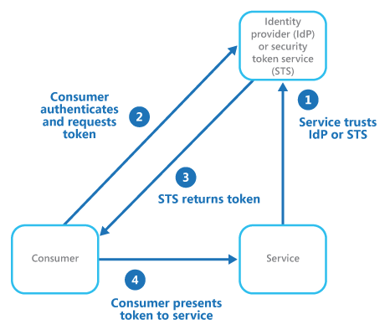

This model is often called claims-based access control. Applications and services authorize access to features and functionality based on the claims contained in the token. The service that requires authentication must trust the IdP. The client application contacts the IdP that performs the authentication. If the authentication is successful, the IdP returns a token containing the claims that identify the user to the STS (note that the IdP and STS can be the same service). The STS can transform and augment the claims in the token based on predefined rules, before returning it to the client. The client application can then pass this token to the service as proof of its identity.

There might be additional security token services in the chain of trust. For example, in the scenario described later, an on-premises STS trusts another STS that is responsible for accessing an identity provider to authenticate the user. This approach is common in enterprise scenarios where there's an on-premises STS and directory.

Federated authentication provides a standards-based solution to the issue of trusting identities across diverse domains, and can support single sign-on. It's becoming more common across all types of applications, especially cloud-hosted applications, because it supports single sign-on without requiring a direct network connection to identity providers. The user doesn't have to enter credentials for every application. This increases security because it prevents the creation of credentials required to access many different applications, and it also hides the user’s credentials from all but the original identity provider. Applications see just the authenticated identity information contained within the token.

Federated identity also has the major advantage that management of the identity and credentials is the responsibility of the identity provider. The application or service doesn't need to provide identity management features. In addition, in corporate scenarios, the corporate directory doesn't need to know about the user if it trusts the identity provider. This removes all the administrative overhead of managing the user identity within the directory.

**Issues and considerations**

Consider the following when designing applications that implement federated authentication:

* Authentication can be a single point of failure. If you deploy your application to multiple datacenters, consider deploying your identity management mechanism to the same datacenters to maintain application reliability and availability.
* Authentication tools make it possible to configure access control based on role claims contained in the authentication token. This is often referred to as role-based access control (RBAC), and it can allow a more granular level of control over access to features and resources.
* Unlike a corporate directory, claims-based authentication using social identity providers doesn't usually provide information about the authenticated user other than an email address, and perhaps a name. Some social identity providers, such as a Microsoft account, provide only a unique identifier. The application usually needs to maintain some information on registered users, and be able to match this information to the identifier contained in the claims in the token. Typically this is done through registration when the user first accesses the application, and information is then injected into the token as additional claims after each authentication.
* If there's more than one identity provider configured for the STS, it must detect which identity provider the user should be redirected to for authentication. This process is called home realm discovery. The STS might be able to do this automatically based on an email address or user name that the user provides, a subdomain of the application that the user is accessing, the user’s IP address scope, or on the contents of a cookie stored in the user’s browser. For example, if the user entered an email address in the Microsoft domain, such as user@live.com, the STS will redirect the user to the Microsoft account sign-in page. On later visits, the STS could use a cookie to indicate that the last sign in was with a Microsoft account. If automatic discovery can't determine the home realm, the STS will display a home realm discovery page that lists the trusted identity providers, and the user must select the one they want to use.

**When to use this pattern**

This pattern is useful for scenarios such as:

* **Single sign-on in the enterprise**. In this scenario you need to authenticate employees for corporate applications that are hosted in the cloud outside the corporate security boundary, without requiring them to sign in every time they visit an application. The user experience is the same as when using on-premises applications where they're authenticated when signing in to a corporate network, and from then on have access to all relevant applications without needing to sign in again.
* **Federated identity with multiple partners**. In this scenario you need to authenticate both corporate employees and business partners who don't have accounts in the corporate directory. This is common in business-to-business applications, applications that integrate with third-party services, and where companies with different IT systems have merged or shared resources.
* **Federated identity in SaaS applications**. In this scenario independent software vendors provide a ready-to-use service for multiple clients or tenants. Each tenant authenticates using a suitable identity provider. For example, business users will use their corporate credentials, while consumers and clients of the tenant will use their social identity credentials.

This pattern might not be useful in the following situations:

* All users of the application can be authenticated by one identity provider, and there's no requirement to authenticate using any other identity provider. This is typical in business applications that use a corporate directory (accessible within the application) for authentication, by using a VPN, or (in a cloud-hosted scenario) through a virtual network connection between the on-premises directory and the application.
* The application was originally built using a different authentication mechanism, perhaps with custom user stores, or doesn't have the capability to handle the negotiation standards used by claims-based technologies. Retrofitting claims-based authentication and access control into existing applications can be complex, and probably not cost effective.

**Example**

An organization hosts a multi-tenant software as a service (SaaS) application in Microsoft Azure. The application includes a website that tenants can use to manage the application for their own users. The application allows tenants to access the website by using a federated identity that is generated by Active Directory Federation Services (AD FS) when a user is authenticated by that organization’s own Active Directory.

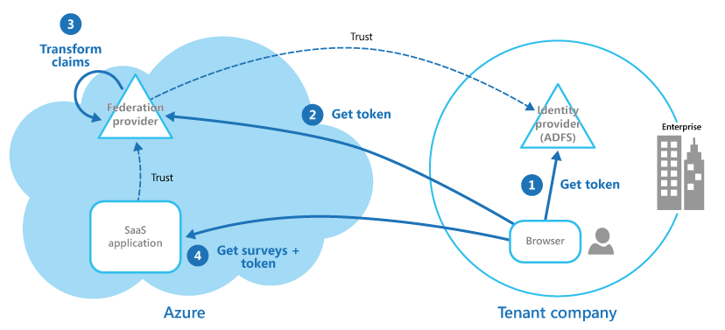

The figure shows how tenants authenticate with their own identity provider (step 1), in this case AD FS. After successfully authenticating a tenant, AD FS issues a token. The client browser forwards this token to the SaaS application’s federation provider, which trusts tokens issued by the tenant’s AD FS, in order to get back a token that is valid for the SaaS federation provider (step 2). If necessary, the SaaS federation provider performs a transformation on the claims in the token into claims that the application recognizes (step 3) before returning the new token to the client browser. The application trusts tokens issued by the SaaS federation provider and uses the claims in the token to apply authorization rules (step 4).

Tenants won't need to remember separate credentials to access the application, and an administrator at the tenant’s company can configure in its own AD FS the list of users that can access the application.

### Geodes

The geode pattern involves deploying a collection of backend services into a set of **ge**ographical n**ode**s, each of which can service any request for any client in any region. This pattern allows serving requests in an *active-active* style, improving latency and increasing availability by distributing request processing around the globe.

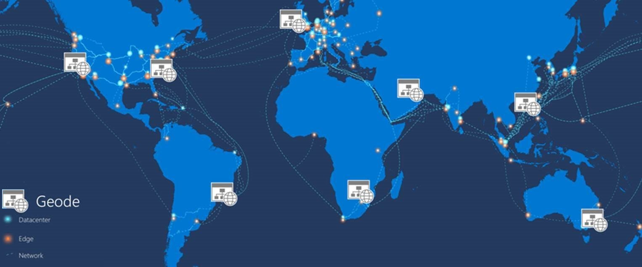

**Context and problem**

Many large-scale services have specific challenges around geo-availability and scale. Classic designs often *bring the data to the compute* by storing data in a remote SQL server that serves as the compute tier for that data, relying on scale-up for growth.

The classic approach may present a number of challenges:

* Network latency issues for users coming from the other side of the globe to connect to the hosting endpoint
* Traffic management for demand bursts that can overwhelm the services in a single region
* Cost-prohibitive complexity of deploying copies of app infrastructure into multiple regions for a 24x7 service

Modern cloud infrastructure has evolved to enable geographic load balancing of front-end services, while allowing for geographic replication of backend services. For availability and performance, getting data closer to the user is good. When data is geo-distributed across a far-flung user base, the geo-distributed datastores should also be colocated with the compute resources that process the data. The geode pattern *brings the compute to the data*.

**Solution**

Deploy the service into a number of satellite deployments spread around the globe, each of which is called a *geode*. The geode pattern harnesses key features of Azure to route traffic via the shortest path to a nearby geode, which improves latency and performance. Each geode is behind a global load balancer, and uses a geo-replicated read-write service like [Azure Cosmos DB](https://docs.microsoft.com/en-us/azure/cosmos-db/introduction) to host the data plane, ensuring cross-geode data consistency. Data replication services ensure that data stores are identical across geodes, so *all* requests can be served from *all* geodes.

The key difference between a [deployment stamp](https://docs.microsoft.com/en-us/azure/architecture/patterns/deployment-stamp) and a geode is that geodes never exist in isolation. There should always be more than one geode in a production platform.

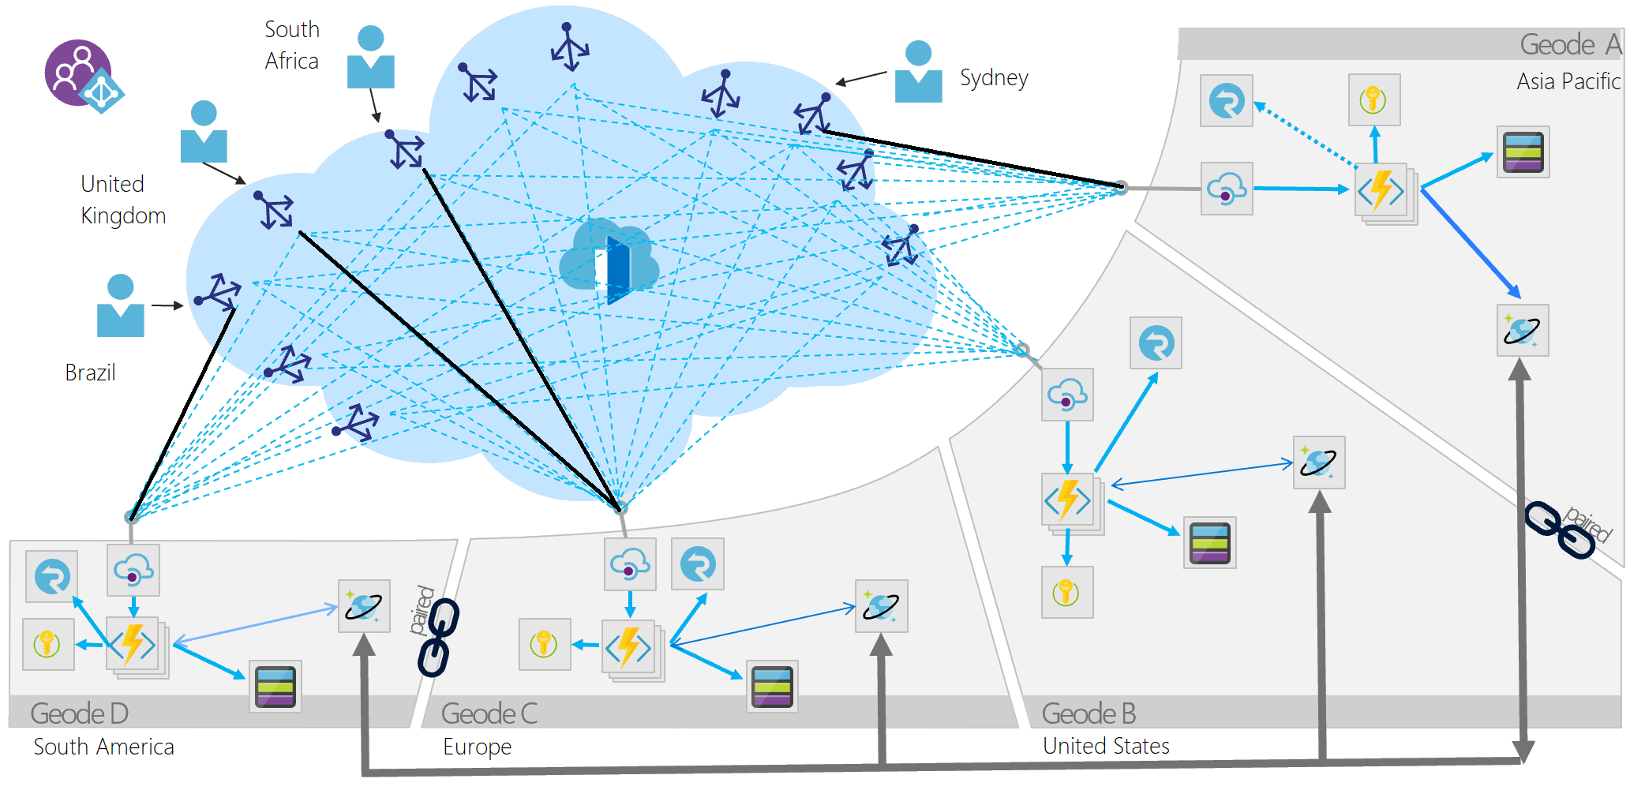

Geodes have the following characteristics:

* Consist of a collection of disparate types of resources, often defined in a template.
* Have no dependencies outside of the geode footprint and are self-contained. No geode is dependent on another to operate, and if one dies, the others continue to operate.
* Are loosely coupled via an edge network and replication backplane. For example, you can use [Azure Traffic Manager](https://docs.microsoft.com/en-us/azure/traffic-manager/traffic-manager-overview) or [Azure Front Door](https://docs.microsoft.com/en-us/azure/frontdoor/front-door-overview) for fronting the geodes, while Azure Cosmos DB can act as the replication backplane. Geodes are not the same as clusters because they share a replication backplane, so the platform takes care of quorum issues.

The geode pattern occurs in big data architectures that use commodity hardware to process data colocated on the same machine, and MapReduce to consolidate results across machines. Another usage is near-edge compute, which brings compute closer to the intelligent edge of the network to reduce response time.

Services can use this pattern over dozens or hundreds of geodes. Furthermore, the resiliency of the whole solution increases with each added geode, since any geodes can take over if a regional outage takes one or more geodes offline.

It's also possible to augment local availability techniques, such as availability zones or paired regions, with the geode pattern for global availability. This increases complexity, but is useful if your architecture is underpinned by a storage engine such as blob storage that can only replicate to a paired region. You can deploy geodes into an intra-zone, zonal, or regional footprint, with a mind to regulatory or latency constraints on location.

**Issues and considerations**

Use the following techniques and technologies to implement this pattern:

* Modern DevOps practices and tools to produce and rapidly deploy identical geodes across a large number of regions or instances.
* Autoscaling to scale out compute and database throughput instances within a geode. Each geode individually scales out, within the common backplane constraints.
* A front-end service like Azure Front Door that does dynamic content acceleration, split TCP, and Anycast routing.
* A replicating data store like Azure Cosmos DB to control data consistency.
* Serverless technologies where possible, to reduce always-on deployment cost, especially when load is frequently rebalanced around the globe. This strategy allows for many geodes to be deployed with minimal additional investment. Serverless and consumption-based billing technologies reduce waste and cost from duplicate geo-distributed deployments.

Consider the following points when deciding how to implement this pattern:

* Choose whether to process data locally in each region, or to distribute aggregations in a single geode and replicate the result across the globe. The [Azure Cosmos DB change feed processor](https://docs.microsoft.com/en-us/azure/cosmos-db/change-feed-processor) offers this granular control using its *lease container* concept, and the *leasecollectionprefix* in the corresponding [Azure Functions binding](https://docs.microsoft.com/en-us/azure/cosmos-db/change-feed-functions). Each approach has distinct advantages and drawbacks.
* Geodes can work in tandem, using the Azure Cosmos DB change feed and a real-time communication platform like SignalR. Geodes can communicate with remote users via other geodes in a mesh pattern, without knowing or caring where the remote user is located.
* This design pattern implicitly decouples everything, resulting in an ultra-highly distributed and decoupled architecture. Decoupling is a good thing, but consider how to track different components of the same request as they might execute asynchronously on different instances. Get a good monitoring strategy in place.

**When to use this pattern**

Use this pattern:

* To implement a high-scale platform that has users distributed over a wide area.
* For any service that requires extreme availability and resilience characteristics, because services based on the geode pattern can survive the loss of multiple service regions at the same time.

This pattern might not be suitable for

* Architectures that have constraints so that all geodes can't be equal for data storage. For example, there may be data residency requirements, an application that needs to maintain temporary state for a particular session, or a heavy weighting of requests towards a single region. In this case, consider using [deployment stamps](https://docs.microsoft.com/en-us/azure/architecture/patterns/deployment-stamp) in combination with a global routing plane that is aware of where a user’s data sits, such as the traffic routing component described within the [deployment stamps pattern](https://docs.microsoft.com/en-us/azure/architecture/patterns/deployment-stamp).
* Situations where there's no geographical distribution required. Instead, consider availability zones and paired regions for clustering.
* Situations where a legacy platform needs to be retrofitted. This pattern works for cloud-native development only, and can be difficult to retrofit.
* Simple architectures and requirements, where geo-redundancy and geo-distribution aren't required or advantageous.

**Examples**

* Windows Active Directory implements an early variant of this pattern. Multi-primary replication means all updates and requests can in theory be served from all serviceable nodes, but FSMO roles mean that all geodes aren't equal.
* A [QnA sample application](https://github.com/xstof/qnademo) on GitHub showcases this design pattern in practice.

## Data Consistency Primer

Cloud applications typically use data that is dispersed across data stores. Managing and maintaining data consistency in this environment can become a critical aspect of the system, particularly in terms of the concurrency and availability issues that can arise. You frequently need to trade strong consistency for availability. This means that you may need to design some aspects of your solutions around the notion of eventual consistency and accept that the data that your applications use might not be completely consistent all of the time.

### Managing Data Consistency

Every web application and service uses data. This data is frequently required to help users and organizations make business decisions, and therefore it may be important that this data accurately represents the most current information available and that it is consistent. Data consistency implies that all instances of an application are presented with the same set of data values all of the time. This approach is sometimes referred to as *strong* data consistency.

In the world of relational databases, consistency is often enforced by transactional models that use locks to prevent concurrent application instances from modifying the same data at the same time. In a strongly consistent system, the locks also block concurrent requests to query data, but many relational databases enable an application to relax this rule and provide access to a copy of the data that reflects the state it was in before the update started. Many applications that store data in non-relational databases, flat files, or other structures follow a similar strategy, known as pessimistic locking. An application instance locks data while it is being modified, and then releases the lock when the update is complete.

In a modern cloud application, the data is likely to be partitioned across data stores hosted at different sites, some of which could be dispersed over a wide geography. This can occur for a variety of reasons: to improve scalability by balancing the load across multiple computers, to improve response time by co-locating data close to the users and services that access it, or to improve availability by replicating data across different sites.

Maintaining data consistency across distributed data stores can be a significant challenge. The issue is that strategies such as serialization and locking only work well if all application instances share the same data store, and the application is designed to ensure that the locks are very short-lived. However, if data is partitioned or replicated across different data stores, locking and serializing data access to maintain consistency can become an expensive overhead that impacts the throughput, response time, and scalability of a system. Therefore, most modern distributed applications do not lock the data that they modify, and they take a rather more relaxed approach to consistency, known as *eventual* consistency.

**Note**

For information about distributing data across remote locations, co-locating data, and replicating and synchronizing data, see [**Data Partitioning Guidance**](https://docs.microsoft.com/en-us/previous-versions/msp-n-p/dn589795(v=pandp.10)) and [**Data Replication and Synchronization Guidance**](https://docs.microsoft.com/en-us/previous-versions/msp-n-p/dn589787(v=pandp.10)).

The following sections provide more information on strong consistency and eventual consistency, and the issues that surround these different approaches to maintaining data consistency in a distributed environment such as the cloud.

### Strong Consistency

In the strong consistency model, all changes are atomic. If a transaction updates multiple data items, the transaction is not allowed to complete until either all of the changes have been made successfully, or (in the event of a failure) they have all been undone. In the time between a transaction starting and completing, other concurrent transactions may not be able access any of the data that has been modified; they will be blocked. If data is being replicated, a transaction that implements strong consistency may not be allowed to complete until every copy of each item that has changed has been successfully updated.

The aim of the strong consistency model is to minimize the chance that an application instance might be presented with an inconsistent view of the data. The cost of implementing this model is the impact it has on the availability, performance, and scalability of the resulting solution. In a distributed environment, if the data stores holding the data affected by a transaction are geographically remote from each other, network latency could adversely impact the performance of such transactions and result in concurrent access to data being blocked for an extended period. If a network failure renders one or more of the data stores inaccessible during a transaction, an application updating data in a system that implements strong consistency may be blocked until every data store becomes accessible again.

Additionally, in a distributed environment such as the cloud, implementing strong consistency is not tolerant of the types of failure that may occur. For example, it may not be possible to roll back a transaction and release the resources that it holds if a component participating in the transaction has stopped responding due to a long-lasting network outage. In this case, it will be necessary to resolve the situation through other means, such as manually reconciling the data.

**Note**

Many forms of data storage used by cloud-based applications do not support strong consistency across different data stores. For example, when using Microsoft Azure Storage it is not possible to implement transactions that span multiple blob or table stores.

In a cloud application, you should implement strong consistency only where it is absolutely necessary. For example, if an application updates multiple items that are located within the same data store, the benefits of strong consistency may outweigh the disadvantages because data is likely to be locked only for a very short period. However, if the items to be updated are dispersed across a network, it may be more appropriate to relax the requirement for strong consistency.

In a system that implements strong consistency but also replicates data to remote locations, it may be appropriate to propagate changes to replicas outside the scope of a strongly consistent transaction. Some level of transient inconsistency is almost inevitable while replicas are updated—but the data will eventually become consistent after the synchronization between replicas has completed. For more information, see the [Data Replication and Synchronization Guidance](https://docs.microsoft.com/en-us/previous-versions/msp-n-p/dn589787(v=pandp.10)).

An alternative approach for maintaining strong consistency across replicated data that is frequently implemented by highly scalable NoSQL databases is to use read and write quorums and versioning. This approach avoids locking data, at the expense of some additional complexity in the processes that read and write data. For more information see the section “Improving Consistency” in Chapter 1, “Data Storage for Modern High-Performance Business Applications” of the guide [Data Access for Highly-Scalable Solutions: Using SQL, NoSQL, and Polyglot Persistence](https://docs.microsoft.com/en-us/previous-versions/msp-n-p/dn271399(v=pandp.10)) on MSDN.

**Note**

Not all data in an application has to be treated in the same way with respect to consistency. An application may implement different strategies for handling consistency across different data sets. The decision over which strategy and consistency model to use for any given dataset should be based on the business requirements of the application.

### Eventual Consistency

Eventual consistency is a rather more pragmatic approach to data consistency. In many cases, strong consistency is not actually required as long all the work performed by a transaction is completed or rolled back at some point, and no updates are lost. In the eventual consistency model, data update operations that span multiple sites can ripple through the various data stores in their own time, without blocking concurrent application instances that access the same data.

One of the drives for eventual consistency is that distributed data stores are subject to the CAP Theorem. This theorem states that a distributed system can implement only two of the three features (Consistency, Availability, and Partition Tolerance) at any one time. In practice, this means that you can either:

* Provide a consistent view of distributed (*partitioned*) data at the cost of blocking access to that data while any inconsistencies are resolved. This may take an indeterminate time, especially in systems that exhibit a high degree of latency or if a network failure causes loss of connectivity to one or more partitions.
* Provide immediate access to the data at the risk of it being inconsistent across sites. Traditional database management systems focus on providing strong consistency, whereas cloud-based solutions that utilize partitioned data stores are typically motivated by ensuring higher availability, and are therefore more oriented towards eventual consistency.

**Note**

Eventual consistency is unlikely to be specified as an explicit requirement of a distributed system. Instead it is often a result of implementing a system that must exhibit scalability and high availability, which precludes most common strategies for providing strong consistency.

An application instance may see a view of a data item affected by an operation in the state it is in while the operation is in flight, and this view may be temporarily inconsistent. Depending on the requirements of the system, the developer might need to design applications to detect and handle such inconsistencies, and then take steps to resolve them if necessary.

Eventual consistency also impacts data consistency when using caching. If the data in the remote data store changes, all copies cached by applications will be most likely be out of date. Configuring a cache expiration policy that prevents cached data from becoming too stale, and implementing techniques such as the [Cache Aside pattern](https://docs.microsoft.com/en-us/previous-versions/msp-n-p/dn589799(v=pandp.10)), can help to reduce the chances of inconsistencies occurring. However, these approaches are unlikely to completely eliminate inconsistencies in cached data, and it is important that applications that use caching as an optimization strategy can handle these inconsistencies.

It is worth bearing in mind that an application may not actually require data to be consistent all of the time. For example, in a typical ecommerce web application that enables a user to browse and purchase goods, any stock levels presented to a user are likely to be static values determined when the details for a stock item are queried. If another concurrent user purchases the same item, the stock level in the system will decrease but this change will probably not need to be reflected in the data displayed to the first user. If the stock level drops to zero and the first user attempts to purchase the item, the system could either alert the user that the item is now out of stock, or place the item on back order and inform the user that the delivery time may be extended.

#### Considerations for Implementing Eventual Consistency

Eventual consistency is often the preferred model for managing distributed data in a cloud environment, but there are many issues that you must consider if you follow this model. These issues are best summarized by using an example. Figure 1 shows a simple ecommerce application that could benefit from following the eventual consistency approach.

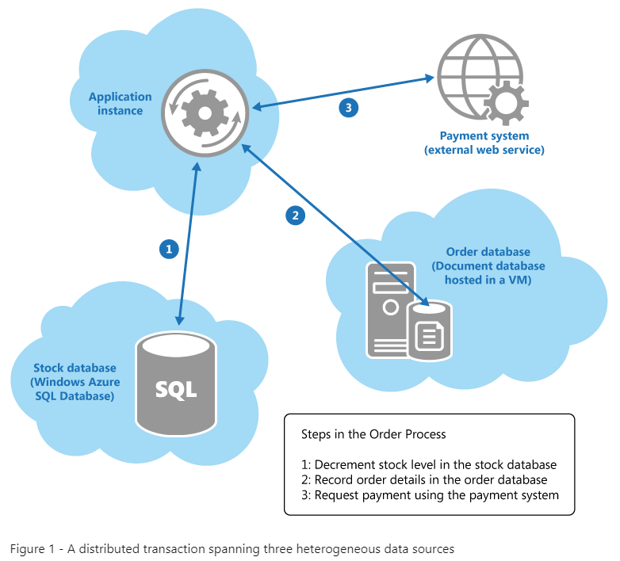

Figure 1 - A distributed transaction spanning three heterogeneous data sources

When a customer places an order, the application instance performs the following operations across a collection of heterogeneous data stores held in various locations:

1. Update the stock level of the item ordered.
2. Record the details of the order.
3. Verify payment details for the order.

**Note**

In some cases a data store can be an external service, such as the payment system shown in Figure 1.

Although these operations comprise a logical transaction, attempting to implement strong transactional consistency in this scenario is likely to be impractical. Instead, implementing the order process as an eventually consistent**series of steps, where each step in the process is essentially an autonomous operation, is a much more scalable solution. While these steps are progressing, the state of the overall system is inconsistent. For example, after the stock level has been updated but before the details of the order have been recorded the system has temporarily *lost* some stock. However, when all the steps have been completed, the system returns to a consistent state and all stock items can be accounted for.

Despite the fact that implementing eventual consistency in this example appears to be conceptually quite simple, the developer must ensure that the system does eventually become consistent. In other words, the application is responsible for guaranteeing either that all three steps in the order process complete, or determining the actions to take if any of the steps fail. How you resolve this situation in any given system is inevitably application specific.

For an example showing how you can implement an eventually consistent system spanning different data stores, see Chapter 8, “[Building a Polyglot Solution](https://docs.microsoft.com/en-us/previous-versions/msp-n-p/dn313279(v=pandp.10)),” in the guide “Data Access for Highly-Scalable Solutions: Using SQL, NoSQL, and Polyglot Persistence” on MSDN. The following sections of this guidance also provide some suggestions.

#### Retrying Failing Steps

In a distributed environment, the inability to complete an operation is often due to some type of temporary error (communication failure is always a possibility.) If such a failure occurs, an application might assume that the situation is transient and simply attempt to repeat the step that failed. Less transient exceptions, such as database or virtual machine failure, may also occur and the remedy might be similar—wait for the system to be recovered and then try the failing operation again. This approach could result in the same step actually being run twice, possibly resulting in multiple updates. It is very difficult to design a solution to prevent this repetition from occurring, but the application should attempt to render such repetition harmless.

One strategy is to design each step in an operation to be idempotent. This means that a step that had previously succeeded can be repeated without actually changing the state of the system. The steps that comprise a business operation are naturally heavily dependent on the business logic of your system, and the way in which you implement them will be heavily influenced by the structure of the data. Defining idempotent steps requires a deep, domain-specific understanding of your system.

Some steps might be naturally idempotent. For example, a step that sets a particular item to a specific value (such as “ZipCode = 11111”) can be repeated many times and the result will always be the same. However, natural idempotency is not always possible. In a system that incorporates services, such as the payment system shown in the ecommerce example, it may be possible to implement some form of artificial idempotency. A common technique is to associate the message sent to the service with a unique identifier. The service can store the identifier for each message it receives locally, and only process a message if the identifier does not match that of a message it received earlier. This technique is known as *de-duping* (the removal of duplicate messages). This strategy, exemplified by the [Idempotent Receiver](http://www.enterpriseintegrationpatterns.com/idempotentreceiver.html) pattern, depends on the service being able to store message identifiers successfully.

**Note**

For more information about idempotency, see [**Idempotency Patterns**](http://blog.jonathanoliver.com/2010/04/idempotency-patterns/) on Jonathan Oliver’s blog.

#### Partitioning Data and Using Idempotent Commands

Multiple instances of an application competing to modify the same data at the same time are another common cause of failure to achieve eventual consistency. If possible, you should design your system to minimize these situations. You should try and partition your system to ensure that concurrent instances of an application attempting to perform the same operations simultaneously do not conflict with each other.

Rather than thinking in terms of simple CRUD (create, retrieve, update, and delete) operations, you can structure your system around atomic commands that perform business tasks in an idempotent style. For more information, see the [Command and Query Responsibility Segregation pattern](https://docs.microsoft.com/en-us/previous-versions/msp-n-p/dn568103(v=pandp.10)). The commands in a CQRS solution are frequently implemented by following the [Event Sourcing pattern](https://docs.microsoft.com/en-us/previous-versions/msp-n-p/dn589792(v=pandp.10)). Event sourcing performs operations on data by driving tasks from a sequence of events, each of which is recorded in an append-only store.

**Note**

For detailed information on using CQRS and Event Sourcing to implement eventual consistency, see [**Reference 4: A CQRS and ES Deep Dive**](https://docs.microsoft.com/en-us/previous-versions/msp-n-p/jj591577(v=pandp.10)) on MSDN.

#### Implementing Compensating Logic

There may ultimately be situations where the logic in the application determines that an operation cannot or should not be allowed to complete (this could be for a variety of business-specific reasons). In these cases you can implement compensating logic that undoes the work performed by the operation, as described by the [Compensating Transaction pattern](https://docs.microsoft.com/en-us/previous-versions/msp-n-p/dn589804(v=pandp.10)).

In the ecommerce example shown in Figure 1, as the application performs each step of the order process it can record the tasks necessary to undo this step. If the order process fails, the application can apply the “undo” steps for each step that had previously completed to restore the system to a consistent state. This technique may be complicated by the fact that undoing a step may not be as simple as performing the exact opposite of the original step, and there may be additional business rules that the application must apply. For example, undoing the step that records the details of an order in the document database may not be as straightforward as removing the document. For auditing purposes, it may be necessary to leave the original order document in place but change the status of the order in this document to “cancelled.”

**Note**

Compensating transactions can be complicated to implement and expensive to perform. You should only use them where they are absolutely necessary.

#### Related Patterns and Guidance

The following patterns and guidance may also be relevant when managing consistency in a cloud application:

* [Compensating Transaction Pattern](https://docs.microsoft.com/en-us/previous-versions/msp-n-p/dn589804(v=pandp.10)). This pattern describes how to undo the work performed by a series of steps, which together define an eventually consistent operation, if one or more of the operations fail.
* [Command and Query Responsibility Segregation Pattern](https://docs.microsoft.com/en-us/previous-versions/msp-n-p/dn568103(v=pandp.10)). This pattern describes how you can segregate the operations that read data from the operations that update data. This pattern can use different models of the same data, and it is necessary to ensure that the information in these models can become consistent.
* [Event Sourcing Pattern](https://docs.microsoft.com/en-us/previous-versions/msp-n-p/dn589792(v=pandp.10)). This pattern is frequently used with the Command and Query Responsibility Segregation pattern. It can simplify tasks in complex domains; improve performance, scalability, and responsiveness; provide consistency for transactional data; and maintain full audit trails and history that may enable compensating actions.
* [Data Partitioning Guidance](https://docs.microsoft.com/en-us/previous-versions/msp-n-p/dn589795(v=pandp.10)). In many large-scale applications, data is divided into separate partitions that can be managed and accessed separately. It may be necessary to ensure that the data is consistent across partitions.
* [Data Replication and Synchronization Guidance](https://docs.microsoft.com/en-us/previous-versions/msp-n-p/dn589787(v=pandp.10)). Data replication and synchronization can help to maximize availability and performance, ensure consistency, and minimize data transfer costs between locations.
* [Caching Guidance](https://docs.microsoft.com/en-us/previous-versions/msp-n-p/dn589802(v=pandp.10)). Data in application caches can become inconsistent across instances and with the data store that acts as the original source of the data. This guidance describes how caches may support expiration policies that can help to reduce the period during which cached data is inconsistent.
* [Cache-Aside Pattern](https://docs.microsoft.com/en-us/previous-versions/msp-n-p/dn589799(v=pandp.10)). This pattern describes how to fetch data into a cache on demand, as the data is required by an application. It can be used to good effect to reduce the overhead associated with repeatedly accessing the same data.

## Spring MVC REST Services

### Beer Distribution Project

Creating a project for Beer distribution.

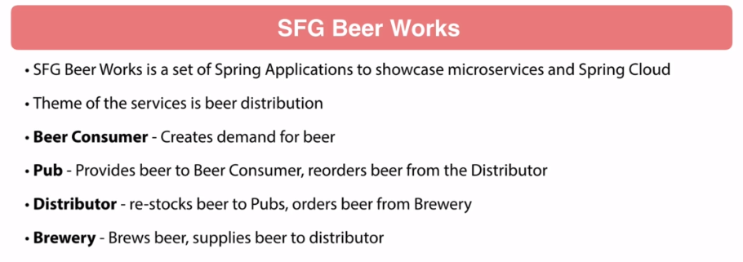

So, you have Pubs that are obviously gonna have customers, that are gonna be drinking beer and they are gonna be placing their orders from a distributor. So, the Distributor is gonna gather beer from multiple breweries and provide at the Pubs. So, that's the role of the Distributor. They will restock beer to Pubs and then they will order beer from breweries. And then Breweries, pretty simple concept, they'll be brewing beer and that will supply beer to the distributor. So, kind of a supply chain here. So, we have a consumer, we have a Pub, Distributor and Breweries. So these 4 components. Now, what's fun about this is for the course, these components, the Beer Consumer is probably the simplest. And I just have a little fun. I'm trying to get my speed skills up, speed on Kotlin. So, I decided to do the Beer Consumer using Kotlin and then also the reactive Webclient. So, that's a small project. And we probably won't get too in-depth on that guy. And then the Pub, that's where we'll be using the functional WebFlux libraries. To keep everything air quotes reactive, we are gonna be using Spring Data Mongo and MongoDB for the Pub. And then also the Distributor, that we're gonna be doing WebFlux as well but this will follow the annotation-based configuration similar to Spring MVC, that will be Spring Data Mongo as well for reactive and MongoDB. I'm using MongoDB in these cases, just because of the reactive libraries available for Mongo. For JPA and SQL libraries, were not reactive yet. They do have, at the time recording, there are some interesting stuff in the works but I don't think anything's production ready for reactive with SQL data stores.

So then, finally, we have the Brewery Application. So, this is gonna be the most traditional application so to speak. Here, we'll be using Spring MVC, Spring Data JPA and Hibernate. Kind of a traditional setup. And this is really gonna be, probably, what you're gonna see the most in it. And this is the first thing that we'll be covering in the course is to use traditional Spring MVC to develop RESTful interfaces. Now coming up, obviously, I just talk about the different services. Each of these services are gonna be used to demonstrate specific features that are related to microservices and Spring Boot and SpringCloud. These coding exercises, I'm gonna be creating GitHub repository specific to course lessons. We will be following branches to show the before and after states in the source code. If you take my other courses, you'll see it's exactly like that.

Ideally, when you start working with this, if you're new to how I do courses, I like to recommend that your workflow is to fork the repository to your own GitHub repository and then follow coding examples along with the course. And I highly recommend, you become familiar with comparing branches in Git so you can compare your repository, your GitHub repository and what you've done to my branches. So, this becomes very helpful to troubleshoot problems if you can do it just between the two. And then if you're running into trouble, something's not working, you can identify any changes. They're very helpful to troubleshoot problems. Now, I do wanna say here, set some expectations about the scope of the course. I'm really looking at developing microservices with Spring and SpringCloud. Prerequisite of the course is to be familiar with Spring Framework and Spring Boot. I'm expecting you to be familiar with mostly content that is covered in my Spring Framework 5, Beginner to Guru course. You don't need to have taken that course but review that course, make sure that you're up to speed on the fundamentals of Spring Framework because we're not gonna be talking about how to manage Spring, how to set properties, how to do profiles and whatnot. We will be using those tools clearly but we're not gonna be teaching those as part of this course. So, I'm not gonna be talking about hibernate relationships. We'll definitely be using it, don't get me wrong. But that is not a educational goal of this course.

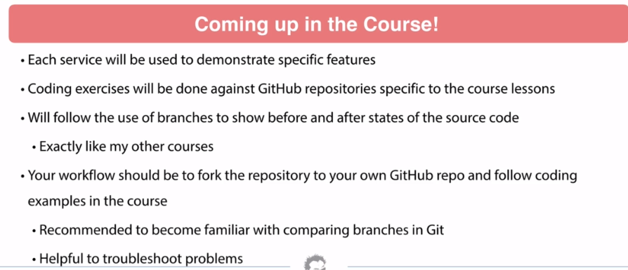

We're really talking about microservices. So, I will be going through explanations, list of them very quickly in the course. Now, coming up when we can start getting into the SpringCloud content. We will continue use course-specific repositories for coding exercises. But as we get further down the road, we are gonna be transitioning to 'Release' repositories when we start getting to actual deploying stuff under SpringCloud. If you remember, if you took my Spring Framework 5 course, I did a 'Pet Clinic' project there where I broke away from using all the branches and just a regular commit. So, as a project, that evolve. I do have a new GitHub organization called sfg-beer-works. This is a separate organization and in this new GitHub organization, I'm doing 'Release' repositories. So, the course-specific repositories will still stay under my GitHub account. So, 'springframeworkguru'. That is actually a GitHub account. And then the Release repositories that's gonna be a set of repositories for these services and some other things that we'll need for the course, that is gonna be under a GitHub organization called 'sfg-beer-works'.

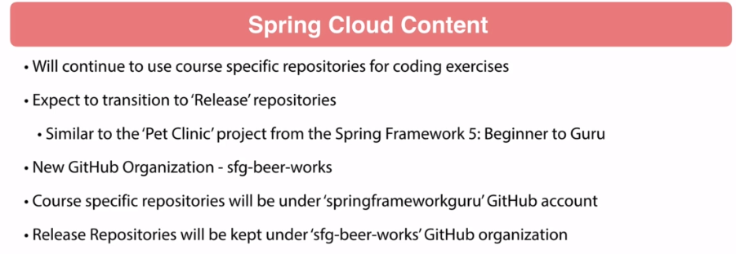

So, that way you'll be able to quick tip on how you can tell so its under springframeworkguru that is a course-specific repository and this is where I'll be doing the before and after branches. The sfg-beer-works, this is where I'll be doing Release repositories. And these will be evolved and we will be doing release artifacts. So, these are release repositories. Inside of these, these are gonna be fully featured Spring Applications. These applications will have features that are not covered in this course. I'll be doing stuff like schedule tasks, logging mappers, a variety of stuff. But it's gonna be a fully featured Spring Application. I will do a code review of these applications. Keep in mind, these are gonna be releases. So, as different versions come out or if I wanna add features to it, we will be going in and doing a formal release process. By a release, we will be releasing artifacts to Maven Central or I should say, we..me.. "I will be doing this".

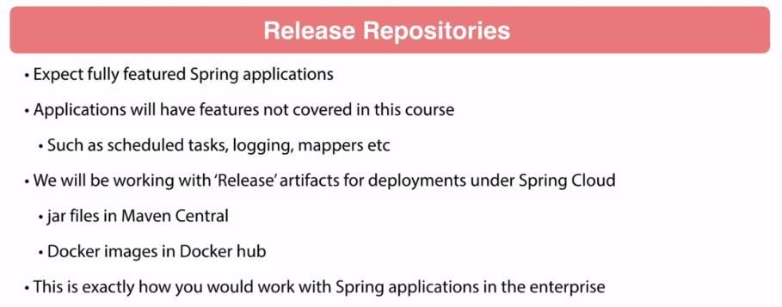

So, I have the ability published jars up to Maven Central as well as publishing images up to Docker Hub. I wanna point out, this is exactly how you work with Spring Applications in the enterprise. You will be working from release artifacts. So, a very important distinction here. So, as we get into deploying Spring with SpringCloud, we will be using these release artifacts and configuring them. I like setting up properties for where the database is at and using username and passwords for databases and all that stuff. So, we'll be getting into some really interesting configuration stuff and deployment. So, I expect a lot of fun content to come up in this course. I'm really looking forward to building all this stuff. So, a lot of good stuff ahead for you and you'll be able to see very realistic stuff. So, just keep in mind there's gonna be two types of repositories and one is where I'm gonna be teaching you specific features. That's where we'll have the before and after branches. Then, we'll have projects for each one of these microservices that we're working with. And we will be through Release process.

**Starting Code**

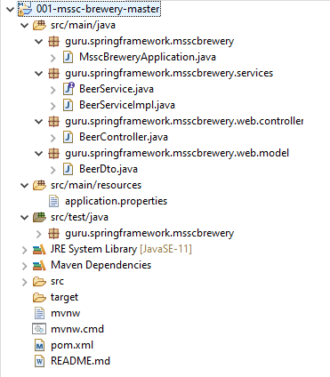

import org.springframework.boot.SpringApplication;

import org.springframework.boot.autoconfigure.SpringBootApplication;

**MsscBreweryApplication.java**

@SpringBootApplication

public class MsscBreweryApplication {

public static void main(String[] args) {

SpringApplication.run(MsscBreweryApplication.class, args);

}

}

**BeerController.java**

import guru.springframework.msscbrewery.services.BeerService;

import guru.springframework.msscbrewery.web.model.BeerDto;

import org.springframework.http.HttpStatus;

import org.springframework.http.ResponseEntity;

import org.springframework.web.bind.annotation.GetMapping;

import org.springframework.web.bind.annotation.PathVariable;

import org.springframework.web.bind.annotation.RequestMapping;

import org.springframework.web.bind.annotation.RestController;

import java.util.UUID;

@RequestMapping("/api/v1/beer")

@RestController

public class BeerController {

private final BeerService beerService;

public BeerController(BeerService beerService) {

this.beerService = beerService;

}

@GetMapping({"/{beerId}"})

public ResponseEntity<BeerDto> getBeer(@PathVariable("beerId") UUID beerId){

return new ResponseEntity<>(beerService.getBeerById(beerId), HttpStatus.OK);

}

}

**application.properties**

**pom.xml**

<?xml version="1.0" encoding="UTF-8"?>

<project xmlns="http://maven.apache.org/POM/4.0.0"

xmlns:xsi="http://www.w3.org/2001/XMLSchema-instance"

xsi:schemaLocation="http://maven.apache.org/POM/4.0.0 http://maven.apache.org/xsd/maven-4.0.0.xsd">

<modelVersion>4.0.0</modelVersion>

<parent>

<groupId>org.springframework.boot</groupId>

<artifactId>spring-boot-starter-parent</artifactId>

<version>2.1.4.RELEASE</version>

<relativePath/> <!-- lookup parent from repository -->

</parent>

<groupId>guru.springframework</groupId>

<artifactId>mssc-brewery</artifactId>

<version>0.0.1-SNAPSHOT</version>

<name>001-mssc-brewery</name>

<description>SFG Brewery</description>

<properties>

<java.version>11</java.version>

</properties>

<dependencies>

<dependency>

<groupId>org.springframework.boot</groupId>

<artifactId>spring-boot-starter-actuator</artifactId>

</dependency>

<dependency>

<groupId>org.springframework.boot</groupId>

<artifactId>spring-boot-starter-web</artifactId>

</dependency>

<dependency>

<groupId>org.springframework.boot</groupId>

<artifactId>spring-boot-devtools</artifactId>

<scope>runtime</scope>

</dependency>

<dependency>

<groupId>org.projectlombok</groupId>

<artifactId>lombok</artifactId>

<optional>true</optional>

</dependency>

<dependency>

<groupId>org.springframework.boot</groupId>

<artifactId>spring-boot-starter-test</artifactId>

<scope>test</scope>

</dependency>

</dependencies>

<build>

<plugins>

<plugin>

<groupId>org.springframework.boot</groupId>

<artifactId>spring-boot-maven-plugin</artifactId>

</plugin>

</plugins>

</build>

</project>

**BeerController.java**

import guru.springframework.msscbrewery.services.BeerService;

import guru.springframework.msscbrewery.web.model.BeerDto;

import org.springframework.http.HttpStatus;

import org.springframework.http.ResponseEntity;

import org.springframework.web.bind.annotation.GetMapping;

import org.springframework.web.bind.annotation.PathVariable;

import org.springframework.web.bind.annotation.RequestMapping;

import org.springframework.web.bind.annotation.RestController;

import java.util.UUID;

@RequestMapping("/api/v1/beer")

@RestController

public class BeerController {

private final BeerService beerService;

public BeerController(BeerService beerService) {

this.beerService = beerService;

}

@GetMapping({"/{beerId}"})

public ResponseEntity<BeerDto> getBeer(@PathVariable("beerId") UUID beerId){

return new ResponseEntity<>(beerService.getBeerById(beerId), HttpStatus.OK);

}

}

**BeerService.java**

import guru.springframework.msscbrewery.web.model.BeerDto;

import java.util.UUID;

public interface BeerService {

BeerDto getBeerById(UUID beerId);

}

**BeerServiceImpl.java**

import guru.springframework.msscbrewery.web.model.BeerDto;

import org.springframework.stereotype.Service;

import java.util.UUID;

@Service

public class BeerServiceImpl implements BeerService {

@Override

public BeerDto getBeerById(UUID beerId) {

return BeerDto.builder().id(UUID.randomUUID())

.beerName("Galaxy Cat")

.beerStyle("Pale Ale")

.build();

}

}

**BeerDto.java**

import lombok.AllArgsConstructor;

import lombok.Builder;

import lombok.Data;

import lombok.NoArgsConstructor;

import java.util.UUID;

@Data

@NoArgsConstructor

@AllArgsConstructor

@Builder

public class BeerDto {

private UUID id;

private String beerName;

private String beerStyle;

private Long upc;

}

You have to send a proper UUID for this to work here. So generate a UUID from any free online UUID generator like this one <https://www.uuidgenerator.net/>

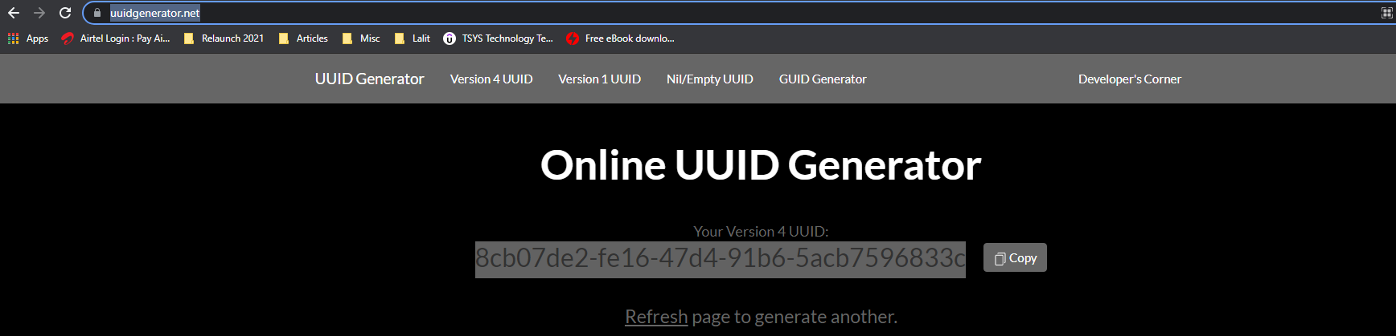

And then request on the port 8080 – a normal number would not work, we need a UUID

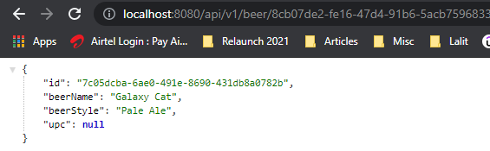

So our application is working now.

Requesting via postman

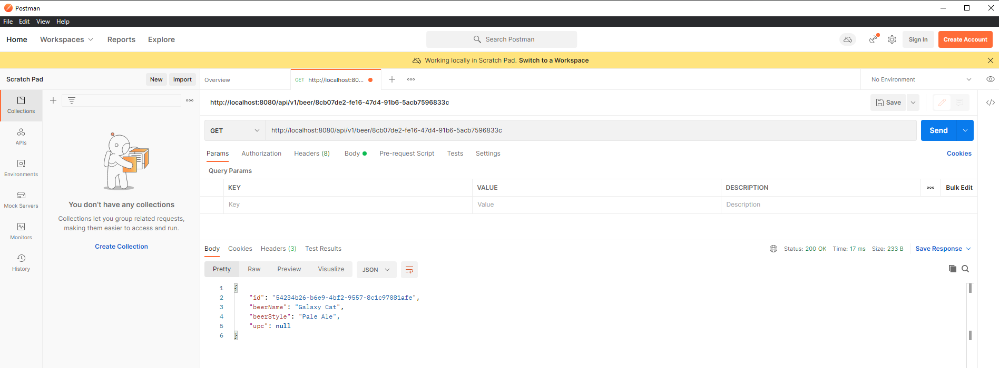

**Axis TCPMon**

See <https://www.codejava.net/ides/eclipse/monitoring-http-requests-and-responses-using-tcpip-monitor-in-eclipse>

The Eclipse IDE has a built-in TCP/IP Monitor tool that allows programmers to intercept communications between client and server through TCP/IP or HTTP protocol in order to monitor, watch and analyze the requests and responses. This article provides the steps which help you to use the TCP/IP monitor for the purpose of monitoring HTTP communications between the client and the server on a localhost machine.

Basically, the TCP/IP monitor acts as a proxy between the client and the server so that it can capture the requests and responses. And the most important thing to remember when using this monitor is that it requires changing the server port at the client side to the port at which the monitor is listening. The following diagram depicts the concepts:

TCP IP Monitor principle

Just search for Axis in the Eclipse Marketplace and install the WSO2

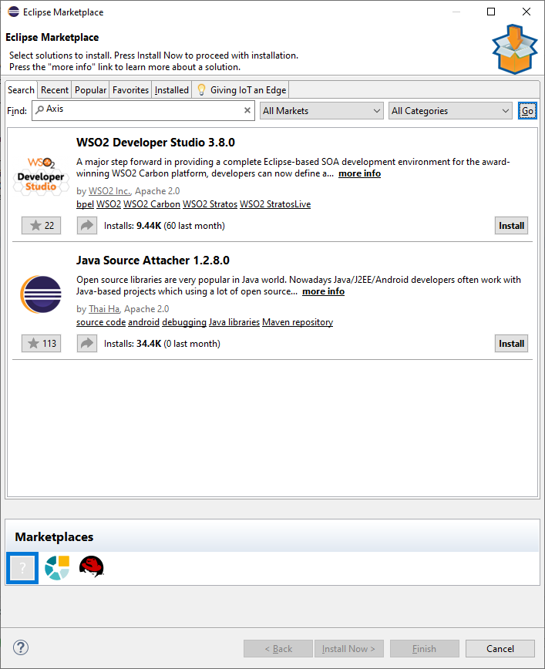

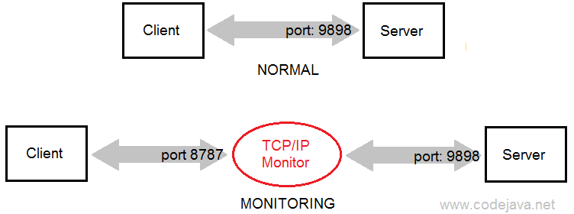

For example, suppose that we need to monitor the HTTP communications of a web application running on localhost (typically under a Tomcat instance inside Eclipse), which would be normally accessed via this URL:

<http://localhost:8080/FileUploadSpringMVC>

And the TCP/IP Monitor is listening on the port number 9898, therefore we have to replace the port 8080 by 9898 as follows:

<http://localhost:9898/FileUploadSpringMVC>

If the monitor is running on the port 9898, it will receive the requests and forward them to the destination server at the port configured (8080).

Now, let’s go through the steps in details. Suppose that we want to monitor a web application developed in the tutorial: Spring MVC File Upload Tutorial with Eclipse IDE. The application is deployed on Tomcat server which is listening on the port number 8080.

Set up a TCP/IP Monitor in Eclipse:

Open the TCP/IP Monitor settings by go to the menu Window > Preferences > TCP/IP Monitor:

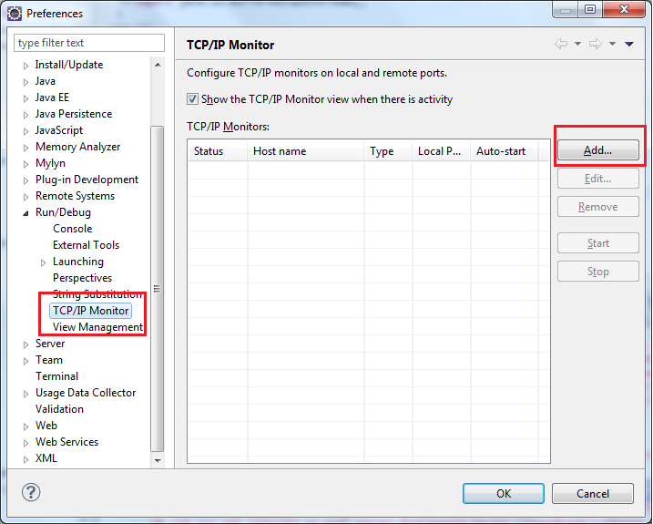

Select TCP IP Monitor in Preferences

Click Add to create a new monitor. In the New Monitor dialog, enter the following information:

Local monitoring port: 9898

Host name: localhost

Port: 8080

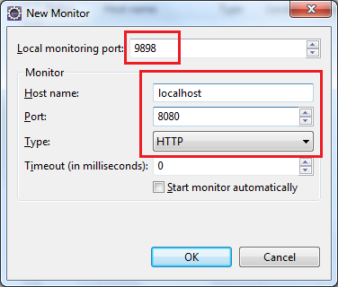

Type: HTTPNew Monitor settings

Click OK to add the new monitor to the list. Select the monitor and then click Start:

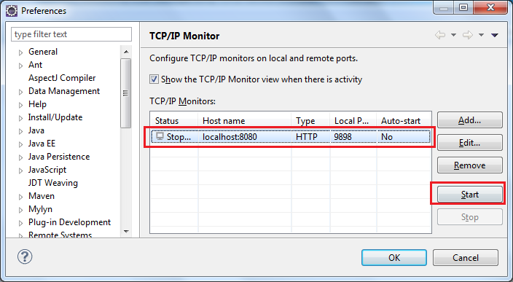

Start TCP IP Monitor

When the Status changed to Started, click OK to close the Preferences dialog. Next, click Window > Show View > Other… > TCP/IP Monitor> OK to open up the TCP/IP Monitor view:

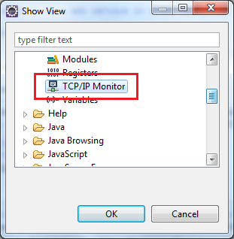

Show TCP IP Monitor View

The TCP/IP Monitor view is added to the workspace but there is no information because no communication happens:

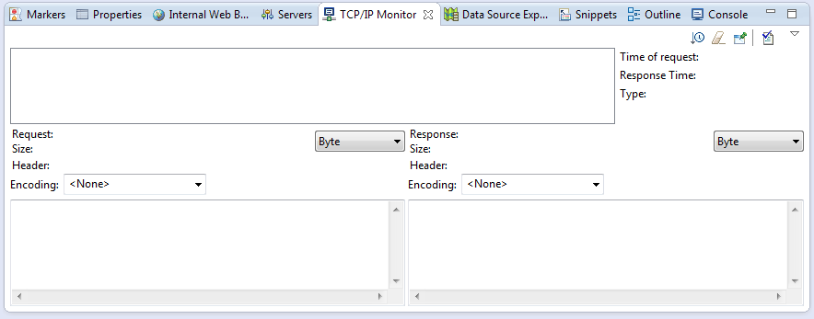

Empty TCP IP Monitor view

Now, make sure that the FileUploadSpringMVC application is up and running; open an Internal Web Browser (or an external browser) and type the following URL:

http://localhost:9898/FileUploadSpringMVC

The monitor immediately displays the request and response information as shown in the following screenshot:

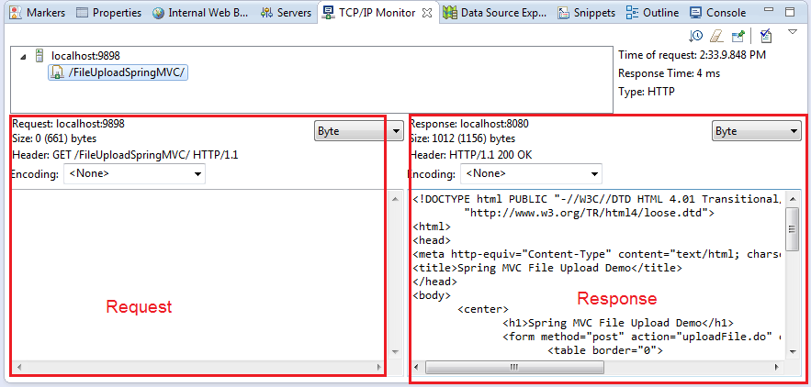

HTTP GET request and response in TCP IP Monitor

Now, go back to the browser and try to enter some information and upload two files:

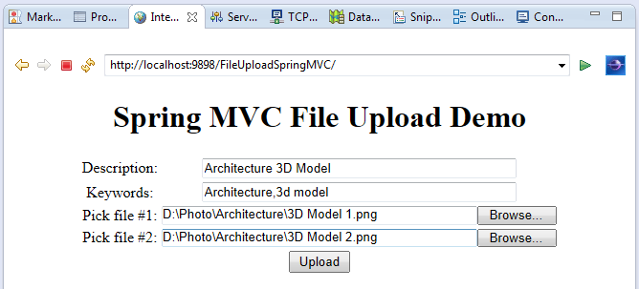

Test FileUploadSpringMVC app

The monitor captures the POST request and HTML response immediately:

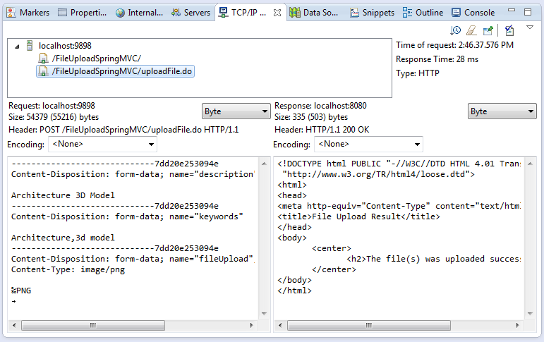

POST request and HTML response in TCP IP Monitor

That’s really useful if we want to analyze the raw request and response! In addition, the TCP/IP monitor allows us to modify and resend the request, as well as watch the request/response in different types and encodings. Let experience the monitor further yourself!

To stop the monitor, go to the TCP/IP Monitor settings in the Preferences dialog (or right click inside the TCP/IP Monitor view and select Properties). Then select the monitor you want to stop, and click Stop:

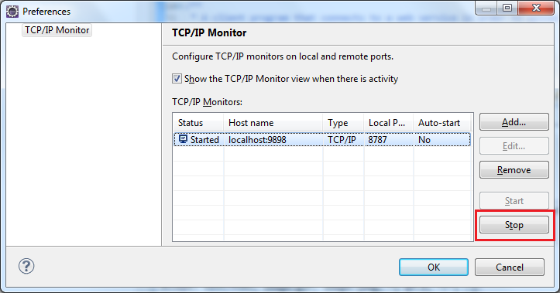

Stop TCP IP Monitor

Remember to change the port in the URL back to the regular number (8080) when the monitor is stopped.

Monitor hosts other than localhost:

Is it possible to monitor the communications between the web browser and sites other then the localhost? Oh, certainly! Here’s an example of the settings that are used to monitor the site [www.bing.com](http://www.bing.com):

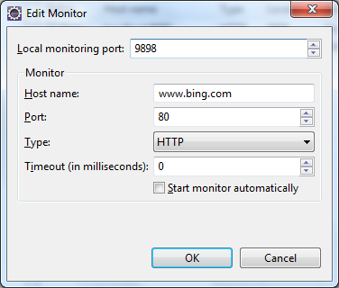

TCP IP Settings to monitor Bing

Now, go to the browser and type the URL as http://localhost:9898, you will see the Bing’s home page! The request and response are captured by the monitor as shown in the following screenshot:

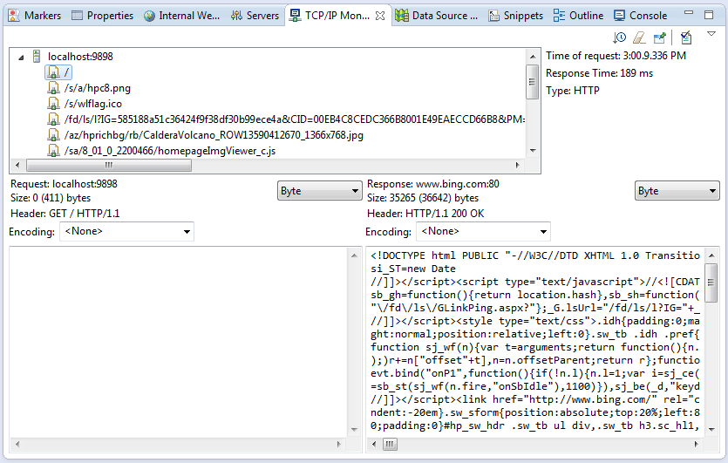

Request and response of Bing site

**Http Get and Post**

Writing the Customer Controller

**CustomerController.java**

import guru.springframework.msscbrewery.services.CustomerService;

import guru.springframework.msscbrewery.web.model.CustomerDto;

import org.springframework.http.HttpStatus;

import org.springframework.http.ResponseEntity;

import org.springframework.web.bind.annotation.GetMapping;

import org.springframework.web.bind.annotation.PathVariable;

import org.springframework.web.bind.annotation.RequestMapping;

import org.springframework.web.bind.annotation.RestController;

import java.util.UUID;

@RequestMapping("api/v1/customer")

@RestController

public class CustomerController {

private CustomerService customerService;

public CustomerController(CustomerService customerService) {

this.customerService = customerService;

}

@GetMapping("/{customerId}")

public ResponseEntity<CustomerDto> getCustomer(@PathVariable("customerId") UUID customerId){

return new ResponseEntity<>(customerService.getCustomerById(customerId), HttpStatus.OK);

}

}

**CustomerService.java**

import guru.springframework.msscbrewery.web.model.CustomerDto;

import java.util.UUID;

public interface CustomerService {

CustomerDto getCustomerById(UUID customerId);

}

**CustomerServiceImpl.java**

import guru.springframework.msscbrewery.web.model.CustomerDto;

import org.springframework.stereotype.Service;

import java.util.UUID;

@Service

public class CustomerServiceImpl implements CustomerService {

@Override

public CustomerDto getCustomerById(UUID customerId) {

return CustomerDto.builder()

.id( UUID.randomUUID() )

.name("Joe Buck")

.build();

}

}

**CustomerDto.java**

import lombok.AllArgsConstructor;

import lombok.Builder;

import lombok.Data;

import lombok.NoArgsConstructor;

import java.util.UUID;

@Data

@NoArgsConstructor

@AllArgsConstructor

@Builder

public class CustomerDto {

private UUID id;

private String name;

}

On Requesting for customer

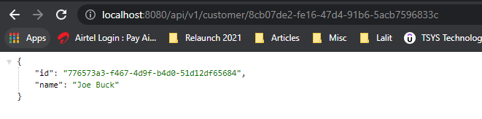

**Handling Post Mapping with Spring MVC**

**Controller**

import org.springframework.http.HttpHeaders;

import org.springframework.http.HttpStatus;

import org.springframework.http.ResponseEntity;

import org.springframework.web.bind.annotation.GetMapping;

import org.springframework.web.bind.annotation.PathVariable;

import org.springframework.web.bind.annotation.PostMapping;

import org.springframework.web.bind.annotation.RequestMapping;

import org.springframework.web.bind.annotation.RestController;

import guru.springframework.msscbrewery.services.BeerService;

import guru.springframework.msscbrewery.web.model.BeerDto;

@RequestMapping("/api/v1/beer")

@RestController

public class BeerController {

private final BeerService beerService;

public BeerController(BeerService beerService) {

this.beerService = beerService;

}

@GetMapping({"/{beerId}"})

public ResponseEntity<BeerDto> getBeer(@PathVariable("beerId") UUID beerId){

return new ResponseEntity<>(beerService.getBeerById(beerId), HttpStatus.OK);

}

@PostMapping // POST - create new beer

public ResponseEntity handlePost(BeerDto beerDto){

BeerDto savedDto = beerService.saveNewBeer(beerDto);

HttpHeaders headers = new HttpHeaders();

//todo add hostname to url

headers.add("Location", "/api/v1/beer/" + savedDto.getId().toString());

return new ResponseEntity(headers, HttpStatus.CREATED);

}

}

**BeerService.java**

import guru.springframework.msscbrewery.web.model.BeerDto;

import java.util.UUID;

public interface BeerService {

BeerDto getBeerById(UUID beerId);

BeerDto saveNewBeer(BeerDto beerDto);

}

**BeerServiceImpl.java**

import guru.springframework.msscbrewery.web.model.BeerDto;

import org.springframework.stereotype.Service;

import java.util.UUID;

@Service

public class BeerServiceImpl implements BeerService {

@Override

public BeerDto getBeerById(UUID beerId) {

return BeerDto.builder().id(UUID.randomUUID())

.beerName("Galaxy Cat")

.beerStyle("Pale Ale")

.build();

}

@Override

public BeerDto saveNewBeer(BeerDto beerDto) {

return BeerDto.builder()

.id(UUID.randomUUID())

.build();

}

}

**Spring Boot Development Tools**

**Developer Tools**

<dependency>

<groupId>org.springframework.boot</groupId>

<artifactId>spring-boot-devtools</artifactId>

<scope>runtime</scope>

</dependency>

• Added to Project via artifact ‘spring-boot-devtools’

• Developer Tools are automatically disabled when running a packaged application (ie java -jar)

• By default, not included in repackaged archives

Now, one of the things that it gives us is an Automatic Restart. And this is actually really cool. I like this quite a bit. What it's gonna do is trigger restart at Spring Context when classes change. And the slick part of what they're doing here is, they're using two different classloaders. One classloader is gonna be your application and the other classloader is gonna be for your project jar dependencies. So, if you think about it, your jar dependencies are gonna be static. Those aren't changing. So, they get loaded into its own classloader and you get a second classloader for stuff that does change. And this makes your restarts very fast because what's gonna happen is, you're not bringing up the entire world, the jars from Spring and all the Springs dependencies and whatever your project needs, that's already loaded into the classloader so you don't have to re-write, re-read all that. And Spring is just restarting the context with fresh classes from your project.

Developer Tools Features

• Eclipse:

• Restart is triggered with save (which by default will compile the class, which triggers the restart)

• IntelliJ:

• By default you need to select ‘Build / Make Project’

• There is an advanced setting you can change to make this more seamless

It does happen pretty rapidly. Now, the way this is going to work in Eclipse, it's gonna get triggered with a save action. And in Eclipse by default, it's gonna compile the class and that when that class object changes, that's what's triggering the restart in the Developer Tool. Now IntelliJ by default, you're gonna have to do a build on it. Go to the menu then Build / Make project. And that's what's gonna trigger it. IntelliJ does have an option to automatically recompile the files but for some reason, it gets disabled when you have an application running. Not something I necessarily agree with. And in a future video, I'm gonna show you how to override this inside of IntelliJ. There's an advanced setting that you can override that property and get IntelliJ to work like Eclipse here. When you save the file in IntelliJ, it does automatic saves. It's gonna trigger a restart for you. Now, one thing that happens is by default templates are gonna be cached when the applications running. This is done for a performance.

Template Caching

• By default templates are cached for performance

• But Caching will require a container restart to refresh the cache

• Developer Tools will disable template caching so the restart is not required to see changes

So obviously, you don't want to be reading your templates over and over. But the downside of this is to see changes when you're making a change to a template, you're gonna have to restart the container. Now, Developer Tools by default, is going to disable template caching so you can see your changes right away. Now, real nice technology that's included with Developer Tools is LiveReload.

LiveReload

• LiveReload is a technology to automatically trigger a browser refresh when resources are changed

• Spring Boot Developer Tools includes a LiveReload server

• Browser plugins are available for a free download at livereload.com

LiveReload is a technology that's automatically trigger a browser refresh. And the way this works is, you need a LiveReload server running. Spring Boot Developer Tools is going to include this. And then you can get a plugin for your browser of choice over at livereload.com. And most... all major browsers are supported and it works well. I've used it a lot on Chrome and Firefox. I generally don't develop in Safari but there is a plug-in available for Safari as well if that is your browser of choice. I'm gonna jump over to IntelliJ and give you a demonstration of them. Now, what I have is, I've got the windows resize. I have the application running in the background. In this little wheel here, that is a Live Reload server saying that the browser is connected and I do have this up and running. So, the first thing I wanna show you is, I have a system outline here and I'm gonna change that to say something let's just say 1234 and when I come up to Build Project, we can see down here, it's gonna trigger a start.

So, you see the Spring Context restarted and that happened pretty pretty darn quick. So, whenever I do it, a class change. I'm gonna just do it. A simple change there again and come in and build. And we can see that it's gonna get picked up here. And the Spring Context reloads really really quick. And we're back up and running so you can see how when you're making changes in Spring Context, how fast or how much faster you're gonna be in your production because you're not going in and restarting things. Now, the next thing, let's take a look at the index page. I'm gonna change it, change the text of My Recipes!. We'll just add some random text there. Now, it's a good habit to click Save because IntelliJ does do an automatic save. Eclipse, you're always clicking save but IntelliJ does do an automatic save for you. But this is now saved but it's not deployed. So, what we need to do is a build here. And we're gonna build the project. And that you can see no class has changed but we automatically reload it. So, do another change here so you can see just how fast that happens. Make sure you save it first.

There's the compiler and you can see how it now quick that's happening. So, if you're on a dual monitor setup, you can see how quickly your changes are gonna be applied. This is a pretty convenient thing to be having. So, you're gonna work within the the Java space and your HTML templates or your Thymeleaf templates and see your changes right away. It's a huge productivity site for you to have. All right, that's Spring Boot Developer Tools. Real cool technology. I hope you can see how that's really gonna change your development. I use it all the time. From experience, it works pretty good. Sometimes the refresh something goes wrong so you do have to do a restart. So just be aware of that. So as you're using it, if something funny happens, just restart the container and you're usually fine. But most of the time, you can sit there and do your development and restart, restart, restart and it works just fine. But every now and then something goes wrong and you actually have to bounce a container and bring it back up. But other than that, they are a huge time saver. I highly recommend you get in the habit of utilizing the Developer Tools to speed up your application development.

**Http PUT Example**

**The Controller Class**

import java.util.UUID;

import org.springframework.http.HttpHeaders;

import org.springframework.http.HttpStatus;

import org.springframework.http.ResponseEntity;

import org.springframework.web.bind.annotation.GetMapping;

import org.springframework.web.bind.annotation.PathVariable;

import org.springframework.web.bind.annotation.PostMapping;

import org.springframework.web.bind.annotation.PutMapping;

import org.springframework.web.bind.annotation.RequestMapping;

import org.springframework.web.bind.annotation.RestController;

import guru.springframework.msscbrewery.services.BeerService;

import guru.springframework.msscbrewery.web.model.BeerDto;

@RequestMapping("/api/v1/beer")

@RestController

public class BeerController {

private final BeerService beerService;

public BeerController(BeerService beerService) {

this.beerService = beerService;

}

@GetMapping({"/{beerId}"})

public ResponseEntity<BeerDto> getBeer(@PathVariable("beerId") UUID beerId){

return new ResponseEntity<>(beerService.getBeerById(beerId), HttpStatus.OK);

}

@PostMapping // POST - create new beer

public ResponseEntity handlePost(BeerDto beerDto){

BeerDto savedDto = beerService.saveNewBeer(beerDto);

HttpHeaders headers = new HttpHeaders();

//todo add hostname to url

headers.add("Location", "/api/v1/beer/" + savedDto.getId().toString());

return new ResponseEntity(headers, HttpStatus.CREATED);

}

@PutMapping({"/{beerId}"})

public ResponseEntity handleUpdate(@PathVariable("beerId") UUID beerId, BeerDto beerDto){

beerService.updateBeer(beerId, beerDto);

return new ResponseEntity(HttpStatus.NO_CONTENT);

}

}

**The Service Interface**

import guru.springframework.msscbrewery.web.model.BeerDto;

import java.util.UUID;

public interface BeerService {

BeerDto getBeerById(UUID beerId);

BeerDto saveNewBeer(BeerDto beerDto);

void updateBeer(UUID beerId, BeerDto beerDto);

}

**The Service Implementation**

import guru.springframework.msscbrewery.web.model.BeerDto;

import org.springframework.stereotype.Service;

import java.util.UUID;

@Service

public class BeerServiceImpl implements BeerService {

@Override

public BeerDto getBeerById(UUID beerId) {

return BeerDto.builder().id(UUID.randomUUID())

.beerName("Galaxy Cat")

.beerStyle("Pale Ale")

.build();

}

@Override

public BeerDto saveNewBeer(BeerDto beerDto) {

return BeerDto.builder()

.id(UUID.randomUUID())

.build();

}

@Override

public void updateBeer(UUID beerId, BeerDto beerDto) {

//todo impl - would add a real impl to update beer

}

}

And in this case, we're gonna return a new ResponseEntity. And this time, we are gonna do a HTTP status. And we're just gonna do a No-Content. So, a No-Content, in case you can't remember these, you can actually do a command click and we can see that a No-Content is an HTTP 204. 204 means that your request if it's successful I understood it and there's no content in the bodies by design. So, that is a my preferred status to use when doing an update. You are basically telling the client that yes I understood, I accepted it, updates happened okay, nothing went wrong. And so in this case here, just to recap.

We are doing a put mapping so when we go against API v1 beer with a specific beer ID, we're gonna handle the update, we're gonna pass in the beerID, the UUID, and the DTO. So, in the Spring Framework is going to take a JSON representation of the BeerDto bind it to the BeerDto object and then that's going to get passed into our BeerService which would go ahead and update the persisted entity, the persisted beer entity which we are not doing in this project. And then here, we are going to be returning back a ResponseEntity and with an HTTP status of 204. Meaning that, I understood you and the update happened normally. And remember, the Puts are considered an idempotent. Meaning that, you can call Put multiple times. And it's not going to have any ramifications on the system data.

**RequestBody**

@RequestMapping("/api/v1/beer")

@RestController

public class BeerController {

private final BeerService beerService;

public BeerController(BeerService beerService) {

this.beerService = beerService;

}

@GetMapping({"/{beerId}"})

public ResponseEntity<BeerDto> getBeer(@PathVariable("beerId") UUID beerId){

return new ResponseEntity<>(beerService.getBeerById(beerId), HttpStatus.OK);

}

@PostMapping // POST - create new beer

public ResponseEntity handlePost(@RequestBody BeerDto beerDto){

BeerDto savedDto = beerService.saveNewBeer(beerDto);

HttpHeaders headers = new HttpHeaders();

//todo add hostname to url

headers.add("Location", "/api/v1/beer/" + savedDto.getId().toString());

return new ResponseEntity(headers, HttpStatus.CREATED);

}

@PutMapping({"/{beerId}"})

public ResponseEntity handleUpdate(@PathVariable("beerId") UUID beerId,

@RequestBody BeerDto beerDto){

beerService.updateBeer(beerId, beerDto);

return new ResponseEntity(HttpStatus.NO_CONTENT);

}

}

**Test Case**

import com.fasterxml.jackson.databind.ObjectMapper;

import guru.springframework.msscbrewery.services.BeerService;

import guru.springframework.msscbrewery.web.model.BeerDto;

import org.junit.Before;

import org.junit.Test;

import org.junit.runner.RunWith;

import org.springframework.beans.factory.annotation.Autowired;

import org.springframework.boot.test.autoconfigure.web.servlet.WebMvcTest;

import org.springframework.boot.test.mock.mockito.MockBean;

import org.springframework.http.MediaType;

import org.springframework.test.context.junit4.SpringRunner;

import org.springframework.test.web.servlet.MockMvc;

import java.util.UUID;

import static org.hamcrest.core.Is.is;

import static org.mockito.ArgumentMatchers.any;

import static org.mockito.BDDMockito.given;

import static org.mockito.BDDMockito.then;

import static org.springframework.test.web.servlet.request.MockMvcRequestBuilders.*;

import static org.springframework.test.web.servlet.result.MockMvcResultMatchers.*;

@RunWith(SpringRunner.class)

@WebMvcTest(BeerController.class)

public class BeerControllerTest {

@MockBean

BeerService beerService;

@Autowired

MockMvc mockMvc;

@Autowired

ObjectMapper objectMapper;

BeerDto validBeer;

@Before

public void setUp() {

validBeer = BeerDto.builder().id(UUID.randomUUID())

.beerName("Beer1")

.beerStyle("PALE_ALE")

.upc(123456789012L)

.build();

}

@Test

public void getBeer() throws Exception {

given(beerService.getBeerById(any(UUID.class))).willReturn(validBeer);

mockMvc.perform( get("/api/v1/beer/" +

validBeer.getId().toString()).accept(MediaType.APPLICATION_JSON))

.andExpect(status().isOk())

.andExpect(content().contentType(MediaType.APPLICATION_JSON_UTF8))

.andExpect(jsonPath("$.id", is(validBeer.getId().toString())))

.andExpect(jsonPath("$.beerName", is("Beer1")));

}

@Test

public void handlePost() throws Exception {

//given

BeerDto beerDto = validBeer;

beerDto.setId(null);

BeerDto savedDto = BeerDto.builder().id(UUID.randomUUID()).beerName("New Beer").build();

String beerDtoJson = objectMapper.writeValueAsString(beerDto);

given(beerService.saveNewBeer(any())).willReturn(savedDto);

mockMvc.perform(post("/api/v1/beer/")

.contentType(MediaType.APPLICATION_JSON)

.content(beerDtoJson))

.andExpect(status().isCreated());

}

@Test

public void handleUpdate() throws Exception {

//given

BeerDto beerDto = validBeer;

String beerDtoJson = objectMapper.writeValueAsString(beerDto);

//when

mockMvc.perform(put("/api/v1/beer/" + validBeer.getId())

.contentType(MediaType.APPLICATION_JSON)

.content(beerDtoJson))

.andExpect(status().isNoContent());

then(beerService).should().updateBeer(any(), any());

}

}

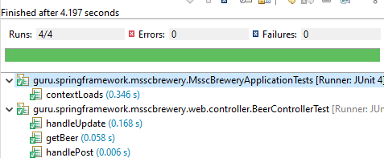

**Http Delete**

We're using the @DeleteMapping annotation so that is going to pick up the request mapping of api/v1/beer. And then, that's gonna be for the HTTP action of Delete. And we are going to take a beerId from the URL and parse it into UUID. So, it will need to be a valid UUID and that will get bound to the parameter beerID. And then, we simply call our BeerService and pass in the beerID. So, pretty simple implementation. The biggest difference here is rather than returning a ResponseEntity like this, I am now using the @ResponseStatus annotation which will give us empty body. And I could have done it here as well. It absolutely could. I've done that because we are returning at an empty ResponseEntity. It's optional to do it either way so sometimes this is a little more convenient. If I needed to set a header, I could do that with the ResponseEntity. That gives me some control over what I'm doing. So up here if I want to return back a header of the location, I could do that. And I could do PutMapping as well. And that's why it I want I don't wanna use the ResponseEntity. Here, I'm not going to provide any additional information to the client. It's just a simple 204. So, this is a good use case for the @ResponseStatus annotation.

@RestController

public class BeerController {

private final BeerService beerService;

public BeerController(BeerService beerService) {

this.beerService = beerService;

}

@GetMapping({"/{beerId}"})

public ResponseEntity<BeerDto> getBeer(@PathVariable("beerId") UUID beerId){

return new ResponseEntity<>(beerService.getBeerById(beerId), HttpStatus.OK);

}

@PostMapping // POST - create new beer

public ResponseEntity handlePost(@RequestBody BeerDto beerDto){

BeerDto savedDto = beerService.saveNewBeer(beerDto);

HttpHeaders headers = new HttpHeaders();

//todo add hostname to url

headers.add("Location", "/api/v1/beer/" + savedDto.getId().toString());

return new ResponseEntity(headers, HttpStatus.CREATED);

}

@PutMapping({"/{beerId}"})

public ResponseEntity handleUpdate( @PathVariable("beerId") UUID beerId,

@RequestBody BeerDto beerDto){

beerService.updateBeer(beerId, beerDto);

return new ResponseEntity(HttpStatus.NO_CONTENT);

}

@DeleteMapping({"/{beerId}"})

@ResponseStatus(HttpStatus.NO_CONTENT)

public void deleteBeer(@PathVariable("beerId") UUID beerId){

beerService.deleteById(beerId);

}

}

**BeerService.java**

public interface BeerService {

BeerDto getBeerById(UUID beerId);

BeerDto saveNewBeer(BeerDto beerDto);

void updateBeer(UUID beerId, BeerDto beerDto);

void deleteById(UUID beerId);

}

**BeerServiceImpl.java**

import java.util.UUID;

import org.springframework.stereotype.Service;

import guru.springframework.msscbrewery.web.model.BeerDto;

import lombok.extern.slf4j.Slf4j;

@Slf4j

@Service

public class BeerServiceImpl implements BeerService {

@Override

public BeerDto getBeerById(UUID beerId) {

return BeerDto.builder().id(UUID.randomUUID())

.beerName("Galaxy Cat")

.beerStyle("Pale Ale")

.build();

}

@Override

public BeerDto saveNewBeer(BeerDto beerDto) {

return BeerDto.builder()

.id(UUID.randomUUID())

.build();

}

@Override

public void updateBeer(UUID beerId, BeerDto beerDto) {

//todo impl - would add a real impl to update beer

}

@Override

public void deleteById(UUID beerId) {

log.debug("Deleting a beer...");

}

}

Full Implementation for Customer similar to Beer

CustomerController.java

package guru.springframework.msscbrewery.web.controller;

import guru.springframework.msscbrewery.services.CustomerService;

import guru.springframework.msscbrewery.web.model.CustomerDto;

import org.springframework.http.HttpHeaders;

import org.springframework.http.HttpStatus;

import org.springframework.http.ResponseEntity;

import org.springframework.web.bind.annotation.*;

import java.util.UUID;

@RequestMapping("api/v1/customer")

@RestController

public class CustomerController {

private CustomerService customerService;

public CustomerController(CustomerService customerService) {

this.customerService = customerService;

}

@GetMapping("/{customerId}")

public ResponseEntity<CustomerDto> getCustomer(@PathVariable("customerId") UUID customerId){

return new ResponseEntity<>(customerService.getCustomerById(customerId), HttpStatus.OK);

}

@PostMapping

public ResponseEntity handlePost(CustomerDto customerDto){

CustomerDto savedDto = customerService.saveNewCustomer(customerDto);

HttpHeaders httpHeaders = new HttpHeaders();

httpHeaders.add("Location", "/api/v1/customer/" + savedDto.getId().toString());

return new ResponseEntity(httpHeaders, HttpStatus.CREATED);

}

@PutMapping("/{customerId}")

@ResponseStatus(HttpStatus.NO_CONTENT)

public void handleUpdate(@PathVariable("customerId") UUID customerId, CustomerDto customerDto){

customerService.updateCustomer(customerId, customerDto);

}

@DeleteMapping("/{customerId}")

public void deleteById(@PathVariable("customerId") UUID customerId){

customerService.deleteById(customerId);

}

}

**CustomerService.java**

import guru.springframework.msscbrewery.web.model.CustomerDto;

import java.util.UUID;

public interface CustomerService {

CustomerDto getCustomerById(UUID customerId);

CustomerDto saveNewCustomer(CustomerDto customerDto);

void updateCustomer(UUID customerId, CustomerDto customerDto);

void deleteById(UUID customerId);

}

**CustomerServiceImpl.java**

import guru.springframework.msscbrewery.web.model.CustomerDto;

import lombok.extern.slf4j.Slf4j;

import org.springframework.stereotype.Service;

import java.util.UUID;

@Slf4j

@Service

public class CustomerServiceImpl implements CustomerService {

@Override

public CustomerDto getCustomerById(UUID customerId) {

return CustomerDto.builder()

.id(UUID.randomUUID())

.name("Joe Buck")

.build();

}

@Override

public CustomerDto saveNewCustomer(CustomerDto customerDto) {

return CustomerDto.builder()

.id(UUID.randomUUID())

.build();

}

@Override

public void updateCustomer(UUID customerId, CustomerDto customerDto) {

//todo impl

log.debug("Updating....");

}

@Override

public void deleteById(UUID customerId) {

log.debug("Deleting.... ");

}

}

**API Versioning**

Now, API versioning is considered a very important best practice when we have APIs. We've already seen an example of this in the course so far. In the URL "/api /v1/beer"-"v1" is the API version. So, it's abbreviated for version 1 of the API. Very common syntax here, as far as how that is laid out. The API part that is kind of an optional thing. Typically, the version number you want that towards the beginning of the URL before you get into the operation. That's typically what you see. That is not an official rule. That's just typically what you see there. Isn't actually an official rule as to where the version has to appear in the URL but by convention. You see a lot of people putting it towards the beginning of the URL of the API.

API Versioning

• Versioning your APIs is considered a best practice

• Example “/api/v1/beer” - “v1” is the API version

• API Versioning allows you to evolve the API without breaking existing API consumers

• Typical lifespan:

• v1 - first release

• v2 - second release, notify consumers v1 version is deprecated

• v3 - remove v1 (optional), notify consumers v2 is deprecated

Now, what the API version allows you to do is it allows you to evolve the API without breaking existing API customer. So, this is very important because as you evolve your APIs, you're gonna have people using them and not everybody's going to be able to transition at the same time so you'll run multiple versions of the API at the same time. Now, typical life span, what you can see is v1 is gonna be your first release of the API. You'll go ahead and release that and then you'll add some functionality and come up with a v2, for an example, and typically at this point you are going to deprecate v1.

Semantic Versioning 2.0.0

• See website - https://semver.org

• Version - MAJOR.MINOR.PATCH

• MAJOR - version for major incompatible API changes - aka breaking changes

• MINOR - new functionality - backwards compatible changes

• PATCH - backwards compatible bug fixes

• API URLs typically only use MAJOR versions

• Can optionally use MINOR and PATCH

• /v1 or /v1.1

Not always, but typically, you're gonna tell consumers of the API that a v1 is now deprecated it's going to go away at some point in the future. Now, when you come up with v3, often because v1 has been deprecated, you are going to remove it. It will no longer be available and then v2 will go to a deprecated status. So, this is kind of how you evolve the API and these are more of guidelines and hard fast rules. Obviously, you would not want to keep v1 around with a v3 unless absolutely necessary. You don't wanna be maintaining three different versions of the same API. There's gonna be some overhead to that. So that's why you wanna deprecated them and then take them away. Now, Semantic Versioning. This is very important concept. I have a website up here. There's a lot more text there as to how semantic versioning is done. But the general concept is you're gonna have major, minor and patch. So, in the first example 2.00, 2 would be version 2 then 0 is gonna be the minor release and the patch is going to be a very small change to it. So, what's important remember is that, when a major is... for major incompatible changes, so, you're gonna break the API so if somebody using the API after this change will not be able to use it without changing their code.

Non-Breaking Changes

• Non-Breaking changes may be performed under MINOR or PATCH versions

• Examples:

• New optional parameter

• New response fields

• New service (endpoint)

• Bug fixes - behavior change, NOT change to API itself

Now minor, this is new functionality or backwards compatible changes. These are changes that do not break the API. Consumers of it can continue using the API without changing their code. So this is very important. Then a patch, you're gonna basically have some bug fixes. Now, API URLs typically only use major versions. That can optionally use a minor or patch. I don't see that too often to be honest. Typically, you're only gonna see a major version in play. Sometimes you'll see the minor but that's more of an exception than the rule.

Breaking Changes

• Breaking Changes should be done under a MAJOR version

• Examples:

• New required parameter

• Removal of existing parameter

• Removal of response value

• Parameter name change or type

• Deprecation of a service

Now, let's talk about Non-Breaking changes. Non- Breaking changes are gonna be something that you can perform under a minor or a patch version. Examples of this is you're gonna have a new optional parameter, a new response field, a new endpoint and a new attempt. Bug fixes, they might cause a step behavior change but not the API itself. So these are all types of changes where a consumer of the API can continue using it and that they are gonna be changed by it. Now, let's contrast these with Breaking Changes. Breaking Changes, you always wanna do a major version. This is going to break anybody that's using it. So, for example, if you add in a required parameter, that would break it. If you remove an existing parameter, that would break a consumer of it. Removing of a response value or a parameter name change or type and duplication of a service notifying that that is going away, technically not a breaking change but you do want the consumers notified. Keep in mind that a breaking change is basically if you have somebody that's using that API, it's going to break their software. So, these are like if you change the name of a parameter and just a small typo can break them because that value is no longer there or if you change the type or add some type of new constraint, this can break people if you change like a date format that can break people. So you wanna be very sensitive of these and make sure that they are done under a major version and that your API consumers are given some time to migrate to the new version. So these are very important concepts. So, just keep in mind, for minor versions where you're typically not evolving the version number of the API, that's gonna be non breaking changes . For things that are gonna break consumers you definitely wanna be doing that under a major version where you're coming up with a new version of the API.

Example of API Versioning

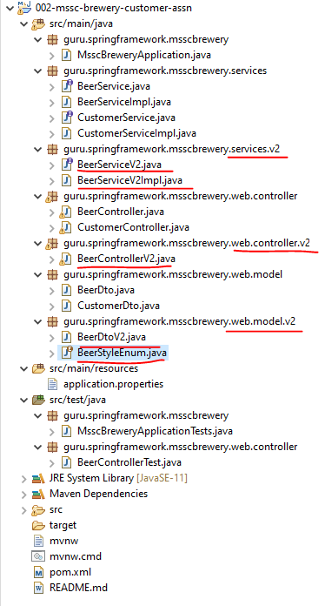

**BeerControllerV2.java**

package guru.springframework.msscbrewery.web.controller.v2;

import guru.springframework.msscbrewery.services.v2.BeerServiceV2;

import guru.springframework.msscbrewery.web.model.v2.BeerDtoV2;

import org.springframework.http.HttpHeaders;

import org.springframework.http.HttpStatus;

import org.springframework.http.ResponseEntity;

import org.springframework.web.bind.annotation.*;

import java.util.UUID;

@RequestMapping("/api/v2/beer")

@RestController

public class BeerControllerV2 {

private final BeerServiceV2 beerServiceV2;

public BeerControllerV2(BeerServiceV2 beerServiceV2) {

this.beerServiceV2 = beerServiceV2;

}

@GetMapping({"/{beerId}"})

public ResponseEntity<BeerDtoV2> getBeer(@PathVariable("beerId") UUID beerId){

return new ResponseEntity<>(beerServiceV2.getBeerById(beerId), HttpStatus.OK);

}

@PostMapping // POST - create new beer

public ResponseEntity handlePost(BeerDtoV2 beerDto){

BeerDtoV2 savedDto = beerServiceV2.saveNewBeer(beerDto);

HttpHeaders headers = new HttpHeaders();

//todo add hostname to url

headers.add("Location", "/api/v1/beer/" + savedDto.getId().toString());

return new ResponseEntity(headers, HttpStatus.CREATED);

}

@PutMapping({"/{beerId}"})

public ResponseEntity handleUpdate(@PathVariable("beerId") UUID beerId, BeerDtoV2 beerDto){

beerServiceV2.updateBeer(beerId, beerDto);

return new ResponseEntity(HttpStatus.NO_CONTENT);

}

@DeleteMapping({"/{beerId}"})

@ResponseStatus(HttpStatus.NO_CONTENT)

public void deleteBeer(@PathVariable("beerId") UUID beerId){

beerServiceV2.deleteById(beerId);

}

}

**BeerServiceV2.java**

import guru.springframework.msscbrewery.web.model.v2.BeerDtoV2;

import java.util.UUID;

public interface BeerServiceV2 {

BeerDtoV2 getBeerById(UUID beerId);

BeerDtoV2 saveNewBeer(BeerDtoV2 beerDto);

void updateBeer(UUID beerId, BeerDtoV2 beerDto);

void deleteById(UUID beerId);

}

**BeerServiceV2Impl.java**

import guru.springframework.msscbrewery.web.model.v2.BeerDtoV2;

import org.springframework.stereotype.Service;

import java.util.UUID;

@Service

public class BeerServiceV2Impl implements BeerServiceV2 {

@Override

public BeerDtoV2 getBeerById(UUID beerId) {

return null;

}

@Override

public BeerDtoV2 saveNewBeer(BeerDtoV2 beerDto) {

return null;

}

@Override

public void updateBeer(UUID beerId, BeerDtoV2 beerDto) {

}

@Override

public void deleteById(UUID beerId) {

}

}

I'm gonna show you some techniques here. There's really no air quotes standard on doing this. There are some common conventions. And one of them is to create a version package. So, you still have everything in the same service. You're gonna evolve this along. Technically, you could stand up another Microservice even for this. But that your use cases may vary probably the most common thing is going to be doing it within that same service and evolving the endpoints itself because you're gonna evolve the touch point with the customer. So here, I have our BeerDto on on the screen. And let's say that we had a requirements change to make the beer style go from a string to an enum. So, let's come in here and start working with that so what we would do is we'd come up here and create a New Package and we'll call that v2 like so. And now, we do a New Java Class. And some people just name it like that. I prefer to do a V2 on the class name itself because what you're gonna get is when you're working with intellisense even though it's in a different package and it would be legal to do that, this gives you a visual cue. So, something nice to work with. So, I'm gonna go ahead and add that in as V2 and we will add this to git and let's go ahead and I'm gonna split this like so and we'll close out this. And now let's go ahead and we will create a New Java Class and we will call this BeerStyleEnum. Make that enumeration and say OK. You know we will add that in to get. And let's go ahead and add in a couple of BeerStyles.

So, we can do the lager, pilsner, ale Stout, Gose America's Mitnick coming up with some really great goses. And I'm really just gonna do IPA. We don't need a lot of them. So, there's our Enum. And then let's go ahead... and I'm just gonna steal this so... and we will take these same annotations. And then, the BeerStyle, we wanna make that the BeerStyleEnum like so. So, that's all we need to do for our model change. So now, you can see in the model I have a package v2. I have my BeerDtoV2. And that it's now has a BeerStyle enumeration so this would be a breaking change. So now, what we wanna do is go ahead and propagate this change through our controller and services. So, I'm gonna come up here to the controller, right click and we'll do a New Package here. We'll call that v2 and say OK. And now we're gonna come into create a new class. Call up BeerControllerV2 and we will add that. And now, main thing that we'd want to do is come up here and say... I still wanna follow this but now we're gonna change this to v2 like so. And actually, we could just add in everything like this. And we will just go ahead and refactor this on the fly. And want all that and that but we do not want these two. You want that to be V2. I'm just going in and changing these to V2s. Now, you can see there also got the BeerService. So, I'm just gonna... option there and we will say create an Interface. And now, we want that in services.v2 as well. So, let's just say OK there. We will add that. And now, you can see that we have our BeerService.

And let's come through here and line to these in order. So... so let's go ahead and create these. And just eyeballing that. That looks all set. Let's come in and go ahead and implement that interface and we want the BeerServiceV2Impl and that's gonna go in the v2 package as well. So, let's go ahead and say OK to that. And it will let IntelliJ create the methods like so. Start going through updating these. That's gonna change all the references. I should have refactored. I had a mistake in the controller name there. So now, everything is happy here. So, effectively, I just created a new objects with a v2 appendant. Appendant to an object name so that you can visually see that a different. So just to recap everything that changed, I created a... a new model. And this model now has a BeerStyle that is Enum. I added in the BeerStyleEnum. You can see it there. And there's the Dto itself. Now, we have the the new BeerController. And everything's just been updated to v2 for your service. And then here's our v2 implementation. I'm just gonna leave these stubbed out like that. I'm not gonna go ahead and implement everything. I just wanna go through the mechanics of creating a second release. And then our second version, I should say. But the one of the most important things is where we have this api/v1/beer. Now we have api/v2/beer. So, that's indicating a major version change... that a breaking change so that... that beer object, the beer model going from a String to Enum that would could break people because they're used to a free-flowing string and now it's restricted to enumeration value.

So, important change. So now, if we evolved that Enum, if we added additional properties to that that would be considered a minor change. So if we picked up additional BeerStyles, we wouldn't have to evolve this. But if we pick up a new mandatory property or change another type or if we change a name, those would all be changes. And then we also go to a different version. And there's different strategies here. So, you might wanna come in and add something like @Deprecated so that is a Java language feature that's kind of optional. But that only indicates that in the source code it does not include it to your client. So, I am not gonna do that here. We'll just roll that back. But that is a good habit to get into to show that that v1 has been deprecated now you have a v2. So actually, I'm gonna leave that there. On second thought, so we'll leave that then for you guys. And that is a standard java annotation. And again, just to reiterate there is really no official standard way of doing this. This is just some best practices I've found from experience. To use the deprecated flag to do the v2, to add the v2 to the object names and also to use a different version for the package. So all these give you visual clues to say, 'hey you're working with a second version of that API layer' and allows you to organize this because I've seen sometimes where you get a version 3, version 4, version 5 and then there can be a lot of changes in flight. So, these are just some good visual cues to not only yourself but to others that are going to be working with the source code base. Different programming shops, different companies may have different standards around this. So, this is gonna be kind of a per developer or per company basis and these are my own personal best practices and things that have built up through experience over time.

**API Versioning and Source Control**

We're going to talk about ways to use source control in relation to the versioning of APIs. So up on the screen here, I have a link. This is actually sent to me by a student and it covers the topic fairly well. I decided it's an important topic so I wanted to add some content to the course about it. Obviously this course isn't on source control but as developers it is an important thing for us to be aware of so I did want to add this content to this course.

<https://github.com/lyndseypadget/semflow>

This is from a presentation that the author did. He's calling it Semflow of semantic versioning workflows and here he starts talking about get branching strategies. So here, we have a what's called a feature branch. You've been seeing me use those in the course already. As I developed through, I'm using branches for lessons so those are in air quotes a 'feature branch' for each lesson that I develop. What this allows me to do is I can maintain the course, I can use those feature branches so I can go back and update things like versions and any corrections, I can make those so I have like miniature features. So that kind of correlates over to API versions. The author has a nice example here. Let me bring this up to the top of the screen here. This stuff tells exactly what we're talking about in the previous video about breaking changes and non breaking changes. So this is a great example here. You can see we have version one of the API and then we need to add in a VIN property and that is a required property. Now that is considered a breaking change so that requires the API to be versioned up. So, exactly what the author did there and now we're adding in on 2.1 we are adding in another property but this is not a required property so that is not a breaking change. You can see that the API was not versioned up. And then the example in Version three, another required property again, a breaking change. So we have to version that up and then 3.1 a non-breaking change. So I come down here a little bit. So inside of source control, you can see here, he's showing an example here so we're all aware of master branch inside of Github and then we are using another feature here a release branch so we have a version one release branch. And then down here, you can see that we're going to a v2 release branch. This illustration is a little bit better there. What's happening inside of the source control system is that we have the version one branch. It allows us to continue developing on version one, and then we'll go to version two for a breaking change and that becomes a branch that we can work on inside of the source control system, and then it's showing a version three.

So, in actual use you could have three different versions of the API running - three different versions being deployed and three different versions being maintained. But each one of those versions is going to have a related branch inside of the repository. So this is very common. You don't need to be using Git. A get by is very popular. It's probably the most popular source control tool used right now. There's a lot of different options out there. A lot of organizations may not be using Git. So it is not a Git specific feature. Just about any major source control system is going to support branching and so you'll be able to set up release branches like we're doing here and track versions of your APIs that way. So very important concept. I'm not going to prescribe a specific way. I work for a start-up by day and we are doing something very very similar to this. Not exactly but very similar. There's a lot of nuances and a lot of opinions but the organization that you go to will probably be doing something like this. They might not, but they will probably be doing something like this. Again it's important concepts so when you have multiple versions of your API running, you need to be properly tracking that inside a source control and using release branches or feature branches are very important. In here, you can see I do want to point out so you've got the v2 release branch. You might have a feature team that will branch off to a feature branch of v2 and then merge back in so very common to do. You might merge that change up to that so to the v3. So a lot of different strategies in play there. When you start doing this you're probably looking under this cone. It's kind of simple. Trust me, it's not that simple. So when you start managing multiple versions of your source control of multiple versions of your microservice, it does start getting a little complex. You do need to be careful but you also need to be aware of how branching and merging works. It's a powerful tool but like any powerful tool, that can be misused and really caused a lot of headaches. But I did want to get this content into the course because this is a very important concept. When you do have microservices, they are going to have a life cycle. You are going to develop them. There is going to be a need to introduce breaking changes introduced a version up and likely you will have to run multiple versions at the same time so over the life cycle this does become very important to master and grasp.

The Blog

Semflow: The SemVer Workflow

A Git Workflow for Version Management: RESTful APIs and beyond

When I mention versioning, a lot of people assume I'm talking about how someone specifies the version of a RESTful API that he or she wants to consume. Namely, URI vs content negotiation. That's not what this article is about, but it is requisite to remember that if you are asking your consumers specify which version they want, you are presumably offering (and to some degree maintaining) multiple versions at a time. If you only offered one version at a time, consumers wouldn't have to specify which one they want. That would be silly, because there's only one choice.

Maintaining many released versions of an API at a time is what this article is about. Specifically, how to do this with git from a release management point of view. That means seeing both the trees and the forest among your git branches. (You see what I did there with the branch pun?)

For the purpose of this article, we assume that the git repository only contains the RESTful API specification (i.e. RAML, Swagger or JSON API files) As such, I'm going focus only on things worthy of major or minor releases according to Semantic Versioning (aka SemVer). Bug fixes which increment the patch number are related to the incorrect implementation of an unchanged specification, and therefore out of scope here.

**Git Branching Strategy Options**

When I mention git branching strategies, a lot of people assume I'm talking about the Gitflow workflow. Some propose Gitflow as a solution for managing releases, or they describe the Feature Branch workflow and call it Gitflow. Occasionally I'll even get a bit of mansplaining about what a branch is. So let's clear the air.

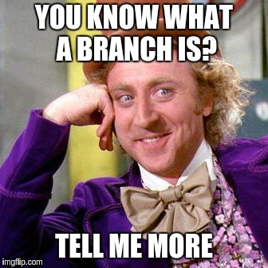

In a nutshell, the Feature Branch workflow dictates that feature-related work should happen on a branch dedicated for that purpose. There is often a common nomenclature for naming these branches. This almost seems like common sense nowadays, because the alternative is that everyone works in the master branch all the time. An API specification is no exception to this principle: its changes should be feature-driven and reviewed/tested before being merged. Feature branches are good.

The Gitflow workflow zooms out a bit, and defines a strict branching model for releasing projects. Vincent Driessen introduces this model in his blog post. This strategy relies on two branches, master and develop, which have an infinite lifetime. Release branches exist temporarily and are deleted after merging into master. This is where you realize that Gitflow is perfect for many applications, as long as they only intend to release and maintain one version of their project at a time. master represents the current release, and develop represents the forthcoming one. You can hotfix the current release, and tags represent older releases, but at that point the code is all on the same master branch.

Given this, can you use Gitflow to track, deploy and troubleshoot multiple releases at a time? Yes. Can you use Gitflow to fix or enhance many releases at a time? No. We need a different model.

**Previous Versions: To Enhance or Not to Enhance**

When I mention enhancing older releases, a lot of people look at me like I'm crazy. “Why would you ever do that?” they ask, as though I'm the world's biggest sucker. Here's where you need to understand why that is necessary (common, even) in the world of RESTful APIs.

The following chart shows how an endpoint can change over time. Let's say you maintain a RESTful API for managing cars at a dealership. All of these are POST calls that accept a car model. I've defined this model in RAML, but I've only included the properties here for brevity.

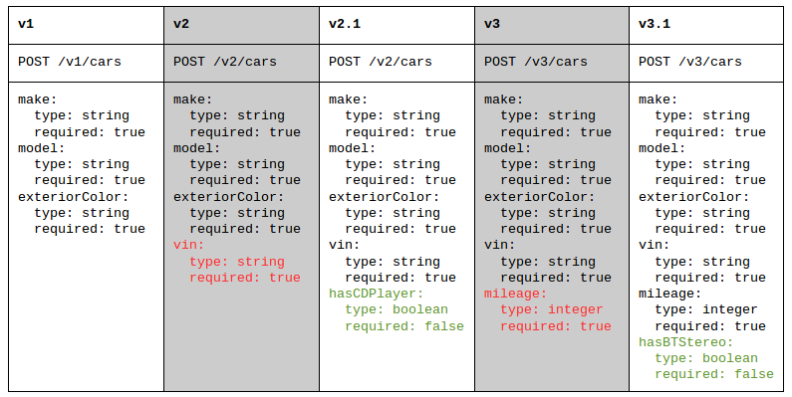

If you're interested, here's how this history played out:

* In v2, it became required to specify a vin when creating a car object. Without one, the request would fail. This is a breaking change, so the major version is bumped.
* In v2.1, a nice-to-have feature was implemented, which introduced the option to indicate whether or not the car has a CD player. If you omit this field, the POST call will still succeed. This is a passive change, so the minor version is bumped. v2 is no longer supported, because consumers using v2 can now use v2.1 without changing their code.
* In v3, the mileage field was introduced. Like vin, this is a breaking change. But there's another subtle change here: the optional hasCDPlayer field is no longer supported/accepted (because the only person who still uses CDs is my grandma). Whether or not that is a breaking or passive change depends on how the system behaves when it is given. You can throw an error - making it break - or you can silently ignore the now-unrecognized field. In this case, I recommend the latter because the field is optional, and you may want to release v2.2 without it.
* In v3.1, yet another optional field was added; bluetooth is all the rage now. Again, v3 is no longer supported because consumers who used it can now seamlessly use v3.1 instead. That's what makes v3.1 passive, by definition.

Let's say that the tablet version of the dealership's car-searching app uses v2.1 and the desktop version uses v3.1. The salesmen at the dealership prefer using tablets, because they can quickly manage car inventory without leaving the customer on the floor. Now, the dealership would like the ability to add/search cars by interior color on the tablet app. This is a request to enhance v2.1 by adding a new optional field called interiorColor, thus making v2.2.

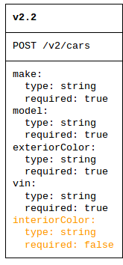

Should this be allowed? Some might say no – only introduce enhancements in the latest release and tell the client to upgrade. This seems unaccomodating. This client here is a car dealership, and they don't have the time or money for an entire v3 upgrade. They just want to add one little field to see if they can sell more cars.

In a perfect world, everyone would be on the latest version. But we don't live in a perfect world, which is why we support multiple versions in the first place. Perhaps such enhancements are experimental business strategies that can revolutionize or devastate the client's sales. I believe it's better to figure that out on a passive older release, so you can decide whether or not to include it in the next version.

**The SemVer Workflow**

The basic premise of the SemVer workflow is to keep each major release in its own branch.

master is not special. When you create a new git repository, master is the just the recommended name for the first trunk-like branch you will create. master is also the default branch. However, until you make the first commit, the first branch doesn’t even exist.

Recall that master represents the last release and develop represents the forthcoming one. If you were really set on keeping those branch names, you could still use many aspects of Gitflow, but you would keep release branches indefinitely. When you release a new major version, it is tagged and merged into master and develop. When you release a new minor version, it is branched from the appropriate release branch.

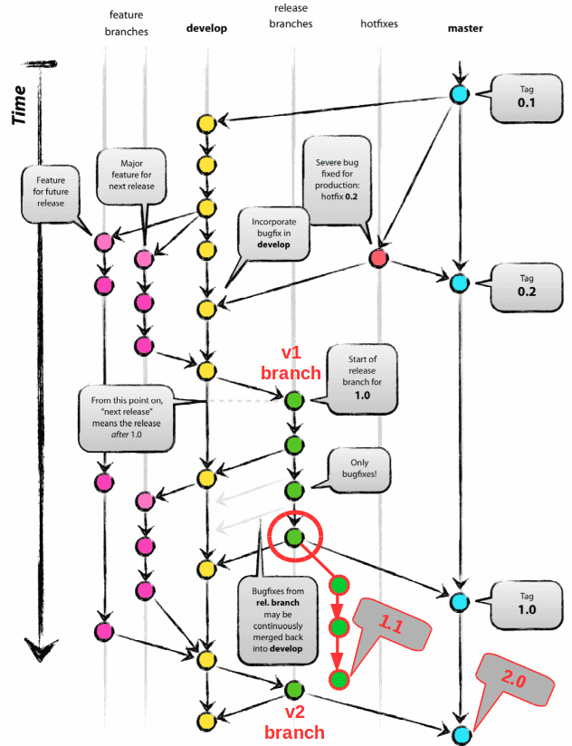

This works, but personally, I think it’s confusing. If we’re going to maintain branches for each major release, I would rather each branch name be explicit. I don’t like having to wonder what major version these branches contain.

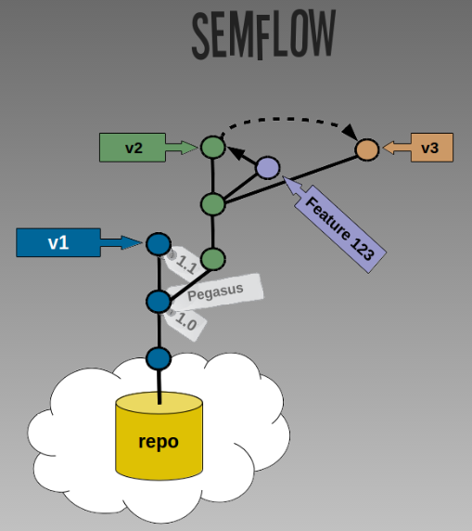

In a SemVer workflow, master and develop do not exist. The name of the “trunk” branch is v0 or v1. Minor releases get a tag (i.e. 1.1.0), while major versions get a tag (i.e. 2.0.0) and a new branch (i.e. v2). Code on each branch’s HEAD (the leaves in the tree) can still be hotfixed if necessary, and enhanced with code from feature branches.

This approach becomes especially useful when you have a feature off of a v(N) branch that you would like to merge into both v(N) and v(N+1). When the feature is complete, you can squash that branch’s commits and cherry-pick them over to other branches as needed, resolving conflicts if necessary. This might seem unlikely, but occasionally you begin a feature expecting both its need and impact to be isolated, but discover later that it could/should be applied more broadly.

For this reason, it’s recommended that you keep a set of code or specification changes separate from the commit that actually bumps the version number or applies a tag. In my case, I track the version number in the package.json file, and I don’t want that change to come along with the RAML modifications I want to apply in a different branch. Failing to keep these separate will result in a post cherry-pick conflict resolution like this:

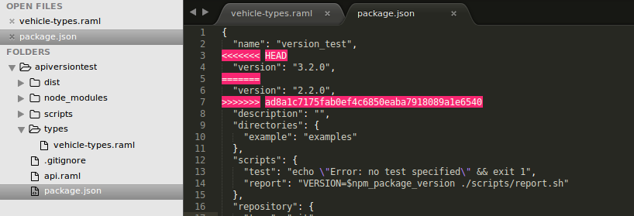

Let’s say I want to bring the vehicle’s interiorColor field into version 3 of the API. In this example, I’m on the v3 branch and cherry-picking a commit from the v2 branch. If I wasn’t paying close attention, I might choose the wrong version, and things would get very ugly.

The SemVer Workflow in Action – An Example

First, we'll create a branch that represents our first “beta” release – v0. This branch contains what will soon become v1 of the API. (If you've already checked in code to master, you can rename it to v0 and delete the master branch!) Remember to set the default branch to v0 in your [Stash] repository settings:

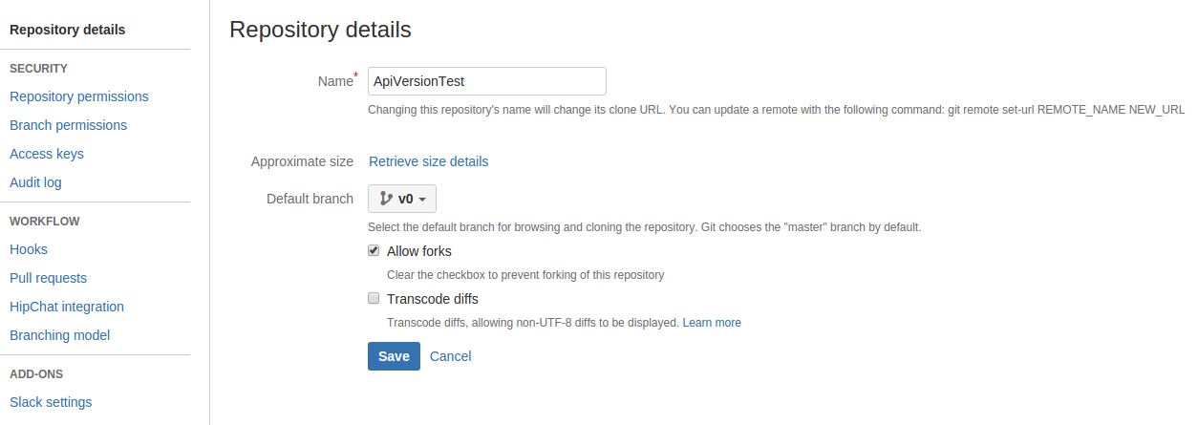

When you're ready to release version 1 of your API, you create a new branch. You can use npm version to tell the project how to increment itself according to SemVer rules, which will create an isolated commit with a tag. (Note that I should have pushed with tags here: git push origin v1 --tags).

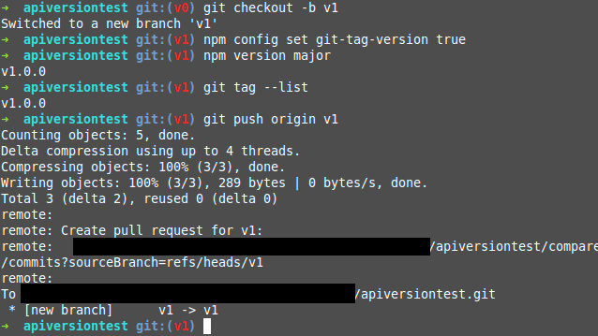

In this case, the RAML itself can have a version number, but I removed it and will rely on the package.json instead. (Scripts can help sync the two - the goal is to have a single source of truth for the version number.)

If I keep adding to the API spec like the example chart above indicates, my tree looks something like this:

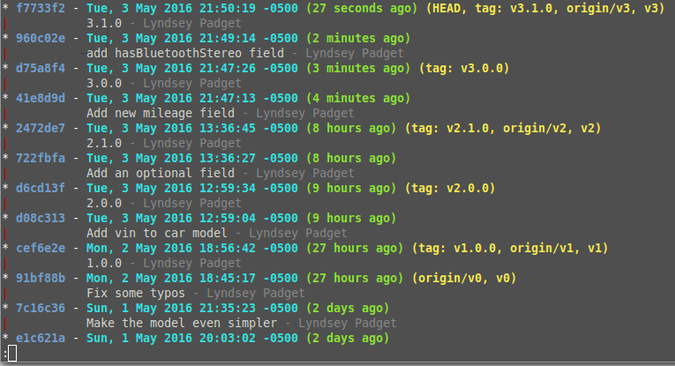

This represents typical development where no minor updates are made to older releases. Notice how it looks linear, even though we’ve made branches for each major version. Then, when we update the v2 branch with an enhancement (v2.2) the tree looks like this:

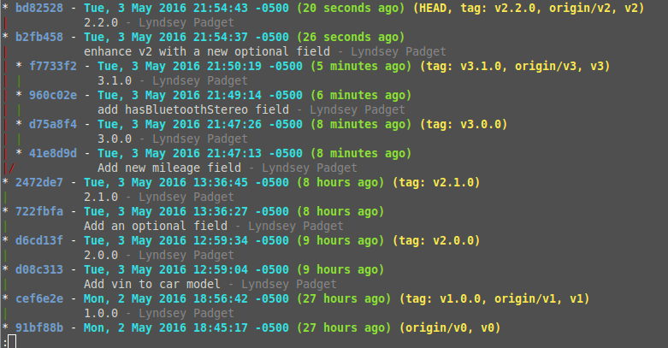

Summary

Git is a powerful and flexible tool. Standard workflows are fundamental in helping teams keep code organized, but they should never box you in. In general, the Feature Branch and Gitflow workflows are fantastic, but you can adapt them to the needs of your project and team. I see the SemVer workflow as one such adaptation. It just so happens that this model applies nicely to multi-versioned RESTful APIs.

### Project

I'm gonna start a live coding assignment. Actually a project. What we're gonna do is show you step by step how to build the beer service micro service. I'm gonna carry this throughout the entire course. And the lessons are gonna start with LC for live coding. And I'm gonna go through step by step and show one of the microservices that we're developing all the way through all the code development on it. So, I'm setting up a new repository here.

|  |  |
| --- | --- |
|  | Picked from here ( proper revision )  <https://github.com/springframeworkguru/mssc-beer-service/tree/fa9009ebe516da5fb1a2649e5fd83b5b32c2a338> |

#### Data Model, Controller, JUnit 5 Controller Unit Tests

**pom.xml**

<?xml version="1.0" encoding="UTF-8"?>

<project xmlns="http://maven.apache.org/POM/4.0.0" xmlns:xsi="http://www.w3.org/2001/XMLSchema-instance"

xsi:schemaLocation="http://maven.apache.org/POM/4.0.0 http://maven.apache.org/xsd/maven-4.0.0.xsd">

<modelVersion>4.0.0</modelVersion>

<parent>

<groupId>org.springframework.boot</groupId>

<artifactId>spring-boot-starter-parent</artifactId>

<version>2.1.4.RELEASE</version>

<relativePath/> <!-- lookup parent from repository -->

</parent>

<groupId>guru.springframework</groupId>

<artifactId>003-mssc-beer-service</artifactId>

<version>0.0.1-SNAPSHOT</version>

<name>003-mssc-beer-service</name>

<description>MSSC Beer Service</description>

<properties>

<project.build.sourceEncoding>UTF-8</project.build.sourceEncoding>

<project.reporting.outputEncoding>UTF-8</project.reporting.outputEncoding>

<java.version>11</java.version>

<jaxb.version>2.3.0</jaxb.version>

<maven.compiler.source>${java.version}</maven.compiler.source>

<maven.compiler.target>${java.version}</maven.compiler.target>

</properties>

<dependencies>

<dependency>

<groupId>org.springframework.boot</groupId>

<artifactId>spring-boot-starter-actuator</artifactId>

</dependency>

<dependency>

<groupId>org.springframework.boot</groupId>

<artifactId>spring-boot-starter-web</artifactId>

</dependency>

<dependency>

<groupId>org.springframework.boot</groupId>

<artifactId>spring-boot-starter-data-jpa</artifactId>

</dependency>

<dependency>

<groupId>com.h2database</groupId>

<artifactId>h2</artifactId>

<scope>runtime</scope>

</dependency>

<dependency>

<groupId>javax.xml.bind</groupId>

<artifactId>jaxb-api</artifactId>

<version>${jaxb.version}</version>

</dependency>

<dependency>

<groupId>com.sun.xml.bind</groupId>

<artifactId>jaxb-core</artifactId>

<version>${jaxb.version}</version>

</dependency>

<dependency>

<groupId>com.sun.xml.bind</groupId>

<artifactId>jaxb-impl</artifactId>

<version>${jaxb.version}</version>

</dependency>

<dependency>

<groupId>org.springframework.boot</groupId>

<artifactId>spring-boot-devtools</artifactId>

<scope>runtime</scope>

</dependency>

<dependency>

<groupId>org.projectlombok</groupId>

<artifactId>lombok</artifactId>

<optional>true</optional>

</dependency>

<dependency>

<groupId>org.springframework.boot</groupId>

<artifactId>spring-boot-starter-test</artifactId>

<scope>test</scope>

<exclusions>

<exclusion>

<groupId>junit</groupId>

<artifactId>junit</artifactId>

</exclusion>

</exclusions>

</dependency>

<dependency>

<groupId>org.junit.jupiter</groupId>

<artifactId>junit-jupiter-api</artifactId>

<scope>test</scope>

</dependency>

<dependency>

<groupId>org.junit.jupiter</groupId>

<artifactId>junit-jupiter-engine</artifactId>

<scope>test</scope>

</dependency>

<dependency>

<groupId>org.mockito</groupId>

<artifactId>mockito-junit-jupiter</artifactId>

<scope>test</scope>

</dependency>

</dependencies>

<build>

<plugins>

<plugin>

<groupId>org.springframework.boot</groupId>

<artifactId>spring-boot-maven-plugin</artifactId>

</plugin>

</plugins>

</build>

</project>

**MsscBeerServiceApplication.java**

import org.springframework.boot.SpringApplication;

import org.springframework.boot.autoconfigure.SpringBootApplication;

@SpringBootApplication

public class MsscBeerServiceApplication {

public static void main(String[] args) {

SpringApplication.run(MsscBeerServiceApplication.class, args);

}

}

**application.properties**

<empty>

**BeerController.java**

import guru.springframework.msscbeerservice.web.model.BeerDto;

import org.springframework.http.HttpStatus;

import org.springframework.http.ResponseEntity;

import org.springframework.web.bind.annotation.*;

import java.util.UUID;

@RequestMapping("/api/v1/beer")

@RestController

public class BeerController {

@GetMapping("/{beerId}")

public ResponseEntity<BeerDto> getBeerById(@PathVariable("beerId") UUID beerId){

//todo impl

return new ResponseEntity<>(BeerDto.builder().build(), HttpStatus.OK);

}

@PostMapping

public ResponseEntity saveNewBeer(@RequestBody BeerDto beerDto){

//todo impl

return new ResponseEntity(HttpStatus.CREATED);

}

@PutMapping("/{beerId}")

public ResponseEntity updateBeerById( @PathVariable("beerId") UUID beerId,

@RequestBody BeerDto beerDto){

//todo impl

return new ResponseEntity(HttpStatus.NO_CONTENT);

}

}

**BeerDto.java**

import lombok.AllArgsConstructor;

import lombok.Builder;

import lombok.Data;

import lombok.NoArgsConstructor;

import java.math.BigDecimal;

import java.time.OffsetDateTime;

import java.util.UUID;

@Data

@NoArgsConstructor

@AllArgsConstructor

@Builder

public class BeerDto {

private UUID id;

private Integer version;

private OffsetDateTime createdDate;

private OffsetDateTime lastModifiedDate;

private String beerName;

private BeerStyleEnum beerStyle;

private Long upc;

private BigDecimal price;

private Integer quantityOnHand;

}

**BeerStyleEnum.java**

public enum BeerStyleEnum {

LAGER, PILSNER, STOUT, GOSE, PORTER, ALE, WHEAT, IPA, PALE_ALE, SAISON

}

**BeerControllerTest.java**

import com.fasterxml.jackson.databind.ObjectMapper;

import guru.springframework.msscbeerservice.web.model.BeerDto;

import org.junit.jupiter.api.Test;

import org.springframework.beans.factory.annotation.Autowired;

import org.springframework.boot.test.autoconfigure.web.servlet.WebMvcTest;

import org.springframework.http.MediaType;

import org.springframework.test.web.servlet.MockMvc;

import java.util.UUID;

import static org.springframework.test.web.servlet.request.MockMvcRequestBuilders.*;

import static org.springframework.test.web.servlet.result.MockMvcResultMatchers.status;

@WebMvcTest(BeerController.class)

class BeerControllerTest {

@Autowired

MockMvc mockMvc;

@Autowired

ObjectMapper objectMapper;

@Test

void getBeerById() throws Exception {

mockMvc.perform( get("/api/v1/beer/" +

UUID.randomUUID().toString())

.accept(MediaType.APPLICATION_JSON))

.andExpect(status().isOk());

}

@Test

void saveNewBeer() throws Exception {

BeerDto beerDto = BeerDto.builder().build();

String beerDtoJson = objectMapper.writeValueAsString(beerDto);

mockMvc.perform(post("/api/v1/beer/")

.contentType(MediaType.APPLICATION_JSON)

.content(beerDtoJson))

.andExpect(status().isCreated());

}

@Test

void updateBeerById() throws Exception {

BeerDto beerDto = BeerDto.builder().build();

String beerDtoJson = objectMapper.writeValueAsString(beerDto);

mockMvc.perform(put("/api/v1/beer/" + UUID.randomUUID().toString())

.contentType(MediaType.APPLICATION_JSON)

.content(beerDtoJson))

.andExpect(status().isNoContent());

}

}

**MsscBeerServiceApplicationTests.java**

import org.junit.jupiter.api.Test;

import org.springframework.boot.test.context.SpringBootTest;

@SpringBootTest

public class MsscBeerServiceApplicationTests {

@Test

public void contextLoads() {

}

}

#### Spring REST Templates

RestTemplate is very very capable. There's a lot that it can do. We are gonna get into kind of a introductory overview. Show you how to use all the basics of RestTemplate so we'll start get our hands on using Spring RestTemplate to consume web services. So it's very important distinction that we're making. So remember, one side is producing it. This is gonna be the client that's talking it so we're gonna be focusing on the client code of that, and then moving on, coming up in the course, we're gonna go back to the producer side and start dealing with validations.

|  |  |
| --- | --- |
|  | So a very important aspect obviously. You don't wanna be tossing garbage into your controllers or your services so validation is a very important part. And then coming up after that, we will be looking at Project Lombok and MapStruct.  We already seen Lombok a little bit. We're gonna take a closer look at Lombok because it is a true time-saver, really a must have go-to tool in my opinion. I use it in my professional development all the time. So, we'll be looking at that coming up in a couple sessions. But in this section, we're gonna be looking specifically at RestTemplate and consuming web services. In fact, we're gonna actually go back and use the Spring MVC Services that we created. We'll write a client that will talk to those and consume those so we'll be able to bring up two Spring Boot instances at the same time and see that interaction. So remember you start thinking in terms of a producer, that's the Spring MVC stuff that we just did and then a client or consumer that is gonna be using a RestTemplate as far as using a Spring Framework. So, a lot of cool content in the section of the course coming up. |

##### GET Example

**Project: 003-mssc-brewery-client-http-get**

We are gonna start taking a look at Spring RestTemplate. So, RestTemplate is really the tool that you use to interact with RESTful web services so exactly like it sounds, RestTemplate. So what I've done is I've created a brand new project. You'll find a link to it, masters. So I've set up the project I wanna go through the Maven configuration and the dependencies that I've brought in and I'm gonna talk through that now. So I'm gonna jump over to IntelliJ and take a look at just the Maven dependencies of this project that we'll be using to explore using Spring RestTemplate. Okay. Up on the screen here. I have the initial project that we'll be working with for the Rest Template client. And you can see up here, on line number 8, I have the Spring Boot 2.2 milestone 2 to release. Now one thing that I do with my course is, I will be updating the Spring Boot version as it comes out. And I try to stay somewhat current on that. I'll do that probably about once a quarter so as I'll go through and start updating some of it. But I'm on the milestone 2 of 2.2 which is gonna be a pretty significant release of Spring Boot. So, we're on some pretty recent stuff here. Then also on line 18, you can see that I am requiring Java 11 for the version of this project. Now not too much as interesting as far as the dependencies, kind of what we saw before we have the spring-boot-starter-web that brings in the web client. I am bringing in devtools and of course Project Lombok. Now, I do wanna point out as I scroll up here. On line 40, Spring Boot starter tests. Right now, they've been talking about upgrading to JUnit 5. Currently on this version of Spring, they are still on JUnit4. There are some things that are stopping them from advancing but it's not gonna stop us. I am gonna write everything in JUnit 5 to keep this course more current for you. So, this is a configuration to overwrite JUnit4. In a future release of Spring Boot, I'll probably remove this exclusion. And I don't think we'll need to actually plunk in the JUnit dependencies once Spring Boot gets up to it. So, I will probably update the pom releases so be sure to check out the repository because I will update releases for that. Now also, I scroll up here a little bit more. On line 68, I am bringing in the surefire-plugin. I am bringing in the milestone 3 of this. There's actually some changes in this version for junit 5 specifically. So there's some things I wanna capture for that. And then here, I am bringing in the Maven Enforcer plugin. So I'm setting up some rules here. If you wanna know more about the enforcer plugin, check out my course on Apache Maven. There's a deep dive. But basically, this enforcer plugin, if you are not running on Maven 3.6.0 or higher or Java 11 or higher, your build is gonna fail. So, I'm forcing... enforcing that we want that to be required there. And a little typo there so we'll fix that. And this is gonna be a requirement to have Maven 3.6 or higher or Java 11 or higher. So, if you do not, you are gonna have some problems as far as running the Maven build. And then finally here, you can see on line 104, I am bringing in the milestone repositories for Spring Framework. That is what allows us to run on the milestone release of Spring boot. And what was that... 2.2.0.M2. So, a milestone 2 release. It's the most recent available release as far as a milestone goes.

**pom.xml**

<?xml version="1.0" encoding="UTF-8"?>

<project xmlns="http://maven.apache.org/POM/4.0.0" xmlns:xsi="http://www.w3.org/2001/XMLSchema-instance"

xsi:schemaLocation="http://maven.apache.org/POM/4.0.0 http://maven.apache.org/xsd/maven-4.0.0.xsd">

<modelVersion>4.0.0</modelVersion>

<parent>

<groupId>org.springframework.boot</groupId>

<artifactId>spring-boot-starter-parent</artifactId>

<version>2.1.4.RELEASE</version>

<relativePath/> <!-- lookup parent from repository -->

</parent>

<groupId>guru.springframework</groupId>

<artifactId>mssc-brewery-client</artifactId>

<version>0.0.1-SNAPSHOT</version>

<name>mssc-brewery-client</name>

<description>SFG Brewery Client</description>

<properties>

<project.build.sourceEncoding>UTF-8</project.build.sourceEncoding>

<project.reporting.outputEncoding>UTF-8</project.reporting.outputEncoding>

<java.version>11</java.version>

<jaxb.version>2.3.0</jaxb.version>

<maven.compiler.source>${java.version}</maven.compiler.source>

<maven.compiler.target>${java.version}</maven.compiler.target>

</properties>

<dependencies>

<dependency>

<groupId>org.springframework.boot</groupId>

<artifactId>spring-boot-starter-actuator</artifactId>

</dependency>

<dependency>

<groupId>org.springframework.boot</groupId>

<artifactId>spring-boot-starter-web</artifactId>

</dependency>

<dependency>

<groupId>org.springframework.boot</groupId>

<artifactId>spring-boot-starter-data-jpa</artifactId>

</dependency>

<dependency>

<groupId>com.h2database</groupId>

<artifactId>h2</artifactId>

<scope>runtime</scope>

</dependency>

<dependency>

<groupId>javax.xml.bind</groupId>

<artifactId>jaxb-api</artifactId>

<version>${jaxb.version}</version>

</dependency>

<dependency>

<groupId>com.sun.xml.bind</groupId>

<artifactId>jaxb-core</artifactId>

<version>${jaxb.version}</version>

</dependency>

<dependency>

<groupId>com.sun.xml.bind</groupId>

<artifactId>jaxb-impl</artifactId>

<version>${jaxb.version}</version>

</dependency>

<dependency>

<groupId>org.springframework.boot</groupId>

<artifactId>spring-boot-devtools</artifactId>

<scope>runtime</scope>

</dependency>

<dependency>

<groupId>org.projectlombok</groupId>

<artifactId>lombok</artifactId>

<optional>true</optional>

</dependency>

<dependency>

<groupId>org.springframework.boot</groupId>

<artifactId>spring-boot-starter-test</artifactId>

<scope>test</scope>

<exclusions>

<exclusion>

<groupId>junit</groupId>

<artifactId>junit</artifactId>

</exclusion>

</exclusions>

</dependency>

<dependency>

<groupId>org.junit.jupiter</groupId>

<artifactId>junit-jupiter-api</artifactId>

<scope>test</scope>

</dependency>

<dependency>

<groupId>org.junit.jupiter</groupId>

<artifactId>junit-jupiter-engine</artifactId>

<scope>test</scope>

</dependency>

<dependency>

<groupId>org.mockito</groupId>

<artifactId>mockito-junit-jupiter</artifactId>

<scope>test</scope>

</dependency>

</dependencies>

<build>

<plugins>

<plugin>

<groupId>org.springframework.boot</groupId>

<artifactId>spring-boot-maven-plugin</artifactId>

</plugin>

<!-- for junit5 support-->

<plugin>

<groupId>org.apache.maven.plugins</groupId>

<artifactId>maven-surefire-plugin</artifactId>

<version>3.0.0-M3</version>

</plugin>

<!-- require maven 3.6.0 or higher, require Java 11 or higher-->

<plugin>

<groupId>org.apache.maven.plugins</groupId>

<artifactId>maven-enforcer-plugin</artifactId>

<version>3.0.0-M2</version>

<executions>

<execution>

<id>enforce-versions</id>

<goals>

<goal>enforce</goal>

</goals>

<configuration>

<rules>

<requireMavenVersion>

<version>[3.6.0,)</version>

</requireMavenVersion>

<requireJavaVersion>

<version>[11,)</version>

</requireJavaVersion>

<requireReleaseDeps>

<onlyWhenRelease>true</onlyWhenRelease>

<message>Release builds must not have on snapshot dependencies</message>

</requireReleaseDeps>

</rules>

</configuration>

</execution>

</executions>

</plugin>

</plugins>

</build>

<repositories>

<repository>

<id>spring-snapshots</id>

<name>Spring Snapshots</name>

<url>https://repo.spring.io/snapshot</url>

<snapshots>

<enabled>true</enabled>

</snapshots>

</repository>

<repository>

<id>spring-milestones</id>

<name>Spring Milestones</name>

<url>https://repo.spring.io/milestone</url>

</repository>

</repositories>

<pluginRepositories>

<pluginRepository>

<id>spring-snapshots</id>

<name>Spring Snapshots</name>

<url>https://repo.spring.io/snapshot</url>

<snapshots>

<enabled>true</enabled>

</snapshots>

</pluginRepository>

<pluginRepository>

<id>spring-milestones</id>

<name>Spring Milestones</name>

<url>https://repo.spring.io/milestone</url>

</pluginRepository>

</pluginRepositories>

</project>

Okay, you can see that the main configuration is pretty straightforward. So what I wanna do now is take a quick look at the project structure.So, this is a standard Spring Boot project, primarily brought down from Spring Initializr.

|  |  |
| --- | --- |
|  | Okay, first off, you can see that I added in my standard .gitignore file so that's one difference from what was downloaded from Spring Initializr. So, go ahead and close that. And, we can see that in this, we got the standard SpringBootApplication. So this is straight out of Spring Initializr as well as the application.properties file. And then I did have to change the test here. We can see that I'm using the junit.jupiter.api as well as the Spring Boot @Test annotation so that was modified from the initial download so we're now compatible with JUnit 5 on our integration test. Then the one other thing, I do wanna point out here is I've brought over the Beer model Dto and the CustomerDto. So, these are POJOs exactly like what we have in the brewery project. So we now have a brewery and brewery client. So we are working on a client side and what we're gonna do is set up this project using just the RestTemplate in this project. We'll set up some integration tests to go out and read from a running instance So, I'm using an integration test and air quotes. But I do wanna point out that, I did create this project and I added in the 2 Dto object. So, for our beer and our customer as well. So, that's these two objects. And then, under client this is where we're gonna create the client class. And I put a package-info in that Java there. A one little quirk with how GitHub works. If you have an empty directory it does not get pushed up to GitHub. So by putting this package-info.java in there, it's just a generic file like so. |

|  |  |
| --- | --- |
| import lombok.AllArgsConstructor;  import lombok.Builder;  import lombok.Data;  import lombok.NoArgsConstructor;  import java.math.BigDecimal;  import java.time.OffsetDateTime;  import java.util.UUID;  @Data  @NoArgsConstructor  @AllArgsConstructor  @Builder  public class **BeerDto** {  private UUID id;  private Integer version;  private OffsetDateTime createdDate;  private OffsetDateTime lastModifiedDate;  private String beerName;  private BeerStyleEnum beerStyle;  private Long upc;  private BigDecimal price;  private Integer quantityOnHand;  } | import lombok.AllArgsConstructor;  import lombok.Builder;  import lombok.Data;  import lombok.NoArgsConstructor;  import java.util.UUID;  @Data  @NoArgsConstructor  @AllArgsConstructor  @Builder  public class **CustomerDto** {  private UUID id;  private String name;  } |

And that will actually create that directory for us. So, the next video will actually start building things out. So, I'm doing this video. So we're gonna create the initial class for our client and that's gonna hold the RestTemplate. So, well I'll create this class. But the first thing I wanna do here is set up the properties. And one thing that's gonna vary a lot is the hostname. And you will see all kinds of is handfuls out on the internet where they hard code the hostname. This is not a very realistic example because your code is probably gonna be running in multiple environments and what you are targeting as far as a hostname that is gonna change so you definitely want that externalize. So, in this next segment, I'm gonna show you how to setup an externalized hostname that will get injected by Spring Framework into your class for the hostname. So, when we want to deploy this application out in the real world, we don't have it hard-coded. Now, hostname is gonna be localhost:8080. Okay, what we wanna do is, first, create our client. And let's come up here. I'm gonna create a New Java Class right in the client package. And we will call this... I'm just gonna call it BreweryClient like so. And we'll add this in. And of course, it's gonna be a component. So, I'm just using the springframework.stereotype for Component. And let's call this private. Just call it apihost like so. And then I'm going to create a Setter for that. And what we wanna do here is, I'm gonna set up @ConfigurationProperties and we will call that sfg.brewery like so. So, this is giving it a prefix. And what we wanna do is take that like so.

And now I'm gonna come down to application.properties. See how it's been saying as apihost. So, that's gonna match up to apihost. So, the way that's gonna work is, this is a prefix dot and then it's gonna match the property name. So, we wanna do that. And here, for our purposes, we wanna http://localhost like so 8080. And that's gonna set that property up. And now by default, it will not fail. So, I'm gonna set this up. So if that is not set, I wanna do ignoreUnknownFields equals false because it defaults to true. So if that is not set then this is gonna fail.

import guru.springframework.msscbreweryclient.web.model.BeerDto;

import org.springframework.boot.context.properties.ConfigurationProperties;

import org.springframework.boot.web.client.RestTemplateBuilder;

import org.springframework.stereotype.Component;

import org.springframework.web.client.RestTemplate;

import java.util.UUID;

@ConfigurationProperties(prefix = "sfg.brewery", ignoreUnknownFields = false)

@Component

public class **BreweryClient** {

. . .

}

**application.properties**

sfg.brewery.apihost=http://localhost:8080

Now, the next thing we wanna do is, let's go over to the brewery. And remember in our controller, we have this api here. This is that path. So, I'm just gonna copy that over and let's jump back over to the client. And here, I'm gonna say public final Sring BEER_PATH_V1. And what this is heading up is a constant for the path. So between the two, the chances are the path is never gonna change. So, the host is gonna be variable from system to system but as you evolve this through that path and theory it should never change. So, that kind of sets up our properties as far as what the RestTemplate is going to need. Now, there's actually several different ways that you can get a hold of a RestTemplate. The recommended way as far as when we're using Spring Boot. What we wanna do is inject in the Rest TemplateBuilder. What this allows us to do is configure that RestTemplate builder so we might wanna like configure security on it or some type of HTTP client library. There's a number of things that we can configure with this for edge cases. But the Spring Boot does come up... come with a pre-configured Rest Template. And you can also override that like everything else inside the Spring Boot and set custom properties on it. So, considered a best practice is gonna hold the Builder and then create a Rest Template from that. This way you are using the standard environment Rest Template. So, you'll pick up anything that you've set up globally. If you were to create a RestTemplate locally, then you are not going to pick up what it's been configured by Spring Boot. So, I'm gonna jump over to IntelliJ now and show you exactly how to set this up for the RestTemplate. A RestTemplateBuilder.

import guru.springframework.msscbreweryclient.web.model.BeerDto;

import org.springframework.boot.context.properties.ConfigurationProperties;

import org.springframework.boot.web.client.RestTemplateBuilder;

import org.springframework.stereotype.Component;

import org.springframework.web.client.RestTemplate;

import java.util.UUID;

@ConfigurationProperties(prefix = "sfg.brewery", ignoreUnknownFields = false)

@Component

public class **BreweryClient** {

public final String BEER_PATH_V1 = "/api/v1/beer/";

private String apihost;

private final RestTemplate restTemplate;

public BreweryClient(RestTemplateBuilder restTemplateBuilder) {

this.restTemplate = restTemplateBuilder.build();

}

public BeerDto getBeerById(UUID uuid){

return restTemplate.getForObject(apihost + BEER_PATH_V1 + uuid.toString(), BeerDto.class);

}

public void **setApihost**(String apihost) {

this.apihost = apihost;

}

}

**package-info.java**

package guru.springframework.msscbreweryclient.web.client;

So what we wanna do is come in here and create a private final RestTemplate. We just call it restTemplate like so. And now let's go ahead and add in its constructor. And what we wanna do is, actually bring in the RestTemplateBuilder. And what we wanna do is set this up. So, we'll take in the restTemplateBuilder. And we will say build so that will set our restTemplate. So what's happening there, exactly is, I'm gonna reformat this a little bit. So, we are going to get Spring will inject a Rest TemplateBuilder instance into our brewery client. And in the constructor, we're gonna initialize the rest Template. Now, let's go ahead and setup our client method using the rest Template. So, we'll do a public and we will turn back a BeerDto like so. Do a getBeerById and that's gonna take in a UUID like so. Now, what we wanna say is return restTemplate. And we'll do a getForObject. And now, what we wanna do is the URL. So that is going to be our apihost plus our beer path. And one thing that we can do here is, I'm going to do a slash like that. So, that will encode that. It's very easy to miss slashes like this. And I also need to add in the uuid.toString() like that. I decided setting up the path. So remember our path for the API is api/v1/beer and then the UUID of the beer itself.

So now, the next parameter that we need to pass is what we're parsing. So, it's gonna be the BeerDto.class. So, this is a very very simple application here. Now we can see that we have the RestTemplate.getForObject and we are building the URL so that's gonna be based on the injected property for the apihost which is gonna be sourced in from application.properties here... from this property. And then, we'll take in this path and then we'll pin to it and the uuid that is passed in and we are telling rest Template that we are expecting to get a BeerDto back from this call. So, let's get rid of this empty space here. And that is the configuration of the restTemplate. Okay, this was a very simple example of using RestTemplate. Really simple example. RestTemplate is actually a very versatile tool. You have a lot of options there. So, I'm just showing you a very simple example right now. So, what we wanna do is go out and exercise API. I'm gonna do this through an integration test. So, an integration test meaning that we're gonna have to bring things up. It's actually kind of borderline functional test. But I'm just... this is normally the way I would test things. It's more to demonstrate using RestTemplate. So, what we wanna do is we'll bring up the brewery service. We'll start that up in the other IDE window and then we'll run our integration tests against port 8080 and get a value back from the other running instance of Spring Boot. Okay, the first thing we wanna do is, actually create a test for this. So, I'm gonna come over here on a class name and option enter. And let's go ahead and create a test. And I only need to test to getBeerById. And... I don't think I need a setUp method. So, let's go ahead and go with that. And of course we'll add that to git.

Now, what we wanna do is come in and say @SpringBootTest. So, that is gonna bring up a standard context. And remember we have a BreweryClient. And we are going to Autowired that. So, we're gonna allow Spring Boot to create an instance of that. And this is important because what we are doing is we're taking the configuration of the restTemplateBuilder and allowing Spring Boot inject that into the Brewery Client.

import org.junit.jupiter.api.Test;

import org.springframework.boot.test.context.SpringBootTest;

@SpringBootTest

public class MsscBreweryClientApplicationTests {

@Test

public void contextLoads() {

}

}

So, let's go ahead and write our test now. So, we should get a BeerDto dto equals client.getBeerById and we just need a randomUUID then we can say assertNoNull(dto). Now, if I run it right now, it's gonna fail because I don't think I have the other service running. So, I wanna verify that if it does fail. And we can see that Failed to the load ApplicationContext. Could not bind properties. So that's important. So it's sfg.brewery, apihost. Okay, I had to fast forward and take a closer look at this error. And what's happening is, we were not getting this to bind properly. And the root cause, actually, was because it was on a milestone release. And what Spring is doing in the milestone release is that they're setting up these properties bindings to be immutable. So, we can actually declare this as final and have Spring manage it. But in this milestone release, it is not behaving properly.

import guru.springframework.msscbreweryclient.web.model.BeerDto;

import org.junit.jupiter.api.Test;

import org.springframework.beans.factory.annotation.Autowired;

import org.springframework.boot.test.context.SpringBootTest;

import java.util.UUID;

import static org.junit.jupiter.api.Assertions.*;

@SpringBootTest

class BreweryClientTest {

@Autowired

BreweryClient client;

@Test

void getBeerById() {

BeerDto dto = client.getBeerById(UUID.randomUUID());

assertNotNull(dto);

}

}

So, what I've done is, I've dropped back to the 2.1.4 release so we will not be on the milestone release because those property bindings are not working properly in the milestone release. So, in an upcoming version, keep an eye on the repository because I will update the release to this and possibly refactor. It's actually a pretty interesting thing what Spring guys are doing is in the bindings. We'll be able to declare these properties as final so the class will be immutable which is a good thing so that class cannot change. But for now, we're going to make it mutable so we'll have a setter so these properties will get bound automatically. We can see here, that this did happen. This is what I expected to happen is that I/O error to fail. So, let's come over here to the brewery. And let's go ahead and start... start this up it comes up pretty quick because it's a very light project, not much going on. So, that has started up already. So now, we can see that Tomcat is up listening on port 8080. And let's come back over to the client project. And now, we can see that this test does infact pass. So, let's come into this and I'm going to run this in the debugger. Oops. don't need that guy. Continue. So now, we're at that break point and we can see the dto.

So we can see that we did get Galaxy Cat. So, that's that detail that dto we are setting up. So, just to prove that to you, let's jump over to the brewery. Remember that we are setting... setting up Galaxy Cat as a pale ale. Pretty simple implementation. So, that's where... that is coming. So, that is from the brewery project being served over port 8080 to our client which is picking it up from that. So just to recap everything that we did. Let's come back up here. So, we're setting a property called sfg.brewery.apihost and that's what's telling it it's at the localhost on 8080. And then in the client, we are using ConfigurationProperties to inject that. Now, it did run into a problem as to this is going to be changing in an upcoming release of Spring. This functionality should stay. As looking at the documentation, this should stay but we'll have new capabilities to actually declare this property as a final so that these properties will be immutable. So here, I'm declaring this as a final property which is exactly what we want and at some point we'll be able to refactor the apihost to be final just like the restTemplate is final so we're injecting that into the final property. But very simple operation. So, we're doing restTemplate. We're saying getForObject. It goes against a URL. And then we specify the class that we want it to deserialize against. So take that Json and populate that object. And we can see here in the debugger, I set up a stop and the test to get a hold of that object that was returned. We can see that the properties did in fact bind properly. And upc of course is null because we didn't set that in the server side.

Calling code that invokes BreweryClient which in turn makes the REST call

import guru.springframework.msscbreweryclient.web.model.BeerDto;

import org.junit.jupiter.api.Test;

import org.springframework.beans.factory.annotation.Autowired;

import org.springframework.boot.test.context.SpringBootTest;

import java.util.UUID;

import static org.junit.jupiter.api.Assertions.*;

@SpringBootTest

class **BreweryClientTest** {

@Autowired

BreweryClient client;

@Test

void getBeerById() {

BeerDto dto = client.getBeerById(UUID.randomUUID());

System.out.println("dto -> "+dto);

assertNotNull(dto);

}

}

**BreweryClient.java**

import guru.springframework.msscbreweryclient.web.model.BeerDto;

import org.springframework.boot.context.properties.ConfigurationProperties;

import org.springframework.boot.web.client.RestTemplateBuilder;

import org.springframework.stereotype.Component;

import org.springframework.web.client.RestTemplate;

import java.util.UUID;

@ConfigurationProperties(prefix = "sfg.brewery", ignoreUnknownFields = false)

@Component

public class **BreweryClient** {

public final String BEER_PATH_V1 = "/api/v1/beer/";

private String apihost;

private final RestTemplate restTemplate;

public BreweryClient(RestTemplateBuilder restTemplateBuilder) {

this.restTemplate = restTemplateBuilder.build();

}

public BeerDto getBeerById(UUID uuid){

System.out.println("Calling REST endpoint: " + apihost + BEER_PATH_V1 + uuid.toString() );

return restTemplate.getForObject(apihost + BEER_PATH_V1 + uuid.toString(), BeerDto.class);

}

public void setApihost(String apihost) {

this.apihost = apihost;

}

}

The controller in the other project 003-mssc-beer-service that receives the call has

import guru.springframework.msscbeerservice.web.model.BeerDto;

import org.springframework.http.HttpStatus;

import org.springframework.http.ResponseEntity;

import org.springframework.web.bind.annotation.*;

import java.util.UUID;

@RequestMapping("/api/v1/beer")

@RestController

public class BeerController {

@GetMapping("/{beerId}")

public ResponseEntity<BeerDto> getBeerById(@PathVariable("beerId") UUID beerId){

//todo impl

return new ResponseEntity<>(BeerDto.builder().build(), HttpStatus.OK);

}

@PostMapping

public ResponseEntity saveNewBeer(@RequestBody BeerDto beerDto){

//todo impl

return new ResponseEntity(HttpStatus.CREATED);

}

@PutMapping("/{beerId}")

public ResponseEntity updateBeerById(@PathVariable("beerId") UUID beerId, @RequestBody BeerDto beerDto){

//todo impl

return new ResponseEntity(HttpStatus.NO_CONTENT);

}

}

##### PUT, POST and DELETE Implementation

**BreweryClient.java**

import guru.springframework.msscbreweryclient.web.model.BeerDto;

import org.springframework.boot.context.properties.ConfigurationProperties;

import org.springframework.boot.web.client.RestTemplateBuilder;

import org.springframework.stereotype.Component;

import org.springframework.web.client.RestTemplate;

import java.net.URI;

import java.util.UUID;

@ConfigurationProperties(prefix = "sfg.brewery", ignoreUnknownFields = false)

@Component

public class BreweryClient {

public final String BEER_PATH_V1 = "/api/v1/beer/";

private String apihost;

private final RestTemplate restTemplate;

public BreweryClient(RestTemplateBuilder restTemplateBuilder) {

this.restTemplate = restTemplateBuilder.build();

}

public BeerDto getBeerById(UUID uuid){

return restTemplate.getForObject(apihost + BEER_PATH_V1 + uuid.toString(), BeerDto.class);

}

public URI saveNewBeer(BeerDto beerDto){

return restTemplate.postForLocation(apihost + BEER_PATH_V1, beerDto);

}

public void updateBeer(UUID uuid, BeerDto beerDto){

restTemplate.put(apihost + BEER_PATH_V1 + "/" + uuid.toString(), beerDto);

}

public void deleteBeer(UUID uuid){

restTemplate.delete(apihost + BEER_PATH_V1 + "/" + uuid );

}

public void setApihost(String apihost) {

this.apihost = apihost;

}

}

And the test case for these methods

import guru.springframework.msscbreweryclient.web.model.BeerDto;

import org.junit.jupiter.api.Test;

import org.springframework.beans.factory.annotation.Autowired;

import org.springframework.boot.test.context.SpringBootTest;

import java.net.URI;

import java.util.UUID;

import static org.junit.jupiter.api.Assertions.*;

@SpringBootTest

class BreweryClientTest {

@Autowired

BreweryClient client;

@Test

void getBeerById() {

BeerDto dto = client.getBeerById(UUID.randomUUID());

assertNotNull(dto);

}

@Test

void testSaveNewBeer() {

//given

BeerDto beerDto = BeerDto.builder().beerName("New Beer").build();

URI uri = client.saveNewBeer(beerDto);

assertNotNull(uri);

System.out.println(uri.toString());

}

@Test

void testUpdateBeer() {

//given

BeerDto beerDto = BeerDto.builder().beerName("New Beer").build();

client.updateBeer(UUID.randomUUID(), beerDto);

}

@Test

void testDeleteBeer() {

client.deleteBeer(UUID.randomUUID());

}

}

Update and delete test cases would fail right now as we do not have a mechanism to store them implemented yet.

#### Http Clients

I want to talk to you about HTTP clients that we will be using with our REST clients. So just a recap, go over a little bit of basics with this. We have three basic communication layers that we're dealing with. So we have HTTP that we've looked at before in the course and that is basically how the client is going to be communicating. It's going to be using HTTP. Now underneath that is going to be TCP, so that is Transmission Control Protocol. So that is the transport layer. Basically what TCP does is that is how data is moved in packets between the client and server. So I don't know if you understand this but the server is going to listen on a port. Ephemeral port is going to be open to communicate back so there's actually two ports in play. The data, what you are sending that all that stuff in the HTTP stuff that we looked at. that is actually going to be divided up into network packets and then transmitted. it gets to the other side, and gets reassembled into that payload. So if remember we had the HTTP. We looked at that. We could see the header of the HTTP, the commands, we can see like the JSON body. All that is going to get divided up into network packets and that packets aren't necessarily guaranteed to arrive in sequence. But there's a way to reassemble those and that's what the TCP is doing so it's taking that basically that request body that you were sending to the server or the sender. The server's responding to you, breaks it up, sends it back or gets it to you.

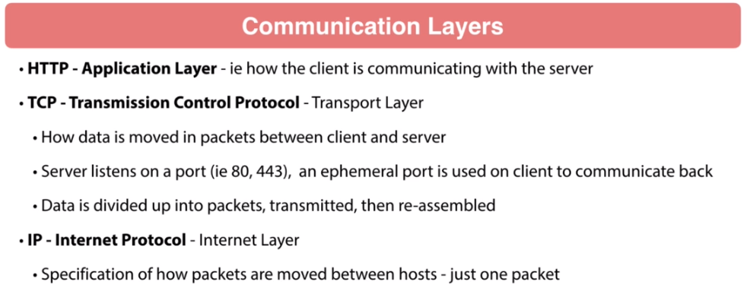

Now then you have the IP Protocol and this is the internet layer. Basically this is going to be the specification of how packets are moved. So this really looks at just one packet so it does the technical specification for that and it gets into a lot of the communication between moving these packets back and forth, but is only looking at one packet. TCP is going to be what's doing with the assembly and getting things reassembled properly. So I don't want to dive too deep into this but it's important to understand that these different layers are involved in this as we're talking network communications. Now, Java Input Output or IO, that is the network communication, so that happens in the java.io packages. These are very very low-level libraries that are used to communicate with the host operating system.

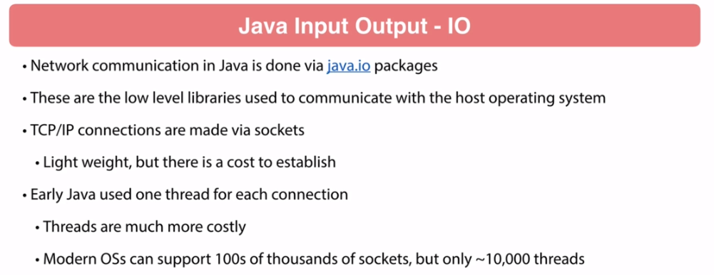

TCP connections are made via sockets. These are very lightweight but there is a slight cost to establish every connection. Early Java would use one thread for each connection. Threads are much more costly than a socket connection. Modern system can actually have like hundreds of thousands of sockets but it's only going to support roughly 10,000 threads, and these are approximations, so depending on the hardware, depending on the operating system, depending on how much juice your computer has. Obviously, a newer laptop or a newer computer with more horsepower is going to be able to support more. An older system obviously less. But I wanted to have that contrast where you can sockets are very very cheap. There is more of a cost to managing threads. Now blocking an I/O. Pre Java 1.4 the threats would get blocked. There would be one connection, one thread per connection.

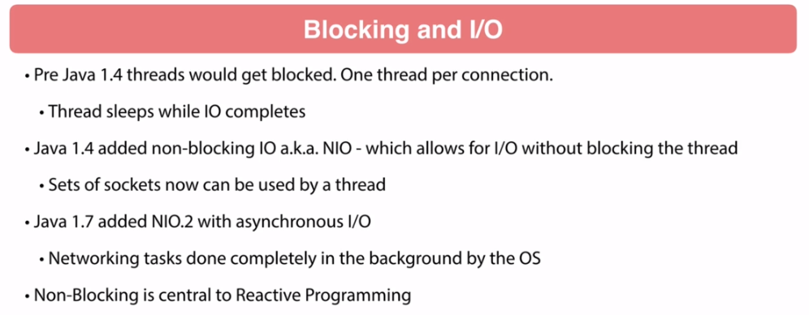

And what happens is while that communication is taking place, that thread gets put into sleep. The way that that is happening that thread goes into sleep and that's usually managed by Java in conjunction with the operating system and when that thread goes into sleep it goes into an idle state and then it has to be brought back to actually run on the CPU and get system resources. There's a cost to all this happening so when that thread gets put to sleep and then gets woke back up, there's going to be a cost happening with that. Java 1.4 added in a non-blocking I/O also known as NIO, which allows for I/O to occur without blocking the thread. There's a set of things that can be done that will allow multiple sockets be used by a thread. And then this got further improved in Java 1.7 with the NIO.2 with asynchronous I/O and effectively what happened is the networking tasks are more and more being pushed to the background operating system. I'm sure if you're familiar with Reactive Programming but non-blocking essential to Reactive Programming. So it's a very important concept where we're allowing that processing thread to be staying active and getting active CPU cycles without getting put to sleep. So, when done properly, this can really help your performance. Speaking of performance, it's not uncommon for microservices to have many many client connections. So when you use a non-blocking client, they are typically going to benchmark higher than blocking clients. Sometimes it can be four to five times even more than that is from terms of connections and throughput.

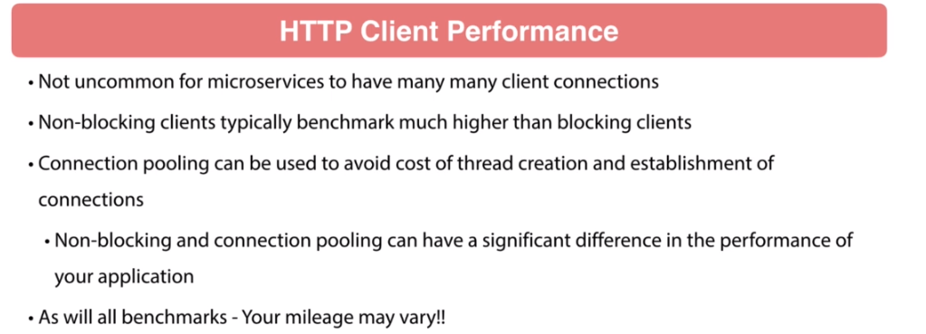

So this can be very very significant and then also we can utilize what's called Connection pooling so when we're talking to a server we are going to establish a connection with that server. When you combine non-blocking with connection pooling you can have a significant difference in the performance of your application so this can really really make a huge difference. I do want to point out as with all benchmarks like your mileage may vary because I'm giving you a general overview of performance. So connection pooling and non-blocking is generally good can make a really really big difference in your at the throughput of your application. But there's always those use cases where it might not. so you want to put that little disclaimer there. Now in Java of course we have a lot of selections, a lot of options. I'm not by any means listing all of them here but there are a number of HTTP clients that can use.

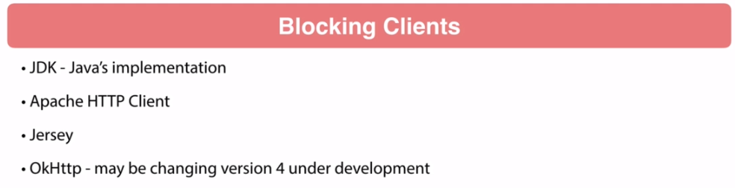

The Java JDK does have its own implementation so that's right in the Java's based libraries that we can utilize. Apache HTTP Client, that is very popular, widely used. Jersey is very popular. OkHTTP, this is from the people at Square. Very robust library and I believe it's blocking right now but they are actively working on a version 4 which I expect them to move that to non blocking. And then we have the non-blocking clients. So we have the Apache Async Client, Jersey Async HTTP Client, and then Netty. I'm pretty sure Netty is the default client that is being used within Reactive Spring. So Netty it's very very performant but Apache is one that I prefer to use and I'll be showing an example coming up in the course.

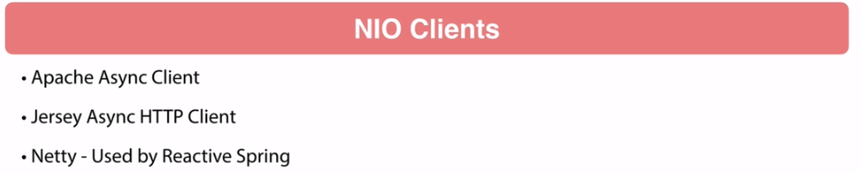

Now the next thing we need to also talk about is HTTP/2. This is generally going to be much more performant than HTTP 1. This is really because of what's going on underneath the cover. So HTTP/2 is going to be utilizing the TCP layer much more efficiently. It does this thing called multiplex streams and actually uses a binary protocol so it works with compression much better. There's reduced latency and when you're dealing with an encrypted connection the encryption is much faster. So there are a significant benefits to this. To you, when you're doing RESTful APIs, functionally the same. It's going to be fairly transparent to you. But the way to utilize HTTP to you is the biggest thing is the server you're talking to needs to support it and you need to be using a client that supports it as well.

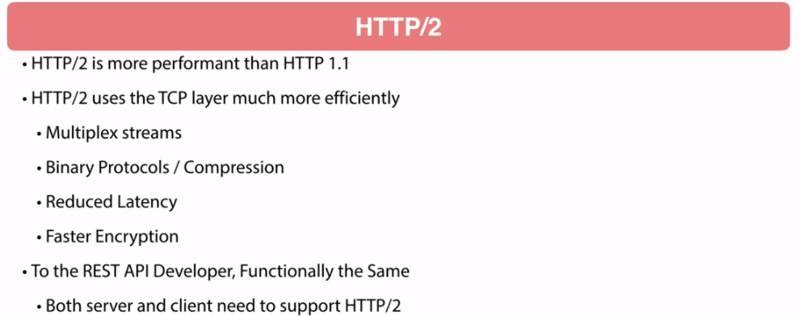

Now currently the HTTP/2 clients that we can select from it is built into the JDK on 9 and above. So that is part of the Java libraries. Then there's Jetty. Nettie again, that is what Spring is using for the Reactive stuff. OkHTTP, that has also got support. Vertex and FireFly. I'm not terribly familiar with those. I know of them but I've never really utilized them.

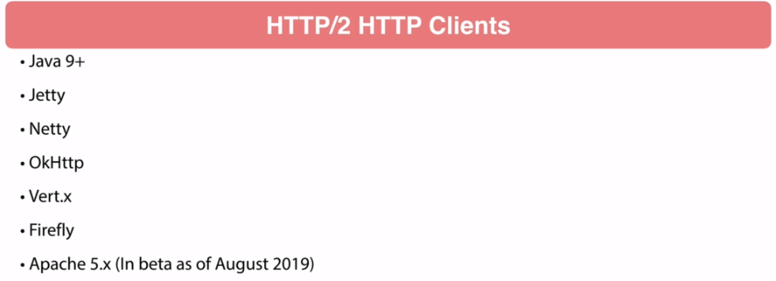

And then Apache is rolling this out and I just looked at their website right now it is August 2019 and it is in beta so they do have their HTTP/2 inbeta and that is likely to change. I expect by the end of the year where they'll be taking that to a final release. And again this list is always going to be changing. Right now circa 2019 of August, HTTP 2 is rolling out in the Java community. So HTTP 1 is probably still the most widely thing used in the enterprise. But with that said, I expect this to be changing over the next year or two. The Java community can be slow to adopt new technologies like this but it has been out for a while and we are rolling over to it and there are a number of advantages to using this. It is definitely much more efficient than HTTP 1 so I expect that will continue to propagate and you'll see more and more enterprises turning to using HTTP/2.

##### Apache HTTP Client Configuration

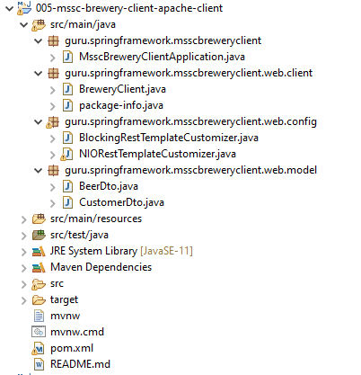

**BlockingRestTemplateCustomizer.java**

import org.apache.http.client.config.RequestConfig;

import org.apache.http.impl.client.CloseableHttpClient;

import org.apache.http.impl.client.DefaultConnectionKeepAliveStrategy;

import org.apache.http.impl.client.HttpClients;

import org.apache.http.impl.conn.PoolingHttpClientConnectionManager;

import org.springframework.boot.web.client.RestTemplateCustomizer;

import org.springframework.http.client.ClientHttpRequestFactory;

import org.springframework.http.client.HttpComponentsClientHttpRequestFactory;

import org.springframework.stereotype.Component;

import org.springframework.web.client.RestTemplate;

@Component

public class BlockingRestTemplateCustomizer implements RestTemplateCustomizer {

public ClientHttpRequestFactory clientHttpRequestFactory(){

PoolingHttpClientConnectionManager connectionManager = new PoolingHttpClientConnectionManager();

connectionManager.setMaxTotal(100);

connectionManager.setDefaultMaxPerRoute(20);

RequestConfig requestConfig = RequestConfig

.custom()

.setConnectionRequestTimeout(3000)

.setSocketTimeout(3000)

.build();

CloseableHttpClient httpClient = HttpClients

.custom()

.setConnectionManager(connectionManager)

.setKeepAliveStrategy(new DefaultConnectionKeepAliveStrategy())

.setDefaultRequestConfig(requestConfig)

.build();

return new HttpComponentsClientHttpRequestFactory(httpClient);

}

@Override

public void customize(RestTemplate restTemplate) {

restTemplate.setRequestFactory(this.clientHttpRequestFactory());

}

}

**NIORestTemplateCustomizer.java**

import org.apache.http.impl.nio.client.CloseableHttpAsyncClient;

import org.apache.http.impl.nio.client.HttpAsyncClients;

import org.apache.http.impl.nio.conn.PoolingNHttpClientConnectionManager;

import org.apache.http.impl.nio.reactor.DefaultConnectingIOReactor;

import org.apache.http.impl.nio.reactor.IOReactorConfig;

import org.apache.http.nio.reactor.IOReactorException;

import org.springframework.boot.web.client.RestTemplateCustomizer;

import org.springframework.http.client.ClientHttpRequestFactory;

import org.springframework.http.client.HttpComponentsAsyncClientHttpRequestFactory;

import org.springframework.web.client.RestTemplate;

//@Component

public class NIORestTemplateCustomizer implements RestTemplateCustomizer {

public ClientHttpRequestFactory clientHttpRequestFactory() throws IOReactorException {

final DefaultConnectingIOReactor ioreactor = new DefaultConnectingIOReactor(IOReactorConfig.custom().

setConnectTimeout(3000).

setIoThreadCount(4).

setSoTimeout(3000).

build());

final PoolingNHttpClientConnectionManager connectionManager =

new PoolingNHttpClientConnectionManager(ioreactor);

connectionManager.setDefaultMaxPerRoute(100);

connectionManager.setMaxTotal(1000);

CloseableHttpAsyncClient httpAsyncClient = HttpAsyncClients.custom()

.setConnectionManager(connectionManager)

.build();

return new HttpComponentsAsyncClientHttpRequestFactory(httpAsyncClient);

}

@Override

public void customize(RestTemplate restTemplate) {

try {

restTemplate.setRequestFactory(clientHttpRequestFactory());

} catch (IOReactorException e) {

e.printStackTrace();

}

}

}

**Rest of the code on Client Side**

**MsscBreweryClientApplication.java**

import org.springframework.boot.SpringApplication;

import org.springframework.boot.autoconfigure.SpringBootApplication;

@SpringBootApplication

public class MsscBreweryClientApplication {

public static void main(String[] args) {

SpringApplication.run(MsscBreweryClientApplication.class, args);

}

}

**BreweryClient.java**

import guru.springframework.msscbreweryclient.web.model.BeerDto;

import guru.springframework.msscbreweryclient.web.model.CustomerDto;

import org.springframework.boot.context.properties.ConfigurationProperties;

import org.springframework.boot.web.client.RestTemplateBuilder;

import org.springframework.stereotype.Component;

import org.springframework.web.client.RestTemplate;

import java.net.URI;

import java.util.UUID;

@ConfigurationProperties(prefix = "sfg.brewery", ignoreUnknownFields = false)

@Component

public class BreweryClient {

public final String BEER_PATH_V1 = "/api/v1/beer/";

public final String CUSTOMER_PATH_V1 = "/api/v1/customer/";

private String apihost;

private final RestTemplate restTemplate;

public BreweryClient(RestTemplateBuilder restTemplateBuilder) {

this.restTemplate = restTemplateBuilder.build();

}

public BeerDto getBeerById(UUID uuid){

return restTemplate.getForObject(apihost + BEER_PATH_V1 + uuid.toString(), BeerDto.class);

}

public URI saveNewBeer(BeerDto beerDto){

return restTemplate.postForLocation(apihost + BEER_PATH_V1, beerDto);

}

public void updateBeer(UUID uuid, BeerDto beerDto){

restTemplate.put(apihost + BEER_PATH_V1 + uuid, beerDto);

}

public void deleteBeer(UUID uuid){

restTemplate.delete(apihost + BEER_PATH_V1 + uuid );

}

public void setApihost(String apihost) {

this.apihost = apihost;

}

public CustomerDto getCustomerById(UUID customerId) {

return restTemplate.getForObject(apihost+ CUSTOMER_PATH_V1 + customerId.toString(), CustomerDto.class);

}

public URI saveNewCustomer(CustomerDto customerDto) {

return restTemplate.postForLocation(apihost + CUSTOMER_PATH_V1, customerDto);

}

public void updateCustomer(UUID customerId, CustomerDto customerDto) {

restTemplate.put(apihost + CUSTOMER_PATH_V1 + customerId, customerDto);

}

public void deleteCustomer(UUID customerId) {

restTemplate.delete(apihost + CUSTOMER_PATH_V1 + customerId);

}

}

**BeerDto.java**

import lombok.AllArgsConstructor;

import lombok.Builder;

import lombok.Data;

import lombok.NoArgsConstructor;

import java.util.UUID;

@Data

@NoArgsConstructor

@AllArgsConstructor

@Builder

public class BeerDto {

private UUID id;

private String beerName;

private String beerStyle;

private Long upc;

}

**CustomerDto.java**

import lombok.AllArgsConstructor;

import lombok.Builder;

import lombok.Data;

import lombok.NoArgsConstructor;

import java.util.UUID;

@Data

@NoArgsConstructor

@AllArgsConstructor

@Builder

public class CustomerDto {

private UUID id;

private String name;

}

**application.properties**

sfg.brewery.apihost=http://localhost:8080

**pom.xml**

<?xml version="1.0" encoding="UTF-8"?>

<project xmlns="http://maven.apache.org/POM/4.0.0" xmlns:xsi="http://www.w3.org/2001/XMLSchema-instance"

xsi:schemaLocation="http://maven.apache.org/POM/4.0.0 http://maven.apache.org/xsd/maven-4.0.0.xsd">

<modelVersion>4.0.0</modelVersion>

<parent>

<groupId>org.springframework.boot</groupId>

<artifactId>spring-boot-starter-parent</artifactId>

<version>2.1.4.RELEASE</version>

<relativePath/> <!-- lookup parent from repository -->

</parent>

<groupId>guru.springframework</groupId>

<artifactId>005-mssc-brewery-client-apache-client</artifactId>

<version>0.0.1-SNAPSHOT</version>

<name>005-mssc-brewery-client-apache-client</name>

<description>SFG Brewery Client</description>

<properties>

<java.version>11</java.version>

</properties>

<dependencies>

<dependency>

<groupId>org.springframework.boot</groupId>

<artifactId>spring-boot-starter-web</artifactId>

</dependency>

<dependency>

<groupId>org.springframework.boot</groupId>

<artifactId>spring-boot-devtools</artifactId>

<scope>runtime</scope>

</dependency>

<dependency>

<groupId>org.projectlombok</groupId>

<artifactId>lombok</artifactId>

<optional>true</optional>

</dependency>

<dependency>

<groupId>org.apache.httpcomponents</groupId>

<artifactId>httpasyncclient</artifactId>

<version>4.1.4</version>

</dependency>

<dependency>

<groupId>org.springframework.boot</groupId>

<artifactId>spring-boot-starter-test</artifactId>

<exclusions>

<exclusion>

<groupId>junit</groupId>

<artifactId>junit</artifactId>

</exclusion>

</exclusions>

</dependency>

<dependency>

<groupId>org.junit.jupiter</groupId>

<artifactId>junit-jupiter-api</artifactId>

</dependency>

<dependency>

<groupId>org.junit.jupiter</groupId>

<artifactId>junit-jupiter-engine</artifactId>

</dependency>

<dependency>

<groupId>org.mockito</groupId>

<artifactId>mockito-junit-jupiter</artifactId>

</dependency>

</dependencies>

<build>

<plugins>

<plugin>

<groupId>org.springframework.boot</groupId>

<artifactId>spring-boot-maven-plugin</artifactId>

</plugin>

<!-- for junit5 support-->

<plugin>

<groupId>org.apache.maven.plugins</groupId>

<artifactId>maven-surefire-plugin</artifactId>

<version>3.0.0-M3</version>

</plugin>

<!-- require maven 3.6.0 or higher, require Java 11 or higher-->

<plugin>

<groupId>org.apache.maven.plugins</groupId>

<artifactId>maven-enforcer-plugin</artifactId>

<version>3.0.0-M2</version>

<executions>

<execution>

<id>enforce-versions</id>

<goals>

<goal>enforce</goal>

</goals>

<configuration>

<rules>

<requireMavenVersion>

<version>[3.6.0,)</version>

</requireMavenVersion>

<requireJavaVersion>

<version>[11,)</version>

</requireJavaVersion>

<requireReleaseDeps>

<onlyWhenRelease>true</onlyWhenRelease>

<message>Release builds must not have on snapshot dependencies</message>

</requireReleaseDeps>

</rules>

</configuration>

</execution>

</executions>

</plugin>

</plugins>

</build>

<repositories>

<repository>

<id>spring-snapshots</id>

<name>Spring Snapshots</name>

<url>https://repo.spring.io/snapshot</url>

<snapshots>

<enabled>true</enabled>

</snapshots>

</repository>

<repository>

<id>spring-milestones</id>

<name>Spring Milestones</name>

<url>https://repo.spring.io/milestone</url>

</repository>

</repositories>

<pluginRepositories>

<pluginRepository>

<id>spring-snapshots</id>

<name>Spring Snapshots</name>

<url>https://repo.spring.io/snapshot</url>

<snapshots>

<enabled>true</enabled>

</snapshots>

</pluginRepository>

<pluginRepository>

<id>spring-milestones</id>

<name>Spring Milestones</name>

<url>https://repo.spring.io/milestone</url>

</pluginRepository>

</pluginRepositories>

</project>

#### External Properties

import org.apache.http.client.config.RequestConfig;

import org.apache.http.impl.client.CloseableHttpClient;

import org.apache.http.impl.client.DefaultConnectionKeepAliveStrategy;

import org.apache.http.impl.client.HttpClients;

import org.apache.http.impl.conn.PoolingHttpClientConnectionManager;

import org.springframework.beans.factory.annotation.Value;

import org.springframework.boot.web.client.RestTemplateCustomizer;

import org.springframework.http.client.ClientHttpRequestFactory;

import org.springframework.http.client.HttpComponentsClientHttpRequestFactory;

import org.springframework.stereotype.Component;

import org.springframework.web.client.RestTemplate;

@Component

public class BlockingRestTemplateCustomizer implements RestTemplateCustomizer {

private final Integer maxTotalConnections;

private final Integer defaultMaxTotalConnetions;

private final Integer connectionRequestTimeout;

private final Integer socketTimeout;

public BlockingRestTemplateCustomizer(@Value("${sfg.maxtotalconnections}") Integer maxTotalConnections,

@Value("${sfg.defaultmaxtotalconnections}") Integer defaultMaxTotalConnetions,

@Value("${sfg.connectionrequesttimeout}")Integer connectionRequestTimeout,

@Value("${sfg.sockettimeout}")Integer socketTimeout) {

this.maxTotalConnections = maxTotalConnections;

this.defaultMaxTotalConnetions = defaultMaxTotalConnetions;

this.connectionRequestTimeout = connectionRequestTimeout;

this.socketTimeout = socketTimeout;

}

public ClientHttpRequestFactory clientHttpRequestFactory(){

PoolingHttpClientConnectionManager connectionManager = new PoolingHttpClientConnectionManager();

connectionManager.setMaxTotal(maxTotalConnections);

connectionManager.setDefaultMaxPerRoute(defaultMaxTotalConnetions);

RequestConfig requestConfig = RequestConfig

.custom()

.setConnectionRequestTimeout(connectionRequestTimeout)

.setSocketTimeout(socketTimeout)

.build();

CloseableHttpClient httpClient = HttpClients

.custom()

.setConnectionManager(connectionManager)

.setKeepAliveStrategy(new DefaultConnectionKeepAliveStrategy())

.setDefaultRequestConfig(requestConfig)

.build();

return new HttpComponentsClientHttpRequestFactory(httpClient);

}

@Override

public void customize(RestTemplate restTemplate) {

restTemplate.setRequestFactory(this.clientHttpRequestFactory());

}

}

**NIORestTemplateCustomizer.java**

import org.apache.http.impl.nio.client.CloseableHttpAsyncClient;

import org.apache.http.impl.nio.client.HttpAsyncClients;

import org.apache.http.impl.nio.conn.PoolingNHttpClientConnectionManager;

import org.apache.http.impl.nio.reactor.DefaultConnectingIOReactor;

import org.apache.http.impl.nio.reactor.IOReactorConfig;

import org.apache.http.nio.reactor.IOReactorException;

import org.springframework.boot.web.client.RestTemplateCustomizer;

import org.springframework.http.client.ClientHttpRequestFactory;

import org.springframework.http.client.HttpComponentsAsyncClientHttpRequestFactory;

import org.springframework.web.client.RestTemplate;

//@Component

public class NIORestTemplateCustomizer implements RestTemplateCustomizer {

public ClientHttpRequestFactory clientHttpRequestFactory() throws IOReactorException {

final DefaultConnectingIOReactor ioreactor = new DefaultConnectingIOReactor(IOReactorConfig.custom().

setConnectTimeout(3000).

setIoThreadCount(4).

setSoTimeout(3000).

build());

final PoolingNHttpClientConnectionManager connectionManager =

new PoolingNHttpClientConnectionManager(ioreactor);

connectionManager.setDefaultMaxPerRoute(100);

connectionManager.setMaxTotal(1000);

CloseableHttpAsyncClient httpAsyncClient = HttpAsyncClients.custom()

.setConnectionManager(connectionManager)

.build();

return new HttpComponentsAsyncClientHttpRequestFactory(httpAsyncClient);

}

@Override

public void customize(RestTemplate restTemplate) {

try {

restTemplate.setRequestFactory(clientHttpRequestFactory());

} catch (IOReactorException e) {

e.printStackTrace();

}

}

}

#### MVC Validation, Error Handling

We're gonna be taking a look at Java Bean Validation. So, this actually an official API as part of Java came out under originally under JSR 303 and this is what kind of introduced a concept of Java Bean Validation. Now before we had this tool set, it was all up to you to do validation. So, it could be rather painful and actually really made your code pretty ugly as far as all his property checking that you'd want to do inside a code and validations. The bean validation that actually made things a lot simpler and it's a nice framework. It's the initial iteration was released on November 16th of 2009 and this has been part of Java EE v6 and above so this is JSR 303. This was also implemented in Spring in version 3 of the Spring Framework and we're in version 5 now. So, the primary of validate focus originally was to define annotations for data validation. The first iteration here on 303 was primarily targeted at field level properties. Now, we had an additional release come out JSR 349. This is released on April 10th in 2013 so still a little ways back but this got put in to JEE v7 and also Spring Framework 4. So, it kind of built upon the 1.1 specification and this expanded out to method level validation also input parameters so you could start using these annotations in a more flexible way and then it also includes dependency injection from being validation component. So, more of a framework that could be used within your code.

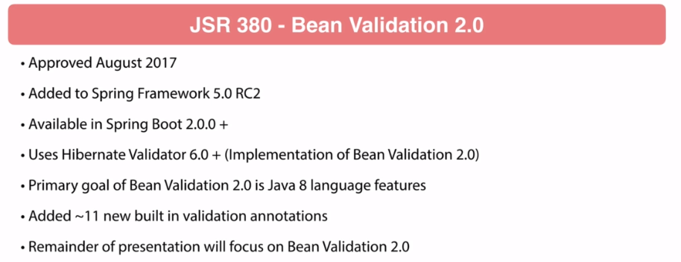

Now, they didn't stop there. Just recently JSR 380 was ratified. This was approved in August of 2017. Originally added to Spring Framework 5 and it was I actually got into Spring Framework 5 in release candidate 2 and this is gonna be available in all Spring Boot 2. So, Spring Boot 2 is where we've switched over to Spring Framework 5. This is going to use Hibernate Validator 6.0. So, the JSR the implementations that basically defined an API the hibernate validator that is an implementation of that API much like JPA as part of the Java itself. It's part of the Java specification but that is only an API set of interfaces basically and it is up to you to select an implementation. So, hibernate is a very popular implementation of it. Hibernate Validator is a implementation of the bean validation API. And as far as I know, I believe Hibernate Validator is the only implementation for Java to my knowledge. I could be very wrong in that but I don't know of another implementation of Bean Validation 2.0. Now, the primary goal of the second release was to use the Java 8 language features and then it also added an about eleven additional validation annotations.

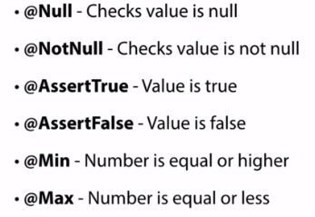 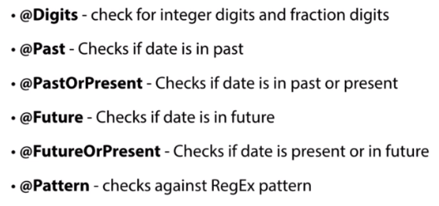

So, the remainder of everything that we'll talk about is we're gonna be talking about being validation 2.0 specifically and be using that throughout the course. So, we're not gonna be talking about the previous release. Now, the built-in constraints that we get out-of-the-box with Bean Validation. We have @Null to see if a values null. @NotNull obviously, not a null. And then, @AssertTrue, @Assertfalse false, @Min and @Max these supplier two numbers. Then we have @Decimal Min and Max. These applied obviously decimal positions. @Negative, @NegativeOrZero. Those are pretty self-explanatory. And then @PositiveOrZero. Again, opposite of negative. @Size, this is an important one. This is gonna check if a string as the size or and it can also be applied to a collection. So, if you're getting back a list, you wanna sure that a list has a certain number of properties and this gonna be a minimum and maximum. @Digits, this can check for digits and fractions of digits. Then @Past, @PastOrPresent, @Future, or @FutureOrPresent these are gonna be dealing with the date in relation to the current date header and this is gonna give you the capability to check against a regex pattern. Then, we have @NotEmpty. @NotEmpty and @NotBlank are two different things. So @NotEmpty checks see if it is null or empty so you could have space characters or line breaks or something in there that technically is not empty. And then @NotBlank is gonna make sure that you do have a string in there so I could have a series of spaces and not blank will fail if it's just spaces so you want some non whitespace characters there.

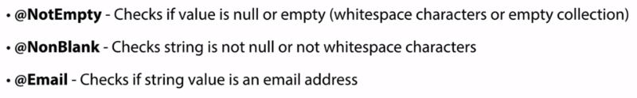

And then email are saying you're gonna check to see if the value is a valid email address. @ScriptAssert, this is a kind of a tricky one to use I've never used it never had a need to use it but you can provide a script to test the entire class. So, kind of an educates that. I've never actually seen it used, no other but never had to use it. A handy one is credit card that's gonna validate that it's a valid credit card number. There's actually a lot that goes into credit card numbers. There's a long if you're curious Google valid credit card numbers. There's like an entire wiki page on it. And so, quite a bit to that. @Currency, this is gonna deal with currency and make sure that you have a valid currency amount. And then we have 2 annotations in relation to durations.

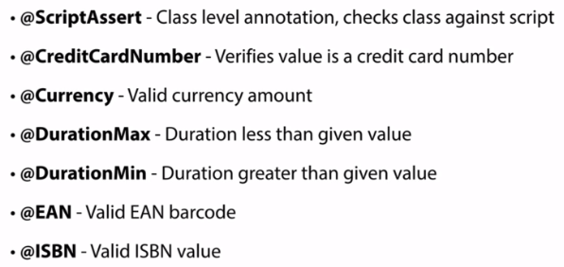

And one thing I wanna point out is when I got to the @ScriptAssert. Forgot to mention this at the beginning of this slide. These are hibernate validator specific constraints. So, previously what we're looking at was everything out being validation. Hibernate validator is giving you these additional bonuses. These are not part of the bean validation specification but they are a part of hibernate validator. So, I'll continue here. @EAN that is a pretty much stands for things it's a European product code. That is ideal with retail operations. Then @ISBN, that's books, that's a number 4 publishing to standards there. And then we have @Length, we make sure that a string length is a specific min or max. @CodePointLength, that validates the code point length of the annotated character sequences between min and max included. And I'm not sure where you use that but it could be a handy one for some type of edge case. I've got a couple different checks on them so these are @LuhnCheck, mod 10, mod 11. There's a specific use cases where those.

May be handy for something that you are working on to validate some type of user input. @Range, the number between a specific range. Then we have HTML. So, you take in an HTML string and make sure that there's no malicious characters in there. @UniqueElements so this is gonna go through a collection to make sure that you have unique elements in it so validating a list has unique entries. @Url that's pretty self-explanatory.

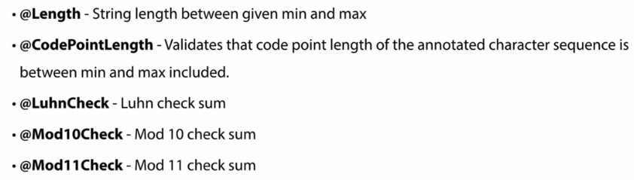

And then hibernate validator also gives you some very specific country constraints. So you can see there on the slide here, we have a couple for Brazilian and then some Polish validators as well. Now, as far as usage goes, we'll be getting into some usage coming up in the course. Hibernate Validator version 6 is, as far as I know, the only implementation of Bean Validation 2.0. There might be another one being developed out there. I am honestly not aware of it. I run a software straight from this.

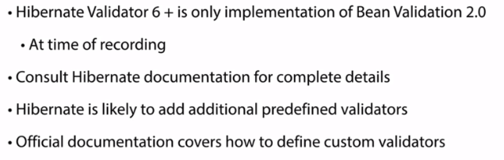

The documentation around the validation capabilities hibernate has some really good documentation. I'm not gonna be able to go too far into depth as far as how all the validation stuff works. There's it's actually a fairly robust tool set. I highly recommend you know and read the official documentation there's a lot of really cool stuff to do with it. And then, bullet point there Hibernate is likely to add additional predefined validators. So, I've gone through what was defined right now at this point in time, fully expect that they'll probably add additional validators in upcoming releases of the Hibernate Validator. And then also if you have a use case where you need to create your own, you can actually define custom validators and this can be very handy. I've seen a need for this a number of times. So if you have a specific use case to define a validator that you want to be able to reuse much with projects or within your project or over several projects you can create your own custom validator and provide an implementation of that for your own personal use.

Validation Jar Dependency

This happened in version 2.3.0 of Spring Boot. I recorded this on the 2.2 line of Spring Boot and this is a very important change with the Spring Boot Starter Web Jars. They used to include a validation starter. That was included in that. It is no longer included. So this needs to be brought in as a separate dependency now they did it for performance reasons. I may or may not agree with the change but it's important as we move into the validation stuff that you bring in the Spring Boots Starter Validation. Spring Boost Starter Validation. You need to bring that dependency in. Otherwise you'll run into problems. Let me toggle over to IntelliJ just quickly and I'll show you that dependency. It's this one right here. You will need to add that to your dependencies for doing validation with Spring Framework. So very very important change that we are having here. And again this only applies to Spring Boot 2.3 or higher. The 2.1 and 2.2 line of Spring Boot, this is included with the web starter and now it's broken out so it's no longer in that web starter and when we start getting to the validation you will need this jar included into your dependencies.

In this video we're gonna go ahead and start adding in some validation constraints. So you can see I've gone back over to the beer client project. So important note to make here. I'm gonna go in and start implementing some validation constraints on this class. And for a dto like this one thing that we want to do is not allow the client to set the ID property. So that's gonna be under our applications control so obviously we don't want a ID coming in and we don't want our beer name to be blank. So we're gonna say not blank like this. Let's take a quick look at this. I'm going to drill into the annotation and then this little guy up here that is going to scroll into the source of that. So here let me resize this a little bit. You can see that I am in the Javax Validation API. So this is getting brought into our class by Spring Boot. The web dependency brings us in and we can see these are the constraints that we talked about. So these are the variety of the the pre built-in constraints for being validation so that is where they live and these are all annotations that we can use. We went through the functionality of all these in a previous video. And if I come down here to the Hibernate, Hibernate validator right here, expand that out. Hibernate validator constraints and this here are all the Hibernate extensions.

So remember in the video I said we went through the functionality of these and discussed their use. This is what we have right now. I'm on the 6.0.16 release. That is the current release at this time. I would not be surprised if the Hibernate team adds an additional constraint validator. So this is an extension to the API. So key point here is to remember this set of constraints here out of this JavaX validation package that is part of the official bean validation API. Whereas these additional constraints here, these are extensions from Hibernate. So very important distinction to remember. I continue implementing these. I'll scroll back up here and back over to the DTO. We'll do not blank on this and let's make sure that our UPC is a positive value. So this is how we can set up some constraints to make sure that this is in fact working properly.

Now what we need to do is come over to our beer controller like this. This is going to be looking at the DTO where we're taking this in. And now if I add an annotation called valid like so, where is that? This is also going to affect the update. These don't have to be in any particular order. I could do request body validator valid requests validator like I have here. So order does not matter. And now let's go ahead and run our test to make sure that we are still passing. And this update failed. Take a look at the update. That's going to be failing on the validation for some reason. Trying to see if it gives me the actual error on this. So it's not happy about the ID being set. So interesting so we'll go ahead and change that. So this tells us what our constraints are in fact working. Let's go ahead and re-run that Oh my mistake there. We actually need to do... Now that should work. So now we're all back in the green. We can prove out that the validations are working. I'm gonna just comment out the beer style on our valid beer and we'll re-run the test and we'll see that that constraint also will fail the test. You can see that these did in fact fail and the the reason of the error that we're getting is rather than a 201 we're getting a 400 back which is telling us that the validation did in fact fail. So let's go back and revert that. We'll run this one more time. And just to recap what we did here. Went into the beer DTO so this is the object that's getting passed in. I set up make sure that ID is null coming in because we don't want the client setting the ID, making sure that the beer name is not blank and the beer style is not blank and we have a positive value for the UPC. And then the way we trigger the actual validation is we add in this annotation valid on the request method. This tells Spring Framework that we want to validate that so if a need the validation constraints do in fact fail, it raises an error and throws out an exception which causes a 400 status be returned to the client.

**BeerControllerV2.java**

import guru.springframework.msscbrewery.services.v2.BeerServiceV2;

import guru.springframework.msscbrewery.web.model.v2.BeerDtoV2;

import org.springframework.http.HttpHeaders;

import org.springframework.http.HttpStatus;

import org.springframework.http.ResponseEntity;

import org.springframework.web.bind.annotation.*;

import javax.validation.Valid;

import java.util.UUID;

@RequestMapping("/api/v2/beer")

@RestController

public class BeerControllerV2 {

private final BeerServiceV2 beerServiceV2;

public BeerControllerV2(BeerServiceV2 beerServiceV2) {

this.beerServiceV2 = beerServiceV2;

}

@GetMapping({"/{beerId}"})

public ResponseEntity<BeerDtoV2> getBeer(@PathVariable("beerId") UUID beerId){

return new ResponseEntity<>(beerServiceV2.getBeerById(beerId), HttpStatus.OK);

}

@PostMapping // POST - create new beer

public ResponseEntity handlePost(@Valid @RequestBody BeerDtoV2 beerDto){

BeerDtoV2 savedDto = beerServiceV2.saveNewBeer(beerDto);

HttpHeaders headers = new HttpHeaders();

//todo add hostname to url

headers.add("Location", "/api/v1/beer/" + savedDto.getId().toString());

return new ResponseEntity(headers, HttpStatus.CREATED);

}

@PutMapping({"/{beerId}"})

public ResponseEntity handleUpdate(@PathVariable("beerId") UUID beerId,

@Valid @RequestBody BeerDtoV2 beerDto){

beerServiceV2.updateBeer(beerId, beerDto);

return new ResponseEntity(HttpStatus.NO_CONTENT);

}

@DeleteMapping({"/{beerId}"})

@ResponseStatus(HttpStatus.NO_CONTENT)

public void deleteBeer(@PathVariable("beerId") UUID beerId){

beerServiceV2.deleteById(beerId);

}

}

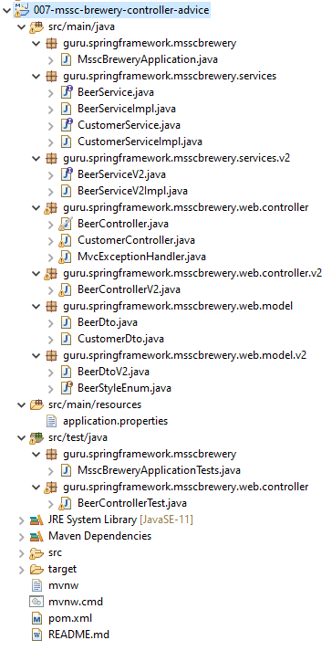

|  |  |
| --- | --- |
| **BeerDto.java**  import lombok.AllArgsConstructor;  import lombok.Builder;  import lombok.Data;  import lombok.NoArgsConstructor;  import javax.validation.constraints.NotBlank;  import javax.validation.constraints.Null;  import javax.validation.constraints.Positive;  import java.util.UUID;  @Data  @NoArgsConstructor  @AllArgsConstructor  @Builder  public class BeerDto {  @Null  private UUID id;  @NotBlank  private String beerName;  @NotBlank  private String beerStyle;  @Positive  private Long upc;  } | **CustomerDto.java**  import lombok.AllArgsConstructor;  import lombok.Builder;  import lombok.Data;  import lombok.NoArgsConstructor;  import javax.validation.constraints.NotBlank;  import javax.validation.constraints.Size;  import java.util.UUID;  @Data  @NoArgsConstructor  @AllArgsConstructor  @Builder  public class CustomerDto {  private UUID id;  @NotBlank  @Size(min = 3, max = 100)  private String name;  } |

**MvcExceptionHandler.java**

import org.springframework.http.HttpStatus;

import org.springframework.http.ResponseEntity;

import org.springframework.validation.BindException;

import org.springframework.web.bind.annotation.ControllerAdvice;

import org.springframework.web.bind.annotation.ExceptionHandler;

import javax.validation.ConstraintViolationException;

import java.util.ArrayList;

import java.util.List;

@ControllerAdvice

public class MvcExceptionHandler {

@ExceptionHandler(ConstraintViolationException.class)

public ResponseEntity<List> validationErrorHandler(ConstraintViolationException e){

List<String> errors = new ArrayList<>(e.getConstraintViolations().size());

e.getConstraintViolations().forEach(

constraintViolation -> {

errors.add( constraintViolation.getPropertyPath() + " : "

+ constraintViolation.getMessage());

});

return new ResponseEntity<>(errors, HttpStatus.BAD_REQUEST);

}

@ExceptionHandler(BindException.class)

public ResponseEntity<List> handleBindException(BindException ex){

return new ResponseEntity(ex.getAllErrors(), HttpStatus.BAD_REQUEST);

}

}

**BeerControllerTest.java**

import com.fasterxml.jackson.databind.ObjectMapper;

import guru.springframework.msscbrewery.services.BeerService;

import guru.springframework.msscbrewery.web.model.BeerDto;

import org.junit.Before;

import org.junit.Test;

import org.junit.runner.RunWith;

import org.springframework.beans.factory.annotation.Autowired;

import org.springframework.boot.test.autoconfigure.web.servlet.WebMvcTest;

import org.springframework.boot.test.mock.mockito.MockBean;

import org.springframework.http.MediaType;

import org.springframework.test.context.junit4.SpringRunner;

import org.springframework.test.web.servlet.MockMvc;

import java.util.UUID;

import static org.hamcrest.core.Is.is;

import static org.mockito.ArgumentMatchers.any;

import static org.mockito.BDDMockito.given;

import static org.mockito.BDDMockito.then;

import static org.springframework.test.web.servlet.request.MockMvcRequestBuilders.*;

import static org.springframework.test.web.servlet.result.MockMvcResultMatchers.*;

@RunWith(SpringRunner.class)

@WebMvcTest(BeerController.class)

public class BeerControllerTest {

@MockBean

BeerService beerService;

@Autowired

MockMvc mockMvc;

@Autowired

ObjectMapper objectMapper;

BeerDto validBeer;

@Before

public void setUp() {

validBeer = BeerDto.builder().id(UUID.randomUUID())

.beerName("Beer1")

.beerStyle("PALE_ALE")

.upc(123456789012L)

.build();

}

@Test

public void getBeer() throws Exception {

given(beerService.getBeerById(any(UUID.class))).willReturn(validBeer);

mockMvc.perform( get("/api/v1/beer/" + validBeer.getId().toString()

).accept(MediaType.APPLICATION_JSON))

.andExpect(status().isOk())

.andExpect(content().contentType(MediaType.APPLICATION_JSON_UTF8))

.andExpect(jsonPath("$.id", is(validBeer.getId().toString())))

.andExpect(jsonPath("$.beerName", is("Beer1")));

}

@Test

public void handlePost() throws Exception {

//given

BeerDto beerDto = validBeer;

beerDto.setId(null);

BeerDto savedDto = BeerDto.builder().id(UUID.randomUUID()).beerName("New Beer").build();

String beerDtoJson = objectMapper.writeValueAsString(beerDto);

given(beerService.saveNewBeer(any())).willReturn(savedDto);

mockMvc.perform(post("/api/v1/beer/")

.contentType(MediaType.APPLICATION_JSON)

.content(beerDtoJson))

.andExpect(status().isCreated());

}

@Test

public void handleUpdate() throws Exception {

//given

BeerDto beerDto = validBeer;

beerDto.setId(null);

String beerDtoJson = objectMapper.writeValueAsString(beerDto);

//when

mockMvc.perform(put("/api/v1/beer/" + UUID.randomUUID())

.contentType(MediaType.APPLICATION_JSON)

.content(beerDtoJson))

.andExpect(status().isNoContent());

then(beerService).should().updateBeer(any(), any());

}

}

#### Project Lombok and MapStruct

We are gonna be taking a look at Project Lombok. We've already looked at it a little bit in the course. We're gonna get into a little more in depth in this section and as I was researching this video I discovered the island of Java. That's what Java, the programming language, is actually named after. So Java is an island in Indonesia. Looks absolutely beautiful there. I've never been there personally. The closest I've come as Guam. So this is a beautiful island and just to the east of it is the island of Lombok. So they are very close to each other. Here's a little map that you can see the island of Java and then the little red dot that is actually the island of Lombok. So Lombok the project was started sometimes slightly before 2009. I said Lombok is a name of a island in Indonesia and Lombok also is Indonesian for chilli I guess and if you look at the Project Lombok website you'll see that they have a little tag line that says spicing up your Java. So interesting how they worked everything together there.

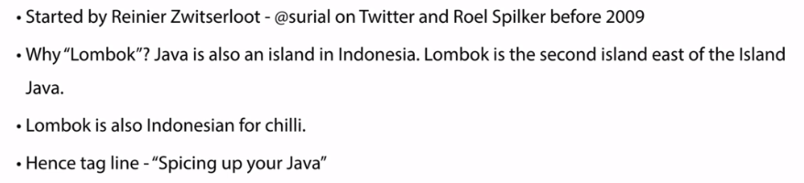

Now Lombok itself what it is doing it hooks into a annotation process or API. So this allows... so I'll hook into the java compiler process that takes the raw source code, passes it to Lombok which will actually perform code generation for us. So it allows these Lombok and the workings to enhance Java code so at the end it produces a completely compiled Java class.

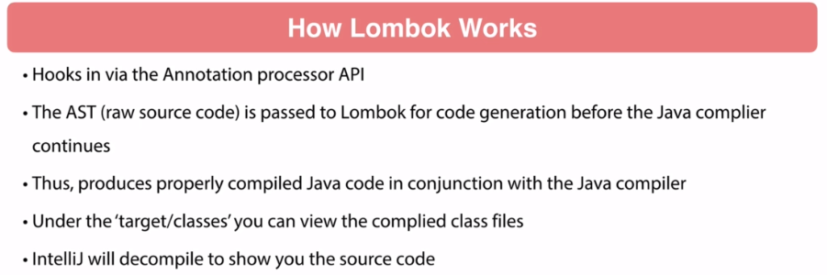

You can see under target classes, you can go in there you can see any compiled class and if you're using IntelliJ IntelliJ it does come with a decompiler which will show you the source code and you can see what Lombok did for your class. So Lombok is a real time-saver. It brings you a lot of functionality. The source code compiled does change and some IDs will get confused by this. So this is probably more of an issue for older IDEs. Modern IDEs IntelliJ, Eclipse, Netbeans do support Project Lombok. I personally do not use Eclipse or NetBeans so I cannot speak to their functionality.

You might need to install a plug-in for it. The newer versions of IntelliJ are very good and there's very nice support for Lombok. The one nuance with IntelliJ is that you do have to go to your compiler settings and make sure that you've enabled annotation processing so that's going to help IntelliJ process those annotations from Lombok and do that code development. Without it, you'll probably see things that aren't working properly inside of your IDE. Your code will compile and work as expected but the IDE will say you're missing getters and setters and stuff like that so that's one symptomatic of where your annotation processing has not been enabled. Now right now we are on version 1.18.8 and this was just released on May 7th 2019. That's actually about a week ago from when I'm recording this. Lombok is evolving. There's stuff that's in the pipeline. They are evolving the projects.

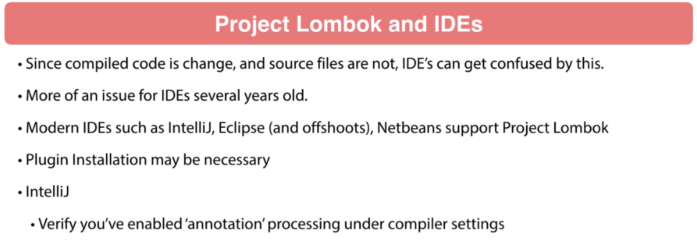

I know this videos can be live for some time so I highly recommend you take a look at the official documentation. I'm giving you overview of Lombok in this presentation. The official documentation has a lot more details than what I'm going to present here. So let's talk about some of the features. You get val and var. This allows you to declare local variables or mutable local variables. So pretty handy very similar to features and other JVM languages. So pretty handy to use here. Now we can set up a @NonNull. This is form like method parameters. This is gonna make sure that they are not null. So very handy and convenient if you want make sure that an object that you're passing into a method is not null. Now @Cleanup - this is a handy utility when you're using resources where you have to close a connection.

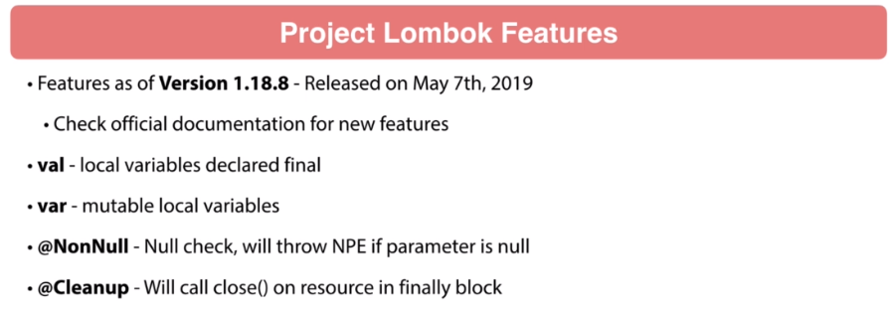

This will generate a finally block and call a closed on that method. So pretty pretty nifty tool to use there. Then we have getters and setters. These are pretty pretty self-explanatory. Allows you to define properties and then Lombok it's gonna take care of that boilerplate code of creating the getters and setters for you. @ToString - this is a very nice one to have. This is going to generate a very nice ToString for your class so it's going to generate the class name and then the field names. So this is real nice to have.

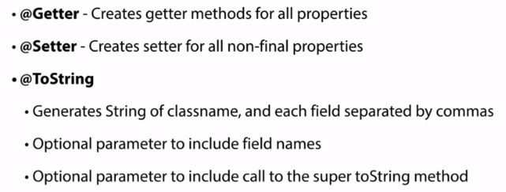

And then you do have optional parameter include field names and also a call to the super method if you've extended class. @EqualsAndHashCode - this can be a thorn on our sides of generating this code. There's a lot of third-party implementations to prevent hand rolling of it. Lombok will help alleviate some of the pain points from that. So I suggest you read the documentation about exactly what it's doing but these are pretty handy and you do have some capabilities where you can exclude specific properties. Now we also have constructor helpers. @NoArgsConstructor - that's going to generate obviously a no args constructor. If there are final fields that will cause a compiler error but you can force that through. I'm not sure why you'd want to but you can do that. @RequiredArgsConstructor - so this is going to create a constructor for things that are just required.

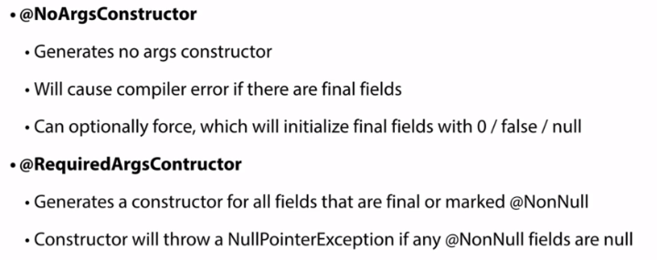

There could be additional properties which are not final or not marked non null, that would not be included. And then finally there's the @AllArgsConstructor - so it gives you a lot of capabilities as far as generating constructors. And then the data annotation. This is going to the scale like a helper so this is going to include @Getters, @Setters, @ToString, @EqualsAndHashcode, and @RequiredArgsConstrutor so very handy.

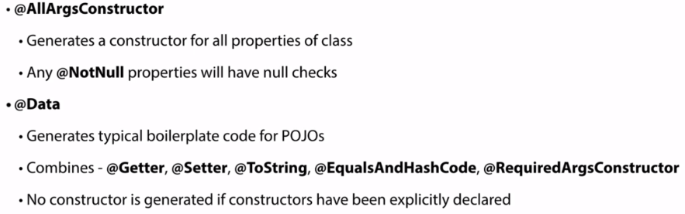

You get those five annotations rolled up in a simple data annotation. Now we have @value. That's a immutable variant of data. So all fields are made private and final so it's a nice handy one to use.

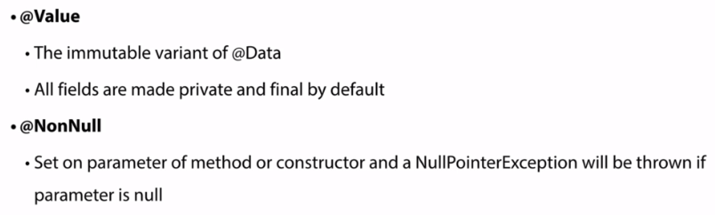

And then @NonNull, so if you pass in a parameter that is null, you'll get a null pointer exception thrown if you use that. @Builder, this is like one of my favorite annotations out of Project Lombok. I've always liked using the builder pattern. The Builder pattern is really nothing new. It's been around for very long time. The problem that I've had with the Builder Pattern is it is annoying to actually implement. I've been around long enough where you actually had to go and hand code that Builder Pattern, so once it was coded, it was really nice. It was great to have.

But there was a lot of coding to implement a builder pattern so that is a welcome feature of Project Lombok. I used the Builder Pattern quite frequently in my coding. @SneakyThrows this will throw checked exceptions without declaring them. @Synchronized -so this is a safer implementation of the Java synchronized command. If you want to get into the details of that I suggest reading the documentation that's kind of interesting what they're doing there and why now. The @Getter annotation does have a option to say lazy true. So if you have some type of expensive operation that's going to calculate a value for getter, what lazy true is going to do, it'll create a small cache and it'll go through that expensive operation the first time and populate the cache and then if you call it again it's gonna read from the cache. So, it could give you a situation where it does help your performance.

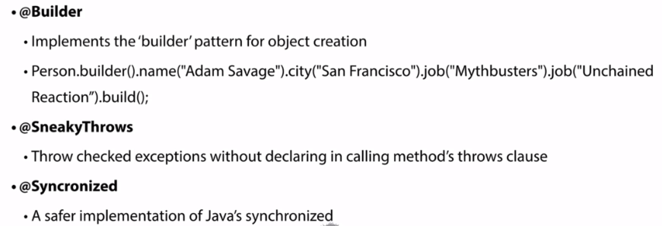

@Log - this annotiation uses Java util logger. You can see there I have on the screen Java util loggers are awful. I'm not a fan of that logging framework. I personally link towards @Slf4j. This is the simple logging facade or facade. Some people like to say for logging I prefer using @Slf4j because through this it abstracts the underlying logging framework.

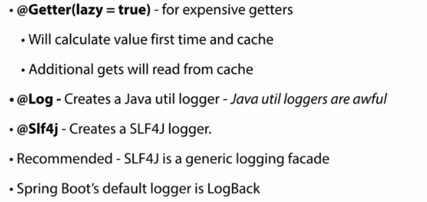

Spring Boot by default is going to use log back. You might want to use log4j or some type of other logging implementation but SLF4J will allow you to swap out different logging framework. So that is my preferences to use SLF4J which abstracts your logging framework. So if at some point in the future you want change you just change the configuration rather than your source code. Now Project Lombok does have a number of experimental features. These are kind of interesting what the project team is doing. I say use these at your own risk. I do not recommend using experimental features in production.

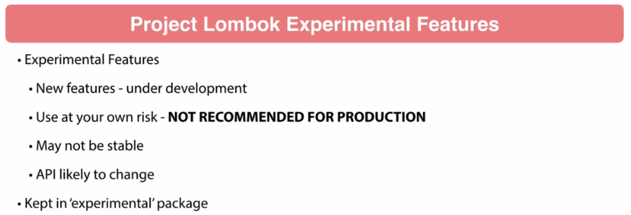

These are fun to experiment with. The problem is these might not be stable. They might be buggy and the API is likely to change. So when you upgrade Lombok you could be breaking things in the future. These are kept in a package has marked experimental and if you know the Project Lombok website, they have a whole section on the experimental features. So again, there's some pretty interesting stuff with the experimental features but don't use that in anything that you can be using in production. It's fine to experiment with, try them out, see how they're working. Just be aware that I wouldn't say put this into production type code with the experimental features because they could be buggy and the API is likely to change and break things to further down the road.

Configuration

Pom.xml

<?xml version="1.0" encoding="UTF-8"?>

<project xmlns="http://maven.apache.org/POM/4.0.0" xmlns:xsi="http://www.w3.org/2001/XMLSchema-instance"

xsi:schemaLocation="http://maven.apache.org/POM/4.0.0 http://maven.apache.org/xsd/maven-4.0.0.xsd">

<modelVersion>4.0.0</modelVersion>

<parent>

<groupId>org.springframework.boot</groupId>

<artifactId>spring-boot-starter-parent</artifactId>

<version>2.1.5.RELEASE</version>

<relativePath/> <!-- lookup parent from repository -->

</parent>

<groupId>guru.springframework</groupId>

<artifactId>008-mssc-brewery-lombok-examples</artifactId>

<version>0.0.1-SNAPSHOT</version>

<name>008-mssc-brewery-lombok-examples</name>

<description>SFG Brewery</description>

<properties>

<java.version>11</java.version>

</properties>

<dependencies>

<dependency>

<groupId>org.springframework.boot</groupId>

<artifactId>spring-boot-starter-actuator</artifactId>

</dependency>

<dependency>

<groupId>org.springframework.boot</groupId>

<artifactId>spring-boot-starter-web</artifactId>

</dependency>

<dependency>

<groupId>org.springframework.boot</groupId>

<artifactId>spring-boot-devtools</artifactId>

<scope>runtime</scope>

</dependency>

<dependency>

<groupId>org.projectlombok</groupId>

<artifactId>lombok</artifactId>

<optional>true</optional>

</dependency>

<dependency>

<groupId>org.springframework.boot</groupId>

<artifactId>spring-boot-starter-test</artifactId>

<scope>test</scope>

</dependency>

</dependencies>

<build>

<plugins>

<plugin>

<groupId>org.springframework.boot</groupId>

<artifactId>spring-boot-maven-plugin</artifactId>

</plugin>

</plugins>

</build>

</project>

|  |  |
| --- | --- |
| **BeerDtoV2.java**  import lombok.AllArgsConstructor;  import lombok.Builder;  import lombok.Data;  import lombok.NoArgsConstructor;  import java.util.UUID;  @Data  @NoArgsConstructor  @AllArgsConstructor  @Builder  public class BeerDtoV2 {  private UUID id;  private String beerName;  private BeerStyleEnum beerStyle;  private Long upc;  } | **CustomerDto.java**  import lombok.AllArgsConstructor;  import lombok.Builder;  import lombok.Data;  import lombok.NoArgsConstructor;  import javax.validation.constraints.NotBlank;  import javax.validation.constraints.Size;  import java.util.UUID;  @Data  @NoArgsConstructor  @AllArgsConstructor  @Builder  public class CustomerDto {  private UUID id;  @NotBlank  @Size(min = 3, max = 100)  private String name;  } |

Lets also see the Service and ServiceImpl classes ( nothing to do with Lombok in these – they just use the builder, data annotation features )

**BeerService.java**

import guru.springframework.msscbrewery.web.model.BeerDto;

import java.util.UUID;

public interface BeerServiceV2 {

BeerDtoV2 getBeerById(UUID beerId);

BeerDtoV2 saveNewBeer(BeerDtoV2 beerDto);

void updateBeer(UUID beerId, BeerDtoV2 beerDto);

void deleteById(UUID beerId);

}

**BeerServiceImpl.java**

import guru.springframework.msscbrewery.web.model.BeerDto;

import lombok.extern.slf4j.Slf4j;

import org.springframework.stereotype.Service;

import java.util.UUID;

@Slf4j

@Service

public class BeerServiceV2Impl implements BeerService {

@Override

public BeerDtoV2 getBeerById(UUID beerId) {

return BeerDto.builder().id(UUID.randomUUID())

.beerName("Galaxy Cat")

.beerStyle("Pale Ale")

.build();

}

@Override

public BeerDtoV2 saveNewBeer(BeerDtoV2 beerDto) {

return BeerDtoV2.builder()

.id(UUID.randomUUID())

.build();

}

@Override

public void updateBeer(UUID beerId, BeerDtoV2 beerDto) {

//todo impl - would add a real impl to update beer

}

@Override

public void deleteById(UUID beerId) {

log.debug("Deleting a beer...");

}

}

**CustomerService.java**

import guru.springframework.msscbrewery.web.model.CustomerDto;

import java.util.UUID;

public interface CustomerService {

CustomerDto getCustomerById(UUID customerId);

CustomerDto saveNewCustomer(CustomerDto customerDto);

void updateCustomer(UUID customerId, CustomerDto customerDto);

void deleteById(UUID customerId);

}

**CustomerServiceImpl.java**

import guru.springframework.msscbrewery.web.model.CustomerDto;

import lombok.extern.slf4j.Slf4j;

import org.springframework.stereotype.Service;

import java.util.UUID;

@Slf4j

@Service

public class CustomerServiceImpl implements CustomerService {

@Override

public CustomerDto getCustomerById(UUID customerId) {

return CustomerDto.builder()

.id(UUID.randomUUID())

.name("Joe Buck")

.build();

}

@Override

public CustomerDto saveNewCustomer(CustomerDto customerDto) {

return CustomerDto.builder()

.id(UUID.randomUUID())

.build();

}

@Override

public void updateCustomer(UUID customerId, CustomerDto customerDto) {

//todo impl

log.debug("Updating....");

}

@Override

public void deleteById(UUID customerId) {

log.debug("Deleting.... ");

}

}

### MapStruct

MapStruct is a project that started 2014 with the first release in 2017. It seems like they are little slow to get started but they kind of firing on all cylinders now. It was founded Gunnar Morling who happens to be also the spec lead for the Hibernate Bean Validation 2.0. I believe he is the employee of Red Hat. He does a lot of stuff with Red Hat. He's got several interesting projects. But since we've been talking about Bean Validation 2.0 previously in the course. I bet you might find that interesting. Now the current release is 1.3.0.Final that just came out this past February.

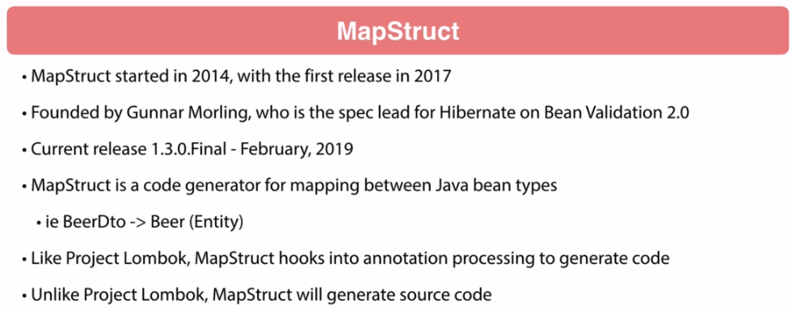

Its currently 2019. It just came out. A lot of really great features in it. Pretty significant release for the 1.3 release. Now what MapStruct is, is a code generator for mapping between Java bean types. And a pattern, we're gonna see quite a bit is taking a web layer, our interface web layer, the DTO objects and converting those to an entity and then back and forth. Now one of the most popular questions I get - why can't we just use our entity classes for the web tier. Actually yes you can. There's nothing preventing you from doing that. Actually Spring has entire project for that Spring data. The Spring Data Rest specifically will expose your entire entities up to the web. From practicality standpoint, when you start getting into larger enterprise type projects, very rarely are you exposing your database objects to your API consumer or to the web tier.

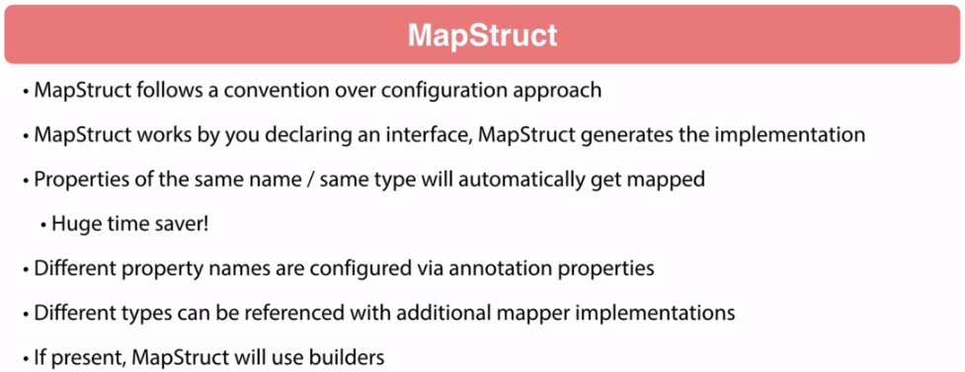

Typically, the consumers of the data are gonna have different needs and demands of them which the persistence layer has so there's gonna be properties that will be excluded. You may not wanna be showing this to the web tier or the API consumer or they might need additional information that you will have to enhance that object. So, there's typically differences there. There's also typically a lot of similarity too. So that's where MapStruct really got to come in handy because it's gonna take a lot of this boilerplate code that you have to do for type conversion and give you a way to efficiently do it. So, like Project Lombok, MapStruct is an annotation processor or some type of annotation processing to generate code. However, unlike Project Lombok, what we'll see MapStruct do, it will actually generate source code. So, we'll generate source code objects and then will get compiled. So one nice thing about MapStruct, it follows convention over configuration. If you follow the convention, it's gonna make life a lot easier for you. Basically what we'll see, we'll get into some examples of this. You configure MapStruct by generating an interface and that interface you'll find a method that will take in type A and generate type B.

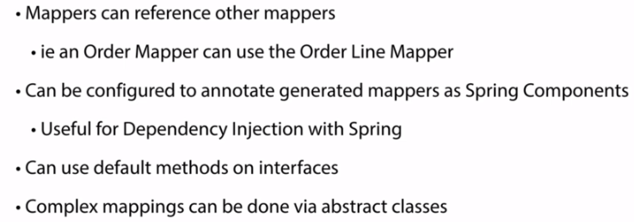

So, that's pretty simple thing there. And then MapStruct is going to generate the implementation. I kind of think of it like Spring Data JPA where you define the interface and Spring Data is going to provide the implementation. Here, MapStruct is going to generate it for us. You actually are go in to and able to go in and view the generated code. Properties of same name and same type will automatically get mapped. This is a huge time saver. So when you are using this DTOs, a lot of times probably 70-80% of time, the types are exactly same, the names are exactly the same. So as long as you follow that convention, MapStruct really makes things easier. Now if you have different property names, you can actually easily configure this via annotations. Through the settings in annotation. Different types, you can do additional mapper implementations. And then also very notable and this just came out in the 1.3 release, just recently, MapStruct will use builders so it's gonna look like generated Project Lombok class, it has the builder pattern on it. MapStruct will actually use those Lombok generated builders. You can also reference other mappers.

A great example, if think about you have an order and that order is gonna add in a list of lines on it, order lines. We can tell the Order Mapper to use the Order Line Mapper. It can be done very transparently, very easy to do. And then MapStruct optionally can be configured to generate mappers as Spring Components so automatically annotate the MS components and Spring will pick those up and then you can use mappers and you just inject them into your class like any others Spring Bean. Very handy to do. And then remember the recent addition to the Java language, we can do default methods. You can do that. If you have more complex mappings, it's gonna be a bit in the course but there's an example where have a MapStruct mapper declare abstract class and that abstract class I'm actually doing a web service call to get additional information. So I have a DTO where I need to enhance the data on that. I'm doing this inside of MapStruct but I'm also making a web service call so you can do a lot with MapStruct. I'm gonna show you some of the capabilities of it in this section. And then later in the course, we will be getting into a more and more MapStruct. I'm not gonna be able to show you every single feature of MapStruct. The documentation for MapStruct is really outstanding so I highly recommend going through it and get familiar with the capabilities. In this section of the course we will be looking closer at MapStruct. We'll look through how to set it up, configure it and some of the basics. As we get into some of the complex examples further down the line, we will be leverage additional features and capabilities of MapStruct.

#### Configuration

This video, I have an update for you, so here you can see I've got map strokes FNQ So when I originally recorded this video, I was on a newer or slightly older version of Lombok. And here you can see if we are using Lamba one 1816 or newer. We need an additional configuration setup for the Lombok maps binding. So it's a fairly recent change. What I'm going to do, because a lot of people are still using older versions of Lombok. So the way I show you in this video works fine for that. And what I'm going to do here is at the end of the video, I'm going to add another update to it and show you how to configure Mavin for the Lombok maps recombining. I'll show you at the end of the video. But if you are using a earlier version, so if you can see it at the top, if you use an Lombok one 16, 14 up to one 1816, do exactly what's shown in this video should be just fine.

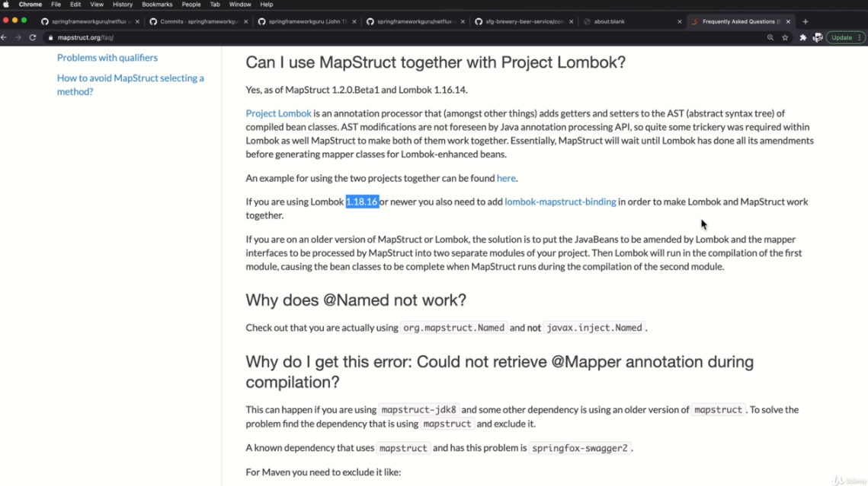

But if you are using a more later version of Lombok, you'll need to add in the step and I'll be showing that at the very end of the video and I'll update everything in the project to use that version. This video, we're going to go ahead and add maps to our project. So I'm going to be using the a little brewery project that we've been using to demonstrate some of the spring NBC features, and we'll get started by adding dependency. So I'm going to come in here right under Lombok and add in the new dependancy. And it's going to be map struck. And this is more. And the one thing is, this is not a curated dependency within Springbrook, at least not at this time. So I do need to clear the version because it's not going to be found in the parent pom. And the current version right now is one three eight zero final. So this is going to bring in the map struct dependency, but our configuration is not done here. We do need to set up the compiler plugin because map struck down and so on is going to work. Fine. Project Lombok on its own is going to work fine. But when you combine them together, there's an additional configuration stuff that we have to do for some of the compiler settings to get things working properly. So let's go ahead and configure that now.

**pom.xml**

<?xml version="1.0" encoding="UTF-8"?>

<project xmlns="http://maven.apache.org/POM/4.0.0" xmlns:xsi="http://www.w3.org/2001/XMLSchema-instance"

xsi:schemaLocation="http://maven.apache.org/POM/4.0.0 http://maven.apache.org/xsd/maven-4.0.0.xsd">

<modelVersion>4.0.0</modelVersion>

<parent>

<groupId>org.springframework.boot</groupId>

<artifactId>spring-boot-starter-parent</artifactId>

<version>2.1.5.RELEASE</version>

<relativePath/> <!-- lookup parent from repository -->

</parent>

<groupId>guru.springframework</groupId>

<artifactId>mssc-brewery</artifactId>

<version>0.0.1-SNAPSHOT</version>

<name>mssc-brewery</name>

<description>SFG Brewery</description>

<properties>

<java.version>11</java.version>

<mapstruct.version>1.4.2.Final</mapstruct.version>

<org.lombok.version>1.18.18</org.lombok.version>

</properties>

<dependencies>

<dependency>

<groupId>org.springframework.boot</groupId>

<artifactId>spring-boot-starter-actuator</artifactId>

</dependency>

<dependency>

<groupId>org.springframework.boot</groupId>

<artifactId>spring-boot-starter-web</artifactId>

</dependency>

<dependency>

<groupId>org.springframework.boot</groupId>

<artifactId>spring-boot-devtools</artifactId>

<scope>runtime</scope>

</dependency>

<dependency>

<groupId>org.projectlombok</groupId>

<artifactId>lombok</artifactId>

<version>${org.lombok.version}</version>

<optional>true</optional>

</dependency>

<dependency>

<groupId>org.mapstruct</groupId>

<artifactId>mapstruct</artifactId>

<version>${mapstruct.version}</version>

</dependency>

<dependency>

<groupId>org.springframework.boot</groupId>

<artifactId>spring-boot-starter-test</artifactId>

<scope>test</scope>

</dependency>

</dependencies>

<build>

<plugins>

<plugin>

<groupId>org.springframework.boot</groupId>

<artifactId>spring-boot-maven-plugin</artifactId>

</plugin>

<plugin>

<groupId>org.apache.maven.plugins</groupId>

<artifactId>maven-compiler-plugin</artifactId>

<version>3.8.0</version>

<configuration>

<annotationProcessorPaths>

<path>

<groupId>org.mapstruct</groupId>

<artifactId>mapstruct-processor</artifactId>

<version>${mapstruct.version}</version>

</path>

<path>

<groupId>org.projectlombok</groupId>

<artifactId>lombok</artifactId>

<version>${org.lombok.version}</version>

</path>

<path>

<groupId>org.projectlombok</groupId>

<artifactId>lombok-mapstruct-binding</artifactId>

<version>0.2.0</version>

</path>

</annotationProcessorPaths>

<compilerArgs>

<compilerArg>-Amapstruct.defaultComponentModel=spring</compilerArg>

</compilerArgs>

</configuration>

</plugin>

</plugins>

</build>

</project>

So there's a default component model setting that equal to spring that is going to tell map start to go ahead and configure when it generates the classes that it's going to tell map start to annotate those classes with a spring component and annotation. So that's one of the overwrites for a mapstruct. So I'm going to do it clean and let's just make sure that everything is still working. Go ahead and package everything.

#### Using Lombok and Mapstruct

|  |  |
| --- | --- |
| import lombok.AllArgsConstructor;  import lombok.Builder;  import lombok.Data;  import lombok.NoArgsConstructor;  import javax.validation.constraints.NotBlank;  import javax.validation.constraints.Null;  import javax.validation.constraints.Positive;  import java.util.UUID;  @Data  @NoArgsConstructor  @AllArgsConstructor  @Builder  public class **BeerDto** {  @Null  private UUID id;  @NotBlank  private String beerName;  @NotBlank  private String beerStyle;  @Positive  private Long upc;  } | import guru.springframework.msscbrewery.web  .model.v2.BeerStyleEnum;  import lombok.AllArgsConstructor;  import lombok.Builder;  import lombok.Data;  import lombok.NoArgsConstructor;  import java.util.UUID;  @Data  @NoArgsConstructor  @AllArgsConstructor  @Builder  public class **Beer** {  private UUID id;  private String beerName;  private BeerStyleEnum beerStyle;  private Long upc;  } |

**BeerMapper.java**

import guru.springframework.msscbrewery.domain.Beer;

import guru.springframework.msscbrewery.web.model.BeerDto;

import org.mapstruct.Mapper;

@Mapper

public interface BeerMapper {

BeerDto beerToBeerDto(Beer beer);

Beer beerDtoToBeer(BeerDto dto);

}

Let's go ahead and in the web, let's create a New Package here. We'll call that mappers like so. In mappers, let's create a New Java Class. This is actually gonna be an interface. We'll call that BeerMapper like so. So I'll add that in. We will add that into Github. To set up a MapStruct Mapper, we just do @Mapper so we just simply annotate that as a Mapper. And now what we can do is BeerDto and we can say beerToBeerDto. This is gonna take in a Beer object like so. And now we wanna do the inverse. So we want a Beer object. We'll do BeerDtoToBeer and this is gonna take in a BeerDto object like so. So now that's all that we've configured and what we've done is we set up this interface BeerMapper and that's gonna do the two-way objects. So now let's go ahead. I'm gonna do a clean. Let's go ahead and do a compile. You can see that that is all happy. Now let's go into our target directory. We see we have a folder for generated-sources annotations and there's our BeerMapperImpl. So let me close this and we'll go to the split-screen on this so we can see what got generated. So this is the interface that we created and over here is a code that was generated by MapStruct. You can see that we've annotated it with the @Generated annotation. So this tells us ed this was created by MapStruct through the mapping processor. Because the compiler flag it's been annotated as a Spring component. So now we can inject this into our classes like any other Spring component.

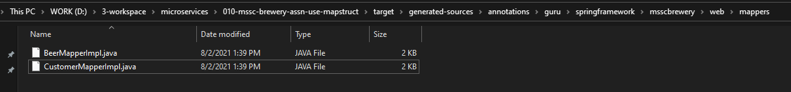

Decompiling this generated file shows

import guru.springframework.msscbrewery.domain.Beer;

import guru.springframework.msscbrewery.domain.Beer.BeerBuilder;

import guru.springframework.msscbrewery.web.model.BeerDto;

import guru.springframework.msscbrewery.web.model.BeerDto.BeerDtoBuilder;

import guru.springframework.msscbrewery.web.model.v2.BeerStyleEnum;

import javax.annotation.processing.Generated;

import org.springframework.stereotype.Component;

@Generated(

value = "org.mapstruct.ap.MappingProcessor",

date = "2021-08-02T13:39:51+0530",

comments = "version: 1.4.2.Final, compiler: javac, environment: Java 11.0.12 (Oracle Corporation)"

)

@Component

public class BeerMapperImpl implements BeerMapper {

@Override

public BeerDto beerToBeerDto(Beer beer) {

if ( beer == null ) {

return null;

}

BeerDtoBuilder beerDto = BeerDto.builder();

beerDto.id( beer.getId() );

beerDto.beerName( beer.getBeerName() );

if ( beer.getBeerStyle() != null ) {

beerDto.beerStyle( beer.getBeerStyle().name() );

}

beerDto.upc( beer.getUpc() );

return beerDto.build();

}

@Override

public Beer beerDtoToBeer(BeerDto dto) {

if ( dto == null ) {

return null;

}

BeerBuilder beer = Beer.builder();

beer.id( dto.getId() );

beer.beerName( dto.getBeerName() );

if ( dto.getBeerStyle() != null ) {

beer.beerStyle( Enum.valueOf( BeerStyleEnum.class, dto.getBeerStyle() ) );

}

beer.upc( dto.getUpc() );

return beer.build();

}

}

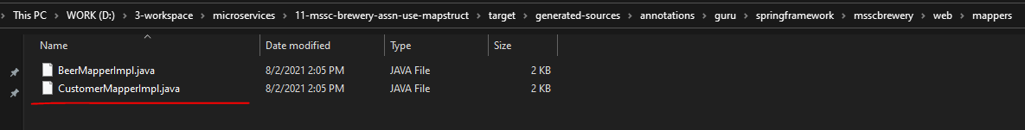

Now you can see here's the implementation that it did. So for the beerToBeerDto, it takes in the beer method and you can see because we have that builder method in there, it's actually leveraging the builder. So it grabs the builder. That sets the id, the name, the style, upc. So let's double check those. So we have id, name, style, upc. It does all that and then it returns build. And then the other one does just the opposite where we also have the Builder pattern implemented. So it's leveraging the builder and then there's just the reverse code where it's returning back a beer object rather than a DTO object. So this is all stuff that was generated for us. Clearly, when you start getting into development like this, this is a lot of stuff that you would have had to do manually. And when you do it manually, obviously that's gonna be error-prone and it's very easy to forget a property or if you have evolved properties again those can be forgotten. And in this case, I set up a very very easy example where we have our two objects that are the same, the same property. So everything here is based for now. so let's just recap everything that was done. I added in a new Beer object in the package domain so I'm emulating. This would be like a JPA entity. That's what I'm emulating here, not persisting at this point. Not in this project. But this is to emulate persistence. And then I didn't have to change anything else. I added in an interface, a simple interface, and declared two methods in it. One that takes in a Beer object and returns back a dto and then another one that takes in the Dto object and returns back the Beer domain object. And then you can see on the right hand of the screen this is a code that was generated by MapStruct. So, you're probably wondering a lot of questions about different data types and different properties and and naming conventions. We will get into that in upcoming videos. I will show you additional capabilities and features of MapStruct going forward in this section of the course and also in future sections of the course because MapStruct is a really neat tool. I think you from here this is a great introduction where you can start seeing some of the capabilities of MapStruct

**pom.xml**

<?xml version="1.0" encoding="UTF-8"?>

<project xmlns="http://maven.apache.org/POM/4.0.0" xmlns:xsi="http://www.w3.org/2001/XMLSchema-instance"

xsi:schemaLocation="http://maven.apache.org/POM/4.0.0 http://maven.apache.org/xsd/maven-4.0.0.xsd">

<modelVersion>4.0.0</modelVersion>

<parent>

<groupId>org.springframework.boot</groupId>

<artifactId>spring-boot-starter-parent</artifactId>

<version>2.1.5.RELEASE</version>

<relativePath/> <!-- lookup parent from repository -->

</parent>

<groupId>guru.springframework</groupId>

<artifactId>11-mssc-brewery-assn-use-mapstruct</artifactId>

<version>0.0.1-SNAPSHOT</version>

<name>11-mssc-brewery-assn-use-mapstruct</name>

<description>SFG Brewery</description>

<properties>

<java.version>11</java.version>

<mapstruct.version>1.4.2.Final</mapstruct.version>

<org.lombok.version>1.18.18</org.lombok.version>

</properties>

<dependencies>

<dependency>

<groupId>org.springframework.boot</groupId>

<artifactId>spring-boot-starter-actuator</artifactId>

</dependency>

<dependency>

<groupId>org.springframework.boot</groupId>

<artifactId>spring-boot-starter-web</artifactId>

</dependency>

<dependency>

<groupId>org.springframework.boot</groupId>

<artifactId>spring-boot-devtools</artifactId>

<scope>runtime</scope>

</dependency>

<dependency>

<groupId>org.projectlombok</groupId>

<artifactId>lombok</artifactId>

<version>${org.lombok.version}</version>

<optional>true</optional>

</dependency>

<dependency>

<groupId>org.mapstruct</groupId>

<artifactId>mapstruct</artifactId>

<version>${mapstruct.version}</version>

</dependency>

<dependency>

<groupId>org.springframework.boot</groupId>

<artifactId>spring-boot-starter-test</artifactId>

<scope>test</scope>

</dependency>

</dependencies>

<build>

<plugins>

<plugin>

<groupId>org.springframework.boot</groupId>

<artifactId>spring-boot-maven-plugin</artifactId>

</plugin>

<plugin>

<groupId>org.apache.maven.plugins</groupId>

<artifactId>maven-compiler-plugin</artifactId>

<version>3.8.0</version>

<configuration>

<annotationProcessorPaths>

<path>

<groupId>org.mapstruct</groupId>

<artifactId>mapstruct-processor</artifactId>

<version>${mapstruct.version}</version>

</path>

<path>

<groupId>org.projectlombok</groupId>

<artifactId>lombok</artifactId>

<version>${org.lombok.version}</version>

</path>

<path>

<groupId>org.projectlombok</groupId>

<artifactId>lombok-mapstruct-binding</artifactId>

<version>0.2.0</version>

</path>

</annotationProcessorPaths>

<compilerArgs>

<compilerArg>-Amapstruct.defaultComponentModel=spring</compilerArg>

</compilerArgs>

</configuration>

</plugin>

</plugins>

</build>

</project>

#### Date Conversion

Okay one thing that's pretty common to have is if this is gonna be my domain class, let's say we're using Hibernate to store it in MySQL so a relational database. So I might have a private property and it could be a Timestamp, the Java SQL class, createdDate, it's pretty common. And then let's do private Timestamp. So these are pretty common properties to have for our use but this is on our domain class but then on our Dto class, we might do something like private OffsetDateTime and then they also date time. So we're gonna have two different types so this is a more generic date property. I think that OffsetDateTime was introduced inside of Java 8. So, this is a good date type to use for your public facing interfaces. The Java SQL timestamp, that is a good timestamp to be using with databases but they are two different types. Dates inside of Java seemed unnecessarily complex to me because we do have quite a number of different options. But here, the timestamp is definitely for persistence to an SQL data store where the DTO is using something more generic.

Problem is this is going to break our mapping logic because now we have to do a type conversion of a date time. I'm gonna show you how to implement that here. So what I can do is come up here and I'm going to add in a new Java class and I'm gonna call that DateMapper like so and I'm gonna add that into to Git. I don't have to do anything special but I do have an implementation of this in another screen and I am going to save you from watching me do a lot of typing. So this actually sets up the conversions between an offset, date and time to timestamp so and back and forth. So it gives us two methods there. And now I can also implement this as a component. So this will get picked up as a Spring Bean. So this is a pretty simple class. It does two things as far as two different type time conversions. Now what I wanna do is tell our BeerMapper to use it. What I can do is come up here and say uses. I'm giving MapStruct a reference to use this so now let's go ahead and compile. You see that does the compilation. In here, let's go ahead and take a look at the generated-sources now. It's gonna be utilizing that DateMapper.

**DateMapper.java**

import org.springframework.stereotype.Component;

import java.sql.Timestamp;

import java.time.OffsetDateTime;

import java.time.ZoneOffset;

@Component

public class **DateMapper** {

public OffsetDateTime asOffsetDateTime(Timestamp ts){

if (ts != null){

return OffsetDateTime.of( ts.toLocalDateTime().getYear(),

ts.toLocalDateTime().getMonthValue(),

ts.toLocalDateTime().getDayOfMonth(), ts.toLocalDateTime().getHour(),

ts.toLocalDateTime().getMinute(), ts.toLocalDateTime().getSecond(),

ts.toLocalDateTime().getNano(), ZoneOffset.UTC);

} else {

return null;

}

}

public Timestamp asTimestamp(OffsetDateTime offsetDateTime){

if(offsetDateTime != null) {

return Timestamp.valueOf(offsetDateTime.atZoneSameInstant(ZoneOffset.UTC)

.toLocalDateTime());

} else {

return null;

}

}

}

import guru.springframework.msscbrewery.domain.Beer;

import guru.springframework.msscbrewery.web.model.BeerDto;

import org.mapstruct.Mapper;

@Mapper(uses = {DateMapper.class})

public interface **BeerMapper** {

BeerDto beerToBeerDto(Beer beer);

Beer beerDtoToBeer(BeerDto dto);

}

So here's our BeerMapperImpl and you can see that MapStruct went in. It did a reflection and said I need to go from a timestamp to a Java SQL timestamp to an offset date and time so I'm gonna implement that. So you can see here it was smart enough because I marked as a Spring component. It's gonna autowire that in so it's working with Spring. It's going ahead doing the auto wire. And then you can see here it's actually gone and utilized that for the two conversions. Again we have our createdDate lastUpdatedDate. So now the MapStruct is smart enough to take away all the configuration from this. You can see how simple this was to implement. So I added in DateMapper. I didn't do anything special. I just created it as a Spring component and then for the BeerMapper I told it to use that and then everything else MapStruct did via reflection knowing that it had these two different date and type conversions. You can see how lightweight MapStruct can be in its implementation. So now I'm doing a number of different types so I have my BeerDto, my DateMapper, and then an interface to do the conversions to and from. You can see how little code I had to write to get so much benefit so MapStruct is definitely bringing a lot to the table for us.

## Trade-Offs

So far, I’ve outlined the reasons people may want to adopt microservices in isolation, and laid out (however briefly) the case for also considering other options. However, in the real world, it’s common for people to be trying to change not one thing, but many things, all at once. This can lead to confusing priorities that can quickly increase the amount of change needed and delay seeing any benefits.

It all starts innocently enough. We need to rearchitect our application to handle a significant increase in traffic, and decide microservices are the way forward. Someone else comes up and says, “Well, if we’re doing microservices, we can make our teams more autonomous at the same time!” Another person chimes in, “And this gives us a great chance to try out Kotlin as a programming language!” Before you know it, you have a massive change initiative that is attempting to roll out team autonomy, scale the application, and bring in new technology all at once, along with other things peo‐ ple have tacked on to the program of work for good measure.

Moreover, in this situation, microservices become locked in as the approach. If you focus on just the scaling aspect, during your migration you may come to realize that you’d be better off just horizontally scaling out your existing monolithic application. But doing that won’t help the new secondary goals of improving team autonomy or bringing in Kotlin as a programming language. It is important, therefore, to separate the core driver behind the shift from any secon‐ dary benefits you might also like to achieve. In this case, handling improved scale of the application is the most important thing—work done to make progress on the other secondary goals (like improving team autonomy) may be useful, but if they get in the way or detract from the key objective, they should take a back seat.

The important thing here is to recognize that some things are more important than others. Otherwise, you can’t properly prioritize. One exercise I like here is to think of each of your desired outcomes as a slider. Each slider starts in the middle. As you make one thing more important, you have to drop the priority of another — you can see an example of this in Figure 2-1. This clearly articulates, for example, that while you’d like to make polyglot programming easier, it’s not as important as ensuring the application has improved resiliency. When it comes to working out how you’re going to move forward, having these outcomes clearly articulated and ranked can make decision-making much easier.

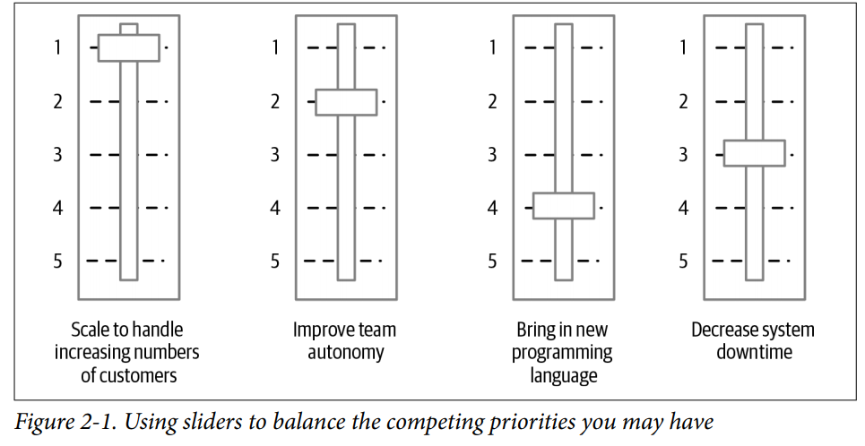

These relative priorities can change (and should change as you learn more). But they can help guide decision-making. If you want to distribute responsibility, pushing more power into newly autonomous teams, simple models like this can help inform their local decision-making and help them make better choices that line up with what you’re trying to achieve across the company.

## Principles

## Videos

<https://www.youtube.com/watch?v=9QTsXLB6Al8&t=1193s>

## Distributed Caching

## Thoughts – Good Articles

Chris Richardson

## Temp